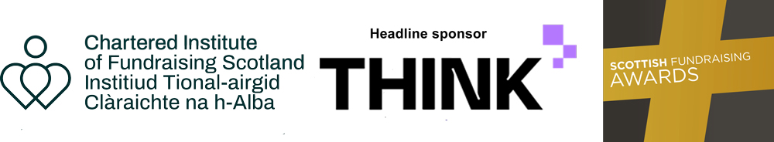

Scottish Fundraising Awards 2024

Best Supporter Experience 2024
- For the campaign that demonstrates the development and implementation of the best supporter experience.
- The application should broadly show how you have offered donors an insight into your work, or brought people closer to your cause to increase income and/or have a meaningful impact on your work.
- The initiative should have taken place in the last 18 months.

Submitting your nomination
- You may enter under multiple categories where appropriate.
- All fields are mandatory; the judging panel will not consider nomination forms with blank spaces.
- All entry forms must be received by 10:00am on Monday 3 June 2024 via the awards nomination website.
- No entries will be accepted after this date.

Name of supporter experience campaign or project.

List the campaign objectives and how it was carried out. Did you use donor insights to create these goals?
(Max 300 words)

How was success intended to be measured? What was the projected income or targets for improving your supporter experience?
(Max 200 words)

What were the actual results? If they were different from projections, please tell us more.
(Max 200 words)

In what way did you involve volunteers, colleagues, trustees, beneficiaries or donors? For example, did you create new ways of showing the impact of donations or learn from existing supporters?
(Max 100 words)

Please tell us the key elements of providing excellent supporter experiences. What did you do differently: did you adapt existing ideas / techniques or create new ones, what channels did you use?
(Max 200 words)

How will this approach to engagement or stewardship influence your fundraising and donor care in the future, if at all?
(Max 200 words)

Please use this space to upload any images you feel will support your nomination.
(Optional)
The files should be in JPG, BMP or PNG formats, big enough to use in printed material, but not greater than 2MB in size. The image files should be titled with the name of your organisation plus the name of the relevant award category i.e., Best Supporter Experience.

Submission summary: please provide us with a summary of your submission; including the key details of your nomination. If shortlisted, this information will be used on the Chartered Institute of Fundraising Scottish Conference website and awards brochure. Please note that your summary may be revised for editorial purposes.
(Max 150 words)

Please upload a few images to be used on our website and printed materials should your nomination be shortlisted.
The files should be in JPG, BMP or PNG formats, big enough to use in printed material, but not greater than 2MB in size. The image files should be titled with the name of your organisation plus the name of the relevant award category i.e., Best Supporter Experience.

Please provide your charity’s website address and social media handles, including LinkedIn

Judging Process
A co-ordinator will receive all applications. Copies of the applications will be shared with members of the judging panel. The panel will decide which applications will be shortlisted. The panel’s decision is final. A co-ordinator will contact all applicants by email confirming the outcome of their application and where a nomination has been shortlisted, outlining the next steps.

Privacy Notice
- The Chartered Institute of Fundraising of Charter House, Canopi, 7-14 Great Dover Street, London SE1 4YR is the Controller.
- The information you provide in this form will be used by the Chartered Institute of Fundraising Scotland to administer the nomination process.
- All received forms will be accessed by a single co-ordinator and will be kept in a secure, restricted access environment. A judging panel will have access to completed forms for the selection process only.
- All copies of the application forms will be securely destroyed within one month following the Awards ceremony.
- Some of the data you supply will be made public if your nomination is shortlisted. This includes names, job titles, companies and photographs where this is relevant to the Award category. This information will be published via our website and in media articles.
- For further information on how your information is used, how we maintain the security of your information and your rights of access to information we hold about you, please see our privacy policy.

