Title of the Article
Author 1 (initials & surname) ¹, Author 2 (initials & surname) ², Author 3(initials & surname) ³ and Author 4 (initials & surname) ⁴
¹ Institution/Organisation, Address
² Institution/Organisation, Address
³ Institution/Organisation, Address
⁴ Institution/Organisation, Address

Abstract
Please write your full paper using this template. Before you submit your proceeding paper please double check that the layout follows these guidelines, otherwise your manuscript will not be accepted. Use the preset text style types (Title, Caption, and Text) for this template. The paper should not exceed 8 pages. The abstract and the main text should be written in Arial Font Size 10 with single line spacing and margins of 2.54 cm (top & bottom) and 1.91 cm (left & right).
Keywords
Please include four to five keywords separated by commas.

1. Introduction
The main text should be formatted in two columns of equal width and 0.5 cm space.
For citations use square brackets numbered in ascending order [1].

2. Experimental
This section describes the experimental set-up and measurement methods used.

3. Results and Discussion
3.1. Sub-Heading
If you would like to include a formula use the mathematic mode and indicate the formula with ascending numbers in round brackets:
$$λ=\frac{J_{r}-J_{r}^{hard}}{J_{r}}$$ | (1)

If you would like to include a table, place the caption above the table.
Table 1. Table caption.
Sample | H_{c} (T) | J_{r} (T)
1 | 2 | 1.1
2 | 3 | 1.2
3 | 4 | 1.3

If you would like to include a figure, place the caption below the figure and describe all symbols shown in the figure. If the figure consists of different subfigures use (a) and (b) for indication. Please use png or jpg format for your figure.
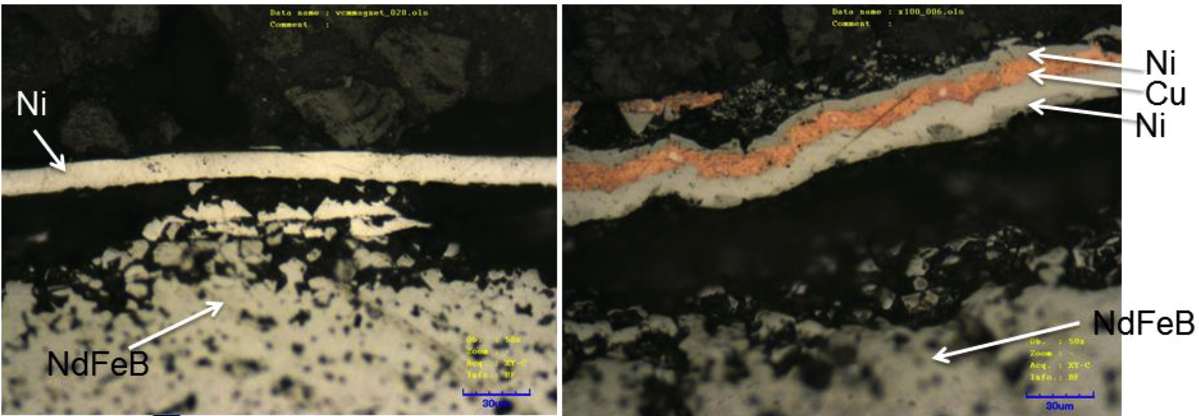
(a)
(b)
Figure 1. Figure caption (showing (a) Ni electroplated NdFeB magnets and (b) Ni-Cu-Ni layer on NdFeB)

4. Conclusion
The conclusion should summarise and conclude the work.

Acknowledgements
Space for the acknowledgements for this work.

References
In this section all authors should be cited with initials and surname as in the order that they appear in the cited article. The article title should be included and the name of the journal should be abbreviated. An example is shown below.
[1] A. Walton, H. Yi, N.A. Rowson, J.D. Speight, V.S.J. Mann, R.S. Sheridan, A. Bradshaw, I.R. Harris, A.J. Williams. The Use of Hydrogen to Separate and Recycle Neodymium-Iron-Boron-type Magnets from Electronic Waste. J. Clean. Prod. 104 (2015) p236-241

