Title:

Path-Dependence in Evolution of Electrical Conductivity in Curing Hybrid Nanocomposites: Important Effects Revealed When Studying Silver Nanobelts in a DGEBA/TETA Epoxy Matrix

Authors:

Geoffrey Rivers1, Pearl Lee-Sullivan1, Boxin Zhao2

1Mechanical and Mechatronics Engineering, University of Waterloo

2Chemical Engineering, University of Waterloo

Abstract:

Using polymer-matrix composites containing silver microflakes and our novel silver nanobelts[1,2], we sought to investigate the relationship between the cure of thermosetting electrically conductive composites and their evolving electrical conductivity. To investigate this in-situ and with resolution in the time domain, we employed three methods of characterizing curing composites: (i) four-wire electrical resistance measurement; (ii) dilatometry, and (iii) modulated temperature differential scanning calorimetry. In these studies, we report that the development of electrical conductivity is reversible and path dependent, where-in the final conductivity is strongly influenced by an interplay of: (a) the vitrification and glass transition properties of the DGEBA/TETA epoxy matrix, (b) the differing surface adhesion between the epoxy and the two types of particles, and (c) the oriented-assembly of the silver nanobelts during cure. Results indicate that small-scale processes during cure in electrically conductive nanocomposites can strongly impact their final conductivities, validating the concern of far-ranging implications on the industry practices. This is contrary to previous literature sources indicating conductive composites undergo a power-law reduction in resistance throughout cure, with final resistance dependent on composition[4]. The additions of silver nanobelts greatly improved conductivity of the composites, and displayed behaviour that indicated that increasing the nanobelt fraction of the filler content can maximize conductivity and improve reliability.

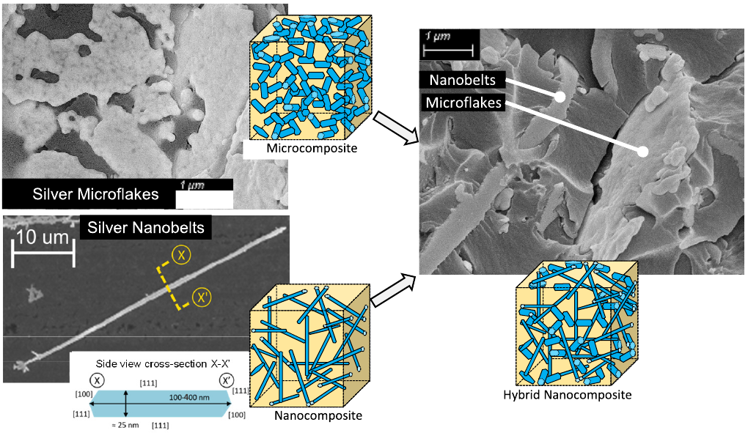

Figure 1: Scanning electron micrographs of silver microflakes in a microcomposite, silver nanobelts on a silicon wafer substrate, and both types of particle in a hybrid nanocomposite ECA. Simplified schematic representations are also provided, not shown to scale.

References:

1 E. Marzbanrad *et al.*, How morphology and surface crystal texture affect thermal stability of a metallic nanoparticle: the case of silver nanobelts and pentagonal silver nanowires Phys Chem Chem Phys, 2015, 17, 315-324

2 G. Rivers *et al.,* Highly-stable silver nanobelts joined via diffusion-free attachment Nanotechnology, 2016, 27

3 B.M. Amoli *et al.,* Electrical Conductive Adhesives Enhanced with High-Aspect-Ratio Silver Nanobelts Macromol Mater Eng, 2014, 299, 739-747

4 M. Inoue *et al.*, Effect of curing conditions on the electrical properties of isotropic conductive adhesives composed of an epoxy‐based binder Soldering & Surface Mount Technology, 2006, 18, 40-45