Microstructural Characterization of Frontal and Flowing Weld Lines in Injection-molded Short Fiber-reinforced Thermoplastics

M. B. Baradi ^{(1, 2)}, C. Cruz², G. Régnier¹, T. Riedel³

¹ PIMM, ENSAM, CNRS, CNAM, 151 bd de l’Hôpital, 75013 Paris, France
² Robert Bosch GmbH, Corporate Sector Research and Advance Engineering, Plastics Engineering, 71272 Renningen, Germany.
³ Robert Bosch GmbH, Corporate Sector Research and Advance Engineering, Analytics, 71272 Renningen, Germany.
Email: MohamedBesher.Baradi@de.bosch.com
Email: Camilo.Cruz@de.bosch.com
Email: gilles.regnier@ensam.eu
Email: Thomas.Riedel@de.bosch.com

Keywords: weld line, injection molding, short fiber-reinforced thermoplastics, fiber orientation, microstructure

Abstract
In this work we present a microstructural characterization of the weld lines (WLs) produced by injection molding of 30 wt% glass fiber-reinforced PBT. We considered frontal and flowing WLs by using different insert shapes and two part thicknesses (1.5 and 3.0 mm). We made computed tomography scans on the complete region of the WLs for analyzing the Fiber Orientation (FO) and fiber Volume Fraction (VF) of the different WL cases. We found that the unfavorable induced FO along the flowing WL does not vanish with the distance from the insert. By means of simulations with commercial software for injection molding, we compare the FO prediction to the experimentally obtained results. Finally, we discuss in this work the relationships between the previous results of tensile tests on the studied WLs and the respective microstructure.

1. Introduction

Injection molding is one of the main fabrication processes used in the industry of plastics. Due to its complexity, many factors have to be considered by the design of injection molded plastic parts. Flaws such as blisters, warpage, voids and weld lines can weaken the injection-molded article and inflect a diminution on the mechanical and visual qualities of the injected product [1]. Weld lines (WLs) induce a big influence on the properties of the injected parts, especially the mechanical properties [2, 8]. Because they form when the separated polymer melts meet during the injection; the initiation of WLs is unavoidable and the properties of the WLs have to be carefully considered during the design phase. The separation of the melt can take place due to inserts inside the mold, pens or multiple injection gates. Meaning that the more complex a part is, the more WLs it will contain. In recent years, simulation has been used as a tool to foresee the flaws and properties of injection-molded articles. However, the prediction of both process and structural simulation tools still have a big room of improvement, espicially when it comes to the prediction of WL mechanical properties [3]. Depending on the formation angle, we can distinguish between frontal and flowing WLs. Frontal WLs form when the separated melt fronts meet in opposite directions and solidify afterwards immediately, these WLs are also called butt or cold WLs. Flowing WLs form when two melt fronts meet and flow through the mold until solidification. Flowing WLs are also called meld or hot WLs and are more probable in industrial parts [3]. In the literature, we can find a vast list of papers characterizing the effect of WLs on the mechanical properties of thermoplastics. Hashemi [4] worked on frontal WLs injected with ABS reinforced with different volume fractions of glass fiber. The WL had no influence on the tensile modulus compared to pristine specimens. Increasing fiber content has significantly decreased the WL integrity factor (ratio of strength with WL to the strength without it). Two main reasons can attribute to the WL weakness; first reason is the incomplete molecular diffusion of the polymer matrix [3]. Second reason is the fiber orientation (FO) at the WL as fibers align parallel to the WL surface eliminating their role in strengthening the part in case of loading perpendicularly to the WL surface [5]. V-notches and molecular orientation can also have an influence on the mechanical properties.

Recently X-ray computed tomography (CT) has proven to be an important method to study the microstructure of plastic parts. The FO at a flowing WL was investigated by Ayadi et al. [6] using x-ray micro-tomography. Results showed that orientation behavior differed depending on the distance from the insert where a noticeable amount of fibers tended to orient in thickness direction just after the insert. Using microfocus X-ray CT, Nagura et al. [7] considered a frontal WL case. Scans on small region regions showed that fibers at the WL orient perpendicular to the flow direction and in thickness drirection.

The mechanical behavior at the WLs of fiber-reinforced polymers is highly related to its microstructure. To enable a better modelling of the WL properties a clear understanding of its microstructure is required.

In this work, two specific molds were developed to conduct a comprehensive microstructural study of both flowing and frontal WLs. We quantitatively define both fiber volume fraction and the Fiber Orientation Tensor (FOT) at different positions. Mechanical tensile tests were also made to assess the mechanical properties at the WL and its connection to the FO.

2. Experiments and Simulation

2.1 Sample Preparation and Mechanical Testing

Polybutylenterephthalat with 30% wt. glass fiber (PBT-GF) was used for the investigation. The injection-molding machine was DK-Codim 175/410. We consider two thicknesses (1.5 – 3) mm, two insert shapes (slit with 1 mm width and cylinder with 15 mm radius) and a plate dimension of (125 x 125) mm Fig. 1. The frontal WL specimen specimen had a 15 mm width at the WL and 150 mm length Fig. 1. The process parameters were fixed at: packing pressure 40 MPa, mold temperature 60°C and melt temperature 250°C. The injection time was 2.3 s for the flowing WLs and 2.1 s for the frontal WLs. An Instron 5966 machine is used for the mechanical tensile tests.

2.3. X-ray Computed Tomography

The CT system was GE v|tmoe|x m 300/180 Metrology Edition with a Nanofocus x-ray tube. We made the flowing WL scans on 5×10×t mm³ zones on different locations as explained in Tab. 1 and Fig. 1. Each scan needed ~3 hours scan time and ~20 GB size. The software Volume Graphics 3.1 was used to evaluate the FO. The FO results were averaged on a hexahedral grid to give a FOT value for each element.

2.4. Fiber Orientation Prediction

We use the commercial software Moldflow® 2018.1 for the evaluation of the FO at the WL. Three simulation models were considered: Reduced strain closure (RSC) model with a reduced strain closure factor (Ki) of 0.05, Moldlfow rotational diffusion model (MRD) with automatically calculated Ci (coefficient of interaction) and Di (coefficients of asymmetry) and finally the Folgar-Tucker model (FT) with automatically calculated Ci.

Table 1. Positions of CT scans for each case of flowing WL

Flowing WL Case | Slit insert (3 mm) | Slit insert (1. mm) | Cylinder insert (3 mm) | Cylinder insert (1.5 mm)
Positions of CT scans | 1, 2, 3 | 1 | 1, 3 |  | 1, 3

We use a fill and pack analysis with the same process parameters used in the injection and a 3D mesh including the runner. The element edge size was 1.5 mm with12 layers through the thickness. We map the predicted FO into the same hexahedral mesh used in the evaluation of the CT scans Using Digimat Map 2017.1. The error was evaluated by means of the root mean square error (RMSE). To have an indicator of the simulation prediction error we take the RMSE value of the error of all the elements in the grid.

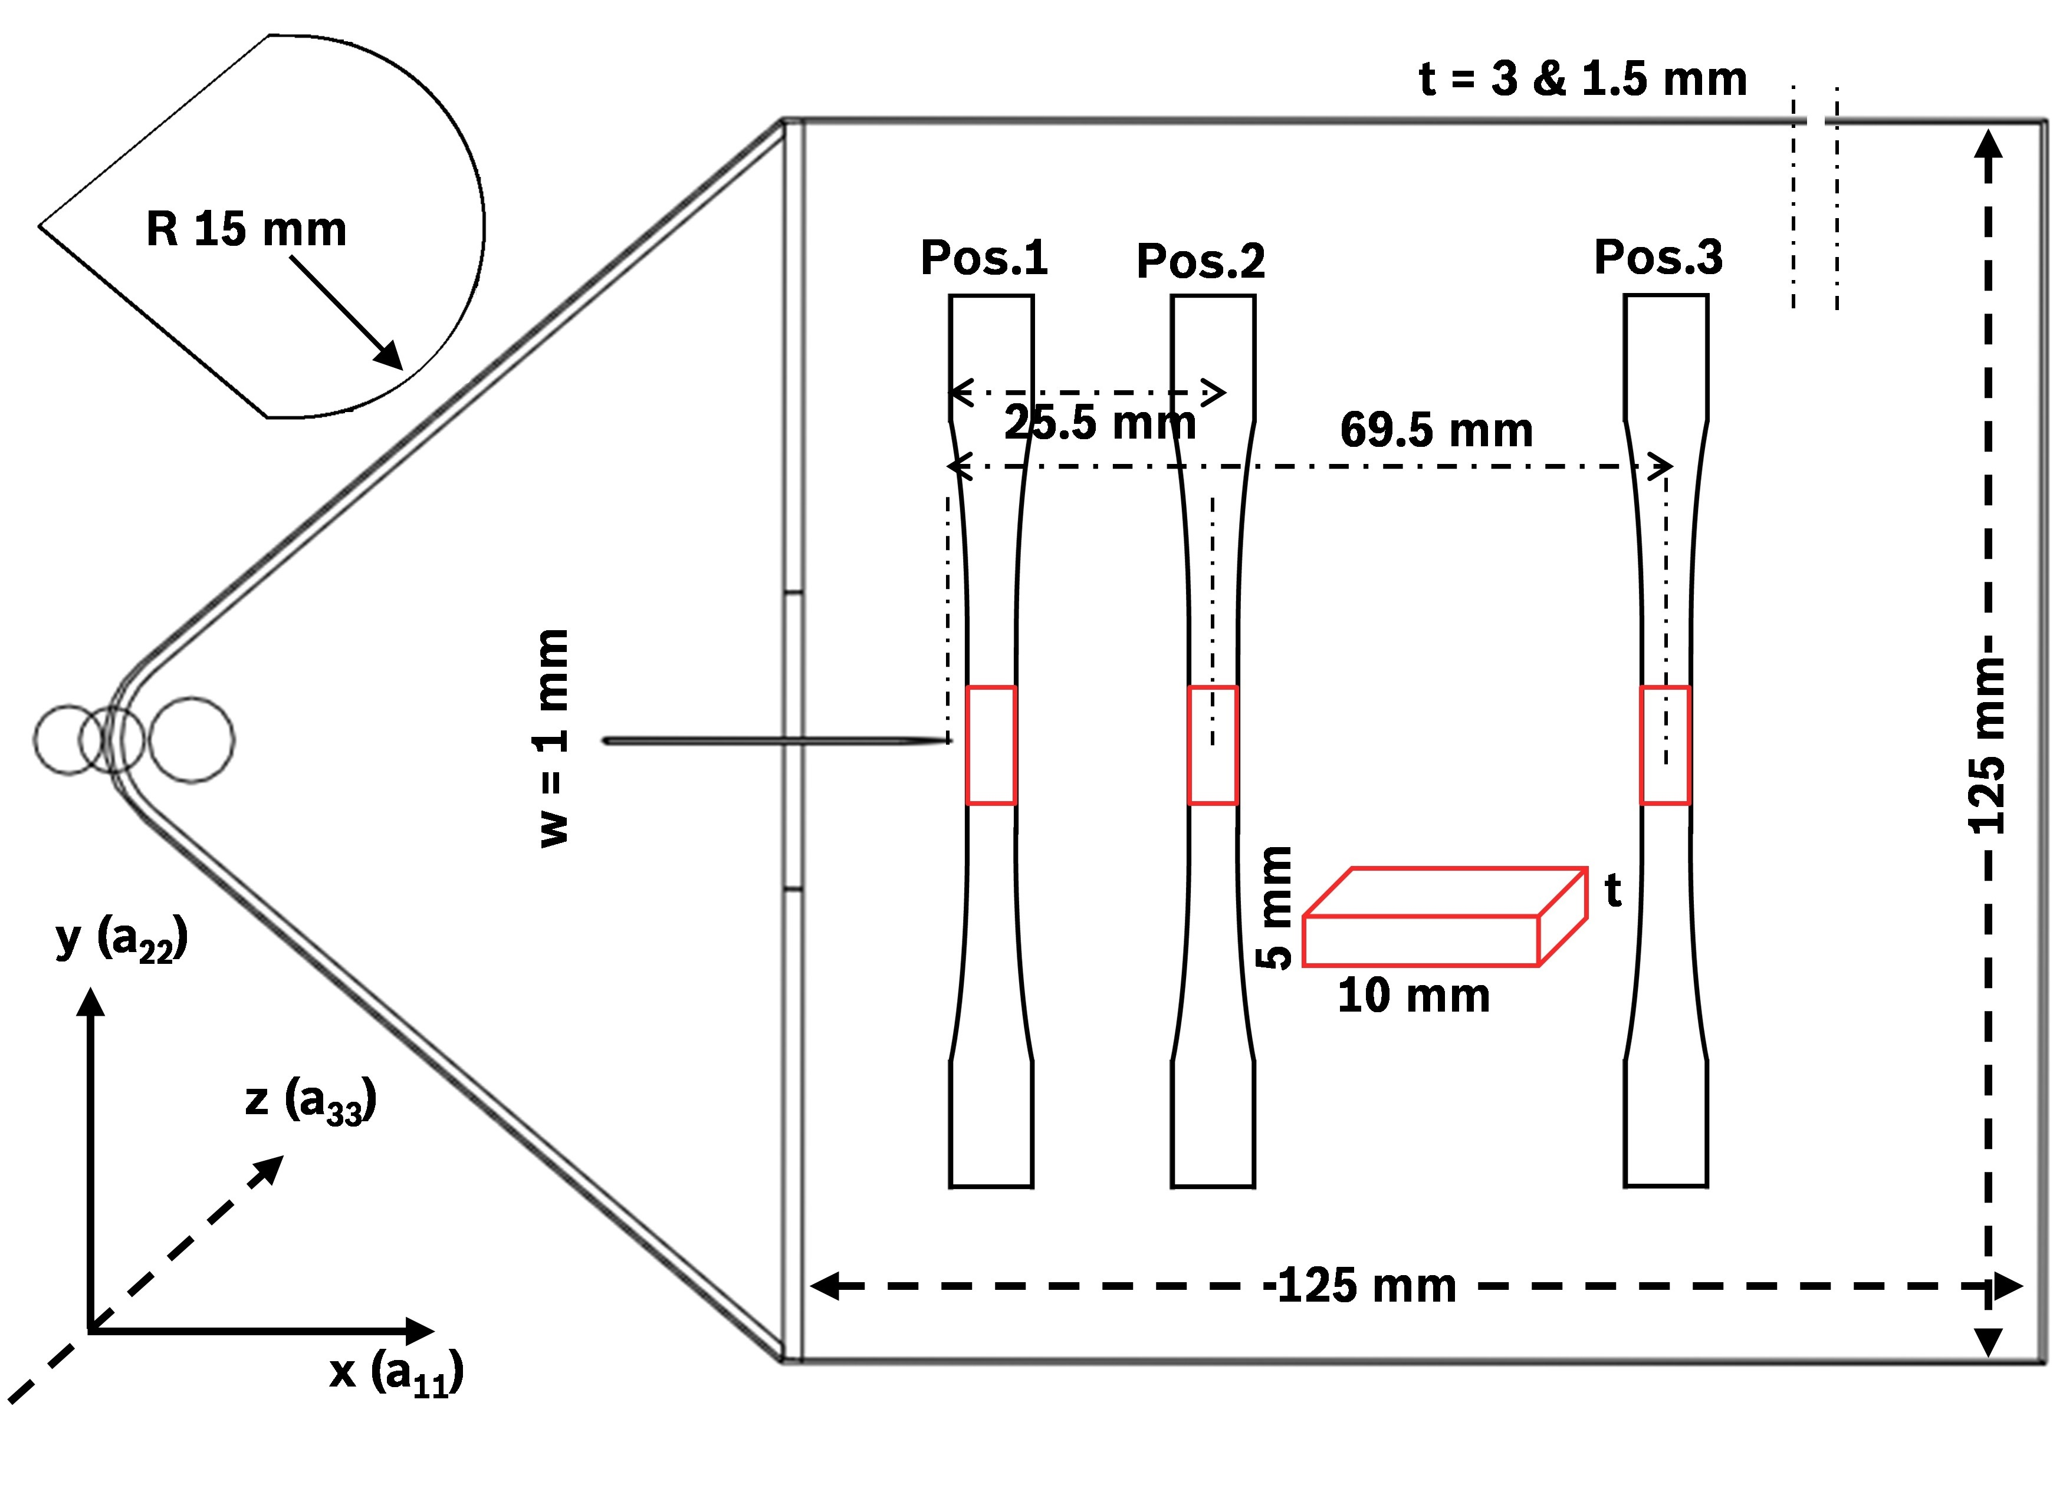

Figure 1 Geometry of the specimens and the location of the CT scans.

3. Results

3.1 Mechanical Testing

The extent of the WLs influence on the mechanical properties can be seen in Fig. 2 and Fig. 3. For the flowing WLs we do mechanical tests on different distances from the insert. The results show the clear influence of the flowing WL on both stress and strain (Fig. 2). We see an increase in the failure strain along the WL in both thicknesses. An influence of the insert shape was also present. The cylindrical insert seems to give a slightly higher failure strain compared to the slit insert far from the insert. The frontal WL results with a 3 mm WL are presented in Fig. 3. The frontal WL induces a reduction of the mechanical strength that reaches 50% and a reduction on failure strain by nearly the third. Changing the process parameters had a low influence on the mechanical properties with a slight increase in failurte stress with higher packing pressure and melt temperature [2].

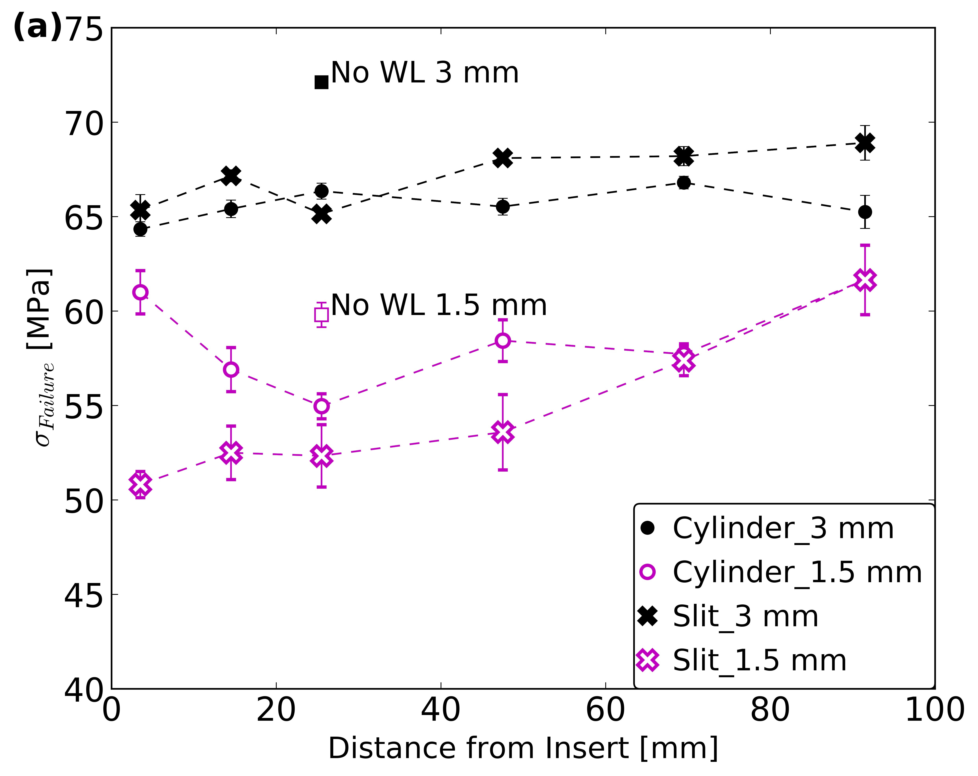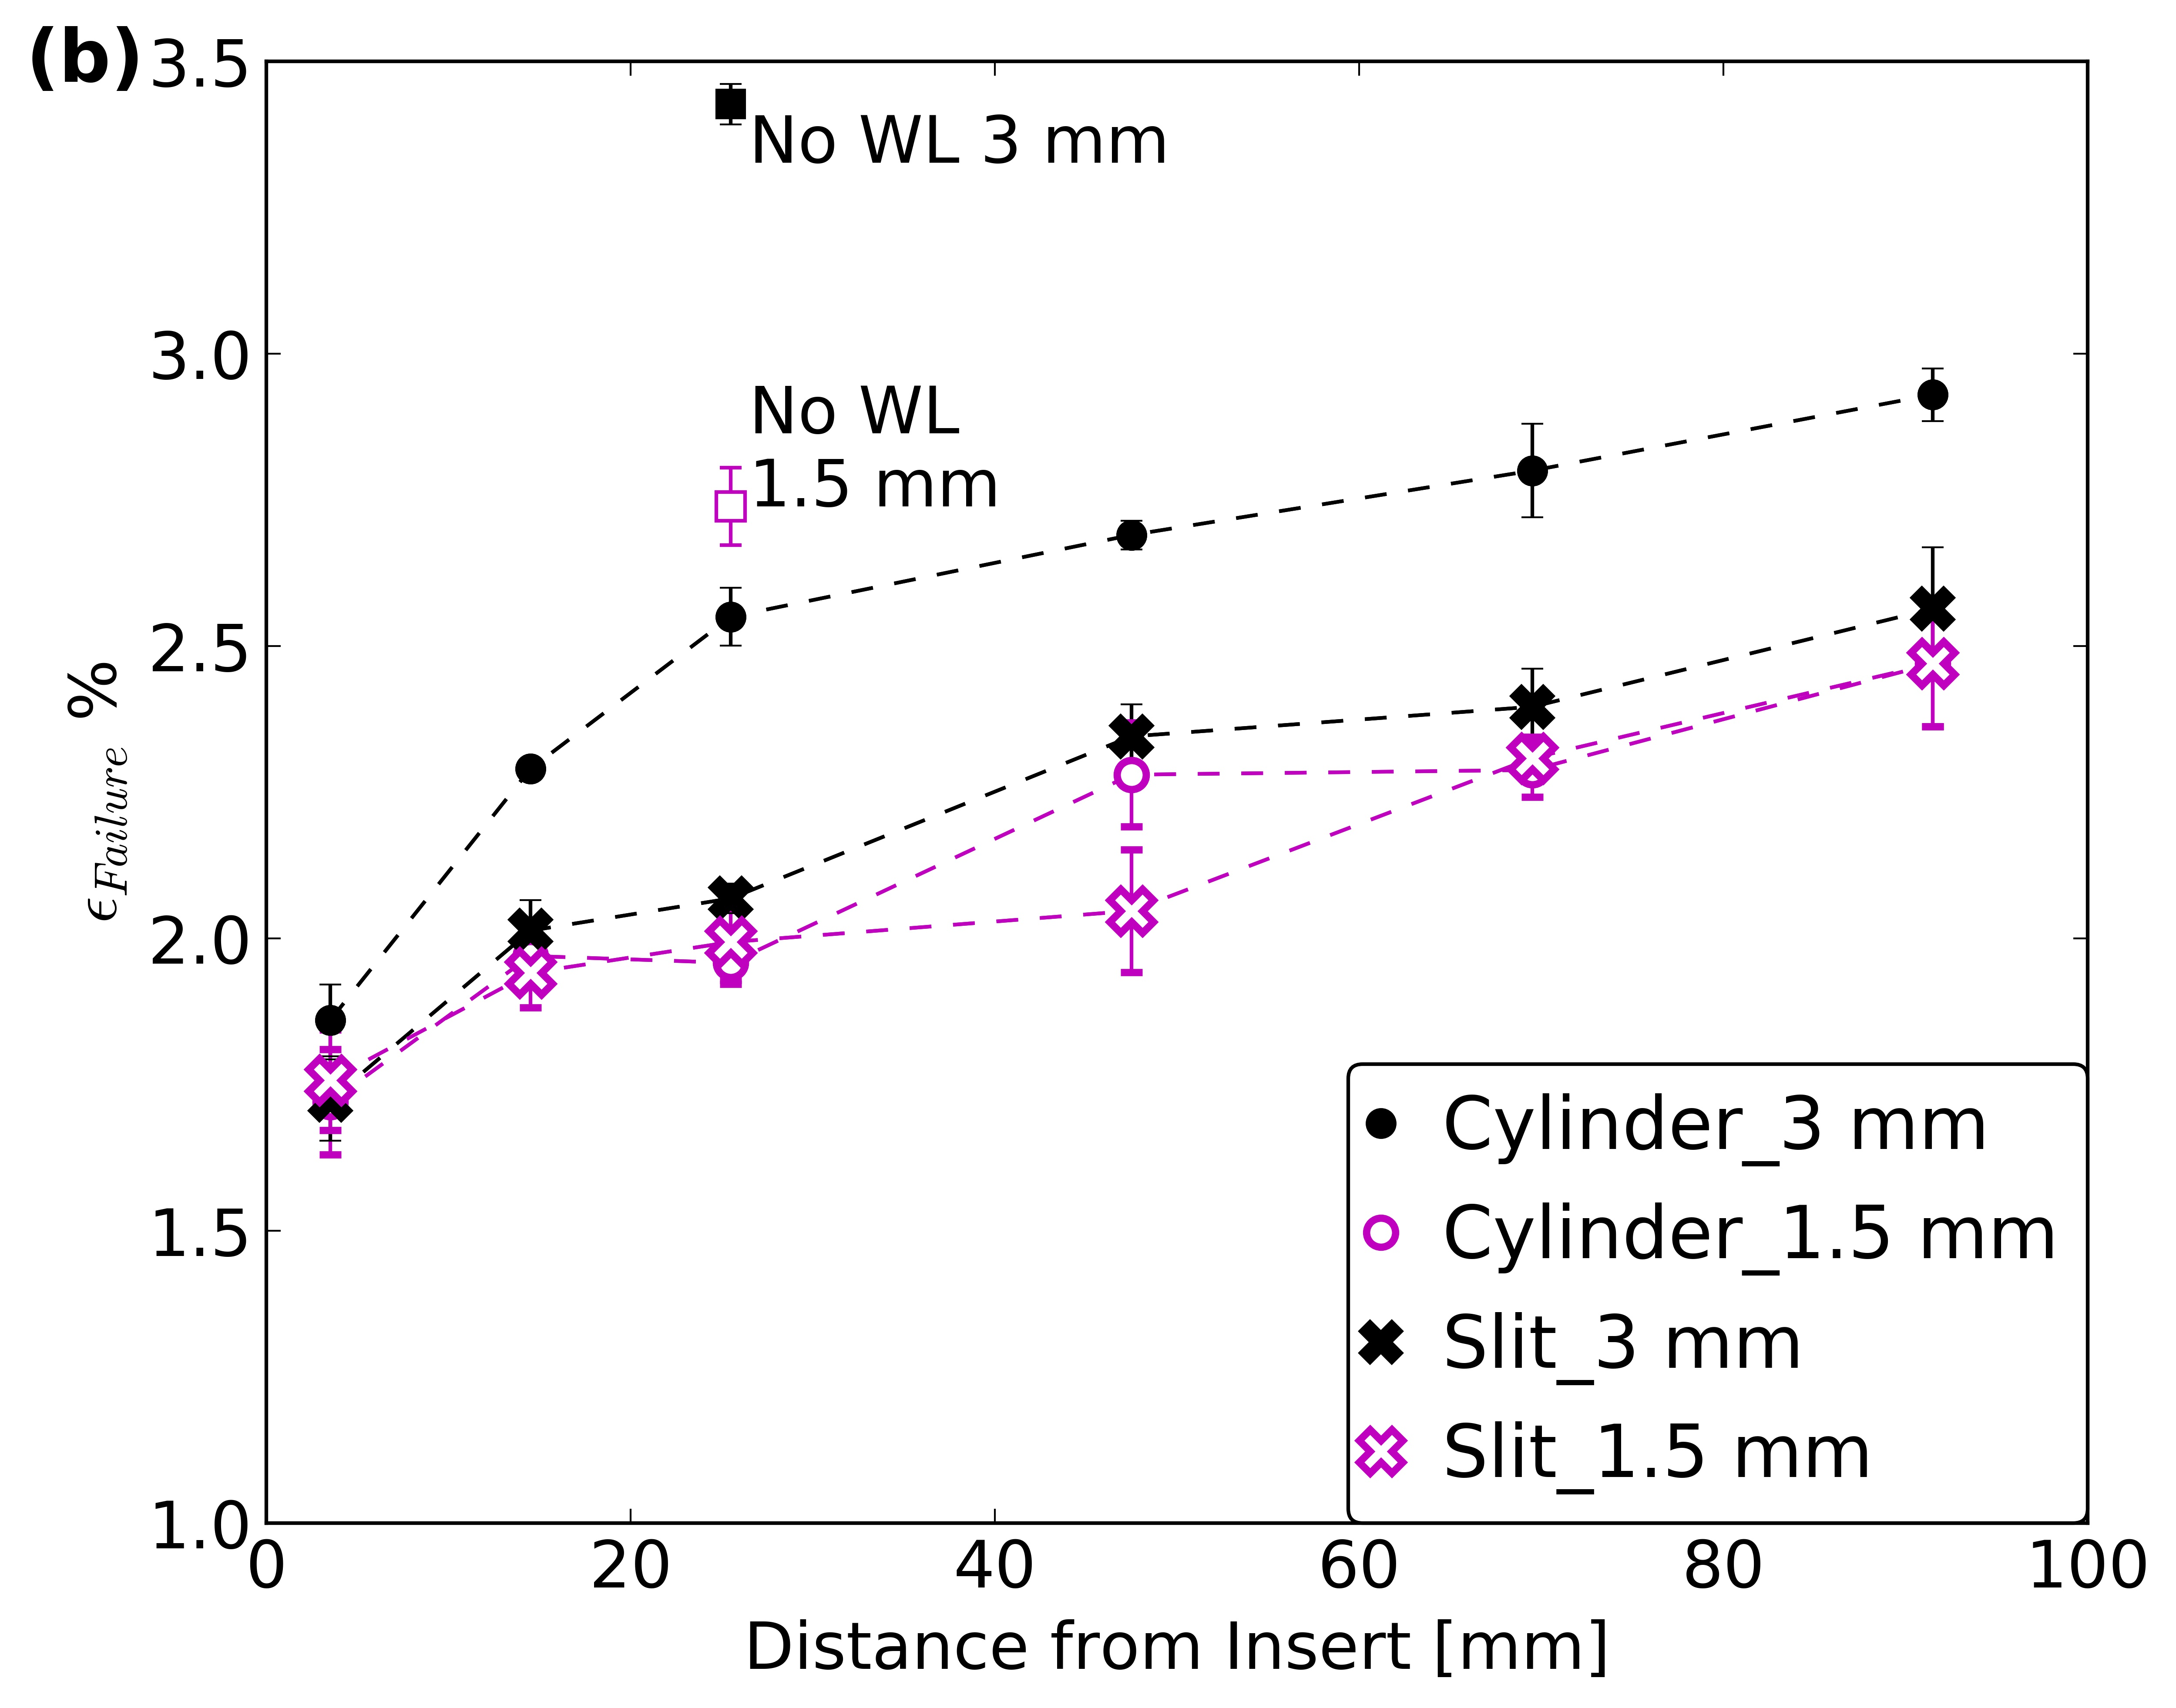

Figure 2 Failure Stress (a) and failure strain (b) behavior of a flowing WL along the distance of the insert [2, 8].

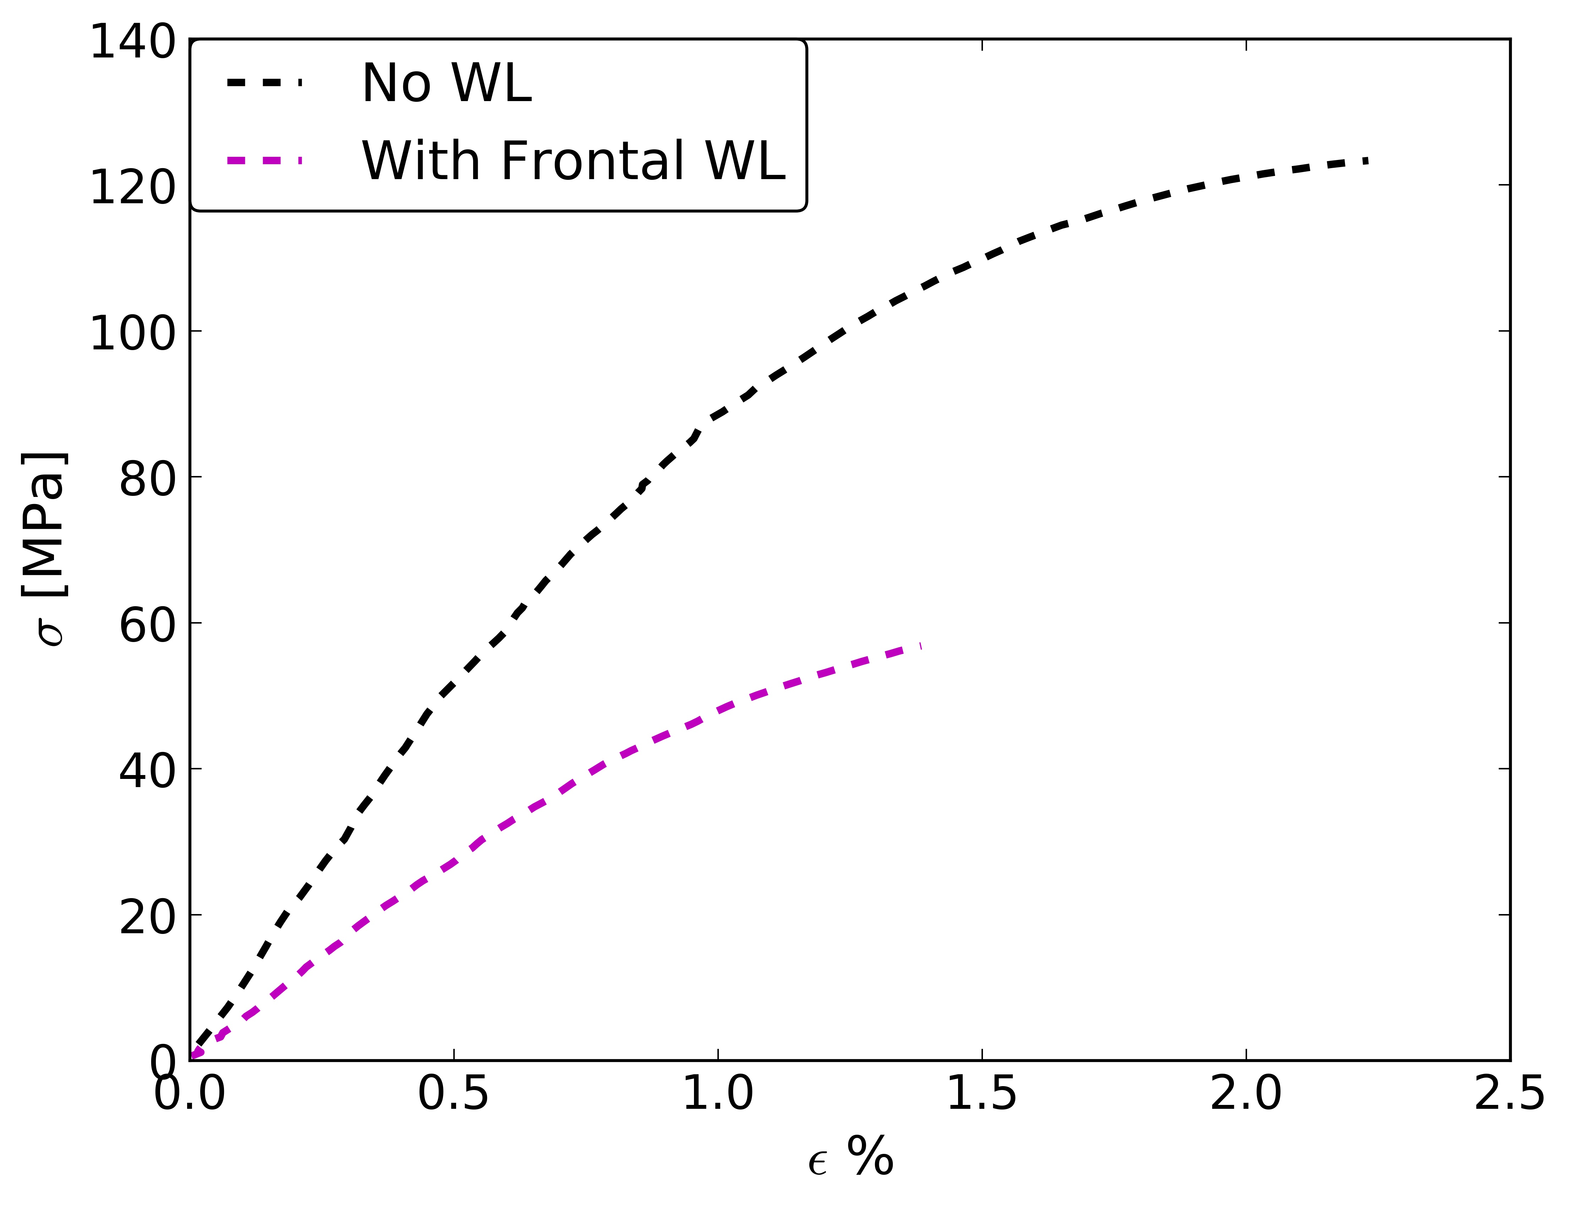

Figure 3 Stress strain diagram of a 3 mm specimen with and without a frontal WL.

3.2 Fiber Orientation

To evaluate the results on the hexahedral grid we tested two element grid sizes (0.1 mm and 0.2 mm). Fig. 4. presents the FO on one set of elements transversally to the flow. We find that the larger element size of 0.2, which would contain ~ 70 fibers compared to ~ 9 fibers with 0.1 mm, is more representative of the FO state. We evaluate all the scans on the same larger elements size. The results show that the FOT component in the flow direction at the WL reaches a maximum value exactly at the WL surface. The changes around the WL show an increasing gradient transversally to the WL that reaches a width of more than 8 mm and an influence of the insert shape was also seen [8]. The frontal WL has also shown a tendency to orient in a FO gradient. Fibers reach a maximum orientation transversal to the flow exactly at the WL.

3.3 Comparison to Simulation

Using a separate CT scan on a specimen without WL, the RMSE value was ~ 0.08-0.1 using the RSC model. We take this value as a reference to assess the prediction error at the WL. Results of the FO prediction of the flowing WL show that the commercial software has as slightly higher RMSE. The RSC and MRD models gave the best values of the error prediction.

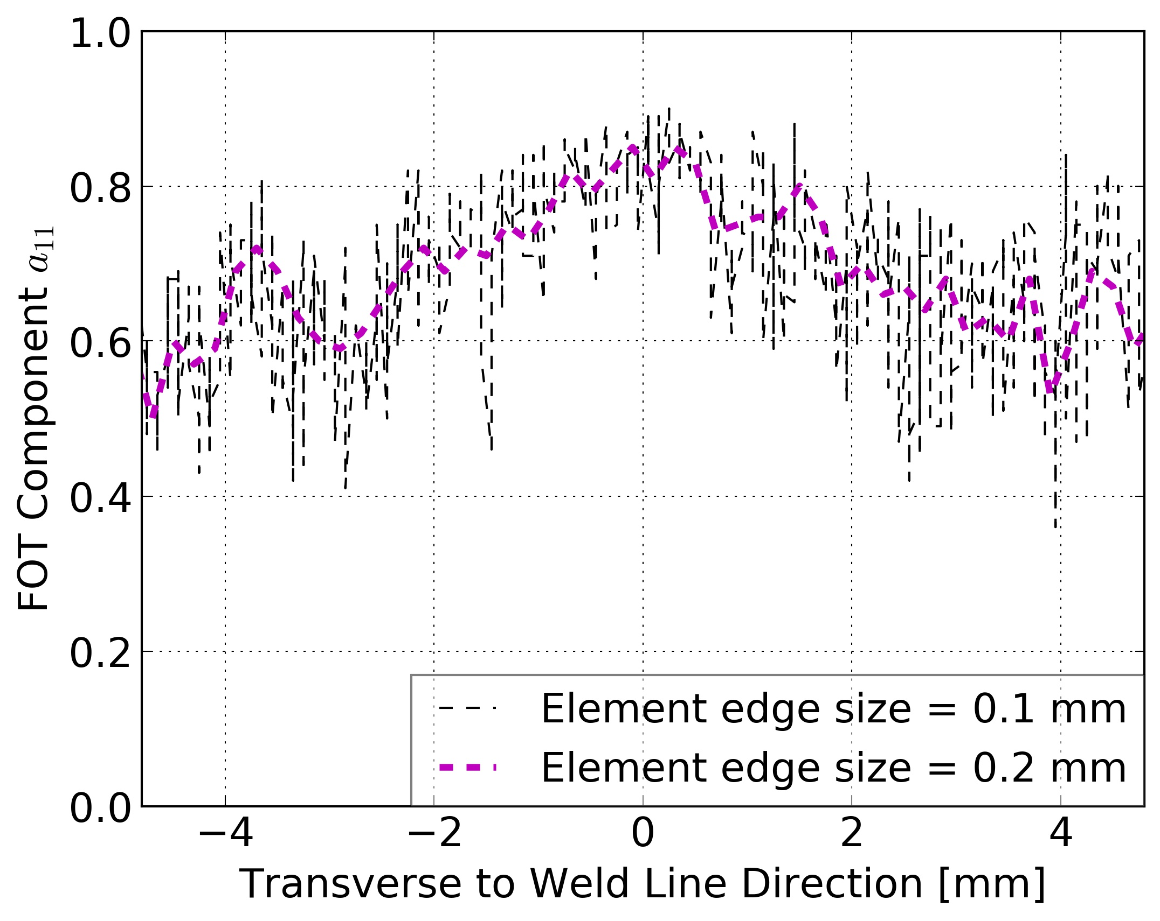

Figure 4 Fiber orientation evaluation on two grid sizes shown on a single set of elements transversal to the WL (WL is at 0 mm).

3. Conclusion

The FO behavior at the WL has a big influence on the mechanical properties of injection-molded parts. Flowing WLs induce an orientation gradient 8 mm wide. The simulative prediction of FO with Moldflow showed that with flowing WLs the software shows a slightly higher error margin to the prediction without WLs.

References

[1] Eyerer , P., „Einführung in Polymer Engineering“, in „Die Kunststoffe und ihre Eigenschaften“ Berlin, Heidelberg: Springer Berlin Heidelberg (2005).
[2] M. B. Baradi, C. Cruz, G. Régnier, Mechanical Characterization of Frontal and Flowing Weld
Lines in Injection-molded Short Fiber-reinforced Thermoplastics. Proceedings of the Europe
Africa Conference 2017 of the Polymer Processing Society (PPS), Dresden, June, (2017).
[3] C. Cruz, “Integrative simulation for assessing the mechanical performance of a weld line on
injection moulded thermoplastic parts” in WCCM 2014, ECCM 2014 and, ECFD, 2334– 2345, 2014.
[4] S. Hashemi. Thermal Effects on Weld and Unweld Tensile Properties of Injection Moulded Short
Glass Fibre Reinforced ABS Composites. Express Polymer Letters1:68-697, 2007.
[5] A. Vaxman, M. Narkis, A. Siegmann, S. Kenig. Weld-line characteristics in short fiber reinforced
thermoplastics. Polymer Composites 12:161–168, 1991.
[6] A. Ayadi, H. Nouri, S. Guessasma, F. Roger. Determination of orthotropic properties of glassfibre
reinforced thermoplastics using X-ray tomography and multiscale finite element computation.
Composite Structers 136:635–649, 2016.
[7] A. Nagura, K. Okamoto, K. Itoh, Y. Imai, D. Shimamoto, Y. Hotta. The Ni-plated carbon
fiber as a tracer for observation of the fiber orientation in the carbon fiber reinforced
plastic with X-ray CT. Composites Part B Engineering 76:38–43, 2015.
[8] M. B. Baradi, C. Cruz, G. Régnier, T. Riedel. Mechanical and Microstructural Characterization of
Flowing Weld Lines in Injection-molded Short Fiber-reinforced PBT. Composite Science and
Technology (under review)

