Spider silk inspired damping fibres drawn from a supramolecular hydrogel composite at room temperature - A step closer to sustainable fibre technology

Darshil U. Shah¹, Yuchao Wu^{2,3}, Michael H. Ramage¹, Oren A. Scherman^{2,3}

¹Department of Architecture, University of Cambridge, Cambridge CB2 1PX, United Kingdom
²Melville Laboratory for Polymer Synthesis, Department of Chemistry, University of Cambridge, Cambridge CB2 1EW, United Kingdom
³Department of Chemistry, University of Cambridge, Cambridge CB2 1EW, United Kingdom
Email: DUS – dus20@cam.ac.uk; YW – yw297@cam.ac.uk; MHR – mhr29@cam.ac.uk; OAS – oas23@cam.ac.uk

Keywords: supramolecular fiber, hydrogel, self-assembly, damping, spider silk

Abstract
We report the aqueous self-assembly of hierarchical supramolecular polymer-colloidal hydrogels consisting of functionalized polymer-grafted silica nanoparticles, a hydroxyethyl cellulose derivative and cucurbit[8]uril. The resulting material (98 wt% water) can be drawn into uniform (6 μm) ‘supramolecular fibres’ at room temperature. They exhibited better tensile strength and superior stiffness to natural fibres such as viscose, protein-based silks, and human and animal hair, while cyclic loading tests illustrated their remarkable damping capacity (60–70%). These supramolecular hydrogels represent a new class of hybrid supramolecular composites, opening a window into fibre technology through low-energy manufacturing from a broad range of sustainable materials.

1. Introduction

Humans have utilised fibres for over 30,000 years [1], although synthetic fibres were not commercialised until the early 1900s [2]. Fibre materials have great impact on our daily lives, with their use ranging from textiles to functional reinforcements in composites. The manufacturing process of conventional man-made fibres is typically limited by extensive energy consumption due to high processing temperatures, and the use of various (often difficult to dispose) solvents. In contrast, spiders can readily spin strong and tough silk fibres at room temperature using water as a solvent and ‘fly-juice’ as a feedstock. Developing such an elegant process for the manufacture of man-made fibres has remained a fundamental challenge, though attempts have been on-going since the very beginning (ca. 1884), when the French scientist Hilaire de Chardonnet invented the first artificial textile fiber, viscose (from wood cellulose), and even called it ‘artificial silk’ [2].

Supramolecular materials comprise of molecular building blocks assembled via non-covalent interactions, such as hydrogen bonding. Due to the reversibility of their non-covalent interactions, and consequent dynamic behaviour and self-healing properties, supramolecular polymeric hydrogels are promising for a range of biomedical and industrial applications, and offer a pathway to form filamentous soft materials.

Inspired by biological systems, we report [3] a supramolecular polymer–colloidal hydrogel composed of 98 wt% water that can be readily drawn into uniform (∼6-μm thick) ‘supramolecular fibres’ at room temperature.

2. Methods

The full materials and methods can be found in Wu et al. [3].

Poly(Nipam-co-HEAm-MV) grafted silica nanoparticles (P1), and hydroxyethylceullose functionalized with naphthalene isocyanate (H1) were produced. The supramolecular hydrogel was fabricated by mixing an aqueous solution of H1 (1 wt%) with an aqueous solution of P1 (1wt%), which was complexed with cucurbit[8]uril (CB[8]) in a 1:1 MV:CB[8] ratio. The hydrogel formation
was dependent on the presence of all three components; in the absence of CB[8], or when CB[8] was replaced by cucurbit[7]uril (CB[7]), which has a cavity that is only large enough to encapsulate MV alone, mixtures of H1 and P1 behaved like a runny liquid. The supramolecular hydrogels were extremely stretchy, and filaments could be drawn from a pool of the hydrogel at room temperature. The hydrogel filaments,when dried (within 30s in air), a fine (between 2 to13 micron, but typically 6

Cryogenic scanning electron microscopy (SEM) images were obtained for the supramolecular hydrogel and fibre using a FEI Verios 460 variable pressure SEM using and InLens detector. The samples were sputter coated with a thin layer of platinum and palladium metals prior to imaging.

Single fibre tensile testings were conducted on an Instron tensile testing machine equipped with a calibrated; fibre samples were loaded onto card frames prior to testing. A combination of tests were conducted including: i) quasi-static (at 1mm/min), ii) single load-unload cycles (to 5% applied strain), iii) multiple load-unload cycles (to 5% applied strain) and iv) progressive load-unload cycles (steps of 2.5% applied strain).

3. Results and Discussion

We report a novel means to assemble supramolecular polymer-colloidal hydrogel composites. Functionalised polymer-grafted silica nanoparticle fillers, semi-crystalline hydroxyethyl cellulose polymer matrix, and cucurbit[8]uril (supramolecular catalyst) undergo aqueous self-assembly at multiple length scales to form the supramolecular hydrogel composite (Fig. 1. a-g), facilitated by nanofibril formation at colloidal-length scale (Fig. 1 f-g) and host–guest interactions at the molecular level (Fig. 1 h-i).

The resulting hydrogel material (98 wt% water) exhibits extraordinary elasticity when pulled; high-aspect ratio (> 1 x 10⁵) supramolecular fibres result from room temperature dehydration of the hydrogel filament. The composite hydrogel is remarkably different to hydrogels assembled from two linear functional polymers, suggesting that its high elasticity emerges from the realignment of nanofibrils during the drawing process.

Fig. 2a presents the tensile stresss-strain behavior of the fibres: they have a tensile modulus of 6.0 GPa, strength of 190 MPa, and failure strain of 18%. The supramolecular fibers posses better tensile properties (stiffness, strength and failure strain) compared to conventional regenerated fibers (e.g. cellulose-based viscose, and protein-based artificial silks) and animal hair (Fig. 3a). Most interestingly, dynamic loading tests (Fig 2b) revealed that the supramolecular fibres have a damping capacity of 60-70%, making them ultra-efficient at absorbing energy, comparable to viscose rayon and spider silks (Fig. 3c). The remarkable damping performance of the fibres is proposed to arise from the complex combination and interactions of ‘hard’ and ‘soft’ phases within the hydrogel and its constituents.

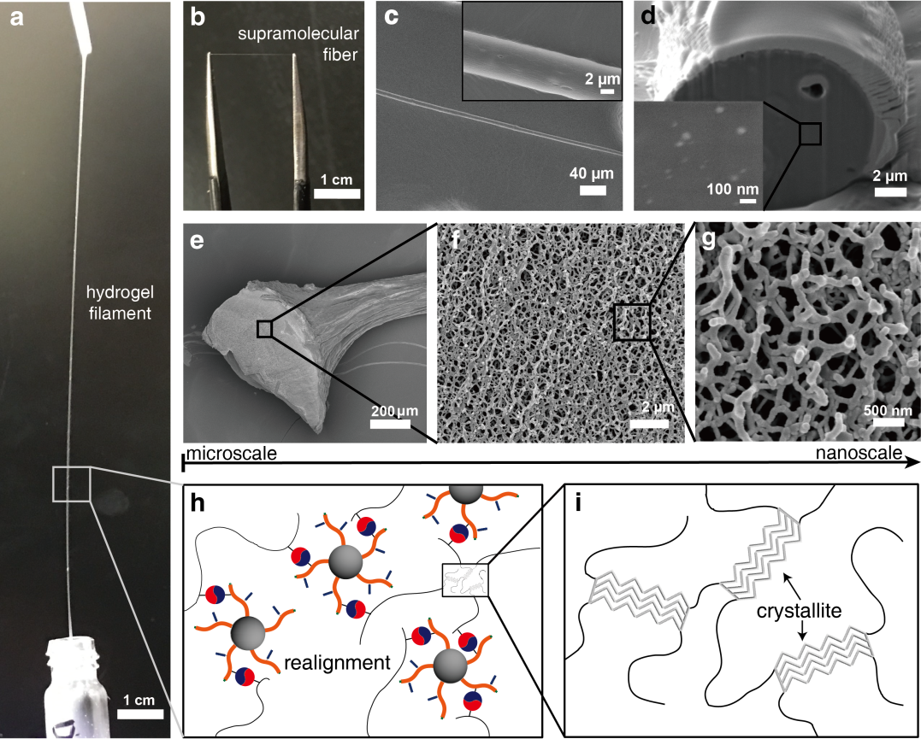

Figure 1. The hierarchical nature of the supramolecular hydrogel composite is readily confirmed through high-resolution microscopy. a-d) show the fibre, e-g) the nanofibril network within the fibre, and h-i) the molecular organisation.

Figure 2. Mechanical properties of supramolecular fibres subjected to a) quasi-static and b) cyclic tensile loads. The damping capacity refers to the ratio of the damping energy (shaded area; area between the loading and unloading curve) to the stored energy (hatched area; area below the loading curve).

Figure 3. Comparison of the mechanical properties of our supramolecular fibre (red) with other typical technical fibres, using data from multiple sources including [2, 4-6]. a) Representative tensile stress-strain curves illustrating the high ductility and moderate stiffness of the supramolecular fibre, and its similar profile to regenerated fibres (cellulose-based viscose and protein-based artificial silks) and animal hairs (human and sheep). b) Ashby plots comparing specific (i.e. per unit density) tensile strength and modulus. Dashed design guide line for maximum flexibility without failure (σ/E = C) are shown. c) The damping capacity of the supramolecular fibre exceeds that of silk and is comparable to viscose, making it a good candidate for energy-absorption applications.

4. Conclusions

Our study provides important understanding of self-assembled supramolecular composite materials, and demonstrates a novel manufacturing process for fibre materials through low-energy manufacturing from a broad range of sustainable materials.

Acknowledgments

This work is published in Wu, Y., Shah, D.U., Liu, C., et al. PNAS, 2017. 114 (31): p. 8163-8168 (accessible at http://www.pnas.org/content/114/31/8163.full).

This work was supported by the Engineering Physical Sciences Research Council (EPSRC) EP/K503496/1 and a Translational Grant EP/H046593/1 as well as a Leverhulme Trust Programme Grant (Natural Materials Innovation); Dr Y. Wu was funded by EPSRC EP/L504920/1. Dr D.U. Shah also thanks the MDPI journal /Fibers/ for awarding the Fibers Travel Award 2018, which part-funds attendance to ECCM18.

References

1. Kvavadze, E., Bar-Yosef, O., Belfer-Cohen, A., Boaretto, E., Jakeli, N., Matskevich, Z., Meshveliani, T, 30,000-year-old wild flax fibres. Science, 2009. 325: p. 1359.
2. Lewin, M., Handbook of fiber chemistry. Third ed. 2007, Boca Raton: CRC Press LLC.
3. Wu, Y., Shah, D.U., Liu, C., Yu, Z., Liu, J., Ren, X., Ramage M.H., Abell, C., Scherman, O.A., Bioinspired supramolecular fibers drawn from a multiphase self-assembled hydrogel. Proceedings of the National Academy of Sciences of the USA 2017. 114(31): p. 8163-8168.
4. CES Selector. 2016, Granta Design Limited: Cambridge, UK.
5. Shah, D., Developing plant fibre composites for structural applications by optimising composite parameters: a critical review. Journal of Materials Science, 2013. 48(18): p. 6083-6107.
6. Vollrath, F., Porter D, Holland C, The science of silks. MRS Bulletin, 2013. 38: p. 73-80.

