Composite matrix design with efficient computational chemistry approaches

Caroline M. Krauter¹, Jacob L. Gavartin², Jeffrey M. Sanders³, Thomas J.L. Mustard⁴, Alexander Goldberg⁵, Andrea R. Browning⁴, and Mathew D. Halls⁵

¹Schrödinger GmbH, Q7 23, 68161 Mannheim, Germany
Email: caroline.krauter@schrodinger.com, Web Page: www.schrodingermaterials.com
²Schrödinger Inc., Cambridge, UK
³Schrödinger Inc., New York, NY 10036, United States
⁴Schrödinger Inc., Portland, OR , United States
Email: andrea.browning@schrodinger.com, Web Page: www.schrodingermaterials.com
⁵Schrödinger Inc., San Diego, CA 92121, United States

Keywords: Computational chemistry, matrix design, crosslinking, molecular dynamics, epoxy, amine, resin

Abstract
Due to their low cost, manufacturability, and unique mechanical and thermophysical properties, thermoset materials have received increased interest in recent years. Understanding the relationship between basic chemical composition, structure morphology, and macroscopic materials properties is crucial for the design of new matrix materials. In the present study we show how automated MD workflows allow for the efficient and accurate simulation of mechanical and thermophysical material properties. The applicability of the described workflows is illustated for a two-epoxy, one-amine curing resin in the presence of a thermoplastic-toughener under dry and wet conditions as an example. Fast, GPU-enabled molecular dynamics simulations in combination with accurate force fields are key factors enabling extended simulation time-scales and increasing simulation throughput.

1. Introduction

As the use and demands on polymer matrix composites increases, the need to predict the behavior of the final polymer product increases as well. The chemistry and processing parameters are key components in the determination of the final polymer matrix properties. Calculations of matrix properties such as glass transition temperature and modulus based on molecular dynamics (MD) are becoming increasingly popular to speed up the process of assessing chemistry and processing [1]. Recent advances make it possible to use GPU hardware for MD simulations, enabling simulation time scales that were not previously accessible. When combined with crosslinking techniques that are flexible in chemistry of the crosslink reaction, prediction of composite matrix properties becomes possible for a large range of polymer matrix materials.

The combination of crosslinking and property prediction provide powerful tools for polymer development. Establishing relationships between basic chemical composition, structure morphology and macroscopic materials properties is the key element in the rational design of more robust, better manufacturable and environmentally friendly matrix materials. An intuitive simulation framework and efficient quantum mechanics and molecular dynamics simulation engines are necessary to be successful in the application of molecular simulation to matrix material design. Here, we will provide a overview description of such a framework and illustrate how it can be applied.

We will discuss the process of constructing a crosslinked network and calculate important properties of the resulting crosslinked matrices. We will illustrate the applicability of the approach using an example of a two-epoxy, one-amine curing resin in the presence of a thermoplastic-toughener, for which experimental results are available [2]. The epoxy monomers used in the present example are N,N′-tetraglycidyl diaminodiphenylmethane (TGDDM) and tri-glycidyl para-aminophenol (TGAP) while the amine is 4,4’-diaminodiphenylsulfone. The thermoplastic phase polymer is polyethersulphone (PES). The molecular structures are shown in Figure 1:

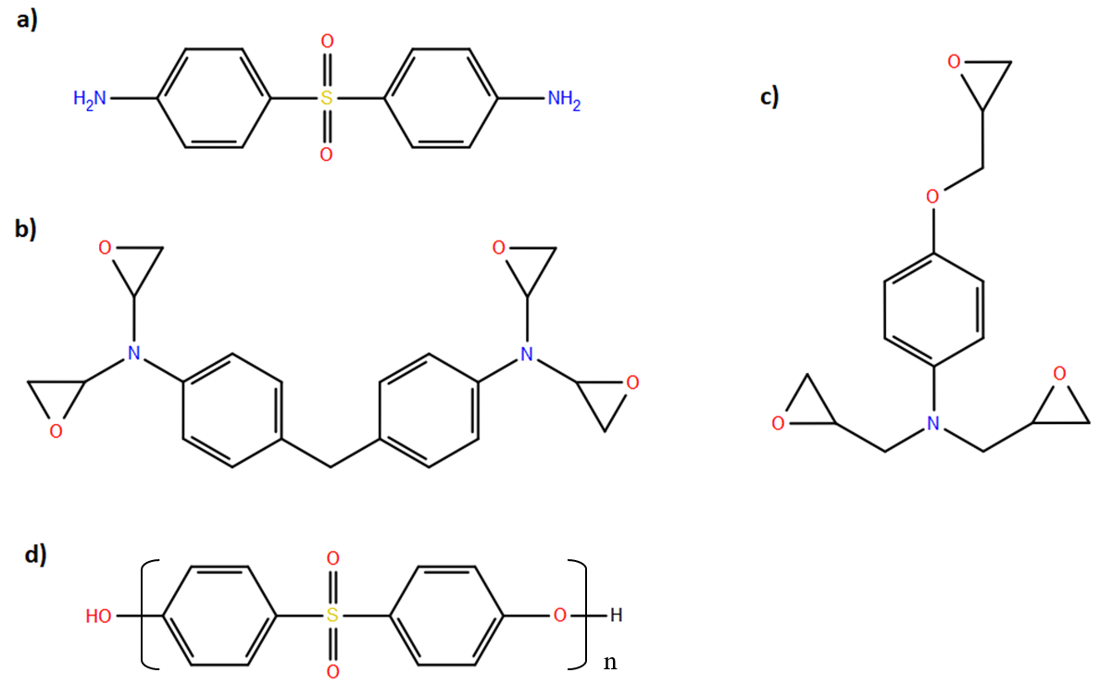

Figure 1. Monomer and polymer thermoplastic structures: a) 4,4-DDS b) TGDDM c) TGAP d) PES (here: n= 20 or 100).

For the resulting crosslinked network, the calculation of T_{g} and mechanical properties using efficient GPU-enabled molecular dynamics simulations will be described. With GPU technology, the accuracy of polymer matrix properties can be improved by extending the time-scale of simulation and increasing simulation throughput. As the influence of water on the matrix is of high importance, water uptake into the crosslinked matrix and its influence on the material’s properties will be examined.

2. Computational Approach

All model building and calculation steps were performed with the Schrödinger Materials Science Suite 2018-1 [3]. For MD calculations, the GPU-enabled efficient Desmond MD engine was used [4,5] in combination with the OPLS3 force field [6,7]. The initial mixture of monomers was determined based on the 75% TGDDM/25% TGAP epoxide blend described in Reference 1. The amine, 4,4-DDS, was added to ensure the epoxide:amine reactive group ratio 1:1. Initial mixture of monomer molecules plus 15 weight percent of the toughener PES was constructed with the Disordered System Builder to arrive at simulation boxes with approximately 15 000 atoms. Cells containing PES in two different degrees of polymerization were considered: in the first case five 20mer chains were included, in the second case one 100mer of PES. In both cases, an entangled polymer building approach was used when constructing the simulation boxes, in which all the polymer initiators and molecular components end atoms are randomly distributed in the simulation cell and are grown in the cell with the backbone dihedral populated according to a Boltzmann distribution at 300 K. For each of the two types of simulation boxes (one 100mer or five 20mers of PES) two replicates were built. The results were averaged over all of simulation boxes.

The simulation boxes were equilibrated using the Compressive Relaxation protocol available in the Schrödinger Materials Science Suite. This relaxation protocol allows for efficient relaxation as well as a high pressure step to remove any excess inner volume and to improve packing. After the relaxation protocol, the systems were propagated for another 5 ns with an NPT ensemble at 300 K and 1 atm with a 2 fs time step to check the convergence of the density.

The equilibrated simulation boxes were used as input for the Crosslink Polymer builder [8]. In this workflow, the polymerization process is performed in an iterative procedure. The reactivities are defined via SMARTS patterns (AB + CD → AC + BD, here with AB defined as “N[H]” and CD defined as “[C;r3;H2]O”). In the present study, the reactivity difference between primary and secondary amino groups was not considered. In principle, however, separate reactivities could be defined based on relative activation barriers or Boltzmann factors, which can be obtained either experimentally or from quantum chemical calculations.

In every iteration of the crosslinking protocol, up to a specified number of new crosslinks is introduced. These are selected from close-by reactive groups considering relative reactivities (if multiple reactions specified). After each crosslinking step, MD equilibrations using an NPT ensemble are performed until density convergence is achieved. In the present study, the number of crosslinks per iteration was set to 5 (corresponding to about 1 % of the crosslinkable bonds) and equilibrations were performed at 800 K/1 atm for 50 ps. The elevated temperature was chosen to increase the mobility in the system and facilitate the curing procedure, especially during the later stages. The iterative procedure stops when either the target crosslink saturation is reached (here 100 %) or a large number of consecutive unproductive runs have been performed (here 20).

On the crosslinked networks, thermophysical and mechanical properties are calculated with the respective workflows. To calculate T_{g} and the volumetric coefficient of thermal expansion (CTE), the system is gradually cooled down stating at high temperature and NPT MD simulations are performed at each step to converge the density. The simulation boxes in this example were brought to a temperature of 1000 K and cooled down to 200 K in steps of 10 K (NPT equilibration for 5 ns at each temperature). The density change with temperature was evaluated using the Thermophysical Property Analysis tool by fitting the data to a hyperbolic curve [9]. The CTE α is given as the slope of the line tangent to the hyperbolic curve. It can be evaluated for any temperature below or above the T_{g}. Here, we evaluated the volumetric CTE for 300 K. The critical distortion can be calculated using the T_{g} and CTE as the amount of volumetric change from the T_{g} to the desired temperature assuming the same glassy CTE for the whole region [9].

After equilibration of the system to 300 K, a series of strain-controlled tensile test calculations can be performed. The Stress Strain workflow was used to deform the cells in small increments along the main axis (here: volume-conserving strain), performing MD NVT relaxation at each strain value and calculating the stress from the final 20 % of each trajectory. Stress-strain curves were generated with the Stress Strain Analysis panel. Elastic properties were calculated from the MD simulations of up to 0.005 strain. Yield strain is obtained by fitting the stress-strain data before clear hardening behavior (at about 0.14 strain) with a 4th order polynomial. Both the maximum in the second derivative of the 4th order polynomial fitted to the results and the 0 point of the second derivative were found. The reported value is the average of 0 point and maximum in 2nd derivative.

Water uptake can have a profound effect on the system properties and an accurate description is crucial. To load water into the simulation boxes, the Penetrant Loading tool was employed. In this approach, water is added iteratively via a grand canonical Monte-Carlo sampling and subsequent MD NPT equilibration. As experimental results are typically obtained for composite systems that are only soaked for 14 days or less, the penetrant loader was run for only one cycle in this case to load about 1-4 weight percent of water into the system.

3. Results and Discussion

Figure 2 shows an example for a resulting crosslinked matrix obtained by the procedure described in the previous section. With the Crosslink Simulation Analysis tool, the crosslinking process can be followed. For example, it can easily been seen that the density of the system is reduced by about 25 % during the course of the crosslinking and the evolution of the different reactive groups can be followed (Figure 3). The gelation point can be analyzed by plotting the contribution of the components with the first and second largest molecular weight. It can be estimated from the inflection point in the contribution from the first largest molecular weight and the peak in the contribution from the first larges molecular weight component (Figure 4). For the present systems, the gelation point occurs at about 40-45 % curing saturation.

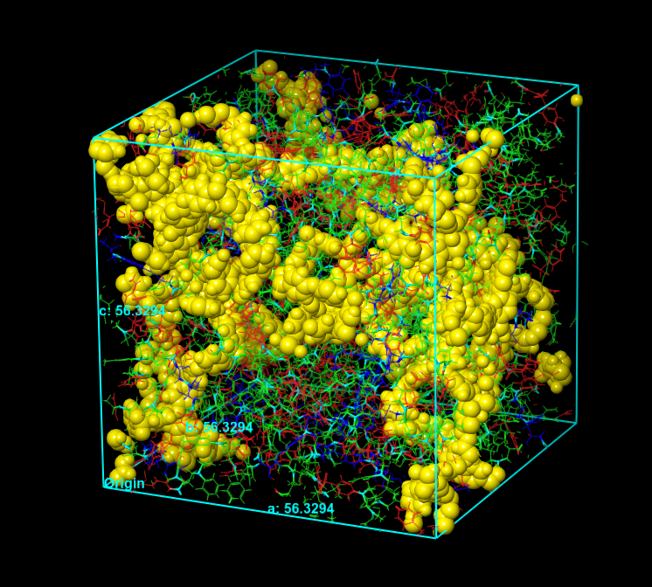

Figure 2. Crosslinked matrix for one of the simulation boxes with one 100mer of PES (final crosslink saturation: 94 %). The polymer toughener is highlighted with yellow and as ball and stick model. The atoms originating from the amine and epoxy components are shown in wire frame representation. The same simulation box is used for the examples in Figures 3 and 4.

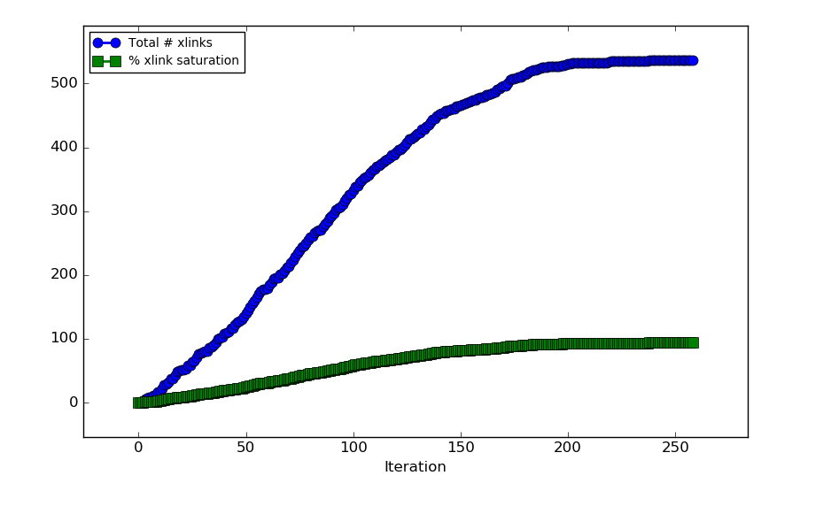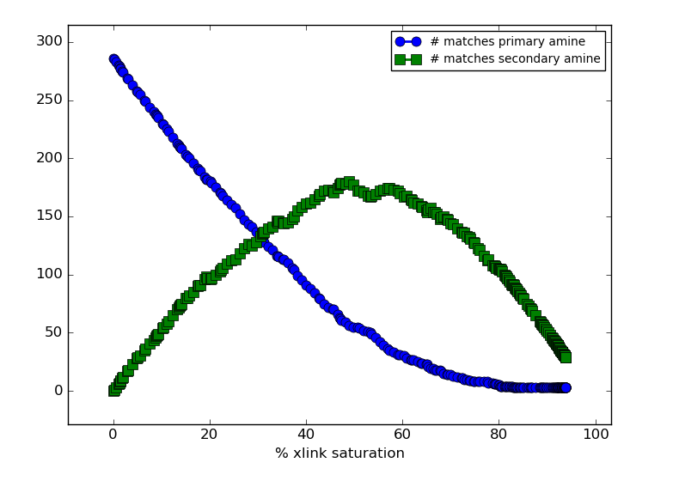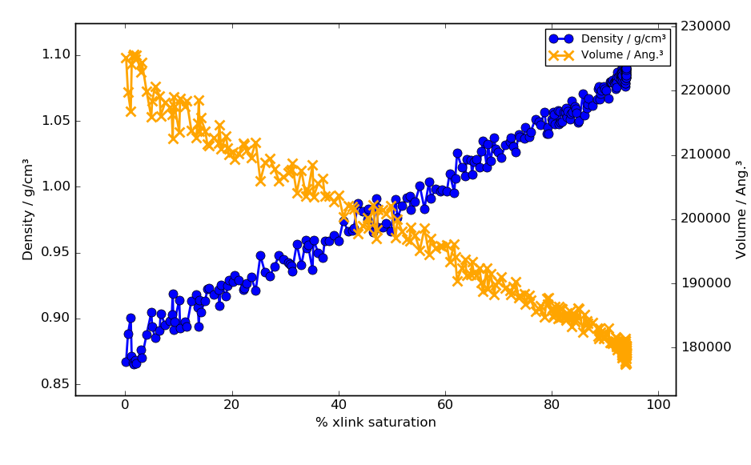

Figure 3: Characteristics of curing process for a simulation box with one 100mer of PES: top left panel shows total number of crosslinks and crosslink saturation with proceeding simulation iterations (final curing degree: 94 %). Top right panel shows evolution of primary and secondary amino groups with crosslinking progress. Bottom panel shows density and volume data during crosslinking.

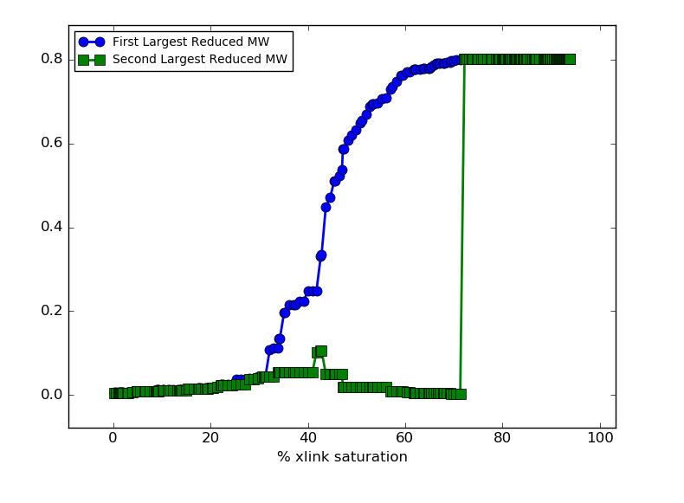

Figure 4. Gel point curve for one of the simulation boxes with one 100mer of PES. The orange area indicates the region of gel formation.

With the crosslinked (dry) matrices, stress strain simulations were performed after equilibration at 300 K as described above. The stress-strain data was averaged over all simulation boxes. From the stress values up to 0.005 strain, Young’s modulus was obtained (Table 1). The resulting value of 2.4 GPa is in general agreement with the experimental value of 3.2 GPa.

The evaluation of the critical distortion as described in the previous section yields a value of 0.075 (Table 1) which is in the range what what has been experimentally measured for epoxy amine and thermoplastic toughened epoxy amine systems [10,11]. Similarly, the critical dilatation of 0.0275 (Table 1) is in good agreement with the experimental value of 0.023 for other thermoplastic amine cured epoxy system [11] showing the applicability of the presented MD approach to calculate critical mechanical properties of crosslinked matrix systems.

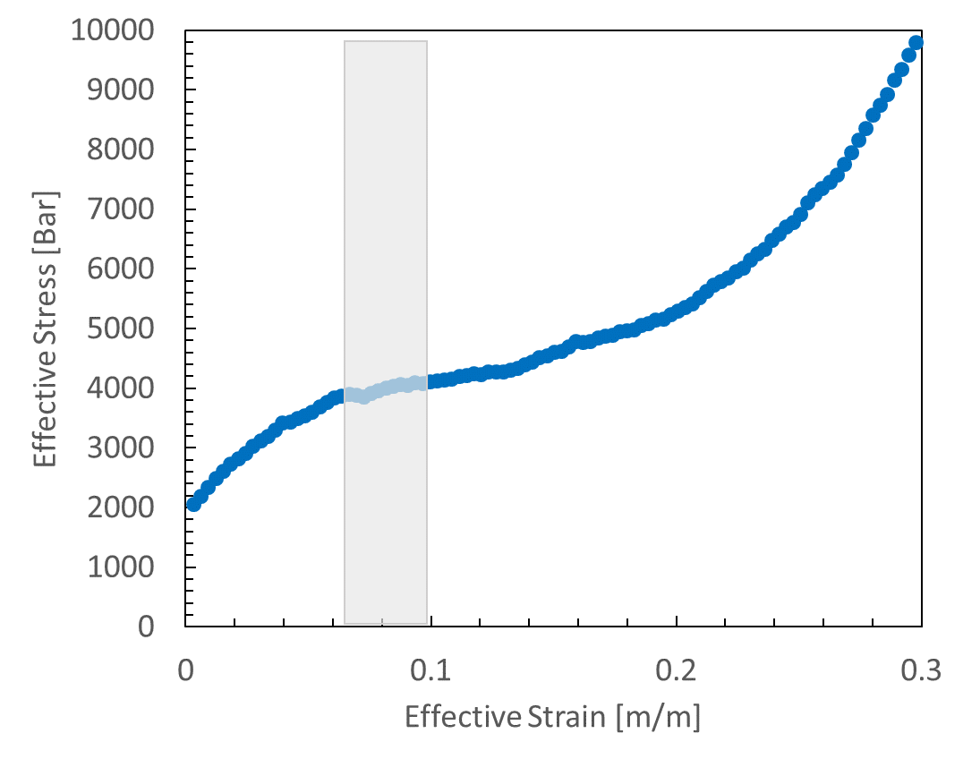

Figure 5. Averaged effective stress vs. effective strain curve for all volume conserving strain simulation for dry systems. The grey area indicates the area around the maximum of the 2nd derivative of the fit and the 0 point, which give the critical distortion.

Table 1. Simulated vs. measured matrix properties. RTD corresponds to measurements/simulations at ambient temperature (300K) and dry matrix. ETW conditions refer to elevated temperature (355 K) and 2-4 weight percent moisture in the matrix. CTE refers to the coefficient of thermal expansion.

Environment | RTD |  | ETW
Property | Measured [1] | MD | Measured | MD
Young’s Modulus (GPa) | 3.2 | 2.4 | - | 1.6
Critical Dilatation (m/m) | - | 0.028 | - | 0.010
T_{g} (K) | 493-543 | 469 | - | 413
Volumetric CTE at RT (x10⁶ m/m/K) | - | 164 | - | 171
Critical Distortion (m/m) | - | 0.078 | - | 0.11

In addition to mechanical properties, thermophysical properties were evaluated according to Section 2. The results are also shown in Table 1. An exemplary T_{g} curve is shown for one of the simulation boxes with one 100mer of PES in Figure 6. The resulting value of 469 K is compared to an experimental value [2] of 493K for PES-associated initial peak in Tan δ curve and large peak at 543 K. Using the techniques described in Section 2, a T_{g} higher than experiments is generally obtained [1]. With the mixed thermoplastic and thermoset system, the comparison to experiments is more complex but this initial example indicates that the experimental T_{g} can be approximated with simulation.

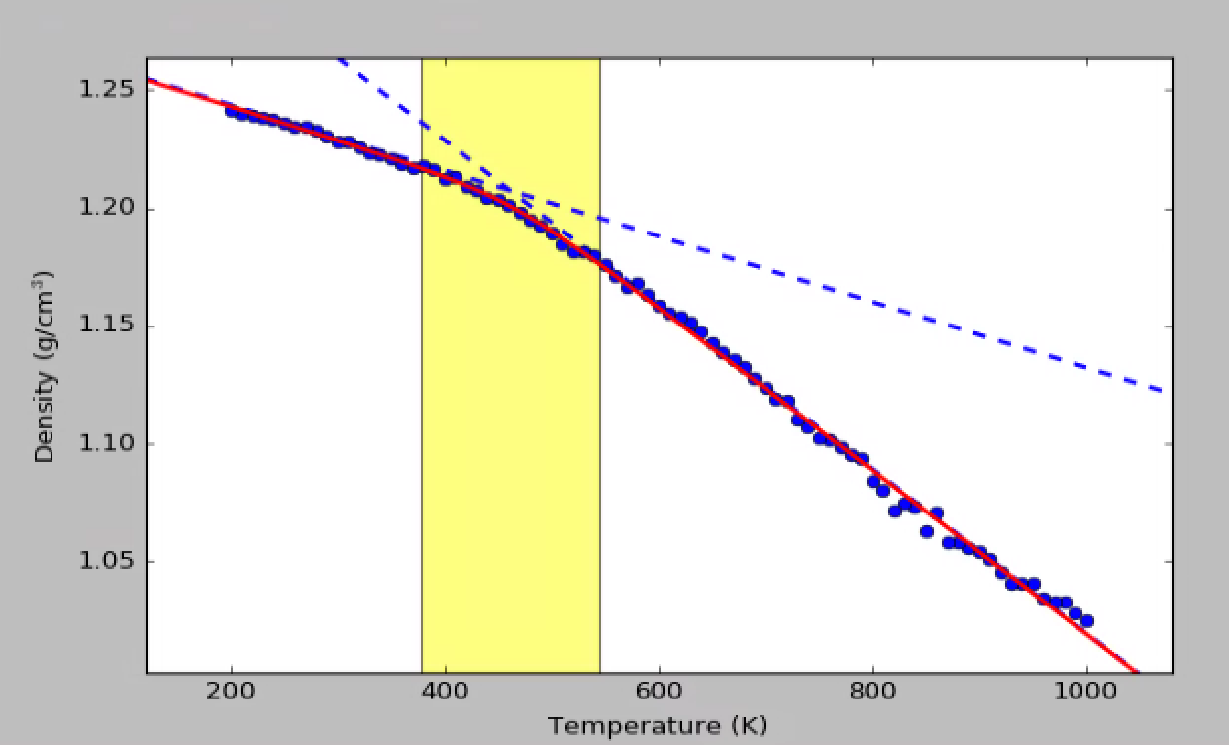
Figure 6: Example density versus temperature plot for a dry simulation box. The red line indicates the hyperbola fit and dashed blue line indicate glassy and rubbery asymtotes. The T_{g} is 461 K for this simulation box. The yellow area indicates the region within 90 % of the asymtotes.

To study the effect of water on the material’s property, 1-4 weight % of water was loaded into the simulation boxes by running the Penetrant Loading tool for one iteration (at elevated temperature). Stress-strain calculations were repeated on the wet systems at elevated temperature (355 K). The plasicizing effect can clearly be seen by the decrease of Young’s modulus (by about 33 %), decrease of T_{g} (by about 12%), the decrease of critical dilatation (by about 64%), and increase of critical distortion (by about 40 %). The T_{g} depression with water is comparable to that seen in a commerical thermoplastic epoxy amine system [12] where a dry T_{g} of 480 K and wet T_{g} of 433 Kwas found.

4. Conclusions

In the present study, a series of workflows was applied to build a crosslinked matrix including a polymer toughener. Mechanical and thermodynamical properties of the resulting matrices were studied under dry and wet conditions and compared to experimental results. The simulations were able to reproduce the experimental results with good accuracy. The critical properties in dilatation and distortion can be used by higher length scale models utilizing Onset-based analysis [13], such as Digimat by e-Xstream Engineering, to predict the failure of a composite laminate.

Such automated MD workflows in combination with modern quantitative force fields and GPU-acceleration allow for easily accessible, accurate, and efficient prediction of thermoset properties. Through the use of simulation to rapidly screen polymer matrix materials for multiple properties, the development of new polymer chemistries and formulations to meeting desired characteristics becomes readily achievable.

Acknowledgements

The authors would would like to acknowledge Joe Sharp and Dr. Jon Gosse from e-Xstream for insightful conversations on critical invariants and prediction of failure in composite laminates.

References

[1] Li, C., A. Strachan. Molecular scale simulations on thermoset polymers: A review. Journal of Polymer Science Part B: Polymer Physics 53: 103–122, 2015.
[2] Cheng, X. (2015). Cure Kinetics, Morphologies, and Mechanical Properties of Thermoplastic/MWCNT Modified Multifunctional Glassy Epoxies Prepared via Continuous Reaction Methods. University of Southern Mississippi PhD Dissertations. 65, 2015.
[3] Materials Science Suite 2018-1, Schrödinger, LLC, New York, NY, 2018.
[4] Desmond Molecular Dynamics System, Maestro-Desmond Interoperability Tools. D. E. Shaw Research, New York, NY, 2018.
[5] K.J. Bowers, et al. Scalable Algorithms for Molecular Dynamics Simulations on Commodity Clusters. Proceedings of the 2006 ACM/IEEE Conference on Supercomputing Tampa, Florida, United States, 2006.
[6] E. Harder, et al. OPLS3: A Force Field Providing Broad Coverage of Drug-like Small Molecules and Proteins Journal of Chemical Theory and Computation. Journal of Chemical Theory and Computation, 12:281-296, 2016.
[7] K.H. DuBay, M.L. Hall, T.F. Hughes, C. Wu, D.R. Reichman, and R.A. Friesner. Accurate Force Field Development for Modeling Conjugated Polymers. Journal of Chemical Theory and Computation, 8:4556-4569, 2012.
[8] J. M. Sanders, et. al, In preparation.
[9] P. N. Patrone, A. Dienstfrey, A.R. Browning, S. Tucker, and S. Christensen. Uncertainty Quantification in Molecular Dynamics Studies of the Glass Transition Temperature. Polymer 87:246-259, 2016.
[10] S. Christensen, R. D’Oyen Computational formulation of a new composite matrix. Scripta Materialia 70:18–24, 2014.
[11] T. E. Tay, V. B. C. Tan, and S. H. N. Tan. Element-Failure: An Alternative to Material Property Degradation Method for Progressive Damage in Composite Structures Journal of Composite Materials, 39:1659-1675, 2005.
[12] K. Marlett, Hexcel 8552 IM7 Unidirectional Prepreg 190 gsm & 35%RC Qualification Material Property Data Report. NIAR: NCAMP CAM-RP-2009-015, 2011.
[13] J. Gosse, S. Christensen, 42nd AIAA/ASME/ASCE/AHSIASC Structures, Structural Dynamics, and Materials Conference & Exhibit; American Institute of Aeronautics and Astronautics, Seattle, Washingtion, United States, 2001.

