Lightweight alternatives to glass fiber/epoxy sheet molding compound (SMC) composites: basalt fibers and cellulose nanocrystals

A. Asadi¹, F. Baaij², RJ. Moon³, T. Harris⁴ and K. Kalaitzidou⁵
¹G.W. Woodruff School of Mechanical Engineering – Georgia Institute of Technology, Atlanta, GA 30332, United States
Email: amir.asadi@tamu.edu, Web Page: https://engineering.tamu.edu/mechanical/people/asadi-amir.html
²G.W. Woodruff School of Mechanical Engineering – Georgia Institute of Technology, Atlanta, GA 30332, United States
Email: ferdinand@baaij.de
³The Forest Products Laboratory, U.S. Forest Service, Madison, Wisconsin 53726, United States
Email: robertmoon@fs.fed.us
⁴G.W. Woodruff School of Mechanical Engineering – Georgia Institute of Technology, Atlanta, GA 30332, United States
Email: tequila.harris@me.gatech.edu
⁵G.W. Woodruff School of Mechanical Engineering – Georgia Institute of Technology, Atlanta, GA 30332, United States
Email: kyriaki.kalaitziodu@me.gatech.edu

Keywords: Cellulose nanocrystals, Basalt fibers, Sheet molding compounds, Lightweighting

Abstract
The focus of this study is: i) understanding the effect of the fiber type and content on the mechanical properties of sheet molding compounds (SMC) composites and ii) investigating possible light-weight alternatives to traditional glass fibers (GF)/epoxy SMC composites. We use GF and Basalt fibers (BF) to make SMC composites. The tensile, flexural and impact properties of the SMC composites are determined as a function of the fiber type and fiber content. Furthermore, we replaced a portion of the fibers, i.e., 12-16 wt%, with a small amount of cellulose nanocrystals (CNC), i.e. ~1 wt% mixed in the SMC resin system, to explore the possibility of lightweighting. We conclude that there is no significant difference between the BF/epoxy and GF/epoxy SMC composites with similar fiber content in terms of the tensile, flexural and impact properties. When CNC are added to the composites, the two fiber systems behave drastically different; lightweight GF/epoxy SMC composites maintain their original properties upon removing portion of GF and addition of CNC, whereas the properties of the lightweight BF/epoxy SMC composites deteriorate.

1. Introduction

Lightweight vehicles are a promising approach to increase the fuel economy. Fiber reinforced polymer composites instead of metallic components in vehicles can provide lightweight structures. Concurrently, use of natural fibers as reinforcement in polymer composites is gaining attention in recent years to reduce the environmental impacts. Basalt fibers (BF) have advantages to other natural fibers (e.g. sisal, kenaf, hemp, flax) because of their superior hygrothermal stability, high strength, modulus and elongation at break, chemical and thermal stability (in the range of -200 to 600-800 ˚C), good thermal insulation, resistance to most weather conditions, easy processability, ecofriendly, and low cost [1-3]. There is a demand to make the lightweight polymer composites even lighter. One approach is to replace the heavier materials in a composite with lighter and stronger ones [4-6]. We have shown that addition of 1-1.5 wt% cellulose nanocrystals (CNC) in 25 wt% GF/epoxy sheet molding compound (SMC) composites can result in 8% weight reduction with similar tensile and flexural properties equal to those of 35 wt% GF/epoxy [7]. CNC are cellulose based, whisker-shaped nanoparticles (3 ̶ 20 nm in width and 50 ̶ 500 nm in length), that can be extracted from trees and plants by acid hydrolyses [8-10]. Their low density (1.6 g/cm3), high aspect ratio (10-100) and surface area, tensile strength of ~3GPa, elastic modulus of 110-220 GPa, surfaces with accessible hydroxyl side groups and their low toxicity make CNC an ideal reinforcement either as a coating on GF [11, 12] or as a dispersion in the polymer matrix [22] for polymer composites.

In this study, we compare the BF to GF in SMC composites and explore lightweighting for both fiber systesm by adding CNC and removing a portion of fibers in terms of the their mechanical performance. 1.4-2 wt% CNC were introduced in the SMC manufacturing line as a dispersion within the epoxy resin (abbreviated as CNC-epoxy). Tensile, flexural and impact results for both GF/epoxy and BF/epoxy SMC composites with and without CNC are presented.

2. Materials and Characterization

2.1. Materias and Fabrication

Multi end roving basalt fibers (TEX 4800, single filament diameter of 10±1 µm) were provided by Mafic Ireland (Kells, County Meath, Ireland) and multi end roving glass fibers ME1510 (TEX 4800, single filament diameter of 10±1 µm) were received from Owens Corning (Oak Brook, IL, US). Both BF and GF were used in the manufacturing of the SMC as received. The resin used in the SMC line was a bicomponent epoxy resin consisting diglycidyl ether of Bisphenol-A epoxy and 556 slow polyamide hardener, by US Composites (Wes Palm Beach, FL). The average length of the BF and GF rovings cut in the SMC line was of 25±0.5 mm. Fumed silica (Aerosil-Cabosil supplied by US composites) was also used as the thickening agent in the SMC resin. CNC in the form of freeze-dried powder with average width and length of 6.4 ± 0.6 nm and 138 ± 22 nm, respectively [13] was supplied by the USDA Forest Service-Forest Products Laboratory (FPL), Madison, WI, USA.

The resin mixture was prepared in a two-step process: 1) The CNC were dispersed in the hardener using sonication and 2) the CNC-hardener suspension was mixed with the epoxy, as described in [14]. The desired CNC amount of 1.4 and 2 wt% with respect to the resin was slowly added into 500 g of hardener, mechanically stirred using a small impeller and finally sonicated (UIP500hd heilscher ultrasonic processor, 34 mm probe diameter, amplitude of 90) for 5 min. Next, 60 g fumed silica thickening agent were mixed with 1000 g epoxy by mechanical stirring at ambient temperature. Finally, the CNC-hardener suspension was added to fumed silica-epoxy mixture and mechanically stirred for 5 min until a homogenous mixture was achieved. We fabricated SMC composites using a Finn and Fram line at Georgia Tech with 50, 60, 65 and 70 wt% GF or BF. Only 60 wt% fibers were used for lightweighting study. After the SMC were manufactured, we stacked them upon another based on the desired thickness and placed them in a hot press for curing. After curing, the samples were cut from the plates using a waterjet (MAXIEM 1515).

2.2. Characterization

Water displacement method was used to measure the specific density according to ASTM D-792. Each density value is an average of at least 11 measurements. The void content of the composites was measured using acid digestion test according to ASTM D3171. Each data point for the void content of a composite with a specific composition is an average of at least six measurements. The tensile and flexural properties of the SMC composites were determined according to ASTM D638 and ASTM D790-02 standards respectively using an Instron 5982 equipped with 100 kN load cell for dogbone specimens. Each tensile and flexural data point is an average of at least 10 measurements. The impact energy was measured using Charpy according to ISO179 standars using an Instron SI series pendulum impact tester with a maximum impact head of 406.7 J (300 ft-lbf). Each impact data point is an average of at least 10 measurements. The quality of fiber wetting by the epoxy resin with or without CNC was assessed based on contact angle measurements using a Ramé–Hart Goniometer (model 500-U1) at ambient conditions..

3. Results and Discussion

Fig. 1 shows the tensile, flexural and impact properties of SMC composites as a function of fiber type i.e., GF vs BF and fiber content varied from 50-70 wt%. Considering the statistical error, both fiber types have similar properties. In addition, no enhancement of the mechanical properties is observed by increasing the fiber content from 60% to 70 wt%. Therefoe, we chose 60 wt% fiber content for lightweighting study.

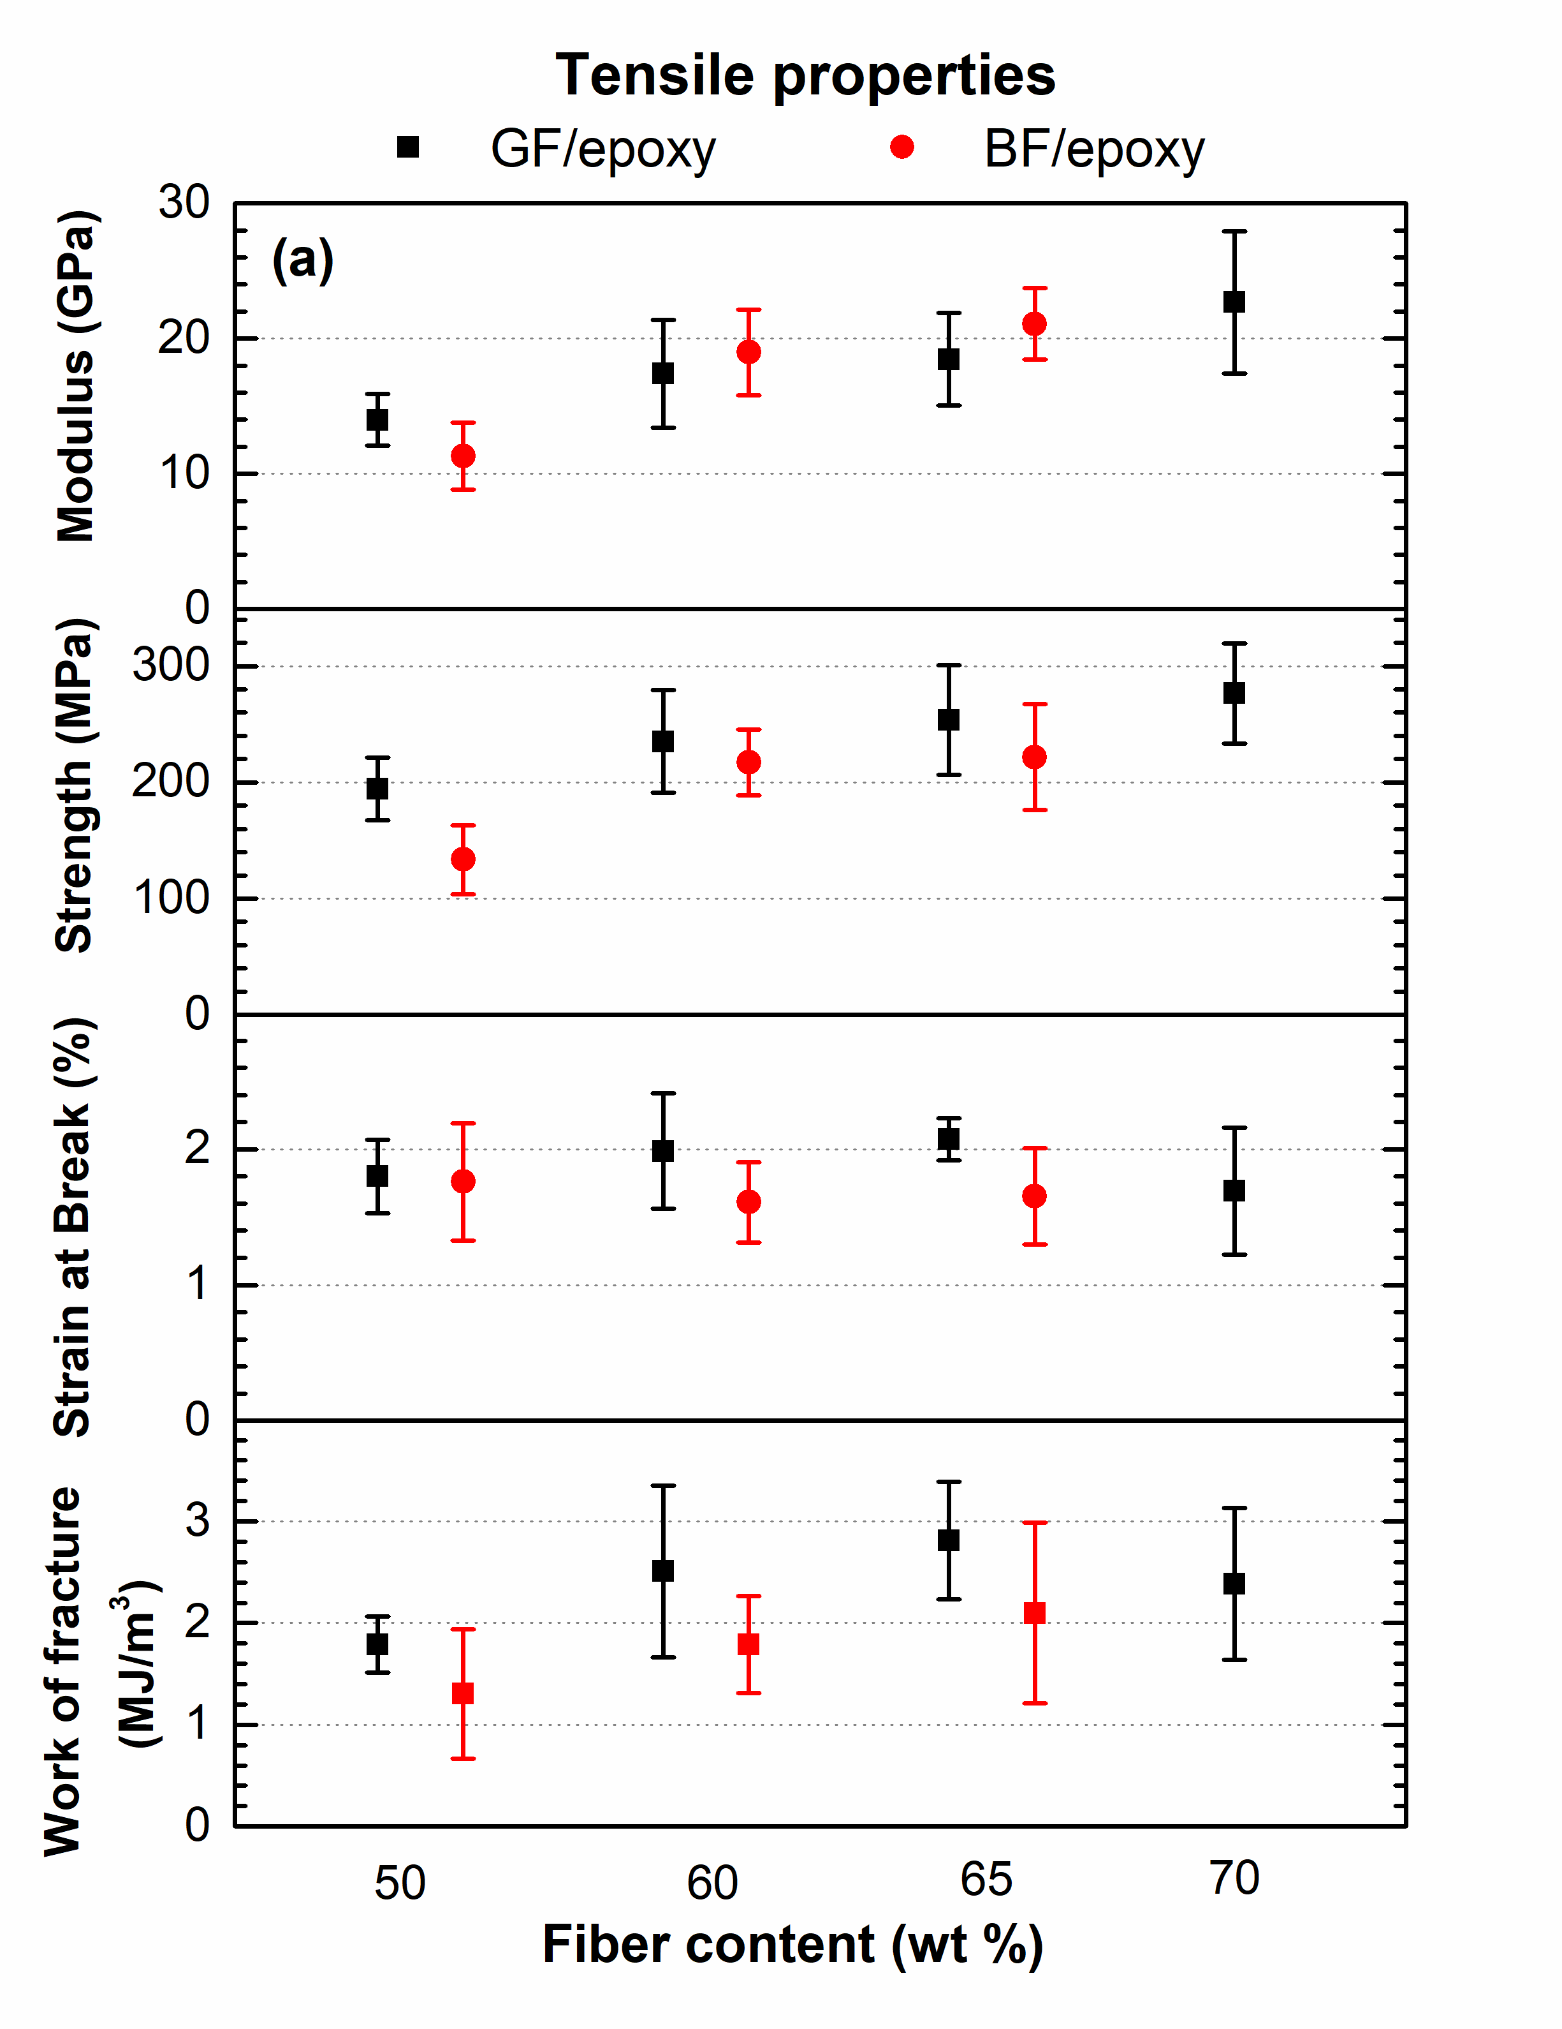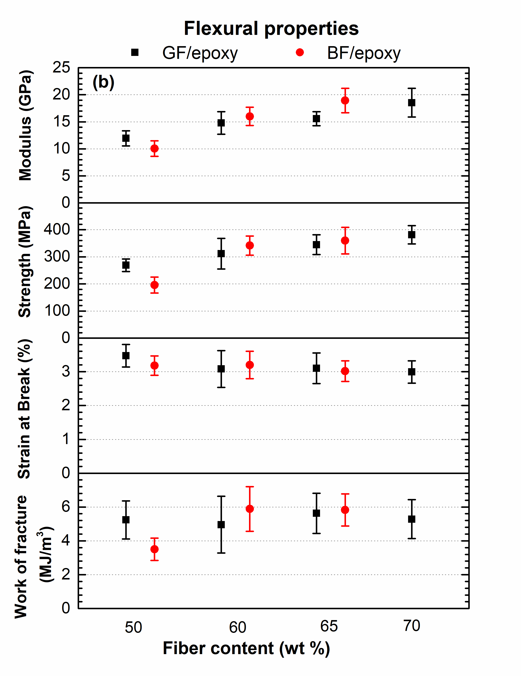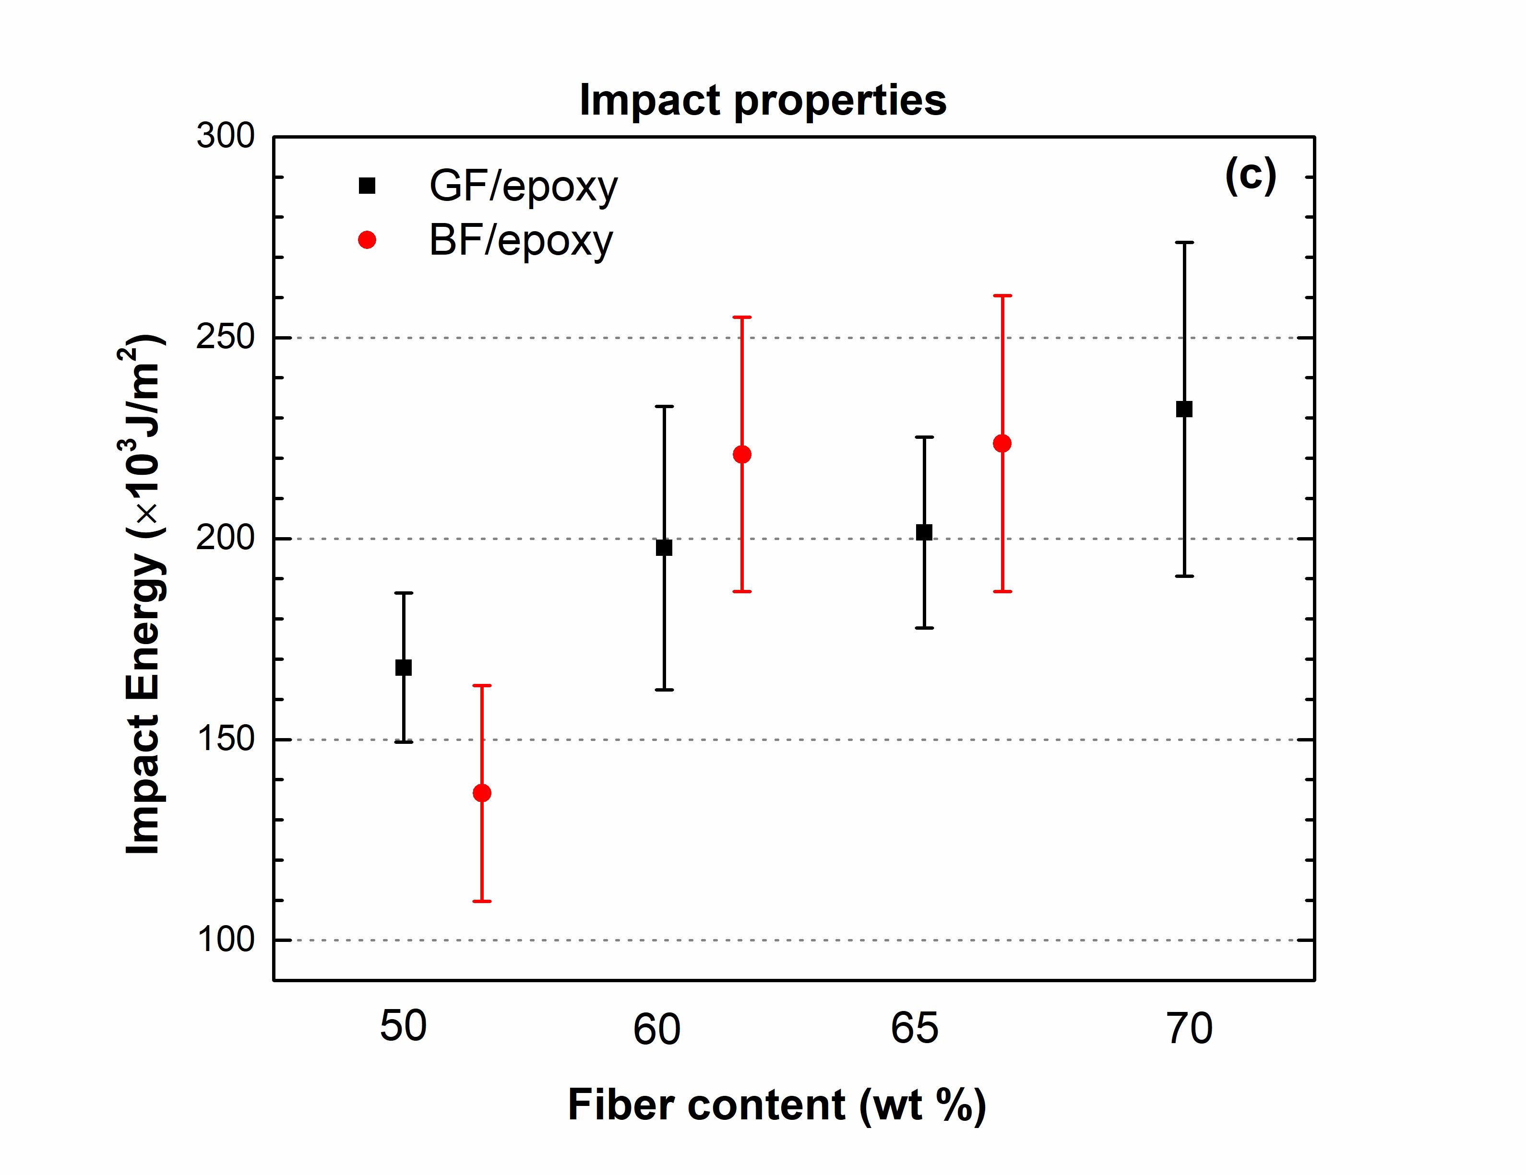

Figure 1. (a) Tensile, (b) flexural and (c) impact properties of GF/epoxy and BF/epoxy SMC composite with respect to the fiber content

The tensile and flexural properties including modulus, strength, elongation at break and fracture toughness, as well as the impact strength of both the GF/epoxy and BF/epoxy composites with or without CNC are shown in Fig. 2. In GF/epoxy composites, when the fiber amount is reduced from 60 wt% to 48 or 44 wt% and 0.9 or 1.1 wt% of CNC (with respect to the composite weight) is added, the tensile modulus reduces with no significant decrease in the tensile strength, elongation at break and work of fracture. On the contrary, in BF/epoxy composites, all tensile properties significantly deteriorate. It appears that non-favorable interfacial interactions between the BF and the CNC-epoxy resin exist, as strength is dictated by the stress transfer ability across the fiber/matrix interface. For flexural properties, a similar decrease in flexural modulus is observed for both the GF/epoxy and BF/epoxy composites upon partial replacement of the fibers by the CNC; whereas the other flexural properties slightly decrease. The impact energy of BF/epoxy composites with CNC also drops larger compared to that GF/epoxy with CNC. The decrease of the flexural properties and impact strength upon addition of CNC is higher in the case of the BF composites.

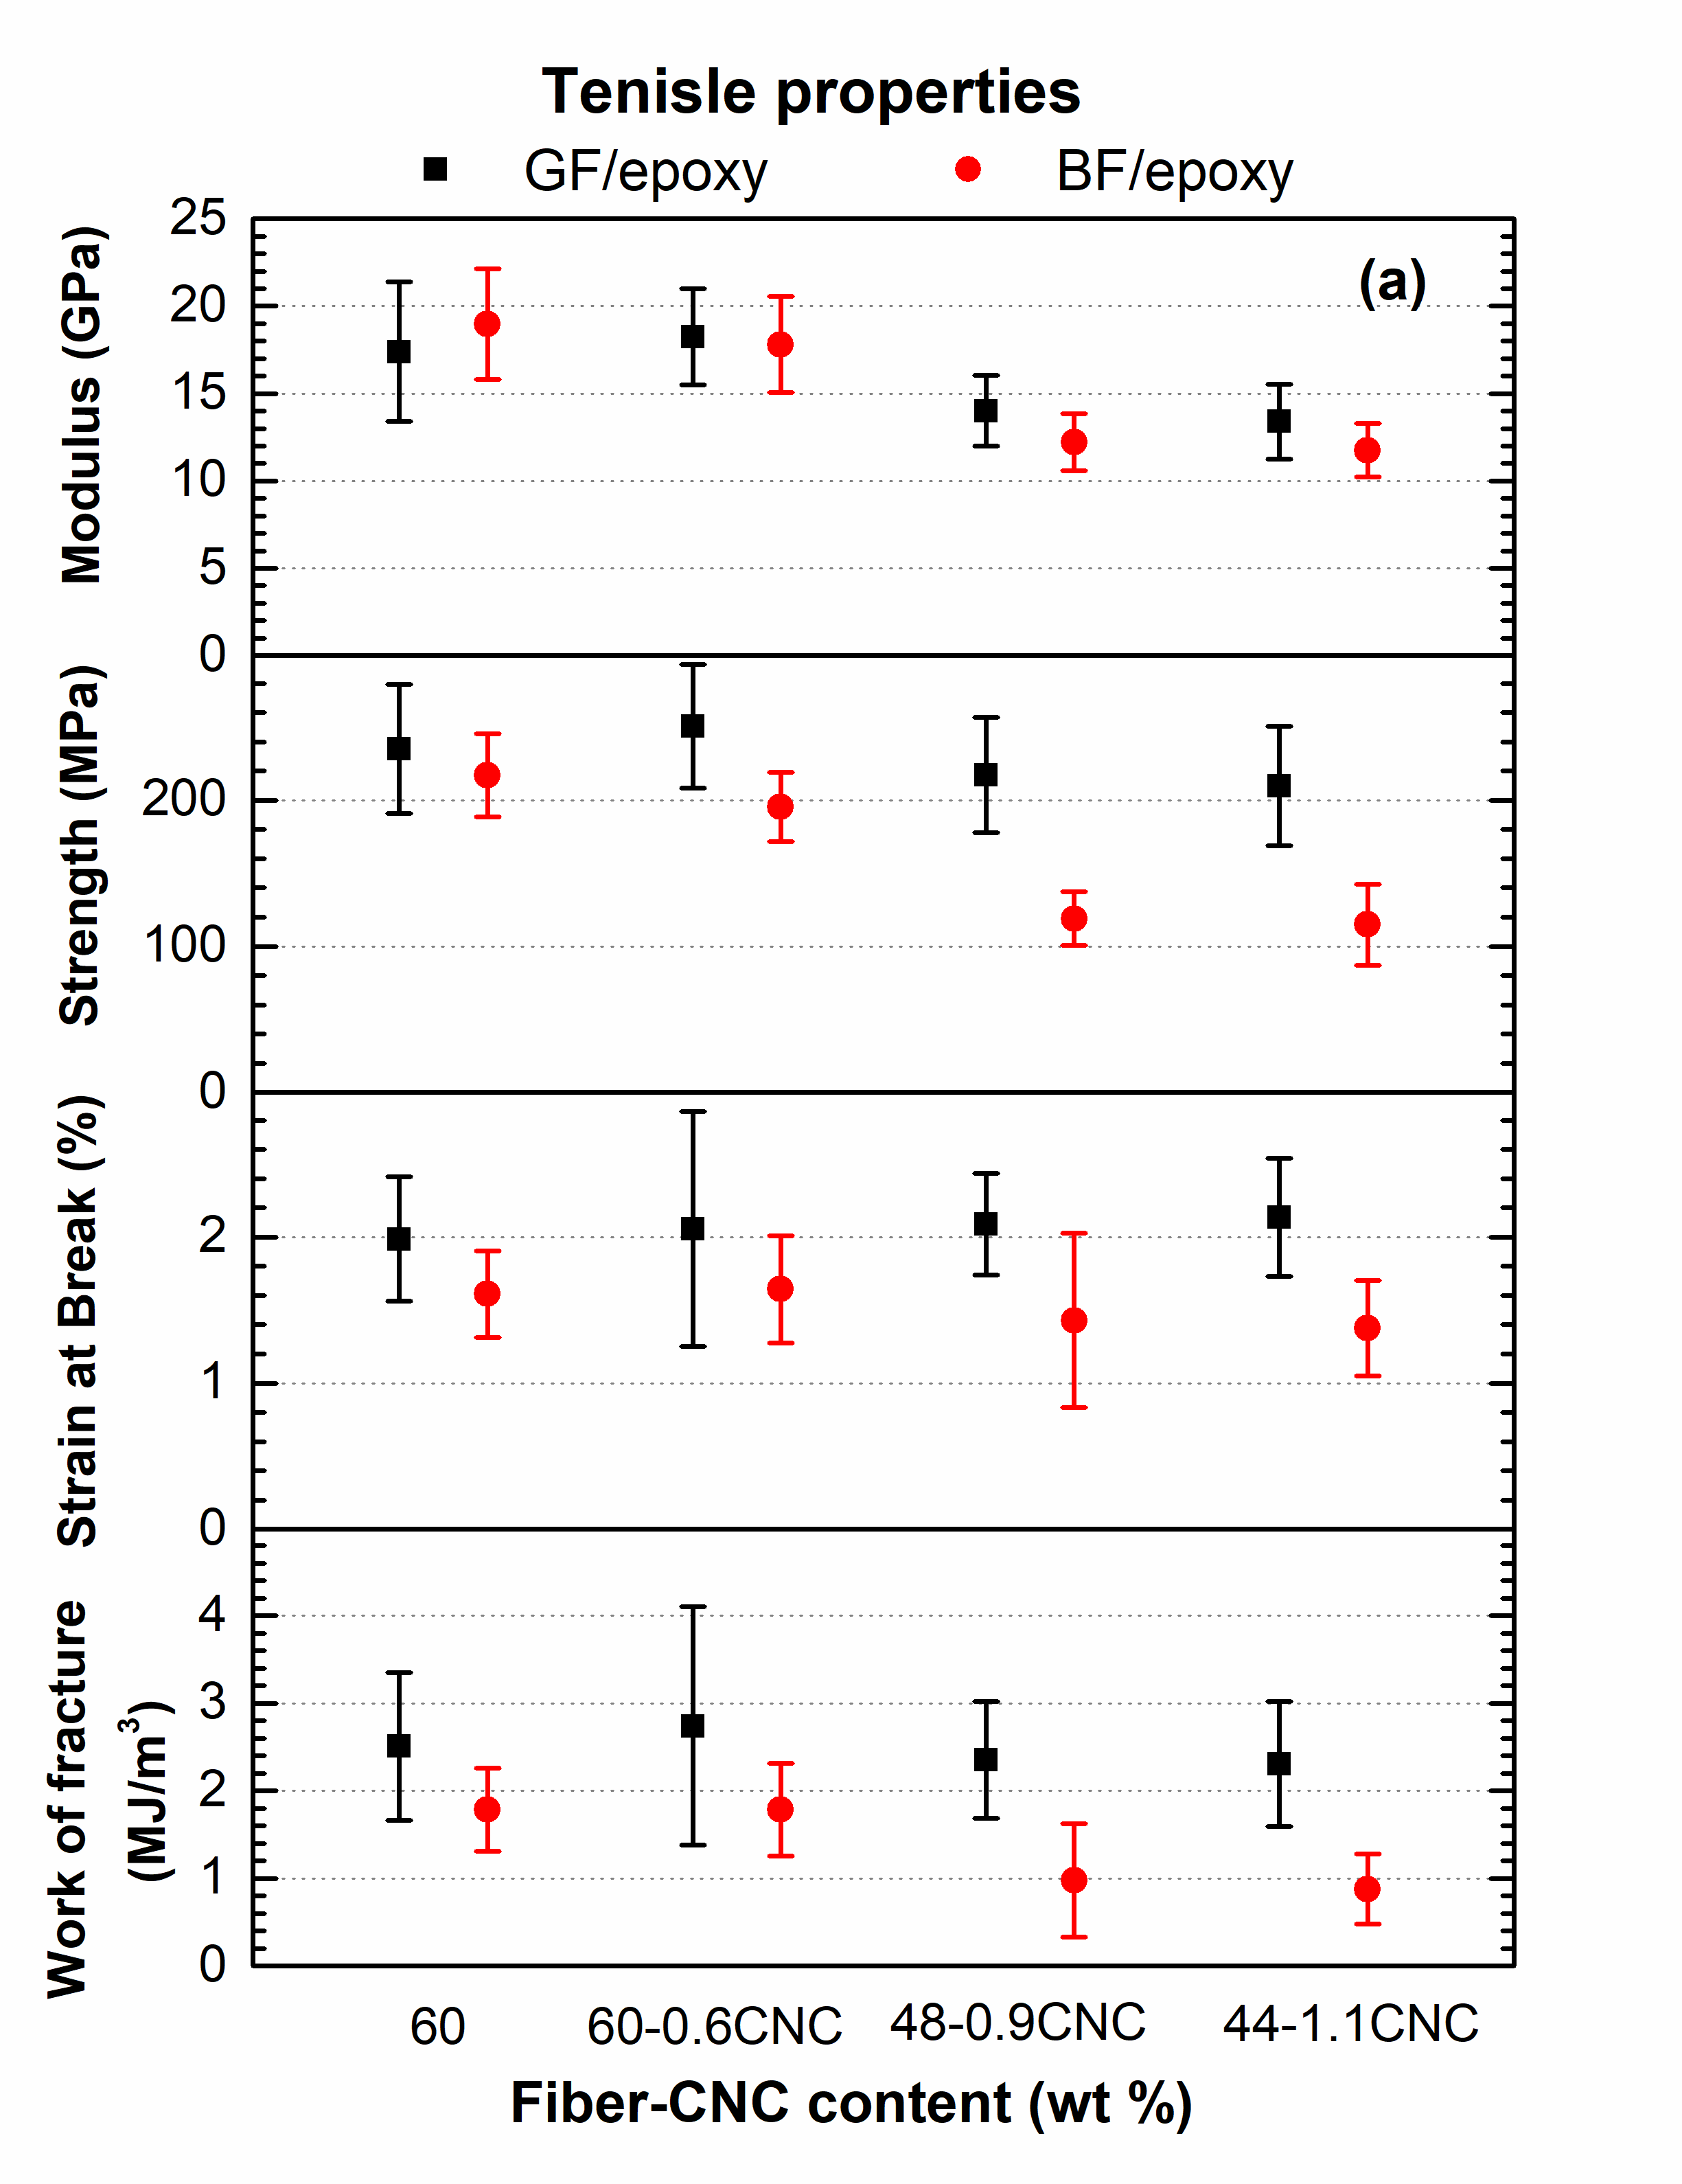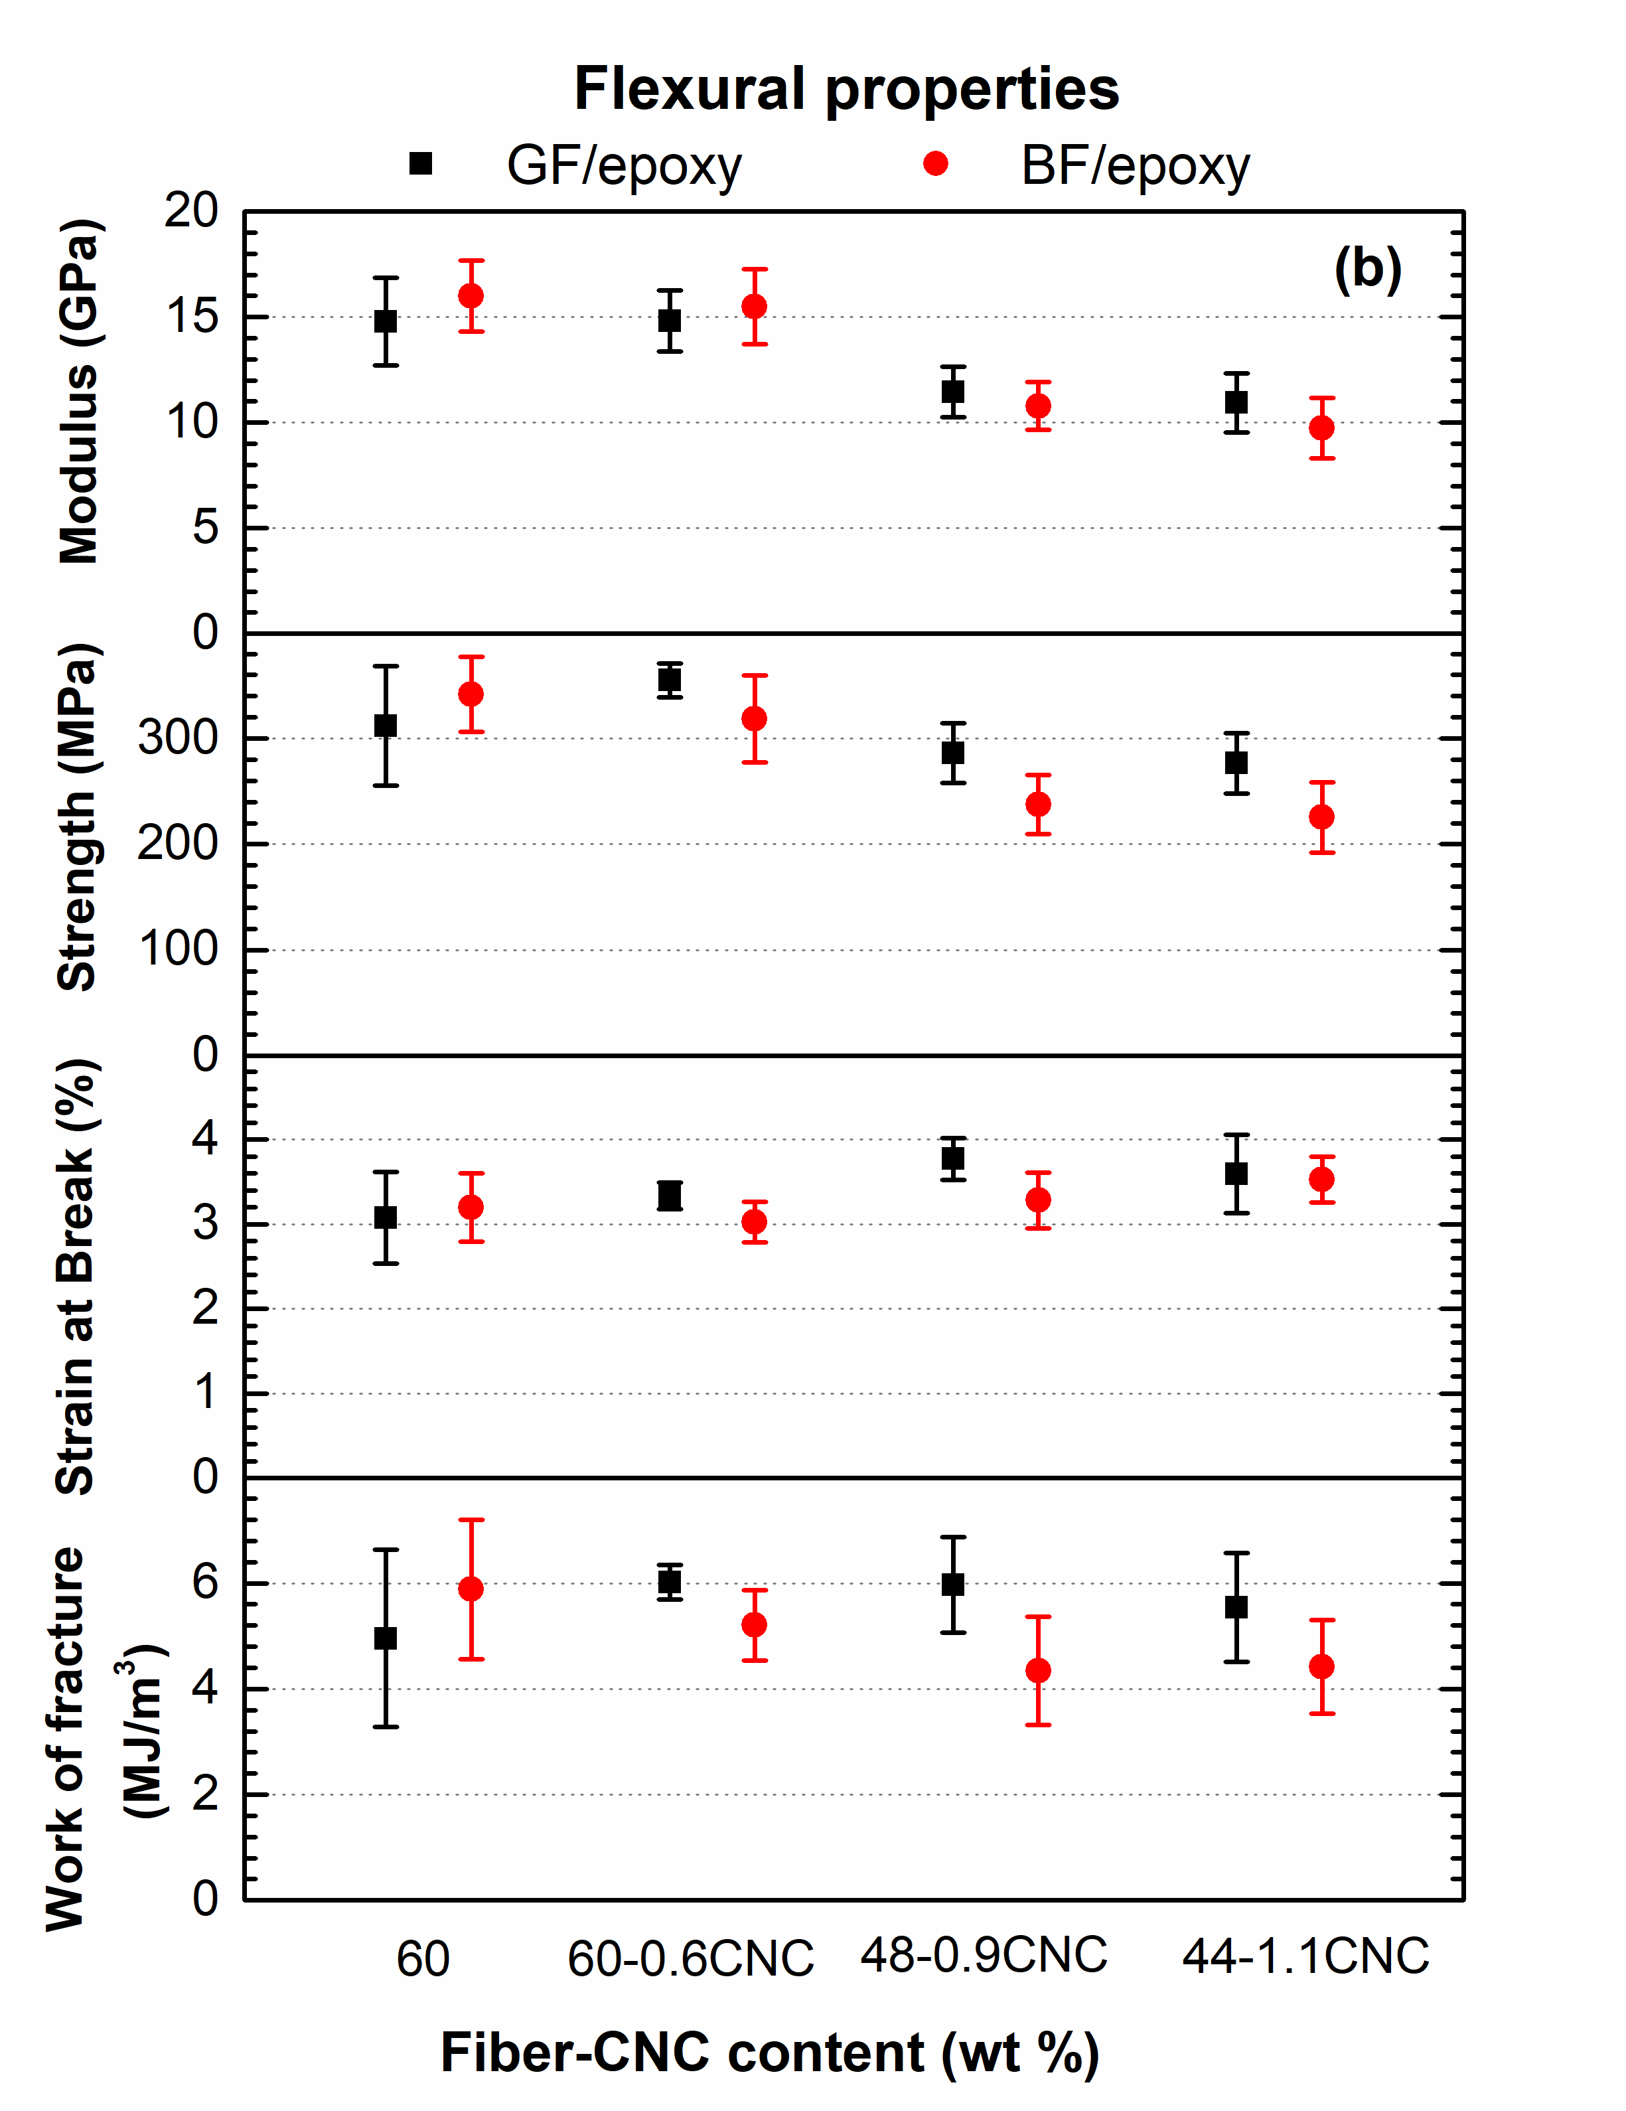
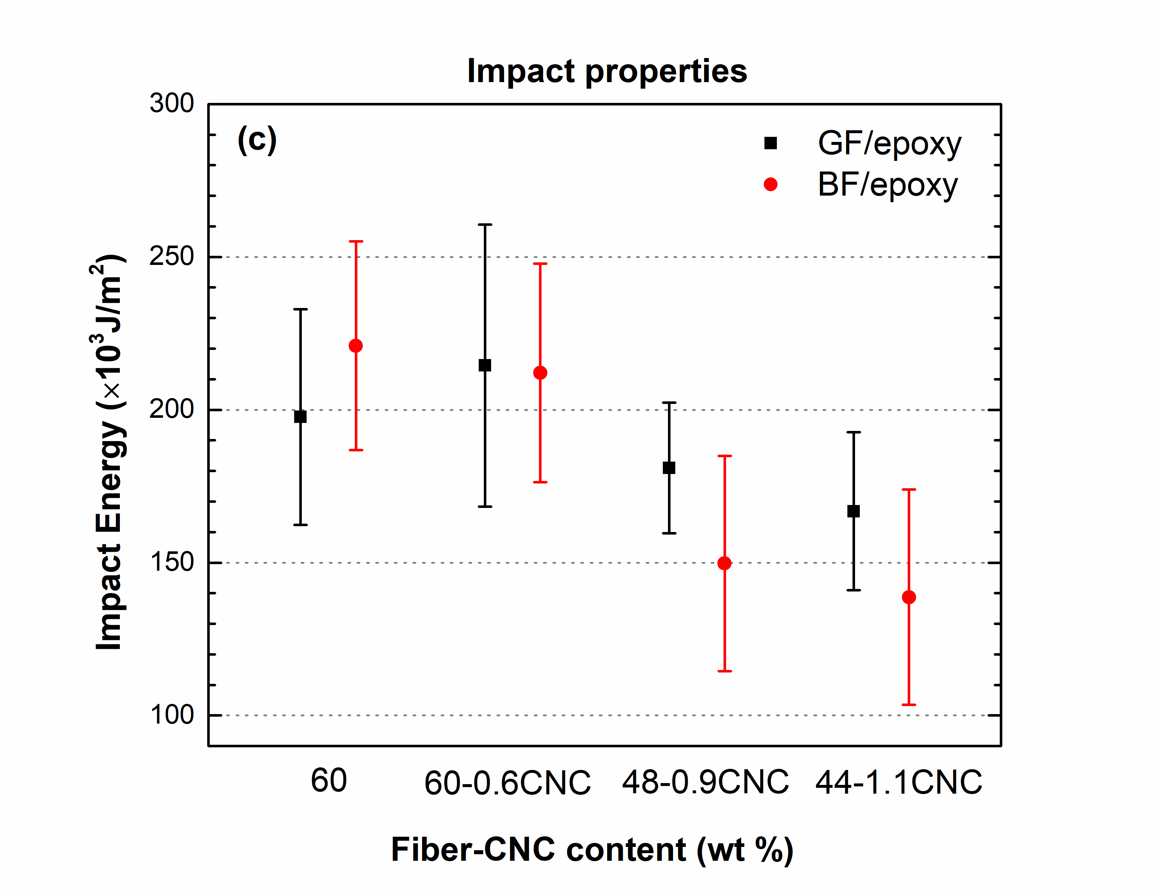
Figure 2. (a) Tensile, (b) flexural and (c) impact properties of lightweight GF/epoxy and BF/epoxy SMC composite containing CNC

Fig. 3 shows the specific properties of GF/epoxy and BF/epoxy with CNC. For 48GF/0.9CNC-epoxy and 44GF/1.1CNC-epoxy SMC composites, the tensile, flexural and impact specific properties are comparable to each other. It implies that up to 16% removal of GF and adding ~1 wt% CNC can maintain the properties achieving ~12% lighter composites. For 48BF/0.9CNC-epoxy and 44BF/1.1CNC-epoxy SMC composites several of the specific properties were lower than the corresponding properties of the 60BF/epoxy. In this case, the property enhancement of the matrix due to the addition of CNC did not offset the deterioration of properties due to the decrease of the fiber content. A possible reason can be that the interactions between the BF and the CNC are not as favorable due to lower wetting of the BF by the CNC modified epoxy resin compaed to that of the GF. To conform this, we compared the void content of the various composites as shown in Table 1 and found that the void content of 48BF/0.9CNC-epoxy and 44BF/1.1CNC-epoxy is higher (14-19%) compared to that of corresponding GF/CNC-epoxy composites (9%). In adition, as presented in Table 2, the wettability results show that the contact angle is higher for the case of BF confirming that stress transfer efficiency is lower between BF and CNC-epoxy resin compared to that of GF.

Table 1. Theoretical density, measured density and void content.

Specimen Type | Void Content  (%)
60GF/epoxy | 10±0.2
60GF/0.6CNC/epoxy | 3.4±1
48GF/0.9CNC/epoxy | 9.5±1.5
44GF/1.1CNC/epoxy | 8.5±0.5
60BF/epoxy | 12.5±0.5
60BF/0.6CNC/epoxy | 14±1
48BF/0.9CNC/epoxy | 14±1
44BF/1.1CNC/epoxy | 17±4

Table 2. Contact angle (˚) results between fiber rovings and either epoxy or CNC-epoxy.

Fiber Type | Neat epoxy | 1.4CNC-epoxy
GF | 30.71 ± 2.81 | 35.03 ± 2.23
BF | 34.16 ± 1.43 | 40.87 ± 0.66

Overall, the lightweight benefit for GF/epoxy SMC composites becomes clear with comparing the experimental specific modulus, strength and impact strength of 60GF/epoxy composite to those of the 48GF/0.9CNC/epoxy and 44GF/1.1CNC/epoxy composites.

3. Conclusions

The major conclusions of this study is that (1) the tensile, flexural and impact properties of GF/epoxy SMC composites are similar to those of BF/epoxy SMC composites for the same fiber content; (2) 10-12% lighter composites can be made by replacing portion of GF in GF/epoxy SMC composites with a small amount of CNC, i.e. ~1wt%, without compromising tensile, flexural and impact properties. Applyig the same approach for the given BF, i.e. adding CNC and removing a portion of the BF, was not possible without significantly compromising the mechanical properties due to higher void content and lower adhesion between BF and CNC-epoxy compared to those of GF.

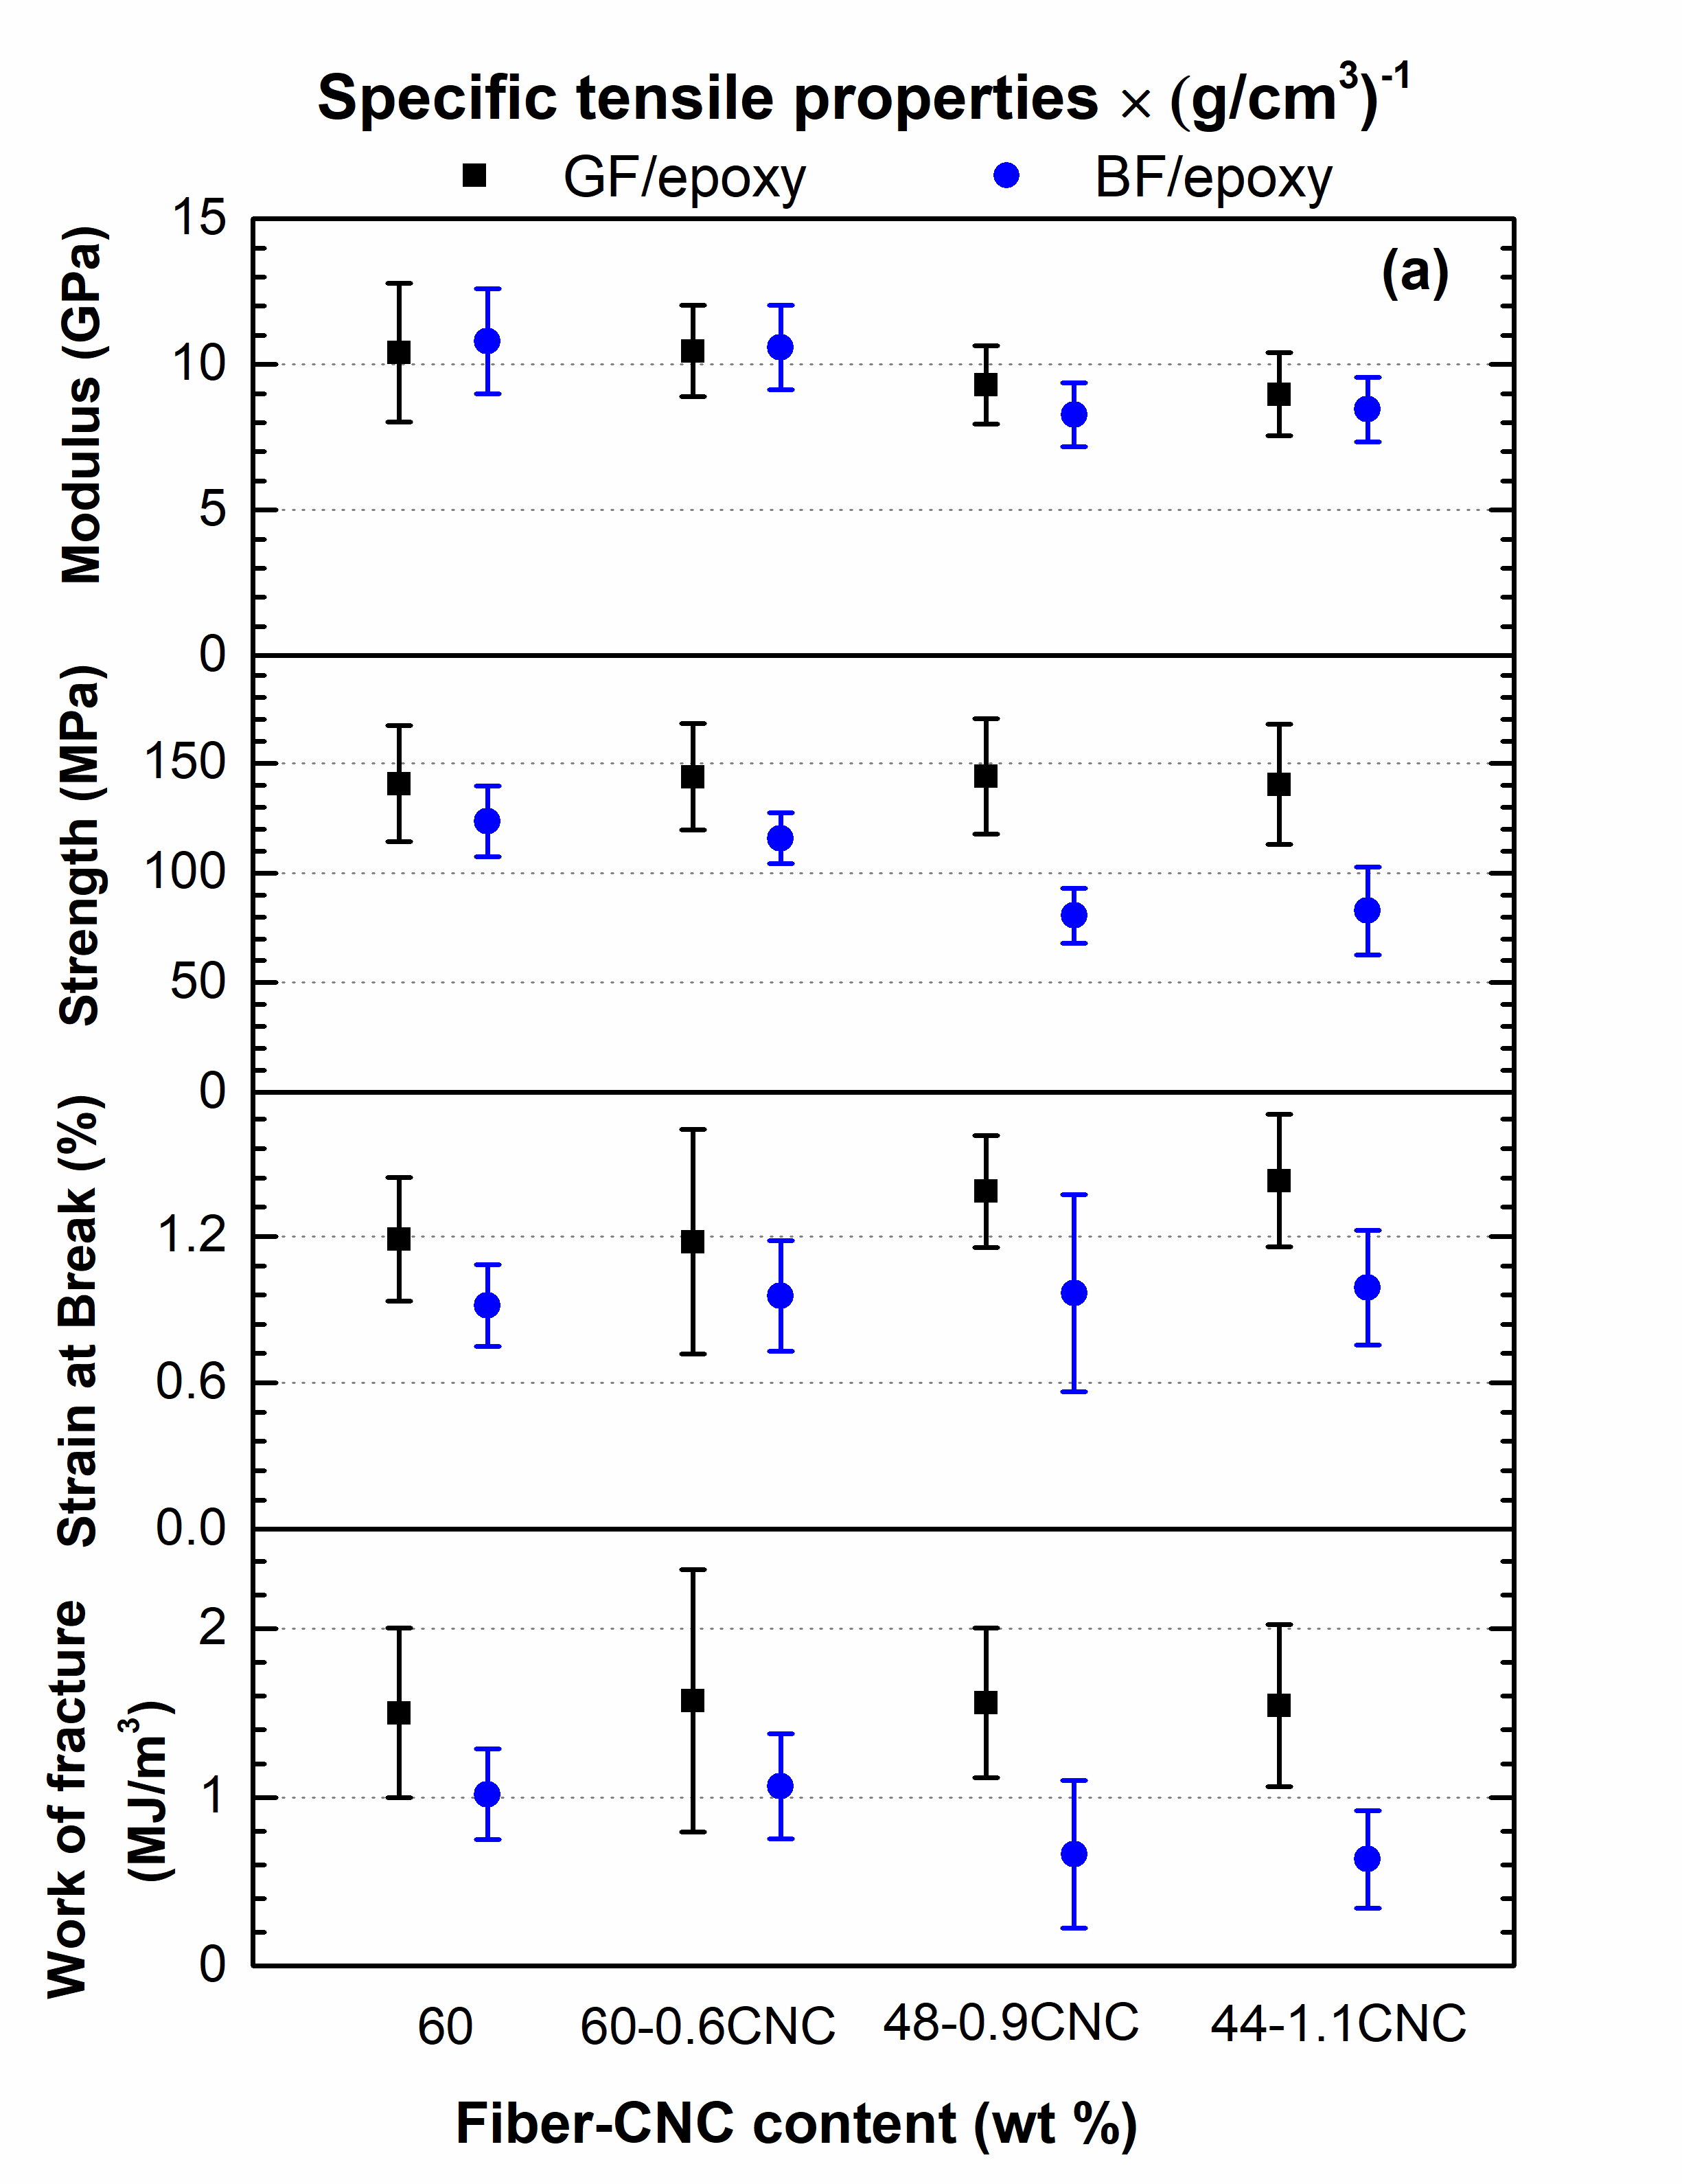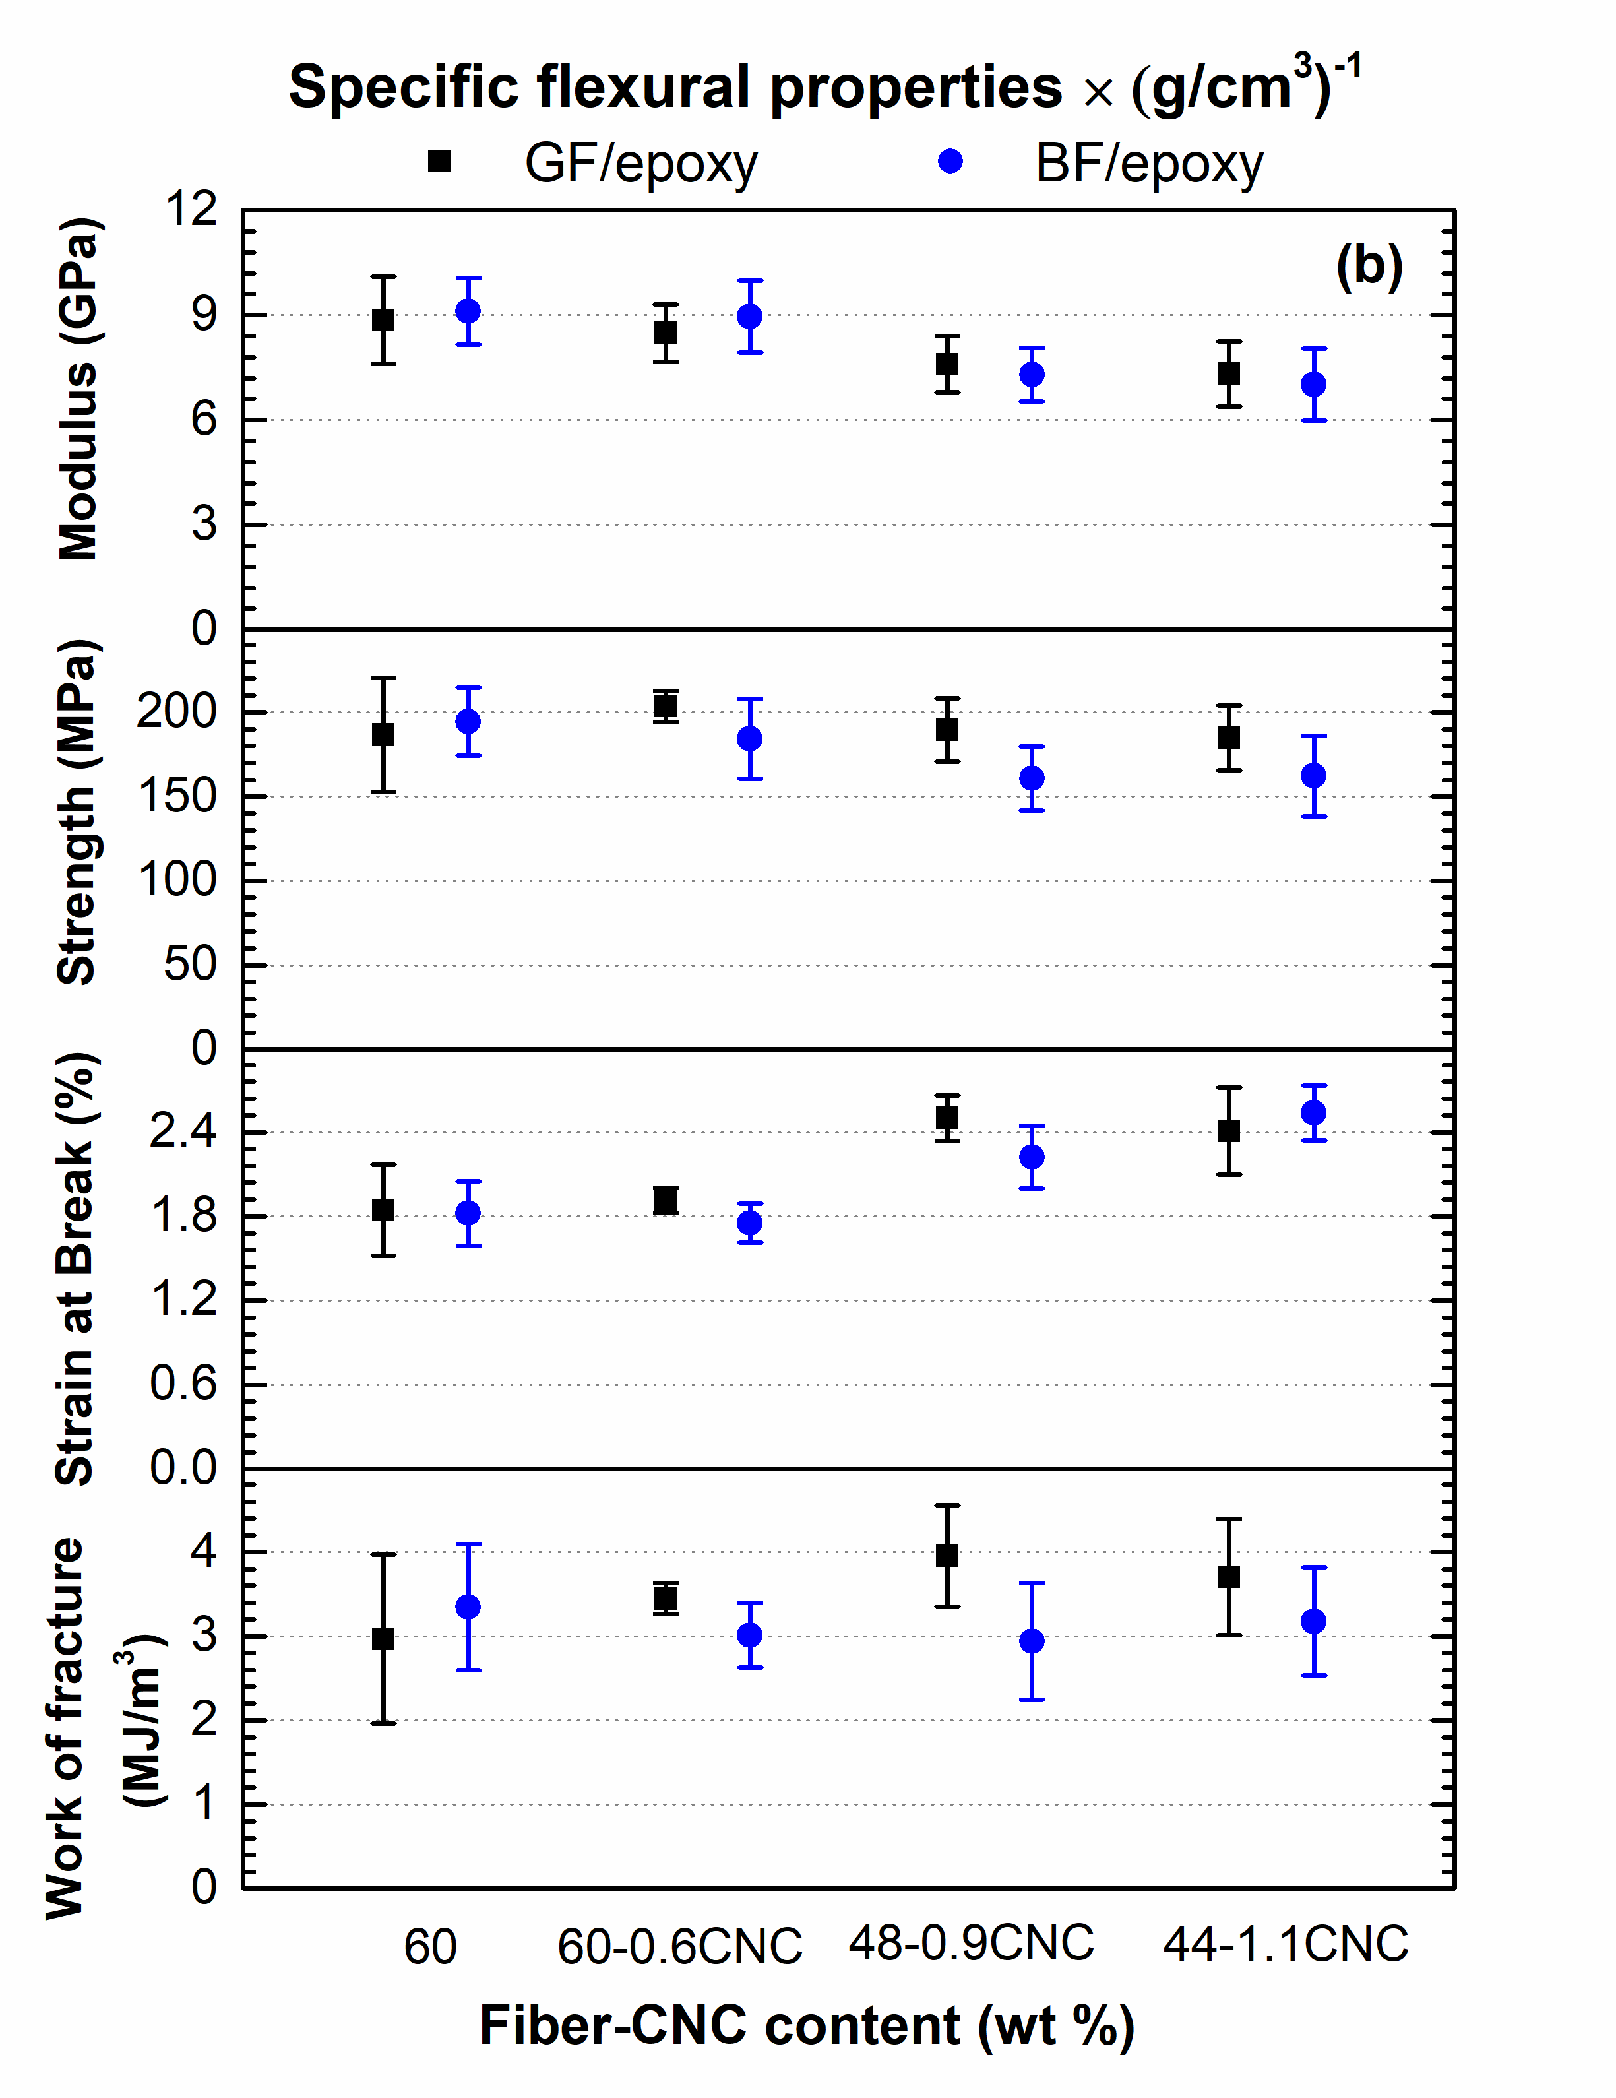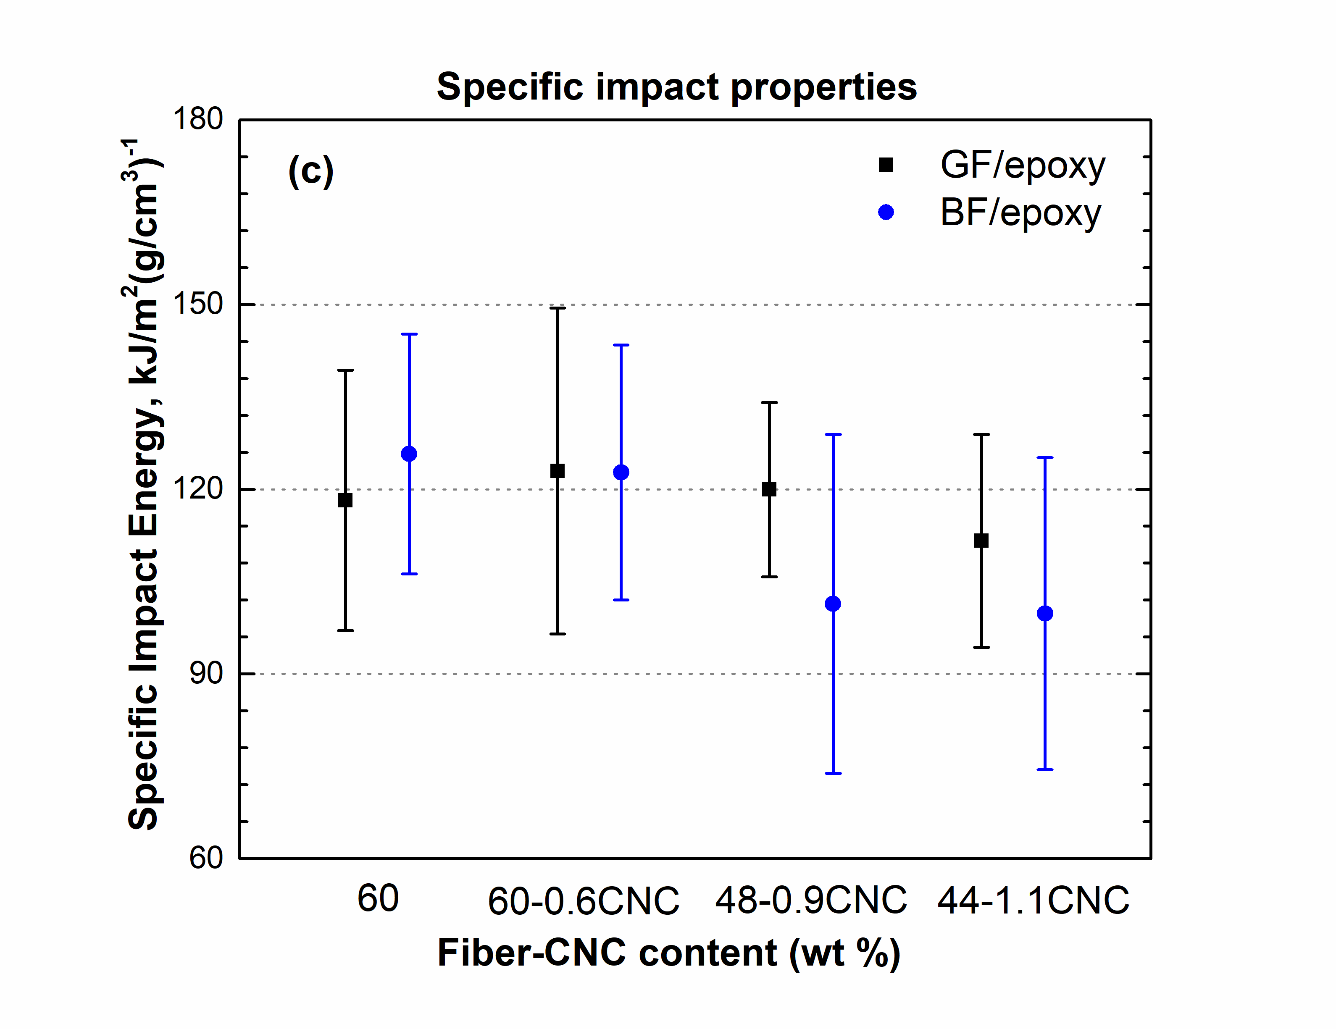
Figure 3. (a) Specific tensile, (b) specific flexural and (c) specific impact properties of lightweight GF/epoxy and BF/epoxy SMC composite containing CNC

Acknowledgement

This work was supported by P³ Nano, the U.S. Endowment for Forestry and Communities and partially by Volkswagen Group of America Inc. The authors would like to thank Prof. Jon Colton for
providing the mechanical testing equipment, Owens Corning for donation of glass fibers and Mafic Ireland for donation of basalt fibers.

References

- V. Fiore, T. Scalici, G. Di Bella, A. Valenza. A review on basalt fibre and its composites, Composites Part B: Engineering, 7474-94, 2015.
- C. Colombo, L. Vergani, M. Burman. Static and fatigue characterisation of new basalt fibre reinforced composites, Composite Structures 94(3):1165-1174, 2012.
- Q. Liu, M.T. Shaw, R.S. Parnas, A.M. McDonnell. Investigation of basalt fiber composite mechanical properties for applications in transportation, Polymer Composites, 27(1):41-48, 2006.
- A. Dorigato, S. Morandi, A. Pegoretti. Effect of nanoclay addition on the fiber/matrix adhesion in epoxy/glass composites, Journal of Composite Materials, 46(12):1439-1451, 2012.
- D. Pedrazzoli, A. Pegoretti, K. Kalaitzidou. Synergistic effect of exfoliated graphite nanoplatelets and short glass fiber on the mechanical and interfacial properties of epoxy composites, Composites Science and Technology, 98:15-21, 2014.
- F. Hussain, M. Hojjati, M. Okamoto, R.E. Gorga. Review article: Polymer-matrix Nanocomposites, Processing, Manufacturing, and Application: An Overview, Journal of Composite Materials, 40(17):1511-1575, 2006.
- A. Asadi, M. Miller, A.V. Singh, R.J. Moon, K. Kalaitzidou. Lightweight sheet molding compound (SMC) composites containing cellulose nanocrystals, Composite Structures, 160211-219, 2017.
- M.A. Hubbe, O.J. Rojas, L.A. Lucia, M. Sain. Cellulosic nanocomposites: a review, BioResources, 3(3):929-980, 2008.
- Y. Habibi, L.A. Lucia, O.J. Rojas. Cellulose nanocrystals: chemistry, self-assembly, and applications, Chemical reviews, 110(6):3479-3500, 2010.
- R.J. Moon, A. Martini, J. Nairn, J. Simonsen, J. Youngblood. Cellulose nanomaterials review: structure, properties and nanocomposites, Chemical Society Reviews 40(7):3941-3994, 2011.
- Y. Chen, X. Zhou, X. Yin, Q. Lin, M. Zhu. A novel route to modify the interface of glass fiber-reinforced epoxy resin composite via bacterial cellulose, International Journal of Polymeric Materials and Polymeric Biomaterials, 63(4):221-227, 2014.
- A. Asadi, M. Miller, R.J. Moon, K. Kalaitzidou. Improving the interfacial and mechanical properties of short glass fiber/epoxy composites by coating the glass fibers with cellulose nanocrystals, Express Polymer Letters, 10(7):587-597, 2016.
- N. Girouard, G.T. Schueneman, M.L. Shofner, J.C. Meredith. Exploiting colloidal interfaces to increase dispersion, performance, and pot-life in cellulose nanocrystal/waterborne epoxy composites, Polymer, 68111-121, 2015.
- S.X. Peng, R.J. Moon, J.P. Youngblood. Design and characterization of cellulose nanocrystal-enhanced epoxy hardeners, Green Materials, 2(4):193-205, 2014.

