emulsion templated macroporous polymer as Micromixer

Hande Barkan-Öztürk¹, Angelika Menner² and Alexander Bismarck^{3,4}

¹ Institute of Materials Chemistry and Research, University of Vienna, 1090 Vienna, Austria
Email: hande.barkan@univie.ac.at
² Institute of Materials Chemistry and Research, University of Vienna, 1090 Vienna, Austria
Email: angelika.menner@univie.ac.at
³ Institute of Materials Chemistry and Research, University of Vienna, 1090 Vienna, Austria ⁴ Department of Chemical Engineering, Imperial College London, SW72AZ London, UK
Email: alexander.bismarck@univie.ac.at

Keywords: PolyHIPE, micromixer, emulsification, macroporous polymer, emulsion template.

Abstract
Microfluidic mixing technology grew rapidly in the past few years due to its many advantages over the macro-scale mixing, especially the ability to use small amounts of internal volume, the fast and controllable mixing process and reactions with very fast kinetic during the laminar flow. By using obstacles in the micromixer, the mixing length and the contact area between the species have been increased. Therefore, the channel geometry and its surface property have great importance to reach a satisfactory mixing results. Since poly(-merised)High Internal Phase Emulsions (polyHIPEs) have more than 74% porosity and their pores are connected each other with pore throats, which cause high permeability, they are ideal candidate to build a micromixer. The HIPE precursor is commonly produced by using an overhead stirrer to obtain relatively large amount of emulsion in batch process. However, we will demonstrate that a desired amount of emulsion can be prepared continuously with micromixer build from polyHIPE, and such HIPE can subsequently be employed as ink in 3D printing process.

1. Introduction

Developing of the micromixers have grown rapidly due to their advantages over the macro scale mixing, including better control of physical reaction parameters, reduced reagent utilization, fast and controllable mixing process, lower energy consumption and therefore, low cost [1], [2]. Because of that, many researches are going on micromixers to adjust their parameters to the chemical and biological fields, for example, chemical synthesis, polymerization and extraction, DNA analysis, detection/analysis of chemical or biochemical content [3].
When the mixing at macro scale occurs with turbulent movement, the mixing of two or more fluids in the micromixer performs mainly by laminar flow which based on the molecular diffusion [4]. Most of the cases, the micromixers have been produced by injection moulding of cyclic olefin copolymer [5], moulding of PDMS onto a plasma etched silica substrate [6] or with a CNC milling machine on a polycarbonate [7]. However, special instrumentations and clean room facilities are necessary to build the device, and therefore, fabricating of the microfluidic mixer is high cost, time consuming and challenging process. Moreover, the channel dimensions cannot be minimized less than hundreds of micrometre due to the physical limitations [5]. Therefore, highly interconnected macroporous polymers, whose pore size can be altered from hundreds to a few µm, can be a good option to produce a micromixer.
One of the best method to prepare macroporous polymer with tailorable properties is emulsion templating, which obtain polymer monolith based on the emulsion structure by polymerization of monomer containing continuous phase and subsequently removing of the dispersed (internal) phase [8]. In case of having more than 74% of internal phase (IP) in the emulsion, it called High Internal Phase Emulsion or HIPE and after the polymerization called as polyHIPE [9]. Moreover, the mechanical and morphological parameters of the resultant polymer can be adjusted easily by changing the internal phase amount, emulsification conditions, emulsifier agents, e.g. surfactant or small particles, in which emulsion known as Pickering emulsion [10], or monomer and crosslinker type and ratio.
PolyHIPEs have found for a wide range of advanced applications, such as catalyst supports, ion-exchange modules, membranes, tissue engineering, etc. Moreover, many researches are going on recently about polyHIPEs as a flow-through reactor or micromixer [11]–[13]. Tebboth and co-workers had produced the micromixer from poly(St-co-DVB)HIPEs to extract the caffeine from an aqueous solution with ethyl acetate [13] and also for the Bourne reaction [11]. In the early works, polyHIPEs had used as a support for the Suzuki cross-coupling reaction or supporting for an immobilized catalyst [14].
Those flow through reactors or micromixers are fabricated by batch mixing, which have significant ascendancy on producing emulsion templates both in laboratory and industry with different parameters. Overhead stirrers are well known for the batch process at the laboratory scale and have been widely used to prepare emulsion templates. However, the emulsion amount is limited by the size of the vessel of the mixing system and in order to modify the mechanical and morphological properties of the resultant monolith, the emulsification has to be performed from the beginning. In our early research [15], a highly viscous emulsion template prepared with overhead stirrer had used to draw a desired pattern with 3D printer. However, we had required approximately 3 ml from the 30 ml emulsion to fabricate this pattern. Furthermore, since the emulsions are kinetically stable, after a few hours break, we had to prepare the emulsion again. Hence, producing an emulsion with continuous flow system is well needed both to obtain certain amount of product and also adjusting the morphology of the emulsion template faster and easily.
In this article, we will explain the synthesis of poly-Pickering-HIPEs and preparation of micromixers from those highly interconnected monoliths. An emulsion will be processed using the poly-Pickering HIPE-micromixer. In addition, after the adopting the micromixers to the movable head of 3D printer, while the emulsification is performed, a desired pattern will be drawn and subsequently polymerized with UV light. The effect of the fluid flow rates and rations will be investigated.

2. Experiment

2.1. Materials

Styrene (S) ≥99%, divinylbenzene (DVB) 80%, α, α′-azoisobutyronitrile (AIBN), calcium chloride dehydrate (CaCl₂·2H₂O) ≥99%, ethylhexyl acrylate (EHA) were purchased from Sigma-Aldrich. Hydrophobic pyrogenic silica particles HDK H20 were purchased from Wacker Chemie AG (Germany). Polyurethane diacrylate “Ebecryl 8402” (PUDA) was kindly supplied by Cytec (Diegem, Belgium). The surfactant Hypermer B246 was kindly supplied by Croda (East Yorkshire, UK). Darocur 1173 was purchased from BASF (Kaisten, Germany). Araldite rapid adhesive was purchased from Rapid Electronics Limited (Essex, UK) and Araldite 2020 was purchased from Farnell element14 (Salzburg, Austria). Non-ionic ethoxylated ester-type surfactant Hypermer 2296 (HLB = 4.9) was kindly provided by Croda (USA). The shrink tube was purchased from Conrad Electronic GmbH (Vienna, Austria). All materials were used as received.

2.2. Methods

2.2.1. Production of Poly-Pickering HIPE Monoliths

The micromixers were fabricated from the poly-Pickering HIPE monoliths, which were produced by polymerisation of particle stabilized HIPEs with surfactant additive, and S and DVB were used as monomer and crosslinker, respectively. The continuous phase of Pickering-HIPEs were prepared with S and DVB (1:1) and 3% (w/v) of hydrophobized pyrogenic silica particles, HDK H20. The continuous phase were homogenized for 15 min at 15 000 rpm using a using Kinematica POLYTRON PT 1600 E. The mixture was transferred into a reaction vessel and 1 mol% AIBN was added. The internal phase was dripped slowly into the CP under constant agitation at 400 rpm. After the addition of all dispersed phase, 10 vol% Hypermer 2296 with respect to the continuous phase amount were added to the Pickering-HIPE and mixed 30 s more. The resultant Pickering-HIPE has 80% IP and 20% continuous phase (CP). Afterwards, the emulsions were transferred from the reaction vessel into Falcon tubes (D_{i} = 13 mm) and polymerized at 70 °C in a convection oven for 12 h. By ending of the time, the monoliths were removed from the tubes and washed with water and then acetone to get rid of the excess CaCl₂·2H₂O and unreactant monomers, respectively. The wet monoliths were dried in the fume hood overnight to evaporate acetone and then they were placed in the vacuum oven at 70 °C for 12 h.

2.2.2. Preparation of Micromixer

The holes were drilled into the poly-Pickering HIPE monolith to a depth of 5 mm to place the PTFE tubes and needle on the top part and on the curved surface 5 mm above the bottom part, and then the tubes were sealed with Araldite Rapid adhesive. The surface of the monolith was covered with same epoxy adhesive, to avoid fluid bypassing. Afterwards, the monolith was placed into a high-temperature heat shrink tubing and, by exposing to hot air from a heat gun, the shrink tubes sealed the monolith. At the final stage, the feed tubes were additionally sealed with Araldite 2020 and the epoxy resin was cured in a convection oven at 70 °C for 4 hours.

2.2.3. Determination of Poly-Pickering Hipes Density and Porosity
The polymer skeletal density (ρ_{s}) was determined using helium pycnometre (Accupyc 1330, Micrometrics, Dunstable, U.K.) and the foam density (ρ_{f}) of the monolith was analysed with an envelope density analyser (Geopyc 1360, Micrometrics, Dunstable, U.K.). The porosity of the monoliths was calculated from the determined densities using the equation given below.

P (%) = ( 1- ρ_{f} / ρ_{s} ) * 100 ( Eq.1)

However, the porosities of the polyH/MIPEs prepared with micromixers cannot determined with envelope density analyser because of their highly compressibility. Therefore, to measure the foam densities, the polyH(M)IPE monoliths were cut into small samples; the specimens were weighed and their dimensions were measured. The foam densities (ρ_{f}) were calculated by:

ρ_{f} = m/V (Eq. 2)

Where, m is the weight of the sample and V is the volume of the sample. Afterwards, the porosities were calculated with Eq. 1.

2.2.4. Morphology of Poly-Pickering HIPEs
The morphology of the monolithic and printed polyHIPEs was investigated using scanning electron microscopy (SEM, JCM-6000, JEOL GmbH, Eching, Germany). The fractured surface of the samples was gold coated using JFC-1200 (JEOL GmbH, Eching, Germany) to guarantee sufficient electrical conductivity. The SEM images were further analysed using image analysis software ImageJ; to achieve the average pore and pore throat sizes of the samples, at least 100 pore or pore throat diameters were recorded.

2.2.5. Micromixer Experimental Setup

The Figure 1 schematically shows the setup of the micromixer made from poly-Pickering HIPE to emulsify, print and polymerize of the two immiscible liquids. The two syringe pumps containing an aqueous solution of 10 g/L CaCl₂.2H₂O and the mixture of 60 vol% EHA, 36 vol% PUDA, 3 vol% Hypermer B246 (with respect to the total continuous phase amount), and 1 mol% (with respect to the double bonds in the monomers) Doracur 1173, respectively, were connected to the flow cell via separate 1/16 inch tubes. After the flow cell was placed onto the movable head of a universal CNC model-making machine (Stepcraft 420, Stepcraft GmbH, Iserlohn, Germany) connected to a computer to print the desire pattern, the continuous and internal phases were pumped in a 1:3 or 1:3.5 ratios with syringe dispensers (EFD Ultra 2800 dispenser, Nordson, Oberhaching, Germany, and syringe pump, PHD Ultra, Harvard Apparatus, U.K.), respectively. The detail information about the flow rates are given on the Table 1. By appearing of the flowing emulsion from the excess tube, the printing of the desired pattern and polymerization with a UV-pen in-situ was started.
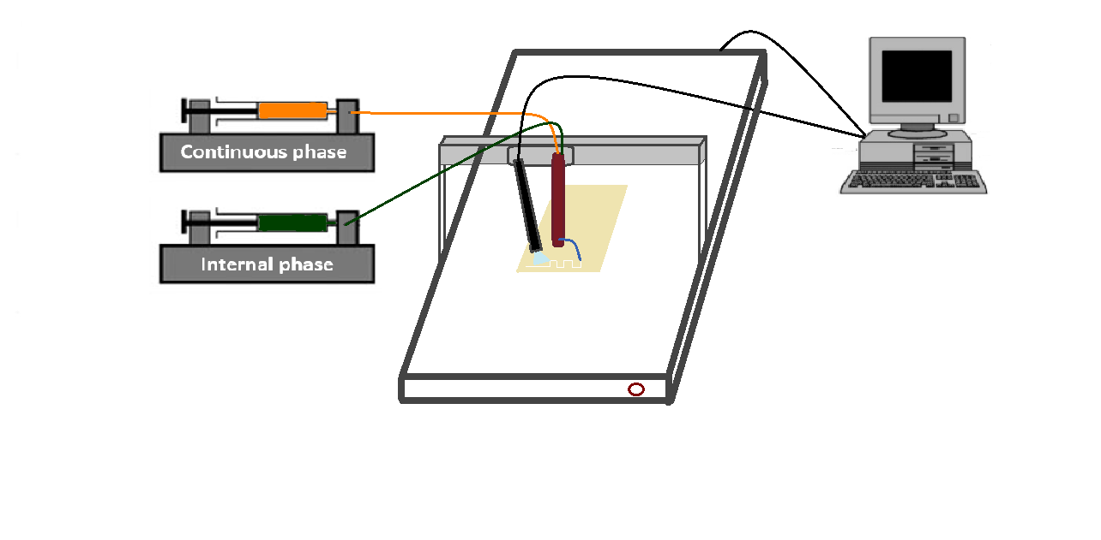
Figure 1. Experimental setup of micromixer on 3D-Printer.

3. Results and Discussion

Macroporous polymers can be obtained by emulsion templating method with tailored morphological and mechanical properties. Interconnected polyHIPEs can be synthesized with the surfactant or both particles and surfactant stabilized high internal phase emulsions. Depend on the stabilizing agent, pores, pore throat diameters and therefore, the permeability of the resultant macroporous polymers show significant differences. The pore size of the poly-Pickering HIPEs is much higher than the surfactant stabilized polyHIPEs and have better mechanical properties [15]. To produce chemically stable macroporous polymers we choose DVB as crosslinker and styrene as co-monomer, because of their well-known characteristic properties [11] and the emulsion was stabilized with fumed hydrophobic silica particles. Moreover, the interconnection between pores are achieved by adding small amount of surfactant (Figure 2).

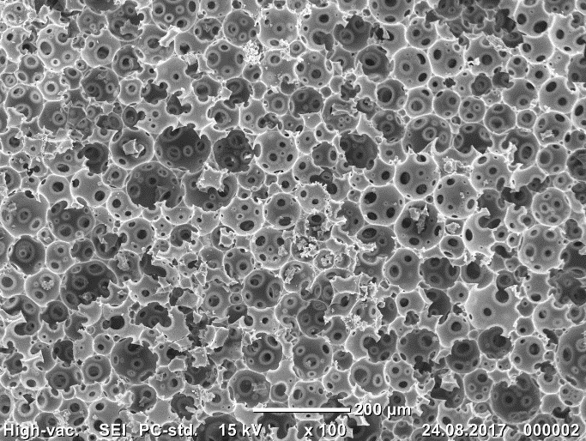
Figure 2. SEM images of poly-Pickering HIPE monolith.

Due to the interconnected porous structure of the surfactant added poly-Pickering HIPEs (Figure 2), broad flow distribution induces the micromixing through the monolith and the fluids are regenerated within the pore structure through the pore throats. Therefore, an emulsion can be prepared with polyHIPEs as a micromixer, when the two immiscible fluids are forced through them.
The micromixer has been tried with different flow rates and flow ratios to produce a highly viscous emulsion and simultaneously polymerised them with UV light to obtain interconnected macroporous polymers. Afterwards, the morphology of the flexible and compressible macroporous polymers was investigated with SEM. Since the structure of the macroporous polymers prepared by emulsion templating method has similar morphology of the emulsion at gel point of the polymerisation, the ratio between internal phase and continuous phase of the emulsion should determine the porosity of the resultant monolith. Hence, IP and CP were dispensed through the micromixer at 3:1 or 3.5:1 ratio, respectively, to reach high or medium internal phase emulsion. However, the hydrophobicity of the channel wall has led to flowing of IP faster than CP. Therefore, until the first droplets of CP coming out from the outlet tube, it was pumped through the micromixer in advance to avoid the leaping out of IP without mixing.
After the micromixer was placed onto the movable head of the CNC milling machine, the head had directed according to the desired pattern that drawn on the software, when the UV light was applying on the pattern surface to polymerise the emulsion subsequently (Figure 3a). Due to the very high viscosity of the emulsion, the walls of the pattern can keep the structure until the polymerisation done completely. In our early research [15], the emulsion was printed with 5 mm/s speed and the polymerisation was done completely until the printing finished. Moreover, in order to prove the high viscosity of the emulsion and also continuously flowing from the outlet tube, a 3D structure was also tried by hand when UV light simultaneously was applied (Figure 3b).
a
b
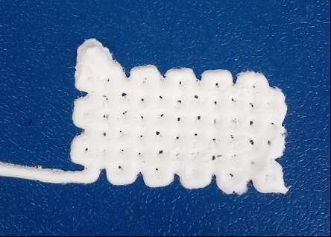 | 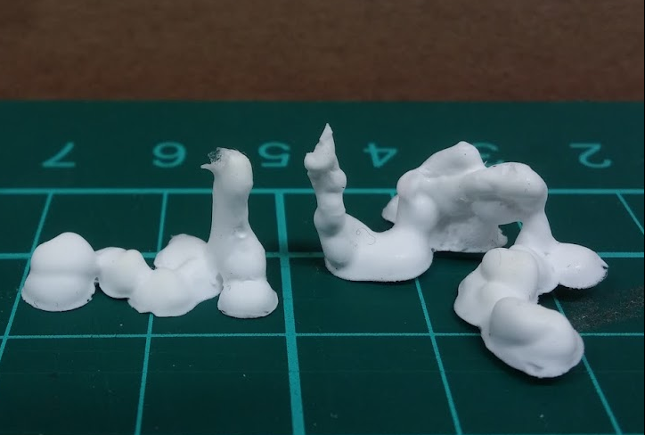
Figure 3. Desire pattern printed macroporous polymer with micromixer (a), 3D structure shape drawn by hand with micromixer (b).

3. Conclusions

Here we demonstrated that a highly interconnected poly-Pickering HIPE is an effective micromixer which can be used to continuously prepare HIPEs and MIPEs. Due to the high permeability of micromixer, highly viscous can be obtain through the micromixer to use as ink in the printing process. Moreover, fast UV-polymerisation causes to achieve different 3D shapes less than a few minutes. Morphology of the resultant macroporous polymer can be adjusted by changing the agitation rate during the micromixing, since increasing flow rate of the phases has direct effect on the mixing performance of the micromixer by changing the permeability and also Reynold number. Medium or high internal phase emulsions were prepared by changing flow ratio of the IP and CP and subsequently polymerized.

References

[1] L. Capretto, W. Cheng, M. Hill, and X. Zhang, “Micromixing Within Microfluidic Devices,” in Microfluidics, vol. 304, B. Lin, Ed. Berlin, Heidelberg: Springer Berlin Heidelberg, 2011, pp. 27–68.
[2] M. Nimafar, V. Viktorov, and M. Martinelli, “Experimental Investigation of Split and Recombination Micromixer in Confront with Basic T- and O- type Micromixers,” Int. J. Mech. Appl., vol. 2, no. 5, pp. 61–69, Dec. 2012.
[3] G. S. Jeong, S. Chung, C.-B. Kim, and S.-H. Lee, “Applications of micromixing technology,” The Analyst, vol. 135, no. 3, p. 460, 2010.
[4] D. H. Kelley and N. T. Ouellette, “Separating stretching from folding in fluid mixing,” Nat. Phys., vol. 7, no. 6, pp. 477–480, Jun. 2011.
[5] D. S. Kim, S. H. Lee, T. H. Kwon, and C. H. Ahn, “A serpentine laminating micromixer combining splitting/recombination and advection,” Lab. Chip, vol. 5, no. 7, p. 739, 2005.
[6] Y. Liu, Y. Deng, P. Zhang, Z. Liu, and Y. Wu, “Experimental investigation of passive micromixers conceptual design using the layout optimization method,” J. Micromechanics Microengineering, vol. 23, no. 7, p. 075002, Jul. 2013.
[7] M. Costantini et al., “Highly ordered and tunable polyHIPEs by using microfluidics,” J. Mater. Chem. B, vol. 2, no. 16, p. 2290, 2014.
[8] M. Tebboth, A. Kogelbauer, and A. Bismarck, “Highly permeable macroporous polymers via controlled agitation of emulsion templates,” Chem. Eng. Sci., vol. 137, pp. 786–795, Dec. 2015.
[9] A. Menner, R. Powell, and A. Bismarck, “Open Porous Polymer Foams via Inverse Emulsion Polymerization: Should the Definition of High Internal Phase (Ratio) Emulsions Be Extended?,” Macromolecules, vol. 39, no. 6, pp. 2034–2035, Mar. 2006.
[10] V. O. Ikem, A. Menner, T. S. Horozov, and A. Bismarck, “Highly Permeable Macroporous Polymers Synthesized from Pickering Medium and High Internal Phase Emulsion Templates,” Adv. Mater., vol. 22, no. 32, pp. 3588–3592, Aug. 2010.
[11] M. Tebboth, A. Kogelbauer, and A. Bismarck, “Effectiveness of Emulsion-Templated Macroporous Polymer Micromixers Characterized by the Bourne Reaction,” Ind. Eng. Chem. Res., vol. 54, no. 22, pp. 5974–5981, Jun. 2015.
[12] J. F. Brown, P. Krajnc, and N. R. Cameron, “PolyHIPE Supports in Batch and Flow-Through Suzuki Cross-Coupling Reactions,” Ind. Eng. Chem. Res., vol. 44, no. 23, pp. 8565–8572, Nov. 2005.
[13] M. Tebboth, A. Kogelbauer, and A. Bismarck, “Liquid–Liquid Extraction within Emulsion Templated Macroporous Polymers,” Ind. Eng. Chem. Res., vol. 54, no. 29, pp. 7284–7291, Jul. 2015.
[14] M. Ottens, G. Leene, A. A. C. M. Beenackers, N. Cameron, and D. C. Sherrington, “PolyHipe: A New Polymeric Support for Heterogeneous Catalytic Reactions: Kinetics of Hydration of Cyclohexene in Two- and Three-Phase Systems over a Strongly Acidic Sulfonated PolyHipe,” Ind. Eng. Chem. Res., vol. 39, no. 2, pp. 259–266, Feb. 2000.
[15] Q. Jiang, H. Barkan, A. Menner, and A. Bismarck, “Micropatterned, macroporous polymer springs for capacitive energy harvesters,” Polymer, vol. 126, pp. 419–424, Sep. 2017.

