Thin film UV-curable acrylate polyurethane/MOF mixed matrix membranes for CO₂ separation

Akbar Shojaei^{*1,2}, Hossein Molavi¹, Seyyed Abbas Mousavi²

¹Institute for Nanoscience and Nanotechnology (INST), Sharif University of Technology, P.O. Box 11155-8639, Tehran, Iran.
²Department of Chemical and Petroleum Engineering, Sharif University of Technology, PO Box 11155-9465, Tehran, Iran.
Corresponding author: Akbar Shojaei, Email: akbar.shojaei@sharif.edu

Keywords: UV-curable acrylate polyurethane, UiO-66, Mixed-Matrix Composite Membranes, Gas separation.

Abstract
The major obstacles in gas separation by mixed-matrix composite membranes (MMCMs) are poor dispersion and poor affinity between polymers and fillers. The present study demonstrates that these challenges can be overcome appropriately by utilizing a series of synthesized MMCMs. MMCMs were prepared with UV-curable polyurethane acrylate and UiO-66 as selective layer and polyester/polysulfone (PS/PSF) as support layer. The physical properties of prepared MMCMs were characterized by X-ray diffraction (XRD), field emission scanning electron microscopy (FESEM) and Fourier transform infrared spectroscopy (FTIR). Microscopic analysis by FESEM revealed that desirable nanoscale dispersion of UiO-66, suitable distribution across the membrane thickness as well as strong interface were achieved by using UiO-66 at moderate loadings. The permeability of pure CO₂ and N₂ gases were determined using constant volume/variable pressure method at 25°C and 6 bar. The results demonstrated that the permeability of aforementioned gases as well as the ideal selectivity in CO₂/N₂ increased by increasing the amount of MOFs loading. The results demonstrated that this membrane could be a promising candidate for practical CO₂ separation.

Introduction

Development of cost-effective and environment-friendly separation processes to remove carbon dioxide (CO₂) emission from flue or fuel gas has attracted the attention of researchers in academia and industry [1–3]. Membrane separation is worth noticing as an energy-efficient and economical technique for gas separation applications [4], because of their outstanding features such as reduced energy consumption, low capital investment, stability at high pressures, simple operations, easy scalability, simple processing and suitable mechanical strength. However, conventional polymeric membranes are limited by a trade-off between permeability and selectivity, so that a polymer with high permeability presents low selectivity and vice versa. There have been extensive efforts during the last several years to surpass this inherent trade-off between permeability and selectivity as follows: 1) synthesizing new polymeric membranes, 2) mixing different polymers to produce polymer blend membranes, 3) using block copolymers containing different blocks in polymer backbone, and 4) developing mixed matrix membranes (MMMs) with inorganic fillers [2].

Generally, MMMs are composed of a continuous polymer phase as matrix and a dispersed inorganic phase as filler. These composite materials provide remarkable separation properties along with facile processing and reasonable mechanical properties respect to neat polymers. Among various fillers used to fabricate MMMs, metal-organic frameworks (MOFs), a new class of highly crystalline and nanoporous materials, are considered as a promising candidate for fabricating new MMMs because of their outstanding features such as high specific surface area, high porosity, tunable pore walls, affinity for specific gases, and flexible chemical composition [2,5,6].

The major issue in fabricating MMMs is improper interfacial adhesion between polymer matrices and fillers, which introduces defects and nonselective interfacial voids leading to deterioration of the membrane performance. Therefore, to address the above issues, UiO-66 was chosen as filler because of their extraordinary water stability (more than one year), high thermal stability (up to 500°C), good chemical resistance toward polar and organic solvents [3,7,8]. Acrylated polyurethane (APU) was chosen as polymer matrix because of its high permeability and selectivity for polar gasses like CO₂ over non-polar gases. APU is actually polyurethane molecule which is end capped with vinyl monomers making APU as crosslinkable polymers using free radical polymerization, which may be activated with UV light. APU is often diluted using reactive diluents like acrylate monomers to improve the processability while the reactive diluents take part in the final cross-linked structure [9,10]. Therefore, the mixture is often composed of two basic components including reactive APU oligomers and reactive acrylate diluents, a mixture abbreviated hereafter with APUA, which is activated by few amounts of photoinitiators.

Experimental

Materials

Poly(ethylene glycol) (PEG) with molecular weight of 1000 g/mol was obtained from Merck, and dehydrated under vacuum at 80°C for 24 h before use. 2-hydroxyethyl methacrylate (HEMA) was obtained from Sigma-Aldrich, and kept dry with a 4A molecular sieve before use for one week. Extra-pure grade of toluene diisocyanate (TDI), dibutyltin dilaurate (DBTDL), benzophenone, dimethylformamide (DMF), N-methyldiethanolamine (MDEA), terephthalic acid, chloroform, and zirconium (IV) chloride (ZrCl₄) were obtained from Merck and Sigma–Aldrich, and used without further purification. Microporous polysulfone support (thickness ~140 μm, reinforced with a polyester non-woven support with a molecular weight cut-off (MWCO) of 500 kDa) was provided by Sharif membrane technology center (SMTC). Nitrogen (N₂) and carbon dioxide (CO₂) were purchased from Roham Gas Co. (Tehran, Iran) with purities higher than 99.8%.

Synthesis of UiO-66 and acrylate polyurethane (APU)

UiO-66 was synthesized according to the procedure reported in previous studies [2,7,11,12]. APU-1000 was synthesized by PEG: TDI: HEMA with mole ratio of 1:2:2 according to the two-step polymerization method described in previous study [9,10,13].

Preparation of mixed-matrix composite membranes (MMCMs)

Measured amount of UiO-66 nanoparticles was dispersed in HEMA through stirring vigorously for 12 h to obtain a homogenous mixture. Desirable amount of as-synthesized APU-1000 was dissolved in HEMA and stirred vigorously at slightly above ambient temperature. The polymer and UiO-66 nanoparticles solutions were mixed in different ratios to control the UiO-66/polymer weight percentage and stirred for overnight. Then benzophenone as photoinitiator (2 wt %) and MDEA as accelerator (2 wt %) were added to the above mentioned mixture and the stirring continued for 3 h. Finally, the homogenous mixture was degassed under vacuum for 12 h to remove air bubbles before it was cast on a flat-sheet microporous polysulfone support using a metal knife with a controlled gap setting. The cast membrane is irradiated from top surface with a 1000 W-UV (365 nm) lamp for specific time. The composition of reaction mixture for preparing different MMCMs is given in Table 1.

Table 1. Chemical composition and morphological data of synthesized MMCMs.

Sample code | UiO-66 loading (%) | R | DPS
APUA | 0 | 1.27 | 0.56
MMCM-1 | 3 | 1.36 | 0.58
MMCM-2 | 6 | 1.45 | 0.59
MMCM-3 | 10 | 1.49 | 0.60
MMCM-4 | 12 | 1.60 | 0.62
MMCM-5 | 15 | 1.46 | 0.59

Characterization

Fourier transform infrared (FTIR) and Attenuated Total Reflectance (FTIR-ATR) spectra (Spectrum 100-FT-IR Spectrometer, Perkin-Elmer) were used to characterize the synthesized UiO-66 and the prepared MMCMs. X-ray diffraction (XRD) (X-pertPhilips, pw 3040/60) analysis was used to evaluate the crystallinity of synthesized UiO-66 and the prepared MMCMs. The scanning electron microscopy studies of the samples were conducted by using a FESEM–MIRA3 TESCAN microscope.

Gas permeation measurement

A standard constant volume/variable pressure apparatus was used to determine the pure gas permeability at the feed pressure of 6 bar and room temperature. The permeability coefficient (P) at steady state was determined using the following equation [2,14]:

(1)

where P is the gas permeability expressed in barrer (1 barrer = 10⁻¹⁰ cm³ (STP) cm cm⁻² s⁻¹ cmHg⁻¹), V is the calibrated volume of the downstream reservoir (cm³), L is the membrane thickness (cm), A is the effective membrane area (cm²), P_{f} is the upstream pressure (cmHg), P₀ is the pressure at standard state and equal to 76 cmHg, T is the operating temperature (K), T₀ is the temperature at standard state and equal to 273.15 K, and dp/dt is the steady-state permeate-side pressure increase (cmHg/s). The ideal selectivity (α) for a gas pair is simply obtained by dividing the pure gas permeability as [15]:

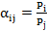 (2)

Results and discussion

FTIR-ATR analysis

The UiO-66 characterized by nitrogen adsorption/desorption, XRD, TGA, FESEM, and FTIR were described in previous studies [7,11,12]. To investigate the possible interactions between UiO-66 nanoparticles and APUA matrix, the FTIR-ATR spectrum of pure APUA is compared with that of MMCMs containing different amount of UiO-66 nanoparticles in Fig. 1. As can be seen from Fig. 1a, there are several characteristic peaks in FTIR-ATR spectra of different MMCMs. The strong and broad peak at 3200-3500 cm⁻¹ is related to the different -NH groups in urethane unit [9,10]. The peaks appearing around 2850-2950 cm⁻¹ are corresponding to C-H stretching vibration of APUA matrix, whereas the strong peaks at 1116 cm⁻¹ and 1105 cm⁻¹ are attributed to the stretching vibration of C-O in urethane unit and C-O-C in polyol groups, respectively [9,10,13].

The characteristic absorption peak appeared around 1690-1750 cm⁻¹ is assigned to the stretching vibration of carbonyl groups (C=O) in urethane unit, which provide the most useful information about micro-phase separation, so have the worth to be investigated. As can be found from Fig. 1b, the carbonyl stretching vibration of APUA matrix is shifted to lower frequencies by increasing the amount of UiO-66 nanoparticles. This red shift could be due to formation of hydrogen bond between urethane groups of APUA and functional groups of UiO-66 nanoparticles, which are similar to the results reported in other studies [2,16].

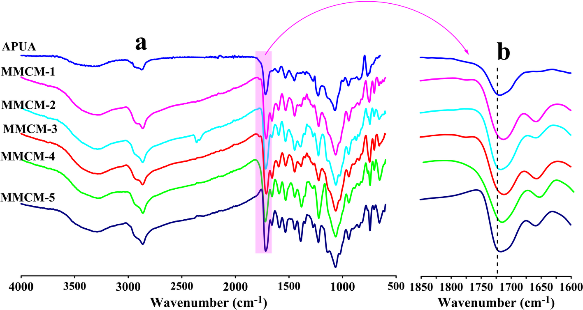

Fig. 1. FTIR-ATR spectra of different MMCMs containing UiO-66.

The degree of phase separation (DPS) between hard and soft segments is unique morphological characteristic parameter which can dominate the final gas separation performance of MMCMs; therefore the DPS in different MMCMs were calculated using the following equation and the results were summarized in Table 1 [13]:

(3)

where R is the carbonyl hydrogen bonding index which can be calculated as follows [13]:

(4)

where A is the intensity of the characteristic absorbance, which was obtained from the spectral region of carbonyl groups that deconvoluted to two Gaussian peaks by Origin software. As can be found from Table 1, the DPS between hard and soft segments increased by increasing the amount of MOFs loading, which could be due to disruption of the hydrogen bond between the urethane –NH groups with ether groups of polyol. The decrease in DPS at higher UiO-66 loading can be attributed to the agglomeration of MOF nanoparticles at these compositions, which prevents the hydrogen bonds formation between polar groups of UiO-66 nanoparticles and ether groups of polyol.

XRD analysis

As can be seen from Fig. 2, pure APUA membrane exhibits a broad peak at the range of 17-25° that could be attributed to amorphous APUA groups present in the membrane matrix, presence of small crystalline structure or diffraction distribution from crystalline regions as described well in literature [9,10,13]. In the XRD patterns of MMCMs containing UiO-66 nanoparticles, the position of this broad peak does not show obvious change, while its intensity decreases by increasing the amount of UiO-66 loading. Because, presence of UiO-66 nanoparticles into APUA matrix prevents the formation of crystalline region due to disturbing the regularity of the nearby chains and results in the increase of micro-phase separation as well as decrease the overall crystallinity of MMCMs.

Compared with pure APUA membrane, in the XRD patterns of MMCMs three new peaks are appeared at around 6.94, 8.06 and 24.77° (see Fig. 2). Additionally, the intensity of these peaks increases by increasing the amount of MOF loading, which indicates the presence of UiO-66 nanoparticles in the APUA matrix. This result denotes that the incorporation of MOF in the APUA matrix does not affect the crystalline structure of this MOF. Additionally, compared with pure UiO-66, the position of these characteristic peaks transferred to the lower degree (higher d-spacing), which could be due to the penetration of APU chins into the pores of porous UiO-66 because of good interaction between two phases [17].

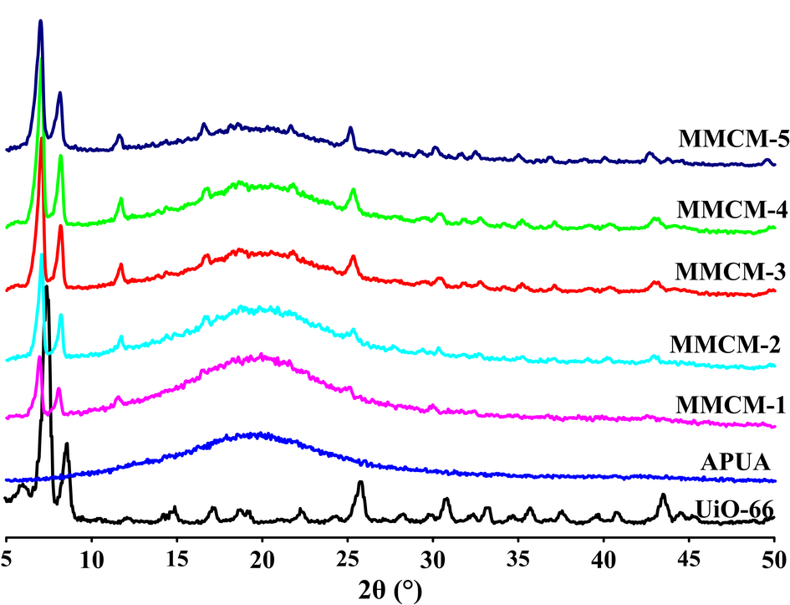

Fig. 2. XRD patterns of different MMCMs containing UiO-66.

FESEM images

In order to investigate the membrane morphology, MOFs dispersion and interfacial interaction at matrix-MOF interface, cross-sectional micrographs of MMCMs were also analyzed using FESEM, and the results are shown in Figs. 3 and 4. From FESEM micrographs (Fig. 3), it is obvious that the composite membrane is made of a porous layer with macro- and micro-porous sponge like and finger like structures, serving only as a mechanical support for the selective layer, and a dense selective layer of APUA with no porosity which is a characteristic for a composite membrane [18].

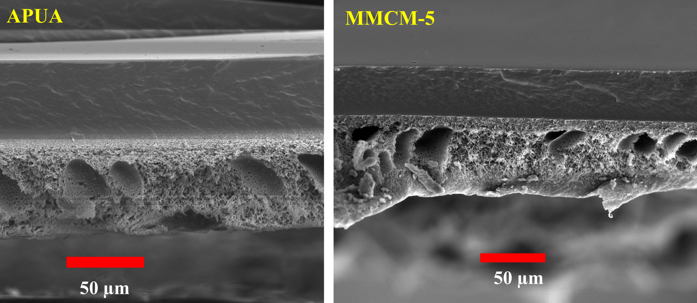

Fig. 3. The low magnification FESEM images of the whole cross-section of APUA and MMCM-5.

Good interfacial adhesion between the top selective layer and the bottom porous layer can be observed in Fig. 3, which might be due to the formation of hydrogen bonds between APU chains and sulfone groups in the polysulfone support layer and the adhesive nature of APU polymer result to firmly adhere top layer on porous layer. This phenomenon obviously increases the selectivity of CO₂ due to improve the interfacial interaction between two layers.

It can be seen in Fig. 3 that the cross section morphology of neat APUA membrane is very smooth without any defects, which is characteristic of a dense APUA membrane. The cross sectional images of MMCMs containing UiO-66 (Fig. 4) show that MOF is homogeneously dispersed without significant aggregation or phase segregation in APUA matrix. The good dispersion of UiO-66 nanoparticles at low to moderate loading in APUA matrix is attributed to the strong interaction between UiO-66 nanoparticles and APUA chains. At high loading (MMCM-5 containing 15 wt% UiO-66), several UiO-66 nanoparticles stick to each other and form big clusters. Although, in MMCM-5 some UiO-66 nanoparticles aggregate to each other and form big clusters, the "sieve in a cage" morphology not still was observed in this condition [14].

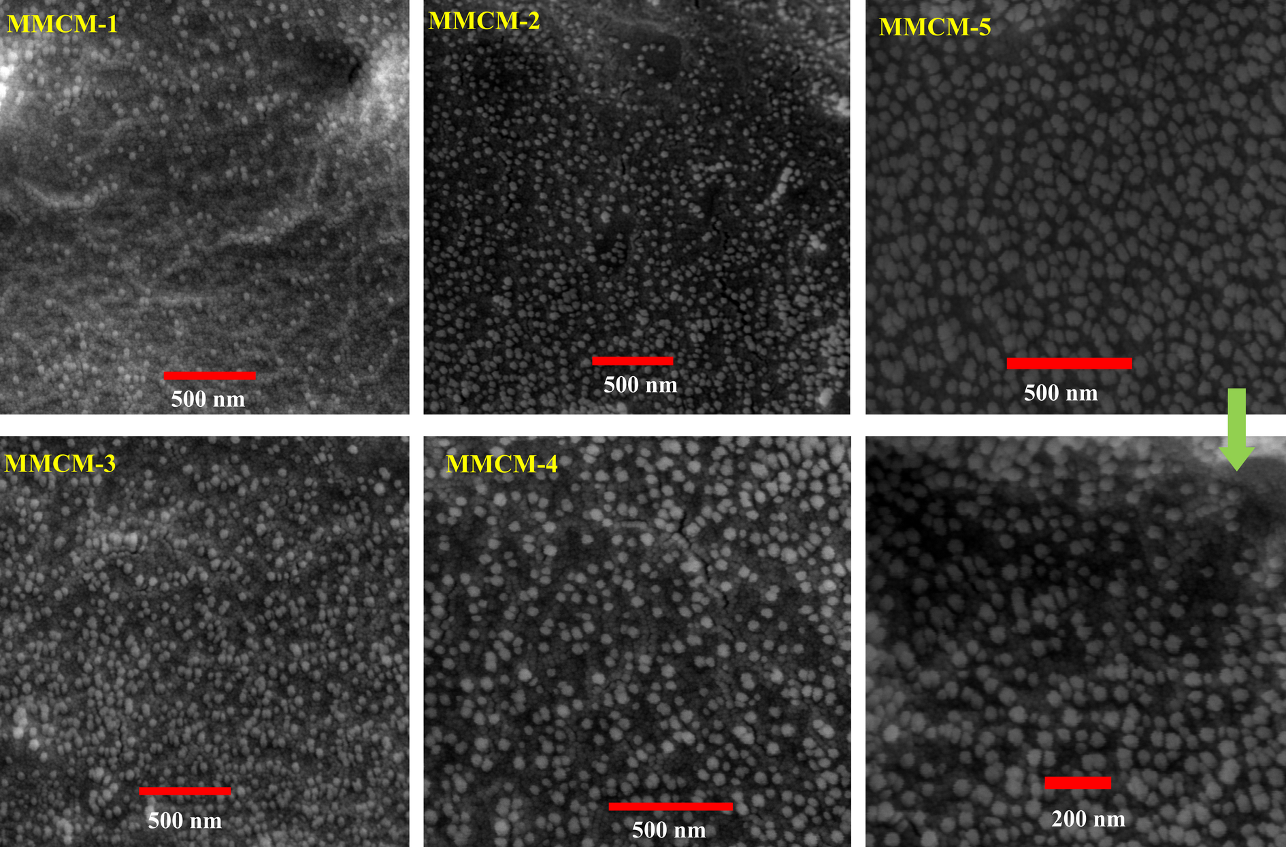

Fig. 4. FESEM images of the cross-section of MMCMs containing UiO-66 at different magnifications.

Gel content

As the APUAs are being cross-linked by UV light, their gel content measured by Soxhlet extraction is also investigated. The gel content is calculated according to the following equation [9,10,13]:

(5)

where m₀ is the initial sample weight and m_{t} is the mass of extracted samples after drying in oven. Three tests are repeated for each sample and average values were depicted in Fig. 5. It can be found that the gel content of mixed-matrix composite membranes containing UiO-66 nanoparticles decreases slowly with the extension of MOFs loading, which might be due to the incomplete curing process caused by shield effect of these nanoparticles [19].

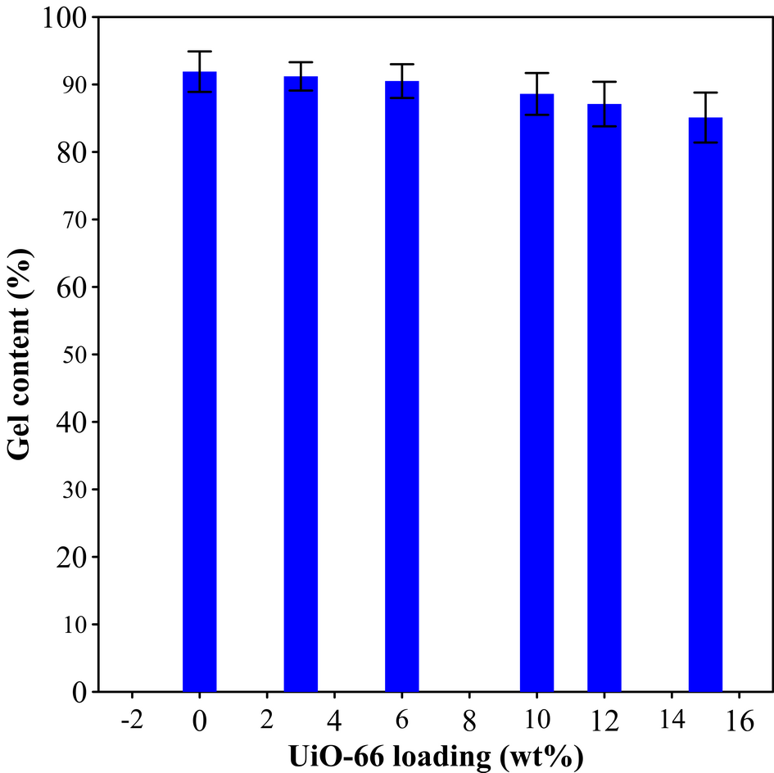

Fig. 5. The gel content of MMCMs containing different amount of UiO-66.

Gas permeation properties

The permeability of pure N₂ and CO₂ gases through MMCMs synthesized in this study was measured at room temperature and upstream pressure of 6 bar. All of the prepared membranes were tested three times to check reproducibility and reliability of the results. Fig. 6 shows that the permeability of all gases increases with increasing the UiO-66 loading which could be due to four main reasons: (1) increase of free volume of MMCMs by disruption of the APUA chain packing, (2) formation of interfacial space between APUA matrix and UiO-66 nanoparticles, (3) introducing extra channels for gas permeation orginated from the porous structure of UiO-66 nanoparticles, and (4) increase of the micro-phase separation between the hard and soft segments by incorporation of UiO-66 nanoparticles into APUA matrix (see Table 1).

From Fig. 6, it can be also found that the ideal CO₂/N₂ selectivity increases with increasing the UiO-66 loading, except MMCM-5, which is attributed to the formation of a defect-free interface between two phases due to interaction between APUA matrix and UiO-66 nanoparticles. In the case of MMCM-5, the permeability of all gases significantly increases, while the ideal CO₂/N₂ selectivity decreases compared to the other MMCMs containing UiO-66 nanoparticles. This observation can be a consequence of the agglomeration occurred at the high loading (15%) of UiO-66 nanoparticles into APUA matrix, as corroborated by FESEM images of MMCM-5 (see Fig. 11). These agglomerated clusters of UiO-66 nanoparticles can form microvoids within the agglomerated particles and APUA matrix which act as non-selective diffusion channels for the gas molecules resulting in lower selectivity of CO₂ against N₂ [2,16].

In this case the gas molecules preferred to diffuse through these non-selective microvoids instead of MOFs pores due to their bigger size. The dominant gas permeation mechanism through these microvoids would be Knudsen diffusion, which permeates N₂ molecule faster than CO₂ molecule due to its lower molecular weight. Therefore, the increase in permeability of N₂ would be more than CO₂ resulting in lower CO₂/N₂ selectivity [20].

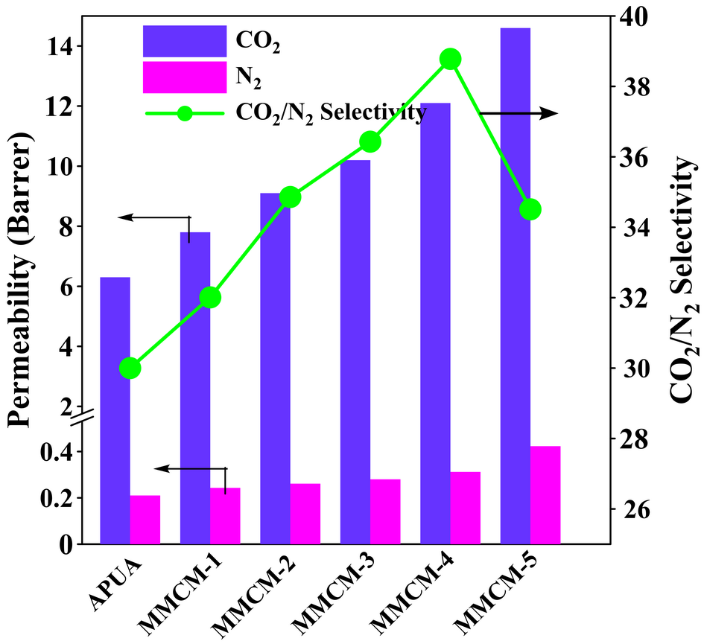

Fig. 6. Gas permeability and CO₂/N₂ selectivity of the MMCMs containing UiO-66.

Conclusion

In summary, mixed-matrix composite membranes (MMCMs) based on UV-curable acrylate polyurethane and UiO-66 nanoparticles as selective layer and polyester/polysulfone (PS/PSF) as support layer were prepared for the first time. The structure of prepared MMCMs was characterized with FTIR-ATR, XRD and FESEM analyses. The results obtained from FTIR-ATR analyses indicated that the micro-phase separation of hard and soft segments increased by increasing the amount of UiO-66 loading. Experimental gas permeation results showed that the permeability of both gases increased with increasing the UiO-66 loading which could be due to the increase of free volume of MMCMs by disruption of the APUA chain packing, introduced extra channels for gas permeation and increased the micro-phase separation between the hard and soft segments. Additionally, the ideal CO₂/N₂ selectivity increased with increasing the UiO-66 loading, which was attributed to the formation of a defect-free interface between two phases due to interaction between APUA matrix and UiO-66 nanoparticles.

References

[1] H. Molavi, F.A. Joukani, A. Shojaei, Ethylenediamine Grafting to Functionalized NH2–UiO-66 Using Green Aza-Michael Addition Reaction to Improve CO2/CH4 Adsorption Selectivity, Ind. Eng. Chem. Res. (2018).
[2] H. Molavi, A. Shojaei, S.A. Mousavi, Improving Mixed-Matrix Membrane Performance Via PMMA Grafting From Functionalized NH 2 -UiO-66, J. Mater. Chem. A. 6, 2018, 2775–2791.
[3] H. Molavi, A. Eskandari, A. Shojaei, S.A. Mousavi, Enhancing CO2/N2 adsorption selectivity via post-synthetic modification of NH2-UiO-66 (Zr), Microporous Mesoporous Mater. 257 (2018) 193–201. doi:10.1016/j.micromeso.2017.08.043.
[4] M. Fang, Z. He, T.C. Merkel, Y. Okamoto, High-performance perfluorodioxolane copolymer membranes for gas separation with tailored selectivity enhancement, J. Mater. Chem. A. (2018) 1–7.
[5] Z. Zhang, Z.-Z. Yao, S. Xiang, B. Chen, Perspective of microporous metal–organic frameworks for CO ₂ capture and separation, Energy Environ. Sci. 7 (2014) 2868.
[6] H. Mahdavi, L. Ahmadian-Alam, H. Molavi, Grafting of sulfonated monomer onto an amino-silane functionalized 2-aminoterephthalate metal-organic framework via surface-initiated redox polymerization: Proton-conducting solid electrolytes, Polym. Int. 64 (2015) 1578–1584.
[7] H. Molavi, A. Hakimian, A. Shojaei, M. Raeiszadeh, Selective dye adsorption by highly water stable metal-organic framework : long term stability analysis in aqueous media, Appl. Surf. Sci. 2018, 445, 424-436.
[8] J.B. DeCoste, G.W. Peterson, B.J. Schindler, K.L. Killops, M. a. Browe, J.J. Mahle, The effect of water adsorption on the structure of the carboxylate containing metal–organic frameworks Cu-BTC, Mg-MOF-74, and UiO-66, J. Mater. Chem. A. 1 (2013) 11922.
[9] M. Alishiri, A. Shojaei, M.J. Abdekhodaie, H. Yeganeh, Synthesis and characterization of biodegradable acrylated polyurethane based on poly(caprolactone) and 1,6-hexamethylene diisocyanate, Mater. Sci. Eng. C. 42 (2014) 763–773.
[10] M. Alishiri, A. Shojaei, M.J. Abdekhodaie, Biodegradable polyurethane acrylate/HEMA-grafted nanodiamond composites with bone regenerative potential applications: structure, mechanical properties and biocompatibility, RSC Adv. 6 (2016) 8743–8755.
[11] H. Molavi, M. Zamani, M. Aghajanzadeh, H. Kheiri Manjili, H. Danafar, A. Shojaei, Evaluation of UiO-66 metal organic framework as an effective sorbent for Curcumin’s overdose, Appl. Organomet. Chem. (2018) e4221. doi:10.1002/aoc.4221.
[12] M. Aghajanzadeh, M. Zamani, H. Molavi, H. Khieri Manjili, H. Danafar, A. Shojaei, Preparation of Metal–Organic Frameworks UiO-66 for Adsorptive Removal of Methotrexate from Aqueous Solution, J. Inorg. Organomet. Polym. Mater. 28 (2018) 177-186.
[13] N.M. Barkoula, B. Alcock, N.O. Cabrera, T. Peijs, Fatigue properties of highly oriented polypropylene tapes and all-polypropylene composites, Polym. Polym. Compos. 16 (2008) 101–113.
[14] Q. Song, S.K. Nataraj, M. V. Roussenova, J.C. Tan, D.J. Hughes, W. Li, P. Bourgoin, M.A. Alam, A.K. Cheetham, S. a. Al-Muhtaseb, E. Sivaniah, Zeolitic imidazolate framework (ZIF-8) based polymer nanocomposite membranes for gas separation, Energy Environ. Sci. 5 (2012) 8359.
[15] E.A. Feijani, A. Tavassoli, H. Mahdavi, H. Molavi, Effective gas separation through graphene oxide containing mixed matrix membranes, J. Appl. Polym. Sci. 46271 (2018) 1–11. doi:10.1002/app.46271.
[16] J. Shen, G. Liu, K. Huang, Q. Li, K. Guan, Y. Li, W. Jin, UiO-66-polyether block amide mixed matrix membranes for CO2 separation, J. Memb. Sci. 513 (2016) 155–165.
[17] R. Semino, J.C. Moreton, N. a. Ramsahye, S.M. Cohen, G. Maurin, Understanding the origins of metal–organic framework/polymer compatibility, Chem. Sci. (2018).
[18] H. Karimi, M. Bazgar Bajestani, S.A. Mousavi, R. Mokhtari Garakani, Polyamide membrane surface and bulk modification using humid environment as a new heat curing medium, J. Memb. Sci. 523 (2017) 129–137.
[19] C. Lv, L. Hu, Y. Yang, H. Li, C. Huang, X. Liu, Waterborne UV-curable polyurethane acrylate/silica nanocomposites for thermochromic coatings, RSC Adv. 5 (2015) 25730–25737.
[20] H. Zhu, L. Wang, X. Jie, D. Liu, Y. Cao, Improved Interfacial Affinity and CO2 Separation Performance of Asymmetric Mixed Matrix Membranes by Incorporating Postmodified MIL-53(Al), ACS Appl. Mater. Interfaces. 8 (2016) 22696–22704.

