Analysis of delamination evolution in multidirectional laminates under fatigue loading
M. Quaresimin, P.A. Carraro, L. Maragoni

¹Department of Management and Engineering, University of Padova, Str.lla S. Nicola, 3, Vicenza, Italy
Email: marino.quaresimin@unipd.it, paoloandrea.carraro@unipd.it , maragoni@gest.unipd.it

Keywords: Fatigue, delamination, transverse cracks, stiffness degradation, modelling

Abstract
In the present work the results of an extensive experimental investigation, aimed at studying the occurrence of matrix cracks and induced delaminations, are presented. Four different glass-epoxy lay-ups were tested under tensile-tensile fatigue loading and the damage progression was fully characterized.

- Introduction
Structural components made of composite materials are often subjected to cyclic loadings. This causes progressive damage which deteriorates the stiffness and leads, eventually, to the failure of the components. For some applications, a damage tolerant approach is preferable than just avoiding the formation of any kind of damage. Therefore it is essential to be able to model the entire damage process. This can be summarized as follows: the first part of the fatigue life is spent for the first crack initiation (N_{i,c}), then, after further cycles, crack multiplication and propagation occurs (N_{p,c}). After that, another portion of life is spent for the initiation (N_{i,d}) and the propagation of delaminations (N_{p,d}). Eventually the final failure occurs (N_{f}).
In the recent years, the authors are working in the characterisation and modelling of the fatigue damage evolution of composite laminates. Some of the works, mainly focused on the first stages of crack initiation, propagation and connected stiffness loss, can be found in [1- 5].
Another relevant damage mechanisms consists of delamination, often induced by the presence of off-axis cracks. In the literature, many experimental studies are devoted to the onset and growth of delaminations, but few focus of the development of delaminations starting from the transverse cracks.
An extensive investigation was performed by Johnson and Chang [6, 7], who analysed the different damage mechanisms involved in the failure process during quasi-static tensile tests of laminates characterized by different lay ups. Another study on the delamination growth induced by transverse cracks was performed by Hallett et al. [8], who carried out a series of tensile tests on quasi-isotropic laminates, monitoring the occurrence of these damage mechanisms. More recently, also Zubillaga and al. [9] investigated the initiation and growth of delaminations caused by the presence of transverse cracks, performing static tensile tests on five different carbon-epoxy lay-ups.
In this work, a brief summary of the results of an extensive experimental campaign of tension-tension fatigue tests are presented. These were carried out on glass/epoxy laminates characterized by four different lay-ups. The main aim is to describe the sequence of damage mechanisms and correlate it to the change of mechanical properties, focusing the attention on the onset and growth of delaminations induced by transverse cracks. This is meant as a necessary step towards understanding and modelling of the fatigue damage evolution in composite laminates.

- Material and methods

  - Materials
Laminates characterized by four different lay ups [0₂/90₄]_{s}, [0/90₂]_{s}, [0/45₂]_{s} and [0/45₂/-45₂]_{s} were manufactured by liquid resin infusion. The materials used were dry unidirectional glass fibres UT-E250 (250 g/m², Gurit) and the epoxy system EC157-W152LR (Elantas). The laminates were cured for three days at room temperature and then post-cured in an oven at 60°C for 12 hours. From these, specimens of 25 mm x 250mm were cut and polished, in order to ease microscopic observations of the damage evolution at the edges. Tabs were also applied at the ends of the specimens, reducing the gage length to 140 mm.

  - Test set-up
Tension-tension fatigue tests were conducted at room temperature with a sine waveform under load control, using a servo-hydraulic MTS 858 testing system, equipped with a 100 kN load cell.
All tests were carried out with a stress ratio of R=0.05. Two different frequency values were adopted, depending on the lay-up. Specimens obtained from the [0₂/90₄]_{s} and [0/90₂]_{s} laminates were tested with a frequency of 10 Hz while those obtained from [0/45₂]_{s} and [0/45₂/-45₂]_{s} laminates with a frequency of 4 Hz to avoid overheating.
Stress levels applied during the tests are reported in Table 1.

Stacking  sequence | Maximum laminate stress σ_{x}  [MPa]
[0₂/90₄]s | σ_{max}=140, 120, 100, 90,80, 70 MPa
[0/90₂]s | σ_{max}=120, 100, 90 MPa
[0/45₂/-45₂]s | σ_{max}=130,120 MPa
[0/45₂]s | σ_{max}=130,120, 110 MPa

Table 1 Stress levels adopted for each specimen configuration

Damage evolution during the test was carefully and extensively monitored through strain and stiffness measurement as well as photographic acquisitions of the specimen surface with back and frontal illumination. Optical microscopic observations on the specimen edges were also taken in some interrupted tests..

- Experimental results

During the tests, the Young's modulus and Poisson's ratio trends were measured, as macroscopic indicators of damage development occurring into specimens.
In all the tests, the first visible event of damage was the initiation of cracks in the off-axis layers, propagating along the fibres’ direction. Crack multiplication and propagation was quantified by calculated the “weighted crack density”, equal to the total crack length, divided by the observation area [5]. Then, the initiation of delamination was observed to occur slightly before the saturation of the crack density. The parameter “delamination ratio” was introduced in order to quantify the growth of this mechanism. This was defined as the ratio between the delaminated area and the area of the interface within the observation region.
Figs. 1 and 2 show the typical trend of weighted crack density, delamination ratio, Young's modulus and Poisson's ratio obtained for the [0/90₂]_{s} and [0/45₂]_{s} laminates. In both cases it is possible to conclude that most of the stiffness loss is due to the evolution of the off-axis cracks, the delaminations providing a minor contribution in this sense.

Figure 1: Normalized Young’s modulus, normalized Poisson’s ratio, weigthed crack density and delamination ratio for the fatigue test carried out with σ_{x}= 120 MPa [0/90₂]_{s}.

Figure 2 Normalized Young’s modulus, normalized Poisson’s ratio, weigthed crack density and delamination ratio for the fatigue test carried out with σ_{x}=120 MPa [0/45₂]_{s}

Fig.3 illustrates the stages of the damage development observed for a [0₂/90₄]_{s} laminate tested with a maximum stress of 90 MPa. The specimen ran out after 10⁶ cycles. In the figure, microscope images of the edges are compared with the pictures of the front side of the specimen.
It is evident that, as soon as the transverse crack reaches the interface, this induces the formation of a delamination in correspondence of the interface between the 0° and 90° plies. Then, the delamination propagates with the number of cycles and, as the delamination grows, some fibres of the 0° layers break in the proximity of the transverse crack and delamination tips.

(a) | 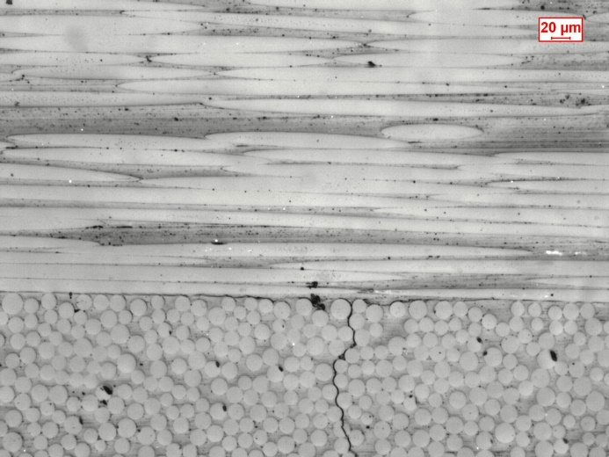  Matrix crack  Delamination
(b) | 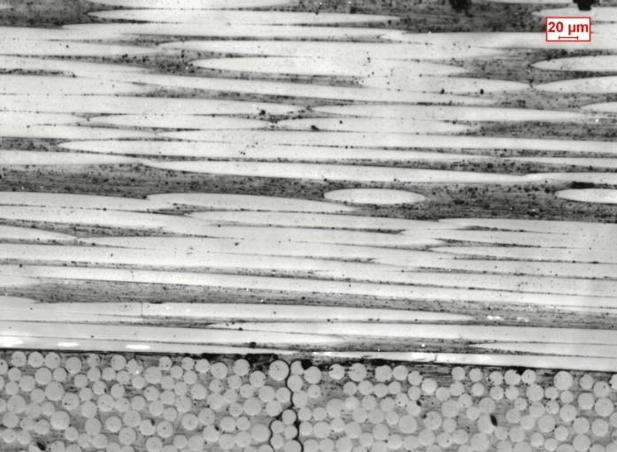  Delamination
(c) | 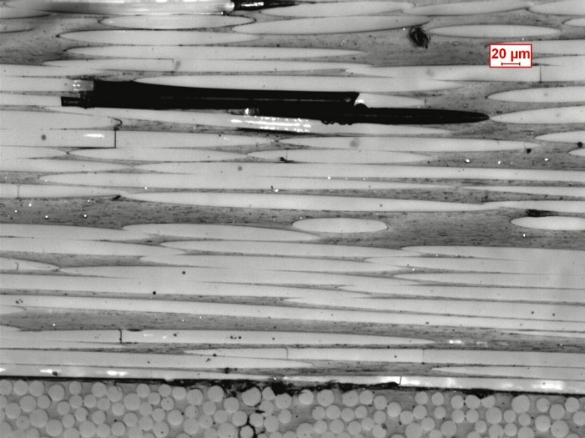  Fibre breaks

Figure 3: Damage development observed in [0₂/90₄]_{s} specimen fatigue tested with a σ_{x}=90 MPa. Images were taken respectively after a) 111 cycles, b) 3934 cycles and c) 165155 cycles.

Fig.4 illustrates the stages of the damage development observed for a [0/45₂/-45₂]s laminate tested with a maximum stress of 130 MPa, failed after 25000 cycles. Off-axis cracks were seen to develop through the thickness of both 45° and -45° plies. Then, delaminations formed both in correspondence of the interface 45°/-45° and the interface 0°/45°, even if with a minor extent. As delamination developed, fibre breaks were seen to form in the 0° ply, in the proximity of the delamination tips.

(a) | 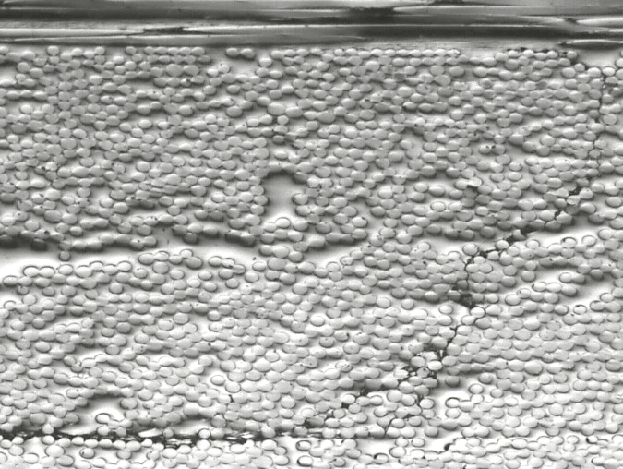  Delamination  Delamination  45° crack
(b) | 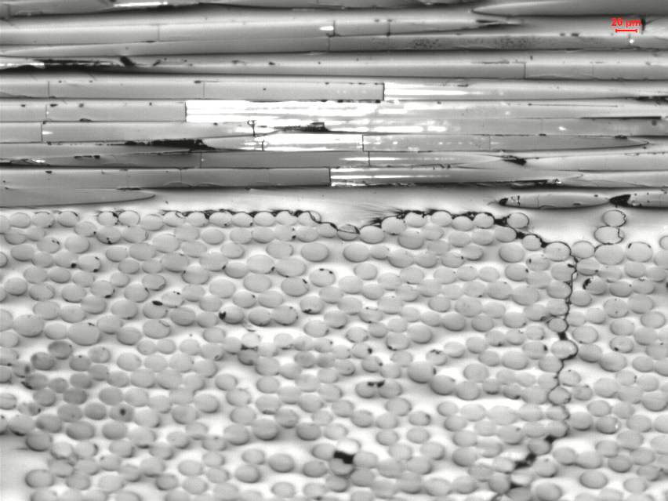  Delamination  Fibre breaks

Figure 4: Damage development observed in [0/45/-45]_{s} specimen fatigue tested with a σ_{x}=130 MPa (N_{f} = 25000). Images were taken respectively after a) 2818 cycles, b) 10322 cycles.

A disadvantage of the [0/45₂/-45₂]_{s} specimens is that the delaminations at the 45°/-45° interface are not visible from the images taken on the specimen surface. The [0/45₂]_{s} lay-up was then selected because of the presence of a reduced number of interfaces (just two between the 0° and 45° layers), which simplifies the visual identification of the delaminations. This lay-up is not balanced, so that there is coupling between the tensile stress and the in-plane shear deformation. The latter is not allowed in the tab region, and this alters the stress field with respect to that calculated with the classical lamination theory (CLT). FE analysis proved that this effect is however restricted to a maximum distance of 20 mm from the beginning of the end tabs. In the remaining part of the specimen the stress field is reasonably more uniform.
Damage development observed for [0/45₂]_{s} laminates is illustrated in Fig. 5, for a specimen tested with a maximum stress of 130 MPa, failed after 59000 cycles. First, 45° cracks form and develop through the thickness of the 45° ply, reaching the interface with the 0° ply. By increasing the number of cycles, delaminations grow along the interface, while fibre breaks start to occur in the 0° ply, in the proximity of the delamination tips.

(a) | 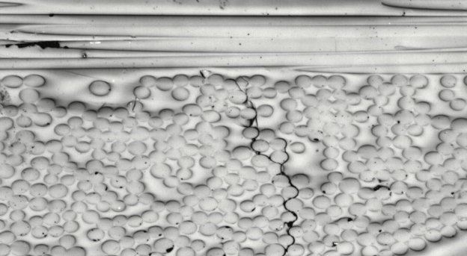  Matrix crack
(b) | 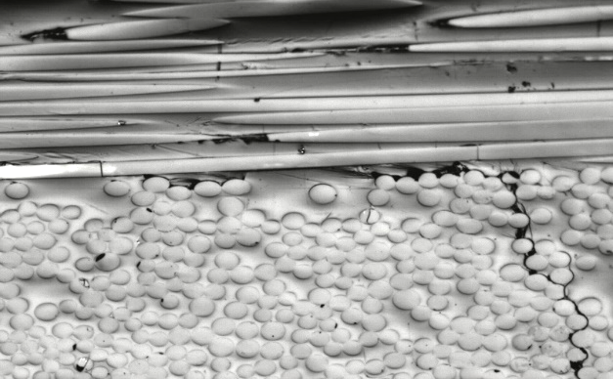  Fibre breaks

Figure 5: Damage development observed in [0/45₂]_{s} specimen fatigue tested with a σ_{x}=130 MPa (N_{f} = 59000). Images were taken respectively after a) 353 cycles, b) 1817 cycles.

- Conclusions
Composite laminates under fatigue loading are prone to different damage mechanisms, which initiate since the early stages of fatigue life, leading to the stiffness loss and eventually to the final failure. In order to develop models for a damage tolerant design approach, it is essential to understand the occurrence of the several damage mechanisms, which can be dependent on the materials adopted, the lay-up and the loading type and multiaxial conditions.
In this work, the preliminary results of an experimental investigation aimed at analyzing the occurrence and growth of damage were illustrated, with particular attention on the progression of delaminations induced by transverse cracks. Glass epoxy laminates characterized by four different lay-ups were manufactured and tested. By means of microscopy observations, the sequence of damage mechanisms and their effects on the mechanical properties were determined.

References
[1] M. Quaresimin, P.A Carraro, On the investigation of the biaxial fatigue behaviour of unidirectional composites, Composites Part B: Engineering, 54, 2013, pp. 200-208.
[2] M. Quaresimin, P.A. Carraro, Damage initiation and evolution in glass/epoxy tubes subjected to combined tension-torsion fatigue loading, International Journal of Fatigue, 63, 2014, 25–35.
[3] M. Quaresimin, P.A. Carraro, L. Maragoni, Early stage damage in off-axis plies under fatigue loading, Composites Science and Technology, 128, 2016, pp. 147-154.
[4] P.A. Carraro, M. Quaresimin, A damage based model for crack initiation in unidirectional composites under multiaxial cyclic loading, Composites Science and Technology, 99, 2014, pp. 154–163.
[5] L. Maragoni, P.A. Carraro, M. Peron, M. Quaresimin, Fatigue behaviour of glass/epoxy laminates in the presence of voids, International Journal of Fatigue, 95, 2017, pp. 18–28.
[6] P. Johnson, F. Chang, Characterization of matrix crack induced failure – Part I: Experiments. Journal of Composite Materials, 35(22), 2001, pp.2009–2035.
[7] P. Johnson, F. Chang, Characterization of matrix crack induced failure – Part II: Analysis and Verifications. Journal of Composite Materials, 35(22), 2001, pp.2037–2074.
[8] S.R. Hallett, W.G. Jiang, B. Khan, M.R. Wisnom, Modelling the interaction between matrix cracks and delamination damage in scaled quasi-isotropic specimens, Composites Science and Technology, 68.1, 2008, pp. 80-89.
[9] L. Zubillaga, A. Turon, J. Renart, J. Costa, P. Linde, An experimental study on matrix crack induced delamination in composite laminates, Composite Structures, 127, 2015, pp. 10-17.

