The effect of organic nano-particles on the hydrothermal ageing of nanoclay-epoxy nanocomposites. A parametric study.
D. Tsimourtos, E. Kollia, C. Kostagiannakopoulou, V. Kostopoulos*
Applied Mechanics Laboratory, Department of Mechanical Engineering and Aeronautics,
University of Patras University Campus, 26500, Patras, Greece

* Corresponding author, e-mail address: kostopoulos@upatras.gr
ABSTRACT
During the last decades, nanoparticles reinforces polymers, called nano-composites, have attracted significant interest by the scientific community and the industry since they provide a new class of lightweight materials with increased properties, even at low nanoparticle content. Specifically, concerning the hydrothermal ageing, nano-fillers usually act as effective barriers against transport of water through the polymers, thus efficiently preventing the deterioration of their physical and mechanical properties, when the polymers are exposed to hydrothermal operating environment.
The main objective of this study is to investigate the thermo-mechanical, mechanical, fracture and thermal properties of an epoxy system (LY 556 supplied by Huntsman, Switzerland), doped with two different types of Nanoclays (Cloisite 30B and Garamite 1958, both provided by Rockwood additives (UK), at three different loading percentages (5, 10, and 15 wt%), after their exposure to hydrothermal environment (distilled water at temperature of 80°C).
Nano-modified suspensions was prepared by using 3 roll-milling technique. Then reference and nano-composite specimens were fabricated and cured using autoclave, according to the resin manufacturer recommended curing cycle, and post-cured for 24h at 50ºC. Tensile (ISO 527-1), three-point bending (ISO 178) tests, Charpy impact and thermal conductivity test were performed for characterizing the materials prior of its exposure to hydrothermal aging.
In parallel, a complete set of specimens from each batch of materials was placed in an environmentally control bath, in distilled water, at 80ºC.
Water gain versus time curves were produced based on weight gain measurements performed at different time intervals until saturation. Furthermore, when saturation was reached, the samples was carefully dried and tested, following the testing protocol as in the case prior of hydrothermal aging, in order to estimate the effect of aging on the properties of the reference and on the different batches of nanoclays modified resin.
In summary, the most significant results are:
- the thermal conductivity of the reference material was increased by the addition of nanoclays.
- At low %wt contents of nanoclay improvement of the mechanical properties of nano-composites was observed.
- The addition of nanoclays into the resin material reduces the water uptake of the resin and prevents the degradation of its mechanical performance after hydrothermal aging.
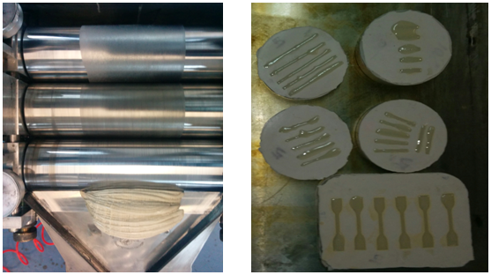
Figure 1: 3 roll-milling technique and specimens molding process.

