development of a closed-loop recycling process for highly aligned discontinuous carbon fibre thermoplastic composites

Rhys J. Tapper*, Marco L. Longana, HaNa Yu#, Ian Hamerton, Kevin D. Potter

Bristol Composites Institute (ACCIS), School of Civil, Aerospace and Mechanical Engineering, Queen’s Building, University of Bristol, University Walk, Bristol, BS8 1TR, United Kingdom

www.bristol.ac.uk/composites

* Corresponding author. Email: r.tapper@bristol.ac.uk

# Present address: Department of Mechanical Engineering, University of Bath, North Road, Bath, BA2 7AY, United Kingdom

Keywords: Recycling; Polymer-matrix composites (PMCs); Compression moulding; Discontinuous reinforcement.

Abstract

In this study the effects of a closed-loop recycling methodology are evaluated for degradation using thermoplastic ocmposites based on discontinuous fibres. The process comprises two fundamental steps: reclamation and remanufacture. The material properties are analysed over two recycling loops. Carbon fibre reinforced polypropylene (CFPP) specimens show no decrease in mechanical properties over repeated recycling loops, the final specimens show an increase of 26 % and 43 % in ultimate tensile strength and ultimate strain, respectively. These are attributed to cumulative matrix residue on the fibre surface after reclamation and subsequently increased fibre-matrix adhesion. The improvement of CFPP properties validate the potential of this proof-of-concept, closed-loop recyclable material. Future studies will investigate alternative, higher performance matrices.

Introduction
The market share of carbon fibre reinforced polymer composites (CFRP) in the automotive industry is predicted to grow as the high-volume manufacture sector starts to adopt CFRP as a lightweighting strategy [1]. Vehicle fuel emissions are heavily regulated, US Corporate Average Fuel Economy standards will limit passenger vehicle emissions to 35 mpg by 2020 [2] and the European Commission has set a target of 57.9 mpg by 2021 [3]. To meet these, and inevitably more stringent future targets, automakers are looking at CFRP to save weight as a method of increasing fuel efficiency. Decreasing vehicle fuel emissions can be achieved by structural lightweighting; a 6-8 % increase in fuel economy can be achieved by a 10 % drop in vehicle weight [4]. The growth of CFRP applications will be accompanied by a global increase in CFRP waste. CFRP waste comes from a variety of sources: testing materials from research and design, manufacturing scrap and end-of-life (EOL) parts [5]; EOL components make up 60 % of all waste composites [6]. Industries which rely on high-volume manufacture will be significantly deterred by the waste burden as many countries already penalise heavily for landfilled waste, on top of landfill tax rates (£84.40 per tonne, excluding gate fees, as of 1st April 2016) [7]. In fact, some EU countries have already banned landfilling; the most common form of waste management for CFRP [8]. Some industries can also be penalised for the lack of recyclable components in their products. The EOL vehicle directive (ELV, 2000/53/EC) states that as of January 2015, 95 % of a passenger vehicles mass must be reused, recycled or recovered [9].

The development of recyclable composites, and processes with which to recycle them, are therefore becoming of greater interest. The term recycling here describes the reclamation of constituents from waste composites and their remanufacture into useful components. Reclaimed carbon fibres (rCFs) can be a fraction of the cost of virgin CFs (vCFs) and therefore the subsequent rCFRP will be at a reduced cost [10]. In the last ten years there have been three comprehensive reviews of the available technologies and future outlook: Pickering in 2006 [11], Pimenta & Pinho et al. in 2011 [12] and Oliveux et al. in 2015 [13].

Separating composites into their high-value constituents is a fundamental component of composite recycling methodologies. Only pyrolysis and solvolysis methods are able to reclaim carbon fibres; in some cases property reclamation is up to 95 % of the virgin tensile stiffness and strength [10,12]. These technologies are already at an industrially applicable level and reclaimed carbon fibres (rCFs are currently produced in thousands of tonnes [10]. The major barrier to the widespread use of rCFs in high-value applications is the lack of industrial scale alignment processes that can provide composites with high volume fractions (50-60 % V_{f}) necessary to provide the mechanical performance expected of high value composites [14]. The technology for the recycling of CFs and their remanufacture into high-value components already exists. The current issue is that thermosetting matrices cannot be reclaimed and there is currently a lack of industrially available technologies that can reclaim thermoplastic matrices along with CFs, into a high-value component. As approximately 50 % of a composite is matrix by volume, recycling of waste matrix material from high value applications is a relatively uncharted area of research.

Thermoplastics offer a unique opportunity for recycling as the molecular structure can be temporarily separated using heat or solvent treatment. Melt processing has been utilised for the recycling of thermoplastic composites for many years [15]. The problem with this method is that the mechanical performance of the recyclate is significantly reduced due to high temperatures and shear forces required for extrusion, breaking down fibres and causing matrix degradation [16–24].

Recycling Methodology
This section details the development of a two-step (reclamation and remanufacture) closed-loop recycling methodology, as outlined in Figure 1. A process can be deemed closed-loop if, once all the initiator material has been added, it requires no additional material to propagate [25]. Closed-loop processes for composites manufacturing and recycling are in accordance with the Circular Economy paradigm presented by the Ellen MacArthur foundation [26] and encouraged by the UK Composite Strategy (2016) [9] for new materials.

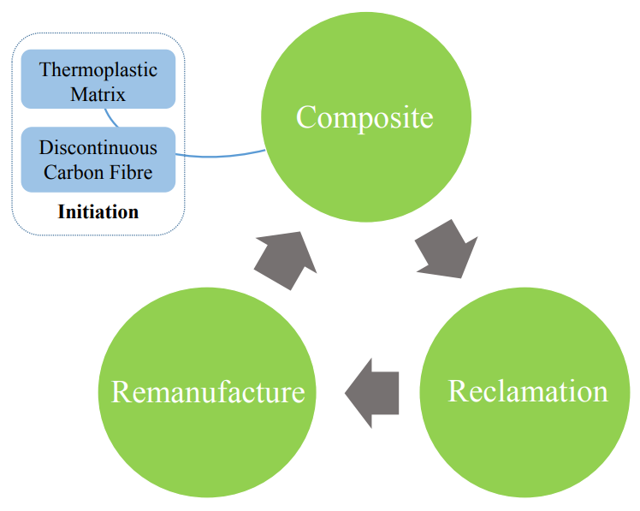

Figure 1. The closed-loop methodology in brief; post initiation the cycle requires no additional material to propagate.

Discontinuous (3 mm) carbon fibres and polypropylene (PP) were selected as constituents due to their processing advantages and intrinsic recyclability. 3 mm long fibres are the optimum length for alignment using the HiPerDiF alignment process, are less prone to breakages than long fibres and are similar in form to rCFs [27]. This combination of materials provides low cost, high-volume parts, with a slight increase in mechanical properties.

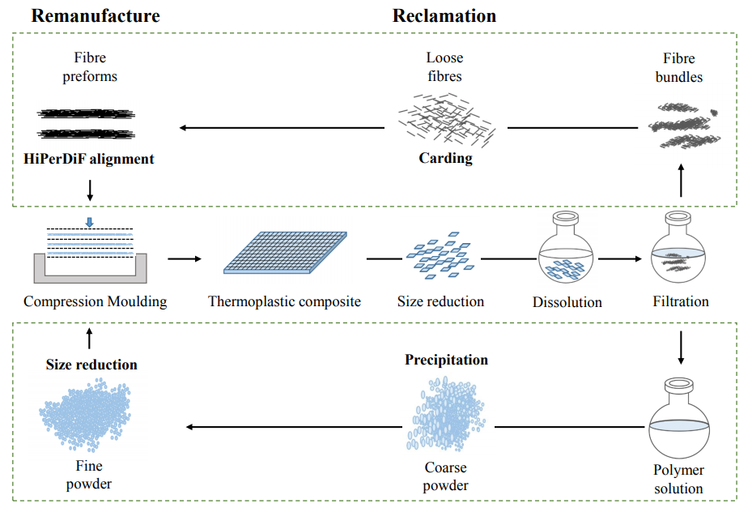

Figure 2. A flow chart outlining the experimental detail of the closed-loop methodology, highlighting the reclamation and remanufacturing processes.

In general, the methodology can be started, arbitrarily, with an initial EOL CF thermoplastic which is washed, shredded and separated into its constituent fibres and matrix. Reclamation consists of matrix dissolution and fibre filtration after this each constituent follows a separate reclamation path, indicated by the hashed boxes in Figure 2. CFPP specimens were shredded and dissolved in xylene at 120 ºC under reflux forming a fibre suspension in a low viscosity polymer solution. Fibres were filtered from the solution, washed, dried in a vacuum oven, then carded by hand to separate fibre bundles and aligned using the HiPerDiF method to produce highly aligned dry fibre preforms. PP was precipitated from solution using a non-solvent, isolated by vacuum filtration, washed and dried. Grain size of the precipitate varied significantly at this stage so mechanical size reduction was used to increase the surface area and homogenise grain size.

Remanufacturing involves the alignment of random fibres into preforms, stacking with reclaimed polymer and compression moulding to form a new specimen. Preforms were stacked in an aluminium tool along with alternating recycled PP precipitate layers producing specimens with 26 % CF fibre volume fraction (Vf_{F}). For the development of a proof-of-concept material, the absolute mechanical performances were of secondary importance, therefore this Vf_{F} has been selected to guarantee maximum fibre impregnation. In future works the impregnation and fibre wet-out will be optimised by increasing matrix melt flow and decreasing melt path lengths to achieve higher volume fractions, and consequently higher mechanical properties.

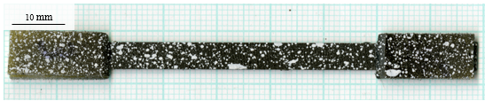

Figure 3. High resolution scan of a CFPP specimen prepared for tensile testing with end tabs and speckle pattern used for video gauge strain measurement.

Material characterisation
CFPP specimens were tested for their tensile properties in accordance with ASTM D3039. Fibre length distribution (FLD) analysis was used to determine the effect of recycling on the average fibre length. Sacnning electron microscopy (SEM) was used to image fibre surfaces.

Results and Discussion
For the FLD an error of ± 0.2 mm was applied for the measurement of fibres using the naked eye. In the vCFPP preform sample 74 % of fibres are in the range of 2.8-3.4 mm, see Figure 4; a similar value to that obtained in other studies involving 3 mm carbon fibres and the HiPerDiF alignment method [30]. After the first recycling loop 42 % of fibres are in the range 2.8-3.4 mm. A combination of the fibre carding and alignment stages could be causing fibre breakages. For r₂CFPP the FLD was evenly distributed with 0.8-0.1 mm, 1.4-1.6 mm and 3.2-3.4 mm having the maximum 9 % of the distribution each.

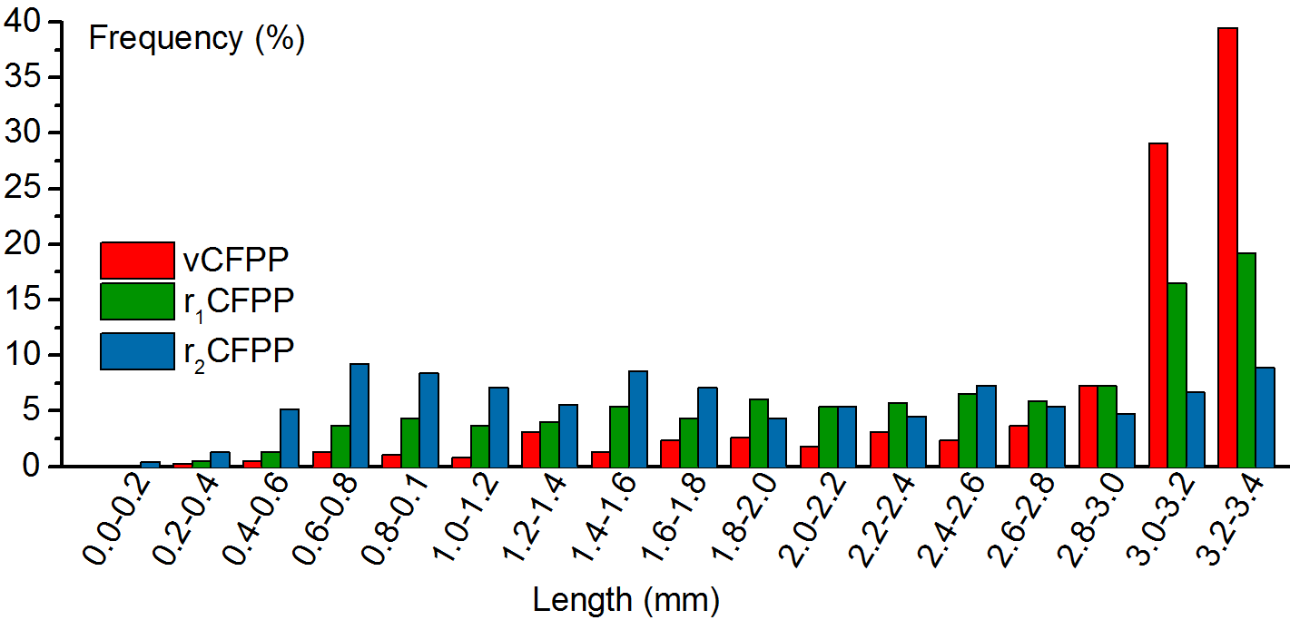

Figure 4. Fibre length distributions of vCFPP, r₁CFPP and r₂CFPP showing percentages of fibres in effective fibre range.

Representative stress-strain curves obtained from tensile tests of vCFPP to r₂CFPP specimens are shown in Figure 5a. Tensile specimens exhibited a typical linear-elastic response followed by brittle fracture, some showing a region of increased compliance just before failure. The vCFPP and r₁CFPP failure mechanism is dominated by fibre pull-out however there is a significant decrease in the amount of fibre pull-out observed at the r₂CFPP fracture surfaces.

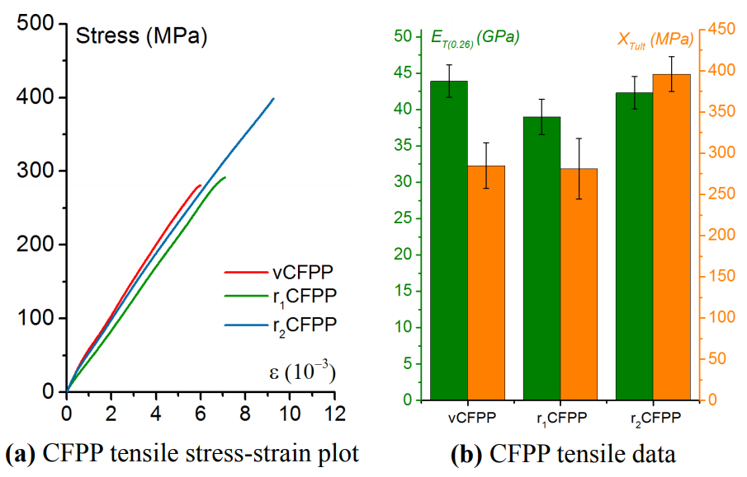

Figure 5. a) Stress-strain curves for CFPP specimens after each loop. b) Bar chart comparing the tensile stiffness (normalised to 26 % Vf_{F}) and ultimate tensile strength of CFPP after each recycling loop.

Vf_{F,} tensile stiffness (E_{T}), ultimate tensile strength (X_{Tult}) and ultimate tensile strain (ε_{Tult}) values are presented in Table 1. The Vf_{F} values are averaged over six specimens, the tensile stiffness E_{T0.26}, describes the average tensile stiffness normalised to a 26 % fibre volume fraction, following the rule of mixtures.

 | E_{T} | Vf_{F} | E_{T} (0.26) | e_{Tult} | X_{Tult} | ρ
 | GPa | % | MPa | % | MPa | g cm⁻¹
vCFPP | 44.0 (5.0)* | 26.2 (8.4) | 43.9 (5.1) | 0.69 (12) | 285 (9.7) | 1.00 (2.6)
r₁CFPP | 39.2 (6.0) | 26.2 (4.6) | 39.0 (5.5) | 0.70 (8.8) | 281 (13) | 1.00 (2.5)
r₂CFPP | 42.8 (5.6) | 26.3 (3.6) | 42.3 (5.1) | 0.99 (4.4) | 396 (5.4) | 1.00 (4.3)
* Coefficient of variance

Table 1. The mechanical performance of CFPP specimens after each recycling iteration.

Overall, the plots show a slight variation in E_{T0.26} between recycling iterations, a decrease after the first followed by an increase after the second iteration. The drop in E_{T0.26} between vCFPP and r₁CFPP can be attributed to fibre breakage during recycling and the increase in the frequency of fibres less than the distance between the alignment plates, d, in the HiPerDiF alignment head. The drop in E_{T0.26} is not as significant as expected, following the conclusions made by Longana et al. [30]. This is due to the decrease in d during HiPerDiF maintenance and optimisation in between studies. Kruskall-Wallis analysis suggests that statistically there is no change in the X_{Tult} and ε_{Tult} between vCFPP and r₁CFPP. As the FLD data show further fibre breakage between r₁CFPP and r₂CFPP it is expected that the stiffness will further decrease as more fibres will be formed with length < d and thus alignment will be reduced. However, an increase in X_{Tult} and ε_{Tult} is recorded after the second recycling iteration, E_{T0.26} remains statistically unchanged.

The SEM micrographs reveal that PP residue is deposited, cumulatively, on fibres after recycling, acting as a form of sizing that increases the adhesion between the fibre and matrix, this is shown in Figure 6. This results in an IFSS increase and is observed as an increase in X_{Tult} and in less pull-out dominated failure. l_{c} is inversely proportional to IFSS, which means that even if the fibre length is slightly reduced through recycling it will remain above the critical length. This also results in increased specimen extension under loading, ε_{Tult}, as the matrix plastic limit is reached before the fibre pull-out strength.

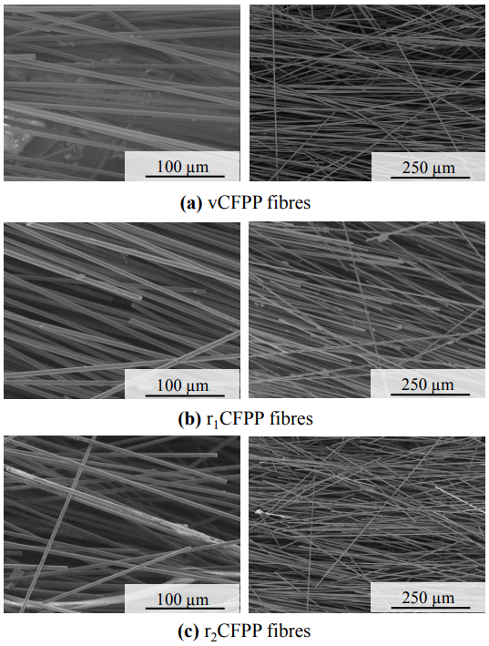

Figure 6. SEM micrographs for; a) vCFPP, b) r₁CFPP and c) r₂CFPP.

The pull-out dominated failure of vCFPP and r₁CFPP can be attributed to the poor adhesion between the surface of carbon fibre and the alipahtic, non-polar polypropylene chains. The deposition of PP on fibres act as a sizing providing a region of increased adhesion at the interface, improving overall fibre-matrix adhesion.

Conclusion
The aim of this study was to develop a closed-loop recyclable composite material and a relative recycling methodology that can produce a high-performance material after multiple loops. CFPP specimens showed no reduction in mechanical performance but an overall increase in tensile stiffness, ultimate tensile strength and ultimate strain after multiple loops. Future work will incorporate a matrix with a higher mechanical performance and thus a more realistic option for the automotive market. CF-polyamide combinations are becoming a material of choice for modern automotive components. The deposition of matrix on the surface of fibres is of interest as it negates the need for an additional sizing step whilst providing an exact matrix specific sizing; the potential for tailorable in-situ sizing therefore be the topic of future investigation. Subsequent studies will therefore focus on the following issues to develop the methodology closer to complete its initial aim of developing a closed-loop recycling process for a competitive, high-performance composite: 1) repeat this study to develop carbon fibre polyamide composite material 2) evaluation of residual matrix performance as a sizing and 3) a comprehensive life cycle analysis of the recycling methodology and a comparison with current reclamation and remanufacturing processes.

References
[1] UK Department for Business Innovation and Skills. The UK Composites Strategy. Innovation 2009:1–36.
[2] Stewart R. Lightweighting the automotive market. Reinf Plast 2009. doi:10.1016/S0034-3617(09)70109-2.
[3] Kodjak D. Policies to Reduce Fuel Consumption, Air Pollution and Carbon Emissions from Vehicles in G20 Nations. 2015.
[4] Vaidya U. Composites for Automotive, Truck and Mass Transit. DEStech publications; 2011.
[5] Panesar S. Converting composite waste into high quality reusable carbon fibre. JEC Compost., Paris, France: 2009.
[6] Halliwell S. End of Life Options for Composite Waste Recycle , Reuse or Dispose ? National Composites Network Best Practice Guide. Natl Compos Netw 2006:1–41.
[7] Job S, Leeke G, Mativenga PT, Oliveux G, Pickering S, Shuaib NA. Composites Recycling: Where are we now? 2016.
[8] Job S. Composite Recycling - summary of recent research and development. 2010.
[9] Composites UK. End-of-Life Solutions for FRP Composites. 2015.
[10] Barnes F. Commercial Aspects of Carbon Fibre Recycling. Go Carbon Fibre Recycl., Manchester: 2015.
[11] Pickering SJ. Recycling technologies for thermoset composite materials—current status. Compos Part A Appl Sci Manuf 2006;37:1206–15. doi:10.1016/j.compositesa.2005.05.030.
[12] Pimenta S, Pinho ST. Recycling carbon fibre reinforced polymers for structural applications: Technology review and market outlook. Waste Manag 2011;31:378–92. doi:10.1016/j.wasman.2010.09.019.
[13] Oliveux G, Dandy LO, Leeke G a. Current Status of Recycling of Fibre Reinforced Polymers: review of technologies, reuse and resulting properties. Prog Mater Sci 2015;72:61–99. doi:10.1016/j.pmatsci.2015.01.004.
[14] Job S, Leeke G, Mativenga PT, Oliveux G, Pickering S, Shuaib NA. COMPOSITES RECYCLING : Where are we now ? 2016:11.
[15] La Mantia F, Gaztelumendi M, Eguiazabal J, Nazabal J. Properties - Reprocessing Behaviour of Recycled Plastics. Handb. Plast. Recycl. 1st ed., Rapra; 2002, p. 127–94.
[16] Steenkamer DA, Sullivan JL. On the recyclability of a cyclic thermoplastic composite material. Compos Part B Eng 1998;29:745–52. doi:10.1016/S1359-8368(98)00016-X.
[17] Eriksson P-A, Boydell P, Eriksson K, Manson J-AE, Albertsson A-C. Effect of thermal-oxidative aging on mechanical, chemical, and thermal properties of recycled polyamide 66. J Appl Polym Sci 1997;65:1619–30. doi:10.1002/(SICI)1097-4628(19970822)65:8<1619::AID-APP18>3.0.CO;2-Q.
[18] Eriksson P-A, Albertsson A-C, Boydell P, Eriksson K, Månson J-AE. Reprocessing of fiberglass reinforced polyamide 66: Influence on short term properties. Polym Compos 1996;17:823–9. doi:10.1002/pc.10675.
[19] Yang HWH, Farris R, Chien JCW. Study of the effect of regrinding on the cumulative damage to the mechanical properties of fiber-reinforced nylon 66. J Appl Polym Sci 1979;23:3375–82. doi:10.1002/app.1979.070231121.
[20] Yin S, Tuladhar R, Shi F, Shanks RA, Combe M, Collister T. Mechanical reprocessing of polyolefin waste: A review. Polym Eng Sci 2015;55:2899–909. doi:10.1002/pen.24182.
[21] Hamad K, Kaseem M, Deri F. Recycling of waste from polymer materials: An overview of the recent works. Polym Degrad Stab 2013;98:2801–12. doi:10.1016/j.polymdegradstab.2013.09.025.
[22] Meran C, Ozturk O, Yuksel M. Examination of the possibility of recycling and utilizing recycled polyethylene and polypropylene. Mater Des 2008;29:701–5. doi:10.1016/j.matdes.2007.02.007.
[23] Da Costa HM, Ramos VD, Rocha MCG. Rheological properties of polypropylene during multiple extrusion. Polym Test 2005;24:86–93. doi:10.1016/j.polymertesting.2004.06.006.
[24] Abbas K. Reprocessing of Thermoplastics. II. Polycarbonate. Polym Eng Sci 1980;20.
[25] Hazell J. Developing a circular economy for novel materials. 2017.
[26] Ellen MacArthur Foundation. Towards the Circular Economy Vol. 1 - An economic and business rationale for an accelerated transition. 2013.
[27] Yu H, Potter KD. Discontinuous fibre alignment method, High Performance-Discontinuous Fibre (HiPerDiF) Method. 1306762.4, 2014.
[28] Achilias DS, Roupakias C, Megalokonomos P, Lappas AA, Antonakou V. Chemical recycling of plastic wastes made from polyethylene (LDPE and HDPE) and polypropylene (PP). J Hazard Mater 2007;149:536–42. doi:10.1016/j.jhazmat.2007.06.076.
[29] Poulakis JG, Papaspyrides CD. Recycling of polypropylene by the dissolution/reprecipitation technique: I. A model study. Resour Conserv Recycl 1997;20:31–41. doi:10.1016/S0921-3449(97)01196-8.
[30] Longana ML. Multiple Closed Loop Recycling of Carbon Fibre Composites with the HiPerDiF (High Performance Discontinuous Fibre) Method. Compos Struct 2016;153:271–7. doi:10.1016/j.compstruct.2016.06.018.
[31] Yu H, Longana ML, Grail G, Pimenta S, Robinson P, Wisnom MR, et al. Aligned Short Fibre Composites With Nonlinear Behaviour. ICCM 20, 2015, p. 19–24.

