Impact and hardness optimisation of cellulose fibre-reinforced PLA/PP composites inspired by the babassu nut pericarp (Orbignya speciosa)

N. Graupner¹, G. Staufenberg¹ and J. Müssig¹

¹ The Biological Materials Group, Faculty 5, Biomimetics, HSB – City University of Applied Sciences Bremen, Neustadtswall 30, D-28199 Bremen, Germany
Email: nina.graupner@hs-bremen.de, Web Page: http://www.hs-bremen.de/internet/de/index.html
Email: jmuessig@bionik.hs-bremen.de, Web Page: http://www.hs-bremen.de/internet/de/index.html

Keywords: bio-inspired fibre-reinforced composites, layered composite, impact strength, regenerated cellulose fibre, polylactide (PLA)

Abstract
The pericarp from the fruit of the babassu palm Orbignya speciosa provides a good combination of hardness and impact strength which is difficult to achieve in artificial materials, making the babassu nut pericarp a promising source for bio-inspiration. Unnotched Charpy impact tests, Shore D hardness tests and scanning electron microscopy were used for mechanical and morphological analysis of the pericarp. Four major principles of the pericarp were found: (i) a hard core (endocarp) is embedded in (ii) a soft outer layer of high impact strength (epicarp) and (iii) is reinforced with fibre bundles of variable fineness (diameter ~100 and ~300 µm), (iv) some of which are oriented radial to the core. Bio-inspired fibre-reinforced composites were produced using abstracted mechanisms of the babassu nut pericarp based on two different matrices: stiff and brittle polylactide (PLA) as a core matrix and soft and ductile polypropylene (PP) used as outer layers. Both polymer materials were reinforced with regenerated cellulose fibres (lyocell) with two different diameters (11 and 36 µm). The bio-inspired composite reached a significantly higher impact strength which is 62% higher than the reference sample produced from the same materials as a mixture. The tensile strength was not negatively affected by the layer arrangement. At the same time the hardness is increased by 8% compared to the PP reference sample. The bio-inspired composite has shown similar fracture mechanisms as compared to the natural role model.

1. Introduction
Due to increasing environmental awareness and shortage of petrochemical resources, the consumption of natural fibres especially for use in composites has increased significantly in recent years. A study by Grand View Research [1] predicts nearly a tripling of market yields of natural fibre-reinforced plastics in Europe from 2013 to 2024. The natural fibres used are often bast fibre bundles which have a high strength and stiffness, but a low toughness due to their function in nature. Therefore, the components made from bast fibres often have a low impact strength, which may be a limiting factor for use in impact-stressed components [2;3]. The investigations of the babassu nut pericarp have shown that it combines high hardness with high toughness – a combination of properties that is often difficult to achieve in engineering materials [4;5;6;7]. For this reason, the pericarp of the babassu nut was analysed in more detail and was transferred in abstracted form to a bio-inspired fibre-reinforced and bio-based composite.

2. Materials & methods
For the analysis of the babassu nut pericarp, six fruits of the Babassu palm (Orbignya speciosa) were supplied by Consulting Service Plants (Dresden, DE). The pericarp of the Babassu nuts (Figure 1, left) was cut in the longitudinal direction into strips of a width of 10 mm for mechanical and morphological examination (Figure 1, right). The kernels were removed. The average length of the specimens was 79 mm. Before the mechanical investigations samples were stored for at least 18 h in the normal climate at 23 °C and 50% relative humidity. Fracture surfaces from the Charpy impact tests were morphologically analsed by Scanning Electron Microscopy (SEM).
On the basis of identified characteristics and principles of the babassu nut pericarp these principles were transferred to technical composites. Two different matrices in fibre form [polylactide (PLA) and polypropylene (PP)] and regenerated cellulose fibres (lyocell) with two different diameters of 11 μm (1.3 dtex) and 36 μm (15.0 dtex) were used. The composites were produced with a fibre mass fraction of 30% via compression moulding. The bio-inspired composite was made from a layer of lyocell/PP as the outer layer and lyocell/PLA as the core layer. In addition to the bio-inspired materials, reference samples were produced consisting only of lyocell/PLA or lyocell/PP, and a homogeneous mixture of lyocell/PP/PLA. The characterisation of the composites was done with impact, tensile and Shore D hardness tests. A detailed description of the methods can be found in [6].

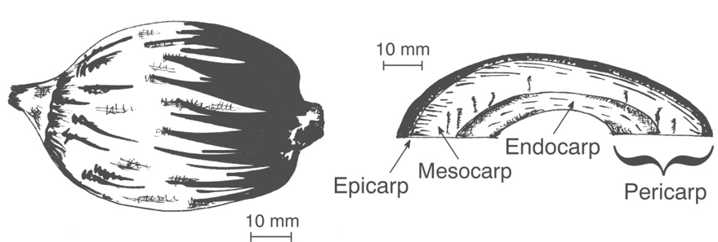

Figure 1. Babassu nut in longitudinal view (left) and cross section through the pericarp (right) [7].

3. Results and discussion
The results of the Shore D hardness of the individual structures of the babassu nut pericarp show an increasing hardness from the epicarp to the endocarp, with the mesocarp showing the lowest value (see Figure 2A). The mesocarp serves primarily as a nutrient, and is in contrast to epicarp and endocarp not interspersed with fibre bundles. During the preparation it was found that the mesocarp could not be prepared as a separate structure due to its brittle character and was therefore not be tested with Charpy impact tests. In comparison to the Shore D hardness, the results of the impact strength show a reverse trend: the toughness decreases from the epicarp to the endocarp (Figure 2B). The overall pericarp structure resulted in values between those of epicarp and endocarp (Figure 2B).
SEM was used to analyse fracture surfaces from the Charpy impact tests in more detail. Figure 2C (center) shows a typical failure mode of a pericarp sample. It can be seen that the sample has considerable delaminations, fibre pull-outs and crack branches. These mechanisms result in efficient energy absorption under impact stress. The delaminated layer of the epicarp shows fibre bundles of two different diameters (Figure 2C, top left), while the mesocarp contains no fibre bundles (Figure 2C, top right). The latter serves as nutrient; starch granules are clearly visible. In the layer between the mesocarp and the endocarp fibres of two different diameters are embedded similar as in the epicarp. However, these are not aligned along the pericarp; the orientation was in a three-dimensional arrangement (Figure 2C, bottom left). Compared to the epicarp, the endocarp shows a smooth fracture surface, which indicates a more brittle failure and could also be confirmed by the results of the Charpy impact resistance.
The structure of the babassu nut pericarp can be described as follows:
- A hard and brittle core is reinforced with fibre bundles of two different diameters, which are aligned in the direction of the pericarp.
- A layer reinforced with fibres in random fibre orientation is located between mesocarp and endocarp.
- The epicarp has a lower toughness and a higher hardness than the endocarp, and is reinforced with fibre bundles of two different diameters aligned along the pericarp.
This structure was transferred in an abstracted form to a layered bio-inspired fibre-reinforced composite. Since the mesocarp displays brittle properties and low hardness, it has not been considered in the technical composite. Figure 3A shows the symmetrical layer arrangement of the bio-inspired composite. Similar to the model of the pericarp, softer and tougher outer layers of lyocell/PP are surrounding a harder and more brittle core of lyocell/PLA. Between core and outer layers a thin layer of lyocell/PLA was arranged with random fibre orientation. For the production of the various layers the matrices (PLA and PP) and lyocell fibres, having a fineness of 1.3 and 15.0 dtex, were mixed by means of a carding process. The fibres are predominantly oriented in the production direction. For the layers with random fibre orientation, a needling process was used to orientate some fibres in z-direction. The different layers were stacked and processed with a hot compression moulding process. As reference samples plates of lyocell/PLA, lyocell/PP and a homogeneous mixture of lyocell/PLA/PP were prepared. The test specimens for the mechanical examinations were produced from the plates (see [6] for more detailed information). The analyses were performed analogous to that of the pericarp and tensile tests were carried out additionally.
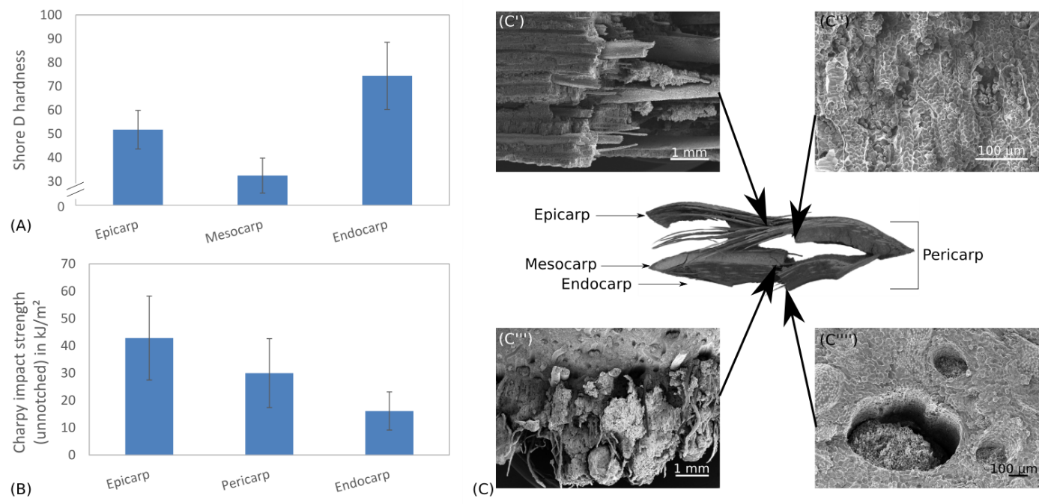
Figure 2. A) Shore D hardness of the different babassu nut structures (epicarp, mesocarp and endocarp); B) Unnotched Charpy impact strength of babassu nut structures (epicarp and endocarp) as well as the whole pericarp structure; C) Fracture behaviour of the babassu nut pericarp.

The Shore D hardness showed the highest value for the lyocell/PLA reference sample followed by the mixture of the lyocell/PLA/PP sample. The lowest value was found in the lyocell/PP sample. Although the bio-inspired sample was produced with a soft lyocell/PP outer layer the hardness was 8% higher compared to the mixed lyocell/PLA/PP sample.
Figure 3B gives an overview about the results of the unnotched Charpy impact strength. The lowest value was measured for lyocell/PLA, which represents the hard and brittle core of the pericarp. The value of lyocell/PP used as soft and ductile outer layers shows a significantly higher value. The lyocell/PLA/PP blend results in an impact strength between lyocell/PLA and lyocell/PP. It could be shown that the bio-inspired structure leads to a significant increase in toughness of 62% compared to the mixed reference sample containing the same material composition. Even the tensile strength shows a slight increase (compare Figure 3C). Compared to the tough lyocell/PP sample, the impact strength value could be exceeded even by 22% due to the layered bio-inspired structure. This increase is based on the fracture mechanisms under impact stress. The bio-inspired structure combines materials (PLA and PP) that have different polarities and thereby promote delamination at the boundary layer, and thus energy absorption under impact stress. The SEM image in Figure 3D shows that delamination, crack deflections and fibre separations have been caused, resulting in efficient energy absorption. The identified breakage phenomena coincide with those of the pericarp.
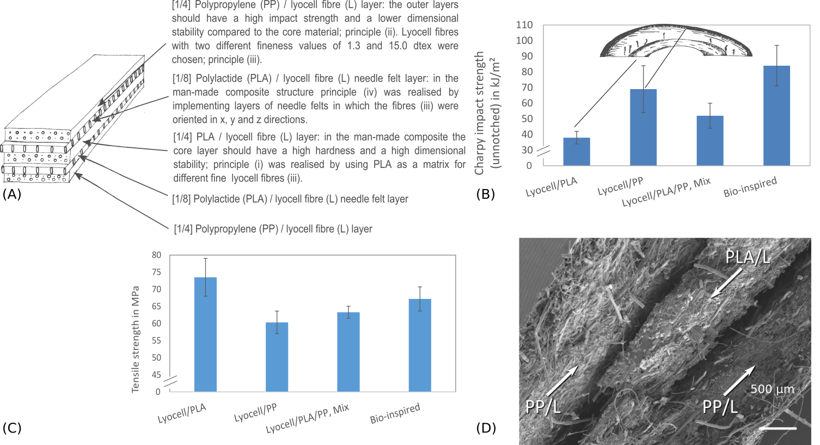
Figure 3. A) Developed model of the babassu nut pericarp for the transfer to a technical cellulose fibre-reinforced composite; B) Unnotched Charpy impact strength and C) Tensile strength of the different reference composites and the bio-inspired composite; D) Fracture surface of the bio-inspired composite.

4. Summary and conclusions
The pericarp of the babassu nut exhibits gradients in hardness and toughness, with the hardness increasing, and the toughness decreasing from the outer epicarp to the inner endocarp. Fibre bundles with two different diameters could be identified in the epicarp and endocarp which are predominantly aligned along the pericarp. A thin layer is present between mesocarp and endocarp with random fibre orientation. An abstracted implementation of this structure in a technical cellulose fibre-reinforced composites using two different matrices and cellulose fibres with two different diameters has shown that the identified principles can be transferred. The impact strength of the bio-inspired sample could be increased beyond the value of the tough reference sample consisting of lyocell fibres and PP. Compared to the mixed reference sample with exactly the same material composition in a homogeneous mixture, the bio-inspired, layered composite showed an increase in toughness of 62%. The hardness of this sample was 8% above the value determined for lyocell/PP. In order to transfer the failure modes identified in the babassu nut pericarp (fibre pull-out, fibre and layer delamination and layer failure) to the technical composite on the one hand ductile fibres were used, and on the other hand the ductile, non-polar matrix PP and the brittle matrix PLA were combined to provoke delaminations between the layers. Overall, it could be shown that the disadvantages of two incompatible matrices such as PLA and PP can be converted into a positive effect: delamination and crack branching caused by the incompatibility lead to an efficient increase in toughness without a decrease in strength values.

References

[1] Grand View Research, Inc., 2016: Natural Fibre Composites Market Analysis By Raw Material (Wood, Cotton, Flax, Kenaf, Hemp), By Matrix (Inorganic Compound, Natural Polymer, Synthetic Polymer), By Technology (Injection Molding, Compression Molding, Pultrusion), By Application (Automotive, Electronics, Sporting Goods, Construction) And Segment Forecasts To 2024. http://www.grandviewresearch.com/industry-analysis/natural-fibre-composites-market (Insight: 05.10.2016).
[2] Bax, B. & Müssig, J., 2008: Impact and tensile properties of PLA/Cordenka and PLA/flax composites Composites Science and Technology, 68, 1601-1607
[3] Graupner, N., 2009: Improvement of the mechanical properties of biodegradable hemp fibre reinforced poly(lactic acid) (PLA) composites by the admixture of man-made cellulose fibres Journal of Composite Materials, 43, 689-702
[4] Schüler, P.; Fleck, C.; Fischer, S.F.; Bührig-Polaczek, A.; Thielen, M.; Seidel, R. & Speck T., 2013: Biomimetic Engineering - Fruit walls and nutshells as inspiration for the development of novel materials. – G.I.T. Laboratory Journal Europe, 3/4: 16 - 19.
[5] Vincent, J. F. V., 1990: Fracture Properties of Plants Advances in Botanical Research, 17, 235 – 287
[6] Staufenberg, G.; Graupner, N. & Müssig, J., 2015: Impact and hardness optimisation of composite materials inspired by the babassu nut (Orbignya speciosa). Bioinspiration and Biomimetics, 2015, 10, 056006
[7] Müssig, J.; Graupner, N. & Labonte, D., 2016: Man-made composite structures inspired by plants. In: Madsen, B.; Biel, A.; Kusano, Y.; Lilholt, H.; Mikkelsen, L. P.; Mishnaevsky Jr., L. & Sørensen, B. F. (ed.): Understanding performance of composite materials - mechanisms controlling properties. Proceedings of the 37th Risø International Symposium on Materials, 2016, 37, 395 – 407

