THE EFFECT OF SPECIFIC SURFACE AREA OF GRAPHENE NANOFILLERS ON INTERLAMINAR FRACTURE TOUGHNESS OF
MULTI-SCALE FIBER-REINFORCED EPOXY COMPOSITES

C. Kostagiannakopoulou, N. Papachristopoulos, V. Kostopoulos*
Department of Mechanical Engineering and Aeronautics, University of Patras,
University Campus, GR-26504 Rio Patras, Greece

*corresponding author, tel. +302610969443, fax. +302610969417
e-mail: kostopoulos@upatras.gr

The poor out-of-plane performance of composite Laminates has acted as an obstacle for extending their use in a variety of application and widely adopting them in the design process. The key properties for enabling such use of composite materials are the interlaminar fracture toughness and damage tolerance of Fiber Reinforced Polymers (FRPs). In recent years the use of carbon nano-species as fillers in the production of nano-reinforced composites has attracted increasing interest owning to their unique properties. Since their discovery, graphene nano-species (GNSs) were considered as potential alternative of carbon nanotubes for the development of nano-composites due to their superior mechanical, thermal and electrical properties. The most widely used graphene nano-species (GNSs) are graphene nanoplatelets (GNPs). Adding GNP nano-fillers in composite laminates may be a promising way for improving FRP’s out of plane performance. However, until now the nano-modification of epoxy matrices of fiber-reinforced composites have not led to the expected properties, considering the extremely high properties of nano-fillers. According to literature [1-2], the dimensional characteristics and the specific surface area (SSA) of nano-fillers are critical factors, which determine the final properties of nano-reinforced composites.
The goal of the present study was to investigate the influence of SSA of GNPs on the fracture properties of carbon fiber reinforced polymer (CFRP) laminates. Toward this direction, two different types of GNPs, purchased from XG-Sciences, namely GNPs C300 and GNPs C500, were used in this study. It is worth noting that both types of the obtained GNPs are of nano-scale thickness with SSAs of 300 and 500 m²/g, respectively. The incorporation of GNPs into the used industrial prepreg epoxy system, Araldite LY1556 provided by Huntsman, was succeeded by using a three-roll mill technique. Following the above process two different types of graphene-modified epoxy blends in content of 0.5%wt. were prepared. These mixtures were used for the impregnation of unidirectional fabrics with a purpose of producing nano-modified UD laminates. The produced materials were cured in an autoclave according to manufacturer instructions.

The results indicate that the introduction of GNPs into the epoxy matrix improved Mode I and II interlaminar fracture properties of the reference composite. Specifically, it was found that the addition of GNPs C500 into the composite caused the increases of 25 and 30% in Mode I and Mode II interlaminar fracture energy, respectively. Finally, it was observed that the interlaminar fracture properties of the reference material enhanced with increasing the SSA of GNPs.

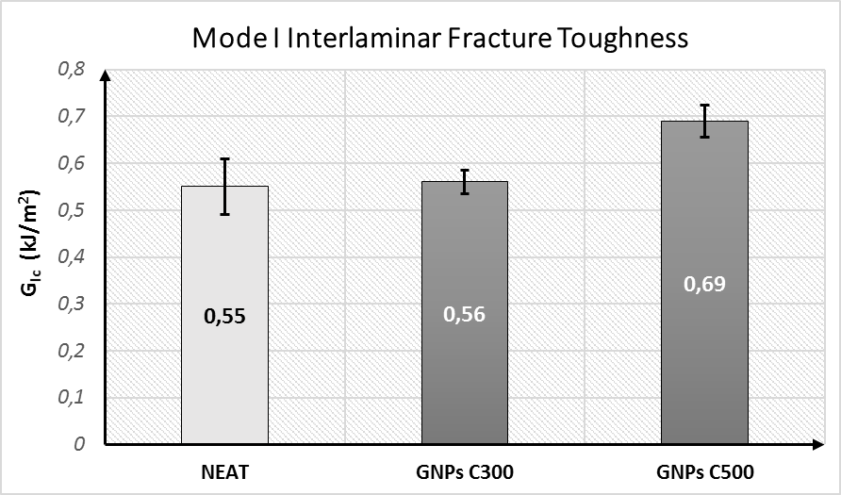
Figure 1: Mode I Interlaminar fracture energy of produced CFRPs.
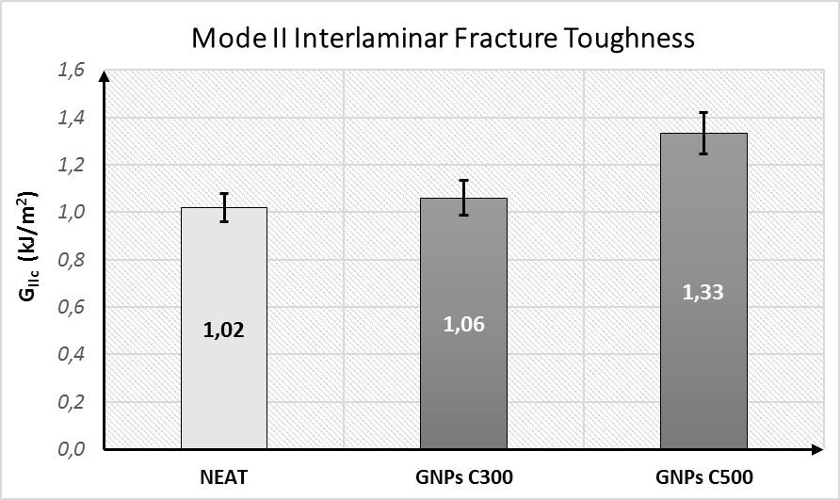
Figure 2: Mode II Interlaminar fracture energy of produced CFRPs.

[1] SG Prolongo, BG Meliton, A Jimenez-Suarez and A Urena: Study of efficiency of different commercial carbon nanotubes on manufacturing of epoxy matrix composites. Journal of Composite Materials 2014, 48(25) 3169–3177.
[2] JG Yanjun Liu, Ricardo Prada-Silvy, Yongqiang Tan Samina Azad Beate Krause, Petra Pötschke, Brian P. Grady: Aspect Ratio Effects of Multi-walled Carbon Nanotubes on Electrical,Mechanical, and Thermal Properties of Polycarbonate/MWCNT Composites. Journal of Polymer Science, Part B: Polymer Physics 2014,52, 73-83.

