Investigation on the Effect of Cooling Rate on the Mechanical Properties of Polypropylene Self-Reinforced Composites

Farzaneh Hassani ^{1, a)}, Peter J. Martin^{1, b)}, Brian G. Falzon^{1, c)}
¹Advanced Composites Research Group, Queen’s University Belfast, UK
^{a)}f.hassani@qub.ac.uk
^{b)}p.j.martin@qub.ac.uk
^{c)}b.falzon@qub.ac.uk

Keywords: self-reinforce composites, SRPP, cooling rate, impact, crystallisation

Abstract

Cooling rate is considered to be one of the most important processing variables which affect the final properties of self-reinforced composites. The effect is more pronounced when the base material is semi-crystalline. The current study investigates the effect of this parameter on the final properties of the self-reinforced polypropylene (SRPP). Bi-component fabrics of SRPP were consolidated at different cooling rates for this study. The DSC thermograms proved different degrees of crystallinity in the laminates. As expected more crystalline region were identified in the laminates consolidated with the lower cooling rate. However, the impact resistance of the same samples were the least due to less toughness of the matrix and more crystalline structure. Little or no change were observed in the tensile mechanical properties and the interlayer bonding of the laminates.

1. Introduction

Self-reinforced composites (SRC) are fully recyclable materials due to the same nature of its constituents. In SRCs, the reinforcement and the matrix are from the same thermoplastic and the concept of creating these one-polymer composites lies in the different melting points of the two phases. The first one-polymer composite was introduced by Capiati and Porter [1] in 1975 by embedding high-density polyethylene filaments in molten low-density polyethylene matrix with a lower melting point. Further investigations of this kind led to creating self-reinforced composites based on other thermoplastic polymers such as polypropylene (PP) [2], Polyethylene therphatalate (PET) [3] and polymethyl methacrylate (PMMA) [4].

Processing parameters in manufacturing the SRCs can highly affect the final properties of the composite. Temperature is considered as the most important one. Compaction temperature is the peak temperature to which the structure is heated for matrix creation and compaction. Pressure is the second parameter which should be accounted for in the processing of SRCs. The effect of processing pressure on the final mechanical properties of the consolidated laminates has been discussed elsewhere [5]. Compaction time is the third parameter in the processing of SRCs. It is expected that relaxation of the tie molecules and the oriented fibres occur in longer compaction times followed by a decrease in the tensile mechanical properties. Work by Swolf et al. [6] confirmed the expected trend with increasing compaction time.

Cooling rate is the fourth parameter whose effect is intensified where the material of interest is semi-crystalline. The effect of cooling rate on the crystal formation and the morphology of different thermoplastics is well established in the literature [7,8] however to the best knowledge of the authors, there has been no study so far on the effect of this factor on the final properties of the self-reinforced polypropylene (SRPP). Work of Loos et al. [9] revealed three distinct regions of crystal formation within the structure; (i) the oriented fibres, (ii) the matrix sphereulites and (iii) the transcrystalline region between the fibres and the matrix (fibre/matrix bonding region). Regions (ii) and (iii) are assumed to be affected by the cooling rate during the consolidation process. Hence, the current paper investigates this factor and tries to develop a guide for tailoring properties based on the final properties’ requirement criteria.

2. Experimental

2.1. Materials and Manufacturing

Co-extruded bi-component polypropylene fabrics were provided by Don and Low Company. The fabrics have an areal density of 107 g/m2 manufactured in plain weave with the same warp and weft tapes with tex 130. Tapes with a width of 2mm are co-extruded in a three-layer structure with a skin of a lower melting point which enables processing in a wide temperature window without melting the cores. A Collins platen press was used to consolidate the SRPP laminates. 10 layers of fabric with 0/90 orientation were consolidated at 130°C for 10 minutes under 70 bar pressure. The laminates were maintained under pressure at 130°C for 10 minutes before cooling at different cooling rates. Three cooling rates of 2.5 °C/min, 10°C/min and 40°C/min were used for cooling the samples.

2.2. Tests

The consolidated samples with 5mg nominal weight were characterised in PerkinElmer DSC instrument. Tensile tests were performed on a Zwick/Roell Z100 tensile machine with a 100 kN load cell according to ASTM D638. A T-peel test was performed according to the standard ASTM D1876. A thin aluminum film was introduced between the mid-layer fabrics before the consolidation process to create unbonded arms. The arms are pulled apart with a cross-head speed of 5mm/min for a distance of 40 mm. The average peel force is then calculated for the displacement of 10 to 50 mm displacement. An instrumented falling dart impact test was used to find out the impact energy required to introduce failure in 50% of the samples with different cooling rates. The tests were completed based on the standard ASTM D5628-96 for which at least 20 samples were tested at different impact energy levels until full penetration of the sample was achieved.

3. Results and Discussion

The first and second heating DSC thermograms of the samples cooled at different cooling rates are shown in Figure 1. As demonstrated in Figure 1.a, samples cooled at a lower cooling rate exhibited a wider side shoulder on the main melting peak which is attributed to higher crystallinity of the matrix which is closer to the fibres. Another small extra peak can also be tracked after the first melting peak neat 120°C which is regarding the less perfect crystal melting of the copolymer. This peak is more pronounced for the laminates cooled at the highest cooling rate of 40°C/min. It is worth noting the second heating rate, as demonstrated in Figure 1.b. The second heating temperature scan can confirm the same trend for all three samples, as the samples have been heated above their melting point once and hence their thermal histories have been cleared and the crystal formation induced during the cooling process.

(a) | 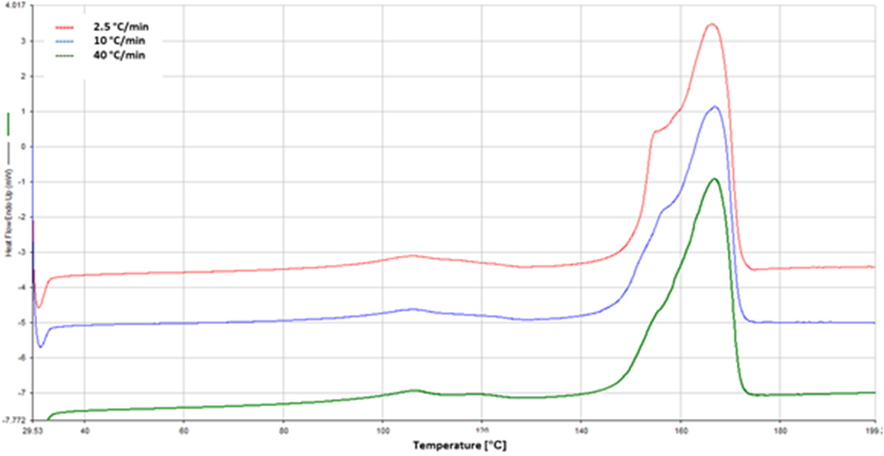
(b) | 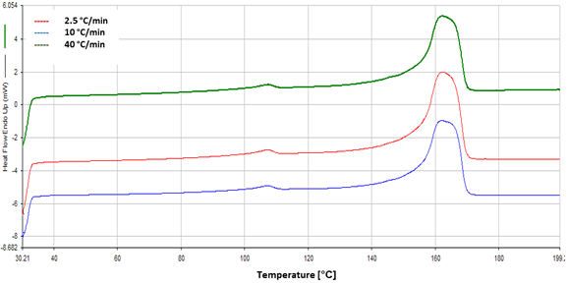
Figure 1- a. First heating rate DSC thermograms of the consolidated samples at different cooling rates. b. Second heating rate DSC thermograms of the consolidated samples at different cooling rates.

The results of the tensile mechanical and the T-peel tests are shown in Figure 2. The mechanical properties of the laminates didn’t show a noticeable change at different cooling rates, indicating that the crystal formation does not affect the mechanical properties and the interlayer bonding. This is in line with the previous work of Yamada and Kamezawa [10] on highly oriented polypropylene which showed that the orientation of the tie molecules between the crystalline structure determine the modulus of the consolidated samples. Hence, as during SRC processing, the core structures remained unchanged and the tensile mechanical properties are expected to be in the same range.

Instrumented falling dart impact test results are shown in . As can be seen, samples with the higher cooling rates had the higher impact resistance. Although most of the completed work on self-reinforced polypropylene and their morphology has focused on the difference between alpha and beta crystals [11-13], the findings in the current work may be compared to those of Barany and Itzer [13] on the impact resistance of self-reinforced composites with iso- and random co-polypropylene matrix. They showed that SRPP with random co-PP matrix has higher impact resistance compared to the i-PP which can be attributed to the higher toughness of the matrix due to more amorphous regions. In the current work, the higher amorphous region is attributed to the laminates consolidated at higher cooling rates and the results are in line with the previous findings of this kind.

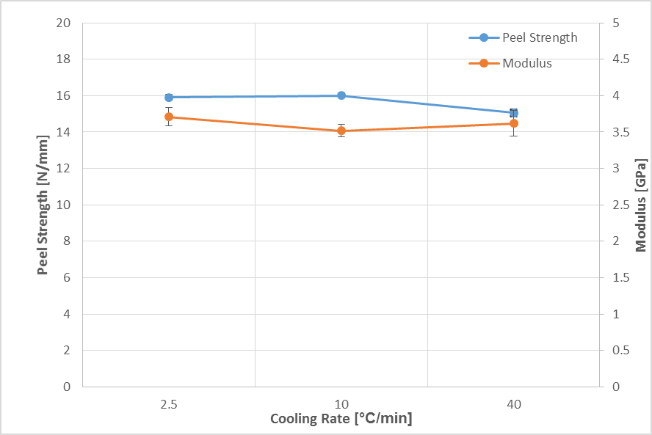

Figure 2- Peel strength and modulus of the consolidated samples at different cooling rates.

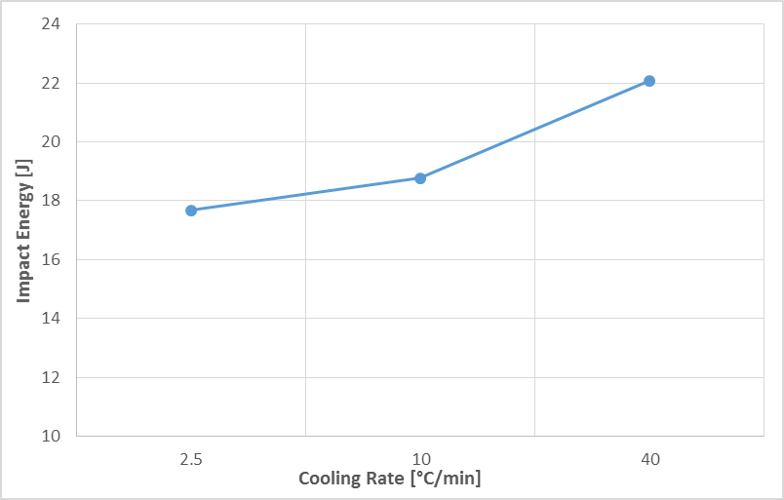

Figure 3- Impact energy to introduce failure in 50% of the samples solidified at different cooling rates.

3. Conclusions

Self-reinforced polypropylene laminates were consolidated at three different cooling rates and the effect of cooling rate on the properties of the laminates have been studied. This study showed that:
- DSC thermal analysis of the samples clearly revealed the different degree of crystallinity at different cooling rates. Samples consolidated at the lowest cooling rate exhibited the largest side peak.
- The density of the laminates consolidated at higher cooling rates was 20% less than that of those consolidated at the lower cooling rate.
- Mechanical properties of the samples didn’t show any pronounced difference for different cooling rates which is the result of an unaffected core structure during the consolidation process.
- Impact resistance of the samples processed at higher cooling rates was higher due to the lesser degree of crystallinity and hence higher toughness

Based on the current study and due to the fact that cooling rate does not change the mechanical properties while affecting the impact properties, the higher cooling rate would be more desireable in SRPP processing.

Acknowledgments

The project has received funding from the European Union’s Horizon 2020 research and innovation programme under the Marie Skłodowska-Curie grant agreement No 721256. Results presented in this paper reflects only the authors’ views and the Agency is not responsible for any use that may be made of the information it contains.

References

[1] R. S. P. N. J. Capiati, “The concept of one polymer composites modelled with high density polyethylene,” Mater. Sci., vol. 10, pp. 1671–1677, 1975.
[2] A. P. Science, “Self reinforcement of polypropylene by flow induced crystallization during continuous extrusion Self-Reinforcement of Polypropylene by Flow-Induced,” J. Appl. Polym. Sci., vol. 67, no. August, pp. 2111–2118, 1998.
[3] J. Min and T. Peijs, “Composites : Part A Self-reinforced poly (ethylene terephthalate) composites by hot consolidation of Bi-component PET yarns,” Compos. Part A, vol. 41, no. 8, pp. 964–972, 2010.
[4] J. L. Gilbert, D. S. Ney, and E. P. Lautenschlager, “Self-reinforced composite poly (methy1 methacrylate): static and fatigue properties,” Biomaterials, vol. 16, no. 14, pp. 1043–1055, 1995.
[5] B. G. F. F. Hassani, P. J. Martin, “The Effect of Processing on the Mechanical Properties of Self-Reinforced Composites,” 21th international Esaform Conference on Material Formingm Palermo, 2018.
[6] Y. Swolfs, Q. Zhang, J. Baets, and I. Verpoest, “Composites : Part A The influence of process parameters on the properties of hot compacted self-reinforced polypropylene composites,” Compos. PART A, vol. 65, pp. 38–46, 2014.
[7] Y. Huang, G. Chen, Z. Yao, H. Li, and Y. Wu, “Non-isothermal crystallization behavior of polypropylene with nucleating agents and nano-calcium carbonate,” Eur. Polym. J., vol. 41, no. 11, pp. 2753–2760, 2005.
[8] A. Gradys et al., “Crystallization of polypropylene at various cooling rates,” vol. 414, pp. 442–446, 2005.
[9] J. Loos, T. Schimanski, J. Hofman, T. Peijs, and P. J. Lemstra, “Morphological investigations of polypropylene single-fibre reinforced polypropylene model composites,” Polymer (Guildf)., vol. 42, no. 8, pp. 3827–3834, 2001.
[10] T. M. Yamada K, Kamezawa M, “Relationship between orientation of amorphous chains and modulus in highly oriented polypropylene.,” J. Appl. Polym. Sci., vol. 37, no. 5, pp. 1810–1815, 1981.
[11] H. B. Chen, J. Karger-Kocsis, J. S. Wu, and J. Varga, “Fracture toughness of alpha and beta phase polypropylene homopolymers and random and block copolymers,” Polymer (Guildf)., vol. 43, no. 24, pp. 6505–6514, 2002.
[12] A. A. A. J. Karger-Kocsis, S. D. Wanjale, T. Abraham, T. Ba´ra´ny, “Preparation and Characterization of Polypropylene Homocomposites : Exploiting Polymorphism of PP Homopolymer,” Appl. Polym. Sci., vol. 115, pp. 684–691, 2009.
[13] J. K.-K. T. Barany, A. Izer, “Impact resistance of all-polypropylene composites composed of alpha and beta modifications,” Polym. Test., vol. 28, pp. 176–182, 2009.

