Simulation on delamination of 90/0 laminate under low-velocity impact load by surface-based cohesive behavior contact in explicit analysis

Xiaodong Wang, Zhidong Guan, Zengshan Li, Geng Han and Shanyi Du

School of Aeronautic Science and Engineering, Beihang University, Beijing 100191, China
Email: wangxd819@163.com
Email: d5062010@163.com
Email: 09512@buaa.edu.cn
Email: super.hangeng@163.com
Email: sydu@hit.edu.cn

Keywords: Delamination, Friction behavior, Puck’s failure criterion, Plastic behavior

Abstract

In this paper, surface-based cohesive behavior contact with the friction behavior taken into consideration is adopted to simulate the delamination of the [90₃/0₃]_{S} laminate under low-velocity impact. To guarantee the effectiveness of this contact on characterizing the friction behavior, the shear behavior of the cohesive contact under compressive stress is simulated, and the result shows that the cohesive contact is able to characterize the cohesive behavior with friction. Besides, the Puck’s failure criterion, good at simulating the matrix dominating failure, is adopted and implemented by the subroutine VUSDFLD in the ABAQUS. Moreover, the plastic behavior of the laminate under in-plane shear stress is considered to study the effect of plasticity on the delamination. The delamination of the laminate under low-velocity impact is simulated firstly. The shape and the area of delamination simulated by the FEM are similar with the experiment, which proves the effectiveness of the cohesive contact on characterizing the real behavior of the interlaminar. Besides, the effect of the friction coefficient and the plastic behavior on the delamination are studied, and the results show that both of them have a significant effect on the delamination.

1. Introduction

Carbon fibre reinforced composite has been widely used in aerospace and defend industry for its excellent mechanical properties. However, the delamination, an important failure behavior in the composites laminates, always appears after low-velocity impact for the weak interlaminar properties. The exist of delamination would cause great decrease of the mechanical properties, especially the compressive properties. So, the delamination behavior under impact and the compression properties after impact become a great aspect in the composites structure design. While, the unclear understanding on these mechanical properties limites the full use of the composites. To understand the mechanism of delamination under impact load, finite element method (FEM) has been widely used to simulate the delamination behavior.

Many approaches have been reported to predicte the delamination initiation and propagation in laminates under impact load, such as the virtual crack closure technique (VCCT) [1,2], cohesive zone model [3–5] and the contimuum damage mechanics (CDM) [6–9]. The cohesive zone model has been widely employed to characterize delamination recently years [10,11], due to its advantages on simulating fracture behavior. However, the cohesive element, general method adopted in the FEM, does not consider the friction behavior under compressive stress. The result is reasonable when the normal stress is tension. while, when the normal stress is compression, the effect of normal stress is usually ignored and the delamination at the interface is considered to be pure mode II, which is unreasonable in physics.

To overcome this problem, researchers proposed different approachs. Li et al. [12] modified the damage criteria by a pre-determined parameter, which can relate the normal compressive stress with the increase in interlaminar shear strength and mode II critical fracture energy. Zhang et al. [13] treated the influence of the normal compressive stress by adding a contact-induced friction between the adjacent plies. However, the model is time-consuming due to the complex finite element model. Zhang et al. [14] introduced the friction behavior by using the surface-based behasive behavior contact in the standard solver, which gave a reasonable result and decreased the time cost obviously. However, the impact progress is equivalent to static indentation progress due to the standard solver. Although, numerous methods have been proposed to introduce the friction behavior into delamination simulation, there are still many problems need to be solved.

In this paper, the surface-based cohesive behavior contact in the explicit solver is adopted to simulate the delamination of the interface, which can be used in the dynamic analysis and consider the friction behavior. The Puck’s failure criterion is adopted to simulate the intralaminar damange, which is good at predicting the strength of the matrix dominated damage under complex stress state. Besides, the plastic behavior of the lamiantes under in-plane shear load is also considered. To verify the accuracy of the model, the delamination of laminate under impact with same condition with experiment is simulated firstly. The shape and the area of delamination simulated by the FEM are similar with the experiment, which proves the effectiveness of the cohesive contact on characterizing the real behavior of the interlaminar. Then, the effect of the friction coefficient and the plastic behavior on the delamination are studied, and the results show that both of them have a significant effect on the delamination.

2. FEM model

The model is depend on a pulished low-velocity impact test [15]. The laminate was fabricated by Seal HS160/REM unidirectional carbon/epoxy prepreg with the stacking sequence of [90₃/0₃]_{S}. The test specimens were cut from the laminate with the size of 87.5×65mm. The specimens were simply supported by a steel plate with a rectangular cutout of 67.5×45 mm. The diameter of the hemispherical impactor was 12.5 mm. The mechanical properties of the laminate is listed in the Table 1.

Table 1. mechanical properties of the laminates

E₁₁=93.7GPa; E₂₂=E₃₃=7.45GPa
G₁₂=G₂₃=G₁₃=3.97GPa
v₁₂=v₂₃=v₁₃=0.261
k_{N}=120GPa/mm; k_{S}=k_{T}=43GPa/mm
N=30MPa; S=T=80MPa
G_{IC}=520J/m²; G_{IIC}=G_{IIIC}=970J/m²

2.1. Geometry model

In the geometry model, due to the symmetry, only one quarter laminate is adopted for simplification. Besides, to simplify the model, the steel support is neglected in this model. The edges contact with the steel support are set as the single support to simulate the boundary condition. the impactor is modeled as a rigid body indentor for its relatively smaller deformation compared with the laminate. The diameter of impactor is 12.5mm the same with the experiment and the mass of impactor is 0.575kg, a quarter of the experiment for symmetry. To simulate the intralaminate damage and delamination, the laminar and the interlaminar need to be modeled separately. However, numerous experiments shown that the delamination only appear between the plies with different orientations. So the adjacent plies with same orientation are modeled as a layer in this paper. The specimen with stacking sequence of [90₃/0₃]_{S} is modeled as three composite layers with surface-based cohesive behavior contact between them. The geometry model is shown in the Fig. 1. The finite element model is modeled with the C3D8R reduced integration solid elements with the size of 2mm. The element size at the region under the impactor is smaller for the complex mechanical behavior, which is 1mm. The element size on the thicknesss direction is 0.125mm the same with the thickness of the sigle ply. The initial velocity of the impactor is calculated by the impact energy and impactor mass and set at the initial step.

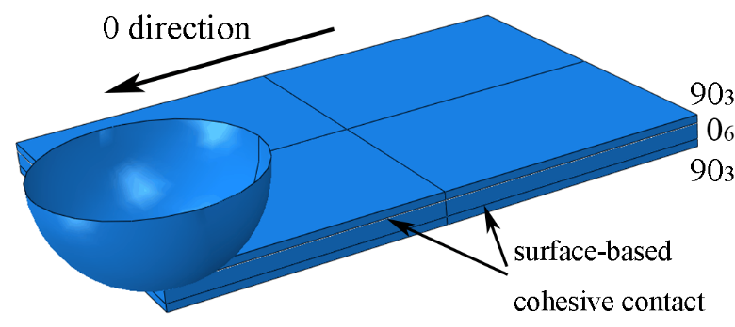

Figure 1. The geometry of the finite element model.

2.2. Constitutive model

Plastic behavior

The composites show obvious plastic behavior under in-plane shear load, which has a significate influence on the failure progress of the composites. To study the effect of the plastic behavior on the delamination of laminates under impact, the in-plane shear plastic behavior is considered in the finite element model. The non-linear response in each ply is represented by using the Ramberg-Osgood constitutive equation [16] as followed:
(1)
Where, is the initial undamaged shear modulus, is the shear strength and n is the shape factor of the nonlinear stress-strain curve. The values of these parameters are selected as 3.97 GPa, 100MPa and 2, respectively.

Intralaminar failure criterion

Puck’s failure criterion and stiffness reduction is adopted in the model to simulate the intralaminar damage initiation and propagation, which is implemented in the ABAQUS by the user defined subroutine VUSDFLD.

The experiment results shown that there is no fiber damage in the laminates under impact load, so only the inter-fiber damage is considered in this model. Puck’s failure criterion is adopted to simulate the damage of the laminate. This criterion is a reliable and accurate failure criterion on determining the strength of the intralaminar damage dominated by the matrix properties. Puck’s failure criterion is developed from the Mohr-Coulomb theory on isotropic materials, which is good at charactering the failure behavior of the materials sensitive to the hydrostatic pressure. This theory is developed by Puck to predict the transverse damage initiation of the transeverse isotropic composite materials. Puck’s failure criterion postulates that the composites occur inter-fiber damage when the stress state on the risk one of all the “action planes” parallel to the fiber direction meet the failure criterion. So, before the failure prediction of composites on certain “action plane”, the stress state on the it should be calculated first. The criterion assumps that the damage of a certain “action plane” is only related to the normal stress () and the shear stresses ( and ), which can be transferred from the material coordinate system by the following equations:
(2)
Where, the, and the, , are the normal stress and shear stress in the material coordinate system, is the rotation angle of the laminate stress around the fibre direction.

In Puck’s failure criterion, the damage risk of composites on a certain “action plane” is charactered by the parameter , where for not damage and for damage. The of a certain “action plane” is calculated by the Eq (3). Two typical damage modes are considered in the criterion and distinguished by the nomal stress acted on the plane.
(3)
Where, is the transeverse tensile strength, is the shear strength under in-plane shear stress, and the other parameters are determined by the following equations:
(4)
(5)
(6)
Where, is the transeverse compressive strength, and , represent the slope of the, fracture envelope at for and , respectively. The corresponding values recommended by Puck for CFRP/Epoxy are chosen as 0.35, 0.3, 0.25 and 0.25, respectively.

Stiffness reduction is adopted to simulate the damage propagation, which is esay to realize but accuraty. Because fiber damage is not considered, only the transeverse modulus and shear modulus is reducted in the model. The stiffness reduction factors are list in the Table 2.

Table 2. The resuction factor of the elastic properties after damage

Elastic properties | E₂ | G₁₂ | G₂₃
Reduction factor | 0.2 | 0.3 | 0.3

Interlaminar behavior

The interlaminar mechanical behavior between two adjacent plies with different stacking orientation is modeled by the surface-based cohesive behavior contact. The mechanical constitutive of this contact is same with the cohesive element, but can introduce the friction behavior. A bi-linear traction-separation law is adopted. Before the initiation of the damage, the mechanical respond is linear elastic and controlled by the stiffness of K. The quadratic nominal stress criterion is adopted to determine the initiation of the damage. Damage evolution behavior after damage initiation is controlled by the fracture energy. To character the evolution behavior under complex stress state, the mixed-mode fracture criterion proposed by Benzeggagh and Kenane is adopted in the model.

The friction behavior is implemented by difining a coulomb firction factor between the two contact surfaces, and the friction coefficient adopted in the model is 0.3.

To guarantee the effectiveness of the contact on characterizing the friction behavior, the shear behavior of the cohesive contact under compressive stress is simulated, and plotted in the Fig. 2. For comparation, the stress-displacement of the model with chohesive element is also shown. It is obvious to find that the strength and the fracture energy release rate of the surface-based cohesive behavior contact are bigger than the results of the cohesive element. And, due to the friction, there is still interaction force between two surfaces when the interlaminar is completely damage. The result shows that the surface-based cohesive behavior contact is able to characterize the cohesive behavior with friction.

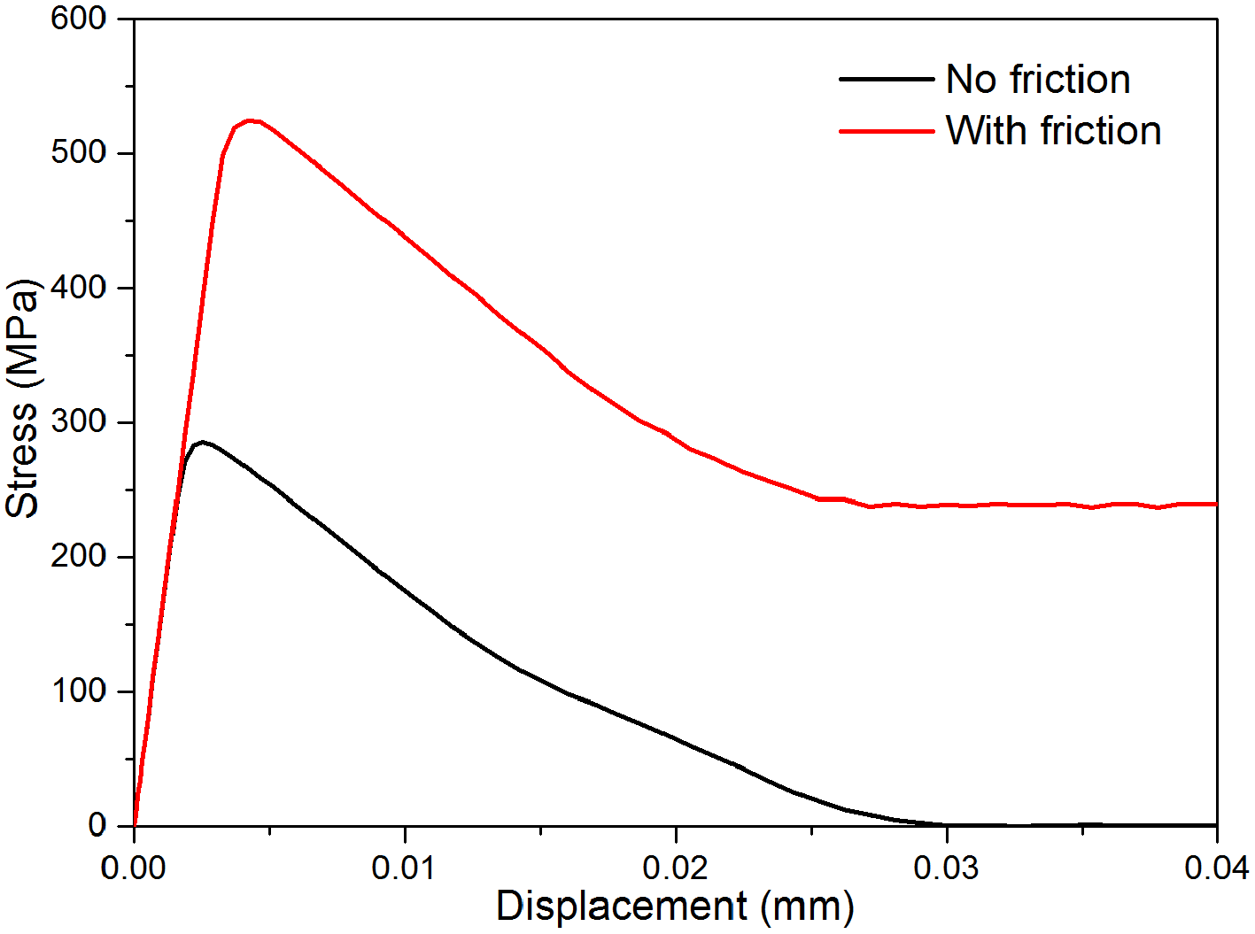

Figure 2. The mechanical respond of the cohesive contact under shear load.

3. Result and discussion

3.1. Verification of the model

To verify the validity of the finite element model, the damage behavior of the laminate under low-velocity impact, same condition with the experiment, is simulated. The interlaminar delamination morphology of the FEM and the experiment is compared firstly. The experiment indicated that the delamination only appear at the lower interlaminar, and the same result is also obtained in the FEM. So, only the delamination at the lower interlaminar is shown in the Fig. 3, which contain the delamination of the experiment (Fig. 3a), the delamination of the FEM (Fig. 3c) and the overlay of them (Fig. 3b). The delamination shape and the delamination area of the simulate result all agree well with the experiment results, reflect the reliability of the model on simulating the delamination of the laminate under impact load. Besides, the Force-Time curve of the simulation and experiment are compared. The curves of the experiment and simulation are list in the Fig. 4. The curve of the simulation is offset by 2 ms, so the results can appear on the same graph. The curve shape of the simulation agrees well with the experiment. And, they all exist some shock at the point of force equal to 1.4 kN. The results indicate that the mechanical behavior of the simulation and the experiment are similar, and the laminate in the experiment and simulation all appear damage at the force of 1.4 kN. It is obvious that the finite element model can give a good simulation on the mechanical behavior and delamintion of the laminate under the low-delocity impact load.

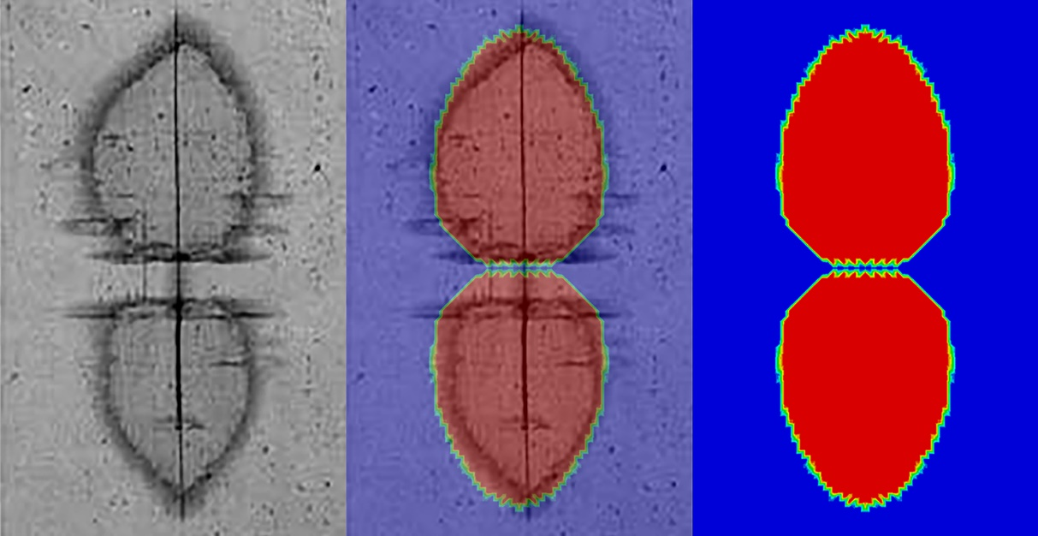

Figure 3. The results of the FEM comparing with the experiment.

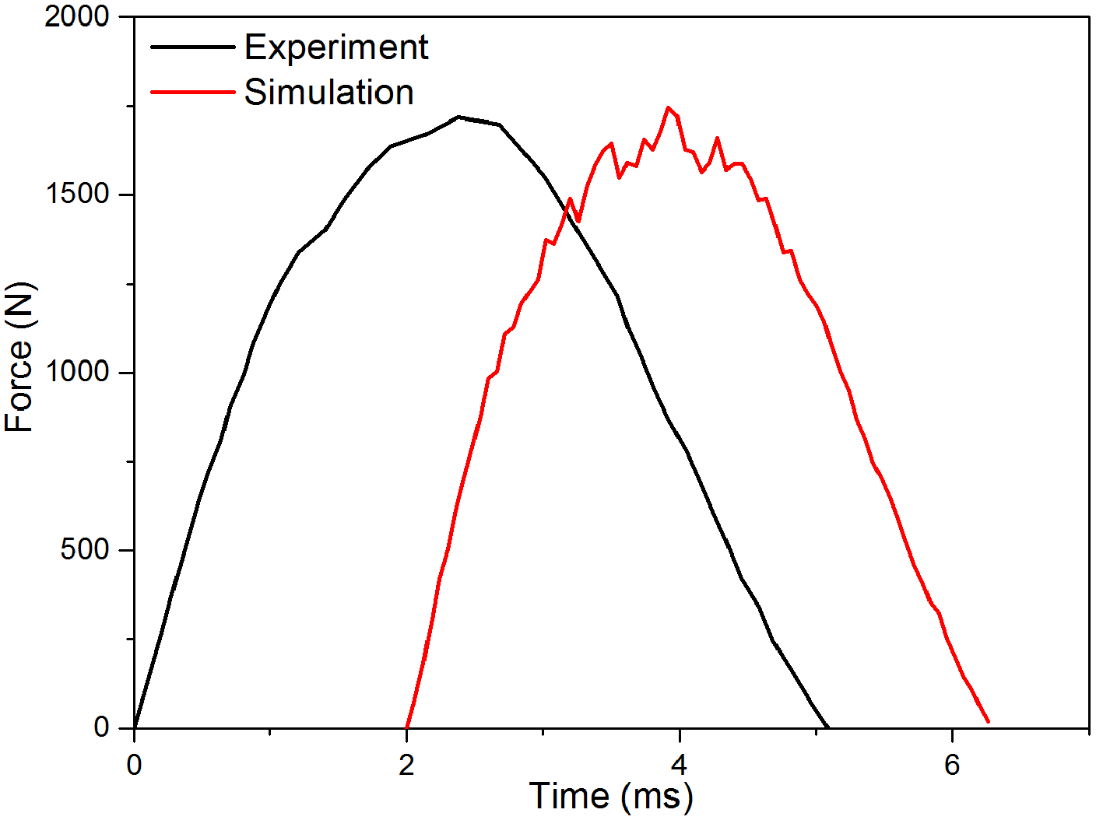

Figure 4. The load-time curves of the experiment and simulation.

3.2. Effect of the friction and plasticity

The effect of the friction coefficient and the plastic behavior on the delamination are studied. For the friction coefficient and plastic behavior, three cases are selected for comparison. For the friction coefficient, and are selected as the control group of the simulation based on experiment (μ=0.3). The delaminations of the lower interlaminar of the three different friction coefficients are shown in the Fig. 5. The results indicate the friction coefficient has a significant influence on the delamination of the laminates under impact. And the delamination area increases with the increase of the friction coefficient. For the plastic behavior, two different non-linear responds are adopted to compare with the based group. And, the two responds have smaller plastic strain and bigger plastic strain with respect to the besed group, respectively. The results of the delamination of laminates with different plastic responds are shown in the Fig. 6. The results reflecte that the plastic behavior has a significant effect on the delamination of the laminate under impact. And the delamination area decreases with the increase of the plastic strain.

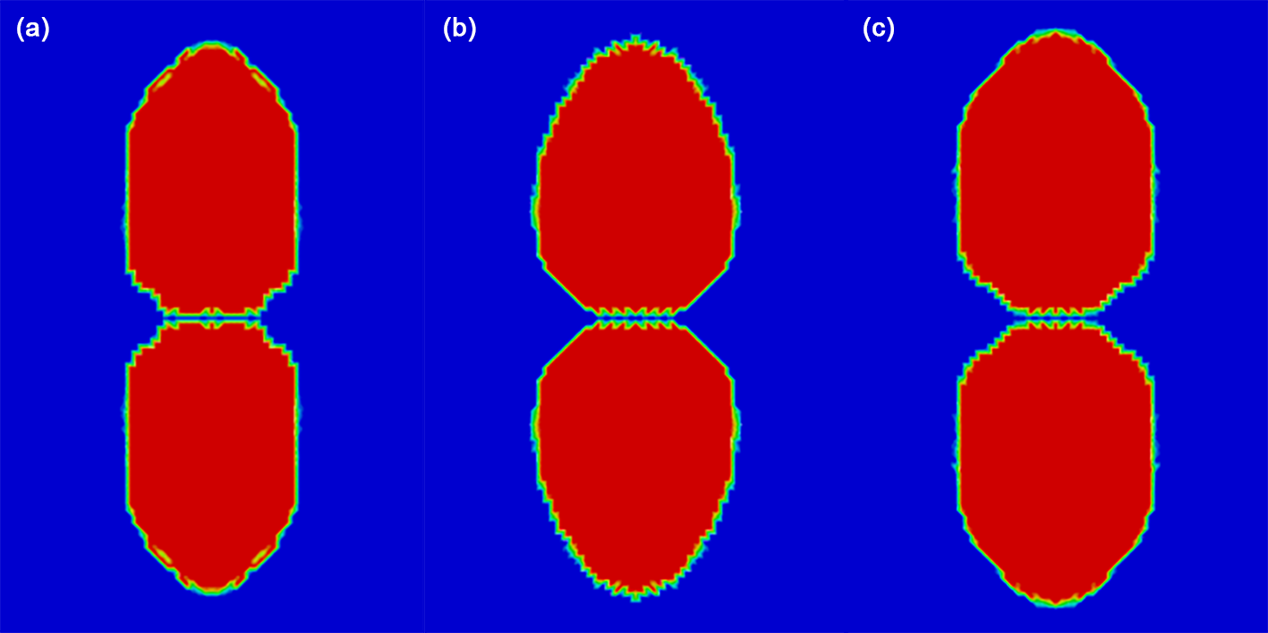

Figure 5. The delamination of laminate with different friction factors.

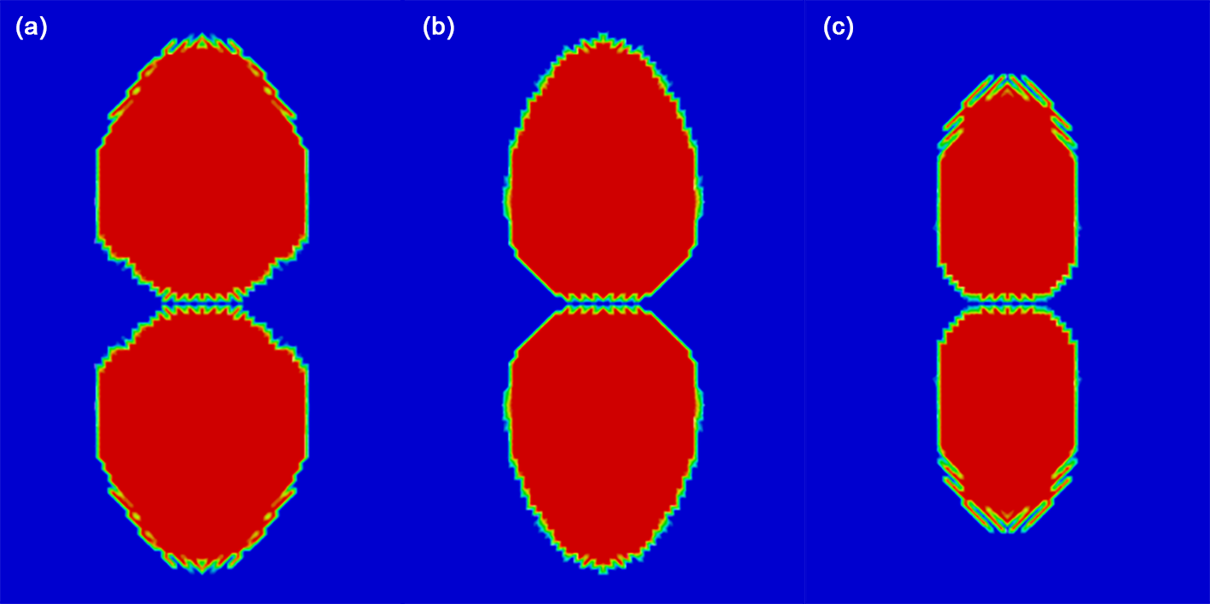

Figure 6. The delamination of laminates with different plastic behavior.

4. Conclusions

In this paper, surface-based cohesive behavior contact is used to simulate the delamination of the [90₃/0₃]_{S} laminate under low-velocity impact. This contact has the same respond with the consive element, but is easy to consider the friction behavior. Besides, For the intralaminar damage, Puck’s failure criterion is adopted and implemented by the subroutine VUSDFLD in the ABAQUS. Moreover, the in-plane plastic behavior is considered.
To verify the realiability of this finite element, the delamination of the laminate under low-velocity impact is simulated firstly. And, the result proves the effectiveness of the cohesive contact to characterize the real behavior of the interlaminar. Besides, the effect of the friction coefficient and the plastic behavior on the delamination are studied. The results show that the firction behavior and the plastic behavior all have a significate effect on the delamination of the laminate under low-delacity impact. the delamination area increases with the increase of the friction coefficient, but decreases with the increase of the plastic strain.

References

[1] Fleming DC. Delamination modeling of composites for improved crash analysis. National Aeronautics and Space Administration, Langley Research Center, Hampton, Virginia, USA, NASA/CR-1999-209725; 1999.
[2] Ronald K. Virtual crack closure technique: history, approach, and applications. Appl Mech Rev 2004;57:109–43.
[3] Aymerich F, Dore F, Priolo P. Prediction of impact-induced delamination in cross-ply composite laminates using cohesive interface elements. Compos Sci Technol 2008;68:2383–90.
[4] Shi Y, Soutis C. A finite element analysis of impact damage in composite laminates. Aeronaut J 2012;116:1131–47.
[5] Caputo F, De Luca A, Lamanna G, et al. Numerical study for the structural analysis of composite laminates subjected to low velocity impact. Compos B 2014;67:296–302.
[6] Donadon MV, Iannucci L, Falzon BG, et al. A progressive failure model for composite laminates subjected to low velocity impact damage. Comput Struct 2008;86:1232–52.
[7] Kim EH, Rim MS, Lee I, et al. Composite damage model based on continuum damage mechanics and low velocity impact analysis of composite plates. Compos Struct 2013;95:123–34.
[8] Riccio A, De Luca A, Di Felice G, et al. Modelling the simulation of impact induced damage onset and evolution in composites. Compos B 2014;66:340–7.
[9] Batra RC, Gopinath G, Zheng JQ. Damage and failure in low energy impact of fiber-reinforced polymeric composite laminates. Compos Struct 2012;94:540–7.
[10] Feng D, Aymerich F. Finite element modelling of damage induced by low-velocity impact on composite laminates. Compos Struct 2014;108:161–71.
[11] de Morais AB. Mode I cohesive zone model for delamination in composite beams. Eng Fract Mech 2013;109:236–45.
[12] Li XQ, Hallett SR, Wisnom MR. Predicting the effect of through-thickness compressive stress on delamination using interface elements. Compos A 2008;39:218–30.
[13] Zhang X, Bianchi F, Liu HQ. Predicting low-velocity impact damage in composites by a quasi-static load model with cohesive interface elements. Aeronaut J 2012;116:1367–81.
[14] Zhang J, Zhang X. Simulating low-velocity impact induced delamination in composites by a quasi-static load model with surface-based cohesive contact[J]. Composite Structures, 2015, 125: 51-57.
[15] Aymerich F, Dore F, Priolo P. Simulation of multiple delaminations in impacted cross-ply laminates using a finite element model based on cohesive interface elements[J]. Composites Science and Technology, 2009, 69(11-12): 1699-1709.
[16] Richard RM, Blacklock JR. Finite element analysis of inelastic structures. AIAA J 1969;7:432e8.

