On the importance of spatial distribution of carbon nanotubes for suppression of stress concentrations and toughness improvement in nanocomposites

Qiang Liu, Stepan V. Lomov and Larissa Gorbatikh

¹Department of Materials Engineering, KU Leuven, Kasteelpark Arenberg 44 box 2450, 3001 Leuven, Belgium
Email: Larissa.Gorbatikh@kuleuven.be, Web Page:
http://www.composites-kuleuven.be

Keywords: carbon nanotubes, nanostructure optimization, genetic algorithm, damage diffusion, toughness

Abstract

Do spatially resolved nanostructures have an advantage over those where reinforcements are homogeneously distributed? In this study we show that the reinforcement distribution and orientation play an important role in suppressing stress concentrations and improving strength and toughness of nanocomposites. The study is performed using a novel computational approach combining a genetic algorithm (GA) and two-scale finite element (FE) analysis. For demonstration of the developed methodology we optimize the distribution and orientation of nanotubes in a plate containing a circular hole to improve its tensile performance. The nanocomposite plate with an optimized CNT network showed much better tensile properties: the stress at break increased by a factor of 2. Three toughening mechanisms were responsible for that, namely (1) a delay in damage initiation due to suppressed stress concentrations around the hole, (2) damage diffusion/crack branching in the matrix and (3) nanotube debonding and pull-out along these branched damage paths. We conclude that nanostructured networks with spatially resolved features at the microscale is an effective way to achieve significant improvements in strength and toughness of nanocomposites.

1. Introduction

Materials design requires selection and optimization of many interdependent parameters and is therefore a complex process. For polymers reinforced with carbon nanotubes (CNTs) and designed for mechanical performance (stiffness, strength, toughness, etc), one is faced with the choice of such parameters as CNT type (single wall vs multi-wall), their length, concentration, orientation, spatial distribution along with polymer type, CNT/polymer interfacial properties,– and this list is not exhaustive. Searching for an optimal set of parameters from a large number of possibilities with an iterative experimental approach is costly and inefficient. Modelling tools can greatly assist in this process.

In the present paper we introduce two of our recent developments: 1) a hybrid optimization framework for the morphological design of CNT networks, and 2) a model to predict damage in these nanocomposites. The computational framework makes use of the genetic algorithm (GA) and the two-scale finite element method (FEM) developed in [1-3] and is called here a GA-FEM optimization tool. The optimization of a CNT network relies on evaluation of stress fields and, more specifically, targets suppression of stress concentrations. The approach is much more general and suitable for other optimization problems as long as they are sensitive to local stress variations. The model to predict nanocomposite’s behavior up to failure accounts for such failure mechanisms as damage in the matrix and CNT debonding.

2. Methodology

2.1. Optimization of the nanostructured network

Our optimization framework is introduced on the example of a rectangle plate containing a circular hole and subjected to tensile loading. The objective is to minimize the stress concentration at the hole by reinforcing the material of the plate with CNTs and optimizing their positions and orientations. The problem is schematically illustrated in Fig. 1(a). Only half of the plate is modelled. The length, width and thickness of the model are 20 μm, 6 μm and 0.5 μm, respectively. The radius of the hole, R, is 2 μm. The plate is subjected to a far-field distributed load of σ₀ = 30 MPa, in the vertical direction. The length and diameter of CNTs are assumed to be 0.6 μm and 9 nm, respectively. The CNT content is 0.3 wt%.

The outcome of the optimization is morphology of the CNT network described by the spatial and orientation distributions of individual CNTs. To describe arbitrary spatial and orientation distributions of CNTs, a discretization strategy similar to that in [4] is adopted. The spatial and orientation distributions of CNTs are considered as design variables. GA, implemented in MATLAB, is chosen as an optimization algorithm. The objective of the present optimization is to minimize stress concentration in the matrix. A straightforward way is to express the objective function, ψ, using the stress concentration factor, K, as:
where σ is the maximum principal stress. In addition to the stress concentration factor, we also introduce a new objective function based on the global measure of stress field, λ, which is defined as:
where V_{hole} is the volume of the half of the hole, σ_{th} and p are two parameters specified before an optimization and H is the Heaviside function. σ_{th} = 50 MPa, p = 2. Consequently, λ could be considered as the volume fraction of the high-stress region relative to the volume of the hole. The mathematical formalism for the optimization problem is reported in detail in [3].

2.2. Prediction of damage development

The model takes advantage of the embedded element (EE) technique built in ABAQUS. Two types of damage mechanisms are introduced into the original FE model in [3]: 1) CNT/matrix interfacial debonding and 2) damage and plasticity in the matrix. The interfacial debonding is modelled using cohesive zone elements. To the best of our knowledge, this is the first FE model that combines embedded and cohesive elements for the interface damage simulation. The interfacial behavior is assumed to follow a bi-linear traction-separation law, and the damage initiation is governed by the criterion of maximum stress. The interfacial shear strength and fracture energy are taken as 60 MPa and 5.35 J/m2, respectively. The epoxy matrix is modelled using an isotropic elastic-brittle constitutive model. The material parameters of CNTs are the same as those in [1].

3 Results and discussion

3.1 Optimal CNT position and orientation

Two reference cases are considered in the current work: the case of pure matrix (without CNTs) and the case of uniformly distributed and randomly oriented CNTs (Fig 1a and b). For the homogenous plate of pure matrix, the stress concentration factor, K, is 3.44 and λ is about 72%. When the plate is reinforced by CNTs with random orientation and uniform distribution, K reduces to 3.07 and λ to 44%. For the optimized morphology (Fig. 1c) where both CNT distribution and orientation were targeted, further significant reduction down to K=1.57 was achieved, thus exhibiting successful suppression of stress concentration. In the meantime, most of the plate also becomes the low-stress region (λ is about 0%.), indicating a significant stress redistribution (Fig.2).

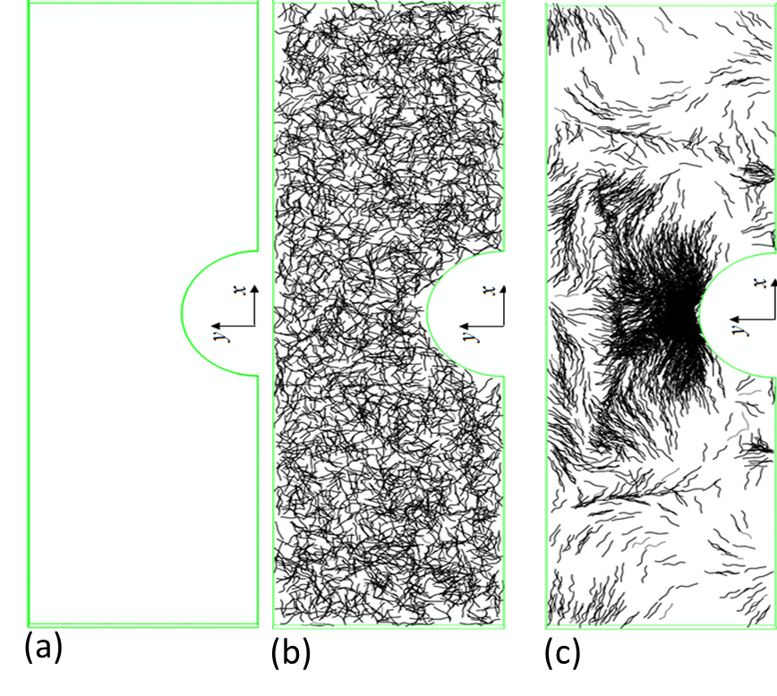

Figure 1. A plate with a circular hole made of (a) a pure polymer, (b) polymer reinforced with uniformly distributed CNTs and (c) with spatially distributed CNTs (optimized configuration).

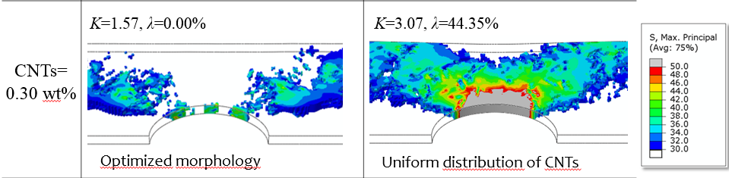

Figure 2. Stress distribution near the hole in the case of spatially distributed and oriented CNTs (left) and uniformly distributed and randomly oriented CNTs (right).

3.2 Tensile behavior and toughening mechanisms

Figure 3 shows the stress-strain curves predicted by the present FE model for the plates made of the materials shown in Fig1. A sharp stress-drop is observed on all three stress-strain curves due to the brittleness of the matrix. Very low peak stress (~17.7 MPa) is predicted for the reference plate due to a significant stress concentration generated by the hole. Here the ratio of the bulk strength (i.e. 60 MPa) to plate strength (i.e. 17.7 MPa) is about 3.39, which matches well with the stress concentration factor of 3.44. The introduction of CNTs leads to a different stress-strain response, which strongly depends on the morphology of the CNT network. For the plate with uniformly distributed and randomly oriented CNTs at 0.3% concentration, only marginal improvements are observed for the peak stress and failure strain. In contrast, the plate with optimized position and orientation of CNTs exhibits a dramatic increases in both plate strength and failure strain, larger than 100%, which indicates significant toughening effects.

Three types of toughening mechanisms are revealed in this modelling study: 1) delay in damage initiation, 2) diffusion of damage via crack branching and 3) energy dissipation through CNT debonding and pull-out.
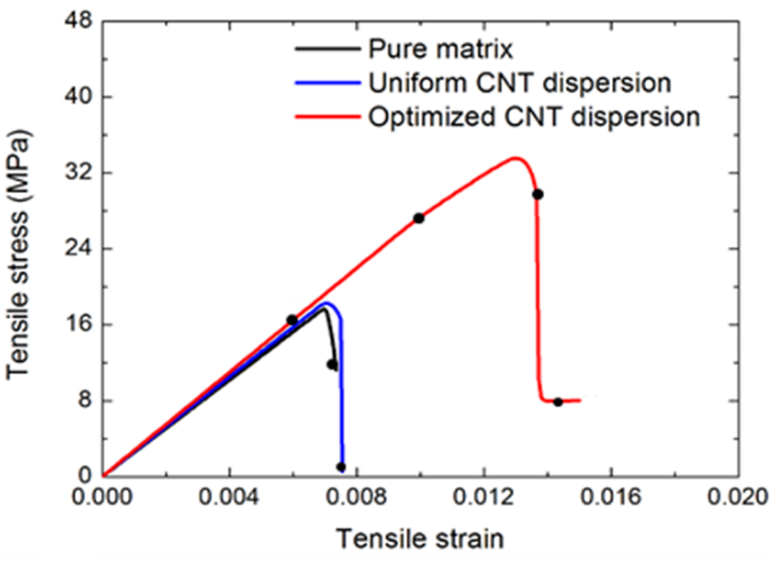
Figure 3. Stress-strain diagrams corresponding to the configurations shown in Figure 1.

4. Conclusions

In this work we propose a new hybrid computational framework to optimize spatial distribution and orientation of nanotubes to target suppression of stresses and then to predict its effect on composite mechanical properties such as stiffness, strength and toughness. The framework is based in a dual-scale FE model, which combines embedded elements (superimposed meshes), representing CNTs, with cohesive elements to model CNT/matrix interface, and the genetic algorithm tools for the CNT network optimization. The studied toughening phenomena occur concurrently at the nano- and micro-scales. We have demonstrated with this approach that the strength and toughness of nanocomposites can be dramatically enhanced by optimizing the spatial position and orientation of CNTs.

Acknowledgments

The authors thank the support from C24/16/021 project, funded by KU Leuven Research Council. S.V. Lomov holds the Toray Chair for Composite Materials at KU Leuven.

References

[1] V.S. Romanov, S.V. Lomov, I. Verpoest, L. Gorbatikh. Modelling evidence of stress concentration mitigation at the micro-scale in polymer composites by the addition of carbon nanotubes. Carbon, 82: 184-194, 2015.
[2] V.S. Romanov, S.V. Lomov, I. Verpoest, L. Gorbatikh. Can carbon nanotubes grown on fibers fundamentally change stress distribution in a composite?. Composites Part A: Applied Science and Manufacturing, 63: 32-34, 2014.
[3] Q. Liu, S.V. Lomov and L. Gorbatikh. Spatial distribution and orientation of nanotubes for suppression of stress concentrations optimized using genetic algorithm and finite element analysis. Materials and Design (under review)
[4] Ghasemi H, Brighenti R, Zhuang X, Muthu J, Rabczuk T. Optimization of fiber distribution in fiber reinforced composite by using NURBS functions. Comp Mater Sci 83: 463-73, 2014.
[5] A. Melro, P. Camanho, F.A. Pires, S. Pinho. Micromechanical analysis of polymer composites reinforced by unidirectional fibres: Part I - Constitutive modelling. International Journal of Solids and Structures, 50(11): 1897-1905, 2013.

