Analysis of cutting force and surface integrity in low frequency vibration drilling CFRP/Ti stacks

Y. Chen¹, H.J. Yang² and Y.S. Zhang³

Jiangsu Key Laboratory of Precision and Micro-Manufacturing Technology, Nanjing University of Aeronautics and Astronautics, Yudao Street 29, Nanjing, 210016, China
¹Email: ninaych@nuaa.edu.cn
²Email: 616262993@qq.com
³Email: zys20081129@qq.com

Keywords: CFRP/Ti stacks, low frequency vibration drilling, cutting force, chip breaking, hole surface

Abstract
During drilling CFRP/Ti stacks, the continuous chips of titanium alloy always scratch CFRP hole wall surface, which give rise to delamination and hole damage of CFRP. In order to address these problems, low frequency vibration drilling (LFVD) technology is applied to break chip of titanium alloy. The experiments on conventional drilling and LFVD of CFRP/Ti stacks have been carried out. Moreover, the influences of the amplitude and processing parameters on chip morphology, the influences of drilling methods on cutting force and surface integrity in LFVD CFRP/Ti stacks are analyzed. The experimental results show that LFVD can effectively break continuous chip of titanium alloy. In addition, with the increase of the amplitude, the chip thickness increases while the chip length decreases. Meanwhile, the chip length and the chip thickness increase with the increase of the feed rate. However, the cutting speed has little effect on the chip size. Compared with conventional drilling, the maximum of thrust force in LFVD is larger. Furthermore, LFVD technology improves the quality of CFRP hole wall.

1. Introduction

Carbon fiber reinforced plastics (CFRP) have been extensively applied in the aerospace industry thanks to their extraordinary mechanical properties including the excellent specific strength and stiffness, which allows a weight reduction to decrease fuel consumption [1, 2]. Meanwhile, in order to withstand high stress and further reduce weight, the hybrid structures made of CFRP and titanium alloy in stacks have increasingly applied in aerospace applications [3-5]. The wing-fuselage connection of Boeing 787 Dreamliner is a typical application. CFRP and titanium alloy are initially separated material layers. Thus, it is necessary to manufacture boreholes to join them by rivets or bolts [6]. Because a large number of holes need to be drilled out, the quality control of drilling becomes significant for achieving undamaged workpieces.

CFRP and titanium alloy belong to the difficult-to-machine materials which leads to additional difficulties to machining of the two kinds of materials in a hybrid stack. Drilling CFRP/Ti stacks usually produces severe hole damage including delamination, matrix degradation and fiber pullout of CFRP, exit burr defect of titanium alloy, etc., which leads to a great deal of rejections in the assembly process. In addition, the drilling action shortens the tool life owing to the rapid tool wear [7]. So far, the drilling process of CFRP/Ti stacks is a quite challenging task due to completely different machinability properties of both materials [8, 9]. High cutting temperatures and insufficient chip extraction of titanium alloy are major concerns in drilling CFRP/Ti stacks, which damages the surface integrity of CFRP. The hot and sharp chips of titanium alloy give rise to damages and disturbances of the surface especially in the CFRP layer [10, 11]. Okamura [12] investigated low frequency vibration drilling (LFVD) of titanium alloy and showed LFVD could control chip formation to reduce chip jamming and reduce drilling temperature. Thus, LFVD is a promising method with better machining performance.

To address above-mentioned problems in, low frequency vibration drilling technology is applied to break chips of titanium alloy during drilling CFRP/Ti stacks in this work. First, the range of vibration conditions for chip breaking is analyzed theoretically and verified by experiments. Then, the chip morphology of titanium alloy in conventional drilling are compared with that in low frequency vibration drilling, and the influence of amplitude, cutting speed and feed rate on the chip size are studied. Furthermore, the differences of cutting force between two varied drilling methods in various amplitudes, speeds, and feed rates are analyzed. Finally, CFRP hole wall morphology, the entrance spalling of the CFRP, CFRP hole surface roughness, and exit burr of titanium alloy are also analyzed in conventional drilling and low frequency vibration drilling.

2. Experimental setup and materials

In this work, all experiments were carried out on a DMG Ultrasonic 20 Linear high-speed machining center, and axial oscillations were generated by a “Sine Holing” vibration tool holder of Mitis-Engineering with an adjustable amplitude of 0-0.50 mm and a fixed frequency of 2.5/rev as shown in Fig. 1. The cutting force was collected with a data acquisition system composed of a 9272 Kistler dynamometer and a 5070A Kistler ampliﬁer. The amplitude was measured by the M70LL/0.5 Ultra-High Speed Laser displacement sensor. After machining, the workpieces were observed through digital microscope HIROX KH-7700 and SEM (scanning electron microscope) Hitachis-3400NⅡ.

The CFRP/Ti stacks consist of 2.8mm-thick CFRP laminate on the top and 1.5mm-thick Ti6Al4V plate at the bottom. The CFRP laminates were fabricated from IMS/X850 prepregs with T800 carbon fibers which were stacked according to the sequence [+45/90/-45/0/+45/90/-45/0/-45/0]s and the fiber volume fraction is 65%. Solid carbide twist drills with diameter of 4.763 mm were used.

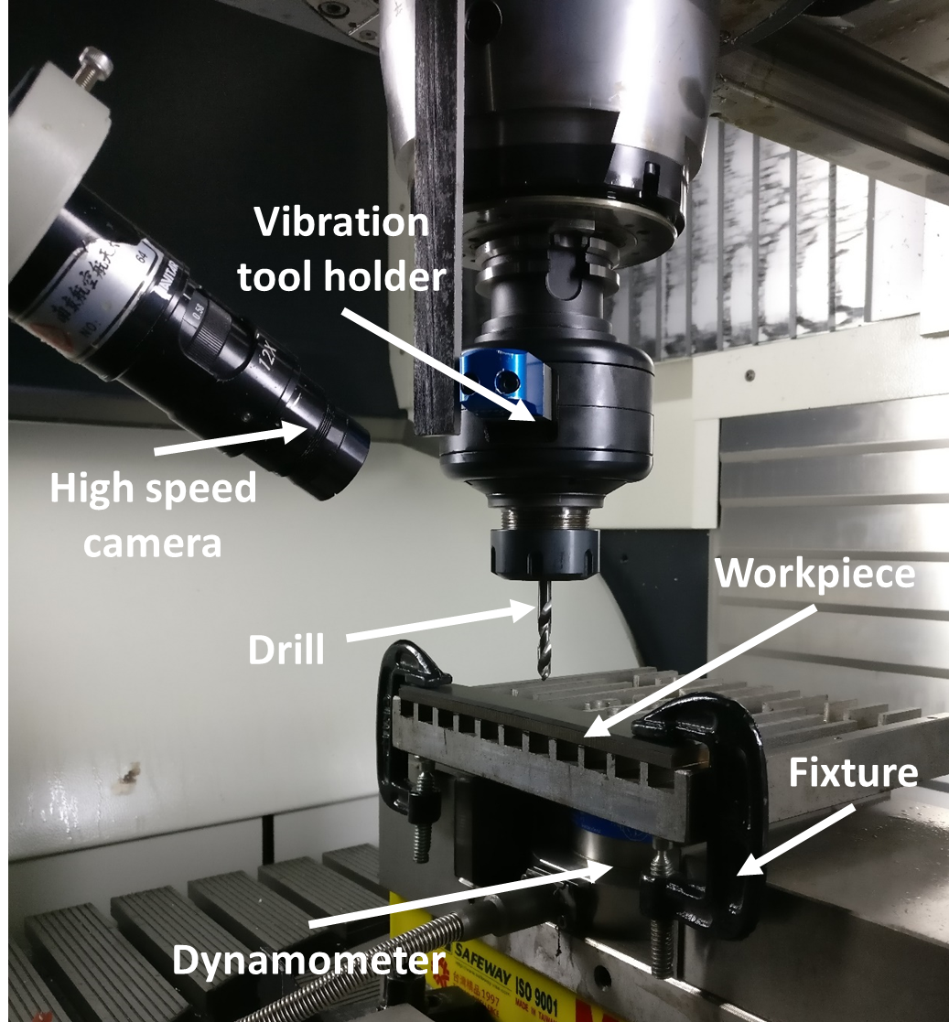

Figure 1. Experimental setup.

Table 1 gives the machining parameters and their values. The test of different parameter combinations were replicated three times. All the drilling experiments have been taken under dry conditions and the CFRP chips were sucked through a vacuum cleaner.

Table 1. Machining Parameters.

Spindle speed n  (rpm) | Feed rate f_{r}  (mm/rev) | Frequency w_{f}  (/rev) | Amplitude A  (μm)
500 | 0.02 | 2.5 | 10
700 | 0.04 | 2.5 | 20
1000 | 0.06 | 2.5 | 30
1500 | 0.08 | 2.5 | 40

3. Results and discussion

3.1. The formation of discontinuous chip during LFVD

For LFVD with two cutting edges, the displacement equation at the middle point corresponding to the curved surfaces can be expressed by [13]:
t=(1，2……m) | (1)
where f_{r} is feed rate, A is amplitude, w_{f} is frequency, θ is rotational angle of the drill.

When the drill is engaged in the material, the uncut chip thickness H_{cut}(t) is equal to the distance between the surface down-hole and the cutting edge. When the drill is separated from the material, the uncut chip thickness is zero, which is described as following.
(2)

Simulation results of five vibration cycles for the viable uncut depth in vibration drilling are shown in Fig. 2, on the condition of A=40 µm, w_{f}=2.5/rev, f_{r}=0.02 mm/rev, n=1000rpm. It indicates that the cutting process in LFVD is a discrete cutting process which essence of this discrete cutting process is to redistribute the uniform uncut cutting depth in conventional drilling and to change into a variable uncut cutting depth [14].

Accoding to the Eq. 1, the condition of the uncut chip thickness H_{cut}(t)=0 can be expressed by:
(3)
In this work, due to w_{f}=2.5/rev, when A≥0.354 f_{r}, the discontinuous chip can be formed. However, A is influenced by material properties, cutting edge radius, and other factors. Chip morphology of titanium alloy using conventional drilling is shown in Fig. 3 (a) on the condition of f_{r}=0.06 mm/rev, n=700rpm, and that using LFVD is shown in Fig. 3 (b) on the condition of A=30 µm, w_{f}=2.5/rev, f_{r}=0.06 mm/rev, n=700rpm. It illustrates that LFVD can form discontinuous chips, which is beneficial in chip ejection and reduce of jamming.

Figure 2. Discontinuous chip formation in LFVAD.

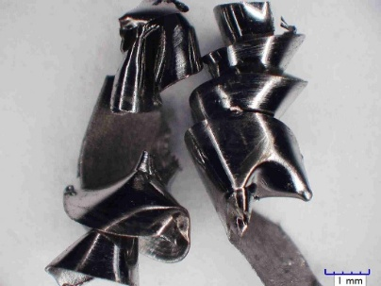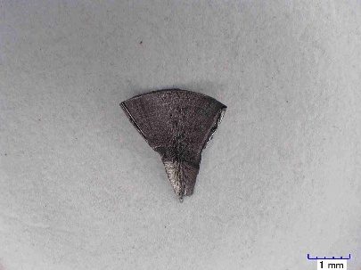
(a) conventional drilling (b) low frequency vibration drilling

Figure 3. Chip morphologies of titanium alloy with different drilling methods.

3.2. Chip morphology analysis

The effects of amplitude, feed rate and spindle speed on chip morphology of titanium alloy are shown from Fig. 4 to Fig. 6. It can be seen that the chip is continuous when the amplitude is 0μm (conventional drilling). However, with the increase of the amplitude, the chip becomes thicker and shorter (as shown in Fig. 4). It is because the uncut chip thickness increase with increase of amplitude. When amplitude is 10μm, conical helix type chips are generated due to not meetting chip breaking conditions.

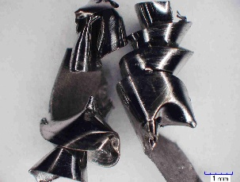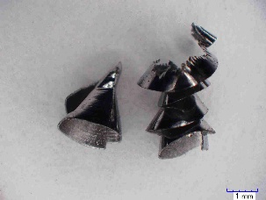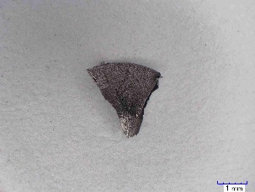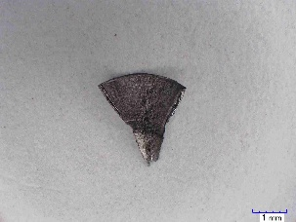
(a) A =0μm (b) A =10μm (c) A =20μm (d) A =30μm

Figure 4. Chip morphologies with different amplitudes (n=700rpm, f_{r}=0.06mm/r).

The chip length and the chip thickness increase with the increase of the feed rate. However, the spindle speed has little effect on the chip size (as shown in Fig. 5 and Fig. 6). The larger volume of material need to be removed with the feed rate, which causes each chip to become longer and thicker. Through theoretical analysis in 3.1, the spindle speed has no effect on chip size. Experiment results confirm the correctness of theoretical analysis.

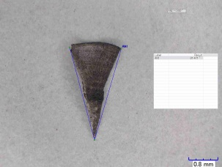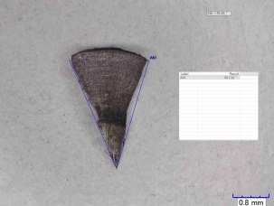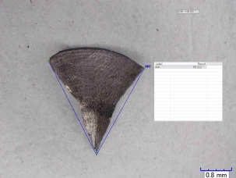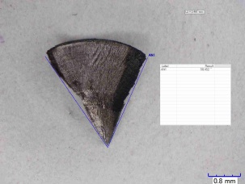
(a) f_{r} =0.02mm/r (b) f_{r} =0.04mm/r (c) f_{r} =0.06mm/r (d) f_{r} =0.08mm/r

Figure 5. Chip morphologies with different feed rates (n=1000rpm, A=40μm).

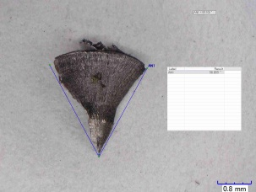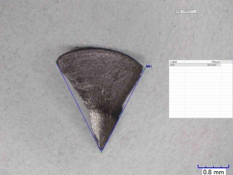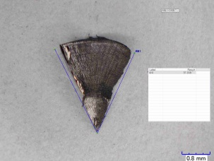
(a) n =500rpm (b) n =700rpm (c) n =1000rpm (d) n =1500rpm

Figure 6. Chip morphologies with different spindle speeds (f_{r}=0.06mm/r, A=30μm).

3.3. Cutting force analysis

Cutting force is the main important factor contributing the mechanical load on the drill. Compared with conventional drilling, the maximum axial force of LFVD is larger as shown in fig. 7. This is mainly due to vibration impact.

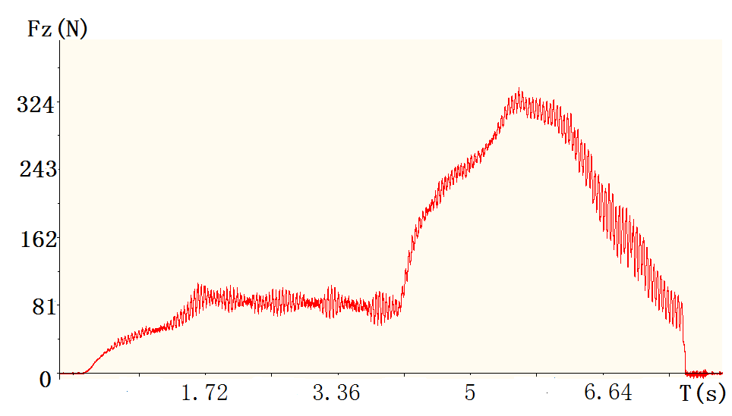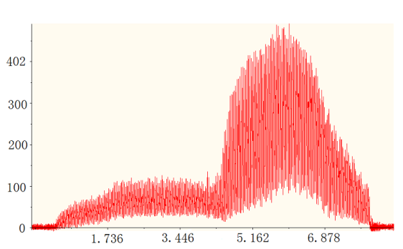

(a) conventional drilling (b) LFVD (A=30μm)

Figure 7. Trust force (n=700rpm, f_{r}=0.06mm/r).

3.4. Hole quality analysis

Error: Reference source not found illustrates the effect of drilling methods on CFRP surface quality. The damage caused by chips scratching is evident in conventional drilling, usually covering several layers at a random position. In contrast, the fragmented chips obtained in LFVD was in a free state in three directions as the chips size is smaller than the chip flute space. Thus, damage caused by titanium chips are reduced greatly and CFRP surface quality is improved.
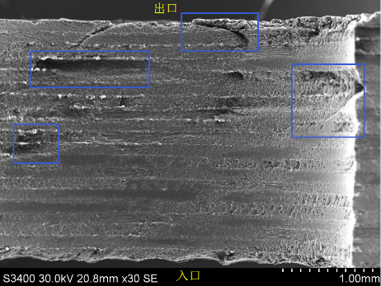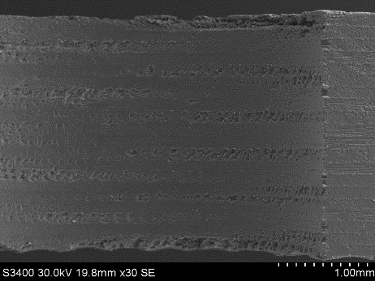

(a) conventional drilling (b) LFVD (A=30μm)

Figure 8. Morphology of CFRP hole wall (n=700rpm, f_{r}=0.06mm/r).

4. Conclusions

The formation of discontinuous chip during LFVD are analyzed and the influences of the amplitude and processing parameters on chip morphology, the influences of drilling methods on cutting force and surface integrity in LFVD CFRP/Ti stacks are investigated. Based on the results obtained from the experiments, the following conclusions could be extracted.

- When amplitude is greater than a certain value related with feed rate, the discontinuous chip can be formed.
- With the increase of the amplitude, the chip thickness increases while the chip length decreases. Moreover, the chip length and the chip thickness increase with the increase of the feed rate. However, the cutting speed has little effect on the chip size.
- The maximum axial force of LFVD is larger than that of conventional drilling.
- LFVD technology can improve surface quality of CFRP hole.

Acknowledgments

This work was supported by the National Natural Science Foundation of China (No. 51375234), Jiangsu Key Laboratory of Precision and Micro-Manufacturing Technology and Funding of Jiangsu Innovation Program for Graduate Education (No. KYLX16_0318).

References

[1] Q.L. Chen, J.W. Zhou, X.M. Chen, Y Chen, and Y.C. Fu. Experimental study on delamination during trimming of CFRP. Advanced Materials Research, 1089(18):331-336, 2015.
[2] W.L. Cong, Z.J. Pei, T.W. Deines, A. Srivastava, L. Riley, and C. Treadwell. Rotary ultrasonic machining of cfrp composites: a study on power consumption. Ultrasonics, 52(8):1030, 2012.
[3] M. Ramulu, T. Branson, and D. Kim. A study on the drilling of composite and titanium stacks. Composite Structures, 54(1):67-77, 2001.
[4] R. Zitoune, V. Krishnaraj, B.S. Almabouacif, F. Collombet, M. Sima, and A. Jolin. Influence of machining parameters and new nano-coated tool on drilling performance of CFRP/aluminium sandwich. Composites Part B Engineering, 43(3):1480-1488, 2012.
[5] I.S. Shyha, S.L. Soo, D.K. Aspinwall, S. Bradley, R. Perry, and P. Harden, et al. Hole quality assessment following drilling of metallic-composite stacks. International Journal of Machine Tools & Manufacture, 51(7), 569-578, 2011.
[6] C. Meier, Bild der Wissenschaft Online, http://www.bild-derwissenschaft. de/bdw/bdwlive/heftarchiv/inc/popup_print.php?object_id=32714169, Access 22.11.2013.
[7] J. Xu, A. Mkaddem, and M.E. Mansori. Recent advances in drilling hybrid FRP/Ti composite: a state-of-the-art review. Composite Structures, 135(1):316-338, 2016.
[8] D.F. Liu, Y.J. Tang, and W.L. Cong. A review of mechanical drilling for composite laminates. Composite Structures, 94(4):1265-1279, 2012.
[9] O. Pecat, and E. Brinksmeier. Low damage drilling of cfrp/titanium compound materials for fastening. Procedia CIRP, 13(13):1-7, 2014.
[10] E. Brinksmeier, and R. Janssen. Drilling of multi-layer composite materials consisting of carbon fiber reinforced plastics (CFRP), titanium and aluminum alloys. CIRP Annals - Manufacturing Technology, 51(1):87-90, 2002.
[11] E. Brinksmeier, S. Fangmann, and R. Rentsch. Drilling of composites and resulting surface integrity. CIRP Annals - Manufacturing Technology, 60(1):57-60, 2011.
[12] K. Okamura, H. Sasahara, T. Segawa, and M. Tsutsumi. Low-frequency vibration drilling of titanium alloy. Jsme International Journal, 49(1):76-82, 2006.
[13] L.P. Wang and L.J. Wang. Prediction and computer simulation of dynamic thrust and torque in vibration drilling. Proc. Inst. Mech. Eng., Part B, 212(6):489-497, 1998.
[14] L.B. Zhang, L.J. Wang, X.Y. Liu, H.W. Zhao, X. Wang, and H.Y. Luo. Mechanical model for predicting thrust and torque in vibration drilling fibre-reinforced composite materials. International Journal of Machine Tools & Manufacture, 41(5):641-657, 2001.

