Hybrid, graphene-reinforced
poly(ether ether ketone) nanocomposites

Dimitrios G. Papageorgiou¹, Mufeng Liu², Zheling Li³, Ian A. Kinloch⁴, Robert J. Young⁵

School of Materials and National Graphene Institute, University of Manchester, Oxford Road, M13 9PL, Manchester, United Kingdom
¹Email: dimitrios.papageorgiou@manchester.ac.uk
²Email: mufeng.liu@postgrad.manchester.ac.uk
³Email: Zheling.li@manchester.ac.uk
⁴Email: ian.kinloch@manchester.ac.uk
⁵Email: robert.young@manchester.ac.uk

Keywords: poly(ether ether ketone), graphene, micromechanics, creep

Abstract
In this work, we investigate the viscoelastic properties and creep mitigation of poly(ether ether ketone) (PEEK) reinforced with graphene nanoplatelets (GNPs) and PEEK reinforced with a hybrid graphene and short glass (GFs) or carbon fibre (CF) filler. The introduction of GNPs has improved significantly the stiffness and the storage modulus of the materials in both PEEK-GNP and hybrid composites. A micromechanics study revealed that the stress was transferred more effectively in the case of the short fibres compared to GNPs, while the reinforcement efficiency of GNPs was slightly reduced in the hybrid samples, as a result of aggregation. Finally, the introduction of GNPs led to a restriction of the mobility of the macromolecular chains of PEEK, which had as a result enhanced creep properties at both room temperature and elevated temperatures. Overall, the produced nanocomposites display properties that would make them attractive in applications where high stiffness and structural integrity are considered a prerequisite, such as in engineering materials or the automotive/aerospace industries.

1. Introduction

The class of polyaryletherketones are considered very important engineering thermoplastics due to their combination of high strength and toughness, their high thermo-oxidative stability, the excellent flame retardancy, their biocompatibility and their chemical and wear resistance . Amongst polyaryletherketones, poly(ether ether ketone) (PEEK) has emerged as one of the most important, high-performance engineering materials and has found application in demanding engineering components such as bearings and piston parts, in aerospace, automotive and chemical process industries, in medical implants and others. However, the constant demand of advanced industries for even better-performing materials, has led to the development of PEEK-based nanocomposites , where nanofillers such as carbon nanotubes and (nano)fibers , and more recently, graphene have been used as reinforcing agents.
Graphene, since its discovery has attracted the attention of both industry and academia due to its extraordinary combination of properties, including its strength and stiffness of 130 GPa and 1050 GPa respectively, its high electron mobility at room temperature, its thermal conductivity and large surface area, amongst others . As it was expected, this multifunctionality of graphene finds perfect use in the field of polymer nanocomposites, as the introduction of graphene-related materials has been proven to produce advanced, high-performing composites that can be used in a number of applications. In this work, we have introduced graphene nanoplatelets (GNPs) into poly(ether ether ketone) by melt-mixing and observed their effect on the mechanical properties and creep mitigation under various experimental conditions. Moreover, as we investigated recently, a strategy that can enhance even further the properties of a composite material or counterbalance some of the disadvantages of a specific filler, is the production of hybrid composites, where two or more reinforcements are used in combination . Therefore, we introduced GNPs in various loadings within PEEK/short carbon fibre (CF) and PEEK/short glass fibre (GF) composites, in order to observe any additive or synergistic effects on the mechanical properties of the hybrid materials. In the past, Diez-Pasqual and coworkers introduced single walled carbon nanotubes (SWCNTs) in continuous PEEK-glass fibre laminates . They observed significant improvements in the storage modulus and glass transition temperature of the nanocomposites, while the tensile properties increased moderately, as a result of the predominant strength of the continuous laminates. Very recently, Su et al. prepared carbon nanotube/carbon fibre/PEEK hybrid composites by spraying CNTs onto PEEK/CF prepregs. The final materials displayed enhanced interlaminar shear strength and flexural strength and modulus as a result of the mechanical interlocking effect of CNTs.
Herein, we have focused on the viscoelastic response and the creep mitigation of PEEK-GNPs and PEEK filled with GNPs and short glass or carbon fibres. The micromechanics of reinforcement have been thoroughly evaluated, while creep, a property that can provide information on the duration of polymers for practical and engineering applications, has been measured at room temperature and at 240 ºC.

2. Materials

PEEK was supplied by Solvay under the commercial name KetaSpire KT-880 NT and exhibited a specific gravity of 1.3 and a melt flow of 36 g /10 min. The glass-filled and the carbon fibre-filled PEEK were also a part of the KetaSpire series of Solvay, under the commercial names KT-880-GF30 and KT-880-CF30. Both materials included a fibre content of 30 wt.%. The specific gravity was 1.53 for KT-880-GF30 and 1.41 for KT-880-CF30, while the melt flow was 14 g / 10 min and 11 g / 10 min for KT-880-GF30 and KT-880-CF30, respectively. The graphene nanoplatelets (xGNPs-M25) were obtained by XG Sciences and according to the supplier, they exhibited a mean platelet diameter of 25 μm and a thickness of 6-8 nm.
The melt-mixing process took place in a high-temperature Thermo Fisher HAAKE Rheomix internal mixer, 150 rpm for 20 mins for each sample. The processing temperature was set at 360 oC for the PEEK-GNP samples, while for the PEEK-GF-GNP and the PEEK-CF-GNP samples, it was set at 370 oC. For the preparation of the dumbbell specimen for the tensile testing of the samples, neat PEEK and the PEEK-GNP samples (with the exception of PEEK-GNP20) were injection moulded in a Haake MinijetPiston injection moulding system. The temperature of the mould was set at 245 ºC and the temperature of the barrel was 390 ºC. The injection pressure was 1200 bar for all samples. The rest of the dumbbells were prepared by hot pressing the composite samples in a stainless-steel, dumbbell-shaped mould between two thermally insulating Kapton films. The length of the carbon and glass fibres were measured after all the processing steps and were found to be 81 ± 30 μm for the GF and 152 ± 50 μm. The GNP contents were 1, 5, 10 and 20 wt% in all three sets of samples and the PEEK-filled materials will be named PEEK-GNPx throughout the manuscript, where x is the filler content in wt%. For the case of the hybrid samples, the PEEK-GF30 and PEEK-CF30 were treated as matrices and GNPs were added during the melt mixing process, a fact that caused a proportional reduction in the overall GF and CF content in the final composites, due to increasing GNP content. Four sets of samples were prepared for the glass fibre-GNP reinforced composites, namely PEEK-GF29.7-GNP1, PEEK-GF28.5-GNP5, PEEK-GF27-GNP10 and PEEK-GF24-GNP20. The same applies also for the carbon-fibre-GNP reinforced composites. The filler volume fraction was calculated from the relationship

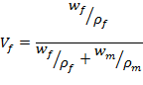
where w_{f} is the weight fraction of the filler and ρ_{f} and ρ_{m} are the densities of the filler and the matrix, respectively. For the case of the hybrid samples, the density and the weight fraction of the CFs and GFs have been taken into account and the relationship has been adjusted.

2.1 Characterization of the PEEK composites

Scanning electron microscopy (SEM) was performed on tensile-fractured samples with a FEI-Sirion FEG-SEM. Tensile testing was performed using an Instron3365 testing system with a load cell of 5 kN and the stress-strain curves were obtained under a tensile rate of 0.5 mm min⁻¹, in accordance with ASTM D638. At least five samples were tested for each filler content and the deformation was recorded with an extensometer mounted on the narrow section of the dumbbells. Prior to mechanical testing, a heat treatment procedure was performed to the samples in order to ensure a similar degree of crystallinity of the matrix and the composites The creep and recovery tests of all samples were performed by using a DMA Q800 analyzer (TA Instruments). The creep strain was recorded as a function of time (creep; 7500 sec, recovery; 3600 sec) under a low stress of 5 MPa at two different temperatures, namely 30 and 240 ºC.

3. Results and Discussion

3.1 Scanning Electron Microscopy

Scanning electron microscopy was employed to investigate the morphology of the samples after tensile testing. From Figure 1a, for the PEEK-GNP10 sample, it can be seen that the surface of the composite was rough, with a number of flakes being pulled out of the matrix, as a result of the tensile testing procedure. Despite the high loading, the distribution of the nanoplatelets can be considered satisfactory, while a small number of voids that are observed can be attributed to the aggregates that were formed and acted as a failure points during the elongation procedure. Regarding the hybrid samples presented in Figures 1b and c, it can be seen that a number of short glass or carbon fibres were pulled out of the matrix. The length of the fibres was varying, while the orientation was random. Moreover, it is important to notice that all fibres were coated with a polymer/GNP mixture, possibly indicating increased interactions between the components of the hybrid composite. Again, circular voids were observed as a result of fibres being pulled out, while the voids with the irregular shapes should be also attributed to aggregation phenomena.

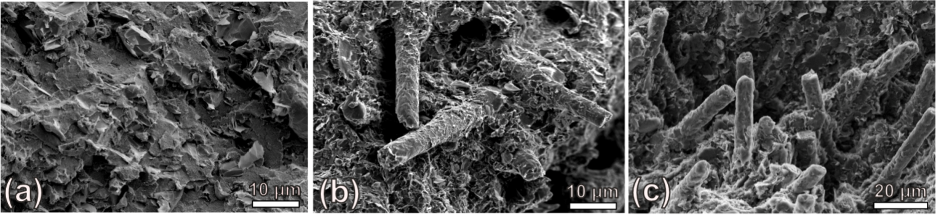

Figure 1. SEM images after tensile fracture from (a) PEEK-GNP10, (b) PEEK-GF27-GNP10 and (c) PEEK-CF27-GNP10 samples

3.2 Tensile testing

The mechanical properties of the composites were evaluated by tensile testing and representative stress-strain curves of the three sets of samples can be seen in Fig. 2(a-c), while the results from mechanical testing can be seen in Fig.2(d, e). It can be realised that the presence of GNPs attributed an increase of the tensile modulus of the composites, even though PEEK is already one of the stiffest engineering plastics. For the PEEK-GNP set of samples, an almost linear increase in the Young’s modulus was observed with increasing filler content, indicating the efficiency of the GNPs. For the hybrid samples on the other hand, the high filler contents lead to a levelling off of the stiffness before reaching the highest total filler content, most probably due to heavy aggregation. As expected, the carbon fibre filled composites (PEEK-CF-GNP) presented higher modulus values than the glass fibre filled ones (PEEK-GF-GNP) as a result of the high inherent stiffness of CFs, compared to GFs .
Regarding the fracture stress, aggregation is known to play a major role on the enhancement of the property and that is why the fracture stress of the hybrid samples was continuously decreasing with increasing GNP content. For the PEEK-GNP samples, a small increase was observed at GNP loadings up to 5 wt%, while from that point on, a decrease was also observed.

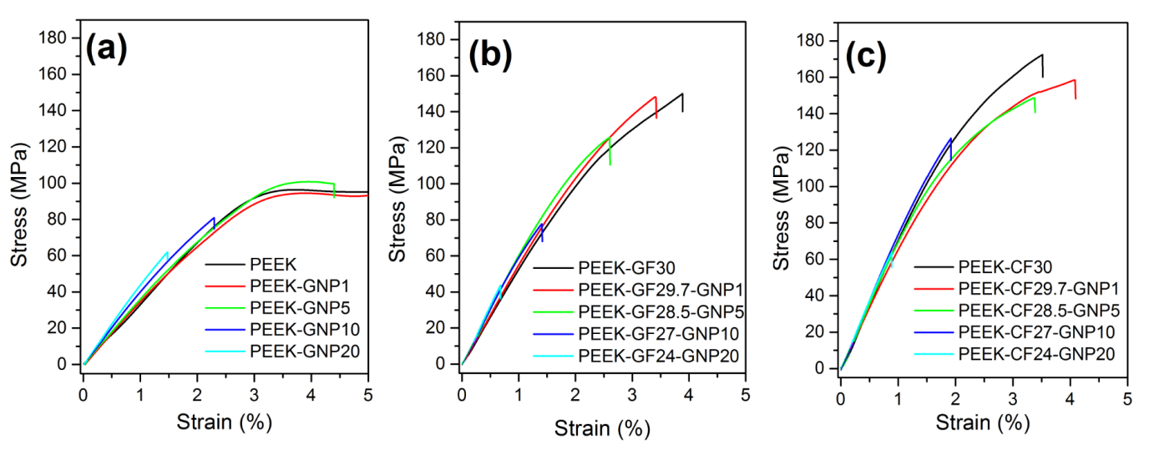
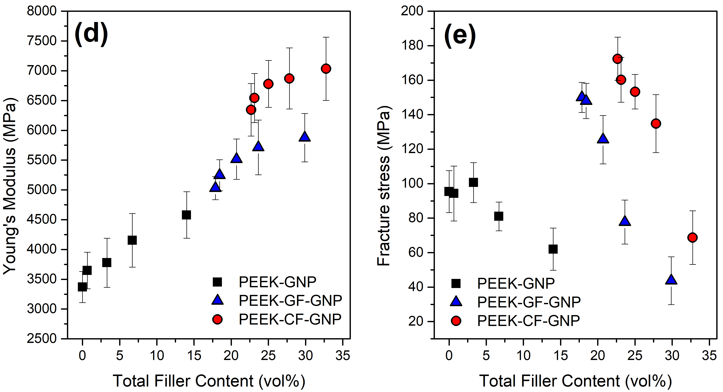

Figure 2. Representative stress-strain curves for (a) PEEK-GNP, (b) PEEK-GF-GNP, (c) PEEK-CF-GNP composites. Experimental results from Young’s modulus (d) and fracture stress (e) for all samples under study

3.3 Creep and Recovery

Creep properties can provide information on the structural behavior of the materials under time-dependent deformation. It is known that in the case of polymers, the macromolecular chains are stretched and re-oriented under a constant load, resulting in dimensional mismatch and even failure of the materials. PEEK is known to display excellent creep resistance, especially at ambient temperatures . The results from the creep and recovery tests of PEEK-GNP can be seen in Fig. 3. The applied stress in the samples was 5 MPa, in order to ensure that the stress deformation of sample was within the elastic range. From Fig. 3 it can be realised that the increase in temperature leads to an increase of the creep strain as a result of the softening of the polymer matrix at elevated temperature and the dilation of the fibre/matrix interface. Obviously, the inelastic strain of PEEK-GNP samples is the highest amongst the three set of samples due to the lower stiffness of the materials, observed from tensile tests. In addition, the slope of the curves during the creep part is also different as a result of the temperature increase. This can be the outcome of the enhanced configurational mobility of polymer chains, as the thermodynamic barrier is overcome through the transformation of enthalpic gain to entropic gain. Therefore, the tie-point stiffness is reduced and the slippage of the chains past each other is facilitated . The increase of the GNP content in all sets of samples leads to a reduction of both the creep deformation and recovery with increasing filler contents, indicating the enhanced creep resistance of the composites after the addition of GNPs.

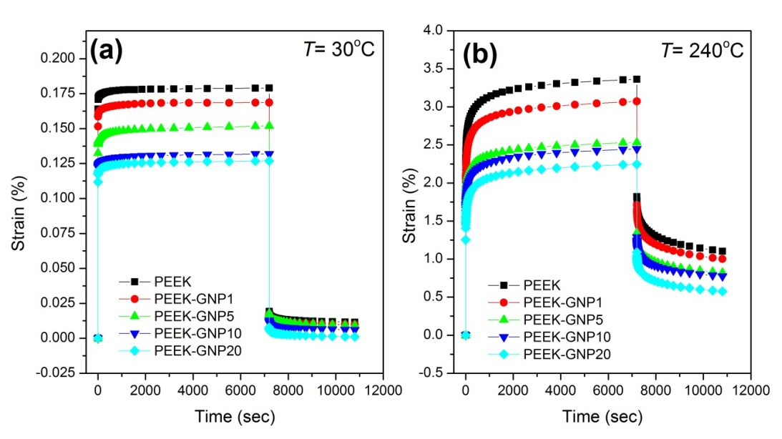

Figure 3. Creep and recovery data as a function of time at (a) 30 ºC and (b) 240 ºC for the PEEK-GNP set of samples

In order to obtain quantitative results on the effect of GNPs on the creep properties of PEEK and the hybrid samples under different temperatures, the ratio of difference in the magnitudes of creep strains between the matrix and the GNP-reinforced composites was calculated from the following relationship which can be considered as a measure of the creep reinforcing efficiency :

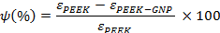

In the case of the hybrid samples, the PEEK-GF30 and PEEK-CF30 were treated as matrices in order to obtain the respective results on the reinforcing efficiency of PEEK-GF-GNP and PEEK-CF-GNP samples. From Fig. 4 it can be realised once again that the graphene nanoplatelets are efficient in the reduction of creep as a result of the formation of a network of cross-linking elements that interconnect the macromolecular chains, increasing this way the cross-linking density and obstructing a disentanglement of the chains under stress and localized re-orientation. This phenomenon is strongly connected to the interfacial bonding between the matrix and the fillers and reveals that the interface between the GNPs and the matrix in all three types of composites is quite good. Moreover, the exceptional performance of the composites at both low and high temperatures indicates that the matrix-filler interface and the ability of the GNPs to obstruct the re-orientation of the chains is not significantly weakened from the increase of temperature. If we examine the results individually we can realise that for the case of the PEEK-GNP samples, the ψ values are almost the same at low and high temperatures, indicating the structural stability of the PEEK/GNP interface, even at high temperatures. The same conclusion can be exported for the PEEK-GF-GNP sample, where the values of ψ are considerably higher than the PEEK-GNP samples, as a result of additive reinforcement from the presence of both fillers. Finally, for the PEEK-CF-GNP samples, their inherent high stiffness leads to a significant increase of ψ at low temperature, while a slightly less pronounced increase was observed at higher temperatures, compared to the other two sets of samples, possibly indicating enhanced crosslinking and a PEEK/CF interface with higher structural integrity.

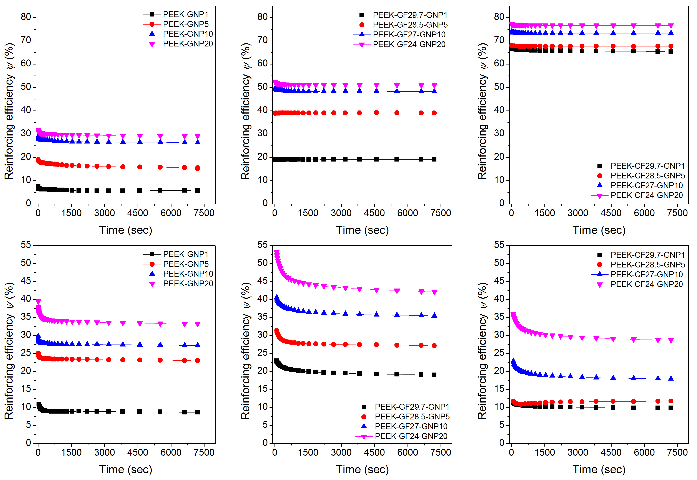

Figure 4. Reinforcing efficiency of GNPs for PEEK, PEEK-GF-GNP and PEEK-CF-GNP samples at different temperatures (top row) 30 ºC and (bottom row) 240 ºC.

4. Conclusions

The effect of the presence of GNPs and the simultaneous presence of CFs or GFs and GNPs on the viscoelastic properties and creep mitigation of a PEEK matrix, was investigated. The presence of GNPs, enhanced the stiffness of the matrix, while the combination of the fillers led to additive reinforcement in terms of both the Young’s modulus and storage modulus of the hybrid composites. The high aspect ratio of the GNPs confined the macromolecular chains of PEEK and restricted their mobility for all samples. This, along with the high stiffness of the materials had as a result an enhancement of the creep properties of the composites. It was realised that the GNPs increased the cross-linking density and obstructed a disentaglement of the PEEK chains at both low and high temperatures, leading to enhanced creep properties. Overall, the viscoelastic and creep performance of the prepared composites should be attractive for high-temperature applications where structural integrity is a prerequisite.

Acknowledgments

This research has been supported by funding from the European Union Horizon 2020 Programme under the Graphene Flagship grant agreement n°604391and the EPSRC (award no. EP/I023879/1). One of the authors (M. Liu) is grateful to the China Scholarship Council for financial support. All research data supporting this publication are available within this publication.

References

[1] Young RJ, Lovell PA. Introduction to polymers: CRC press; 2011.
[2] Díez-Pascual AM, Naffakh M, Marco C, Ellis G, Gómez-Fatou MA. High-performance nanocomposites based on polyetherketones. Progress in Materials Science. 2012;57(7):1106-1190.
[3] Newcomb BA, Chae HG, Thomson L, Luo J, Baek J-B, Kumar S. Reinforcement efficiency of carbon nanotubes and their effect on crystal-crystal slip in poly (ether ketone)/carbon nanotube composite fibers. Composites Science and Technology. 2017;147:116-125.
[4] Sandler J, Werner P, Shaffer MS, Demchuk V, Altstädt V, Windle AH. Carbon-nanofibre-reinforced poly (ether ether ketone) composites. Composites Part A: Applied Science and Manufacturing. 2002;33(8):1033-1039.
[5] Liu L, Yan F, Li M, Zhang M, Xiao L, Shang L, et al. Improving interfacial properties of hierarchical reinforcement carbon fibers modified by graphene oxide with different bonding types. Composites Part A: Applied Science and Manufacturing. 2018;107:616-625.
[6] Papageorgiou DG, Kinloch IA, Young RJ. Mechanical properties of graphene and graphene-based nanocomposites. Progress in Materials Science. 2017;90:75-127.
[7] Papageorgiou DG, Kinloch IA, Young RJ. Graphene/elastomer nanocomposites. Carbon. 2015;95:460-484.
[8] Papageorgiou DG, Terzopoulou Z, Fina A, Cuttica F, Papageorgiou GZ, Bikiaris DN, et al. Enhanced thermal and fire retardancy properties of polypropylene reinforced with a hybrid graphene/glass-fibre filler. Composites Science and Technology. 2018;156:95-102.
[9] Papageorgiou DG, Kinloch IA, Young RJ. Hybrid multifunctional graphene/glass-fibre polypropylene composites. Composites Science and Technology. 2016;137:44-51.
[10] Díez-Pascual AM, Ashrafi B, Naffakh M, González-Domínguez JM, Johnston A, Simard B, et al. Influence of carbon nanotubes on the thermal, electrical and mechanical properties of poly(ether ether ketone)/glass fiber laminates. Carbon. 2011;49(8):2817-2833.
[11] Su Y, Zhang S, Zhang X, Zhao Z, Jing D. Preparation and properties of carbon nanotubes/carbon fiber/poly (ether ether ketone) multiscale composites. Composites Part A: Applied Science and Manufacturing. 2018;108:89-98.
[12] Frank O, Tsoukleri G, Riaz I, Papagelis K, Parthenios J, Ferrari AC, et al. Development of a universal stress sensor for graphene and carbon fibres. Nature Communications. 2011;2:255.
[13] Thomason J, Vlug M. Influence of fibre length and concentration on the properties of glass fibre-reinforced polypropylene: 1. Tensile and flexural modulus. Composites Part A: Applied Science and Manufacturing. 1996;27(6):477-484.
[14] Maksimov RD, Kubat J. Time and temperature dependent deformation of poly (ether ether ketone)(PEEK). Mechanics of composite materials. 1997;33(6):517-525.
[15] Ganss M, Satapathy BK, Thunga M, Weidisch R, Pötschke P, Janke A. Temperature dependence of creep behavior of PP–MWNT nanocomposites. Macromolecular rapid communications. 2007;28(16):1624-1633.
[16] Ghosh SK, Prusty RK, Rathore DK, Ray BC. Creep behaviour of graphite oxide nanoplates embedded glass fiber/epoxy composites: Emphasizing the role of temperature and stress. Composites Part A: Applied Science and Manufacturing. 2017;102:166-177.

