EFFECTS OF MICROSTRUCTUREAL ARRANGEMENT OF GRAPHENE SHEETS ON THERMAL CONDUCTIVITY OF POLYMERIC COMPOSITES

Shu Lin BAI, Yunhong ZHAO, Yafei ZHANG, Haoming FANG
Department of Materials Science and Engineering
College of Engineering, Peking University, 100871 Beijing, China
Email: slbai@pku.edu.cn, Web Page: http://en.coe.pku.edu.cn/Faculty-A-Z/78.htm

Keywords: graphene, poymer, microstructure, thermal conductivity

Abstract
The graphene filled polymer composites have both good mechanical and thermal properties and may be applied for heat management of electronics. The strategies to fabricate three-dimensional (3D) graphene structures as well as their polymeric composites are summarized. First, the polymeric composites composed of 3D graphene foam (GF) and polydimethylsiloxane were manufactured. The thermal conductivity (TC) of composite is 0.56 Wm⁻¹K⁻¹ at only 0.7 wt%, i.e. about 300% that of pure matrix. The incorporation of multilayer graphene flakes as second fillers raised the TC to 1.1Wm⁻¹K⁻¹, Second, by using the rolling technique, the vertical alignment of graphene film resulted in 2.6 Wm⁻¹K¹ at 16wt%. Furthermore, by increasing the loading to 92wt%, the TC of composites increased to 612 Wm⁻¹K⁻¹. Ice-templated assembly strategy is also a promising and simple method to realize 3D graphene structure (aerogel). Other techniques such as 3D hot pressing and 3D printing were also utilized to prepare 3D graphene filled polymeric composites and the resulted TC was satisfactory. Based on above study, the 3D structural arrangement of graphene is a promising method to fabricate the polymeric composites with excellent thermal and mechanical performance.

1. Introduction
Recently, graphene-based composites [6] have been regarded as the most promising candidate for heat dissipation materials due to ultra-highly thermal conductivity (~5300Wk⁻¹m⁻¹) [7] and excellent mechanical properties of graphene. Initially, the researchers just followed the conventional method to fabricate graphene-based polymeric composites via simple stirring and mixing. It is found that the poor dispersion and moderate loading of graphene are crucial challenge in this process due to the huge surface area (2630 m²/g) [9] and light weight of graphene. In most reported results [10], the thermal conductivity of composites obtained via traditional strategies is hard to exceed 5Wm⁻¹K⁻¹. Therefore, novel approaches need to be developed
For a single layer GNPs with a perfect crystal structure, thermal conduction along the carbon plane is ballistic with an ultra-highly thermal conductivity. However, when constructing it into macroscopic structure, the large interface, boundary gaps as well as defects would lead to phonon leakage and umklapp scattering [13]. Further, when incorporating it into composites, the phonon mismatch between polymer and graphene crystal lattices would inevitably cause phonon scattering again. To reduce the interfacial thermal resistance inside the composites, one of the efficient strategies is to decrease the interfacial area. Besides, increasing the size of graphene from nanometer to micrometer or even from single nanoplatelet to 3D interconnected structure was found to be a significant and feasible method. Recently, numerous efforts have been made on microstructure engineering of graphene including construction of 3D interconnected frameworks and high orientation processes to enhance thermal conductive performance of composites. In this paper, recent research progress on microstructure engineering of graphene towards highly thermal conductive composites is firstly summarized. Moreover, the effectiveness, mechanism and theoretical simulation of these structures for thermal conductive enhancement are discussed. A schematic summary of microstructure engineering of graphene is shown in Fig. 1.
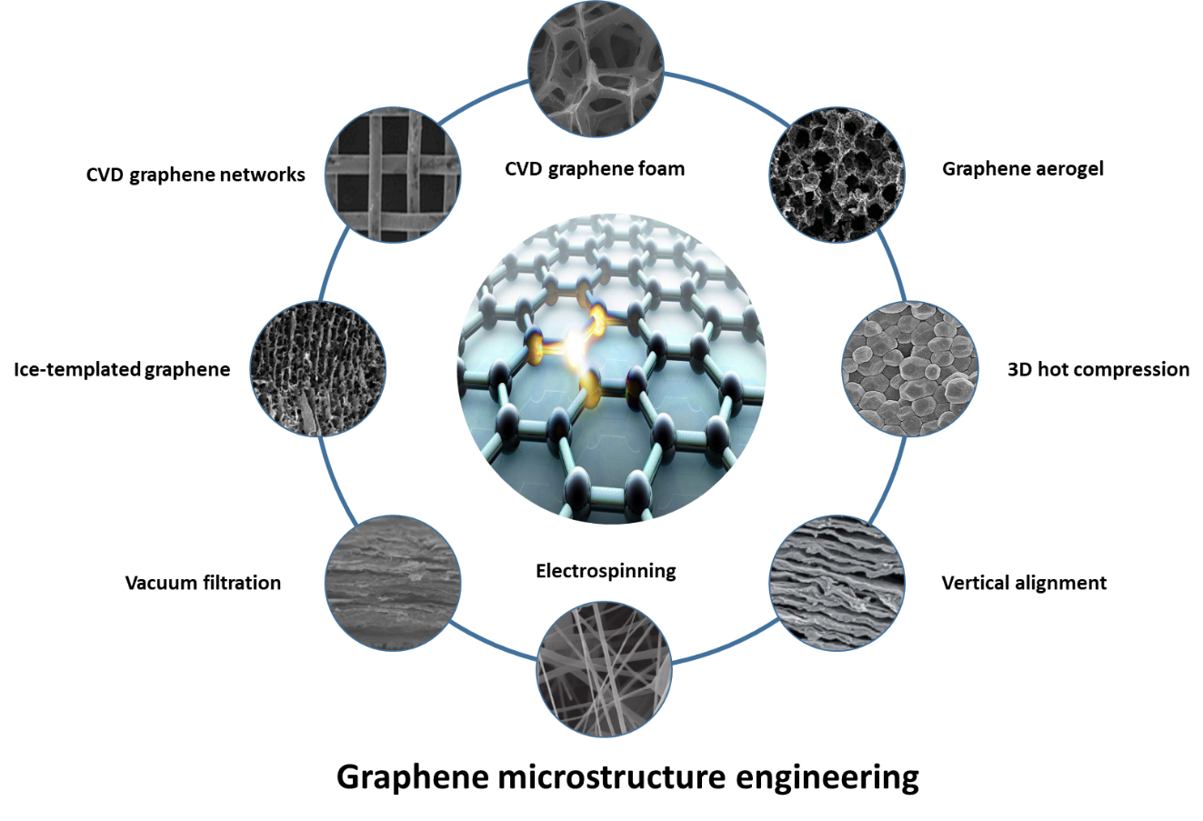
Figure 1 Summary for microstructure of graphene towards highly thermal conductive composites

2. 3D interconnected structure

2.1 Template-based synthesis
Chemical vapor deposition is the most efficient approach to gain monolayer graphene film with large area and high quality [15]. Moreover, various substrates have been reported for graphene formation such as metals [21], alloys [31] and [32] as well as inorganic materials [33]. In addition to CVD method, graphene can also grow directly from carbon atoms aggregation. In general, the quality of graphene is determined by several factors such as roughness and grain size of substrates, lattice match between graphene and substrate and growth condition such as temperature and pressure. Therefore, the quality and thermal conductivity of graphene vary with respect to different methodologies. Zhao et al. [36] synthesized graphene onto nickel foam via CVD and gained 3D interconnected GF by etching off nickel. Then the composite was fabricated by infiltrating PDMS into graphene foam and a highly thermal conductivity of 0.56Wm⁻¹K⁻¹ at 0.4 wt.% was achieved. Gong et al. [37] and Yang et al. [38] used nickel mesh network as growth templates to obtain GMN through similar CVD process. With polyimide and epoxy as matrix, the fabricated composites show thermal conductivity of 3.73Wm⁻¹K⁻¹ and 1.15Wm⁻¹K⁻¹, respectively.

Carbonization of polymer frameworks
Hierarchically porous polymers including PU foam [43], melamine foam [44], pitch [46] and aromatic polyimides [48] are the common template for carbon foam due to simple synthesis route of one-step polymerization. The obtained graphene foams inherit the open cellular and interconnected structure from these polymer foams after carbonization. Karthik et al. [52] used this method to fabricate the GF/PCM composites with TC of 3.77Wm⁻¹K⁻¹ at 25wt.%. Liu et al. [53] improved this method by coating GNPs on PU foam and then carbonizing PU at 700°C. The obtained graphene foam/epoxy composites exhibit 1.52Wm⁻¹K⁻¹ at 5wt.%. Actually, carbonization of polymer template can easily gain a GF with higher loading than CVD method. However, the quality of obtained GF seems to be not good enough. Interconnected degree of the GNPs is obviously lower than the GF from CVD method. In addition, the GNPs are stacked together rather than forming a smooth and flat surface in pyrolysis carbon. Summarily, carbonization process actually provides a feasible strategy to get carbon foam with high loading, but the relatively poor quality of carbon foam degrades its performance.

Ice template
Lian et al. [55] prepared VAHIGNs by a low cost three-step procedure, including formation of graphene oxide liquid crystals, oriented freeze casting and annealing reduction under Ar ambiance. The low-density ordered networks were utilized as the secondary phase to construct epoxy composite which has a highl TC of 2.13Wm⁻¹K⁻¹ at 0.92 vol.%. The porosity of graphene networks can be controlled by freezing temperature and rate during casting. Yang et al. [57] found that the micropores became sparser and smaller with decreasing freezing temperature. The obtained HPSs/PCMs composites exhibit a TC of 1.84Wm⁻¹K⁻¹ at 19.2 wt.% of BN. Schiffres et al. [58] discovered that if the freezing front is moving beyond a critical speed, the drag acting on a nanoparticle will exceed the free-energy gradient driving force, leaving the nanoparticles engulfed in the crystal, rather than concentrated and compressed into the intercrystal region.

Aerogel
Aerogel of all carbon materials has attracted tremendous attention to serve as the thermal conductive composites. Zhang et al. [63] synthesized 3D graphene aerogel by using a modified hydrothermal reduction of LGO. Subsequently, fabrication of GAPC has been employed with PDMS matrix via ice-bath-assisted infiltration and vacuum curing processes. The obtained composite exhibits a TC of 0.68Wm⁻¹K⁻¹ at 1wt.%. Yang et al. [65] fabricated high density graphene hybrid aerogels by self-assembly of aqueous mixtures of GO and high-quality GNPs. The corresponding PCCs with 12wt.% of graphene exhibit a TC of 5.92Wm⁻¹K⁻¹.

3D hot compression
3D hot compression can solve the problem of poor dispersion of GNPs and form a cellular graphene framework for heat conduction by “one-step” fabrication. Wu et al. [70] designed and prepared an unique segregated double network by cooperating GNPs and MWCNT in PS. The TC of composites is 1.08Wm⁻¹K⁻¹ with 8vol.%. Another method is to fabricate the composites from special heterogeneous powders with core-shell structure (polymer ball and graphene serve as core and shell, respectively) by hot compression. Tu et al. [72] used electrostatic assembly strategy to introduce the negatively charged GO particles onto positively charged PS latex. The GNPs networks are constructed in the PS matrix by hot pressing in-situ reduction. The TC of obtained nanocomposites is 0.47Wm⁻¹K⁻¹ at 1.53vol.%.

Hybrid
Zhao et al. investigated various hybrid composites consisting of GF and secondary fillers such as CF [73], MGF [74], as well as CB [75]. The result is presented in Fig. 2(a). It was found that when the content of CB increased to 8wt.%, the CB linking lines made up a continuous network of thermal transportation as shown in Fig. 2(b). Due to the synergic effect of CB and GF, the TC of composites can be enhanced remarkably.
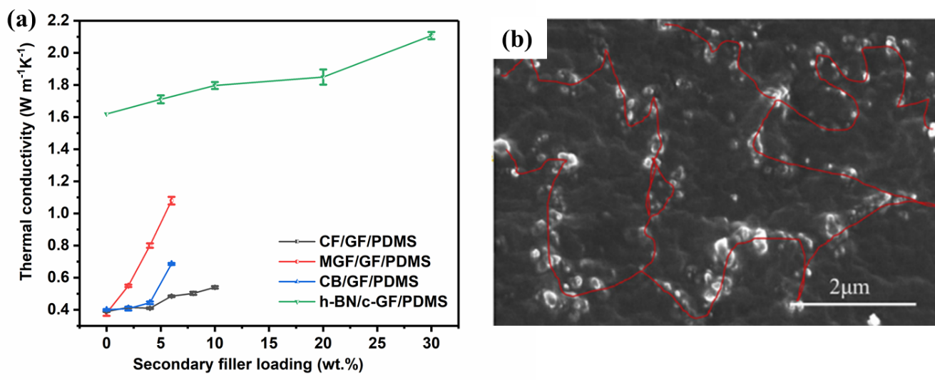
Fig.2 (a) Thermal conductivity of composites filled with graphene foam and second fillers. (b) SEM image of freeze-fractured surface of CB/GF/PDMS composite containing 8wt% CB.

High orientation
Graphene is an anisotropic thermal conductor, whose in-plane TC is about 5300Wm⁻¹K⁻¹, but out-of-plane value is lower than 10Wm⁻¹K⁻¹ [77]. Thus, various researches concentrated on making the best use of the ultra-high in-plane TC of graphene in order to improve the heat dissipation performance of composites. Han et al. [81] proposed a two-step reduction and hand-rolling process of graphene (Fig.3a). The TC of obtained composite is up to 2.645Wm⁻¹K⁻¹ at 15.79 wt.%. Following this strategy, Zhang et al. [82] fabricated VAGF by rolling graphite sheets (Fig.3b), then penetrated liquid PDMS to gain the composite with ultra-high out-of-plane TC of 614.85Wm⁻¹K⁻¹at 92.3wt.%.
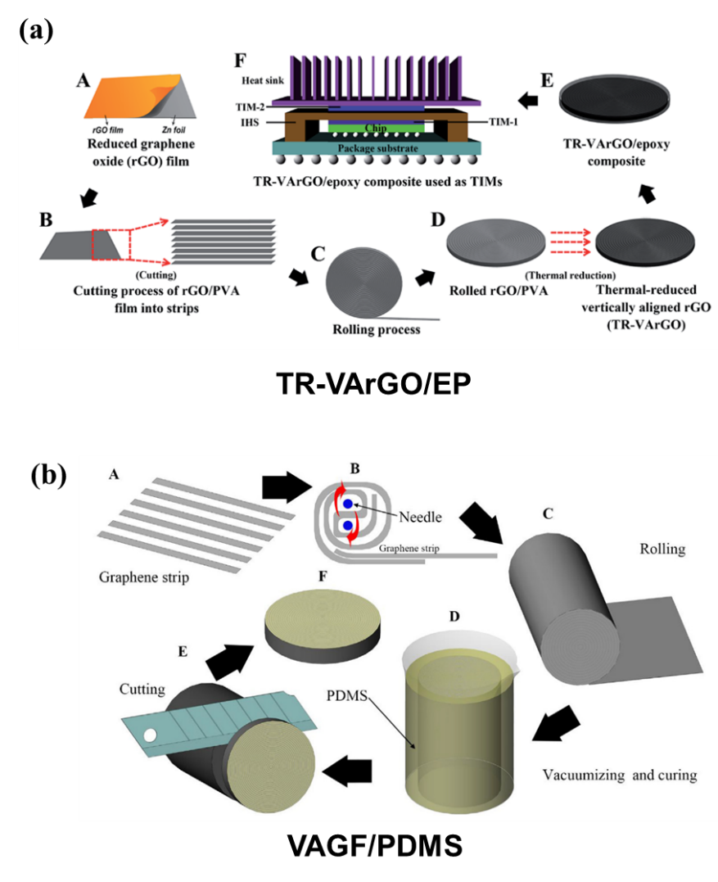
Figure 3 Fabrication procedure of (a) TR-VArGO/epoxy composite and (b) VAGF/PDMS composite.

Conclusions
TC of graphene-based polymer composites largely depends on intrinsic microstructures of graphene. Different preparation methods of 3D graphene lead to different microstructures. These methods produce some defects like boundaries and impurities that result in lower thermal conductivity. The larger the inter-distance between graphene is and lesser the integrity is, the lower thermal conductivity of composites is. If the boundary width of filler is larger, the interfacial thermal resistance would increase largely. Although the alignment and high orientation processes can make the best use of ultra-high in-plane thermal conductivity of graphene, thermal conductivity along other directions would be small. Higher loading is required to reach the exceptional thermal conductivity of composites. The low loading increases considerably mean inter-particle distances and thus phonon scattering inside composites. In general, graphene loading is below 20wt.% and thermal conductivity of composites does not exceed 10Wm⁻¹K⁻¹ in reported publications, which is not good enough for commercial application.

Acknowledgments
The work is supported by NSFC and NSAF with grant Nos. 11672002 and U1730103.

References
[1] S. Stankovich, D.A. Dikin, G.H. Dommett, K.M. Kohlhaas, E.J. Zimney, E.A. Stach, R.D. Piner, S.T. Nguyen, R.S. Ruoff, Graphene-based composite materials, Nature 442(7100) (2006) 282-286.
[2] Z. Wang, R. Xie, C.T. Bui, D. Liu, X. Ni, B. Li, J.T.L. Thong, Thermal transport in suspended and supported few-layer graphene, Nano Lett. 11(1) (2011) 113-118.
[3] M.D. Stoller, S. Park, Y. Zhu, J. An, R.S. Ruoff, Graphene-based ultracapacitors, Nano Lett. 8(10) (2008) 3498-3502.
[4] N. Burger, A. Laachachi, M. Ferriol, M. Lutz, V. Toniazzo, D. Ruch, Review of thermal conductivity in composites: mechanisms, parameters and theory, Prog. Polym. Sci. 61 (2016) 1-28.
[5] W. Feng, M. Qin, Y. Feng, Toward highly thermally conductive all-carbon composites: Structure control, Carbon 109 (2016) 575-597.
[6] E. Koren, E. Sutter, S. Bliznakov, F. Ivars-Barcelo, P. Sutter, Isolation of high quality graphene from Ru by solution phase intercalation, Appl. Phys. Lett. 103(12) (2013) 121602.
[7] Y. Zhang, Y. Fu, M. Edwards, K. Jeppson, L. Ye, J. Liu, Chemical vapor deposition grown graphene on Cu-Pt alloys, Mater. Lett. 193 (2017) 255-258.
[8] B. Dai, L. Fu, Z. Zou, M. Wang, H. Xu, S. Wang, Z. Liu, Rational design of a binary metal alloy for chemical vapour deposition growth of uniform single-layer graphene, Nat Commun 2 (2011) 522.
[9] L. Shi, K. Chen, R. Du, A. Bachmatiuk, M.H. Rummeli, K. Xie, Y. Huang, Y. Zhang, Z. Liu, Scalable seashell-based chemical vapor deposition growth of three-dimensional graphene foams for oil-water separation, J Am Chem Soc 138(20) (2016) 6360-3.
[10] Y.-H. Zhao, Z.-K. Wu, S.-L. Bai, Study on thermal properties of graphene foam/graphene sheets filled polymer composites, Composites, Part A 72 (2015) 200-206.
[11] J. Gong, Z. Liu, J. Yu, D. Dai, W. Dai, S. Du, C. Li, N. Jiang, Z. Zhan, C.-T. Lin, Graphene woven fabric-reinforced polyimide films with enhanced and anisotropic thermal conductivity, Composites, Part A 87 (2016) 290-296.
[12] G.Y. Yang, L. Chen, P. Jiang, Z.Y. Guo, W. Wang, Z.P. Liu, Fabrication of tunable 3D graphene mesh network with enhanced electrical and thermal properties for high-rate aluminum-ion battery application, RSC Adv. 6(53) (2016) 47655-47660.
[13] N. Chen, Q. Pan, Versatile fabrication of ultralight magnetic foams and application for oil–water separation, ACS Nano 7(8) (2013) 6875-6883.
[14] J. Chen, J. Xu, S. Zhou, N. Zhao, C.P. Wong, Nitrogen-doped hierarchically porous carbon foam: A free-standing electrode and mechanical support for high-performance supercapacitors, Nano Energy 25 (2016) 193-202.
[15] W. Wu, X. Huang, K. Li, R. Yao, R. Chen, R. Zou, A functional form-stable phase change composite with high efficiency electro-to-thermal energy conversion, Appl. Energy 190(Supplement C) (2017) 474-480.
[16] Y. Li, B. Shen, X. Pei, Y. Zhang, D. Yi, W. Zhai, L. Zhang, X. Wei, W. Zheng, Ultrathin carbon foams for effective electromagnetic interference shielding, Carbon 100(Supplement C) (2016) 375-385.
[17] M. Karthik, A. Faik, P. Blanco-Rodríguez, J. Rodríguez-Aseguinolaza, B. D’Aguanno, Preparation of erythritol–graphite foam phase change composite with enhanced thermal conductivity for thermal energy storage applications, Carbon 94 (2015) 266-276.
[18] Z. Liu, D. Shen, J. Yu, W. Dai, C. Li, S. Du, N. Jiang, H. Li, C.-T. Lin, Exceptionally high thermal and electrical conductivity of three-dimensional graphene-foam-based polymer composites, RSC Adv. 6(27) (2016) 22364-22369.
[19] G. Lian, C.-C. Tuan, L. Li, S. Jiao, Q. Wang, K.-S. Moon, D. Cui, C.-P. Wong, Vertically aligned and interconnected graphene networks for high thermal conductivity of epoxy composites with ultralow loading, Chem. Mater. 28(17) (2016) 6096-6104.
[20] J. Yang, L.-S. Tang, R.-Y. Bao, L. Bai, Z.-Y. Liu, W. Yang, B.-H. Xie, M.-B. Yang, An ice-templated assembly strategy to construct graphene oxide/boron nitride hybrid porous scaffolds in phase change materials with enhanced thermal conductivity and shape stability for light–thermal–electric energy conversion, J. Mater. Chem. A 4(48) (2016) 18841-18851.
[21] Q. Zhang, X. Xu, H. Li, G. Xiong, H. Hu, T.S. Fisher, Mechanically robust honeycomb graphene aerogel multifunctional polymer composites, Carbon 93 (2015) 659-670.
[22] J. Yang, X. Li, S. Han, Y. Zhang, P. Min, N. Koratkar, Z.-Z. Yu, Air-dried, high-density graphene hybrid aerogels for phase change composites with exceptional thermal conductivity and shape stability, J. Mater. Chem. A 4(46) (2016) 18067-18074.
[23] K. Wu, C. Lei, R. Huang, W. Yang, S. Chai, C. Geng, F. Chen, Q. Fu, Design and preparation of a unique segregated double network with excellent thermal conductive property, ACS Appl Mater Interfaces 9(8) (2017) 7637-7647.
[24] Z. Tu, J. Wang, C. Yu, H. Xiao, T. Jiang, Y. Yang, D. Shi, Y.-W. Mai, R.K.Y. Li, A facile approach for preparation of polystyrene/graphene nanocomposites with ultra-low percolation threshold through an electrostatic assembly process, Compos. Sci. Technol. 134 (2016) 49-56.
[25] Y.-H. Zhao, Y.-F. Zhang, S.-L. Bai, X.-W. Yuan, Carbon fibre/graphene foam/polymer composites with enhanced mechanical and thermal properties, Composites, Part B 94 (2016) 102-108.
[26] Y.-H. Zhao, Y.-F. Zhang, S.-L. Bai, High thermal conductivity of flexible polymer composites due to synergistic effect of multilayer graphene flakes and graphene foam, Composites, Part A 85 (2016) 148-155.
[27] Y.-H. Zhao, Y.-F. Zhang, Z.-K. Wu, S.-L. Bai, Synergic enhancement of thermal properties of polymer composites by graphene foam and carbon black, Composites, Part B 84 (2016) 52-58.
[28] A.A. Balandin, Thermal properties of graphene and nanostructured carbon materials, Nat Mater 10(8) (2011) 569-81.
[29] D. Han, Y.-H. Zhao, Y.-F. Zhang, S.-L. Bai, Vertically and compactly rolled-up reduced graphene oxide film/epoxy composites: a two-stage reduction method for graphene-based thermal interfacial materials, RSC Advances 5(114) (2015) 94426-94435.
[30] Y.-F. Zhang, D. Han, Y.-H. Zhao, S.-L. Bai, High-performance thermal interface materials consisting of vertically aligned graphene film and polymer, Carbon 109 (2016) 552-557.

