EVALUATION BY WICKING TESTS OF CAPILLARY PRESSURE AS FUNCTION OF TEMPERATURE FOR UNCURED RESINS
Monica Francesca Pucci¹, Pierre-Jacques Liotier^{2*}, Sylvain Drapier².
¹C2MA, IMT Mines Alès, Univ Montpellier, 6 Avenue de Clavières 30100 Alès, France
²Mines Saint-Etienne, Univ Lyon, CNRS, UMR 5307 LGF, Centre SMS, Departement
MPE, F-42023 Saint-Etienne France
*Corresponding author (liotier@emse.fr)
Keywords: Liquid Composite Molding – Wetting – Capillary pressure

Abstract
Unsaturated permeability evaluation still remains an issue in composite manufacturing. Test liquids, considered as models for resins, have been largely used. Silicone oil is the most common test liquid for permeability measurements and has been used in benchmarks for unsaturated permeability evaluation [1]. But the choice of this liquid relies only on its viscosity which is comparable to the one of a liquid epoxy used for composite manufacturing. Capillary effects have been totally neglected for those measurements and the validity of this assumption has never been verified. Indeed, silicone oil is a totally wetting liquid. Epoxy resin at its liquid state has a very different behavior as it has been proved by the characterization of surface tension and its components for some uncured epoxy resins [2]. Wicking tests in carbon fabric reinforcements were carried out with different test liquids at several temperatures following a procedure established in previous works [3]. Silicone oil was used in comparison with an epoxy resin. Trends of wicking were found to be significantly different proving that the physico-chemical properties have thus also to be considered to choose a model liquid for permeability measurements. To go further, the definition of an unsaturated permeability has to be questioned.

1. Introduction

Test liquids used for permeability characterization, such as silicone oil, have wetting properties depending on temperature that are largely different from ones of epoxy resins. Silicone oil, due to its low and non-polar surface tension, is a totally wetting liquid [4]. Contrarily, measurements of surface tension and of dispersive and polar components for an uncured epoxy resin showed the partially wetting behavior of resins [2].
Moreover, recent studies proved the interest in using wicking tests for the characterization of capillary effects during impregnation of reinforcements, due to interactions between fluid and fibers [3].
The present work focuses on wicking tests in carbon fabrics using different test liquids at several temperatures, following an established procedure [3]. The aim is to evaluate if the choice of silicone oil as test liquid is suitable to determine morphological parameters of fibrous preforms, and define an unsaturated permeability value.

2. Theory

Wicking of a liquid in a fibrous medium compacted in a cylindrical sample holder can be described by the Washburn law [5]. This equation can be considered as equal to the Darcy law [6] in order to define an equivalent capillary pressure P_{cap} [3]. Followig the unidirectional flow hypothesis, the mass gain m measured by a tensiometer during wicking can be expressed as in equation 1, according to the Washburn theory, and as in equation 2 in agreement with the Darcy law [3]:
$$m^{2}(t)=\left[\frac{\left(c\bar{r}\right)ε^{2}{\left({πR}^{2}\right)}^{2}}{2}\right]\frac{ρ^{2}γ_{L}\text{cos}θ_{a}}{η}t$$ | (1)

$$m^{2}(t)=\frac{2K{\text{ερ}}^{2}({πR}^{2})^{2}P_{\text{cap}}}{η}t$$ | (2)

where R is the radius of the cylindrical sample holder and t the time of flow. η is the fluid viscosity of the liquid,ρ its density and γ_{L} its surface tension. K is the permeability in the considered wicking direction [7-8], ε the porosity of the fibrous medium. c is a parameter related to tortuosity, r the mean capillary radius of the porous medium and θ_{a} the apparent advancing contact angle . The squared mass gain should thus show a linear trend as a function of time, in order to estimate a capillary pressure and validate the assumption of a constant permeability.

Considering the mass gain as equivalent in both equations makes possible to derive Eq. 3 from Eq. 1 and 2:
$$P_{\text{cap}}=\left(c\bar{r}\right)ε\frac{γ_{L}\text{cos}θ_{a}}{4K}$$ | (3)
A relation between capillary pressures considering two different liquids wicking in a preform with the same morphology can be made. Considering the permeability as constant and related to the morphology of the preform, a ratio between capillary pressures can thus be expressed. If the preform is considered as unchanged during both wicking tests and the permeability is the same, the following ratio can be expressed as follows, considering the silicone oil as totally wetting:
$$P_{\text{cap}−\text{re}\text{sin}}=P_{\text{cap}−\text{Si}}\frac{γ_{L−\text{re}\text{sin}}}{γ_{L−\text{Si}}}\text{cos}θ_{a−\text{re}\text{sin}}$$ | (4)
with P_{cap−resin} , γ_{L−resin} and θ_{a−resin} being respectively the capillary pressure, the surface tension and the mean advancing contact angle for a wicking test with resin and P_{cap−Si} and γ_{L−Si} the capillary pressure and surface tension with the silicone oil.
Then, performing a capillary wicking in the same preform with resin, it is possible to compute, for each time step recorded by the tensiometer, the permeability that should be obtained with the considered capillary pressure:

$$K(t)=\underset{C}{\underbrace{\left[\frac{η_{\text{re}\text{sin}}}{2{\text{ερ}}_{\text{re}\text{sin}}^{2}({πR}^{2})^{2}P_{\text{cap}−\text{re}\text{sin}}}\right]}}\frac{m^{2}(t)}{t}=C\frac{m^{2}(t)}{t}$$ | (5)
The permeability should then be directly proportional to the slope of the squared mass gain measured by the tensiometer against time during wicking. Spontaneous impregnation of fibrous medium by different test liquids could thus be a mean to verify the validity of the permeability parameter, especially in transient flows.

3. Results

Wicking has been performed in a carbon quasi-UD fabric from Hexcel Corp. (reference: 48580), following the procedure established in previous studies [3]. The silicone oil is the XIAMETER® PMX 200-50 CS and the epoxy resin is the SP106 from GURIT® without hardener. Fig. 1 shows that even if silicone oil is used as a model for liquid resin in permeability measurements, it has a very different behavior during wicking.

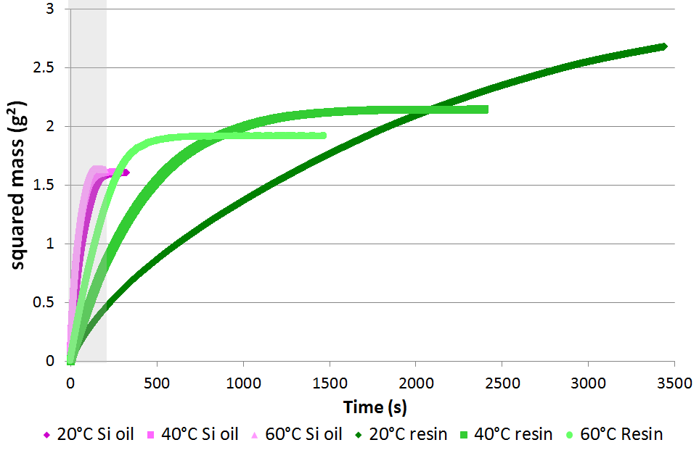

Figure 1.: Full time wicking in fabric for silicone oil and epoxy resin at three different temperatures.

Fig. 2 shows that resin has a behavior that can be modelled by Darcy and Washburn laws, which means that it is possible to estimate an equivalent capillary pressure. Measurements of both silicone oil and resin viscosity and surface tension, a capillary pressure can be calculated for the resin/carbon fibers couple, thanks to data from previous work [3].

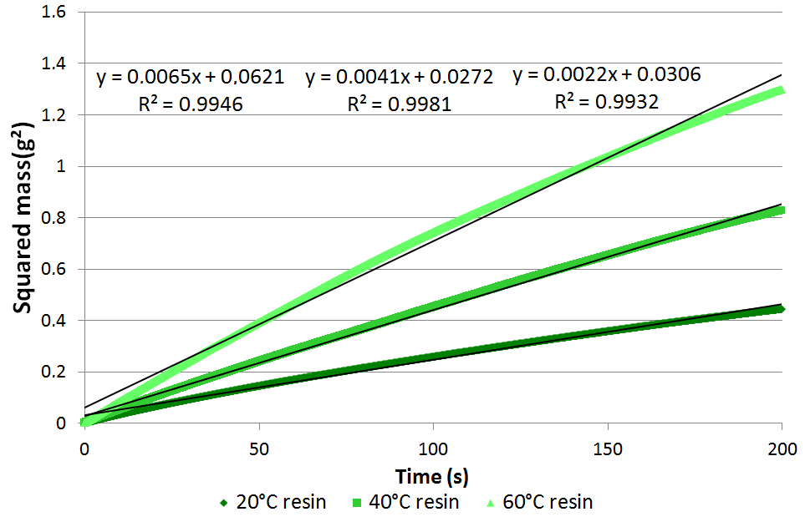
Figure 2.: Linear fit up to 200s with resin.

Fig. 3 and 4 show that wicking with silicone oil cannot be described with the same models, this hinders a proper estimation of an equivalent capillary pressure or permeability with this test liquid.

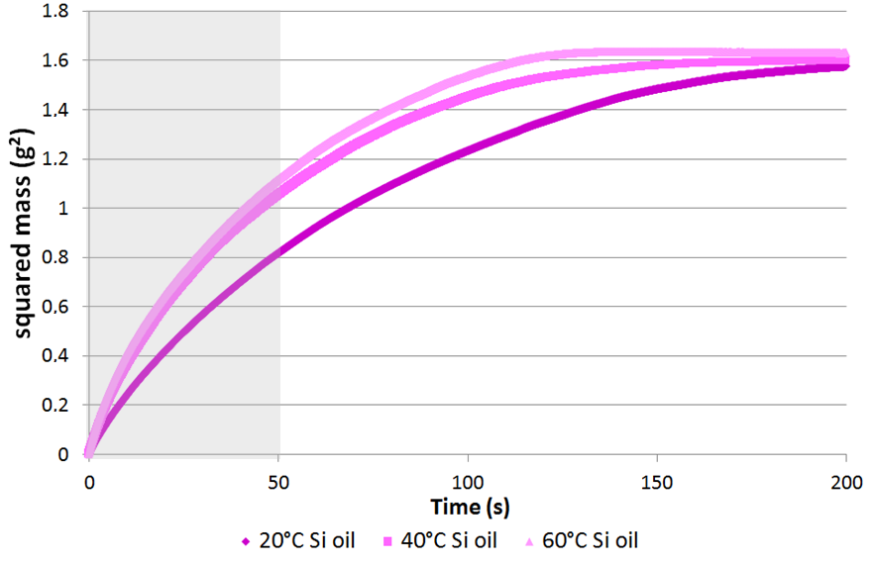
Figure 3.: Full time wicking in fabric for silicone oil.

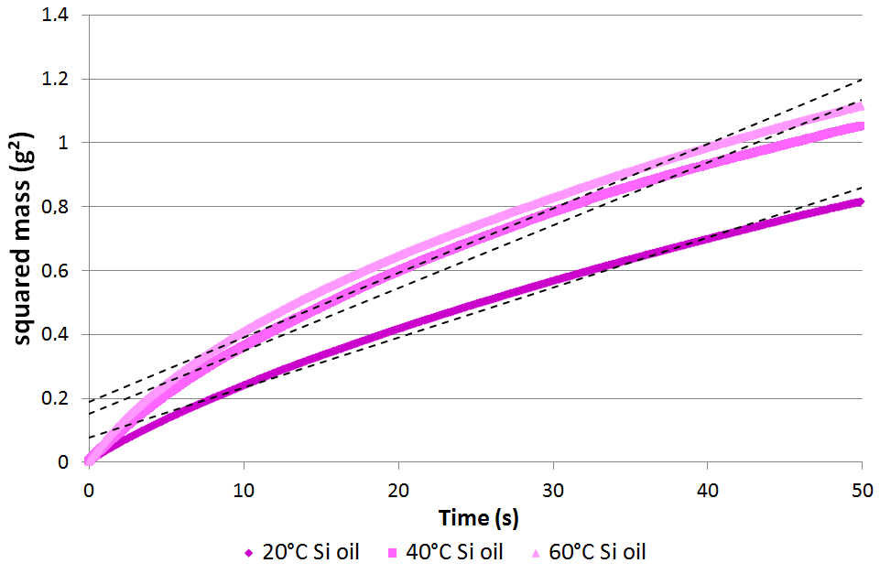
Figure 4.: Non-linear behavior even for the first 50s of wicking with silicone oil.

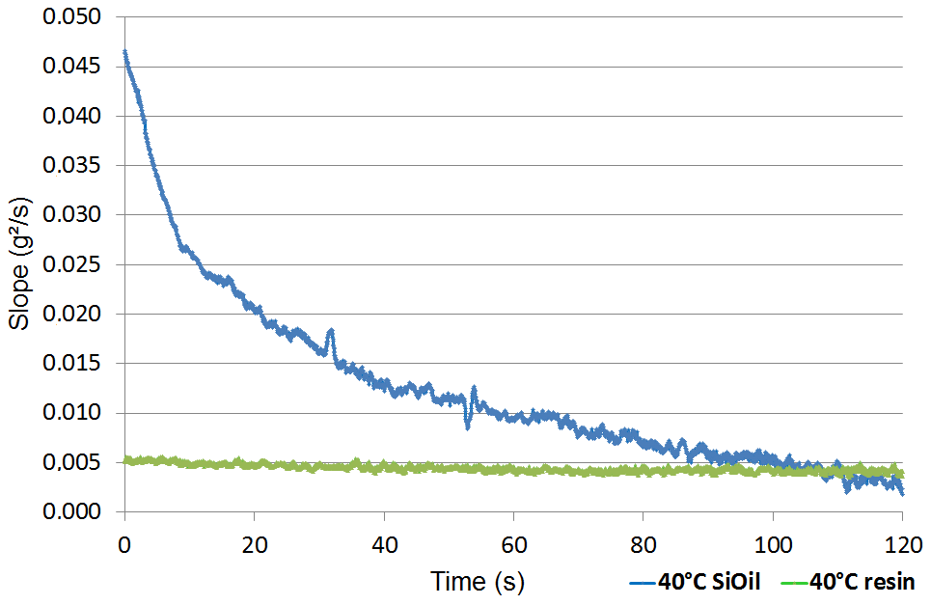
Figure 5.: Slope of squared mass against time at 40°C for both test liquids – directly related to permeability.

Furthermore, the calculated slope of the squared mass against time during wicking should be directly related to permeability. It is shown in Fig. 5 that permeability estimated from equation 5, with a capillary pressure determined from equation 4, would not be constant for silicone oil. This seems to indicate an inconsistency. Either there is a default in the capillary pressure definition, or a problem in unsaturated permeability definition. However, silicone oil does not seem to be a good model for uncured resin for wicking such as for low pressure gradient driven infiltration.

4. Conclusion

A lot of interesting conclusions can be drawn from those tests, but the main one is that wicking of silicone oil into carbon reinforcements cannot be described with the common equations used for permeability estimation. Since no pressure gradient is applied in this test, the physico-chemical differences between resin and silicone oil make the comparison impossible. It is also impossible to consider a capillary pressure for silicone oil at all tested temperature. This could indicate that viscosity should not be the only parameter affecting the choice of a a non-reactive liquid to model liquid resin. These results also raise questions about the validity of unsaturated permeability estimation, or on the meaning of unsaturated permeability itself.

References

- N. Vernet, E. Ruiz, S. Advani, J.B. Alms, M. Aubert, M. Barburski, B. Barari, J.M. Beraud, D.C. Berg, N. Correia, et al. Experimental determination of the permeability of engineering textiles : Benchmark ii. Composites Part A : Applied Science and Manufacturing, 61 :172–184, 2014.
- M.F. Pucci, P.J. Liotier, and S. Drapier. Tensiometric method to reliably assess wetting properties of single fibers with resins: Validation on cellulosic reinforcements for composites. Colloids and Surfaces A : Physicochemical and Engineering Aspects, 512 :26–33, 2017.
- M.F. Pucci, P.J. Liotier, and S. Drapier. Capillary wicking in a fibrous reinforcement - orthotropic issues to determine the capillary pressure components. Composites Part A : Applied Science and Manufacturing, 77 :133–141, 2015.
- Sauer, B. B., Kampert W. G. Influence of viscosity on forced and spontaneous spreading: Wilhelmy fiber studies including practical methods for rapid viscosity measurement. Journal of colloid and interface science 199(1): 28-37, 1998.
- E. W. Washburn, Note on a method of determining the distribution of pore sizes in a porous material, Proceedings of the National Academy of Sciences of the United States of America 115–116, 1921.
- H. Darcy, Les fontaines publiques de la ville de Dijon: exposition et application, Victor Dalmont, 1856.
- R. Arbter, J.M. Beraud, C. Binetruy, et al. Experimental determination of the permeability of textiles: a benchmark exercise. Composites Part A ; 42: 1157–1168, 2011.
- Lundström T. S., Stenberg R., Bergström R., Partanen, H., Birkeland P. A.: In-plane permeability measurements: A nordic round-robin study. Composites Part A:Applied Science and Manufacturing, 31: 29–43,2000.

