Static and Ballistic performance of Helicoidal, Cross-ply and Quasi-isotropic laminates

J.L. Liu, T.M. Woo, V.B.C. Tan¹

¹National University of Singapore, , 9 Engineering Drive 1, Singapore 119575.
mpetanbc@nus.edu.sg

Keywords: Helicoidal laminates, Ballistics, Biomimicry

Abstract
In attempts to mimic the configuration of crustacean exoskeleton, previous research has shown that stacking unidirectional laminates helicoidally with small inter-ply angles improves its delamination resistance and increased the transverse load bearing capability of the laminates. However helicoidal laminates absorbed less energy under transverse loading compared with common cross-ply laminates despite their higher peak transverse because failure was abrupt and occurred at lower plate deflection. Thus it was not certain if helicoidal laminates had any advantage over traditional laminates in stopping high energy projectiles. In addition to their quasi-static transverse load performance, the ballistic performance of helicoidal, quasi-isotropic and cross-ply laminates is also presented. The results confirm that helicoidal laminates consistently outperform other laminates in terms of peak transverse load and offer show that they have superior ballistic resistance. Quasi-isotropic laminates displayed the lowest ballistic limit compared to other laminates of identical thickness. Thin cross-ply laminates have the best ballistic performance compared to other laminates. However the ballistic limit of helicoidal laminate surpasses cross-ply laminates as the laminate thickness increases. In general, beyond a certain thickness, helicoidal configuration outperform other laminates under both static loading and ballistic impact.

1. Introduction

Fibre reinforced composite materials are increasingly used in civil, marine and aerospace applications due to their high specific stiffness and strength. Inspired by observations of the exoskeletal structure of crustaceans by Bouligand [1], it has been shown that stacking unidirectional carbon fiber composite helicoidally with small inter-ply angles leads to significant improvement in terms of maximum transverse load resistance by several researchers (Liu et. al. [2], Shang et. al. [3], Apichattrabrut and Ravi-Chandar [4] and Cheng et. al. [5]). Liu et. al. [2] showed that under transverse loads, there are only a few large delamination within helicoidal laminates in contrast to the multiple delamination in cross-ply laminates. The small inter-ply angle of helicoidal laminates gives rise to better delamination resistance and consequently improves their transverse load bearing capability.

However, previous studies have been limited to ad hoc helicoidal laminate configurations without a systemic investigation into laminate parameters like laminate thickness and inter-ply angles. The static transverse load of both thin and thick helicoidal laminates comprising 16 plies (1.28mm) to 73 plies (5.84mm) are determined and compared to common cross-ply and quasi-isotropic laminates. It was observed that most helicoidal laminates outperform common cross-ply and quasi-isotropic laminates in terms of maximum transverse load, in agrrement with the results and explanations presented by Liu et. al. [2]. Although most helicoidal laminates have higher maximum transverse load than other laminates, their energy absorption capability is lower than cross-ply laminates. For the example of laminates with 37 plies, the single helicoidal laminate SH37 has 74% higher peak load than the cross-ply laminate CP37, however, the area under load-displacement curve SH37 is smaller than that of CP37. This rasied questions regarding the ability of laminate to withstand high velocity impacts.

Following the static transverse load tests, the ballistic performance of helicoidal, cross-ply and quasi-isotropic laminates was investigated. Under the impact of a 6mm diameter steel sphere with the mass of 7 grams, ballistic limit of SH37 laminates was found to be 154.1m/s whereas CP37 recorded a ballistic limit of 140.5 m/s. Other helicoidal configurations were also testd and some also showed higher ballistic limit than cross-ply laminates with the same number of plies. These findings showed that helicoidal laminates could outperform other common configurations not only in terms of maximum transverse load but also better in terms of ballistic performance.

The results show different stacking sequences affect both ballistic and transverse loading performance of the laminates - the ballistic and static performance of thick laminates can be improved significantly by stacking them helicoidally while maintaining the same thickness. Why some helicoidal laminates outperforms common configurations in terms of ballistic performance despite their lower energy absorption under the static loads would require a deeper study into the mechanisms governing affect ballistic performances.

2. Experiment set up

2.1 Materials and stacking sequence

Cross-ply, helicoidal and quasi-isotropic laminates were fabricated from unidirectional T700/2510 carbon-epoxy prepregs. The mechanical properties of the material are shown in table 1. Individual plies were cut into 100 x 100mm squares and laid manually to form laminates of various configurations as shown in Table 2. The laminates are cured in an oven under 30 kPa pressure. The temperature is raised from room temperature to 140ºC over 2 hours and maintained for 2 hours. The specimens are then cooled over 8 hours to room temperature. Three specimens were initially produced for each configuration for static transverse load test and up to 9 specimens were initially produced for each configuration for the ballistic test.

Table 1. Mechanical and physical properties of CU-075 prepreg (ASTM D790, ASTM D6641, ASTM D3518 and Shang et. al. [3])

Property | Value
Nominal ply thickness | 0.08mm
Areal density | 0.121 kg/m²
Modulus (fibre direction), E₁ | 107 GPa
Modulus (Transverse direction), E₂ | 7.99 GPa
In-plane shear modulus, G₁₂ | 4.00 GPa
Out-of-plane shear modulus, G₂₃ | 3.5 GPa
In-plane Poisson's ratio, ν₁₂ | 0.32
Out-of-plane Poison's ratio, ν₂₃ | 0.45
Tensile strength (fibre direction), σ_{1t} | 1650 MPa
Compressive strength (fibre direction), σ_{1c} | 1250 MPa
Tensile strength (transverse direction), σ_{2t} | 45.1 MPa
Compressive strength (fibre direction), σ_{2c} | 141 MPa
In-plane shear strength, τ₁₂ | 75.0 MPa

The specimens are tested under transverse loading following the experimental set up described in [2]. The specimens are simply supported on an open cylindrical support of 75mm internal diameter and subjected to a transverse load at the centre through a 12mm hemispherical tup. Three specimens of each configuration are tested to ensure consistency. Micro-CT scans were then performed to observe the damage of the specimens.

A smooth bore gas gun was used to propel a projectile (steel ball) of diameter 12 mm and mass 7.0 g. The impact velocity of the projectile was measured using a pair of light gates positioned between the gas gun muzzle and the target. Specimens were again simply supported by mounting the specimens using low-strength adhesive putty on the same solid metal cylinder used in the static tests. The centre of the specimen was aligned with the trajectory of the projectile.

Table 2. Laminate configuration

Designation | Description | Number of plies | Configuration
CP16 | Cross-ply | 16 | [(0º/90º)₇/0º]
QI16 | Quasi-isotropic 45 degree | 16 | [(0º/90º/45º/-45º)₄]
SH16 | Single Helicoidal (12º between adjacent ply, completing 180 degree) | 16 | [0º/-12º/-24º … /-168º /-180º]
CP19 | Cross-ply | 19 | [(0º/90º)₉/0º]
QI19 | Quasi-isotropic 45 degree | 19 | [0º/(0º/90º/45º/-45º)₂/90º/(0º/90º/45º/-45º)₂/0º]
SH19 | Single Helicoidal (10º between adjacent ply, completing 180 degree) | 19 | [0º/-10º/-20º … /-170º/-180º]
CP25 | Cross-ply | 25 | [(0º/90º)₁₂/0º]
SH25 | Single Helicoidal (7.5º between adjacent ply, completing 180 degree) | 25 | [0º/-7.5º/-15º … /-172.5º/-180º]
CP31 | Cross-ply | 31 | [(0º/90º)₁₅/0º]
SH31 | Single Helicoidal (6º between adjacent ply, completing 180 degree) | 31 | [0º/-6º/-12º … /-172º/-180º]
CP37 | Cross-ply | 37 | [(0º/90º)₁₈/0º]
QI37 | Quasi-isotropic 45 degree | 37 | [(0º/90º/45º/-45º)₉/0º]
SH37 | Single Helicoidal (5º between adjacent ply) | 37 | [0º/-5º/-10º … /-175º/-180º]
DH37 | Double Helicoidal (10º between adjacent ply, completing 360 degree) | 37 | [0º/-10º/-20º … /-350º/-360º]
CP55 | Cross-ply | 55 | [(0º/90º)₂₇/0º]
TH55 | Triple Helicoidal (10º between adjacent ply, completing 540 degree) | 55 | [0º/-10º/-20º … /-530º /-540º]
CP73 | Cross-ply | 73 | [(0º/90º)₃₆/0º]
SH73 | Helicoidal (2.5º between adjacent ply) | 73 | [0º/-2.5º/-5º … /-177.5º /-180º]
DH73 | Double Helicoidal (5º between adjacent ply, completing 360 degree) | 73 | [0º/-5º/-10º … /-355º/-360º]
QH73 | Quadruple Helicoidal (10º between adjacent ply, completing 720 degree) | 73 | [0º/-10º/-20º … /-710º/-720º]

3. Experiment Result

3.1 Static loading result

The peak load is compared among specimens as shown in Table 3. Two parameters were considered in the comparison of these laminates – peak load and the energy absorbed by the laminates. The area under load vs displacement curve is taken to be the amount of energy required to fail the laminates. The energy absorption is an averaged value because the load vs displacement curves are not identical.

Helicoidal configurations consistently displayed higher peak load than cross-ply configurations. The differences in peak loads are 7%, 30%, 43%, 74%, 65% and 24% for 16, 19, 31, 37 (SH37 vs. CP37), 55 and 73-ply (QH73 vs. CP73) laminates respectively. The tests showed that thin laminates like SH16 failed due to buckling. No obvious fiber/matrix damage was observed within SH16 specimens. Other specimens failed due to fiber or matrix damage.

For 37ply specimens, helicoidal configuration with smaller inter-ply angles (5º for SH37) performs better than helicoidal configuration with larger inter-ply angles (10º for DH37), whereas for 73-ply specimens, the trend is reversed. Cross-ply configurations have larger energy absorption than helicoidal configuration with difference of 78%, 80%, 34%, 55%, 35% for 16, 19, 31, 37 (CP37 vs. SH37) and 73-ply (CP73 vs. QH73) specimens respectively; with the only exception being 55-ply specimens where TH55 has 25.4% higher energy absorption than CP55.

Generally, helicoidal configurations have higher peak load and cross-ply configurations have larger energy absorption capabilities. Quasi-isotropic configuration performed poorly in terms of both peak load when compared with helicoidal laminates and energy absorption when compared with cross-ply laminates.

Table 3, Peak load of various laminates and the estimated energy absorption of static test
Number of plies | Designation | Peak load (N) | Estimated energy absorption of static test (J)
16 | CP16 | 3202 | 9.8
16 | QI16 | 3102 | 7.8
16 | SH16 | 3409 | 5.5 (buckling occurred)
19 | CP19 | 4215 | 18.3
19 | QI19 | 4121 | 11.3
19 | SH19 | 5625 | 10.4
25 | CP25 | 4865 | 25.7
25 | SH25 | 8149 | 15.7
31 | CP31 | 5571 | 25.3
31 | SH31 | 10742 | 24.6
37 | CP37 | 7056 | 60.6
37 | QI37 | 9190 | 34.3
37 | DH37 | 10720 | 27.5
37 | SH37 | 12210 | 27.8
55 | CP55 | 9597 | 46.0
55 | TH55 | 15890 | 57.7
73 | CP73 | 19068 | 140.5
73 | QI73 | 18581 | 67.0
73 | QH73 | 23836 | 60.5
73 | DH73 | 18879 | 64.2
73 | SH73 | 16400 | 91.2

3.2 Ballistic limit result

The ballistic limits for all laminates are shown in Table 4 and plotted out in Figure 1. Quasi-isotropic laminates consistently performed poorly. Hence, no quasi-isotropic laminates were prepared for 25, 31 and 55-ply laminates. For 16, 19 and 25-ply specimens (thin plates), cross-ply laminates had the highest ballistic limits. Interestingly, CP19 has comparable ballistic limit as CP37 despite its thickness being nearly half of CP37. There is a drop in the ballistic limits of cross-ply lamintaes from CP19 to CP25. The ballistic limit of cross-ply laminates then slowly increases as laminate thickness increases. Thin helicoidal laminates has much lower ballistic limit than thin cross-ply laminates, but as laminate thickness increases, the ballistic limit of helicoidal laminates steadily increases and surpasses cross-ply laminates when the ply count reaches 31. Further increasing the number of plies resulted in helicoidal laminates showing obvious superiority over cross-ply ones in terms of ballistic limits. It is also observed that the static energy absorption has no obvious bearing on the laminates’ ballistic performance.

Table 4, Ballistic limit, impact energy, and estimated energy absorption of static test.
Designation | Ballistic limit  (m/s) | Projectile’s kinetic energy (J) | Estimated energy absorption of static test  (J)
CP16 | 122.4 | 52.4 | 9.8
QI16 | 69.4 | 16.9 | 7.8
SH16 | 80.1 | 22.5 | 5.5 (buckling occur)
CP19 | 140.2 | 68.8 | 18.3
QI19 | 71.4 | 17.84 | 11.3
SH19 | 95 | 31.6 | 10.4
CP25 | 129.3 | 58.5 | 25.7
SH25 | 104.5 | 38.2 | 15.7
CP31 | 130.4 | 59.5 | 25.3
SH31 | 133.2 | 62.1 | 24.6
CP37 | 140.5 | 69.1 | 60.6
QI37 | 118.5 | 49.1 | 34.3
SH37 | 154.1 | 83.1 | 27.5
DH37 | 142.7 | 71.3 | 27.8
CP55 | 145.3 | 73.9 | 46.0
TH55 | 173.7 | 105.6 | 57.7
CP73 | 187.1 | 122.5 | 140.5
QI73 | 182.1 | 116.1 | 67.0
SH73 | 206.2 | 148.8 | 60.5
DH73 | 207.4 | 150.6 | 64.2
QH73 | 204.5 | 146.4 | 91.2
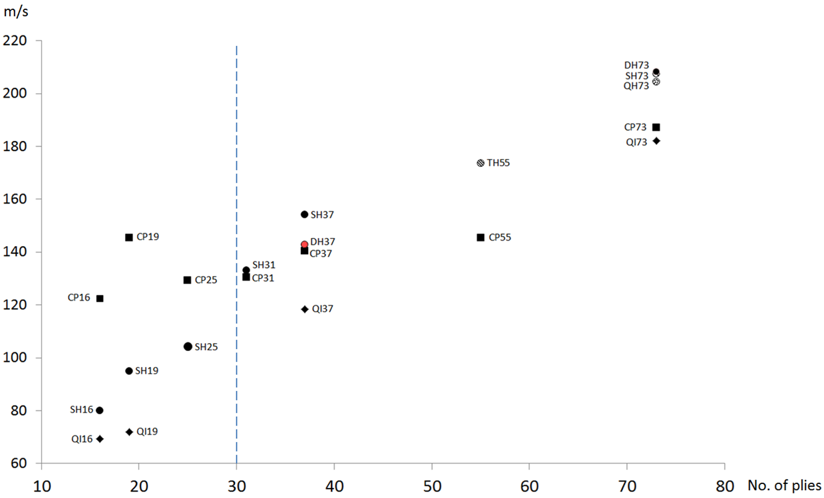
Figure 1. Ballistic limit of various laminates

4. Conclusions

Experimental results of static tests show that helicoidal laminates consistently outperform cross-ply and quasi-isotropic laminates in terms of peak load. In one case, the helicoidal laminate had 80% higher peak load than cross-ply laminates with the same number of plies. Ballistic tests showed that quasi-isotropic laminates have the lowest ballistic limit. Thin cross-ply laminates (CP16, CP19) have the hghest ballistic resistance compared to other laminates. However, the specific ballistic limit of cross-ply laminates decreases dramatically as laminate thickness increases from 19 to 37 plies. Despite the thickness increasing by 95%, the ballistic limit for cross-ply laminates stagnated at 140m/s for both CP19 and CP37. With the same number of plies, thin helicoidal laminates (SH16, SH19) have lower ballistic limits than cross-ply laminates CP16 and CP19, but thicker helicoidal laminates (SH37, SH55, SH73) have higher ballistic limit than CP37, CP55 and CP73.

This study shows that the transverse load characteristics and ballistic limits of laminates can be improved significantly by mimicking the configuration of crustacean exoskeleton. Further study will look into the mechanisms responsible for such improvements.

Acknowledgments

The support through Ministry of Education (MOE, Singapore) grant reference no. RG00005644 is gratefully acknowledged.

References

[1] Y. Bouligand, Sur une architecture torsadée répandue dans de nombreuses cuticules d’Arthropodes, CR Acad. Sci. Paris 261 (1965) 3665e3668.
[2] J.L. Liu, H. P. Lee, and V. B. C. Tan. "Failure mechanisms in bioinspired helicoidal laminates." Composites Science and Technology 157 (2018): 99-106.
[3] J. S. Shang, N. H. H. Ngern, and V. B. C. Tan, Crustacean-inspired helicoidal laminates, Compos. Sci. Technol., vol. 128, pp. 222–232, 2016.
[4] T. Apichattrabrut, K. Ravi-Chandar, Helicoidal composites, Mech. Adv. Mater. Struct. 13 (1) (2006) 61—76.
[5] L. Cheng, A. Thomas, J.L. Glancey, A.M. Karlsson, Mechanical behavior of bioinspired laminated composites, Compos. Part A Appl. Sci. Manuf. 42 (2) (2011) 211e220.

