EXPERIMENTAL VERIFICATION OF THE DAMAGE MODEL OF ORTHOTROPIC COMPOSITE MATERIALS UNDER MULTIAXIAL LOADING

P.A. Dodonov, N.N. Fedonyuk

The Krylov State Research Centre, Composite Structures Department, St. Petersburg, Russia
Email: dodonovpavel@gmail.com, Web Page: www.krylov-center.ru

Keywords: damage model, progressive fracture, multi-axial loading, experiment, non crimp fabrics, remnant strain

Abstract
This paper analyses test data for a layered polymeric composite material under combined loading. The tests were performed as per Arcan test principle. The materials tested in this study were based on glass- and carbon non crimp fabrics (NCF) with orthogonal fibers and vinyl-ether binder, manufactured as per closed-moulding technologies (RTM and VARTM). The angle of orthogonal fibers varied with respect to the sample orientation. The strains were determined using the optical method, which enabled accuracy assessment of the test data processing guidelines. The test data were used to verify the numerical model of material and showed a good correlation with it both for comparison of straining diagrams and assessment of damage based on the changes in elastic properties, as well as for assessment of accumulated plastic strain.

1. Introduction

Hull structures of marine objects made of polymeric composite materials typically have their bearing elements relatively thick, layered, with intricate stacking sequence, to withstand tough operational conditions. Development of these structures goes hand-in-hand with development of their material because it is an integrated technological process. Investigating the properties of polymeric composites, from inception of the initial damage to failure in different loading conditions, will enable more efficient use of material and provide for development of scientifically justified strength standards. An integral part of these studies is numerical simulation of the processes taking place in the material, as well as identification of its critical states.

A peculiarity of modern composite hull structures is that they are made of multi-axial fabrics consisting of several stacked layers with different orientation angle of their unidirectional reinforcing material, and their impregnation with binder is performed as per closed-moulding technologies (RTM and VARTM). This method enables manufacturing of large hull structures with thick members because moulding is a very efficient process, with relatively low man-hour demand.

The main purpose of this work is to develop a numerical prediction procedure for effective strength parameters of layered plates forming hybrid polymeric composite materials based on arbitrary combinations of multiaxial fabrics and vinyl-ether binder. To this effect, it is necessary to construct and verify a mechanical & mathematical model that would simulate the processes taking place in the structure of composite material. The polymeric composite material discussed in this paper is based on fabrics with orthogonal fibers. The model of material adopted in this study can describe damage accumulation and plastic strains of polymeric composite material under increasing multi-axial (combined) load, up to the terminal state (failure of material). The basic element in this model is the layer with long unidirectional reinforcing fibers.

Basically, damage accumulation is development of micro-cavities and micro-cracks that lead to macro-fracturing and failure of material. For the material under investigation, this is a complex process involving interaction of different mechanisms, which is due, first of all, to the structure of the composite at micro- and meso-level. As a result, dispersed accumulated damage, along with plastic strain growth, might go simultaneously with brittle failure of elements in the composite.

2. Experimental study of polymeric composite material under combined loading

2.1. Modification of Arcan test procedure

In our case, the tests were performed with special rigging, see Fig. 1. Developing this setup of tests (with combined loading), we combined the method suggested by M. Arcan and the standard test rigging described in ASTM D7078. M. Arcan and his co-authors suggested their own test method for composite materials [1], so it has no standard rigging or test samples. Our rigging was based on the drawings and shape of the specimens indicated in ASTM D7078 testing standard.

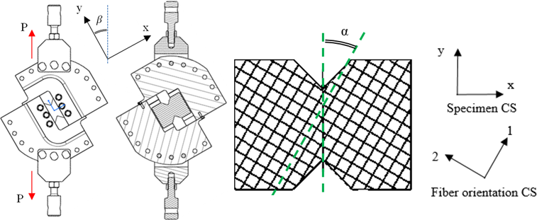

Fig. 1. Layout of rigging, installation of specimen and coordinate system 012 for reinforcing fibers with variation of V-notch angle.

This test can be performed with pre-specified ratio between transverse and shearing force acting in the mid-section of specimen. Averaged tangential stresses τ_{XY} and tension stresses σ_{xx} can be calculated as follows:
(1)
Here, b and h are width and thickness of mid-section for a butterfly-shaped specimen, and P is external load. Angle β describes deviation between load vector and test section orientation of the specimen (see Fig. 1). To combine shear loading with the load applied along the fibers, angle α (between fiber direction and tested surface orientation of the specimen, see Fig. 1) was set. It has been formulated how to calculate σ_{yy} depending on external load σ. This required introduction of λ parameter dependent on the parameters of tested material, direction of reinforcing fibers, V-notch angle of sample and β angle. The values of λ for used combinations of α and β angles of the materials investigated during these tests were determined as per the calculation data obtained for the finite-element numerical model. In calculations, λ was determined through stress state assessment of 2x2 mm area in the middle zone of the specimen’s test section.

2.2. Test results

Fig. 2 shows the photos of a CRP sample based on UD2 bi-axial diagonal carbon fabric with stacking sequence [+45°/-45°]) during the tests with combination of angles α = – 22.5°; β = 75°. The surface of the specimen is covered with a special paint, to enable operation of optical strain gauging system. The failure was observed in mid-section of the specimen. Fracturing started at the tips of V-notches and then propagated to the entire section as failure process was going on.

During the tests of GRP specimens, to monitor the progress of GRP structure damage, a couple of specimens underwent additional transillumination check. Fig. 3 shows the photos of GRP specimen (based on SD1 glass fabric with stacking sequence [0°/90°]) during the tests with combination of angles α = 35°; β = 75°. Similarly to other specimens, fracturing started at the tips of V-notches. The damage can be observed all along the specimen.

Fig. 4 shows the fields of normal stresses ε_{xx} and ε_{yy} during the tests of CRP based on UD2 carbon fabric, with combination of angles α=35° and β=75°. Test results were recorded and partially processed by GOM ARAMIS optical system for displacement field measurements. This system can determine all components of strain tensor at the specified point of specimen surface. Strain measurements were taken at the center of the specimen’s narrow section and averaged for 2х2 mm area. Strain concentrators were recorded at the tips of V-notches. During the study, these strains were converted into 012 coordinate system of reinforcing fibers and compared versus calculation results for stresses σ₁₁, σ₂₂ and τ₁₂ based on the changes in external load P.

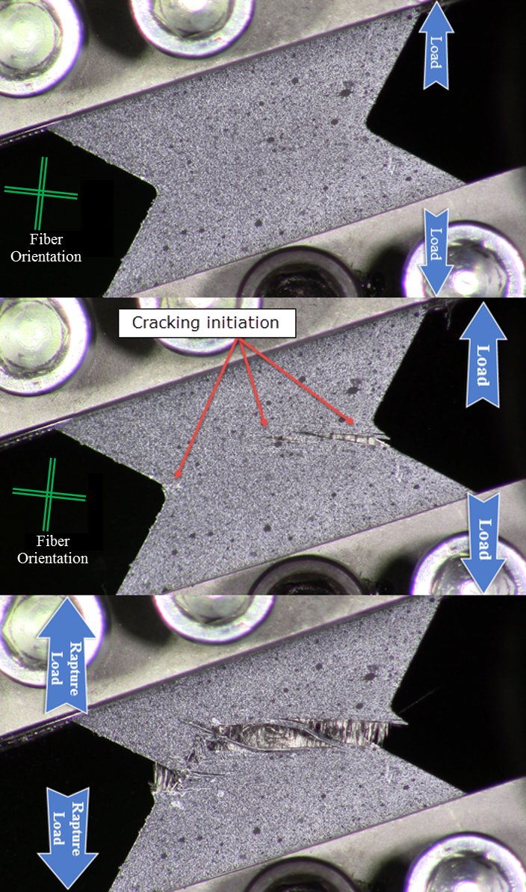

Fig. 2. Failure of CRP sample based on UD2 fabric during the tests with combination of angles
α = – 22.5º; β = 75º.
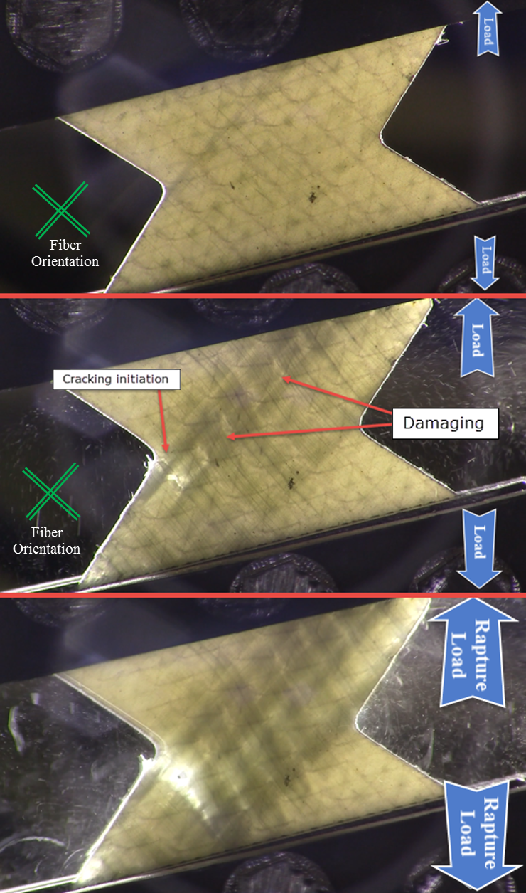

Fig. 3. Failure of GRP sample based on SD1 fabric during the tests with combination of angles
α = 35º; β = 75º

2.3. Damage accumulation model

Straining and failure of material were simulated taking into account the decline in elastic parameters of material and the accumulation of plastic damage. The main provisions and tools of damage mechanics were formulated in Kachanov [2] and Rabotnov [3]. Based on the material model suggested by Ladevèze [4] and Zinoviev [8], the model of monolayer with unidirectional fibers was developed [5]. Then, for more accurate behavior prediction of material with failing fibers, Daniels approach was applied [6, 7], where failing material is represented as a “bundle of threads”.

Polymeric composites with orthogonal fibers are regarded as a structure consisting of two equivalent monolayers with unidirectional fibers. Each monolayer has its own internal damage parameters d_{a}, d_{p}, d_{ap}, their subscripts corresponding to the anisotropy direction of the layer: along fibers a, transversal p and shear ap. In this study, damage parameters d_{a}, d_{p}, d_{ap} are used as internal variable states of material:
, | (2)
where $E_{a,p}^{ }$ and $G_{ap}^{ }$ are Young’s modulus and shear modulus in the loaded monolayer, and $E_{a,p}^{0}$, $G_{ap}^{0}$ are Young’s modulus and shear modulus for the intact monolayer.
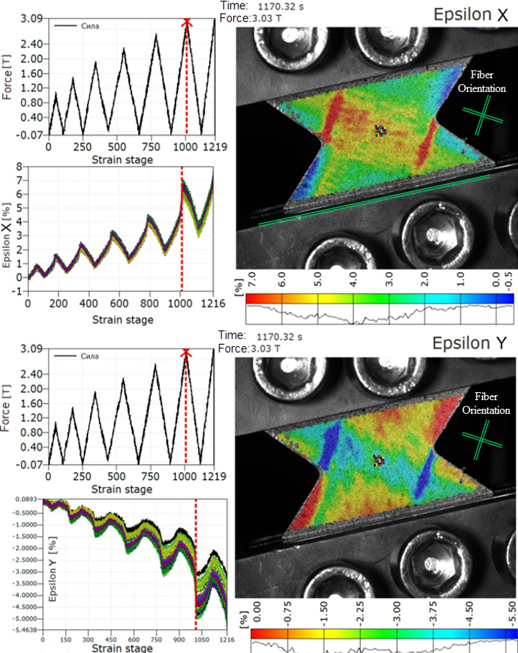

Fig. 4. – Normal stress fields during the tests of CRP based on UD2 fabric
with combination of angles α = – 35º; β = 75º.
Damage progress law is determined as per the best correlation with the test data and, taking into account damage parameters, is a part of the algorithm describing progressive damage of the layer. Thus, the following model of progressive damage was suggested, taking into account damage accumulation in the monolayer:
$\left\{\begin{matrix}\begin{matrix}d_{ap}=0, & at & \{\sqrt{\underline{Y}}<\sqrt{Y_{0}} \& d_{a,p}<1\} \\ d_{ap}=d_{ap}^{sat.}-Be^{-ω\sqrt{\underline{Y}}}, & at & \{\sqrt{\underline{Y}}>\sqrt{Y_{0}} \& \left|τ_{ap}\right|<П_{ap} \& d_{a,p}<1\} \\ d_{p}=b_{3}d_{ap}, & at & \{d_{ap}<1 \& П_{pp(-)}<σ_{pp}<П_{pp(+)}\}\end{matrix} \\ \begin{matrix}d_{ap}{=d}_{p}=1, & if & \{\left|τ_{ap}\right|=П_{ap} or σ_{pp}=П_{pp\left(±\right)} or d_{a}=1\} \\ d_{a}=\frac{1}{S\sqrt{2π}}\int_{0}^{{\tilde{σ}}_{aa}}{e^{- \frac{1}{2}{\left[\frac{z-M_{(±)}}{ S}\right]}^{2}}}dz, & at & П_{aa(-)}<σ_{aa}<П_{aa(+)} \\ d_{a}=1, & if & σ_{aa}=П_{aa(±)}\end{matrix}\end{matrix}\right.$ | (3)
Here, П_{aa(+/-)}, П_{pp(+/-)}, П_{ap} are limit stresses in the monolayer, as determined in 0ap coordinate system of the layer. Effective stresses ${\tilde{σ}}_{aa}$, ${\tilde{σ}}_{pp}$ and ${\tilde{τ}}_{ap}$ are used for stress state assessment taking into account the accumulated damage. The limitation introduced for stresses $σ_{aa}$ is true in the damage accumulation law for parameter $d_{a}$ if average statistical strength model of “bundle of threads” $M_{(±)}$ from the Daniels model [6, 7] is used. Strength $M_{(±)}$ is determined as per the limit strength of monolayer along fibers $П_{aa(±)}$ and variation coefficient $k_{ν}$ for the normal distribution. The constants of material, d_{ap}^{sat.}, ω, $Y_{0}$ and B, are determined as per shearing test data. Damage accumulation in transverse and shear directions, $d_{p}$ and $d_{ap}$, is related to thermodynamic forces $Y_{d_{p}}$ and $Y_{d_{ap}}$:
$\left\{\begin{aligned}Y_{d_{p}}=\frac{{σ_{pp}}_{ }^{2}}{2E_{p}^{0}{\left(1-d_{p}\right)}^{2}} \\ Y_{dap}=\frac{{{}_{ap}}^{2}}{{2G}_{ap}^{0}{\left(1-d_{ap}\right)}^{2}}\end{aligned}\right.$ | (4)
To take into account the effect of transverse stresses upon damage variable d_{ap}, for the case of multi-axial loading, an equivalent thermodynamic force $\underline{Y}$ is introduced:
$\underline{Y}(t)=\sup_{τ≤t}(b_{2}Y_{dp}+Y_{dap})$, | (5)
where b₂ is the coefficient of tension/shear coupling. Coupling coefficients b₂ and b₃ determine the effect of transverse stresses σ_{pp} upon damage accumulation in the layer and growth of accumulated damage in shear direction d_{ap} [4, 5].

The model of monolayer was implemented as an independent software code enabling numerical simulation of behavbiour for a layered structure consisting of different monolayers, under any type of plane combined loading.

2.4. Verification of numerical model

During the tests with combined loading, composite material, apart from shear load, also suffers additional normal loads directed along and across the monolayer with unidirectional fibers. The progress law for shear damage was approximated as per the results of pure-shear tests, where the material was not exposed to these normal loads. Sensitivity analysis was performed with different coupling coefficients of the suggested model. The results have shown that the most important factor for the behavior of material under combined loading is the change in coupling coefficient b₂. Fig. 5 compares simulation results with different b₂ for the CRP based on UD2 fabric. Test results were given in 012 coordinate system of reinforcing fibers. Simulation results have shown that damage accumulation mechanisms have their effect not only upon the change in Young’s moduli of polymeric composite material but also upon its non-linear strain pattern. Let us consider the test example given below (combination of angles α = – 22.5º, β = 75º). By the time when shear stresses achieve the level of τ₁₂ = 50 MPa (failure of Sample 4, Fig. 5b), the stresses along fibers are σ₁₁ ≈ 677.4 MPa (разрушение failure of Sample 4, Fig. 5b), which corresponds to 77% of this material’s limit tension strength along fibers. Fig. 5b shows that as b₂ grows from 0.0 to 5.0 at τ₁₂ = 50 MPa, shear strains increase from γ₁₂ = 2.3% to 3.9%.

For polymeric composites based on fabric combination UD1+UD2 (stacking sequence [0º/90º]+[+/–45º]), simulation results are compared versus the test data. Fig. 6a illustrates the sections of limit surfaces, damage accumulation surfaces and plastic strains. An example of tension damage progress in different layers during the tests is shown in Fig. 6b.

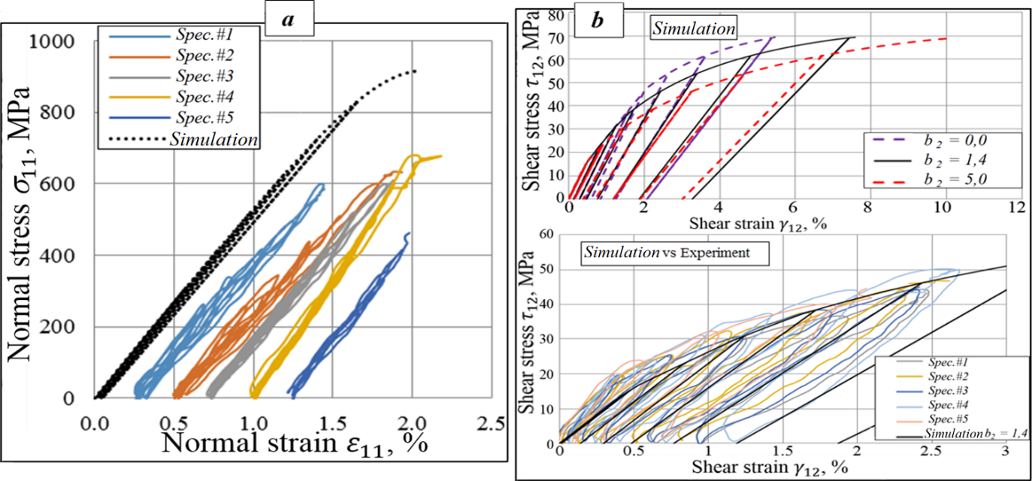

Fig. 5. Experimental stress-strain diagrams for UD2 fabric-based CRP
(combination of angles α = – 22.5º, β = 75^{o)} versus the simulation data.

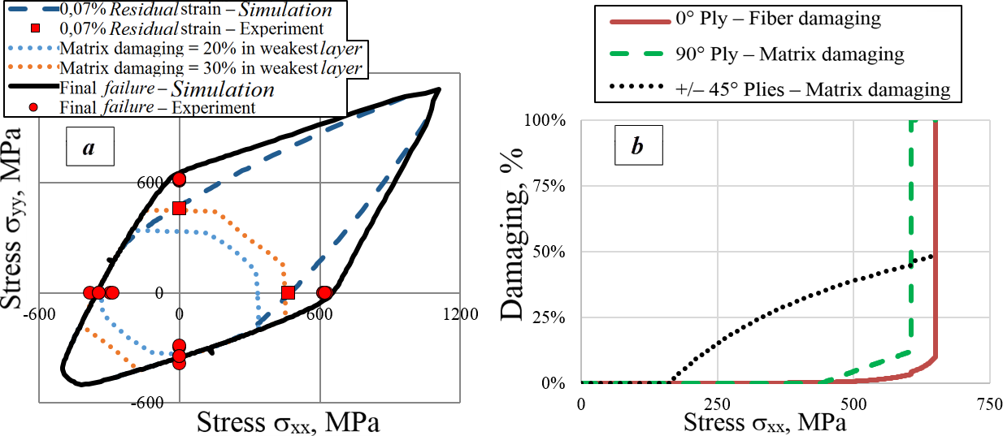

Fig. 6. Simulation results: а) loading surfaces (in comparison with the test data);
b) uniaxial tension damage accumulation in different layers of polymeric composite
based on UD1+UD2 fabric combination.

3. Conclusion

The model of polymeric composite monolayer was developed, taking into account damage and plastic strain accumulation. It was assessed how the parameters of damage accumulation model influence failure processes that take place in polymeric composite under combined loading. For a number of polymeric composite materials, monolayer model parameters were verified, including elastic and strength properties of monolayer with unidirectional fibers, as well as parameters characterizing the laws of damage progress and plastic strain accumulation. Comparison of the test data for combined loading versus numerical simulation results has shown that verification of parameters for the suggested model might lead to more accurate predictions for damage accumulation in the layers of composite material in complex stress-strain state. It was analysed how well numerical simulation results converge with the test data for polymeric composites based on various combinations of fabrics. High accuracy of simulation results was demonstrated not only by comparison of effective elastic and strength parameters, but also by comparison of plastic strain growth for the material based on a combination of fabrics.

References

[1] M. Arcan, Z. Hashin, A. Voloshin, A Method to Produce Uniform Plane-stress States with Applications to Fiber-reinforced Materials. Experimental mechanics, 18(2): 141-146, 1978.
[2] L. M. Kachanov. Time of the rupture process creep conditions, Izv Akad Nauk S.S.R. Otd, Tech. Nauk, 8: 26-31, 1958.
[3] Y. N. Rabotnov. Creep rupture. Proc. XII. Int. Cong. Appl. Mech. Stanford-Springer, 1968.
[4] P. A. Ladevèze. Damage computational method for composite structures. Computer Structures, vol. 44, 1992.
[5] Dodonov P.A., Fedonyuk N.N., Damage model for the composite material under multiaxial loading in Proceedings of the 17th European Conference on Composite Materials (ECCM17), München, from June 26th to 30th, paper#3.03-07, 2016.
[6] Daniels H.E. The statistical theory of the strength of bundles of threads. Proc Roy Soc; A183: 405, 1945.
[7] Sapozhnikov S.B. and Cheremnykh S.I. The strength of fibre reinforced polymer under a complex loading. Compos Mater; 47: 2525–2552, 2013.
[8] P. Zinoviev, S.V. Grigoriev, O.V. Labedeva, L.R. Tairova. Strength of multilayered composites under plane stress state. Composite Science Technology, 58:1209–24, 1998.

