Effect of thermal welding repair for damaged ultra-thin chopped carbon fiber tape reinforced thermoplastics

Hideki Toyoda¹, Wataru Sato¹, and Jun Takahashi¹

¹ Department of Systems Innovation, School of Engineering, The University of Tokyo, 7-3-1 Hongo, Bunkyo-Ku, Tokyo 113-8656, Japan
Email: toyoda-hideki@cfrtp.t.u-tokyo.ac.jp

Keywords: CFRTP, UT-CTT, Repair, Ultrasonic welding

Abstract
Carbon fiber reinforced plastics (CFRP) are lightweight compared to metallic materials with the same mechanical properties. Especially, ultra-thin chopped carbon fiber tape reinforced thermoplastics (UT-CTT), which are a type of randomly oriented strands (ROS), are a promising material for practical applications because of their high volume fraction of fibers (V_{f}). Moreover, CFRTP can be bonded again by thermal welding, which can lead to having a potential to recover the properties easily. This study is focused on making clear the effect of patch repair on the damaged UT-CTT. In this study, a specimen having a notch at the center was defined as the damaged specimen. The repair method is bonding patches to the damaged surface by ultrasonic welding. Flexural properties of repaired UT-CTT specimens were obtained by the three-point bending test. Test results show that the flexural properties of UT-CTT with a small notch can be recovered by repair bonding UD patch and ultrasonic welding is useful for bonding UD patches to UT-CTT.

1. Introduction

CFRP have superior specific rigidity and strength, which lead to a broad range of applications such as airplane and automobile. It has contributed to reducing energy consumption and CO₂ emission in these transportation field. In the previous applications of CFRP such as airplane and sporting goods, continuous CFRP with thermosetting resin have been widely used. On the other hand, suitability for complex-shaped components and high cycle moldability as well as superior mechanical properties are necessary for mass-produced automobiles, so discontinuous CFRP with thermoplastic resin have been actively developed in many research groups [1, 2]. Especially, ultra-thin chopped carbon fiber tape reinforced thermoplastics (UT-CTT), which are a type of ROS [3]-[5], are a promising material for practical applications because of their high volume fraction of fibers (V_{f}). Moreover, as another strong point, CFRTP can be bonded by thermal welding, which can lead to having a potential to recover the properties. Previously, the effect of repair on continuous CFRP was investigated and it revealed that continuous CFRP can be recovered after damaged by impact or bending load [6, 7]. Therefore, it is also necessary to examine the effect of repair in discontinuous CFRTP. The objective of this study is to make clear the effect of patch repair on the flexural properties of UT-CTT.

2. Specimen preparation

2.1. Materials

The material used in this study was UT-CTT, which is made from unidirectional prepreg sheets of carbon fiber reinforced polyamide 6 (CF/PA6). Carbon fiber and PA6 were provided by Mitsubishi Chemical Co. The sheets were manufactured by using tow spreading technology of Industrial Technology Center of Fukui Prefecture and their carbon fiber volume fraction is 54%. In this study, we prepared prepreg sheet with 44 µm thickness and cut them into chopped tapes with 19 mm in length and 5 mm in width, which are components of UT-CTT. UT-CTT plates were made through dispersion of tapes and compression molding. Dispersion method applied in this study is making intermediate sheets with well-dispersed tapes on the in-plane direction and stocking them into the molding die. To make the intermediate sheets, the chopped tapes are dispersed by wet dispersion method and the dispersed tapes are briefly heated and compressed. CTT plates were molded under the condition that temperature of the mold was up to 255 °C and molding pressure was up to 5 MPa.

2.2. Preparation of notched specimens

UT-CTT flat plate was cut into specimens, whose length was 80 mm, width was 30 mm, and thickness was 2 mm. In this study, two types of notched specimens are prepared. One is a specimen in which a notch was made at the center in the width direction of the specimen and the other is a specimen in which a notch was made over the whole area in the width direction of the specimen as shown in Figure 1 and Figure 2. In this study, the former one is called “small notched specimen” and the latter one is called “large notched specimen”. The 0.4, 0.8, and 1.2 mm depth notches were made for each type specimen.

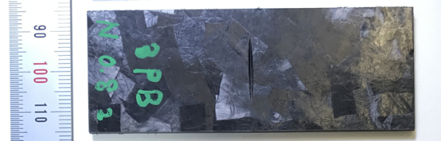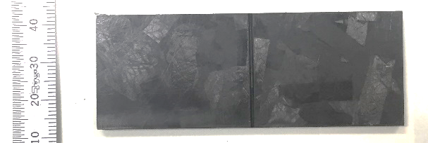

Figure 1. Small notched specimen (left) and large notched specimen (right).

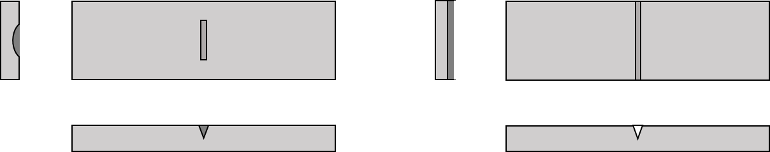

Figure 2. Shape of small notched specimen and large notched specimen.

2.3. Repair method

The notched specimens are repaired by bonding patches to the notched area. Patches are produced by compression molding of UD sheets whose uppers and lower parts sandwiched by the PA6 film shown in Figure 3. This procedure makes UD sheets impregnated with PA6. Patch length is 10 mm and width is 30 mm. In this study, the bonding method is ultrasonic welding, which is to press the patch on the notch part and use ultrasonic to stick them together as shown Figure 4. The condition of ultrasonic welding is shown in Table 1. The repaired specimens were made through these procedures as shown in . Small and large notched specimens with 1.2 mm depth notch were repaired changing the number of patches from one to four. In this study, the repaired specimen from the small notched specimens is called “small repaired specimen” and the repaired specimen from the large notched specimen is called “large repaired specimen”.

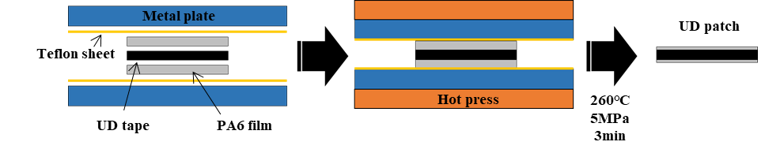

Figure 3. The making process of UD patch.

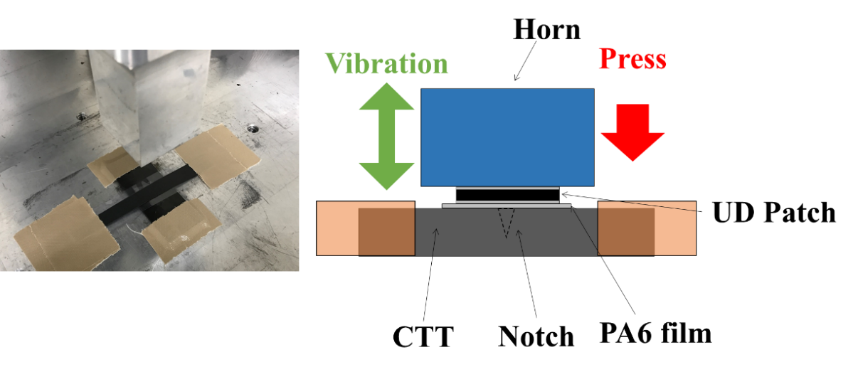

Figure 4. Ultrasonic welding.

Table 1. The condition of ultrasonic welding.

Air pressure | Amplitude | Vibration time | Trigger load | Holding time
[MPa] | [%] | [sec] | [N] | [sec]
0.2 | 100 | 2 | 500 | 5

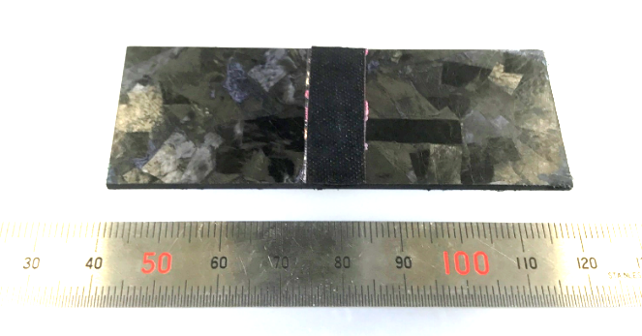

Figure 5. Small repaired specimen.

3. Experiment

2.3. Experimental method

To obtain the flexural properties of notched specimens, a three-point bending test was conducted. Both of small and large notched specimens with each notch depth (0.4 mm, 0.8 mm, and 1.2 mm) and repaired specimens with each patch thickness (44 µm, 88 µm, 132 µm, and 176 µm) were used for the test shown in Figure 6. The test was conducted under the condition that the span length was 64 mm and the stroke speed was 5 mm/ min. For each type, the number of specimens used in this experiment was three.

Table 2. Dimension of specimens and test condition.

Dimension of specimen |  |  | Span  length | Stroke  speed | Number of  specimen
Length | Width | Thickness | Span  length | Stroke  speed | Number of  specimen
[mm] | [mm] | [mm] | [mm] | [mm/min]
80 | 30 | 2 | 64 | 5 | 3

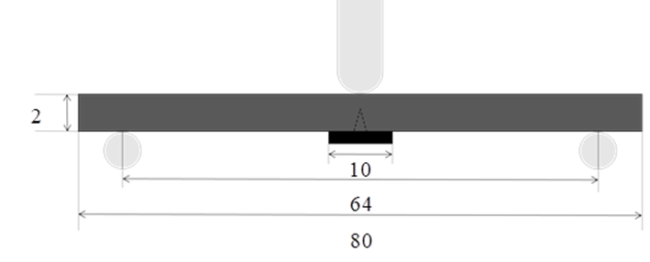

Figure 6. Three-point bending test of a repaired specimen.

3.1. Flexural test for notched specimens

Figure 7 shows the flexural rigidities and failure loads both of small and large notched specimens with each notch depth. We can see that specimens with deeper notches have lower flexural rigidities and failure loads. Especially, large notched specimens with more than 0.8 mm depth notch have remarkably low properties compared with non-damaged specimens. Moreover, their results show larger scatter than other notched specimens and non-damaged specimens. The reason can be assumed that the specimen part just under the penetrator is thin due to a notch.

Figure 8 shows the fracture behavior of a small notched specimen during three-point bending test. The fracture behaviors of all the specimens used in the experiment were same with the behavior Figure 8 shows. At first, the notched specimen broke at the upper side (compression side). After that, it broke at the lower side (tensile side). It can be said that the notch doesn’t affect the fracture behavior on the ground that this behavior is same with that of a non-damaged specimen.

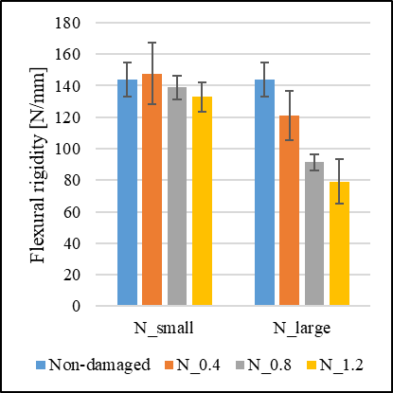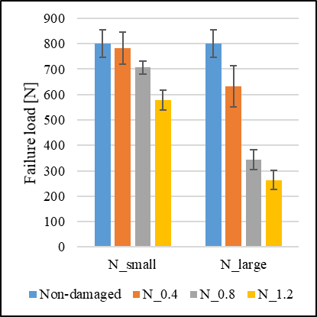

Figure 7. Flexural rigidities and failure loads of notched specimens and non-damaged specimens.

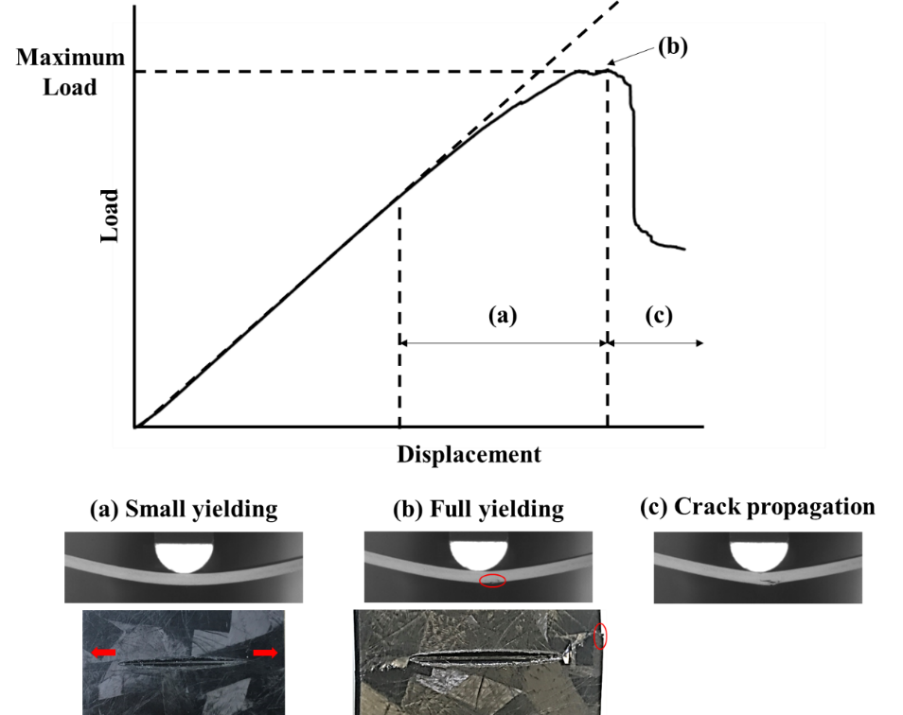

Figure 8. Fracture behavior of notched specimens.

3.2. Flexural test for repaired specimens

In order to investigate the effect of patch repair on notched specimens, we conducted three-point bending test and obtained flexural rigidities and failure loads of repaired specimens. Figure 9 and Figure 10 show surfaces and cross-sections of a small repaired specimen using two patches (left) and four patches (right) after fracture. In all the small repaired specimens using one or two patches, it was observed that crack reached the outermost patch. In the case of small repaired specimens using three or four patches, in all the specimens, patches were detached from specimens before crack reached the outermost patch. A patch is assumed to be too short to repair using more than three patches. In this study, for repairing large notched specimens, longer patches (30 mm) were used to prevent patches peeling. As a result, in all the large repaired specimens, it was observed that crack reached the outermost patch.

Figure 11 shows the flexural rigidities and failure loads of repaired specimens obtained from the test. The flexural rigidities of small and large notched specimens can be recovered enough by repairing with more than two patches. When using four or more patches, the failure loads of small notched specimens can be recovered enough. On the other hand, even if four patches are used for repair, the failure loads of large notched specimens cannot be recovered to the same level of the non-damaged specimen.

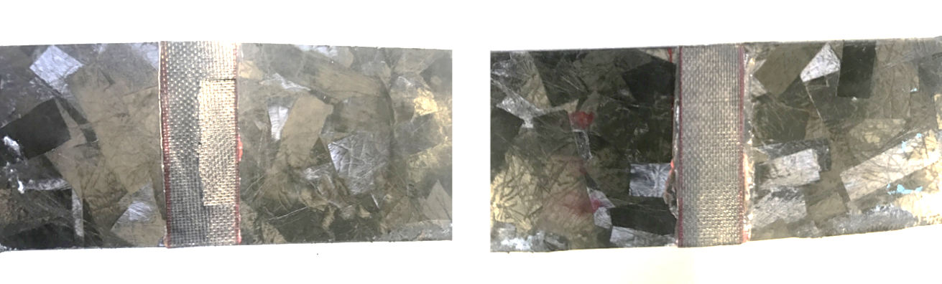

Figure 9. Surfaces of small repaired specimens using two patches (left) and four patches (right) after fracture.

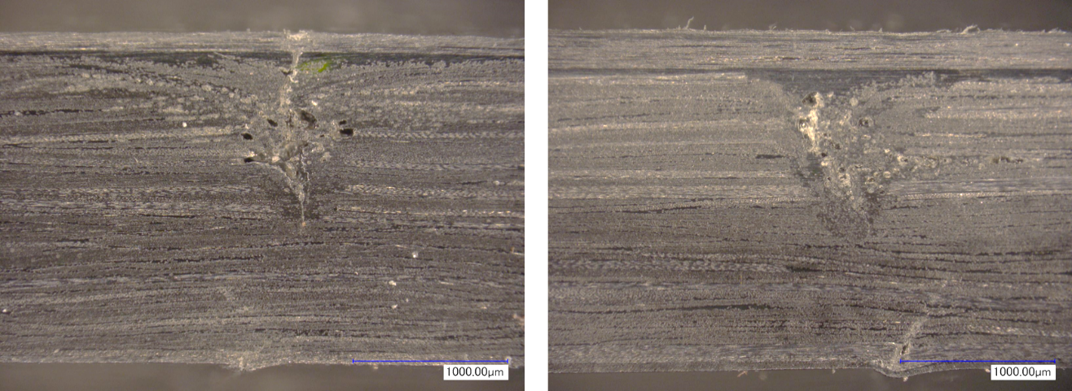

Figure 10. Cross sections of small repaired specimens using two patches (left) and four patches (right) after fracture.

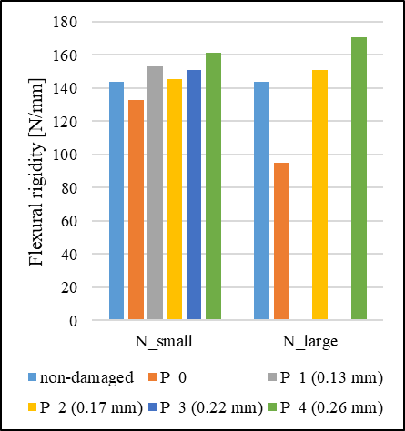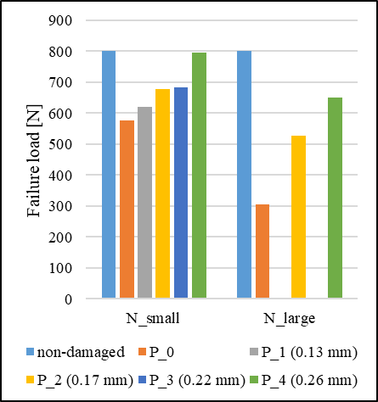

Figure 11. Flexural rigidities of notched specimens and non-damaged specimens.

4. Conclusions

In this study, the effect of patch repair on notched specimens made of UT-CTT was investigated. The following conclusions were obtained.
- UT-CTT specimen with a deeper notch has lower flexural rigidity and failure loads than the non-damaged UT-CTT specimen.
- In the flexural test, UT-CTT specimen with a notch show same fracture behaviour with the non-damaged specimen.
- The flexural properties degradation of small notched specimens were smaller than ones of large notched specimens. The properties of small notched specimens can be recovered by using less than four UD patch. Flexural rigidities of large notched specimens were also recovered to the same level of the non-damaged specimen.
Based on the results, it is assumed that UT-CTT with a small surface damage such as a scratch or a notch can be repaired by bonding several UD patches. However, to recover the property of the component with a large surface damage, we have to use more than four patches, which may be too thick for the component. Ultrasonic welding is assumed to be useful as bonding method of UD patches to UT-CTT.

Acknowledgments

Part of this study was conducted as a part of the Japanese METI project "the Future Pioneering Projects / Innovative Structural Materials Project" since 2013fy. The authors would like to express sincerely appreciation to the project members who have provided valuable information and useful discussions.

References

- F. Rezaei, R Yunus, N.A. Ibrahim and E.S. Mahdi. “Development of short-carbon-fiber-reinforced polypropylene composite for car bonnet”. Polymer-Plastics Technology and Engineering, 47, (2008), 351-357.
- K. Friedrich and A.A. Almajid. “Manufacturing aspects of advanced polymer composites for automotive applications”. Applied Composite Materials. 20, (2013), 107-128.
- M. Selezneva and L. Lessard. “Characterization of mechanical properties of randomly oriented strand thermoplastic composites”. Journal of composite materials, 50, 20 (2016), 2833-2851.
- M. Selezneva, S. Roy, L. Lessard and A. Yousefpour. “Analytical model for prediction of strength and fracture paths characteristic to randomly oriented strand (ROS) composites”. Composites Part B, 96, (2016), 103-111.
- A. Levy and P. Hubert. “Interstrand void content evolution in compression moulding of randomly oriented strands (ROS) of thermoplastic composites”. Composites Part A, 70, (2015), 121-131.
- Manato Kanesaki, Chika Uchijo, Mototsugu Tanaka, Hiroshi Saito, Masaaki Nishikawa, Masaki Hojo and Isao Kimpara. “Repair of impact damage by thermoplasticity and experimental evaluation of residual compressive strength on CF/PA6 Laminates”. Journal of the Japan Society for Composite Materials, 40, 3 (2014), 106-117.
- Masahiro Yamamoto, Rei Yamagishi, Kiyotaka Obunai, Tadao Fukuta and Koichi Ozaki. “Fundamental Research of Repair for Bending Damaged Carbon Fiber Reinforced Thermoplastics under Bending Load”. Transactions of the Japan Society of Mechanical Engineers, Series A, 79, 802, (2013).

