Analysis and Material Preparations of Gradient Connections for Corrugated Sandwich Structure’s Thermal Short-circuiting
Songhe Meng*, Zhaocai Hu, Jinping Li, Qiang Yang
Center for Composite Materials and Structures, Harbin Institute of Technology, Harbin, 150001, China

Abstract
Thermal protection system as a key subsystem of hypersonic aircraft is to force the thermal structure coupling direction of integration. As a typical integrated thermal protection system, corrugated sandwich structure of the web facing heat short circuit and thermal mismatch effects are obvious problems. Our main goal is to solve the thermal short circuit problem in the integrated thermal protection connection structure by designing the cold and hot connection structure with gradient transitional features. First, the finite element analysis model of thermal response was established. The thermo-mechanical response finite element analysis model was established and the temperature distribution of the web model with linear gradient material was analyzed. Compared with the single ceramic web, the temperature on the back of the ceramic-polyimide gradient web was decreased by 66.5K (Fig.1). The thermal stress distribution of the gradient web was significantly more uniform, and the stress value of the ceramic-polyimide gradient web was decreased by 58.3%. The linear gradient material web plays a role in reducing thermal short-circuit problems compared to typical ceramic webs and can significantly decreases the thermal short-circuit effect of the classical integrated thermal protection system.
Then, we used laser pyrolysis method to prepare the gradient material. Through the laser heating, it can be formed thermal gradient in material, and the material in different regions formed different degrees of pyrolysis material. The pyrolysis surface temperature reaches about 800℃, the back of the temperature is about 320℃. Then we prepared the gradient Polysilane/polyimide material (Fig.2). After analysis, the average density of the gradient material is 0.8052g/cm³. When the temperature is 32℃, the average thermal conductivity of the gradient material is 0.1775W·m·K⁻¹.
Keywords: Thermal protection system; thermo-mechanical response; thermal short-circuit problems; gradient material
Corresponding author: Songhe Meng
E-mail: mengsh@hit.edu.cn
Tel/Fax: +86-451-86417560

REFERENCES

- David E. Glass. Ceramic Matrix Composite (CMC) Thermal Protection Systems (TPS) and hot structures for hypersonic vehicles[C]. 15th AIAA International Space Planes and Hypersonic Systems and Technologies Conference, Dayton, Ohio, USA, April 28-1, 2008. AIAA 2008-2682.
- Satish Kumar Bapanapalli. Design of an integral thermal protection system for future space vehicles[D]. Florida, USA: University of Florida, 2007.
- Oscar Matinez. Micromechanical analysis and design of an integrated thermal protection system for future space vehicles[D]. Florida, USA:University of Florida, 2007.
- Anurag Sharma. Multi-fidelity design of an integral thermal protection system for future space vehicle during re-entry[D]. Florida, USA: University of Florida，2010.
- Satish K. Bapanapalli, Oscar M. Martinez, Christian Gogu, Bhavani V. Sankar, Raphael T. Haftka. Analysis and Design of Corrugated-Core Sandwich Panels for Thermal Protection Systems of Space Vehicles. The 47th AIAA/ASME/ASCE/AHS/ASC Structures, Structural Dynamics, and Materials Conference. AIAA 2006-1942.
- S. Sarkar, Z.H. Gan, L.N, An and L. Zhai, Structural evolution of polymer-derived amorphous SiBCN ceramics at high temperature, The Journal of Physical Chemistry C, 115, 2011, pp. 24993-25000 (doi: 10.1021/jp203287h).
- Daryabeigi K, Splinter S, Knutson J. Characterization of structurally integrated TPS for hypersonic vehicles[C]. Fundamental Aeronautics 2008 Annual Meeting，USA, October 7-9, 2008.
- Bey K S, Butcher K J. Thermal structural analysis of structurally integrated thermal protection systems [C]. Fundamental Aeronautics Program Annual Meeting, Atlanta, Georgia, USA, October 7-9, 2008.
- Craig Stephens. Optimization and fabrication studies in the development of structurally integrated thermal protection system technology [R]. NASA Dryden Flight Research Center: DFRC-1065, 2009.
- Xie G N, Wang Q, Zhang W H, et al. Optimization design and analysis of multilayer lightweight thermal protection structures under aerodynamic heating conditions[J]. Journal of Thermal Science and Engineering Applications, 2013, 5(1):011011.
- Yoshimitsu, Salcaguchi. Modification of crystallization properties of Polyethylene terephthalate by copolymerization with arylate-units[J]. Hydroquinone-containing Copolemers. 1997, 38(9): 2201-2207.
- Ronald E Myers, Strongsville Ohio. High Char Yield Silazane modified phenolic Resin. US:005089552Λ[P]. 1992, 02, 18.
- Vernon T. Bechel, Janis M. Brown, Marilyn R. Unroe. Bismaleimide/Preceramic Polymer Blends for Hybrid Material Transition Regions: Part 1. Processing and Characterization[J]. High Performance Polymers, 2012, 25(4)
- Zhou H, Liu F, Zhang Y, et al. Novel Acetylene-terminated Polyisoimides with Excellent Process ability and Properties Comparison with Corresponding Polyimides[J]. J Appl Polym Sci, 2011, 122: 3493-3503.
- J.W.Gao, C.Y.Wang. Modeling the solidification of functionally graded materials by centrifugal casting, Material Science and Engineering. 2000, A292:207

FIGURES
Figure captions:
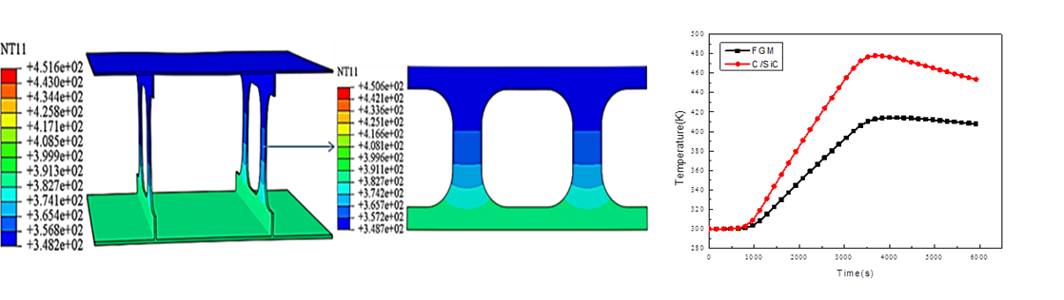
Fig.1. Comparison of the model back temperature curves between ceramic-polyimide gradient web and ceramic web

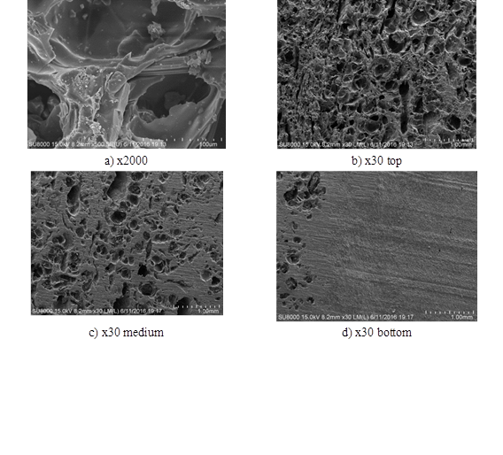
Fig.2. gradient sample electro-micrograph at different positions

