A novel approach for the autonomous inspection and repair of aircraft composite structures

I. Gray¹, M. J. Padiyar¹, I. Petrunin¹, J. Raposo¹, L. Zanotti Fragonara¹, V. Kostopoulos², T. Loutas², S. Psarras², G. Sotiriadis², V. Tzitzilonis³, K. Dassios⁴, D. Exarchos⁴, T. Matikas⁴, G. Andrikopoulos⁵ and G. Nikolakopoulos⁵

¹School of Aerospace, Transportation and Manufacturing, Cranfield University, College Road, Cranfield, United Kingdom
Email: i.gray@cranfield.ac.uk, m.padiyar@cranfield.ac.uk, i.petrunin@cranfield.ac.uk, j.raposo@cranfield.ac.uk, l.zanottifragonara@cranfield.ac.uk Web Page: http://www.cranfield.ac.uk
² Department of Mechanical Engineering & Aeronautics, University of Patras, Patra 265 04, Greece
Email: kostopoulos@mech.upatras.gr, thloutas@upatras.gr, spsarras@upatras.gr, gsotiriadis@upatras.gr, Web Page: http://www.web-page-example.com
³ Exis Innovation Ltd, Wilbury Way, Hitchin, United Kingdom
Email: vasilis.tzitzilonis@exisinnovation.co.uk, Web Page: https://www.exisinnovation.co.uk/
⁴ Department of Materials Science and Engineering, University of Ioannina, Ioannina 455 00, Greece
Email: kdassios@cc.uoi.gr, exarchosd@gmail.com Web Page: http://www.uoi.gr/en/
⁵ Department of Computer Science, Electrical and Space Engineering, Lulea University of Technology, 97187, Luleå, Sweden
Email: geonik@ltu.se, Web Page: https://www.ltu.se/

Keywords: phased-array, infrared thermography, autonomous inspections, vortex robot, composites NDT

Abstract
The paper presents the results obtained in the first two years of the H2020 CompInnova project which deals with the development of an innovative approach for inspection and repair of damage in aeronautical composites. The development of a newly designed robotic platform for autonomous inspection using combined infrared thermography (IRT) and phased array (PA) non-destructive investigation for damage detection and characterization, while integrated with laser repair capabilities. PA and IRT are combined in order to detect near-surface and sub-surface damages. Development of a novel thermographic technique termed Pulsed Phase-informed Lock-In Thermography, enables for the first time the rapid and quantitative assessment of damage in the materials. Furthermore, the results are fused using machine learning and image processing techniques for detection and sizing in real time. This will provide the information needed for an automatic laser repair procedure capable of removing precisely ply-by-ply the material. This method allows to have a well-treated surface to apply a repair patch. The three different modules (PA, IRT and laser repair) are integrated on an autonomous robotic platform. The robot is going to be able to attach and move on surfaces of different orientations via the use of a vortex-based actuation system, thus providing the ability to autonomously access, scan and repair the different sections of an aircraft fuselage.

Introduction

In the aerospace industry high level of safety for passengers and goods transferred are of the utmost importance. Aircraft are subject to ground and periodic testings to examine their integrity and functionality resorting both to traditional visual inspections and non-destructive testing (NDT) as requested by European Avitation Safety Agency (EASA) and Federal Administration Aviation (FAA). Currently, C and D type of checks are carried out every 15-21 months and 6 years respectively on aircrafts. C-checks require up to 6000 man-hours, whilst D checks may require up to 40000 man-hours, therefore there is a paramount industrial interest in the reduction of inspection time due to the high costs of trained technician without compromising in efficacy and accuracy of the NDT [1].
In the last years, interest in autonomous/automated inspection has been growing, as the innovation projects of large airliners like EasyJet [2] and Air France Industries-KLM [3] in unmanned aerial vehicles for visual inspections (typical examples of A checks) certify.
Nonetheless, the problem of autonomous inspections in the case of C and D checks remain unsolved, since multiple robust NDT techniques (i.e. ultrasonic testing, infrared thermography, x-ray radiography, acoustic emissions, shearography or electromagnetic testing) need to be used. In this context the CompInnova methodology was proposed. The authors are developing an automated prompt NDT approach capable to detect, evaluate and repair damages in composite aircraft structures. A robotic platform, based on a vortex-based actuation system, will be used to carry out NDT resorting to combined infrared thermography (IRT) and phased array ultrasonic (PA) for damage detection and characterization. The robot is going to be able to attach and move on surfaces of different orientations via the use of a vortex-based actuation system, thus providing the ability to autonomously access, scan and repair the different sections of an aircraft fuselage. The robotic platform is combining infrared thermography (IRT) and phased array (PA) non-destructive investigation for damage detection and characterization and is going to be integrated with laser repair capabilities. PA and IRT are combined in order to detect near-surface and sub-surface damages. Furthermore, the results are fused for detection and sizing in real time and stored in a database for later comparison. This will provide the information needed for an automatic laser repair procedure capable of removing precisely ply-by-ply the material. This method allows to have a well-treated surface to apply a repair patch. An advanced localization system allows the integrated system for a customizable and robust inspection and repair procedure, adjusted to fit the set requirements.

Phased-Array ultrasonic inspection module

A linear phased-array transducer is made of a number of tightly packed piezoelectric elements (typical configurations are from 16 to 256 elements). The main advantage of PA during inspection of composite is that it allows for a very good productivity (scan speed) having a very high resolution in comparison with conventional ultrasonics other NDT methods. The main drawbacks are an higher transducer cost and a requirement for operator training, that CompInnova is trying to overcome.

PA instruments can automatically activate consequent element groups with no movement of the array probe and so a 2-D region under the probe can be examined and depicted with the aid of Bscans. By moving of the array probe along in specified patterns the entire surface of the specimen is scanned and the result can be shown as a top view Cscan image. In real life of aerospace maintenance activities, PA transducers can be implemented for high level of inspection standards and are extensively allowed for the inspection of critical aircraft structural parts [4].

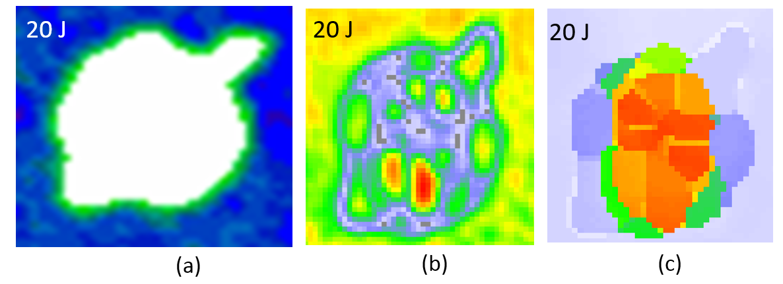
Figure 1. Comparison of conventional ultrasonic C-Scan and pulse-echo PA imaging (a) and (b) amplitude C-scan (c) Time of Flight (ToF) C-scan on the impacted side.

The present work discusses the results from the first phase of the experimental studies which aims at evaluating the current state of art PA wheel transducer and its limitations against project requirements. Composite laminates using IMS-977-2 pre-preg with layup [45/−45/90/0/90/0/90/−45/45]_{2s} were manufactured in autoclave process and cut into coupons of 100 x 150 mm. These coupons are then impacted with different impact energy levels using a calibrated drop-weight impact testing machine to simulate in-service defect due to low velocity impact damage. These samples where then inspected by conventional ultrasonic inspection by double through transmission technique and Phased Array wheel probe at 5 MHz frequency and scanning resolution of 1 mm. For a particular case of 20 J impact on the laminate, Figure 1(a) and (b) shows amplitude C-scan and Figure 1(c) Time of Flight C-scan.
For conventional composite repair approach, the total projected area of the damage is found through ultrasonic NDT from the amplitude based C-scans and this area is scraped out and repaired with a bonded patch. However, the key advantage of novel composite repair module developed in CompInnova is that it can be used to remove damaged material ply-by-ply untill the thickness where the damage has been propagated. Hence PA inspection is used to identify through-the-thickness information of impact damage through a process of slicing the full waveform A-scans captured during scanning [5]. Figure 2 shows the sliced C-scan images which starts from 5th layer from top and each slice corresponds to approximately 2 layers (0.4mm). The peak amplitude within the sliced part of the full waveform A-scan is used to generate the sliced C-scan image [6].

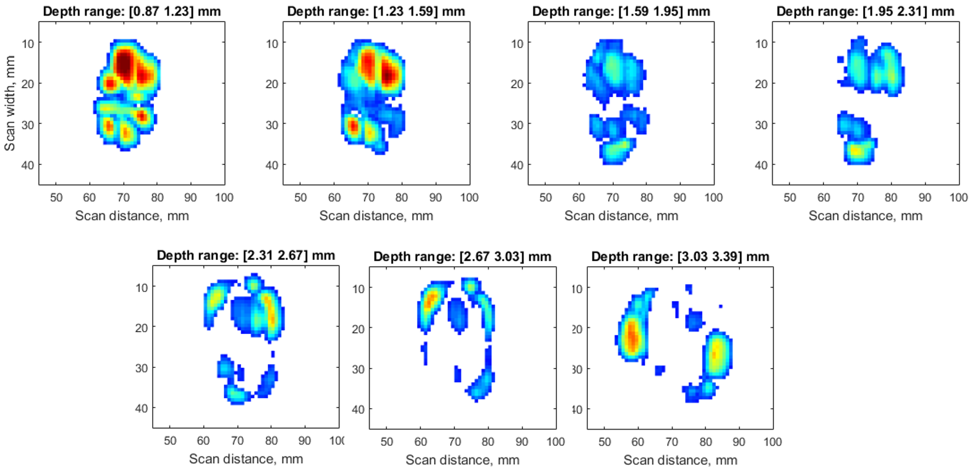
Figure 2. Automated slicing of PA C-scan showing through thickness damage pattern due to laminate [45/−45/90/0/90/0/90/−45/45]_{2s} subject to 20 J impact damage
It was observed that due to mulitple delamination at the impact damage there was overalapping of the echos from the multiple interfaces which makes it difficult to resolve the damages. To avoid the overlapping of echos there is need to improve the axial resolution by combination of increasing the frequency of the transducer and through signal processing. However higher frequency leads to larger attenuation of the signals.The second phase of the laboratory test deals with the optimization of operating parameters during automated scanning, integration of suitable PA subsystems like couplant pump and wedge, and post-processing of C-scan image for resolution improvement.

Infrared thermography module

Infrared thermography (IRT) is a powerful non-contact technique for the wide-area detection of subsurface defects in aircrafts. It analyzes the information contained in energy waves radiated from the material, to acquire information about subsurface defects. Depending on thermal stimulation requirements, IRT approaches can be categorized into active and passive ones. However, due the inability of currently available IRT methodologies to perform fast and, at the same time, reliable quantitative inspections, the current state-of-the-art does not allow exploitation of infrared thermography towards satisfying the need of fast, reliable and qualitative damage detection in aircraft components [7].
The present study proposes an innovative thermographic approach for the fast quantitative assessment of damage in aircraft based on the combination of Pulsed Phase Thermography (PPT) and optical Lock-in Thermography (LT). The two-step approach, termed Pulsed Phase-informed Lockin Thermography, relies on the fast initial qualitative assessment of defect location by PPT which indicates the frequency range over which LT is subsequently applied for the accurate, quantitative characterization of damage dimension and depth. In the proposed approach, the total time requirement for the full assessment of damage within the Instant Field of View (IFOV) is of the order of 60 sec. The principle of the approach is summarized in Fig. 1 and explained in the following. Initially, the area under investigation is inspected by typical PPT. Therein, the heating and cooling sequence of the material under the optical excitation of a thermal square pulse is captured by the IR sensor and the temporal variation of collected thermal waves is converted -by Fast Fourier Transform (FFT)- to frequency variation, which relates to the depth at which the defect lies and provides phase and amplitude information. It must be noted that the excitation source can be of any type including lamps, microwaves, ultrasounds o Eddy currents. Pattern recognition software is then employed on the set of pulsed phase thermographs of different excitation frequencies, f₁, f₂,…,f_{n}, for the rapid identification of the frequency, f_{i}, associated with the optimal thermograph contrast, which signifies that the specific frequency can probe best the defect, at the depth it lies. This initial part, of identification of the optimal frequency for assessing the defect fi, lasts approximately 10 sec. Once fi has been identified, it is used as input in the second and final step of the proposed methodology, wherein a sinusoidal thermal pulse optically excites the same area of investigation under lock-in configuration at a frequency equal of fi. The collected lock-in thermogram contains quantitative information about damage shape and dimensions.

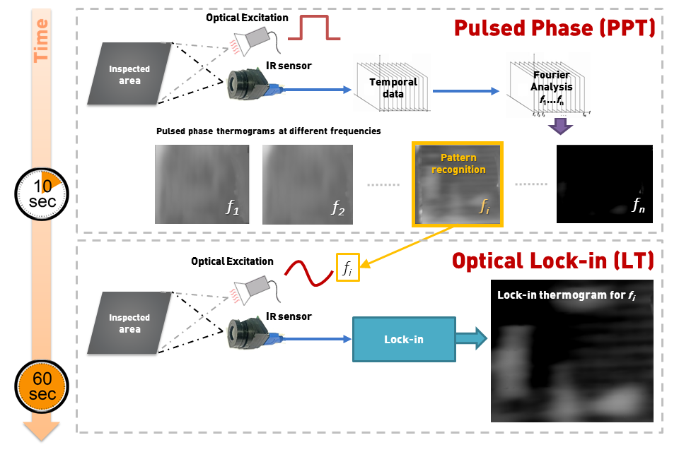

Figure 3. Pulsed phase thermography with optical lock-in.

Defect detection and characterization

An imaging analysis software for automated defect detection and localization and online storage has been developed, able to deal with both PA and IRT data. In this software, different image processing algorithms were implemented and integrated for real time processing during the inspection. An input code was programmed to allow PA/IRT data (e.g. defect location, 3D damage size etc.) to be easily and automatically inserted to the parametric numerical models of the under-inspection components. The image analysis software is based on 4 modules Figure 4 :
- Comparison of the PA or IRT image with previous images of the component;
- Initial image analysis for background separation;
- Automated defect recognition;
- Sizing through contour analysis;
- Patch Geometry Calculation if repair is needed.

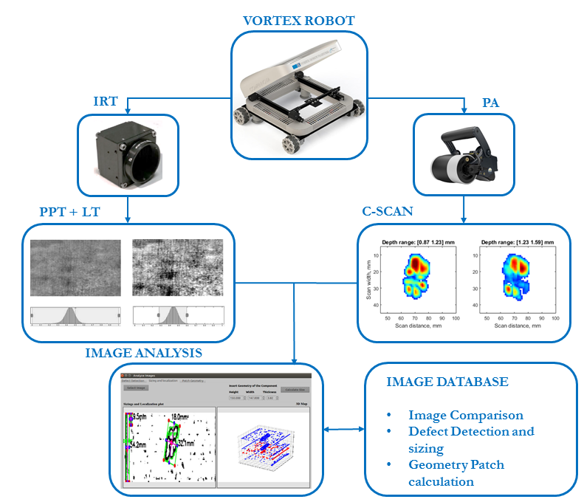
Figure 4. Block Diagram of the software of the automated defect detection, sizing and storage of patch geometry calculation

For the comparison of images (acquired in different scans) a Structural Similarity algorithm was implemented. The main advantage of this technique is the decrease of the computational complexity resulting real time process with good accuracy results. Additionally, the creation of an archive database with previous inspection data provides the capability to the user to choose any previous PA-UT or IRT image of the component to compare with the current inspected data. This comparison can give information regarding the ageing of the inspected part during service life. Also, this is a quick method to give the trigger for further investigation or not.
The primary analysis is based on image segmentation using different thresholding algorithms followed by automated defect detection and sizing algorithm which was integrated into a Graphical User interface (Figure 4). In addition, an algorithm for the calculation of the patch geometry was implemented. Lastly, a database was developed to store all the necessary data from the inspections. The combination of both PA-UT and IRT imaging subsystems, providing a reliable and automatic process, will be validated and fine-tuned further during the lab-trials.

Damaged material removal and repair

Part of the Vortex Robot is the repair module that consists of a laser material removal and a patch placement module, Figure 5. The choice in the framework of CompInnova was the GLPM-20-Y13 laser (IPG Photonics) with mean Power of 20 Watt, wavelength at 532nm and Frequency Repetition up to 600 kHz. Laser processing can support a precise ply-by-ply removal in composite structures and the specific laser was chosen due to its relatively low weight (~1.5 kg) and compact dimensions. In order to reduce further the weight of the Vortex Robot the galvo-scanner was replaced with XYZ motor system. To this direction a XYZ moving stage was utilized to move the laser head and an in-house software was developed to control the laser operation and "talk" with the control software of the moving stage. The software also controls the brushing sub-system in order to remove the residues of the ablation process and the patch placement sub-system. The determination of the optimal parameter values of a multi-variable process such as the laser ablation of composites for repair purposes, in a multi-objective optimization scheme was investigated. A design of experiments approach and more specifically the Box-Behnken Design was adopted in order to design the experimental study the effect of the process parameters on the material removal mechanisms, the SLSS of a stepped lap joint (ASTM D 5868 – 01) as well as the Heat Affected Zone (HAZ) extent in 3 different areas.

Figure 5. Schematic of the repair module

The required parameters for the laser operation were set in an in-house developed National Instruments Virtual Instrument code. In addition, the software allowed different hatching strategies giving the flexibility of trying them and observe the influence they had on the material removal procedure.
The statistical tools that employed to this direction were the classical Analysis Of Variance (ANOVA) and the Response Surface Methodology (RSM) through the Box-Behnken Design (BBD). The ANOVA tables were useful to assess the statistical significance or the absence of significance of the various process parameters as well as their interactions and may assist in understanding the effect of the process parameter to the removal and damage mechanisms. The BBD allowed quadratic fitting of all response surfaces of interest and this in turn renders the multi-objective optimization of the process feasible. The identification of a near-optimal solution for the values of the process parameters was achieved by simultaneously allowing the relative maximization of the SLSS and the removal rate and the minimization of the HAZ measured in several locations. The near-optimum parameters for the laser process with minimum HAZ, maximum SS and RR as the objective are determined at f ≈ 500 kHz, V ≈ 1570 mm/min and HD ≈ 171 μm. It can be said that in the studied range of values the lowest scanning speed, a medium hatching distance and a close to maximum pulse frequency are required to achieve near-optimal responses.

Vortex robot platform for deployment of the inspection and repair equipment

For the needs of deploying the aforementioned NDT inspection and repair equipment, a novel Vortex Robotic Platform (VRP) is being developed at LTU. In this section, an outline of the basic specifications of a VRP design will be presented from a conceptual point-of-view.
Specifically, the VRP will possess the following core abilities:
- remaining attached to the inspected surface, independently of its curve and orientation
- transferring the inspection and repair equipment to the area of interest
- undertaking the motion planning sequence for the inspection and repair modules via an integrated robotic manipulator
The conceptual design of the VRP, which will enable these abilities, along with a visualization of its deployment on an airplane fuselage are presented in Figure 6.
An overview of the technical components utilized in the VRP design regarding locomotion, vortex adhesion and robotic manipulation are presented in Figure 6. The dimensions of the VRP’s chassis are ultimately governed by the required scanning area of the robotic manipulator, which will undertake the motion planning sequences for the inspection and repair equipment, added on the manipulator’s head plate. Given the posed soft constraint of a sufficiently large scanning area, which is estimated at a minimum 0.3 × 0.3 m (length×width) and is directly affected by the specifications of the NDT equipment, the chassis is designed with an outer dimension of 0.7 × 0.7 m (as highlighted in Figure 6). The height of this conceptual design is set at 0.38 m and governed by the covering structure placed for protecting the enclosed equipment.
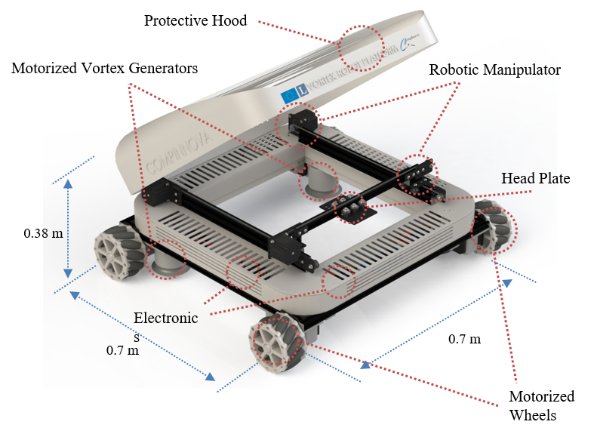 | 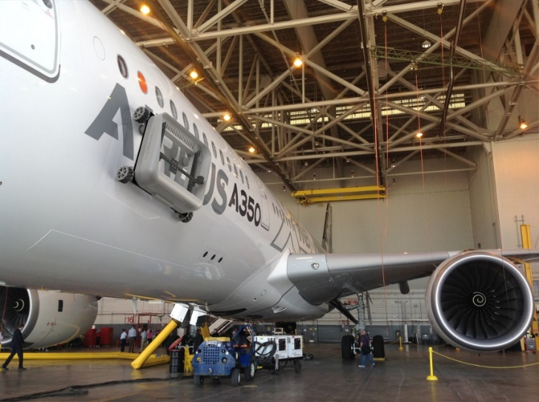
Figure 6. (left) CAD representation of the VRP design with highlighted main components, used for locomotion, vortex generation and robotic manipulation, (right) Visualization of the VRP attached on the cabin surface of an AIRBUS A350.

The VRP’s ability to remain attached on the inspected surface, independently of its curve and orientation is being addressed via the use of a Vortex Actuation System (VAS) based on Electric Ducted Fans (EDFs). As displayed in Figure 7, the enablement of the EDF’s rotation causes the airflow to be sucked into the rotating ducted fan through the gap between the front shroud and the test surface, and finally sucked out from the upper sections of the duct. As the airflow rotates in the direction of the ducted fan’s movement, a vortex is generated which causes a negative pressure rise concentrated at the fan’s center area. That pressure drop is the governing cause of the EDF generating a suction force applied on the test surface.

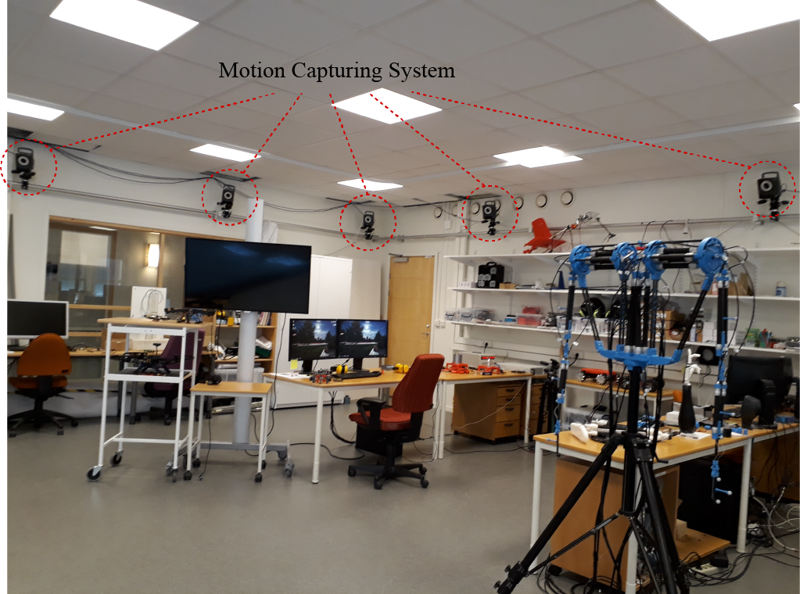 | 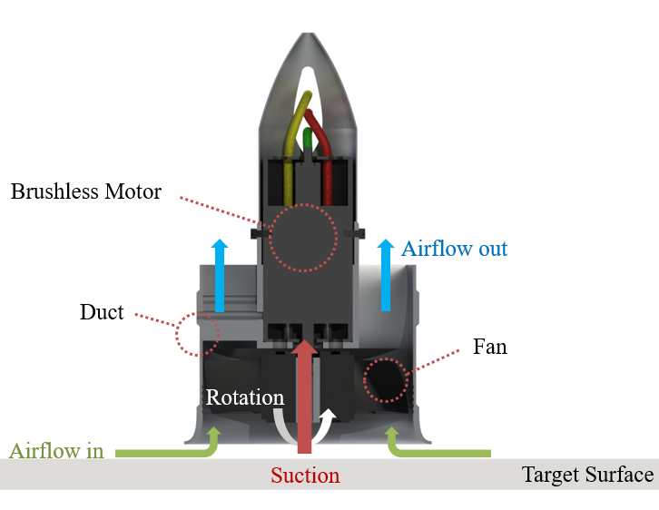

Figure 7. (left) Partial view of the Robotics Lab at LTU, highlighting the VICON motion capturing system utilized for the localization of the VRP components, (right) Cross-sectional view of an Electric Ducted Fan (EDF), displaying the vortex adhesion principle with highlighted airflows and generated suction during rotation.

This contact-less adhesion technique complies with the NDT guidelines in terms of avoiding the deformation of the targeted surface and thus reducing the risk of causing new damage or increasing an existing fracture in the composite material. The VAS efficiency has been experimentally evaluated and its structural optimization considering design and operational characteristics e.g. shroud size, distance from target surface has lead to a novel methodology capable of providing adhesion forces much greater than the free-flight thrust capabilities of commercial EDFs [8], [9].
Accurate localization of the VRP while moving onto the airplane fuselages, as well of the moving inspection and repair modules via the robotic manipulator, will be of utmost importance for the successful operation of the CompInnova platform. At the prototype evaluation stage, localization will be provided by a multi-camera VICON motion capturing system, property of the Robotics Lab at LTU. This system is able to provide translational and rotational movement information of the VRP’s subcomponents at a millimeter accuracy.

Conclusions and perspectives (Cranfield)

The paper presented the ongoing developments of a new methodology for the inspection of aerospace composite structures using a vortex robot platform equipped with both PA and IRT inspection devices. The information about damage provided by the two imaging techniques can be fused using a software and the damage can be localized. Moreover, the development of an automatic laser repair procedure able to remove the material ply-by-ply is presented. This will render possible repair using patches on a well-treated surface.

Acknowledgments
The authors wish to acknowledge the contribution from the European Union's H2020 Framework Programme, call FET-OPEN under grant agreement No 665238 CompInnova.

References
[1] J. Baaran, “Visual Inspection of Composite Structures,” 2009.
[2] BBC News, “Easyjet develops flying robots to inspect aircraft,” 2014. [Online]. Available: http://www.bbc.co.uk/news/business-27308232. [Accessed: 02-May-2018].
[3] AFI KLM, “Hawk-eyed free-flying drones to inspect aircraft,” 2016. [Online]. Available: http://airfranceindustries.airfrance.com/AFIKLMEM/en/g_page_standard/MediaRelation/BlueLink_26_October2016/BlueLink26_INNOVATION.html. [Accessed: 02-May-2018].
[4] M. V. Hosur, C. R. L. Murthy, T. S. Ramamurthy, and A. Shet, “Estimation of impact-induced damage in CFRR laminates through ultrasonic imaging,” NDT E Int., vol. 31, no. 5, pp. 359–374, Oct. 1998.
[5] T. E. Preuss and G. Clark, “Use of time-of-flight C-scanning for assessment of impact damage in composites,” Composites, vol. 19, no. 2, pp. 145–148, Mar. 1988.
[6] Z. Bergant, J. Janez, and J. Grum, “Ultrasonic Testing of Glass Fiber Reinforced Composite With Processing Defects,” in 12th International Conference of the Slovenian Society for Non-Destructive Testing, 2013.
[7] X. P. V. Maldague, “Introduction to NDT by active infrared thermography,” Mater. Eval., vol. 60, no. 9, pp. 1060–1073, 2002.
[8] A. Brusell, G. Andrikopoulos, and G. Nikolakopoulos, “Novel considerations on the negative pressure adhesion of electric ducted fans: An experimental study,” in 2017 25th Mediterranean Conference on Control and Automation (MED), 2017, pp. 1404–1409.
[9] G. Andrikopoulos and G. Nikolakopoulos, “Design, Development and Experimental Evaluation of a Vortex Actuation System,” in IEEE/ASME International Conference on Mechatronic and Embedded Systems and Applications (MESA), 2018.

