DIMENSION STABILITY AND THERMOMECHANICAL CHARACTERIZATION OF MAIZE STARCH REINFORCED WITH AGAVE SALMIANA FIBER COMPOSITES

A. Reyes-Samilpa¹, R. Fangueiro², J. A. Reyes-Agüero³, M. C. Gutiérrez⁴

¹CIIDIR Unidad Oaxaca, Instituto Politécnico Nacional, Hornos No. 1003, ZIP 71230, Col. Noche Buena, Santa Cruz Xoxocotlán, Oaxaca, México
Email:areyess1700@alumno.ipn.mx
²Escola de Engenharia, Universidade do Minho, Campus de Azurém, 4800-058 Guimarães, Braga, Portugal
Email: rfangueiro@civil.uminho.pt
³Universidad Autónoma de San Luis Potosí, IIZD, Altair No. 200, Fraccionamiento del Llano, ZIP 78377. San Luis Potosí, SLP, México
Email: reyesaguero@uaslp.mx
⁴CONACyT - Instituto Politécnico Nacional, CIIDIR-Unidad Oaxaca, Hornos No. 1003, ZIP 71230, Col. Noche Buena, Santa Cruz Xoxocotlán, Oaxaca, México
Email: michavezg@ipn.mx

Key words: Agave salmiana fiber, maize starch, extrusion-injection, bio-composites.

Abstract
Several species of Agave plants are used for extracting fiber from their leaves. This activity represents an important economic profit for some mestizos and indigenous groups in México. Agave salmiana is mainly used in the production of distilled beverages known as “mezcal” or fermented beverages such as “pulque”. In this work, variety Xa’mni of Agave salmiana fiber, obtained by the traditional technique of manual decorticating young-raw leaves, was used as the reinforcement material of bio-composites made of plasticized maize starch by the extrusion-injection method. The influence of the presence of the fibers affecting thermomechanical properties on the polymeric matrix was evaluated through thermomechanical analysis. From these analysis, it can be observed on one side, that bio-composites made of maize starch plasticized with 20% of glycerol reinforced with 10% of Agave salmiana fibers increases glass transition temperature (T_{g}) from 94°C to 108°C in penetration mode analysis, indicating a higher thermal resistance to penetration; though, this property diminishes with further addition of fiber content. On the other hand, in macroexpansión test coefficient of thermal expansion (CTE) remains the same in formulations with 10 and 20% fiber content, and it only diminishes when 30% content of fiber is added.

1. Introduction

Bio-composites have been widely studied by academics and used in textile, construction, automotive and food industries since they can be a partial solution of material accumulation in landfills, mainly relating to plastic waste. The development of composite materials made of biodegradable polymeric matrix reinforced with natural fibers encourages the use of friendly environmental materials, such as thermoplastic starch (TPS) reinforced with vegetal fibers bio-composites [1]. Starch is the most important polysaccharide used for biodegradable plastic films preparation and it is considered as one of the most promising natural polymers due to its low costs, availability and biodegradability [2,3].
Adding vegetal fibers to a polymeric matrix in bio-composites increases mechanical properties and thermal stability, when compared to thermoplastic starch [4]. Furthermore, lignocellulosic fibers, vegetal fibers, as bamboo (Bambusa emeiensis), coir (Cocos nucifera), flax (Linum usitatissimum), sisal (Agave sisalana), among others, present several advantages over synthetic fibers such as abundance, low density or lightness, low costs and biodegradability [3,5,6]. Both thermoplastic maize starch, containing ca., 20% of amylose and ca., of amylopectin [7], used as polymeric matrix phase and lignocellulosic Agave salmiana fibers, containing ca., 49% of cellulose and 8% of lignin [8], as reinforcing material phase are obtained from natural resources, which makes possible to obtain a bio-composite material. The hypothesis is that due to the hydrophilic nature of both phases, it may result in a good phase interaction (matrix-reinforce) during the bio-composite production [9,10,11].

These materials can be exposed at high or low temperatures, high content of moisture and ultraviolet light [12] through their life cycle. These environmental factors affect mostly their physical, mechanical and thermal properties. Although starch polymers are easy to handle in the production stage, they are highly moisture susceptible [13,14,8], which may cause effects in their physical properties, and when used in composites, the matrix-fiber interphase is affected, modifying their mechanical properties [15]. Hence, the aim of this work is to study the thermomechanical effect of Agave salmiana fibers as reinforcement of thermoplastic maize starch bio-composites. In further mechanical, thermomechanical and morphological tests, aging by environmental factors effects, biodegradability and degree of swelling on bio-composites will be evaluated.

2. Materials and methods

2.1. Polymeric matrix

Sigma-Aldrich maize starch and ACS Fermont glycerol were used to obtain the polymeric matrix of the bio-composite materials.

2.2. Fibers preparation

Fiber from Xa’mni variety of Agave salmiana was collected in Mezquital Valley, Hidalgo, México by a traditional manual method, consisting in decorticate young-raw leaves to remove parenchyma tissue; once fiber is obtained, it passes through a final washing-bleaching process in a soap-vinegar-water mixture. Agave salmiana fibers were milled in a Fritsch Cutting Mill Pulverisette 19 with tungsten V blades and 250 μm trapezoidal perforations stainless steel sieve. Once milled, and in order to obtain a length range between 75 μm and 300 μm, fibers were passed through W. S. Tyler ASTM E-11 cylindrical stainless steel sieves No. 200 to No. 50, respectively. The resulting fibers were placed in 10 x 15 cm aluminum foil trays and dried in an Arsa AR-290D oven at 60° C ±2 ° C for 24 h prior the bio-composite preparation.

2.3. FTIR characterization of fibers

To evaluate if there is any effect in the fibers structure due to its location within the leaf, they were classified into two types: lateral (L) and central (C) and analyzed by Fourier transforms infrared spectroscopy (FTIR). Analysis were recorded on an Agilent Technologies Cary 630 FTIR spectrometer, with attenuated total reflectance mode (ATR). The spectrum of Xa'mni fibers (Agave salmiana) was recorded in the range from 4000 to 400 cm⁻¹ with a resolution of 2 cm⁻¹ and 64 scans.

2.4. Bio-composites preparation

The initial moisture of Sigma-Aldrich maize starch content is < 15.0%. Wetting of the cornstarch was carried out with Acua Azul 20% purified water in a beaker, manually mixed with a glass stirrer, 24 h prior to the extrusion process, 20% of glycerol as plasticizer was added to maize starch. Each formulation was manually mixed for 10 minutes before introducing it into the extrusion equipment.

In order to obtain the bio-composite, Agave salmiana short fibers randomly orientated were manually added to the polymer matrix of maize starch (MG) at concentrations of 10, 20 and 30%; after mixing, glycerol was added. Bio-composites were obtained by extrusion-injection method. In the extrusion process, a DSM Xplore MC-5 extruder with double conical screw was used. The equipment was adjusted to a temperature of 90° C into the three heating zones, with 3 minutes of processing time at 100 RPM. Injection process was performed in a DSM Xplore IM 5.5 equipment with a temperature of 95 °C in the heating barrel and 35 °C in the injection mold. Both polymeric matrix and bio-composite material were obtained under the same conditions.
Samples of each material (MG and MGA) for different tests were obtained: seven for tensile tests by the extrusion-injection method according to standard ASTM D638, and six for thermomechanical analysis according to ASTM E 831, these samples were obtained from tensile probes, using an Acco single hole paper punch.

2.5. Thermomechanical characterization of materials

Thermomechanical tests were performed in a TA Instruments Q400 Analyzer under the ASTM E 831 standard. To calculate coefficient of thermal expansion (CTE), macroexpansion test was carried out with an applied force of 0.02 N and a ramp of 5° C min⁻¹ form -20 °C to 100 °C. On the other hand, glass transition temperature (T_{g}) was calculated by penetration tests, with 0.05 N of applied force, from room temperature (24 °C) to 170 °C with 10 °C min-1 heating ramp, respectively.

3. Results and discussion

3.1. FTIR characterization of fibers

FTIR spectra of Xa’mni variety of Agave salmiana showed a broad peak at ca. 3400 cm⁻¹ attributable to OH groups present in lignin, cellulose, hemicellulose and water [16], in fibers obtained from young-raw leaves (Figure 1). Bands in a range from 1600 to 1400 cm⁻¹ are related to lignin aromatic rings [17] this can be interpreted only as a superficial change in fibers during the washing-bleaching process. Peaks at ca. 1100 cm-1 are assigned to C-O-C groups present in cellulose, hemicellulose and lignin [16]. Hence, neither washing treatment nor location within the leaf modify fibers structure.

3.2. Thermomechanical characterization of materials

Reinforcing material improves thermomechanical properties of the polymeric matrix plasticized with 20% of glycerol. In penetration mode trials, the addition of 10% Agave salmiana fiber increases 14% the hardness of the polymeric matrix, but adding 20 and 30% of fiber decreases 29% T_{g}. This behavior was also observed by Schlemmer et. al., [9] with the addition of reinforcing material to acetylated cassava starch. Coefficient of thermal expansion decreases 17% only in bio-composites with 10% of fiber in comparison to the polymeric matrix CTE (Table 1). This was also observed by Yang et al., [18] in polypropylene reinforced with rice husk flour and wood flour bio-composites due to lignocellulosic fibers minimizes thermal expansion in composite materials as an effect of preventing changes caused by cold and warm atmospheric changes.

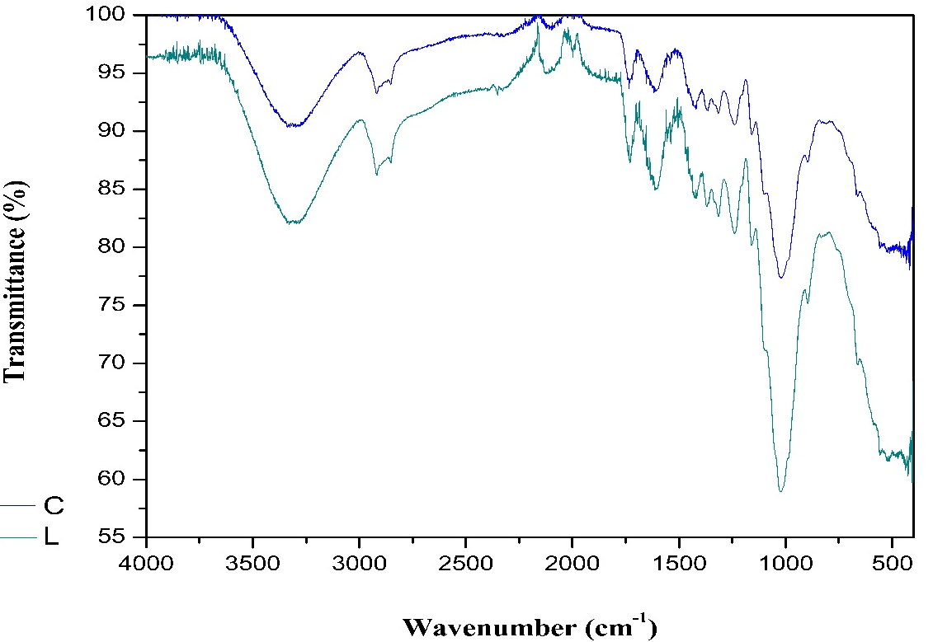

Figure 1. Washed fibers obtained from young-raw leaves in lateral and central section.

Table 1. Thermomechanical properties of polymeric matrix and bio-composite reinforced with Agave salmiana fiber.

Sample | Raw leaves fiber | Penetration | Macroexpansion
 | (%) | T_{g} (°C) | α (μ/mm ◦C)
MG | -- | 94 | 0.064 ± 0.005
MGAc10 | 10 | 108 | 0.062 ± 0.004
MGAc20 | 20 | 66 | 0.064 ± 0.009
MGAc30 | 30 | 67 | 0.053 ± 0.007

4. Conclusions

Agave salmiana fibers addition improves thermomechanical properties in maize starch as expected, particularly in formulations with 30% of fiber content, where CTE decreases 17% and T_{g} decreases 29% compared to pure polymeric matrix; these changes can be attributable to the free volume generated between fiber-matrix phases that increases with the addition of fiber content. Hence, morphological and mechanical characterization must be performed to analyze matrix-fiber interaction related to the fiber content and to the influence of similar functional groups of both phases.

Acknowledgments
A. Reyes-Samilpa acknowledges to IPN-CONACyT for scholarship 553944, and to people in Mezquital Valley, Hidalgo, México for their help in the obtainment of Agave salmiana fiber. The authors acknowledge to CONACyT for providing financial support 251504 and 264110.

References

[1] J. Sahari and S.M. Sapuan. Natural fibre reinforced biodegradable polymer composites. Reviews on Advanced Material Science, 30:166-174, 2011.
[2] P. Bhanu; V. K. Gupta; D. Pathania and A. S. Singha. Synthesis, characterization and antibacterial activity of biodegradable starch/PVA composite films reinforced with cellulosic fibre. Carbohydrate Polymers, 109:171-179, 2014.
[3] A. Edhirej; S.M. Sapuana; M. Jawaid and N. I. Zahari. Cassava/sugar palm fiber reinforced cassava starch hybridcomposites: Physical, thermal and structural properties. International Journal of Biological Macromolecules, 101:75–83, 2017.
[4] H. Pulido G., E. Hernández, M. Rabalero V., R. J. Sanjuan R. and C. F. Jasso G. Mechanothermal performance evaluation of a biodegradable resin as coupling agent for hydrophobic polymer/cellulosic composites. Maderas. Ciencia y Tecnología, 16(4):463-486, 2014.
[5] S. Mukhopadhyay and R. Fangueiro. Physical Modification of Natural Fibers and Thermoplastic Films for Composites – A Review. Journal of Thermoplastic Composite Materials, 2:135-162, 2009.
[6] R. D. S. G. Campilho. Natural Fiber Composites. CRC Press Tylor and Francis Group, 2016.
[7] G. Ruíz A. Obtención y caracterización de un polímero biodegradable a partir del almidón de yuca. Ingeniería y Ciencia, 2(4):5-28, 2006.
[8] C. D. Naranjo, L. Alamilla-Beltrán, G. F. Gutiérrez-López, E. Terres-Rojas, J. Solorza-Feria, S. Romero-Vargas, H. T. Yee-Madeira, A. Flores-Morales and R. Mora-Escobedo. Isolation and characterization of cellulose obtained from Agave salmiana fibers using two acid-alkali extraction methods. Revista Mexicana de Ciencias Agrícolas, 7(1):31-43, 2016.
[9] L. Yu, K. Dean and L. Li. Polymer blends and composites from renewable resources. Progress in Polymer Science, 31:576-602, 2006.
[10] D. Schlemmer, A. Rómulo S. and M. J. A. Sales. Morphological and thermomechanical characterization of thermoplastic starch/montmorillonite nanocomposites. Composite Structures, 92: 2066-2070, 2010.
[11] M. Cerón A. R. El problema de la hidrofilicidad en materiales plásticos derivados de almidón. Biotecnología en el Sector Agropecuario y Agroindustrial. Ed. Esp. 2:41- 48, 2013.
[12] B. C. Ray and D. Rathore. Environmental damage and degradation of FRP composites: A review report. Polymer Composites. 36(3):410-423, 2014.
[13] W. D. Callister Jr. Ciencia e Ingeniería de los Materiales 2. Reverté, 1996.
[14] L. Jiang and J. Zhang. Biodegradable polymers and polymer blends. In: Ebnesajjad S. 2013. Handbook of biopolymers and biodegradable plastics. Properties, processing and applications. Elsevier, 2011.
[15] M. S. Sreekala, M. G. Kumaran and S. Thomas. Water sorption in palm oil fiber reinforced phenol formaldehyde composites. Composites Part A: applied science and manufacturing. 33:763-777, 2002.
[16] M. C. Gutiérrez., M. A. De Paoli, M. I. Felisberti. Biocomposites based on cellulose acetate and short curauá fibers: Effect of plasticizers and chemical treatments of the fibers. Composites: Part A, 43:1338-1346, 2012.
[17] E. Jiménez-Muñoz, F. Prieto-García, J. Prieto-Méndez, O. A. Acevedo-Sandoval and R. Rodríguez-Laguna. Caracterización fisicoquímica de cuatro especies de agaves con potencialidad en la obtención de pulpa de celulosa para elaboración de papel. DYNA, 83(197):133-143, 2016.
[18] H. S. Yang, M. P. Wolcott, H. S. Kim and H. J. Kim. Journal of Thermal Analysis and Calorimetry, 82:157-160, 2005.

