Polyethylene glycol-silver nanowire/expanded vermiculite shape-stabilized composite phase change materials: form stabilization, thermal conductivity enhancement and thermal energy storage behavior
Yong Deng (dengyong@cugb.edu.cn), Jinhong Li, Tingting Qian,
Weimin Guan, Yali Li, Xiaoping Yin
Beijing Key Laboratory of Materials Utilization of Nonmetallic Minerals and Solid Wastes, National Laboratory of Mineral Materials, School of Materials Science and Technology, China University of Geosciences, Beijing, 100083, P.R. China
A series of novel polyethylene glycol-silver nanowire/expanded vermiculite shape-stabilized composite phase change materials (PEG-Ag/EVM ss-CPCMs) were prepared to overcome liquid leakage during phase transition and enhance the thermal conductivity of PEG. In these PEG-Ag/EVM ss-CPCMs, PEG served as the phase change material for thermal energy storage; Ag NW served as thermal conductivity enhancement filler; EVM acted as the supporting material to provide structural strength and prevent the leakage of melted PEG. SEM analysis results indicated that Ag NW wrapped with PEG was well dispersed and enwrapped inside the pores and surfaces of EVM (Fig.1). It was found that the maximum encapsulation capacity of PEG in all PEG-Ag/EVM ss-CPCMs with good shape stability was 66.1 wt.%. The thermal conductivity of PEG-Ag/EVM ss-CPCMs could be greatly enhanced by the prepared Ag NW. A theoretical calculation method was developed to predict and evaluate the thermal conductivity enhancement ability of Ag NW. The predictions were consistent with experimental results (Fig.1). The thermal conductivity of PEG-Ag/EVM ss-CPCM19.3 reached 0.68 W/m K, and corresponding phase change latent heat was 96.4 J/g. The supercooling extent of PEG in PEG-Ag/EVM ss-CPCMs decreased approximate 7 °C because the EVM could act as a heterogeneous nucleation center to promote the crystallization of PEG. FT-IR and TGA results showed that the PEG-Ag/EVM ss-CPCMs exhibited excellent chemical compatibility and thermal stability.
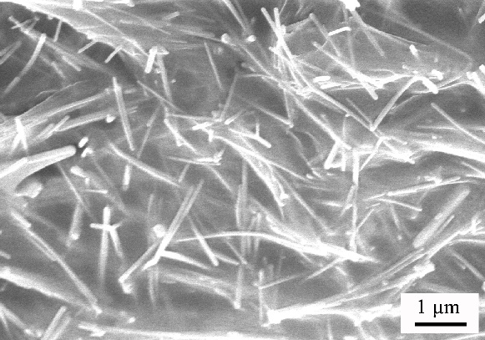
Fig.1 SEM image and thermal conductivity of PEG–Ag/EVM ss-CPCMs.

