A fragments distribution analysis to understand force variations during a CFRP crushing test

S. Rivallant¹, A. Gonzalez¹, F. Tostain¹, C. Espinosa¹

¹Université de Toulouse, CNRS, ISAE-SUPAERO, Institut Clément Ader (ICA)
10 avenue E. Belin – BP 54032 – 31055 TOULOUSE Cedex 4 – France
e-mail : samuel.rivallant@isae.fr

Keywords: crushing, composites, fragment distribution, post-mortem reconstruction, force prediction

Abstract
This paper presents an analysis of fragments due to the crushing of composite laminates. Firstly an identification of the fragments is presented. Most fragments created during the crushing are identified: length, location in the thickness and in the length of the laminate. Then, a complete analysis of the fragments length and distribution has been done, showing that the size of fragment depends on its position in the laminate. A model is then proposed, in the plateau phase of crushing, to establish a link between the oscillation of force during crushing and the size and position of fragments observed. This model is shown to be able to predict the instantaneous drops in the force caused by the plies breakings.

1. Introduction

In different industries such as aeronautics or automotive, composite is used to create energy absorber in case of crash. [1-5]. A key aspect of the crashworthiness of a composite structure is the failure mode the plies experience, which is the main variable that determines the energy absorption amount and stability. As explained by Farley in [6], the damage mechanisms can essentially be divided into splaying and fragmentation. Splaying occurs mainly in the outer plies, caused by delamination. Fragmentation may occur in two different scales: localized fragmentation is due to micro-buckling of fibers near the tip for the 0° plies, or shear micro-cracks for the 90° plies. Meanwhile, the second level of fragmentation, often referred to as inside ply failure, is due to classical intra-laminar ply failure, fiber breakage and matrix cracks. This mode is not located at the tip of the plate.
Localized fragmentation is the mode where more energy is absorbed [7], but it is not completely stable, since it evolves into undamaged splaying or inside ply failure modes during the crush. This results in a global drop of the force experienced by the composite plate [1].
The objective of this work consists in studying the force transmitted by a ply under inside ply failure, which will be shown as equivalent to the force released when the ply breaks or, more precisely, when the detached fragment breaks in a buckling mode. For this objective, the counting and positioning of the fragments created during the crushing is necessary. Some studies have been conducted in this direction but with different materials, such as pasta, in order to obtain the characteristic fragments lengths [8]. In this case, the aim is to establish a model for the force variation based on the size and position of the fragments before breaking. A distribution analysis will allow identifying the plies with a higher contribution to the force transmitted to the plate.
Experimental tests of crushing of flat chamfered laminates have been done in this study, in order to provide insight into the fragmentation mechanisms that arise at the mesoscale during the crushing process. Light is shed on the loss of crushing resistance because of inside ply fragmentation of plies or groups of plies that are at a certain position along the plate thickness.

2. Mechanical tests

2.1. Material and set-up

Quasi-static crushing tests of laminated plates have been performed in a test setup specifically designed to avoid global buckling of the plate during crushing (Fig. 1a). A free crushing distance of 20 mm is present between the horizontal guides and the base plate to avoid tearing of the plate as observed in classical crushing setups. More explanations on the set-up can be found in [10,11]. Here, the setup is used in a universal testing machine with a 20 mm/min crushing speed. Data collected during the experiments are the crushed distance x, the force, and pictures of the plate sides.
The plates are made of 0.125 mm thick unidirectional T700/M21 prepreg. The specimens are 160 x 60 mm² rectangular laminates (Fig. 1b) made of 32 plies (4 mm thickness) with the stacking sequence [(0°/90°)_{x8}]_{sym}. At one extremity of the plate, a 45° chamfer trigger is machined to initiate the crushing.
Only two tests are presented, named T090n1 and T090n2.

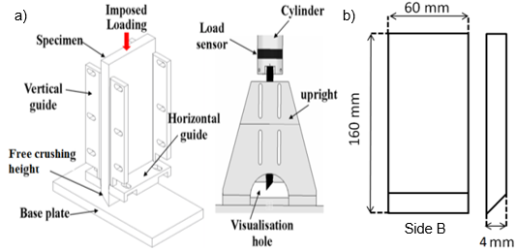

Figure 1. (a) Test setup (external and internal views) – (b) Specimen

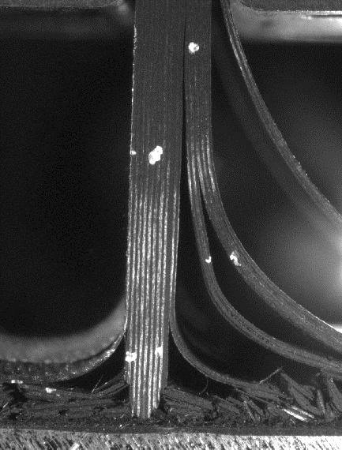

Figure 2. Force-displacement curve (left) and picture of crushing during plateau phase.

2.2. Crushing tests results

The force-displacement curves from experiments are shown in Fig. 2, revealing three different phases:
- Initiation phase: from the first contact to the peak force. The maximum force is obtained for a displacement of approximately 3 mm, when a sudden vertical delamination crack appears.
- Transition phase: the force decreases from the peak until reaching the plateau phase (after about 10 mm). A difference can be seen during this stage between the two tests, the accumulation of debris in the central part of the plates leading to different behaviors before reaching the plateau.
- Plateau phase: this is the phase that will be studied more in details in this study (from 10 mm to 80 mm). Its interest resides in the fact that the force takes a constant mean value with repeated oscillations. Damage is stabilized in a ‘laminar’ crushing process. This mean force value is linked to the volume of matter that is crushed and to the energy absorption capability of the plate (SEA).
Fig. 2 also shows a picture from the test, during the plateau phase, when damage mechanisms affecting each ply are established. One can observe delamination, splaying of plies and fragmentation.

3. Analysis of fragments

3.1. Identification

For the two tests, fragments remain attached to the specimen, which enable to identify them. A scan of both sides of each specimen is made after crushing, as shown in Fig 3. Each fragment is manually identified and located on its corresponding ply. Afterwards, a custom-made code calculates its length and position in the plate length from the extremity. This approach allows obtaining a reconstruction of the original plate with each fragment in the position where it belonged before breaking.

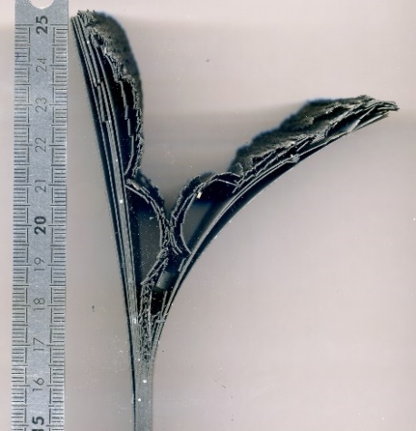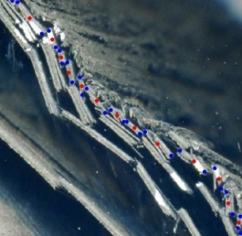

Figure 3. Scan of T090n1 - Side A: post-mortem specimen and details on fragments identification.

Once all fragments have been identified and positioned, a complete plate reconstruction can then be performed. Fig. 4 shows the result for the plate T090n1 with different colors for the 0° plies (orange) and the 90° plies (blue). Only 100 mm of the plate is represented, since the crushed distance is around 90 mm. The horizontal black lines represent a delamination between adjacent plies, while the vertical lines symbolize the locations of ply failures – i.e., extremities of the fragments previously measured and located. Localized fragmentation appeared during these tests, at the center of the crushing damage zone. This mechanism leads to the creation of very small fragments, hardly identifiable. This zone is then represented as a continuous entity (in purple). It can be observed that the plies often appear in groups of two.
A red line has been added to the graph to represent the chamfer before crushing. A difference can be observed between this line and the reconstruction, especially in the plies around the localized fragmentation zone. This is mainly due to fragment length measurement errors and to the fact that a few fragments are ejected from the plies during the initiation phase.
A first visual analysis of plies subjected to inside ply failure shows a gradient in the fragments size as a function of their distance from the localized fragmentation: the shorter fragments being located near the localized fragmentation region. Another conclusion from these graphs is that the two sides are not identical, i.e., fragments have not the same size for a given position. This means that the behavior of the plate is strictly not uniform in the width. Nevertheless, the global behavior is the same: mean size of fragments and location of delamination.

Figure 4. Plate T090n1 reconstruction, Side A and inverted Side B.

Figure 5. Fragments distribution: a) for all plies – b) for 2 specific blocks of plies.

3.2. Distribution of debris

This plate reconstruction allows performing an analysis of the fragments distribution based on their position in the thickness and along the plate length.
Fig. 5a shows the fragments repartition in plies based on their length for specimen T090n1. As mentioned previously, plies 10 to 13 are subjected to localized crushing. Plies 1 to 5 and 18 to 32 are mostly under splaying mode, except a few fragments during the first part of the test. Between these two families, four groups of two plies separated by delamination are fragmented in medium size fragments (6-7, 8-9, 14-15 and 16-17). In order to facilitate the lecture of Fig. 5, a color has been assigned to each category of ply, depending on the main mode experienced: splaying (blue), localized fragmentation (red) or inside ply failure (green).
Fig. 5b shows details of the distribution for plies 14-15 and 16-17. It is representative of what is globally observed in the plies with inside ply failure: the groups of plies closer to the localized fragmentation zone (plies 8-9 and 14-15), show a less elongated distribution with a main quantity of fragments between 1 and 2 mm length. On the other hand, outer plies 6-7 and 16-17 have a wider range of lengths with most of them being between 2 and 3 mm. This result confirms the visual analysis made on Fig. 4, with smaller fragments near the crushing zone. The two specimens studied in this paper show a fairly close correspondence in fragment length distributions.

4. Force-displacement curve reconstruction

It has been shown [10] that during crushing, the amplitude of the force is mainly due to the summation of two mechanisms: the localized crushing, resulting in a mean force proportional to the number of plies in crushing, and the inside ply failure with macro-fragments. The objective of this section is to establish the relation between these fragments identified in the post-mortem specimen and the force drops measured during the experimentation. The study is done during a part of the plateau phase since the number of plies under each type of crushing mechanism is constant in this phase.

4.1. Force model

As we have access to the distribution of fragments along the length of each group of plies, we chose to make a reconstruction of the force from a simple model of force rise and drop linked to each fragment.
The plateau force shown in Fig. 2 can be decomposed into a constant force, F_{min}, and a series of oscillations. This constant force is considered to be caused mainly by the plies under localized fragmentation, with a value for the MCS (Mean Crushing Stress) of 270 MPa [9]. Splaying damage mechanisms and other mechanisms such as friction are considered to have a much smaller influence.
Therefore, the breaking of the 4 groups of plies that fragment under inside ply failure (plies 6-9 and 14-17) are assumed to be at the origin of the oscillations.
A model of the force transmitted to the plate when a ply or group of plies reaches the base is proposed, related to the characteristics of the fragments induced by the failures in these plies. Fig. 6 shows a schematic view of this model. Every time a group of contiguous plies touches the base (x₁), there is a rise in the force transmitted to the plate (ΔF), and this force is constant while the group of plies remains in contact with the base, until it breaks into fragment after buckling (x₃). At this moment, the added force decreases to zero, as the fragmented ply does not sustain any more the load since it is not in contact with the base anymore. After a certain displacement, the plies (next future fragment) reach the base and the process starts again. One limitation of this model is that the effect of the delamination produced when the fragment touches the base is not taken into account.
The contribution of each group of plies on the total force is then a succession of boxcar functions, while the addition of all the plies contribution creates a complex force. From the plate reconstruction, the displacement for which each fragment touches the ground (x₁) is known, as it corresponds to the position of the fragment in the length of the ply, but the displacement elapsed until it breaks (Δx) and the force transmitted by each individual fragment (ΔF) are still unknown, and cannot be obtained directly from the plate reconstruction. Therefore, a model is needed for these two variables.
The relation between Δx and the length of each fragment have been obtained with the help of the camera pictures recorded during the tests and the lengths from the analysis of the post-mortem specimens. The objective was to find a generic law to approximate Δx for all the fragments. The exact value of Δx has been calculated for 44 fragments (plate T090n1), and with a linear regression, it gives:
Δx=0.38L | (1)
This means that, in average, each fragment of a group of plies breaks after a displacement of the plate equal to 38% of the fragment length from the moment it touches the base.

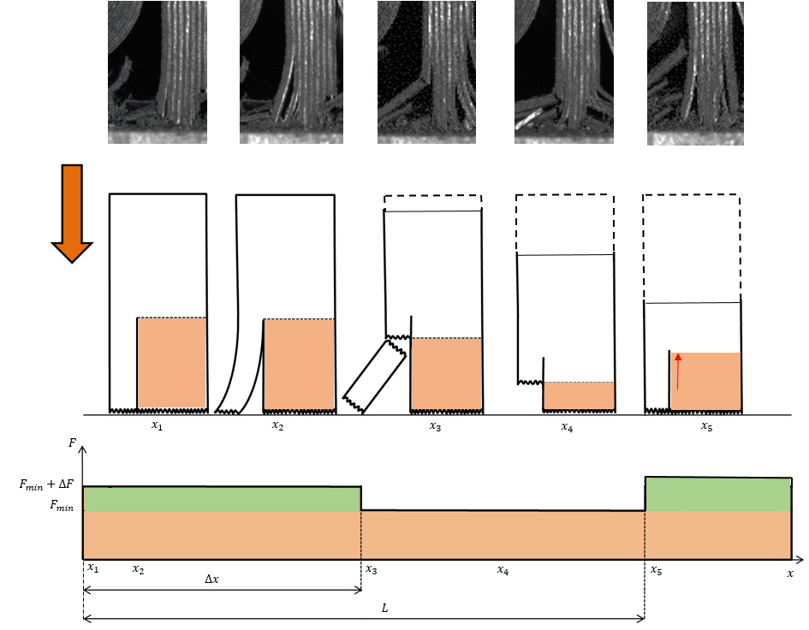

Figure 6. Scheme for the force model on one group of plies.

Figure 7. Force increment model for a group of plies: 0º-90º (left) and 90º-90º (right)

The amplitude of the force sustained by a group of plies (ΔF) is assumed as the critical buckling force of a beam clamped at one of its extremities, since plies before fragmentation are subjected to a compression force. This model assumes that the plies length taken into account for the buckling calculation is the same as the length after the rupture, i.e. the fragment's length.
For the computation of the critical force, the laminate theory has been applied, taking 120 GPa as the compressive modulus for the 0º plies and 9 GPa for the 90º plies. For the group of two plies formed by one 0º ply and one 90º ply (plies 6-7, 8-9 and 14-15), this results in 〈EI〉=2200 MPa⋅mm⁴, while for the group of 90º-90º plies (plies 16-17), 〈EI〉=700 MPa⋅mm⁴. As the buckling force approaches infinity when the fragment is very short, there is a competition in the plies between buckling and localized crushing: for fragments shorter than a given length (Fig. 7), the critical buckling force calculated is higher than the mean crushing stress (MCS). In these cases, the MCS will be applied instead of the critical buckling force. The critical sizes that determine if the force transmitted is due to buckling of the fragment or localized crushing of the central are 1.16 mm (0º-90º) and 0.66 mm (90º-90º).

4.2. Results and discussion on the force reconstruction

The contribution of all the fragments in all the groups of plies results in the addition of boxcar functions related to each fragment. The total force on the plate, in the plateau phase (between 40 mm and 60 mm of displacement), is then constructed by adding the contribution of all groups of plies.
The comparison between this force prediction and the value obtained during the experimentation is shown in Fig. 8 for test T090n1. The force drops have been indicated with dotted lines in order to facilitate the lecture, since the main resemblance between the predicted and measured forces is in the drops, and less in the rises. This is explained by the fact that the proposed model supposes an instantaneous step on the force when a ply reaches the base, which is not exactly the case. These dropping zones are better modelled since, when a fragment breaks, its force transferred to the plate stops instantly.

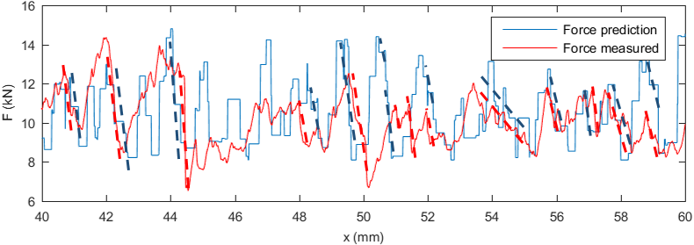

Figure 8. Total force reconstruction for T090n1 and comparison with real force.

5. Conclusions

The aim of this study was to establish the link between the plate breakings during the crushing test and the force registered. A first analysis of the post-mortem specimen has allowed identifying the plies under splaying, inside ply failure, and localized fragmentation. It has also been shown that the delamination fractures essentially arise every two plies, forming groups of two plies.
An analysis of the fragments distribution has been performed in order to study the link between the fragments size and the ply where they are located. It has been shown that the size of the fragments in the center zone suffering from localized fragmentation is very small and often non-identifiable. Fragments created in neighbor plies have a more variable length with one particular length contributing to the global resistance force.
A model has been proposed for the force transmission between the plate and the base, in which the plies under splaying and crushing create a constant load representing the minimum load measured during the plateau phase, and the plies under inside ply failure are responsible for the oscillations of this stable phase.
This model, based on the fragment buckling and MCS, uses the fragment length from the post-mortem specimen analysis to calculate the force transmitted. This force appears when the fragment touches the base until it breaks, moment at which the force transmitted is zero. The model allows predicting adequately the force drops registered, since its abruptness is very similar to the one proposed.

Acknowledgments

The authors gratefully acknowledge the French National Research Agency (ANR) for the financial support of PhD program through the VULCOMP 2 Project. The authors also want to thank all the members of this project: Airbus Group Innovation, Holo3, ICA, Impetus-AFEA, I2M, LMT-Cachan and ONERA.

References

[1] D. Hull, “A unified approach to progressive crushing of fibre-reinforced composite tubes,” Composites Science and Technology, vol. 40, no. 4, pp. 377 – 421, 1991.
[2] S. Heimbs, F. Strobl, P. Middendorf, and J. Guimard, “Composite crash absorber for aircraft fuselage applications,” Structures Under Shock and Impact XI, WIT Transactions on The Built Environment, vol. 113, 2010.
[3] J. Lavoie and S. Kellas, “Dynamic crush tests of energy-absorbing laminated composite plates,” Composites Part A: Applied Science and Manufacturing, vol. 27, no. 6, pp. 467 – 475, 1996.
[4] C. Bisagni, G. D. Pietro, L. Fraschini, and D. Terletti, “Progressive crushing of fiber-reinforced composite structural components of a Formula One racing car,” Composite Structures, vol. 68, no. 4, pp. 491 – 503, 2005.
[5] A. Esnaola, I. Tena, J. Aurrekoetxea, I. Gallego, and I. Ulacia, “Effect of fibre volume fraction on energy absorption capabilities of e-glass/polyester automotive crash structures,” Composites Part B: Engineering, vol. 85, pp. 1–7, 2016.
[6] G. Farley and R. Jones, “Crushing characteristics of continuous fiber-reinforced composite tubes,” Journal of composite Materials, vol. 26, no. 1, pp. 37–50, 1992.
[7] A. Mamalis, M. Robinson, D. Manolakos, G. Demosthenous, M. Ioannidis, and J. Carruthers, “Crashworthy capability of composite material structures,” Composite Structures, vol. 37, no. 2, pp. 109 – 134, 1997.
[8] J. Gladden, N. Handzy, A. Belmonte, and E. Villermaux, “Dynamic buckling and fragmentation in brittle rods,” Physical review letters, vol. 94, no. 3, p. 035503, 2005.
[9] H. Israr, S. Rivallant, and J. Barrau, “Experimental investigation on mean crushing stress characterization of carbon-epoxy plies under compressive crushing mode,” Composite Structures, vol. 96, pp. 357 – 364, 2013.
[10] H. Israr, S. Rivallant, C. Bouvet, and J. Barrau, “Finite element simulation of 0°/90° CFRP laminated plates subjected to crushing using a free-face-crushing concept,” Composites Part A: Applied Science and Manufacturing, vol. 62, pp. 16 – 25, 2014.
[11] A. Duong, S. Rivallant, J. Barrau, C. Petiot, and B. Malherbe, “Influence of speed on the crushing behavior of composite plates,” in 7th Asian-Australasian Conference on Composite Materials, Taipei, Taiwan, 2010.

