Dynamic Performances of Basalt Fibre Laminates at Room and Low Temperatures

I. Papa, V. Lopresto

Department of Chemical, Materials and Industrial Production Engineering, University of Naples Federico II, P.le Tecchio 80, 80125 Naples
Email: ilaria.papa@unina.it, lopresto@unina.it

Keywords: basalt fibre, vinylester resin, extreme conditions, low velocity impact behaviour.

Abstract
Basalt fibre reinforced plastic laminates in vinylester resin were obtained by overlapping plain woven fabrics by resin infusion technique. Rectangular specimens, 100mm x 150mm, were cut from the original panels and impacted at penetration and at increasing energy values, at two different temperatures (room and -50°C). The final aim was to investigate the damage onset and propagation by correlating the absorbed energy to the impact one and to study the dynamic behaviour in extreme conditions of basalt laminates.

1. Introduction

The increasing interest in environmental field had promoted the use of natural fibres in polymer reinforcing. Many kind of natural fibre, like sisal, kenaf, hem, flax, coconut and banana, lower the mechanical properties and are very sensible to thermal and hygroscopic load.
Basalt fibre laminates could be the alternative taking into account the environmental problem. It was in fact largely demonstrated that their mechanical performances are comparable to the glass ones [1-2] allowing to propose their application in fields like, for example, the naval one.
Basalt fibres derives from selected basalt rocks, they are obtained at high temperature and no precursor is necessary. Moreover, no additives are necessary in the manufacturing process that means an economic gain.
The main advantages of these fibre, that rends them very interesting for marine applications, is the low water absorption [3]. Vinyl ester resin is of naval interest too because of the low humidity absorption and the low viscosity, the latter useful for the infusion process.
In literature, many papers [4-9] were devoted to the study of the performances of basalt fibre laminates obtained with epoxy thermosetting resins but few of them are about the low velocity impact behaviour of the same fibres immersed in vinylester resin and tested in extreme loading conditions.
Understanding the dynamic response of these composites poses a number of theoretical and methodological challenges due to their inhomogeneity and anisotropy, determining the mechanics of damage formation. These challenges are further exacerbated when considering applications on marine vessels, where extreme temperatures and fluid-structure interaction must be taken into account.
The dynamic behaviour and the impact damage represent a major threat in the field of composite materials and basalt fibres laminates have already shown some potential in terms of energy absorption, as detailed in [10].
However, composite materials in general are non-homogeneous and anisotropic and can fail according to a variety of damage modes which are not always visible but may potentially lead to a complete collapse of the structure, without showing any external evidence [11-13].
For this reason, an experimental campaign of impact tests was organized and performed on laminates made of basalt fibres in vinyl ester resin matrix. Basalt fibre reinforced vinyl ester resin laminates obtained by overlapping plain woven fabrics by resin infusion technique were impacted at a velocity of about 4 m/s at room temperature and at -50°C up to penetration, by applying increasing energy levels. All the load-displacement curves were recorded and analysed. The aim was to investigate the damage onset and propagation by at now correlating the absorbed energy to the impact one, and to study the dynamic behaviour in extreme conditions. Lower absorbed energy were measured at lower temperatures.

2 Materials and experimental methods

Basalt fibre reinforced plastic plates, 400 mm in side, were fabricated by resin infusion technology using 200 g/m² plain woven fabrics and a vinylester Crystic Resin VE679PA. They were obtained by stacking 16 and 22 layers, in order to investigate the effect of the thickness on the mechanical properties and the impact response. The volumetric fibre percentage, V_{f}, was 48%.
Impact tests were carried out by a falling weight machine, Ceast/Instron, up to penetration and at different increasing energy levels, 5, 10, 20 and 30J, measured on the increasing first part of the load curve. The latter was used to investigate the damage start and evolution [14-15].
Rectangular specimens, cut to 100 mm x 150 mm by a diamond saw from the original panels, were supported by the clamping device suggested by the ASTM D7136 Standard and were centrally loaded by an instrumented cylindrical impactor with a hemispherical nose of 19.8 mm diameter.
The impact tests were carried out at room and at a low temperature of -50°C thanks to a thermal chamber and the results in terms of load curves and absorbed energy were studied and compared to the ones obtained at room temperature.

3. Results

In Fig. 1 and 2 the load displacement curves at the increasing energy levels were reported for both the laminates investigated, 16 and 22 layers respectively. As it is clear and expected, at the increasing of the impact energy, an increase in maximum load, deflection and absorbed energy was observed whereas the rigidity is always the same. The latter significantly increases at the increasing of the thickness as clearly evidenced by Fig. 3. It is interesting to note that an impact energy of 30J caused an almost penetration on the thinner laminate, evidenced by the sudden load drop of the signal after the maximum load. The same does not happen on the thicker laminate.
What above discussed was observed also at low temperature. However, the graphs are not reported here for brevity.

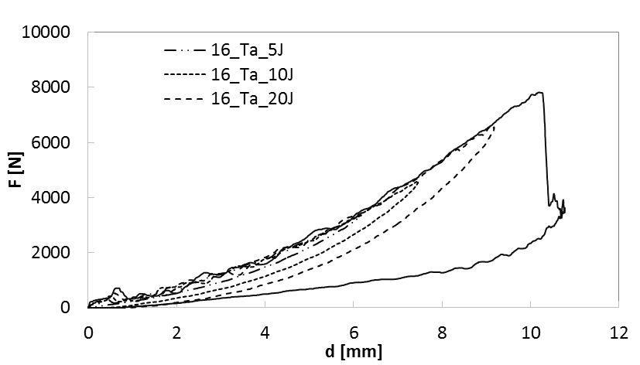

Figure 1. Load curves at increasing energy levels. n = 16 layers

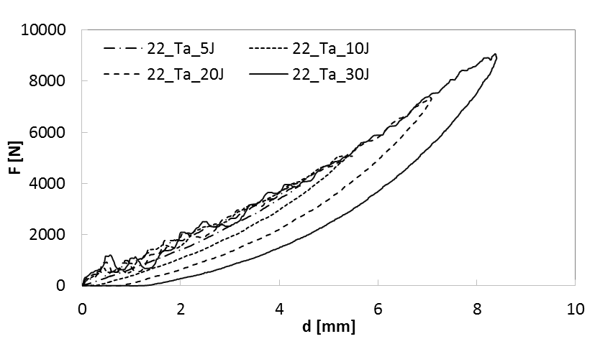

Figure 2. Load curves at increasing energy levels. n = 22 layers

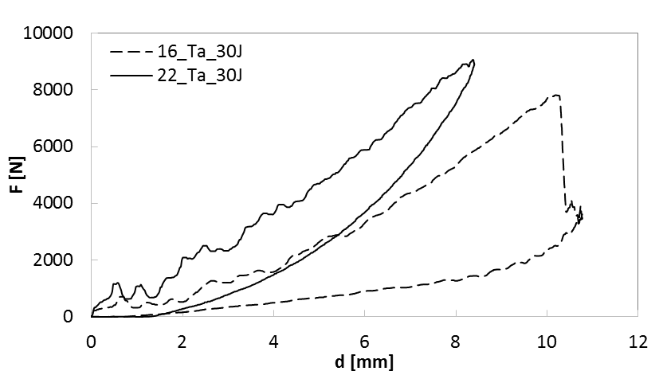
Figure 3. Load curves at increasing number of layers, 16 and 22. U = 30J.

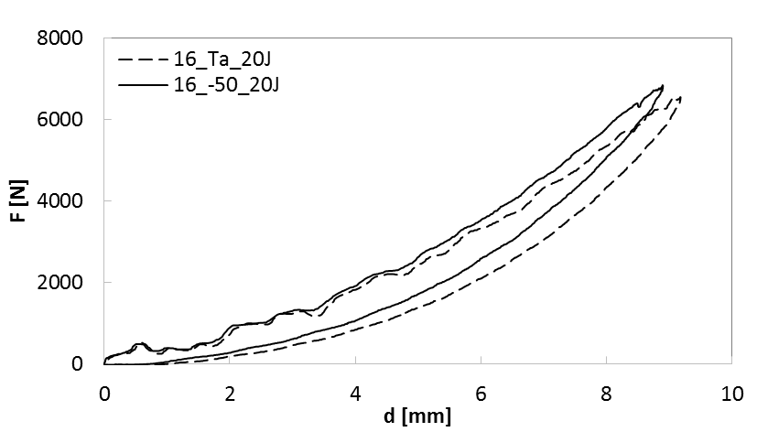
Figure 4. Load curves at room and low temperature. U = 20J; n = 16 layers.

In Fig. 4, the load curves obtained at room and low temperature, impacting the thinner specimens by 20J of impact energy, are compared. What is clear from the figure, is the higher rigidity in extreme conditions revealed after 5mm of deflection. The higher maximum load at a lower deflection at -50°C, was observed too.
In table 1 and 2, the impact parameters in terms of maximum load, F_{max}, energy in correspondence of the maximum load, U_{max} and the absorbed energy, U_{a}, are reported for all the laminates tested in the different loading conditions.

Table 1. Impact parameters; n = 16 layers
16 Plies
U [J] | T [°C] | F_{max} [N] | U_{max} [N] | U_{a} [J]
5 | Ta | 3360.62 | 8.71 | 1.29
10 | Ta | 4581.20 | 13.87 | 3.48
20 | Ta | 6556.32 | 23.83 | 7.54
30 | Ta | 7817.82 | 34.48 | 24.50
5 | -50 | 3554.44 | 8.70 | 1.11
10 | -50 | 4722.28 | 13.74 | 2.75
20 | -50 | 6847.94 | 23.72 | 6.11

Table 2. Impact parameters; n = 22 layers
22 Plies
U [J] | T [°C] |  | F_{max} [N] | U_{max}[N] | U_{a} [J]
5 | Ta | 3938.69 |  | 8.70 | 1.13
10 | Ta | 5036.04 |  | 13.65 | 3.13
20 | Ta | 7367.17 |  | 23.76 | 7.27
30 | Ta | 9065.73 |  | 34.91 | 14.04

As expected, the maximum load, F_{max}, as well as the energy in correspondence of this value of force, U_{max}, increase at the increasing of the impact energy in both room and low temperature conditions. What is unexpected is the fact that the absorbed energy is a little bit lower at the increasing of the thickness. The latter observed phenomenon is contrary to what usually found in literature on traditional carbon/glass fibre laminates [16].
Moreover, it was interesting to note a decrease in absorbed energy at the decreasing of the temperature. It is a very interesting result since the absorbed energy is strictly correlated to the internal damage. It will be so interesting to analys the specimens by NDT to investigate the internal damage, correlating it to the amount of the energy absorbed during the dynamic phenomenon.

3. Conclusions

A large campaign of experimental low velocity impact tests, at room and at low temperature, has been carried out on composite laminates made of basalt fibre immersed in vinylester resin. The scope of the research is to investigate the dynamic behaviour under impact conditions of basalt fibre composite laminates in order to propose them for marine applications. Both fibre and resin used in the present research work present in fact the precious carachteristic of the low water absorption very good for Naval field
Among the expected results about the dependence of impact parameters like maximum force and energy on the thickness of the laminate, the decreasing of the absorbed energy at the increasing of the thickness was unespected. It will be very interesting to correlate it to the internal damage.
As well as, it will be interesting to correlate the internal damage to the absorbed energy measured at low temperature. The latter was found to be lower than the one measured at room temperature, denoting a lower propensity to propagate the internal damage when the temperature is less than zero.

Acknowledgments

The authors gratefully acknowledge the ONR Solid Mechanics Program, in the person of Dr. Yapa D.S. Rajapakse, Program Manager, for the financial support provided to this research.

References

[1] V. Lopresto, C. Leone, I. De Iorio “Mechanical characterization of basalt fibre reinforced plastic” Composite Part B, Vol. 42 (2011), pp. 717-723.
[2] P. Morgan. “Carbon fibers and their composites. “ CRC Press Taylor & Francis Group, 2005
[3] H. Koerber, J. Xavier, P.P. Camanho, Y.E. Essa, and F. Martín de la Escalera. “ High strain rate behaviour of 5-harness-satin weave fabric carbon-epoxy composite under compression and combined compression-shear loading. “ International Journal of Solids and Structures, 54:172–182, 2015.
[4] Fiore V., Scalici T., Di Bella G., Valenza A. “A review on basalt fibre and its composites. “ Composites: Part B Engineering, 2015, Vol. 74, pp. 74-94.
[5] Pickering K.L., Aruan Efendy M.G., Le T.M. “A review of recent developments in natural fibre composites and their mechanical performance. “ Composites Part A: Applied Science and Manufacturing, 2016, Vol. 83, pp. 98-112.
[6] Dorigato A., Pegoretti A. “Fatigue resistance of basalt fibers-reinforced laminates. “ Journal of Composite Materials, 2012, vol. 46, pp. 1773–85.
[7] Liu Q., Shaw M.T., Parnas R.S., McDonnell A.-M. “Investigation of basalt fiber composite mechanical properties for applications in transportation. “ Polymer Composites, 2006, vol. 27, pp. 41–48.
[8] Carmisciano S., De Rosa I.M., Sarasini F., Tamburrano A., Valente M. “Basalt woven fiber reinforced vinylester composites: flexural and electrical properties. “ Materials and Design, 2011, vol. 32, pp. 337–42.
[9] Colombo C., Vergani L., Burman M. “Static and fatigue characterisation of new basalt fibre reinforced composites. “ Composite Structures, 2012, vol. 94, pp. 1165–74.
[10] V. Lopresto, A. Langella, M. Ricciardi, F. Sarasini, I. Tirillò, V. Pagliarulo, M.C. Seghini, P. Russo, P. Russo, I. Papa, “Behaviour of basalt/epoxy laminated structures under dynamic conditions“, Proceedings of AIMETA 2017, 4-7 September 2017, Salerno, Italy, pp. 1983-1988.
[11] S. Liu, Z. Kutlu, and F. K. Chang, “Matrix cracking and delamination propagation in laminated composites subjected to transversely concentrated loading.” Journal of Composite Materials, 27 (5), (1993) 436-470.
[12] F.K. Chang, H.Y. Choi, and H.S. Wang, “Damage of laminated composites due to low velocity impact”, 31st AIAA/ASME/ASCE/AHS/ASC Structures, Struct. Dyn. and Mater. Conf., Long Beach, CA, April 2-4, 1990, pp. 930-940.
[13] M.G. Stout, D.A. Koss, C. Liu, J. Idasetima, “Damage development in carbon/epoxy laminates under quasi-static and dynamic loading”, Compos. Sci. and Technol., Vol. 59 (1999) 2339-2350
[14] V. Lopresto, G. Caprino, A. Langella, C. Leone, “Penetration and indentation on basalt fibre reinforced plastic laminates under low velocity impacts”, Proc. of 15th European Conference on composite Materials, June 24-28, 2012 Venice, Italy
[15] Scarponi C, Valente M. “An application of a new ultrasonic technique to jute composite laminates subjected to low velocity impacts. “ Int J Mater Prod Techn 2006;26(1-2):6-18.
[16] G. Caprino, V. Lopresto, C. Scarponi, G. Briotti “Influence of material thickness on the response of carbon-fabric/epoxy panels to low-velocity impact“, Composites Science and Technology, Vol. 59 (1999), pp. 2279-2286.

