Low-Cost Fabrication of Fiber Reinforced Plastics by Ultrasonic Processing

A. Gomer¹, W. Zou¹, N. Grigat¹, J. Sackmann¹ and W.K. Schomburg¹

¹Konstruktion und Entwicklung von Mikrosystemen (KEmikro), RWTH Aachen University, Campus-Boulevard 30, 52074 Aachen, Germany
Email: Gomer@kemikro.rwth-aachen.de, Web Page: www.kemikro.rwth-aachen.de

Keywords: Ultrasonic fabrication, Fiber reinforced plastics (FRP), Carbon fiber, Glass fiber, Thermoplastic matrix, Fabrication of CFRP

Abstract
Common state of the art fabrication of CFRP is characterized by discontinuous processes with long cycle times and high investment costs, what leads to the high material costs of CFRP products. This paper describes a new approach using ultrasonic processing for the fabrication of CFRP made of thermoplastic polymer foils and carbon fibers. Within just one continuous process the ultrasonic fabrication processes raw materials into semi-finished CFRP materials or CFRP products. It requires cycle times of only a few seconds and investment costs in the order of some 10,000 €. Furthermore, various thermoplastic materials such as PP or PA as well as different fibers such as glass or carbon can be processed. Besides this, the raw materials can be stored for an unlimited time at room temperature. Both discontinuous and continuous processes are possible and have been demonstrated.

Tests of the specimen’s mechanical properties showed that a fibre content of 39 weight-% and a tensile strength of 500 MPa have been achieved by ultrasonic welding of four layers of foils from polyamide, each 100 µm in thickness, and three layers of carbon fibres, each 100 µm in thickness, in between.

1. Introduction

Fiber reinforced plastics (FRP) consist of glass (GFRP) or carbon (CFRP) fibers, which are embedded into a matrix material made of thermoplastic or thermoset polymer. The tensile strength to density ratio of CFRP, which is typically approximately 1.2 to 1.6 GPa / (g cm⁻³), is more than four times higher than the one of steel [1,2]. By replacing steel with CFRP, it is possible to reduce the components weight by 70 % without any loss of mechanical resilience [2]. Therefore, CFRP is mainly used in lightweight applications such as airplanes and electrical or sports cars [3]. However, the major drawback of CFRP for its industrial use is its high material costs, which can reach up to more than 300 US$ / kg depending on the field of application [3]. The reason for these high material costs is the fabrication of CFRP: The most common state of the art industrial fabrication processes of CFRP products are the pultrusion, the winding and the layup of prepregs [3]. These fabrication processes are either discontinuous and have long overall cycle times of up to 15 hours [4] including the hardening process in an autoclave. Or they are continuous and fully automated but require high investment costs for the production machinery of several 100,000 € [1,5]. Furthermore, changes of the products geometry are expensive due to specialized machining tools making the fabrication process inflexible and economic only in large-scale production.

Ultrasonic processing is the generic term for several processes employing ultrasound to deform or weld materials. The cycle time of these processes are only a few seconds and required investment costs are only in the order of some 10,000 € [6]. Because of the local heating of the material, ultrasonic processing is relatively low energy consuming and various thermoplastic polymers can be processed [6,7]. Because of low investment costs, ultrasonic fabrication can be used for cost effective small-scale production as well as for automated roll-to-roll fabrication in large-scale production [6,8].

2. Ultrasonic Fabrication of CFRP

Within the new approach presented in this paper, the beneficial characteristics of the ultrasonic processing are used and applied on the fabrication of CFRP. Figure 1 shows schematically the process.

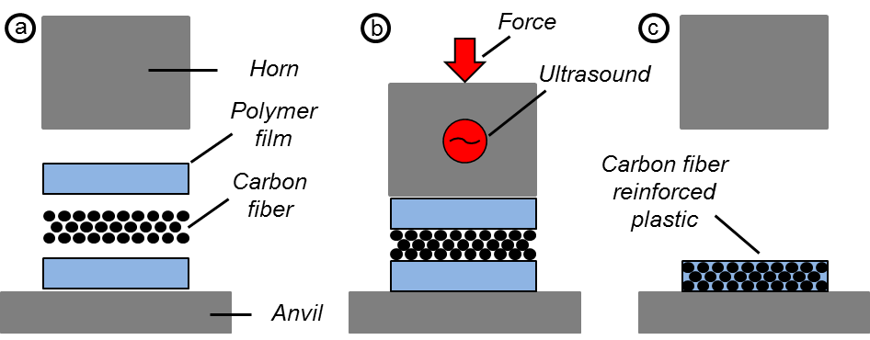

Figure 1. Schematically illustration of the ultrasonic fabrication of CFRP.

A layer of carbon fibers with a thickness of approximately 100 μm was placed between two layers of polypropylene (PP), each 200 μm in thickness. This stack of carbon fibers and polymer foils was positioned between the horn and the anvil of an ultrasonic welding machine, see Fig. 1a. The horn was compressing the sample (Fig. 1b), and as soon as the force reached a certain trigger force, ultrasonic vibrations were generated for a predetermined welding time. Friction heat was generated between fibers and polymer melting the polymer and embedding the fibers. After 1.5 s the ultrasound was deactivated, and the polymer solidified in 1 s, the so called holding time, because the heat was dissipating into horn and anvil. During the holding time, the compressing pressure was retained. Finally, the CFRP sample was released, see Fig. 1c.

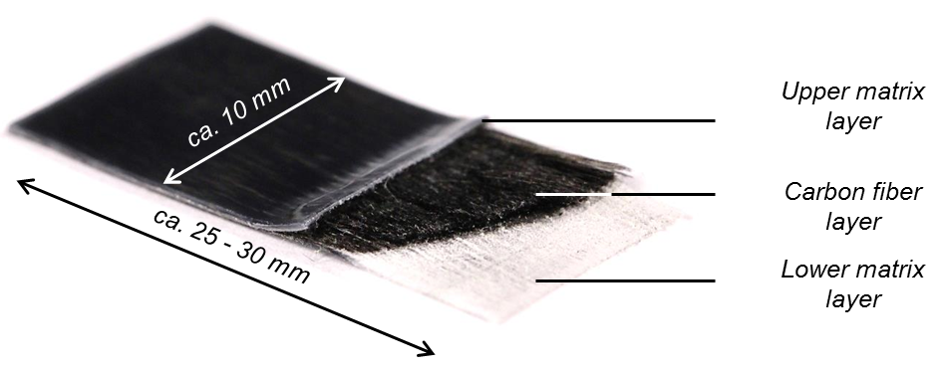

Figure 2. Ultrasonically fabricated CFRP made of carbon fibers between two layers of PP.

Figure 2 shows an ultrasonically fabricated CFRP sample made of one layer of carbon fibers and a matrix made of two layers of PP foils. The processing parameters of ultrasonic welding are summarized as process A Table 1. All fibers are orientated unidirectional. The thickness of the samples after processing is approximately 470 µm. To demonstrate that fibers are embedded into the matrix, the upper layer has been partly cut off and removed.

Ultrasonic fabrication allows also manufacturing of multi layered CFRP. For this, additional layers of fibers and polymer foils are stacked and positioned under the horn of the ultrasonic welding machine, see left part of Fig. 3. Similary to the prior description, ultrasound is being activated and the CFRP manufactured. By successively adding layers of carbon fibers and polymer foils, the overall thickness of the fabricated CFRP can be increased. Experiments showed that it is possible to ultrasonically process up to six layers of carbon fibers, each 100 µm in thickness, and seven layers of PP foils, each 200 µm in thickness, within just one welding process. The right part of Fig. 3 displays a cut through a CFRP sample consisting of seven layers of PP foils and six layers of carbon fibers with thickness of approximately 1,8 mm in total. Again, all fibers are orientated unidirectional. The processing parameters of this process B are summarized in Table 1. Also multi-directional orientated CFRP have been fabricated by ultrasonic processing by placing the fibers at different orientations between the polymer layers.

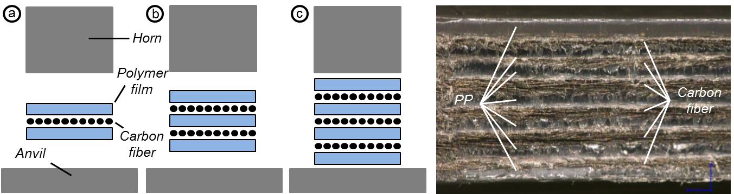

Figure 3. Schematically illustration of the ultrasonic fabrication of multi layered CFRP (left). Microscopically view on a cut through a CFRP sample with a total thickness of approximately 1,8 mm made of six layers of carbon fibers and seven layers of PP-foils (right).

For further experiments, polyamide (PA) was employed as matrix material. Based on the described working principle, several PA foils were positioned under the horn and processed to CFRP with a PA matrix. It was not only possible to variate the matrix material but also its thickness. In additional experiments, PA foils with a thickness of 100 μm and 200 μm have been tested. Table 1 summarizes the parameters for process C ultrasonically welding three layers of carbon fibers, each 100 µm in thickness, and four layers of PA foils, each 100µm in thickness. In general, the thinner the used polymer foil, the higher is the weight content of the manufactured CFRP. The weight content describes the ratio of the carbon fiber weight material to the total weight of the CFRP sample. Usually, the higher the weight content, the higher is the mechanical resilience of the CFRP. But at the same time, the higher the weight content, the more complicated and therefore expensive is the fabrication process [2].

GFRP have already been made by ultrasonic fabrication from continuous commingled glass fibers and PP filaments in a roll-to-roll process [9]. Our experiments showed that this is also possible with the process described in this paper. According to the description above, glass fibers were employed instead of coarbon fibers. During the ultrasonic fabrication of GFRP cycle times are in the order of seconds, similar to the fabrication of CFRP. Table 1 summarizes the parameters for process D ultrasonically welding five layers of glass fibers, each 100 µm in thickness, and six layers of PA foils, each 100µm in thickness.

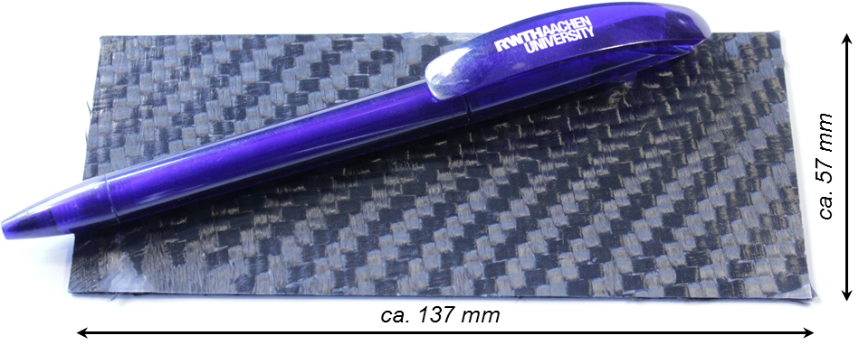

Figure 4. Ultrasonically fabricated CFRP plate.

In further experiments, canvas from carbon fibers orientated in to 0 ° and 90 ° direction were used instead of unidirectional rovings to reduce the anisotropy. Carbon fiber canvas with a thickness of 250 μm were placed between four layers of PA, each 200 μm in thickness, and processed ultrasonically. Table 1 summarizes the parameters for process E. The fiber reinforced plate fabricated this way was 57 mm, 137 mm and 0.9 mm in length, width and thickness, respectively. The manufactured CFRP sample is shown in Fig. 4.

Table 1. Overview of parameters for the ultrasonic fabrication of CFRP. In process A and C the Branson Ultrasonics 2000 IW/IW+ ultrasonic machine was used. In process B the Herrmann Ultraschall HiQ DIALOG 1200 ultrasonic machine was used. In process D and E the Herrmann Ultraschall HiQ DIALOG 6200 ultrasonic machine was used.

Process | Welding force  (N) | Trigger force  (N) | Welding time  (s) | Holding time  (s) | Ultrasonic amplitude  (µm)
A: 1 layer of fiber and 2 layers of PP foils, each 200 µm in thickness | 3200 | 220 | 1.5 | 1.0 | 32.0
B: 6 layers of fiber and 7 layers of PP foils, each 200 µm in thickness | 800 | 600 | 0.65 | 2.0 | 30.0
C: 3 layers of fiber and 4 layers of PA foils, each 100 µm in thickness | 1800 | 870 | 1.5 | 1.0 | 30.4
D: 5 layers of fiber and 4 layers of PA foils, each 100 µm in thickness | 2000 | 500 | 4.5 | 5.0 | 30.0
E: 1 layer of canvas and 4 layers of PA foils, each 100 µm in thickness | 2000 | 500 | 16.0 | 5.0 | 30.0

Besides the discontinuous fabrication process, CFRP were also fabricated continuously by ultrasonic welding machines consisting of a disk-shaped rotating horn and anvil. Similar to the discontinuous process, fibers were positioned between the foils and placed under the horn. The experiments showed, that it is possible to fabricate samples from four layers of PA foils, each 150 µm in thickness, and three layers of carbon fibers, each 100 µm in thickness, with a total length of up to 30 cm. Figure 5 shows the experimental set up as well as the fabricated sample.

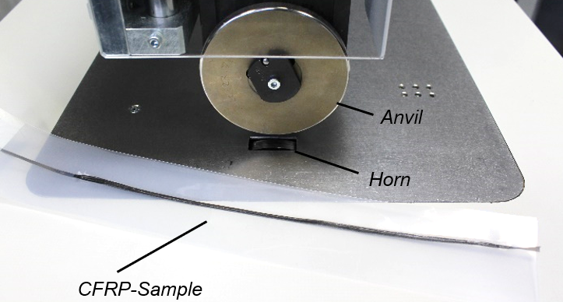

Figure 5. Experimental set up and CFRP sample produced by continuous ultrasonic fabrication.

3. Mechanical Testing

The mechanical properties of the CFRP samples generated by ultrasonic processing were tested with a tensile testing machine. Figure 6 summarizes the results. The samples consisted in one case of PP foils, each layer 200 μm in thickness, and in the other one of PA foils, each 100 μm in thickness. The thickness of the carbon fiber layer was 100 μm in all cases. Besides changing the polymer foils thickness, samples with different fiber weight content were manufactured by increasing the amount of polymer and fiber layers: Since one layered samples consist of one layer of fibers and two layers of polymer, adding one layer of fibers and one layer of polymer successively shifts the ratio of fiber to polymer within an FRP.

Figure 6. Average tensile strength and the standard deviation as a function of fiber content of the ultrasonically manufactured CFRP with PP and PA matrix.
Figure 6 plots the tensile strength as a function of fiber content of the ultrasonically fabricated CFRP samples with a PP or PA matrix. As expected, the tensile strength is rising with fiber weight content. Furthermore, the tensile strength of samples with the PA matrix in general was higher than with the PP matrix. The tensile strength of the virgin PP and PA foil was approximately 30 MPa and 50 MPa, respectively. The maximum tensile strength of 502 MPa ± 42 MPa was achieved with a PA matrix and a fiber content of 39 weight-%.

In common state of the art production, weight contents of up to 60 weight-% can be achieved [2]. Up to now, the experiments showed that ultrasonically manufactured CFRP consisting of four layers of PA foils, each 100 μm in thickness, and three layers of carbon fibers, each 100 μm in thickness, achieved a weight content of 39 weight-% with process C in Table 1.

4. Conclusions

Fiber reinforced plastic samples and plates have been fabricated by ultrasonic welding of polymer foils and carbon fibers with a cycle time of a few seconds. The required ultrasonic welding machine is commercially available for some 10,000 €. This may pave the way for a low-cost production of FRP parts. The maximum outer dimensions and thickness of the produced FRP plates were so far 5.7 × 13.7 cm and 0.9 mm, respectively.
The process has been shown here only for PP and PA as matrix material as well as glass and carbon fibers, but in principle all thermoplastic foils and fiber materials stable enough at the softening temperature of the matrix polymer can be employed opening up a large palette of FRP materials with a lot of properties to choose from.
Outer dimensions of the samples are limited by the size of the sonotrodes and the power available from the available ultrasonic welding machines. Therefore, further investigations extending these limits are desirable.

Acknowledgments




This research activity has received thankfully a financial support from the European Union’s Horizon 2020 research and innovation program under grant agreement no. 678875 of the “ambliFibre” project.

References

[1] M. Neitzel, P. Mitschang and U. Breuer. Handbuch Verbundwerkstoffe – Werkstoffe, Verarbeitung, Anwendung. Carl Hanser, 2014.
[2] H. Lengsfeld, F. Wolff-Fabris, J. Krämer, J. Lacalle and V. Altstädt. Faserverbundwerkstoffe – Prepregs und ihre Verarbeitung. Carl Hanser, 2014.
[3] T. Kraus, M. Kühnel and E. Witten. Composites-Marktbericht 2016 - Marktentwicklungen, Trends, Ausblicke und Herausforderungen. Carbon Composites e.V., 2016.
[4] F. Henning and E. Moeller. Handbuch Leichtbau – Methoden, Werkstoffe, Fertigung. Carl Hanser, 2011.
[5] Industrievereinigung Verstärkte Kunststoffe. Handbuch Faserverbundkunststoffe/Composites. Springer Vieweg, 2014.
[6] J. Sackmann, K. Burlage, C. Gerhardy, B. Memering, S. Liao and W.K. Schomburg. Review on ultrasonic fabrication of polymer micro devices. Ultrasonics, 56:189-200, 2015
[7] H.P.C. Daniels. Ultrasonic Welding. Ultrasonics, 3:190-196, 1965
[8] M. Pasternak,. Laminieren von Carbon-Preforms. Kunststoffe 10:188-189, 2012.
[9] F. Lionetto, R. Dell’Anna, F. Montagna, A. Maffezzoli. Ultrasonic assisted consolidation of commingled thermoplastic/glass fiber rovings. Frontiers in Materials 2:1-9, 2015.

