Methodology for consideration of ageing in the design of tidal turbine blades

S. Paboeuf¹, S. Durand², A.Favry², E. Billaudeau², P. Casari³, L. Mouton¹

¹Bureau Veritas Marine & Offshore, Expertise Department,
8 boulevard Albert Einstein, 44323 Nantes Cedex 3, France
Email: stephane.paboeuf@bureauveritas.com, Web Page: http://www.veristar.com
²Meca, Composite materials design office,
12 rue du chapeau rouge, 44000 Nantes, France
Email: samuel.durand@cluster-meca.fr, Web Page: http://www.cluster-meca.fr
³Institut de Recherche en Génie Civil et Mécanique, Université de Nantes,
37 Boulevard de l’Université, BP 406, 44602 Saint-Nazaire cedex, France
Email: Pascal.Casari@univ-nantes.fr, Web Page: http://www.univ-nantes.fr

Keywords: accelerated ageing test, composite material, tidal turbine blade, master curve, safety factor

Abstract
Due to a huge potential, more and more tidal turbine projects are developed in the world. The market study, performed by SEENEOH [1], shows that the majority of projects are horizontal axis turbines with composite materials blades. To assess the design of blades, some guidance notes and standards have been issued by Classification Societies as Bureau Veritas [2] or DNVGL. In addition, the Technical Specification IEC62600-2 [3], within the International Electrotechnical Commission (IEC) Technical Committee TC 114 “Marine energy - Wave, tidal and other water current converters”, has been published in August 2016. These documents give the process for the design evaluation of blades in composite materials and associated safety coefficients however the influence of sea water environment on the material is not controlled.
The aim of this paper is to propose a methodology, developed in the framework of the research project VICOMTE [4], to consider the ageing effect of the sea water on the tidal blade composite material. The goal of this methodology is the design optimisation of tidal blades by considering the ageing mechanical properties of the material instead of inclusive safety coefficient. This approach allows not only the design optimisation but also to increase the reliability of the blade structure. The methodology is based on accelerated tests, static and cyclic, to elaborate master curves and evaluate the influence of sea water aggression on the mechanical properties. The aged mechanical properties will be used for the design assessment and the certification of blades.

1. Introduction

Tidal turbines have a tremendous potential worldwide. The market study, performed by SEENEOH [1], shows that the majority of projects are horizontal axis turbines with composite materials blades and estimates a cumulating available power of 150TWh/year in the world. To assess the design of blades, some guidance notes and standards have been issued by Classification Societies as Bureau Veritas [2] or DNVGL. In addition, the Technical Specification IEC62600-2 [3], within the International Electrotechnical Commission (IEC) Technical Committee TC 114 “Marine energy - Wave, tidal and other water current converters”, has been published in August 2016. These documents give the process for the design evaluation of blades in composite materials and associated safety coefficients. However, the long term performance in the marine environment of this kind of structure is difficult to predict.
The present paper describes a methodology to consider the ageing effect of the sea water on the tidal turbine blade in composite materials. The methodology was developed in the framework of the research project VICOMTE [4] and the goal is to consider the ageing mechanical properties in the design optimisation of blades. The methodology is based on accelerated tests, static and cyclic to elaborate master curves and evaluate the influence of sea water aggression on the mechanical properties. The aged mechanical properties may be used for the design assessment and the certification of blades.

2. Standards

The Guidance Note NI603 Current and Tidal turbines [2], published by Bureau Veritas in May 2015, gives requirements for the design assessment and certification of current and tidal turbines.
For the design assessment of composite materials blade, the note proposes two approaches:
- An analytical method named “streamlined method” for the preliminary design;
- A numerical method based on Computational Fluid Dynamics (CFD) and Finite Element Analysis (FEA).
The note NI603 indicates also the safety factors to be considered for composite materials blade for both approaches. Safety factors are obtained from a combination of several parameters (Eq. 1), see table below (Table 1):
SF ≥ α.CV.CF.CR.CL | (1)
With:
α: Basic allowable stress factor to be taken equal to:
- for normal operation: α = 1,0;
- for extreme: α = 0,8;
- for testing: α = 0,7;
- for accidental and transportation and installation, allowable stress factor is to be agreed with the Classification Society on a case by case basis depending on the considered scenario.

Table 1. Partly safety factors for composite materials blade – NI603 [2]

Partly Safety Factor
C_{V} Ageing effect | Monolithic laminates | 1.35
C_{V} Ageing effect | Sandwich core material | 1.25
C_{F} Fabrication process | Prepreg | 1.2
C_{F} Fabrication process | Infusion and vaccum | 1.3
C_{F} Fabrication process | Hand Lay Up | 1.4
C_{F} Fabrication process | Sandwich core material | 1.0
C_{R} Type of stress | Tensile or compressive stress parallel to continuous fibre | 2.6
C_{R} Type of stress | Tensile or compressive stress perpendicular to continuous fibre | 1.2
C_{R} Type of stress | Shear stress | 2.0
C_{R} Type of stress | Whatever the type of stress in an elementary layer of mat type | 2.0
C_{L} Type of load | Basic design | 1.6
C_{L} Type of load | Final design | 1.1

The main advantage of the combination of several parameters is to be able to control each factor independently according to the confidence about it. Indeed, the designer can modulate the safety factor of the fabrication process if the manufacturer has a high quality achievement or decrease the ageing effect coefficient from a hygro-mechanic study and accelerated fatigue tests.

3. Accelerated ageing methodology

The methodology developed in the framework of the VICOMTE project [4] is based on the viscoelastic behaviour of composite materials, i.e. the time-temperature dependence, as defined by Miyano [5], [6], [7]. The time-temperature superposition principle established by Miyano allows to reduce the duration of tests to evaluate the long term influence of the environment on composite materials mechanical properties.

The method seems very promising however, to apply it, a set of conditions shall be fulfilled to respect the superposition principles. Those are stated in the following:
- Time-temperature equivalence is only applicable for non-destructive viscoelastic behaviour and for resistance properties of the material. Additionally, the failure mode is to be identical whatever the temperature.
- Linear cumulative damage law for monotone loading shall be verified. This assumption allows to evaluate the long-term fatigue life with complex loading by summing all damages of each loading case. This allows to determine the creep master curves by performing quasi-static tests.
- Linear dependence of fatigue strength on stress ratio R. If this assumption is validated, creep (R=1) and fatigue (R=0) results enable establishing the fatigue behaviour whatever the stress ratio.

If the three above conditions are respected, the fatigue strength of a composite material can be determined whatever the test frequency, the stress ratio and the temperature. So, the following information will be necessary:
- Master curve of viscoelastic resin modulus;
- Master curve of CRS (Constant Strain-Rate) strength;
- Master curve of creep strength;
- Master curve of fatigue strength for zero stress ratio.

For a composite structure that is exposed to a fairly constant temperature, such as a tidal turbine and in the hypothesis of negligible impact of hydrolysis or other phenomenon of progressive degradation at constant water absorption level, we have an evaluation of the time necessary to reach the saturated state of the immersed material with temperature acceleration. Thanks to the establishment of the master curves, we can quantify the accelerated ratio and know when in normal condition of temperature and real time the composite saturates, and reaches the aged state.
Thus, the objective is to immerse samples of composite at high temperature, in order to reach quickly the aged state of the material. By performing tests on those specimens right after immersion, we can establish the aged mechanical characteristics that are representative of the material aged of more than the time at design temperature.
Finally and for thin laminates it shall predict the mechanical properties after a long immersion with a simple short immersion tests at 3 temperatures followed by the appropriated mechanical tests.

4. Experimental approach

As explained above, the methodology is based on experimental approach. This paper details step by step the tests to perform to be able to evaluate the influence of environment on mechanical properties of composite material and to consider them in the tidal turbine blade design.

4.1. Reinforcement content

Reinforcement content of the material is to be evaluated according to standard ISO1172 or ASTM D3171 in case of carbon or aramid fibres [8].
Objective: Determination of reinforcement content for numerical simulations.

4.2. DMA/DSC tests

In order to determine the glass transition temperature (Tg) of the composite and to define the maximum temperature to be used for accelerated tests, DMA (Dynamic Mechanical Analysis) or DSC (Differential Scanning calorimetry) tests are to be performed.
Standards propose in NI613 [9] may be applied:
- DMA: ISO 6721-11, ASTM D7028 or ATSM E1640
- DSC: ISO 11357-2, ASTM E1356 or ASTM D3418
Objective: Determination of Tg and maximum test temperatures.

4.3. Water diffusion tests

The objective of these tests is to study the diffusion kinetic.
Thanks to the previous experiments to determine the glass transition temperature Tg, and by considering that the design temperature lies below the glass temperature, test temperatures can be defined as:
- Ta: Design temperature;
- Ti: Intermediate temperature (Ta+Te)/2;
- Te: Extreme temperature (Tg – 20°C).

In case of negative glass transition temperature, Ti and Te are to be defined outside the glass transition zone.

Thin samples (few millimetres) of bulk resin are to be produced and immersed in sea water at Ta, Ti and Te. Samples are regularly extracted from immersion and weighted. Typical results are presented below (Fig. 1).

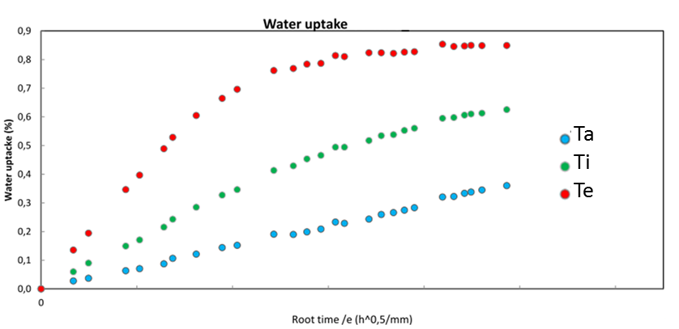

Figure 1. Example of measured weight gain at different temperatures

Specimens are considered saturated when curves reach a plateau as the red curve (Fig. 1). The immersion time to obtain the water saturation of the material (99.9%) is calculated according to [10].
Curves (Fig. 1) allow to determine the ageing time t₁ at temperatures Ta, Ti and Te used to slide master curves in log-time domain (Fig. 3). At initial state, time is noted t₀.
Objective: Quantification of the diffusion kinematic and ageing time t₁ determination.

4.4. Static tensile tests (longitudinal and transversal)

Composite ply initial and saturated mechanical properties are determined in longitudinal and transversal direction. A minimum of three specimens each are to be tested in accordance with ISO 527 [11].
Objective: Determination of longitudinal (E11) and transversal (E22) Young modulus and breaking stresses (σ_{r}) at t₀ and t₁.

4.5. In-plane shear tests

Standard ASTM D3518 [12] is to be applied for in-plane shear tests. Tests should be performed at initial state t₀ and ageing t₁.
Objective: Determination of shear modulus (G12) and breaking shear stress (τ_{r}) at t₀ and t₁.

4.6. Compression tests

Compression tests are to be performed according with ASTM D695 or ISO14126.
Objective: Determination of transverse modulus (K) at t₀ and t₁.

4.7. Four-Points bending tests

Specimens used for 4-points bending tests are to be designed in order to have matrix failure modes.

4.7.1. Static tests

4-points static bending tests (Fig. 2) are to be performed with a minimum of three specimens and in accordance with ISO 14125 [13] at initial state t₀ and ageing t₁.

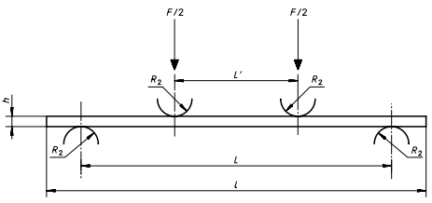

Figure 2. 4-points bending test (L=3L’) – ISO14125 [13]

Objective: Determination of longitudinal (E11) Young modulus and breaking stresses (σ_{r}) at t₀ and t₁.

4.7.2. Fatigue tests

Fatigue and static specimens are identical. A load ratio R=0 is considered. Tests at t₀ and t₁ should be carried out.
Objective: Determination of longitudinal (E11) Young modulus and breaking stresses (σ_{r}) at t₀ and t₁.

4.7.3. Creep tests

Creep and static specimens are identical. A load ratio R=1 is considered. Tests at t₀ and t₁ should be carried out.
Objective: Determination of longitudinal (E11) Young modulus and breaking stresses (σ_{r}) at t₀ and t₁.

4.8. Master curves

Master curves (Fig. 3) will be plotted from tests results as described above, will confirm the long-term behaviour of the material and will allow to assess ageing and fatigue effect on the mechanical properties. Master curves are based on the time-temperature dependence properties of viscoelastic materials.

Following master curves will be obtained from tests by sliding temperature curves:
- Master curve of viscoelastic resin modulus;
- Master curve of CRS (Constant Strain-Rate) strength;
- Master curve of creep strength;
- Master curve of fatigue strength for zero stress ratio.

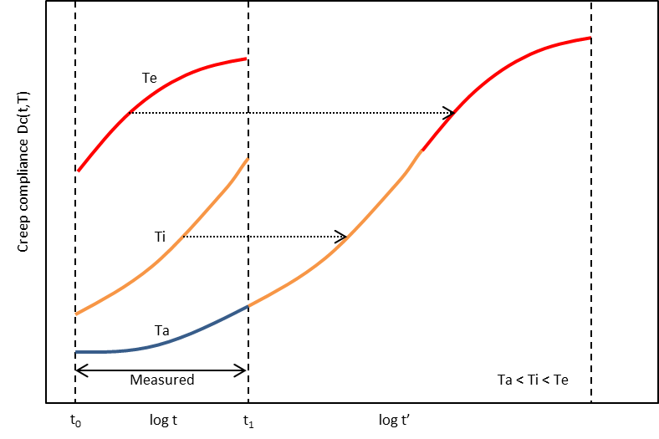

Figure 3. Master curve, sliding factor determination

Within the frame of the previous hypotheses, it may be possible to interpret such curves and conclude on the final state of material. All failure modes in static, fatigue and creep are to be analysed and should be identical upon temperature.
Depending on the final application case, loading conditions and failure mode investigated, tests should be adapted accordingly.

5. Summary

The following flowchart (Fig.4) summarises tests to be performed in order to evaluate mechanical properties at ageing stage.

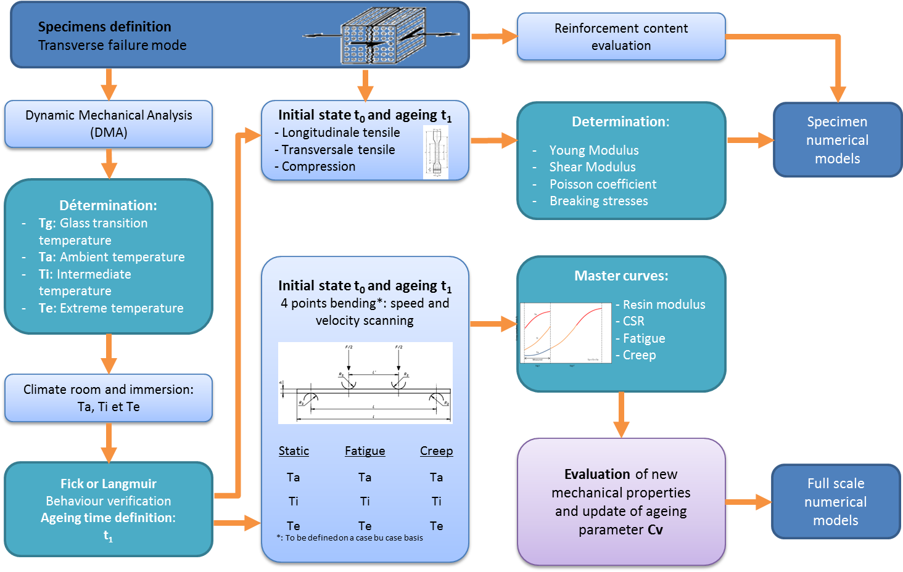

Figure 4. Accelerated ageing methodology flowchart

6. Interpretation

The methodology developed in the framework of the research project VICOMTE [4] allow to evaluate the influence of the environmental condition, i.e. sea water for tidal turbine blade, on the mechanical properties of composite material. By realising the immersion at 3 different temperatures up to water saturation, it is possible to quantify the acceleration realised by the temperature and to extrapolate to real lifetime, that is difficult to access by non-accelerated tests.
This method realised on thin samples allow to define the long term mechanical properties of the saturated material. Moreover, by coupling such results with a diffusion model, we have a clear understanding of a composite structure immersed and loaded. Thus, the accuracy of calculations is enhanced. This may be considered in the safety factor for the structural design of tidal turbine blades.

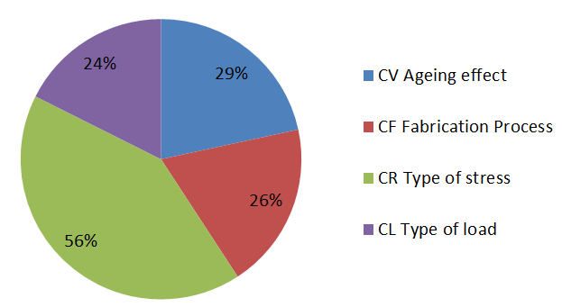

Figure 5. Partly coefficient factor weight in comparison with global safety factor

Depending on the targeted lifetime and test results, the reduction will be more or less important. The partly safety factor C_{v} (Table 1) will be updated accordingly in the design phase to consider the real effect of sea water on mechanical properties.
Today, for a monolithic laminate in tension, the ageing parameter C_{v} represents about 30% of the global safety factor (Fig. 5). That means that, the design could be optimized in considering ageing mechanical properties at the first stage of a project development. The partly safety factor will be reduced at a minimum value, in agreement with the classification society.

7. Conclusion
In conclusion, the experimental approach described above is based on viscoelastic behaviour of composite materials, i.e. time-temperature dependence, and to be applicable, numerous assumptions are to be validated among which, fairly constant service temperature and permanent immersion.
The main interest of this approach is to be able to anticipate long-term mechanical properties of an immersed composite material with a set of simple tests and to consider them during the design phase. It allows to evaluate the environmental condition influence on the material. Coupled with a diffusion model such as the one that has been developed in the project VICOMTE [4] and [14], thick 3D structures may be modelled considering the actual aged properties through the material. Having a better knowledge and confidence of the ageing mechanisms of the composite material, safety factors may be lowered and structure optimized.
However, and in despite of a promising experimental method to assess the long-term mechanical properties for underwater composite material, it appears that assumptions are stringent and cannot be easily generalised.
The closest application of the methodology seems to be for bonding assembly. Indeed, the diffusion models and failure modes are simpler in the adhesive layer than in laminated composite. Further investigations to asses long term adhesive behaviour could be promising and may be used in shorter terms.

Acknowledgments

Authors gratefully acknowledge all partners of the VICOMTE project: IRT Jules Verne, Meca, Université de Nantes, General Electric and Bureau Veritas.

References

- SEENEOH – Etude de marché de l’hydrolien – Janvier 2017
- Bureau Veritas, NI603 Current and tidal turbines – May 2015
- IEC62600-2 Design requirements for marine energy systems – August 2016
- Research Project VICOMTE, IRT Jules VERNE, 2015-2018
- Miyano, Nakada, McMurray, Muki, Prediction of Flexural Fatigue Strength of CRFP Composites under Arbitrary Frequency, Stress Ratio and Temperature, Journal of Composite Materials, 1997 31:619
- Miyano, Nakada, Sekine, Accelerated testing for long-term durability of GFRP laminates for marine use, Composites Part B 35, Elsevier, 2004
- Miyano, Nakada, Ichimura, Hayakawa, Accelerated testing for long-term strength of innovative CFRP laminates for marine use, Composites Part B 39, Elsevier, 2008
- NR546 Hull in Composite Materials and Plywood, Material Approval, Design Principles, Construction and Survey – Bureau Veritas – February 2017
- NI613 Adhesive Joints and Patch Repair – Bureau Veritas – May 2015
- C.-H. Shen and G. S. Springer, Moisture Absorption and Desorption of Composite Materials, J. Composite Materials, vol. 10, Jan. 1976
- ISO527-4 Plastics - Determination Of Tensile Properties Part 4: Test Conditions For Isotropic And Orthotropic Fibre-reinforced Plastic Composites
- ASTM D3518 Standard Test Method for In-Plane Shear Response of Polymer Matrix Composite Materials by Tensile Test of a ±45° Laminate
- ISO14125 Flexural Properties of Fiber-Reinforced Plastic Composites
- Khazaie, Mbacke, Jacquemin, Fréour, Numerical Modelling of Coupled Hygro-mechanical Behaviour of Compoosite Materials, 6th European Conference on Computational Mechanics (ECCM6), 7th European Conference on Computational Fluid Dynamics (ECFD7), Glasgow, 2018.

