VISCOELASTIC BENDING OF SYMMETRICAL AND NONSYMMETRICAL COMPOSITE SANDWICH BEAM WITH
3-POINT BENDING

Miroslav J. Cerny¹, Pavel Slapak¹

¹ Czech Technical University in Prague, Klokner Institute, Solinova 7, 166 08 Prague 6, Czech Republic

Email: cerny@hppro.klok.cvut.cz, Web Page: http://hppro.klok.cvut.cz

Keywords: viscoelasticity, bending, sandwich beam, composites

Abstract
In this study, the viscoelastic bending of the sandwich beams will be treated. The sandwich beams will be of symmetrical and nonsymmetrical structure. The bearing layers are considered elastic, the internal core linear viscoelastic. The model of deflection for a sandwich beam with composite skins and a polymer core loaded by concentrated load is given. Theoretical results are compared with data from tests on sandwich beams.

1. Introduction

Sandwich panels and beams are increasingly used for components in civil and mechanical engineering. Sandwich panels and beams offer a high stiffness to weight ratio, but creep even at room temperature, what is limits their use in structural applications. In this study, the viscoelastic bending of the sandwich beams will be treated. The sandwich beams will be of symmetrical [1] and nonsymmetrical structure. The bearing layers are considered elastic, the internal core linear viscoelastic [2]. The model of deflection for a sandwich beam with composite skins and a polymer core loaded by concentrated load is given. Theoretical results are compared with data from tests on sandwich beams. Analytical solutions for elastic behavior are already available [3].

2. Viscoelastic Modeling of sandwich beam loaded by P in the middle

2.1. Symmetrical sandwich beam with viscoelastic core

Sandwich beam consists of a core of thickness 2s₀ and the skins with thickness r. Material constants are Young modules of the skins E and shear is described by integral operator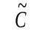.
For the vertical displacement at the middle of the beam applies [1]
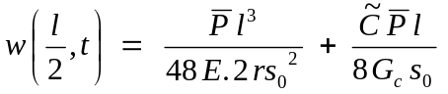
where 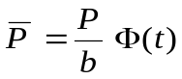, Φ(t) is Heaviside function and is a time integral operator, P is load and l is beam length.

2.2. Nonsymmetrical sandwich beam with viscoelastic core

We consider geometric and physical nonsymmetrical structure of the beam.
Sandwich beam consists of a core of thickness 2s and the skins, from which the upper has thickness r_{h} and lower r_{d} , respectively. Material constants are Young modules E_{h} , E_{d} and shear is described by integral operator.
For a maximal vertical displacement under concentrated load P we get
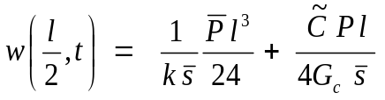
where 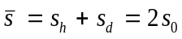 , when 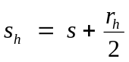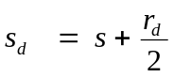
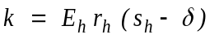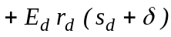 , where 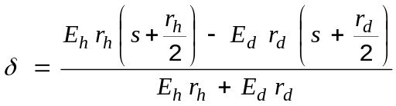
Further 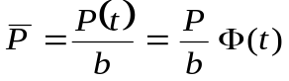, where Φ (t) is a Heaviside function, b is a beam width.
Operator 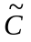 is of the form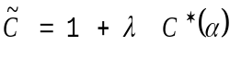. Parameters 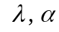 are changing according to adopted mechanical model, e.g. for the Poynting-Thomson model (linear solid) and arrangement 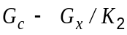 we get the following relationship:
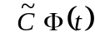 = 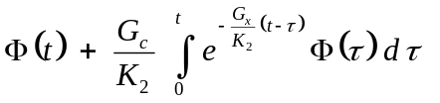 = 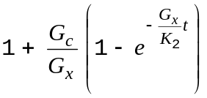

Relation for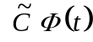 can be substituted into the above equation and we get similarly as in symmetrical case:

3 Experimental evaluating of creep for the sandwich samples

Mechanical tests have been performed on a sandwich plate with bearing layers from composite, reinforced by glass fibres and polyester matrix [2]. Further, the sandwich testing samples were loaded by constant load in a set-up developed and manufactured in Klokner Institute. Vertical displacements were measured by LVDTs and strains by strain gauges. Testing samples were loaded and unloaded at least for 100 h.

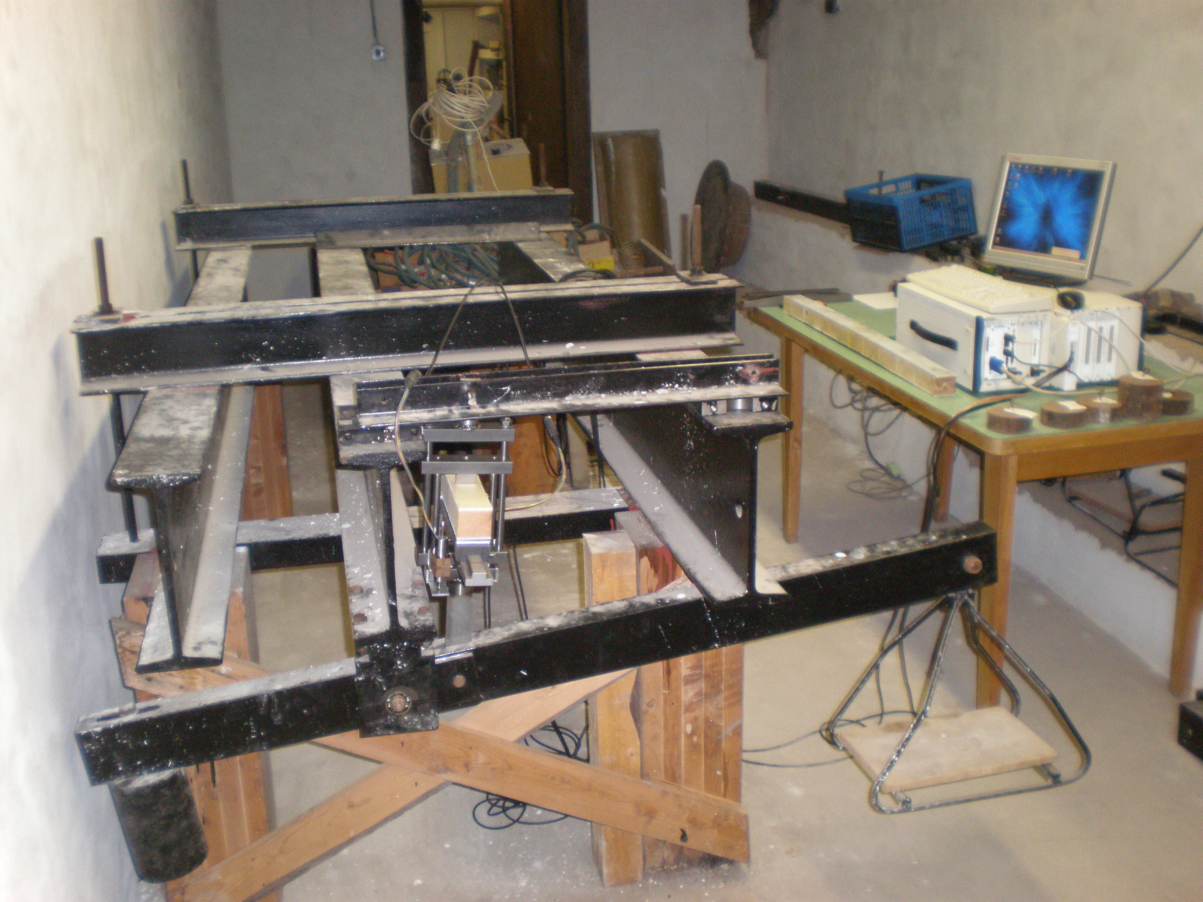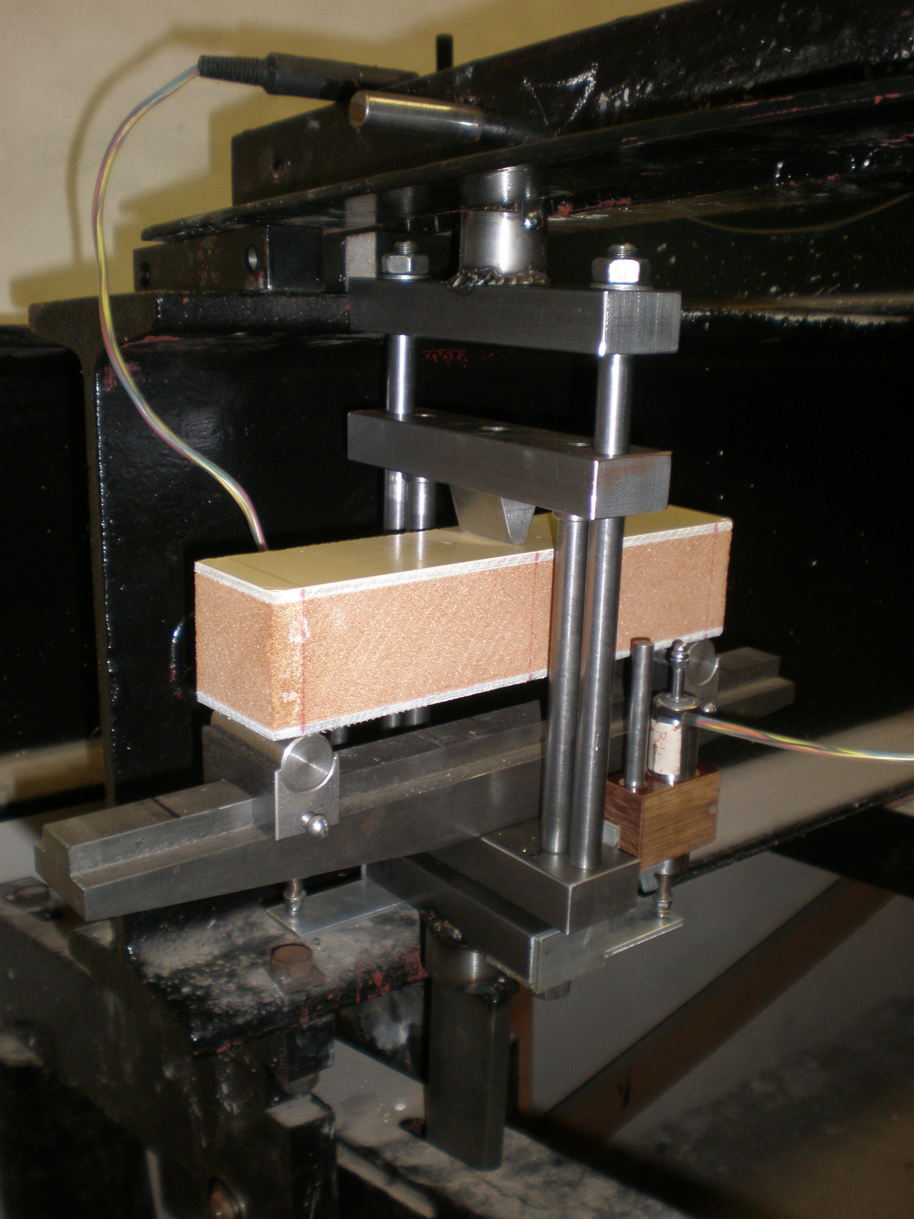
Fig.1 Testing set-up Fig.2 Sandwich beam

4 Results from experiment
Mechanical tests have been performed on a symmetrical sandwich beam with bearing layers from composite, reinforced by glass fibres and polyester matrix [2]. Further, the testing samples were loaded by constant load in a set-up developed and manufactured in Klokner Institute. Vertical displacements were measured by LVDTs and strains by strain gauges. Testing samples were loaded by 300 and 600 N and unloaded at least for 100 h. The tests show a good agreement with calculated values (Fig.3).

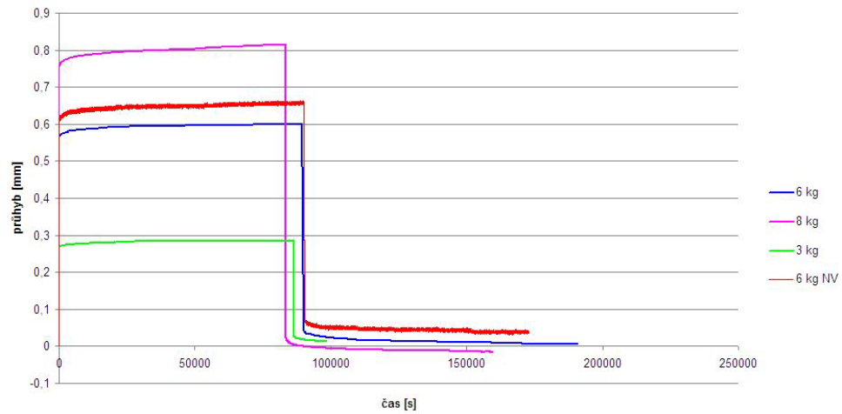

w
[mm]

time [s]
Fig.3 Experimental evaluating of creep for the symmetrical sandwich beam

Conclusion
The experimental determination of viscoelastic behavior of the core for sandwich beams has been given and Poynting- Thomson model used.
The sandwich beams will be of symmetrical [1] and nonsymmetrical structure. The bearing layers are considered elastic, the internal core linear viscoelastic [2]. The model of deflection for a sandwich beam with composite skins and a polymer core loaded by concentrated load is given. Theoretical results are compared with data from tests on sandwich beams.
Acknowledgement
The presented work has been supported by grant No UNMZ/73/0014/16.
References
[1] Cerny M.J., Slapak P., Behavior of Composite Sandwich Beam in Bending, Proceedings, ECCM15, Venice (2012)
[2] Cerny M.J., Slapak P., Visco-elastic Bending of Sandwich Beam with Foam Core, Proceedings, EAN2016, Srni (2016)
[3] Vinson J.R., 1999, Sandwich Structures of Isotropic and Composite Materials, Technomic.

