AN ALL POLYMERIC LIGHTNING STRIKE PROTECTION MATERIAL FOR FRP COMPOSITES

V. Kumar^{1*}, T. Yokozeki¹, T. Goto², T. Takahashi² and Sukanta Das¹

¹Department of Aeronautics and Astronautics, The University of Tokyo
7-3-1 Hongo, Bunkyo-ku, Tokyo, 113-8654, Japan
Email: vipin.kr27@aastr.t.u-tokyo.ac.jp, web page: http://www.u-tokyo.ac.jp

²Department of Organic Device Engineering, Yamagata University
4-3-16, Jonan, Yonezawa, Yamagata, 992-8510, Japan
Email: t-goto@yz.yamagata-u.ac.jp, web page: http://www.yamagata-u.ac.jp

Keywords: Polyaniline; LSP; Electrical conductivity; Conductive composites.

Abstract
Most common lightning strike protection (LSP) technology consists of expended metal foils/films on top of composite structures. This technology possesses disadvantages such as increased weight, galvanic corrosion, expensive integration and repair process. In the present study, authors showed an all-polymeric LSP technology and confirmed its effectiveness against lightning strike. Polyaniline is an intrinsic conductive polymers, which can be rendered conductive by doping with a strong acid. Dodecylebenzesulfonic acid is used as dopant for PANI in current work. Authors, prepared a thermosetting resin system, where, DBSA doped PANI complex (semi-doped) was mixed with divinylbenzene (DVB). This conductive resin system was used to impregnate glass fiber (GF) and carbon fiber (CF) to prepare conductive GFRP and CFRP laminate composites. Prepared composites were tested against simulated lightning strikes of 40 kA. Very limited visible damage was observed in both the cases.

1. Introduction

Carbon Fiber Reinforced Composites (CFRP) are replacing conventional metallic structure in aerospace industry due to their high specific strength and stiffness [1]. However, due to their low electrical conductivity and low fire resistance property they are vulnerable to thunder lightning strikes and static discharge [2]. Literature reveals that an aircraft is struck by lightning every 1000-2000 flying hours, approximately amounting to one strike per year for commercial aircrafts. There have not been many catastrophic accidents in the past few years due to lightning strikes, mainly due to the current lightning strike protection system (LSP) being used in composite airplanes. The most commonly used LSP technology comprises of expended metal foils/film (EMF) on the outer surface of the airplanes to create a passage for the lightning current to exit from the aircrafts safely [3], [4]. This methodology is nearly as old as the idea of using composite components in aerospace industry. There has not been many competition to this technology until now. But with the recent development of new structural conductive materials and technologies, researchers have started to look for alternate options to the current lightning strike protection system [5], [6]. Presently metallic mesh or films are being used on the top of CFRP structures to counter this problem. During a lightning strike event, present technology ensured safety of the passengers but cannot guarantee full safety of the structure, which could lead to the very expensive repair [7], [8]. Some other disadvantages like increased weight, integration and galvanic corrosion problem are also associated metal mesh & film based lightning strike protection technology [9].

Many researchers have studied various innovative ways to make FRPs safe against lightning strike. The most leading research field in this regard is to make epoxies conductive by introducing various nanofillers i.e. carbon nanotube, graphene and carbon black [10]–[12]. Some researchers have shown improved electrical conductivity of resin but with a cost of either manufacturability or mechanical properties [6]. Reason for such behavior is the dispersion of these nano-fillers. With increased amount of these nanofillers, high viscosity of the resin or reduced mechanical properties are reported. Therefore some of the researchers started to look for another options such as intrinsic conductive polymers i.e. Polyaniline, PEDOT etc. However, most of them used these ICPs especially with epoxies. It has been found that Polyaniline is not so compatible with commercial epoxies [13], [14]. Polyaniline either loose its conductivity due to de-doping or hinder the curing of epoxies itself. However, some reports has shown some promising results recently [15].
Nevertheless, authors chose even a different route to make thermosetting resin. They used an another new thermosetting polymer divinylbenzene, which is compatible with PANI to make PANI-based highly conductive and strong resin [16], [17]. Also, the viscosity of the prepared resin is optimum for impregnating carbon/glass fabrics to prepare conductive FRPs [18]. Of course aerospace industry is the most crucial for LSP technology but FRP being used in wind mills are also prone to such unwanted natural phenomenon. Therefore, in the work special attention is given to the lightning strike protection of GFRPs. In present work, authors showed the effectiveness of this resin system against simulated lightning strikes of 40 kA. PANI-based resin impregnated GFRP and also CFRP were tested against 40 kA.

2. Experiment

2.1. Materials

A semi-doped Polyaniline-DBSA paste was prepared by mixing PANI and DBSA in 1:2 weight ratio and heated for 6 hours at 60°C. With this controlled thermal treatment a uniformly semi-doped PANI-DBSA complex was obtain, which was further added with divinylbenzene in a weight ratio of 1:1. The mixture of PANI-DBSA/DVB was mixed properly using a centrifugal mixer to obtain a good dispersion of PANI in DVB resin. Firstly, the prepared resin was used to impregnate 12 plies of commercial glass fabric (obtained from UNITIKA ltd.), which were stacked and cured at 120°C for 2 hours. A PANI-GFRP composite panel was obtained after curing. This sample will be referred as PANI-Resin-GFRP hereafter. Also, this resin was also used to impregnate 8 plies of TR-30 carbon fabric, which were stacked and cured at 120°C for 2 hours. This specimen will be referred as PANI-Resin-CFRP hereafter.

2.2. Experiment setup

High impulse current generator situated in National Composite Center at Nagoya University in Japan is used to simulate the lightning strike current. A waveform defined by SAE ARP-5412 B standard is referred to apply the lightning current as shown in Figure 1. In current work, modified component A of the waveform is applied for research purpose. Specimen was mounted on a copper jig and the gap between discharge electrode and specimen was kept at 2 mm. High speed camera images were obtained at a frame rate of 500kfps (4µs) with Shimadzu Hyper Vision HPV-1 (Shimadzu Corporation) using 180 mm F 3.5APO MACRO EX DG HSM (Sigma) lens. Ultrasonic images were obtained before and after the lightning test by an ultrasonic flaw detector (HIS3 HF, Krautkramer GmbH) attached to a 3.5 MHz transducer. Conductive FRPs were tested against 40 kA lightning current.
The electric charge Q and the action integral I of the applied waveform were around 3.3 (C) and 99000 (A²s) for 40 kA waveform. CASIO Exilim HS EX-ZR200 camera was used to capture the still images of samples before and after the test.

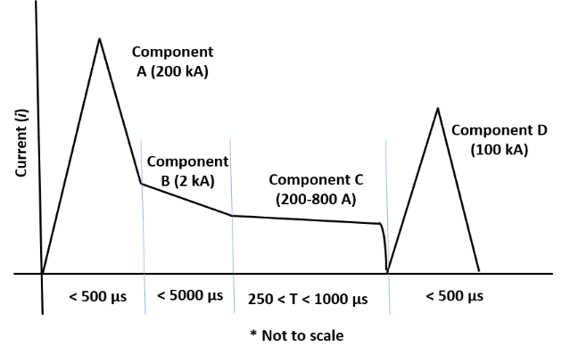
Figure 1. Lightning waveform defined by SAE ARP-5412B standard.

3. Results & Discussion

  - Visual inspection

Still images of the experimental setup, and specimens after lightning attachment are shown in Figure 2. Images show a remarkable effectiveness of PANI-resin GFRP and PANI-resin CFRP against simulated lightning current. No catastrophic damage is observed in both of the case. In case of PANI-based GFRP faded color in horizontal direction of the specimen shows the path taken by the lightning current to reach to the metal jig. It should be noted that, in this specimen insulating glass fabric were used and hence, PANI-based resin was the only electrically conductive component to carry the current. These experiments confirm that PANI-based resin alone can disperse electric current effectively. As shown in the Figure 2(b), there was no significant damage to the specimen but some part of the CFRP got delaminates. There was no damage on the back side of the specimen, which confirmed that lightning current didn’t penetrate into the specimen and PANI acted as a faraday cage for the specimen in both the cases.

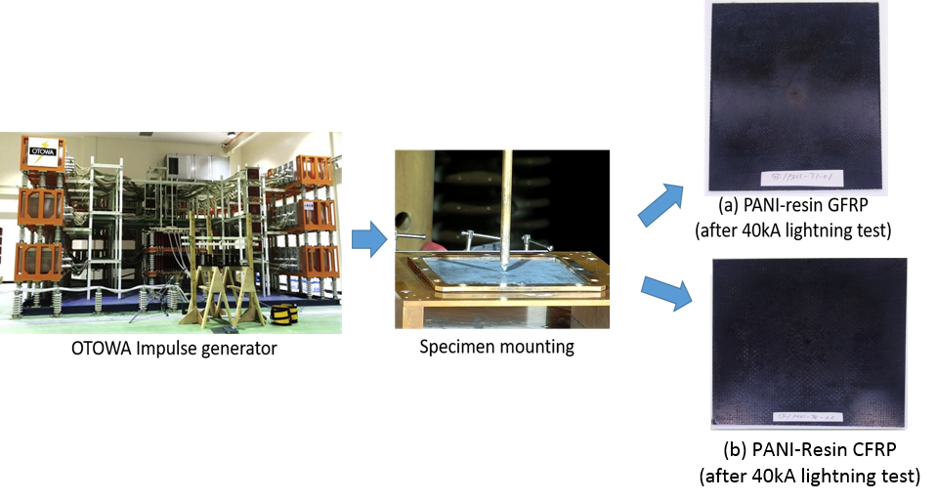
Figure 2. Simulated lightning strike test flow and specimen after lightning strike.

  - Slow motion camera images

Effectiveness of PANI-based LSP to diverge the incident impulse current was studied using high speed camera images. A representation of lightning attachment and its behavior on the surface of specimen presented in Figure 3. In both the cases current dispersed on the surface of the specimen towards the grounding jig fixture. It is well known that the main damage due to direct lightning strikes comes from the Joule’s effect. Joule effect assigned to the heat generated when current pass through a resistive material. Joule heat is directly related to the electric resistance of the material. From the high speed camera, it can be observed that current remained on the surface and reached to the metal jig safely. High resistance of commercial CF/epoxy composite and low heat resistance are absent in case of PANI-resin GFRP and hence provided better safety against lightning current.
Electrically conductive PANI offered very highly conductive path to the lightning current to reach the grounding setup, demonstrated by a branched like bright zones from the point of lightning arc attachment towards the metal jig. Perpendicular directions to the jig was obvious shortest paths taken by the current. PANI-based resin behaved as an effective faraday cage for the CFRP structure and no visible penetration of lightning current into the composite was observed in high speed camera images.

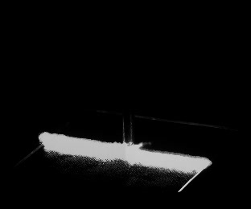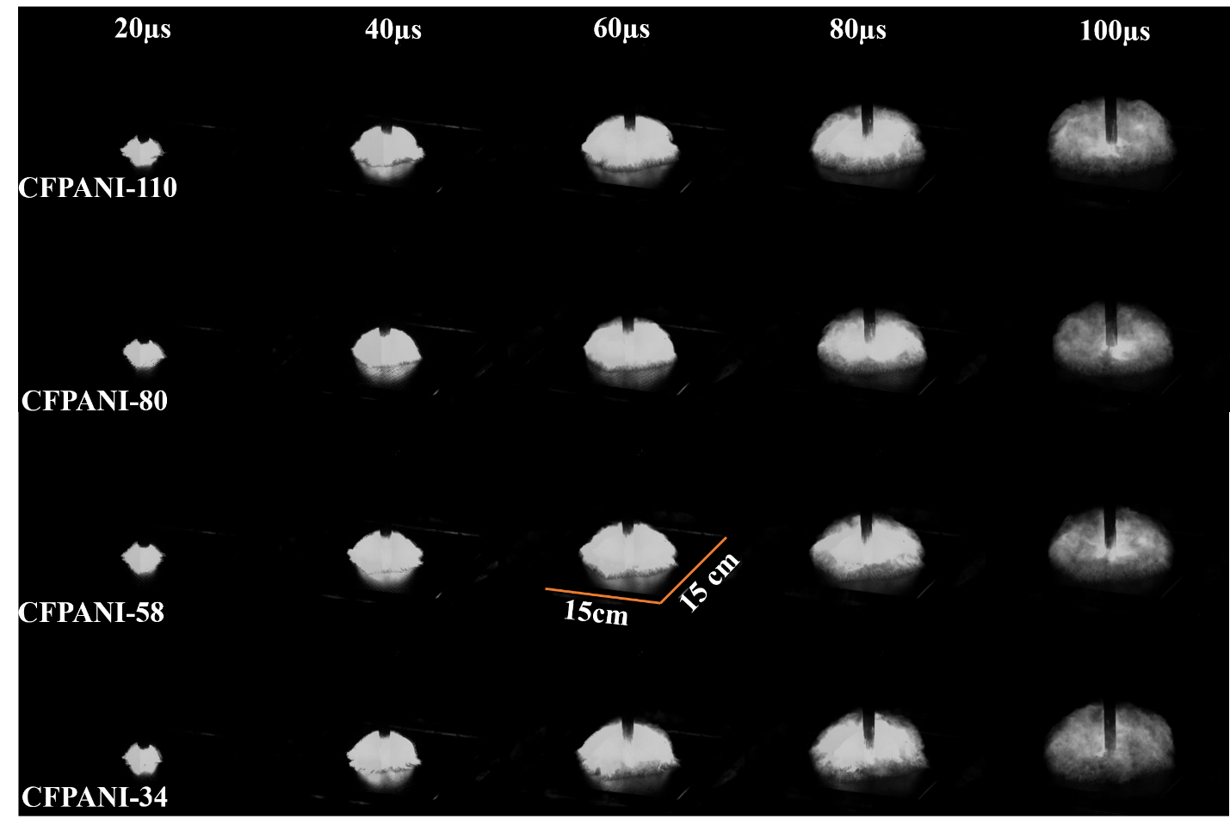
(a)
(b)
15 cmm
15 cm
Figure 3. (a) PANI-resin GFRP during 40 kA lightning test (b) PANI-resin CFRP during 40 kA lightning test
  - Non-destructive inspection

Post damage analysis is utilized to judge the effectiveness of PANI-based composite against lightning strikes. Visual inspection presented in previous sections fairly predicted the reason and extent of damage, but an interior damage can only be evaluated with special techniques. In this paper, authors used a non-destructive image processing technique using ultrasonic equipment to evaluate any internal damage or delamination in the specimens. Front face was investigated before and after lightning strike. Results are shown in Figure 4.
C-scan and B-scan confirm that there is very small damage in both the cases. No delamination is observed in GFRP and very less delamination is pbserved in CFRP. Delamination between CF plies arises due to decomposition of resin between them, but no such delamination is observed in PANI-resin GFRP. Exact reason for this behavior need to be studied in more details. In case of PANI-resin GFRP, a very small damage to the GFRP structure is observed owing to the fact that PANI-resin protection acted as an efficient faraday cage for the structure and enabled the safe movement of current to the ground system without damaging specimen at all. This is a remarkable achievement compared to other nano-filler based LSP technologies.
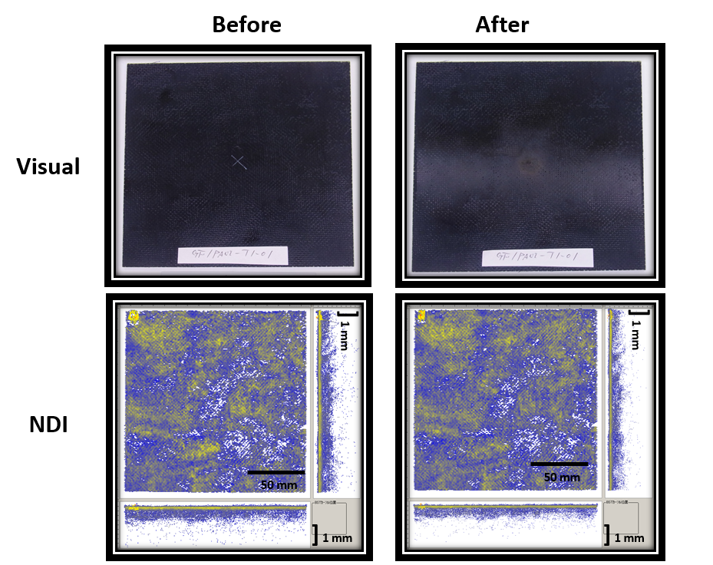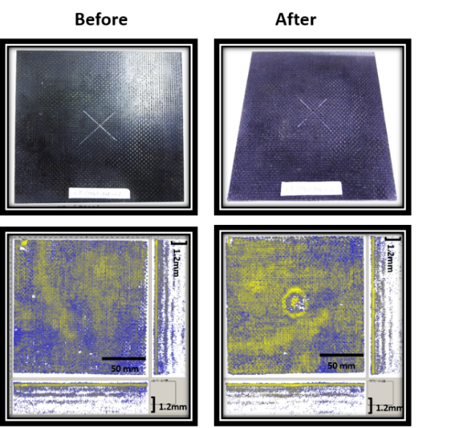
- (b)
Figure 4. Visual and NDI testing (a) PANI-resin GFRP after 40 kA lightning test. (b) PANI-resin CFRP after 40 kA lightning test.

3. Conclusions

In the current work, an all polymeric conductive resin system is checked for its effectiveness against simulated lightning strike protection. Polyaniline is used to make thermosetting resin electrically conductive and this resin system was used to impregnate glass/carbon fabric to prepare conductive FRP laminate. These specimens were tested against simulated lightning current of 40 kA. Both specimen showed that PANI has enough electrical and thermal stability to withstand against simulated lighting current up to 40 kA. A very small damage to the FRPs protected with conductive PANI were observed in thickness direction but there was no catastrophic damage. Slow motion camera confirmed that PANI acts as a faraday cage enabling a very good dispersion the lightning current on the specimen surface without damaging it. Still images confirmed an absence of pyrolysis effect in both the case. Ability of PANI to form a 3-D conductive network in all directions due to its self-assembling property, good thermal stability, low cost, easy applicability and corrosion resistance properties make this material a very strong contender in current lightning strike protection technology.

Acknowledgments

The authors acknowledge JSPS for the financial support of this project (Grant-in-Aid for Scientific Research, 16H02424).

References

[1] X. Zhang, Y. Chen, and J. Hu, “Recent advances in the development of aerospace materials,” Prog. Aerosp. Sci., vol. 97, no. August 2017, pp. 22–34, 2018.
[2] M. Gagné and D. Therriault, “Lightning strike protection of composites,” Prog. Aerosp. Sci., vol. 64, pp. 1–16, Jan. 2014.
[3] A. Katunin, K. Krukiewicz, A. Herega, and G. Catalanotti, “Concept of a Conducting Composite Material for Lightning Strike Protection,” Adv. Mater. Sci., vol. 16, no. 2, 2016.
[4] “Lightning Strikes: Protection, Inspection, and Repair,” https://www.boeing.com/commercial/aeromagazine/articles/2012_q4/4/, pp. 18–28.
[5] P. S. M. Rajesh, F. Sirois, and D. Therriault, “Damage response of composites coated with conducting materials subjected to emulated lightning strikes,” Mater. Des., vol. 139, pp. 45–55, 2018.
[6] Y. Hirano, T. Yokozeki, Y. Ishida, T. Goto, T. Takahashi, D. Qian, S. Ito, T. Ogasawara, and M. Ishibashi, “Lightning damage suppression in a carbon fiber-reinforced polymer with a polyaniline-based conductive thermoset matrix,” Compos. Sci. Technol., vol. 127, pp. 1–7, 2016.
[7] J. M. Welch, “Repair Design, Test, and Process Considerations for Lightning Strikes,” CACRC/MIL-HDBK-17 Conf., 2007.
[8] J. Wolfrum, T. J. Schuster, and T. Körwien, “Effects of heavy lightning strikes on pristine and repaired carbon composite structures,” J. Compos. Mater., vol. 51, no. 25, pp. 3491–3504, 2017.
[9] A. Ghavamian, M. R. Maghami, S. Dehghan, and C. Gomes, “Concerns of corrosive effects with respect to lightning protection systems,” Eng. Fail. Anal., vol. 57, pp. 434–443, 2015.
[10] M. S. Ha, O. Y. Kwon, and H. S. Choi, “Improved Electrical Conductivity of CFRP by Conductive Silver Nano-particles Coating for Lightning Strike Protection,” in ICCM17, 2009, pp. 1–10.
[11] J. Gou, Y. Tang, F. Liang, Z. Zhao, D. Firsich, and J. Fielding, “Carbon nanofiber paper for lightning strike protection of composite materials,” Compos. Part B Eng., vol. 41, no. 2, pp. 192–198, 2010.
[12] J. H. Han, H. Zhang, M. J. Chen, D. Wang, Q. Liu, Q. L. Wu, and Z. Zhang, “The combination of carbon nanotube buckypaper and insulating adhesive for lightning strike protection of the carbon fiber/epoxy laminates,” Carbon N. Y., vol. 94, pp. 101–113, 2015.
[13] B. G. Soares, M. L. Celestino, M. Magioli, V. X. Moreira, and D. Khastgir, “Synthesis of conductive adhesives based on epoxy resin and polyaniline.DBSA using the in situ polymerization and physical mixing procedures,” Synth. Met., vol. 160, no. 17–18, pp. 1981–1986, 2010.
[14] W. Jia, R. Tchoudakov, E. Segal, R. Joseph, M. Narkis, and A. Siegmann, “Electrically conductive composites based on epoxy resin with polyaniline-DBSA fillers,” Synth. Met., vol. 132, no. 3, pp. 269–278, 2003.
[15] A. Katunin, K. Krukiewicz, R. Turczyn, P. Sul, A. Lasica, and M. Bilewicz, “Synthesis and characterization of the electrically conductive polymeric composite for lightning strike protection of aircraft structures,” Compos. Struct., vol. 159, pp. 773–783, 2017.
[16] V. Kumar, T. Yokozeki, T. Goto, and T. Takahashi, “Mechanical and electrical properties of PANI-based conductive thermosetting composites,” J. Reinf. Plast. Compos., vol. 34, no. 16, pp. 1298–1305, 2015.
[17] V. Kumar, T. Yokozeki, T. Goto, and T. Takahashi, “Synthesis and characterization of PANI-DBSA/DVB composite using roll-milled PANI-DBSA complex,” Polymer (Guildf)., vol. 86, pp. 129–137, 2016.
[18] V. Kumar, T. Yokozeki, T. Goto, T. Takahashi, S. R. Dhakate, and B. P. Singh, “Irreversible tunability of through-thickness electrical conductivity of polyaniline-based CFRP by de-doping,” Compos. Sci. Technol., vol. 152, 2017.

