**Modeling natural fiber composites microstructures**

**for predicting their water aging**

Romain Léger1, Cécile Mattrand2, Ahmed Mooti3 and Stéphane Corn1

1 C2MA, IMT Mines Ales, Univ Montpellier, Ales, France

[romain.leger@mines-ales.fr](mailto:romain.leger@mines-ales.fr), <http://c2ma.mines-ales.fr>

2 Université Clermont Auvergne, CNRS, SIGMA Clermont, Institut Pascal, F-63000 Clermont-Ferrand, France

[cecile.mattrand@sigma-clermont.fr](mailto:cecile.mattrand@sigma-clermont.fr), <https://www.sigma-clermont.fr>

3 Ecole Supérieure du Bois, Ecole Centrale de Nantes, Nantes, France

[ahmed.mooti@eleves.ec-nantes.fr](mailto:ahmed.mooti@eleves.ec-nantes.fr), <http://www.ecoledubois.fr/>

**Keywords:** Natural fiber composites, realistic microstructure, water diffusion, numerical modeling, durability

**Abstract**

The prediction of the in-service behavior and durability of composite materials reinforced with natural fibers is a challenge when they are subjected to simultaneous multi-physical inputs, such as water exposure combined to mechanical loadings. Understanding the response of the material may require an accurate description of its microstructure at different scales. This work proposes an original approach devoted to generate realistic virtual microstructures in order to predict numerically the hygroscopic behavior of composites reinforced with natural fibers.

1. Introduction

Many companies show interest in natural fiber composites (NFC) as a substitute to traditional glass fiber composites. Indeed, natural fibers (NF) present very interesting properties in comparison to glass fibers, such as low density, high specific stiffness and also biodegradability. However, the use of NF in structural applications is still limited by several disadvantages. First, NF exhibit high variability in their dimensions, shapes and mechanical properties. They also require lower processing temperatures which makes it necessary to reconsider existing processes or the choice of a matrix [1]. Another drawback is the poor durability in humid environment of these composites due to the hydrophilicity of plant fibers [2,3]. Although some authors have shown that fatigue behavior could be improved after humid aging [4], most works demonstrate that static and dynamic behavior of NFC is impaired by moisture [5,6].

Therefore, the prediction of the mechanical strength of NFC in humid environment and the comprehension of the underlying phenomena remain challenging. The experimental exploration of the sensitivity of the diffusional and mechanical behavior of NFCs to variations of microstructural features such as fibers shapes and dispersion would lead to a gigantic work. Thus, parametric numerical simulations based on a finite element modeling are a more reasonable and efficient alternative.

This work proposes a modeling strategy of unidirectional NFC microstructures based on relevant morphological parameters. Numerical predictions of the diffusive and mechanical behavior of NFCs are subsequently performed and the influence of the microstructural features is assesed.

2. Materials and Methods

2.1. Composite Materials

The resin used for the studied composite is an Enydyne® dicyclopentadiene isophthalic unsaturated polyester (Cray Valley –Rouvroy, France), polymerized with 1.8% w/w of methyl ethyl ketone peroxide Luperox K1S® (Arkema – Colombes, France). Quasi-unidirectional flax fabrics were manufactured by Fiber Recherche Developpement (Troyes, France) for a weight of 390 g/m2 (Weft: 360 g/m2 / Warp: 30 g/m2).

Four layers of flax fabrics were vacuum infused with the resin to obtain 300 x 250 mm flax fiber reinforced composite (FFRC) sheets. A constant pressure of 100 mbar was maintained during the 24 hours curing of the resin at room temperature. A subsequent 24h post-curing in an oven at 60°C was necessary to obtain a polyester crosslinking rate of 88%. Thickness ranged from 2.7 to 3.4 mm for the FFRC. Beam samples were cut to size of 250 mm x 25 mm using a diamond blade. FFRC of 32% vol. of fibers were obtained. Small samples of polyester (15 x 8 x 3 mm) were also produced for this study. All specimens were stored in a climatic room, at 23°C and 50% H.R., before testing.

The cross-sectional multiscale microstructure of the composite is displayed in Fig. 1. Two scales can be observed: the yarn scale, which contains 46% areal fraction of uniformly dispersed reinforcement that can be divided in single elementary fibers and fibre bundles, and the composite scale with yarns arranged in staggered rows into the matrix [7]. As a first approach, only the intra-yarn microstructure is considered in this work.



Figure 1 - Multiscale microstructure of the unidirectional flax fiber reinforced polyester

2.2. Image analysis and microstructure modeling

The synthesis of virtual but statistically representative microstructures was endeavoured in order to assess the sensitivity of the composite to its microstructural features. Here, the procedure is based on a three steps sequence. Firstly, images obtained by scanning electron microscopy of the polished FFRP cross-sections, see section 2.1, are analysed with a semi-automated procedure using Aphelion®, which quantifies elementary fibers and bundles on the basis of their morphological parameters (surface, elongation and convexity measurements). Then, each elementary fiber and bundle cross-section is described by means of its complex coordinates *zn(i)* which stands for the nth complex coordinate of the ith elementary fiber or bundle, see Fig. 2. Each complex function is analyzed in the frequency domain by performing a Fourier transform.



**Figure 2.** Definition of an elementary fiber or bundle contour

This leads us to a collection of Fourier coefficients *Zk(i)* per fiber*, k={1,2,…, N(i)*}, with *N(i)* the number of pixels composing the contour of the ith fiber or bundle. As *Ne*, resp. *Nb*, elementary fibers, resp. bundles, have been featured in the database, each real and imaginary part of Fourier coefficients can be modeled as a random variable, see Fig. 3.



**Figure 3.** Fourier analysis of a fiber

By identifying the distributions and the correlations of the first random variables of the Fourier decomposition, one can capture the main dispersion in the elementary fiber and bundle shapes. The inverse Fourier transform of the random Fourier coefficients sampled from their probabilistic distributions allows an easy generation of virtual shapes statistically representative of the observed ones. More details are available in [8, 9]. The last step lies in arranging the previously simulated fibers in a given Volume Element (VE). A specific algorithm has been been developed for this purpose. It is assumed that the fibers are randomly spaced, *i.e.* no spatial correlation is taken into account. The proposed algorithm merges two existing strategies, namely LS-RSA (Level Set controlled Random Sequential Adsorption) [10] and RSE (Random Sequential Addition) [11]. They are slightly modified here to incorporate the constraints linked to the complex and arbitrary shapes of the fibers, which has never been done to the best authors’ knowledge. This allows us to simulate unidirectional NFC with reinforcement volume ratio up to 60%, see Fig.4 and 5 for illustration with *Vf* =46%.

2.3. Diffusion and swelling modeling

In order to predict the water diffusion and the swelling of this FFRP, a numerical finite element model (FEM) based on the generated microstructures has been implemented in Comsol Multiphysics®. Five virtual statistically representative microstructures (1.5mm x 0.4mm) have been generated (Fig. 4c). They are compared with two other type of microstructures (Fig. 4a and 4b) with the same ratio but composed of regularly and randomly dispersed cylindrical fibers (uniform diameter of 20 µm) in order to assess the impact of morphology and distribution on diffusion, swelling and stress fields. The studied composite is unidirectionally (UD) reinforced and a preferential diffusion is expected in the permeable fiber direction since their diffusion coefficient *Df* and water uptake at saturation *Msf* are usually higher than that of the matrix [12, 13]. However, because the high length-to-thickness and width-to-thickness ratios of the UD beam samples induce for every cross-section water diffusion fluxes that are mostly in-plane oriented, a 2D diffusion was considered and modeled (Fig. 5) [14, 15].

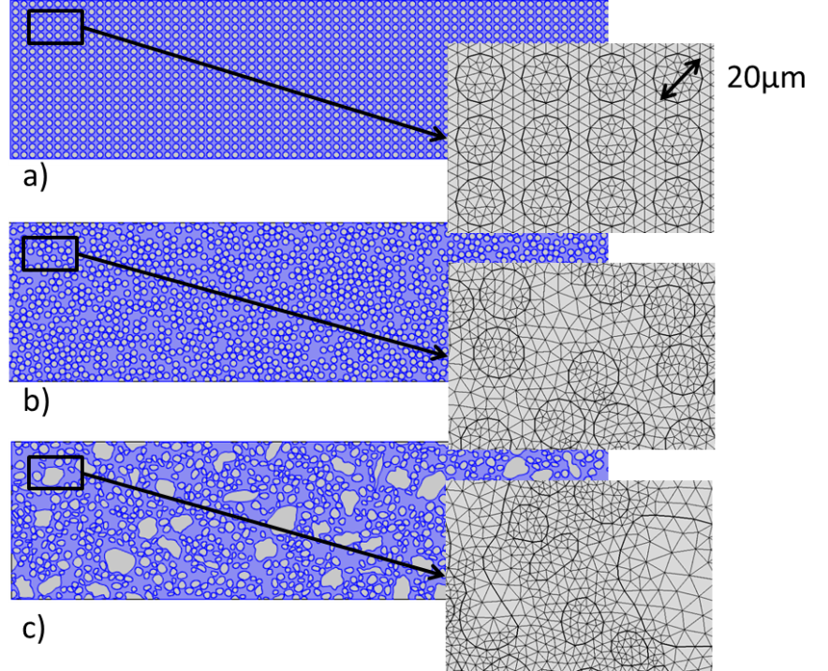

**Figure 4.** Examples of generated microstructures (*Vf* =46-47%) – a) Regularly dispersed circular fibers – b) Randomly dispersed circular fibers – c) Randomly dispersed statistically representative fibers.

In a first approach, the diffusion law in both matrix and fibers is supposed to follow the Fick’s law. Diffusion coefficients *Dc* and *Dm*, water uptakes *MSc* and *MSm* of composite and matrix respectively and matrix swelling coefficient *m* have been measured during an aging in distilled water at 30°C (see Table 1). Note that the swelling of the composite is not isotropic, with an increase in thickness 3 times greater than the increase in width (and length swelling is negligible). Swelling of matrix is isotropic. Diffusion and swelling coefficients are supposed to not depend on the local water uptake. Diffusion coefficient and water uptake of flax fibers have been determined (see Table 1) according to the work of Gueribiz et al [12]. Note that the diffusion coefficient and the water uptake of flax fibers in the composite calculated with this method are about 10 times lower than classical values directly measured on fiber samples. This could be attributed to the fact that fibers are partially penetrated by the matrix and become less sensitive to water. Fiber swelling coefficient has been taken from the literature [16] and is supposed to be isotropic (see Table 1).

Let *Cw* be the local water concentration, then, with the assumption of uniform diffusivity *D*, the Fickian diffusion is described by equation 2 :

|  |  |
| --- | --- |
| $$\frac{∂C_{w}}{∂t}=D∆C_{w}$$ | (2) |

Obviously, water concentration is discontinuous across the interface between permeable fiber and matrix. To solve this numerical problem a normalized field variable, namely the relative water uptake, has to be introduced and should be continuous across the interface. Such variable *W* has been introduced by some authors [17, 18] :

|  |  |
| --- | --- |
| $$W=\frac{C_{w}}{C_{ws}}$$ | (3) |

where *Cws* is the water concentration at saturation. Let *M* be the local water uptake in percent :

|  |  |
| --- | --- |
| $$M=\frac{m-m_{0}}{m_{0}}×100=\frac{m_{w}}{m_{0}}×100$$ | (4) |

where *m* is the local mass of humid composite around a point and *m0* its initial value. *mw* represents the local mass of absorbed water. If one considers the volume to remain constant during diffusion, then *W* can be rewritten :

|  |  |
| --- | --- |
| $$W=\frac{M}{M_{s}}$$ | (5) |

with *Ms* the water uptake at saturation. Then, *W* is following a Fickian law, as long as *Ms* for matrix and fiber is constant during the simulation :

|  |  |
| --- | --- |
| $$\frac{∂W}{∂t}=D∆W$$ | (6) |

*W* and its flux should also be continuous at the interface [17, 18].

The mechanical behaviour is assumed elastic for this first study :

|  |  |
| --- | --- |
| $$\overset{̿}{σ}=\left[C\right]:\overset{̿}{ε_{el}}$$ | (7) |

where $\overset{̿}{σ}$ is the stress tensor, $\left[C\right]$ the stiffness matrix and $\overset{̿}{ε_{el}}$ the elastic tensor which depends on swelling coefficient ** :

|  |  |
| --- | --- |
|  | (8) |

where $\overset{̿}{ε_{h}}$ represents the swelling tensor :

|  |  |
| --- | --- |
| $$\overset{̿}{ε_{h}}=βM\overset{̿}{I}=βM_{s}W\overset{̿}{I}$$ | (9) |

Elastic properties have been measured on the matrix, and taken from the literature for flax fiber (transverse modulus estimation) [19].

In terms of boundary conditions, the blue line (Fig. 5) represents the edge subjected to water (*W*=1) and free to swell. Symmetry conditions are imposed on the other edges (red solid lines), which correspond to zero water flow for diffusion and no orthogonal displacement for mechanics [14, 15]. A sensitivity study to the mesh fineness has led to a 150000 elements model (with smallest elements area of 1µm2).

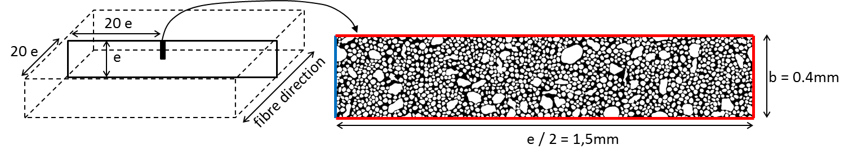

**Figure 5.** Mechanical and hydric boundary conditions.

**Table 1.** Diffusion, swelling and elastic properties of composite, fibers and matrix.

|  |  |  |  |  |  |  |
| --- | --- | --- | --- | --- | --- | --- |
|  | *Diffusion coefficient D*  (mm2/s) | *Water uptake at saturation Ms*  (%) | *Swelling coefficient *  * * ** | *Modulus E*  *(GPa)* | *Poisson coefficient * | *Density of dry matter (g/cm3)* |
| Matrix | 1.28e-6 | 0.9 | 4.3e-3 | 3.1 | 0.35 | 1.12 |
| Composite | 1.64e-6 | 6 | - | - | - | 1.27 |
| Flax fiber | *1.34e-7* | *14.5* | 11.4e-3 | 7 | 0.4 | 1.54 |

3. First results

Composite global water uptake *MC* (%) and swelling in the thickness direction $ε_{h}^{thick}$ (%) are calculated (eq. 10 and 11) for each of the 3 simulated microstructures and plotted in Fig. 6.

|  |  |
| --- | --- |
| $$M_{C}={\left(M_{Sm}\iint{WdS_{m}}+M_{Sf}\iint{WdS_{f}}\right)}/S$$ | (10) |

where *MSm*, *MSf* and *S* indicate the water uptake at saturation for the matrix, water uptake at saturation of the fibers, and the FEM surface which is divided in *Sm* the matrix surface and *Sf* the fiber surface.

|  |  |
| --- | --- |
| $$ε_{h}^{thick} (\%)=100\frac{\int{\frac{u}{b}dl}}{e/2}$$ | (11) |

*u* is the displacement of a node which is integrated along the left edge of the FEM. *e/2* is the thickness of the FEM, *b* its width (Fig. 5).

It can be observed from our results that the influence of the microstructure (dispersion and shape of fibers) is negligible on both the global sorption kinetics and swelling of the free edge. The overall diffusion behavior of the composite is Fickian, thus its kinetics could be modeled by one homogeneous diffusion coefficient (which can be a tensor in order to account for anisotropy) and one water uptake at saturation for the composite, like it is frequently done in the litterature with a Fickian law [20].

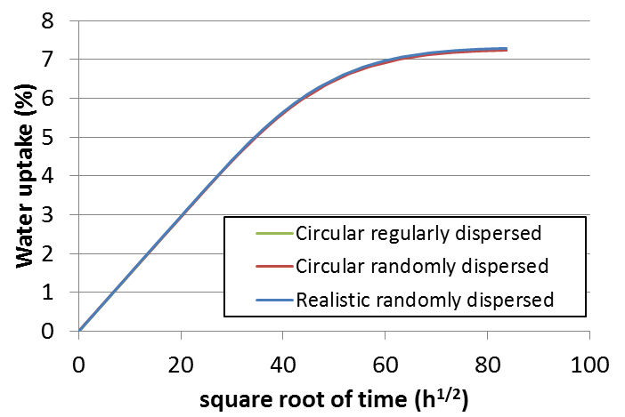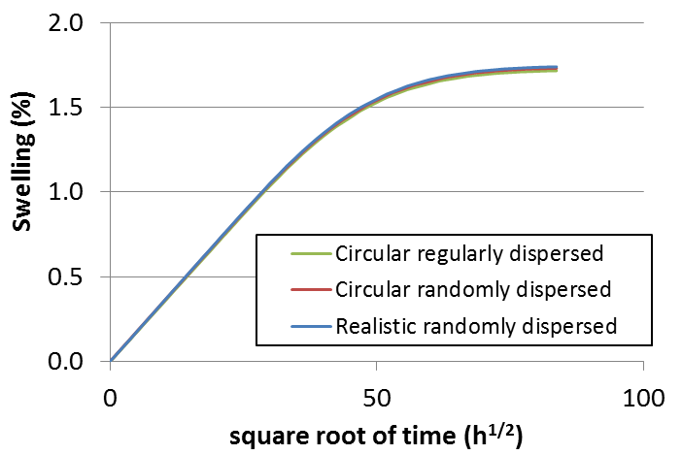

**Figure 6.** Water uptake and thickness swelling of the 3 FEM models.

Concerning the stress distribution, really, high Von Mises stress values are obtained at saturation (Fig. 7) but this is consistent with the modeling choices made in this first approach of the problem. Indeed, matrix and fibers have been modeled as elastic materials and their properties do not depend on the local water uptake, which is obviously a limit in this model. At saturation, both matrix and fibers could behave like viscoelastoplastic materials [21], leading to decrese their apparent stiffness and, as a consequence, actual stresses should be lower than those simulated and actual swelling should be higher.

Nevertheless, the impact of dispersion and shape of fibers on stress distribution can be analyzed on the basis of these results. It can be observed that the random dispersion of fibers has a strong impact on the stress distribution in matrix which is shifted towards higher levels (Fig. 8). The closest the fibers, the higher the Von Mises stresses in the matrix. The impact on stresses in fiber is moderated with slightly higher values. The shape of NF is responsible for local stress concentration, but seems to be of second order by comparison with the spatial arrangement of fibers in the matrix (Fig. 8).

4. Conclusions

The prediction of NFC durability is a technical and scientific challenge as they can be submitted to multiple simultaneous solicitations. Modeling a realistic microstructure can help understanding the behavior of such composite at a local scale and subsequently at a global scale. Here, an efficient method has been developed to create realistic numerical microstructures on the basis of simple morphological parameters. Modeling of the diffusion of water and of the swelling of this composite have been first attempted with some hypotheses. It appears that both arrangment and shape of fibers has no real impact on the overall diffusion kinetics, nor on the swelling behavior. Stress distributions resulting from the differential swelling of matrix and fibers are mostly impacted by the arrangement of fibers. The influence of fibers contour was found to be of second order in that study but additional simulations should be performed to confirm those results.

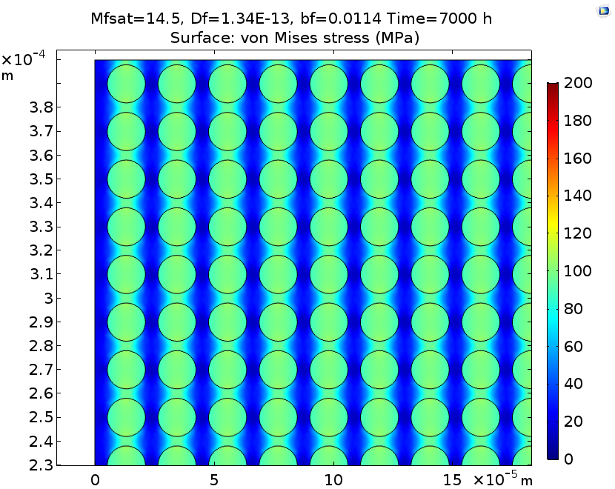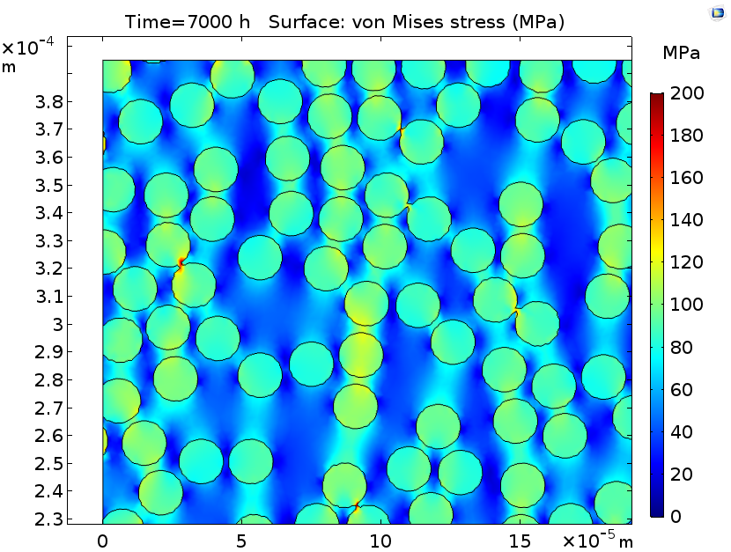 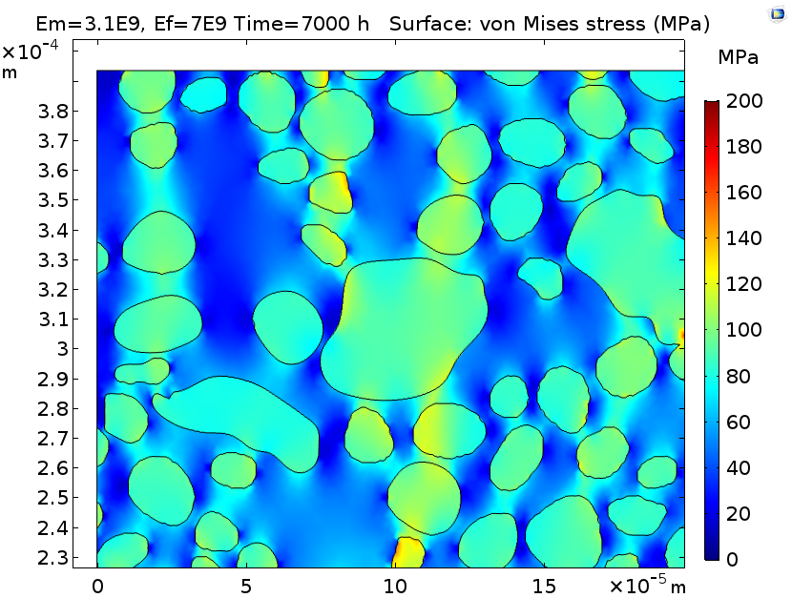

**Figure 7.** Stress distribution in MPa at saturation (7000h) of 3 flax/polyester composites FEM.

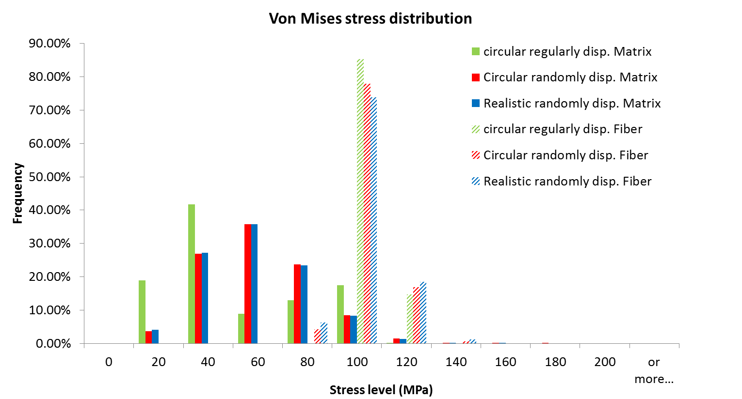

**Figure 8.** Stress distribution in matrix and fibers at saturation (7000h) of 3 flax/polyester composites FEM.

References

[1] K.L. Pickering, M.G. Aruan Efendy and T.M. Le. A review of recent developments in natural fiber composites and their mechanical performance. *Composites Part A : Applied Science and Manufacturing, 83:98-112, 2016*

[2] A. Célino, S. Fréour, F. Jacquemin and P. Casari. The hygroscopic behavior of plant fibers: a review. *Frontiers in Chemistry, 1:1-12, 2014.*

[3] A. Le Duigou, A. Bourmaud and C. Baley. In-situ evaluation of flax fiber degradation during water aging. *Industrial Crops and Products, 70:204-210, 2015.*

[4] M. Berges, R. Léger, V. Placet, V. Person, S. Corn, X. Gabrion, J. Rousseau, E. Ramasso, P. Ienny and S. Fontaine. Influence of moisture uptake on the static, cyclic and dynamic behaviour of unidirectional flax fiber-reinforced epoxy laminates. *Composites Part A : Applied Science and Manufacturing, 88:165-177, 2016.*

[5] G. Apolinario Testoni, P. Ienny, S. Corn, R. Léger, A. Bergeret and J. M. Haudin. Effects of water aging on the mechanical properties of flax and glass fiber composites : Degradation and reversibility. *RILEM Bookseries 12, Springer Publishing, 183-196, 2016.*

[6] A. Le Duigou, A. Bourmaud, P. Davies, and C. Baley. Long term immersion in natural seawater of Flax/PLA biocomposite. *Ocean Engineering 90:1-9, 2014*.

[7] R. Léger, G. Apolinario Testoni, S. Corn and P. Ienny. A multiscale finite element model to predict the diffusional behavior of biocomposites dedicated to structural applications. *Proceedings of the 17th European Conference on Composite Materials ECCM-17, Munich, Germany, June 26-30 2016.*

[9] C. Mattrand, A. Béakou, K. Charlet*.* Numerical modeling of the flax fiber morphology variability. *Composites Part A* : *Applied Science and Manufacturing, 63:10-20, 2014.*

[9] C. Mattrand, A. Béakou, K. Charlet*.* Fourier based methodology for simulating 2D-random shapes in heterogeneous materials. Computational Mechanics, 56:371-388, 2015.

[10] B. Sonon, B. François, T.J. Massart. A unified level set based methodology for fast generation of complex microstructural multi-phase RVEs. *Computer Methods in Applied Mechanics and Engineering, 223-224: 103-122, 2012*.

[11] L. Yang, Y. Yan, Z. Ran, Y. Liu. A new method for generating random fibre distributions for fibre reinforced composites. *Composites Science and Technology, 76: 14-20, 2013*.

[12] D. Gueribiz, F. Jacquemin, H. Bourenane and S. Fréour. Diffusion modeling of composite with permeable fiber. *Applied Mechanics, Behavior of Materials and Engineering Systems. Springer Publishing, 311-321, 2017*.

[13] A. Célino, S. Fréour, F. Jacquemin and P. Casari. Characterization and modeling of the moisture diffusion behavior of natural fibers. *Journal of Applied Polymer Science, 130:297-306, 2013*.

[14] T. Peret, A. Clément, S. Fréour and F. Jacquemin. Numerical transient hygro-elastic analyses of reinforced Fickian and non-Fickian polymers. *Composite Structures, 116:395-403, 2014.*

[15] Y. Joliff, L. Belec and J.F. Chailan. Modified water diffusion kinetics in an unidirectional glass/fiber composite due to the interphase area : Experimental, analytical and numerical approach. *Composite Structures, 97:296-303, 2013.*

[16] A. Le Duigou, J. Merotte, A. Bourmaud, P. Davies, K. Belhouli and C. Baley. Hygroscopic expansion : A key point to describe natural fiber/polymer matrix interface bond strength. *Composites Sceince and Technology, 151:228-233, 2017.*

[17] E.H. Wong, Y.C. Teo and T.B. Lim. Moisture diffusion and vapour pressure modeling for electronic packaging. *Proceedings of the 48th Electronic Component Technology Conference, Seattle, USA, May 1998.*

[18] S. Yoon, B. Han and Z. Wang. On moisture diffusion modeling using thermal-moisture analogy. *Journal of Electronic Packaging, 129:421-426, 2007.*

[19] C. Baley, Y. Perrot, F. Busnel, H. Guezenoc and P. Davies. Transverse tensile behavior of unidirectional plies reinforced with flax fibers. *Materials Letters, 60:2984-2987, 2006*.

[20] S. El Hadi, D. Scida, M. Assarar and R. Ayad. Assessment of 3D moisture diffusion parameters on flax/epoxy composites. *Composites Part A : Applied Science and Manufacturing, 80:53-60, 2016.*

[21] C. Poilâne, Z.E. Cherif, F. Richard, A. Vivet, B. Ben Doudou and J. Chen. Polymer reinforced by flax fibres as a viscoelastoplastic material. *Composite Structures, 112:100-112, 2014*.