PUSHING LOT`S OF AIR INTO PEEK AND PEKK

Angelika Menner ¹, Dmitrii Rusakov² and Alexander Bismarck^{3,4}

¹ Institute of Materials Chemistry and Research, University of Vienna, 1090 Vienna, Austria
Email: angelika.menner@univie.ac.at
² Institute of Materials Chemistry and Research, University of Vienna, 1090 Vienna, Austria
Email: dmitrii.rusakov@univie.ac.at
³ Institute of Materials Chemistry and Research, University of Vienna, 1090 Vienna, Austria ⁴ Department of Chemical Engineering, Imperial College London, SW72AZ London, UK
Email: alexander.bismarck@univie.ac.at

Keywords: PEKK & PEEK foams, thermally-induced phase separation (TIPS), macroporous polymers.

Abstract
Thermally induced phase separation (TIPS) of polymer solutions at low temperatures is a common method to produced polymer foams. However, so far it has not been adopted for manufacturing monolithic PEEK and PEKK foams. Here we present our first high porosity PEEK and PEKK foams obtained by a modified TIPS process, which is based on the temperature dependent solubility of PEEK and PEKK in specific aprotic high boiling point solvents like diphenylketone. After dissolving various amount of polymer, we adjust the morphology of the resulting PEEK or PEKK foams by changing process parameters like the cooling rate; homogeneous networks of highly interconnected pores with pore sizes of approx. 1-3 µm have been achieved. Most importantly, however, for the first time, we have been able to produce mechanically strong, macroporous PEEK and PEKK monoliths with porosities of up to 90%.

1. Introduction

Polyetherketoneketone (PEKK) and polyetheretherketone (PEEK) are semi-crystalline thermoplastic polymers from polyaryletherketones family, with outstanding mechanical properties (with Young’s modulus approx. 4.0 GPa), a melting point higher than +340°C and low flammability[1]. Furthermore, PEEK and PEKK have a high resistance to most of the common solvents but at temperatures above the glass transition temperature PEKK can be dissolved in high boiling point aprotic solvents [2]-[4]. Furthermore, PEKK shows good bio-compatibility and can be effectively reinforced by nano particles and carbon fibres [5]. Such high-performing polymers have a high market price and it would be beneficial to use them as polymer foams rather the bulk polymer in order to reduce material and, therefore, costs. Porous polymers are commonly used in various applications e.g. as membrane [6], catalyst support[7] and construction materials[8] as well as in fuel cells [9], in biomedical application [10] etc..
However, producing porous PEKK and PEEK is a significant challenge as these polymers are intrinsically difficult to foam, because of the low melting strength. Commonly, porous PEKK and PEEK is produced by gas blowing [11] or use of porogens like sodium chloride to create porous structure [12]. These processes have some disadvantages like high energy consumption. Furthermore the resulting materials have an inhomogeneous close-cells structure and a porosity of only 50-60%.
The question is how can we push more air into PEKK and PEEK and improve the morphology of the macroporous polymers?

A common technique to produce macroporous polymers is thermally induced phase separation (TIPS) [13], which is based on solubility differences of polymers in a solvent at high and low temperatures. Thereby, a polymer is dissolved in a solvent and the temperature of the obtained, homogeneous solution is decreased below the cloud point, at which demixing occurs. The structure of the polymer-rich phase determines the morphology of resulting macroporous polymer [14].
Here we will present evidence that the TIPS process can be used to manufacture macroporous PEKK and PEEK. The morphology of such polymer foams can be adjusted by modifying the polymer concentration and process parameter such as the cooling rate.

2. Experimental Section

2.1. Materials

Polyetherketoneketone (PEKK) and polyetheretherketone (PEEK) were kindly supplied by Victrex plc. Diphenyl sulfone, benzophenone and ethanol were purchased from Sigma-Aldrich.

2.2. Methods

2.2.1. Thermally induced phase separation

PEKK or PEEK and varying amounts of a high boiling point aprotic solvents were transferred into a small glass vial equipped with a glass covered magnetic stirring bar and covered with aluminium foil. The vial was then placed in a 250mL jacketed round bottom glass vessel (Fig. 1), which was connected to the high temperature thermostat Huber Unistat T305W HT (Huber AG, Germany; max temperature +300 °C , programmable heating and cooling system), and a thermocouple (Labor Thermometer TFX 410-1) was immerged into the sample. Furthermore, a IKA RCT Classic heating plate was placed underneath the vessel.
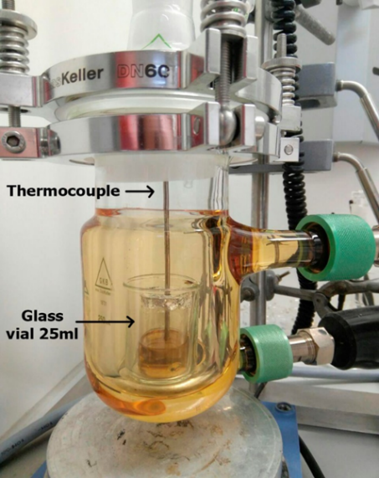
Figure 1. Glass vessel with a homogeneous PEKK solution in 25mL glass vial.

The vessel`s temperature was gradually increased until the solution became transparent and the mixture was stirred for 20 min at 200 rpm to insure its homogeneity. Afterwards the temperature was decreased to 120 °C at specific cooling rate thereby passing the cloud point; the cooling rate was varied in order to investigate its influence on the structure of the resulting polymer foam. The solidified sample was taken out of the vial and purified by Soxhlet extraction with ethanol for 24 hours. Afterwards, the samples were dried in a freeze dryer for at least 20 h.

2.2.3. Determination of the Density and Porosity of the Macroporous Polymers
The skeletal density (ρ_{s}) of the PEKK and PEEK foams was determined by helium replacement pycnometry (in a Accupyc 1330, Micrometrics, Dunstable, U.K.) using the 1 cm³ sample chamber while the foam density (ρ_{f}) of the macroporous polymers was measured with the envelope density analyser Geopyc 1360 (Micrometrics, Dunstable, U.K.). This instrument also calculated the sample’s porosity (P) using the equation given below.

P (%) = ( 1- ρ_{f} / ρ_{s} ) · 100 ( Eq.1)

2.2.4. Morphology of the Macroporous Polymers
To determine the morphology of the porous polymer scanning electron microscopy (JEOL JCM-6000, JEOL Ltd, Japan) was used. Therefore, each sample was cut or broken in the lateral direction and fixed onto a sample holder with black carbon tape. Afterwards, the samples were gold coated in an argon atmosphere using JFC-1200 (JEOL GmbH, Eching, Germany) to guarantee sufficient electrical conductivity.

3. Results and Discussion

We synthesised macroporous PEKK by an adapted temperature induced liquid/solid phase separation process. Therefore, various amounts of PEKK were dissolved in a high boiling point solvent at temperatures exceeding the polymer’s glass transition temperature. Afterwards, the temperature of the polymer solution was decreased at set cooling rates below the cloud-point. At this point, the homogeneous solution separated into two phases, polymer poor and polymer rich phase, resulting after solvent extraction in porous polymers.

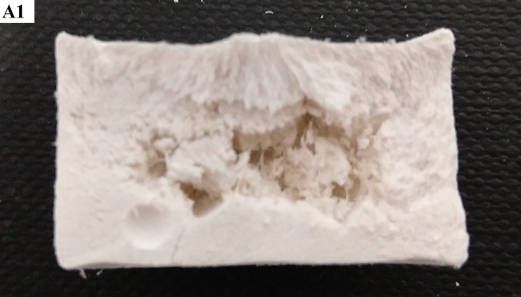
Figure 2. Photographs (A1-D1) and SEM images (A2-D2) taken at x500 magnification of PEKK foams having a porosity of approx. 90%: The cooling rate during preparation was increased from A to D.

Figure 2 shows photographs of the cross section of samples obtained at increasing cooling rates and their SEM images. All samples have similar skeletal densities of approx. 1.4 g/cm³ as well as porosities of about 90% as in this case the concentration of the polymer solution used to produce the polymer foams was kept constant while the cooling rate was successively increased. One can see that the structures of A and B, which were produced with the lowest cooling rates, are rather inhomogeneous; large voids can be observed in the centre of the samples and on a micrometre scale vertically elongated pores are visible. Samples C and D (obtained at ever increasing cooling rates) have a more homogeneous structure with only a few very large pores. Their SEM images reveal that the elongated pores become smaller in diameter. These findings demonstrate that the polymer concentration determined the porosity of the polymer foams while the cooling rate defined the pore structure.

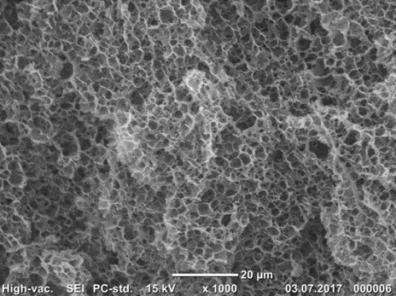
Figure 3. SEM image of 80% porous PEKK

This synthesis route was adapted to the fabrication of macroporous PEEK (Figure 3). This demonstrates the TIPS process is a universal method for the fabrication of macroporous high performance polymers. It was also demonstrated that the used polymer solvents can be recovered and reused, rendering this method into a cost-effective process.

3. Conclusions

We have shown that high porosity PEKK and PEEK samples can be prepared using TIPS. Furthermore, we proved that the cooling rate influences the sample’s morphology. We conclude that TIPS can be used as a simple and promising method for the production of macroporous high performance polymers.

Acknowledgments

We greatly acknowledge the FWF for funding DR (I 1800-N28).

References

- K. C. H. Gardner, B. S. Hsiao, R. R. Matheson, B. A. Wood, Polymer, vol. 33, , no. 12, pp 2483-2495, 1992.
- D. V.Rosato, D. V. Rosato, “Plastic product material and process selection handbook”, Elsevier, ISBN 978-1-85617-431-2, 2004
- T. E. Attwood, P. C. Dawson, J. L. Freeman, L. R. J. Hoy, J. B. Rose, P. A. Staniland, “Synthesis and properties of polyaryletherketones”, Polymer, vol. 22, no. 8, pp 1096-1103, ISSN 0032-3861, 1981.
- Y.Ke, Z. Wu, (), Investigations of the practical routes, structure, and properties for poly(aryl ether ketone ketone) polymers. J. Appl. Polym. Sci., vol. 67, pp 659–677, 1998.
- Daoji Gan, Wenjing Cao, Caisheng Song, Zhijian Wang, “Mechanical properties and morphologies of poly(ether ketone ketone)/glass fibers/mica ternary composites”, Materials Letters, vol. 51, no. 2, pp 120-124, ISSN 0167-577X, 2001.
- I. Pulko, V. Smrekar, A. Podgornik, P. Krajnc, “Emulsion templated open porous membranes for protein purification” Journal of Chromatography A, vol. 1218, pp. 2396–2401, .
- M. J. Sundell, E. O. Pajunen, O. E. O. Hormi, J. H. Nasman, “Synthesis and Use as a Catalyst Support of Porous Polystyrene with Bis(phosphonic acid) -Functionalized Surfaces”, Chem. Mater., vol. 5, pp 372-376, 1993.
- M. Danielsson, “ Toughened rigid foam core material for use in sandwich constructions”, Cellular Polymers, vol. 15, no. 6, pp 417-435, 1996.
- S. Bosea, T. Kuilaa, T. X. H. Nguyenb, N. H. Kimc, K. Laua, J. H. Lee, “Polymer membranes for high temperature proton exchange membrane fuel cell: Recent advances and challenges”, Progress in Polymer Science, vol. 36, no. 6, pp 813–843, June 2011.
- S. M. Kurtza, J. N. Devine, “PEEK biomaterials in trauma, orthopedic, and spinal implants”, Biomaterials, vol. 28 pp 4845–4869, 2007.
- S. C. Tan, Z. Bai, H. Sun, J. E. Mark, F. E. Arnold, C. Y.-C. Lee, “Processing of microcellular foams from polybenzobisthiazole/polyetherketoneketone molecular composites”, Journal of Materials Science, vol. 38, no. 19, pp 4013–4019, October 2003.
- G. L. Converse, T. L. Conrad, C. H. Merrill, R. K. Roeder, “Hydroxyapatite whisker-reinforced polyetherketoneketone bone ingrowth scaffolds”, Acta Biomaterialia, vol. 6, no.3, pp 856-863, ISSN 1742-7061, 2010.
- P. van de Witte1, P. J. Dijkstra, J. W. A. van den Berg, J. Feijen, Journal of Membrane Science, vol. 117, no. 1-2, pp 1-31, 1996.
- R. H. Mehta, D. A. Madsen, D. S. Kalika, “Microporous membranes based on poly(ether ether ketone) via thermally-induced phase separation”, Journal of Membrane Science, vol. 107, no. 1-2, pp 93-106, 1995.

