**VALORIZATION OF WASTE FIBRES FROM POSIDONIA OCEANICA SEAWEEDS IN A BIO-COMPOSITE: INFLUENCE OF FIBRE TREATMENT AND AGEING ON PROPERTIES**

E.Y. MAHAMAT SALEH, L. BELEC, S. BERLIOZ, J.F. CHAILAN

Laboratoire Matériaux Polymère Interface Environnement Marin (MAPIEM EA 4323), Université de Toulon CS 60584 - 83041 TOULON CEDEX 9 - FRANCE

Email: [belec@univ-tln.fr](mailto:belec@univ-tln.fr), http://mapiem.univ-tln.fr

**Keywords:** bio-composites, waste fibre, treatment, ageing

**Abstract**

The valorization of an abondant marine residue as a filler in a bio-based epoxy matrix is studied. Raw fibres of Posidonia Oceanica (PO) are extracted from balls seasonnaly rejected on beaches. Mats elaborated from untreated fibres, sodium hydroxide or sodium bicarbonate treated fibres are dried and impregnated by a commercial bio-based epoxy before curing.The effects of treatments on fibres are analyzed by infrared spectroscopy (FTIR) which shows a small impact on fibre surface chemistry. Fibres and cryofractured surfaces of the different composites are observed with Scanning Electron Microscopy (SEM). Fibre/matrix interfaces are also characterized by Atomic Force Microscopy. A good interfacial cohesion is shown whatever the treatment.The effects of fibre treatment on thermal and mechanical behavior of the composites are evaluated. An increase of the flexural modulus is measured for small amounts of fibres. The water uptake at 85% RH and 60 °C for 6 weeks increases after alkali treatments which could be explained by fibres degradation. Thus, PO could be an interesting filler for epoxy matrices without initial alkali treatment which is more environmentally friendly.

1. Introduction

Posidonia Oceanica is an endemic seaweed widely spread in the Mediterranean Sea. Seasonally, leaves or fibrous balls of this plant accumulate on beaches and must be removed. This available lignocellulosic fibre has been used in gluten matrices [1] or thermoplastic matrices [2]or cements [3] which toughness can be increased with low amount of PO fibres. Nanowhiskers of PO fibres were also elaborated and used as fillers in different polymer matrices [4-6]. Fibre treatments are generally used on vegetable fibres such as hemp or flax to remove extractible parts of fibres such as lignine and hemicellulose which decrease thermal and mechanical properties [7-9]. They also improve fibre-matrix interactions. Moreover, hemicellulose contains OH groups which increase natural fibres hydrophily. Alkali treatments should then improve hydrothermal resistance of biocomposites. NaOH [3,10] or sodium bicarbonate [11] which is more respectful to environment are used at various concentrations up to 10% wt in water. We chose to associate a bio-based epoxy matrix to developpe a composite as environmental friendly as possible. The association with PO fibres has never been described yet.

2. Materials and testing methods

The pre-polymer GREENPOXY56 is made of 56% of bio-based carbone. It is associated with a amine hardener SD7203. Both components are furnished by SICOMIN, in proportions of 100/37 in weight.

Raw fibres of Posidonia Oceanica are extracted from aegagropiles balls collected on the beach and rinsed with water to remove sand and residues. They are then dried for 48 h at 23 °C and then immersed in NaOH solution (6% w/v) or NaHCO3 (10% w/v) for 24 h at 23 °C before being filtred, rinsed with demineralized water and dried for 2 h at 100 °C. A mat of fibres is prepared and recovered by the resin in a mold to get around 10 wt.% of fibres. A first curing cycle of 24 h at 23 °C is followed by a second cycle at 45 °C for 24 h. Composite plates of around 4 mm thick are obtained.

The matrix/fibre interfacial strength is determined by a three-point bending test according to ISO178 standard. Tests are performed on a MTS DY35 universal tensile equipment. The samples of 80x10x4 mm3 were cut with a diamond tested at constant crosshead speed of 2 mm/min. Each value is an average of five measurements.

The viscoelastic behaviour of the bulk resin and the composite is studied by dynamic mechanical analysis using a DMA Q800 from TA Instruments. Samples sizes of 40x8x4 mm3 are cut and tested in single cantilever mode with 10 µm amplitude at 1 Hz. A heating rate of 3 °C/min is applied between 30 °C and 130 °C.

AFM measurements are performed on a NanoScope MM-Peak Force QNM® controller equipped with a V9 MULTIMODE2-U Atomic Force Microscope from BRUKER. Cantilever probes RTESPA-300 model from BRUKER with a constant spring around 40 N/m are chosen. Each cantilever is systematically calibrated on a hard reference sample and the tip radius is estimated from scans on reference polystyrene samples with PeakForce setpoint around 20 nN. The surface moduli are calculated by DMT model. The samples used for AFM measurements are cut perpendicularly to fibre axis and polished up to 1 µm with diamond grinding paste using ethanol as solvent to avoid fibre swelling and dried.

FTIR spectra are collected on a Thermo Scientific Nicolet IS50 spectrophotometer in Attenuated Transmission Reflexion (ATR) mode. All spectra are the coadditions of 32 scans taken at a resolution of 4 cm−1.

Hygrothermal ageing tests are performed on samples of 7x5 cm² maintained at a temperature of 60 °C with a relative humidity of 85% for 6 weeks in a CTS-C 20/200 climate chamber.

3. Results and discussion

3.1. Effect of fibre treatment on fibres and composite microstructure

Cellulose, hemicelluloses and lignine all contains alkene, esters, aromatics, ketone and alcohol, with different oxygen-containing functional groups OH (stretching wide band around 3500 cm-1 and bending at 1652 cm-1), C=O (around 1730 cm-1 ), C–O–C (1270 cm-1 ), and C–O–(H) (cm-1) [12]. But hemicellulose is known to contain a higher amount of C=O compounds while lignin possess a higher amount of aromatic ring (C=C stretching at 1610 cm-1). The analysis in ATR mode shows a low intense peak shoulder at 1716 cm-1 which slightly decreases after NaOH treatment (Fig. 1). It suggest that the amount of hemicelluloses is low on raw fibres. A decrease in 1600 cm-1 area after NaOH treatment can result from lignin partial removal. The spectrum after NaHCO3 treatment is very similar to the spectrum of untreated fibres. Compared to other natural fibres, the amount of lignine or hemicellulose in Posidonia Oceanica fibers from balls is probably lower due to a prolonged immersion period being rolled on the sand by the waves.

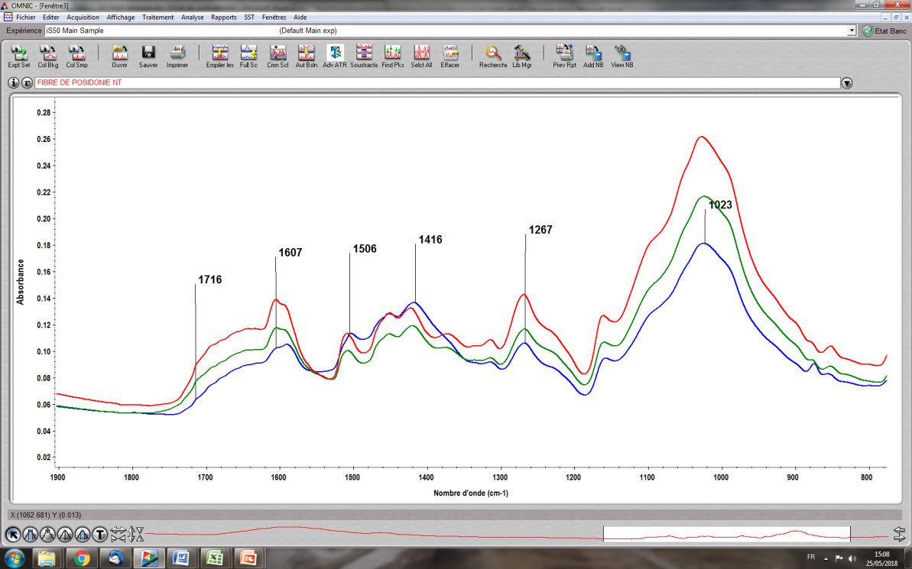

Untreated

NaHCO3 treatment

NaOH treatment

**Wave number (cm-1)**

**Figure 1.** Effect of fibre treatment on surface chemistry

SEM observations of fibres show a dispersion in fibre shape and structure within the same pellet even before treatment (Fig. 2). Indeed, cylinders or tapes of 100-200 µm width can be observed. Each fibre regroups several individual fibrils of around 10 µm diameter bounded by the compound middle lamella [13]. The prints of fibrils on tapes surface suggest that they result from fibres delamination. After NaOH treatment, many tapes, more or less split into individual fibrils and many fibres with a degraded primary wall or compound middle lamellae are observed (Fig. 2b). After NaHCO3 treatment, an intermediate microstructure between untreated fibres and NaOH treated fibres is observed. After cryofracture, fibre/matrix interfacial failures with fibre pull-out are mainly observed with or without treatment. Fibre/matrix cohesion appears good in each case, without void at interfaces. Within fibres, some fibrils are filled and some are empty, surrounded by a regular cell wall and by the primary wall and middle lamella. After NaOH treatment, a similar fracture behavior is observed but a majority of fibrils seem to be filled with irregular degraded walls (Fig. 2b’). After NaHCO3 treatment, the fractography is intermediate.

fibre n traitée vieilli24h02.tiffibre trtée NaOH vieilli24h09.tiffibre traitée NaHCO n vieill10.tif

**a’ b’ c’**

**a b c**



**Figure 2.** SEM images of untreated (a) NaOH treated (b) NaHCO3 treated (c) fibres and cryofractured biocomposites filled with untreated (a’) NaOH treated (b’) NaHCO3 treated (c’) fibres.

AFM analysis show a cohesive interface between fibres and matrix (Fig. 3). The height image shows fibre/matrix interface (a) and multiple cell walls surrounding filled and empty lumen. DMT scans show walls with higher modulus values. The 2nd cell wall modulus appears higher than the 1rst wall, which are both higher than matrix and lumen modulus values (around 3-4 GPa). After NaOH and NaHCO3 fibre treatments, an increase of fibre lumen diameter is observed with a decrease in walls thickness or disappearance of 1st wall or compound middle lamella.



**Figure 3.** AFM height measurement of biocomposite filled with (a) untreated fibres (b) NaOH treated fibre and (c) NaHCO3 treated fibre. (a’) modulus image of biocomposite with untreated fibres

3.1. Influence of fibre treatment on composite properties

It is noticeable that including less than 10 % by weight of fibres increases the flexural modulus by 14% (Fig. 4). NaOH treatment only increases by 4 % the modulus compared to untreated fibres. NaHCO3 treatment gives similar results as untreated fibres. It suggests that the interfacial properties are correct and that load transfer to the fibres is efficient even on untreated fibres.

**Figure 4.** Comparison of flexural modulus between resin and treated fibres composites

DMA results are very similar whatever the treatment. Moreover, a decrease of Tan  height and surface (Table 1) is observed for all composites compared to the resin alone. The peak amplitude is proportional to the number of relaxing species. Taking account of fibre fraction, around 10%, the fact that the decrease is higher suggests that molecular motions and relaxations are hindered by fibre. This can be due to interactions with fibre surface or by resin diffusion.

**Table 1.** Analysis of Tan  peak obtained by DMA for resin and treated fibres composites

|  |  |  |
| --- | --- | --- |
| **sample** | **T** (°C | **area (min)** |
| **Epoxy resin** | 96 | 6 |
| **Untreated** | 95 | 4 |
| **NaOH** | 95 | 4 |
| **NaHCO3** | 93 | 3.6 |

3.2. Influence of fibre treatment on ageing behavior

Generally, alkali treatments are used to remove hemicellulose which is more hydrophylic than cellulose. Fig. 5 shows an opposite trend with an increase of diffusion coefficient and mass at saturation after alkali treatments. Compared to neat resin, the increase of mass at saturation is around 10% for untreated fibres composite and above 20% for treated ones. Diffusion coefficients are respectively 1.5x10-8, 3.6x10-8, 5x10-8 and 6x10-8 cm²/s for the resin, composites with untreated, NaOH and NaHCO3 treated fibres.



**time1/2 (hour1/2)**

**Figure 5.** Influence of fibre treatment on water uptake at 60 °C and 85% RH

4. Conclusions

Thermal and mechanical properties of the biocomposites are very similar whatever the fibre treatment. It appears from FTIR results and SEM and AFM observations that alkali treatments do not remove much hemicellulose or lignine which is probably low in Posidonia Oceanica fibres from balls after a prolonged immersion period being rolled on the sand by the waves. Alkali treatments emphasize fibre degradation which increases water diffusion inside fibres. Thus, this available lignocellulosic fibre could be an interesting filler for composites materials provided an adequate surface treatment to increase their compatibility with organic matrix and improve the biocomposite water resistance and mechanical strength.

Acknowledgments

The authors gratefully thank Karl Bouton for his usefull contribution to the study.

References

[1] B. Ferrero, V. Fombuena, O. Fenollar, T. Boronat, R. Balart. Green composites based on wheat gluten matrix and posidonia oceanica waste fibres as reinforcements. *Polymer Composites.* 34: 1663-1669, 2013.

[2] L. Allègue, M. Zidi, S. Sghaier; Mechanical properties of Posidonia oceanica fibres reinforced cement. *Journal of Composite Materials*. 49: 509-517, 2015.

[3] R. Khiari, M. N. Belgacem. Potential for using multiscale Posidonia oceanica waste: current status and prospects in material science. *Lignocellulosic Fibre and Biomass-Based Composite Materials*. Book chapter 21: 447-471, 2017.

[4] F. Bettaieb, R. Khiari, A. Dufresne, M. F. Mhenni, S. Boufi. Nanofibrillar cellulose from Posidoniaoceanica: Properties and morphological features. Industrial *Crops and Products*. 72: 97-106, 2015.

[5] F. Bettaieb, R. Khiari, M. L. Hassan, M. N. Belgacem, M. F. Mhenni. Preparation and characterization of new cellulose nanocrystals from marine biomass Posidoniaoceanica. *Industrial Crops and Products.*72: 175-182, 2015.

[6] F. Bettaieb, R. Khiari, M. F. Mhenni, M. N. Belgacem. Mechanical and thermal properties of Posidonia oceanica cellulose nanocrystal reinforced polymer. *Carbohydrate polymers.* 12: 99-104, 2015.

[7] A. Rachini, G. Mougin, S. Delalande, J. -Y. Charmeau, E. Fleury. Hemp fibers/polypropylene composites by reactive compounding: Improvement of physical properties promoted by selective coupling chemistry. *Polymer Degradation and Stability.* 97: 1988-1995, 2012.

[8] A. Lefeuvre, A. Bourmaud, C. Morvan, C. Baley. Elementary flax fibre tensile properties: Correlation between stress–strain behaviour and fibre composition. *Industrial Crops and Products*. 52: 762-769, 2014.

[9] S. Kalia, B. Kaith, I. Kaur, Pretreatments of natural fibres and their application as reinforcing material in polymer composites-A review. *Polymer Engineering & Science.* 49: 1253-1272, 2009.

[10] Alsaeed, T., B. Yousif, H. Ku, The potential of using date palm fibres as reinforcement for polymeric composites. *Materials & Design.*43: 177-184, 2013.

[11] V. Fiore, T. Scalici, F. Nicoletti, G. Vitale, A. Valenza. A new eco-friendly chemical treatment of natural fibres: Effect of sodium bicarbonate on properties of sisal fibre and its epoxy composites. Composites Part B: Engineering. 85: 150-160, 2016.

[12] H. Yang, R. Yan, H. Chen, D. H. Lee , C. Zheng. Characteristics of hemicellulose, cellulose and lignin pyrolysis, *Fuel.* 86: 1781-1788, 2007.

[13] N. Saba, M. T. Paridah, M. Jawaid. Mechanical properties of kenaf fibre reinforced polymer composite: A review. *Construction and Building Materials*. 76: 87-96, 2015.