**EXPERIMENTAL AND NUMERICAL PROGRESSIVE FAILURE ANALYSIS OF CORRUGATED CORE TYPE COMPOSITE SANDWICH STRUCTURE**

Emre Calik1, Nuri Ersoy2, Fatih E. Oz3

1-2-3Department of Mechanical Engineering, Bogazici University, Bebek, 34342, Istanbul, Turkey Emails: emre.calik@boun.edu.tr1, [nuri.ersoy@boun.edu.tr](mailto:nuri.ersoy@boun.edu.tr)2, [fatih.oz@boun.edu.tr](mailto:fatih.oz@boun.edu.tr3)3

**Keywords:** sandwich structure, composite materials, finite element modelling, progressive failure analysis, delamination, CFRP

**Abstract**

The aim of this study is to investigate the failure mechanisms of corrugated core type Carbon Fibre Reinforced Polymer (CFRP) composite sandwich structure under quasi-static loading condition. A new corrugated core type composite sandwich structure is designed by using a special combination of laminates in which plies are stacked in different sequences. In this design, AS4/8552 prepreg material is used for both of core and facesheets in a single process to eliminate the need for secondary bonding operations. Finite Element Analysis (FEA) is performed by using ABAQUS software to predict failure responses of the structure. Hashin Failure Criterion is used to predict intralaminar failure modes and Cohesive Zone Model is utilized to simulate the inter-laminar damage. Four-point bending and compression tests are also carried out to investigate the post-failure behaviour of the structure and to check the correlation between simulation and experiment.

1. Introduction

Composite sandwich structures have been more desirable and their applications have been dramatically increasing in a wide range of industries such as aerospace, aviation, automotive, marine, power systems, etc. Their superior material properties such as high stiffness/strength to weight ratio and high corrosion resistance stand out as the key drivers behind this trend. It is possible to design a composite sandwich structure special to any operating condition by changing its geometry, stacking sequence, fibre direction, material, etc. Therefore, there are limitless options to design the most functional composite structure by meeting operational requirements. A typical composite sandwich structure is comprised of two layers and a core inserted in between these layers. There are several studies on functional novel cores in composite sandwich structures that have advantages as compared to conventional honeycomb or foam. Hollow functional cores are preferred since they allow a space between facesheets and can be utilized for other purposes such as cabling and thermal managements.

In this study, the corrugated core design proposed by Cinar et al. [1] is chosen as specimen geometry. In this sandwich structure, contact surface between core and facesheets is higher compared to previous designs and this is the main advantage in terms of avoiding debonding failure [1]. The main aim of this study is to investigate failure behaviour of this special composite sandwich structure by both numerical and experimental methods. Compression and four-point bending tests are performed as well as a finite element model is developed to predict the progressive failure behavior of the specimens under the loading conditions in these tests. Hashin Failure Criterion is implemented to predict in-ply failures and Cohesive Zone Model is defined to simulate delamination behaviour. Finally, progressive failure analysis and experimental results are compared and the accuracy of FEA is discussed.

**2. Experimental Study**

**2.1 Specimen Preparation**

Hexcel's unidirectional AS4/8552 prepreg system is used in this study [2]. Nominal thickness of this prepreg is 0.184 mm. Cured ply properties of AS4/8552 are given in Table 1. A large corrugated sandwich plate is manufactured as follow: First, AS4/8552 prepregs are wrapped around nine aluminum mandrels, having 50 mm width and 25 mm thickness, with desired stacking sequence; [90/0/90/0]. These form the core sections. Then these wrapped nine mandrels are stacked horizontally next to each other. Afterwards facesheets are stacked on and under the wrapped aluminum mandrels with [0/90/0/90] lay-up orientation. Fig. 1 shows schematic representation of stacking sequence and structure. Stacked plies with wrapped mandrels are placed under vacuum bag carefully. Then it is cured in autoclave according to the Manufacturer's Recommended Cure Cycle (MRCC). 7 bar pressure and -1 bar vacuum is applied during curing process to evacuate the air inside the prepregs. After curing, aluminum mandrels are removed easily thanks to the difference in thermal expansion coefficients of composite and aluminum materials. Test specimens are cut from the large corrugated plate using a water cooled diamond disc. Two specimens with one core section are cut for compression tests. Moreover, two specimens with three core sections are cut for four-point bending tests.

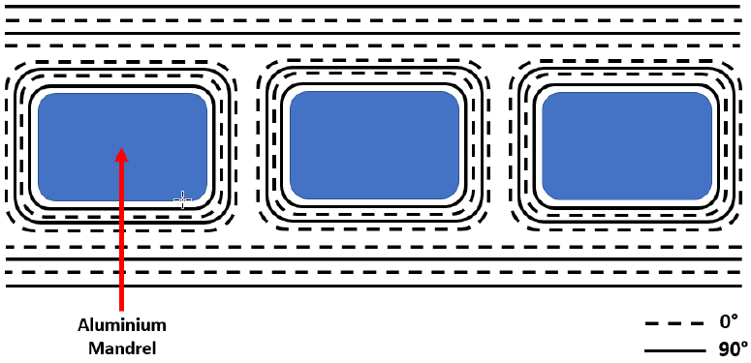

**Figure 1.** Schematic Representation of Lay-Up

**Table 1.** Material Properties of AS4/8552

|  |  |  |
| --- | --- | --- |
| Description | Symbol | Value |
|  |  |  |
| Density [g/cm3] | ρ | 1.58 |
| Longitudinal Modulus [GPa] | E11 | 141 |
| Transverse Modulus [GPa] | E22=E33 | 9.75 |
| Poisson's Ratio | ν12 | 0.267 |
| Shear Moduli in 1-2 plane [GPa] | G12 = G13 | 5.2 |
| Shear Moduli in 2-3plane [GPa] | G23 | 3.19 |
| Longitudinal Tensile Strength [MPa] | XT | 2200 |
| Longitudinal Compressive Strength [MPa] | XC | 1500 |
| Transverse Tensile Strength [MPa] | YT | 81 |
| Transverse Compressive Strength [MPa] | YC | 260 |
| In-plane Shear Strength [MPa] | S | 80 |

2.2 Test Procedure

2.a

Four-point bending test is performed for two specimens having three core sections. The specimens are supported by two rollers at right and left edges of the plate so that support rollers align vertically with outermost core ribs. Other two load rollers are aligned with inner core ribs from top of the structure and they move downward at 10 mm/min until total displacement of load rollers reaches to 30 mm. Fig. 2.b shows four-point bending experimental setup.

**b.**

**a.**

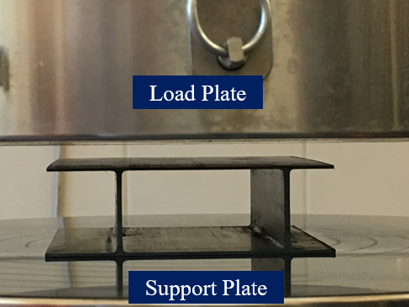 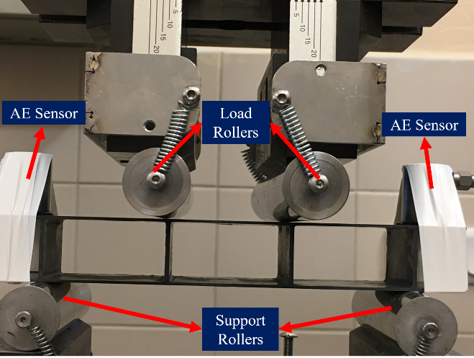

**Figure 2.** **a.** Compression Test Setup, **b.** Four-Point Bending Test Setup

3. Numerical Analysis

Commercial finite element program ABAQUS/Explicit is used to simulate the behavior of corrugated core type composite sandwich structure under quasi-static loading condition. Although implicit solver seems to be appropriate choice for quasi-static analysis, it is recommended that explicit solver is more efficient especially for simulations involving contact and large deformations [3].



First of all, the solid model of each ply is created separately as three dimensional extrusions. This allows the user to define material, fibre direction, ply thickness and geometry unique to each laminate. In the modelled structure, the stacking sequence is [90/0]2s for upper/bottom facesheets and [0/90]2s for webs. Each ply thickness is 0.184 mm. These parameters are defined for each ply by using "Composite Layup" option with material properties given in Table 1.

Turon et al. [4] claim that the effective elastic properties of the material are not affected by the cohesive surface as long as the through-the-thickness Young's modulus of the material (E3) is much less than multiplication of the lamina thickness (t) and penalty stiffness (K). It is concluded that penalty stiffness can be formulized as shown in Eq. 1:

|  |  |  |
| --- | --- | --- |
|  | $$K=\frac{αE_{3}}{t}$$ | (1) |

Where α is a parameter larger than 1. In Turon’s study [4], α was recommended to be chosen as 50.

The choice of mesh size is quite crucial in FE simulations because it has direct impact on run time and analysis accuracy. More accurate results can be achieved with smaller mesh size but this might increase run time excessively. Therefore optimum mesh size must be chosen. This choice is made based on the number of elements in the cohesive zone. Turon et al. [4] suggest that by keeping interfacial fracture energy constant and changing the interfacial fracture strength, the cohesive zone length can be increased artificially, which means that larger elements can be used to apply the Falk's [5] recommendation to use 2-5 elements over the cohesive zone length. The artificial interfacial fracture strength can be formulized as shown in Eq. 2:

|  |  |  |
| --- | --- | --- |
|  | $${\overline{τ}}^{0}=\sqrt{\frac{EG_{c}}{N_{e}l_{e}}}$$ | (2) |

Where $N_{e}$ is the number of elements in the cohesive zone and $l_{e}$ is the mesh size.

The penalty stiffness values are calculated for each mode by using Eq. 1 recommended by Turon [4] and summarized in Table 2. In order to fully define traction-separation curve, interfacial fracture strength and interfacial fracture energy parameters must be also introduced under "Damage Option". Interfacial fracture energy values for AS4/8552 prepreg material are determined by performing Double Cantilever Beam (DCB) test for Mode 1, End Notched Flexure (ENF) test for Mode 2 and the parameters for Mode 3 fracture are taken to be the same as Mode 2. The average fracture energy values for each failure mode are summarized in Table 2. The related interfacial fracture strength values are adjusted by using Eq. 2 and keeping the largest element length used in the model as 0.7 mm. As it is indicated before, Falk et al. [5] suggest that implementing 2-5 elements in the cohesive zone length would give satisfying results. In this study, the number of element in the cohesive zone length is taken as 4, so the cohesive zone length is needed to be 2.8 mm. The interfacial fracture strength values adjusted per Eq. 2 are also summarized in Table 2. The frictional force between the seperated surface is modelled under "Tangential Behaviour" option by defining friction coefficent. Friction coefficient are generally determined by experimental studies. In this study, it is chosen as 0.3 as indicated in Sokolinsky et al. [6].

**Table 2.** Inter-laminar Properties of AS4/8552

|  |  |  |  |  |
| --- | --- | --- | --- | --- |
| Property | Symbol | MODE 1 | MODE 2 | MODE 3 |
| Penalty Stiffness [N/mm3] | Kn,s,t | 2.65x106 | 1.42x106 | 1.42x106 |
| Interfacial Strength [MPa] | τn,s,t | 35 | 70 | 70 |
| Fracture Energy [KJ/m2] | Gn,s,t | 0.28 | 2.59 | 2.59 |

Two different models are implemented to model compression and four-point bending tests. Boundary conditions are assigned as indicated in Fig. 3.a and 3.b. Constant velocity (300 mm/s) is defined to reference point of loading plate in compression model and reference point of loading roller in four-point bending model. Although implemented velocity is ten times higher than quasi-static test speed, increasing velocity is necessary to decrease run time for explicit analysis. Since dynamic effects become significant only beyond 500-1000 mm/s, the artificial increase in the velocity does not have an impact on numerical accuracy [6].

Both structure is modelled as half-section by using symmetry boundary condition in order to decrease run time. Compression model is supported by fixed bottom plate whereas four-point bending model is supported by fixed bottom roller. All nodes are fixed in z-direction to prevent unrealistic deformation behavior. All plies except bead section are meshed with Continuum Shell Elements (SC8R). This element type has 3D geometry but its kinematic and constitutive behavior are similar to those of conventional shell elements. In ABAQUS, built-in Hashin Failure Criterion is defined with Continuum Shell Element.

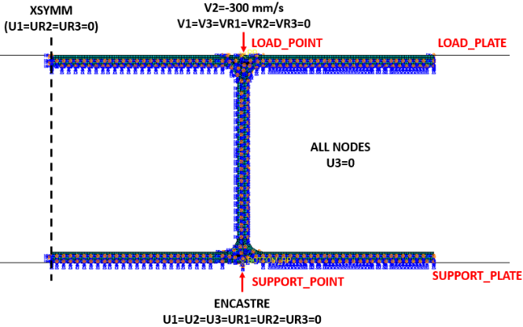 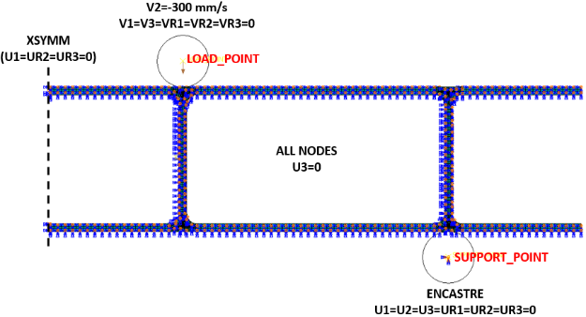

**b.**

**a.**

**Figure 3. a.** Boundary Conditions of Compression Test Model, **b.** Boundary Conditions of Four-Point Bending Test Model

4. Results and Discussion

4.1 Compression Test

Progression of failure mechanisms observed during compression test are presented in Fig. 4. Firstly, buckling failure occurs in the middle of left rib section of the structure and then delamination initiates at this buckle zone at a load of 1132N. At the same time, buckling starts also in the middle of right rib section. Finally, left rib section is totally delaminated in the middle and right rib section is delaminated close to rib-facesheet intersection. Along with that, fibre breakage and matrix cracking are also observed in the delamination zones.

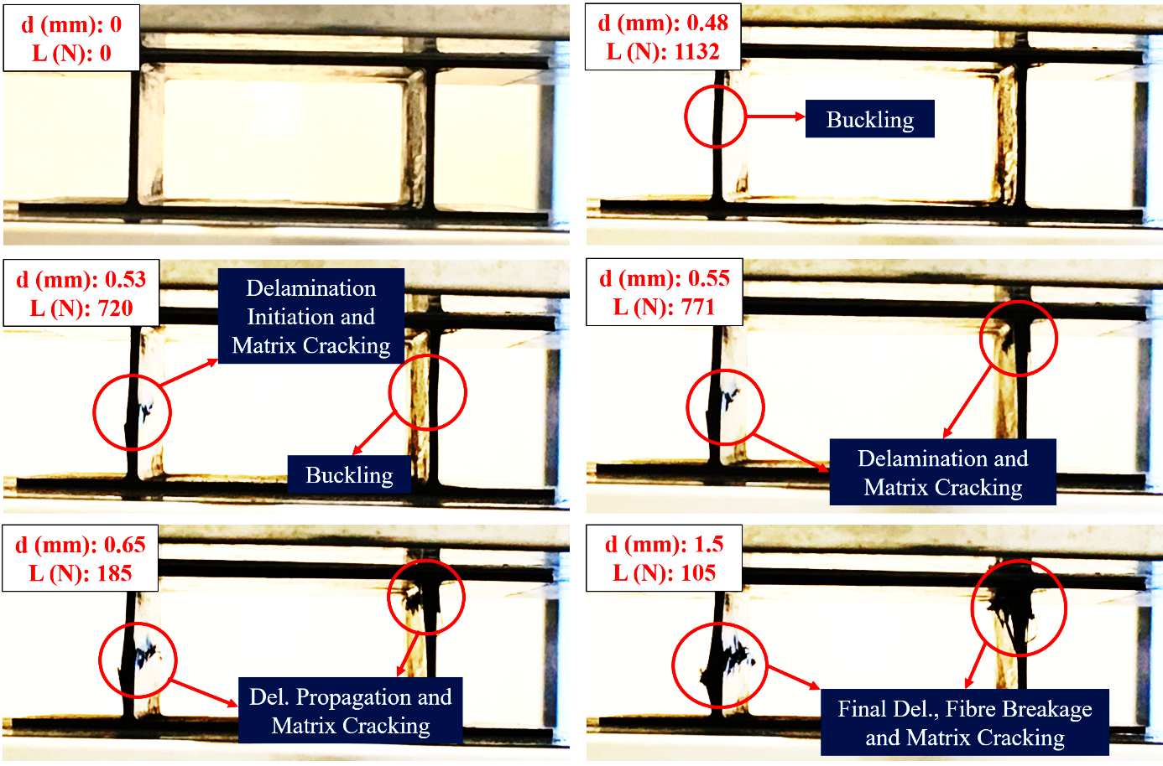

**Figure 4**. Failures in Compression Test

Predictions with finite element progressive failure model are summarized in Fig. 5.a and 5.b where damage is shown consecutively for increasing values of the roller displacement, *d*. Please note that only Hashin’s Fibre and Matrix Compression Failure Indices are shown for the sake of brevity. It is seen that damage initiates with rib buckling. Then, delamination initiation and propagation occur at buckle zone of rib plies. Simultaneously, in-ply fibre and matrix failures take place. Upper and lower rib-facesheet interfaces are the first areas exposed to in-ply failures. As buckling and delamination grow, in-ply failures spread to delaminated zones.

Compression test and simulation load displacement curves are demonstrated in Fig. 6. It is seen that buckling is the dominant failure mechanism which determines load-carrying capacity of the structure. Buckling failure initiates at 0.48 mm in 1st compression test and at 0.51 mm in 2nd compression test. On the other hand, the same failure occurs at 0.5 mm in FEA. This is where a major load drop occurs and there is close match between test and simulation. It can be also said that the general trend in load-displacement curve after buckling failure is also predicted reasonably well.

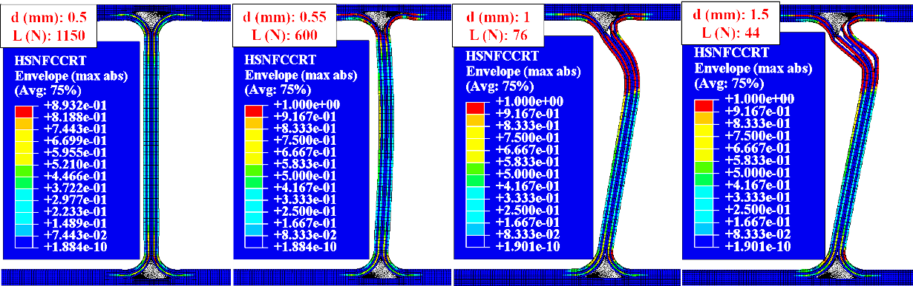

**a.**

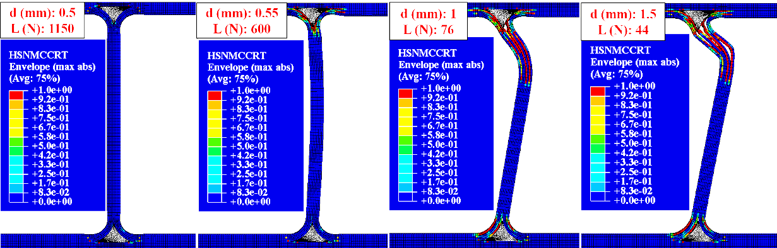

**b.**

**Figure 5. a.** Delamination and Hashin’s Fibre Compressive Failures in Compression Test Simulation, **b.** Delamination and Hashin’s Matrix Compressive Failures in Compression Test Simulation

emre

**6**Load-Displacement Curves Obtained in Compression Tests and FEA Simulation

4.2 Four-Point Bending Test

Failure mechanisms in four-point bending test are illustrated in Fig. 7. Delamination is the first failure mode observed and it starts around bottom left & right bead sections where rib-facesheet intersection surfaces are located. As load rollers bend the structure further, delamination zones grow and matrix cracks occur on the same area. Delamination and matrix cracking failures are also observed at rib-facesheet intersection surface around upper left & right bead section. Surfaces around bottom left & right bead sections are totally delaminated by the end of test. The same failure pattern is observed also in bottom middle left & right as well as in upper middle left bead section surfaces.

The damage patterns obtained by FEA is illustrated in Fig. 8 and it is seen that the damaged shape is similar to specimen geometry obtained at the end of four point bending tests. Since rib-facesheet intersection surfaces are the main weakness areas of the structure in four point bending test, these areas are investigated further in detail. It is seen that major delamination failures occur around upper-middle, upper-right and bottom-right bead sections. Although there are also Hashin's matrix and fibre damages around rib-facesheet intersections, tensile matrix damage is the dominant Hashin's failure mode.

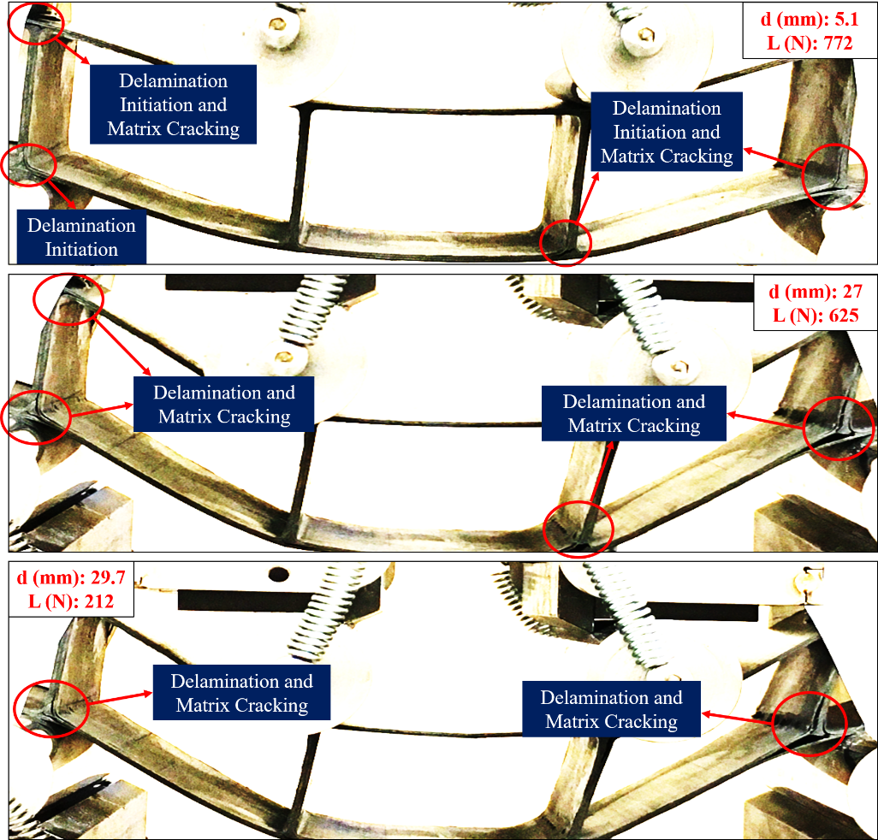

7-

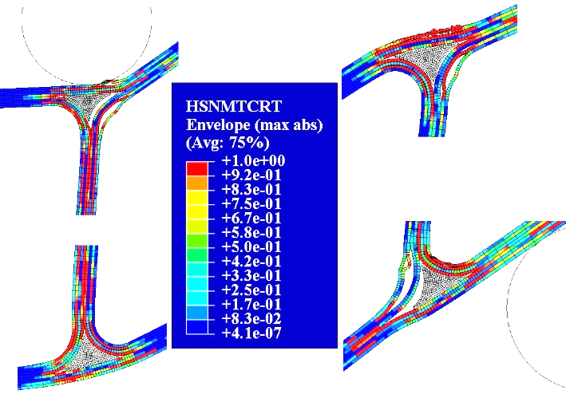

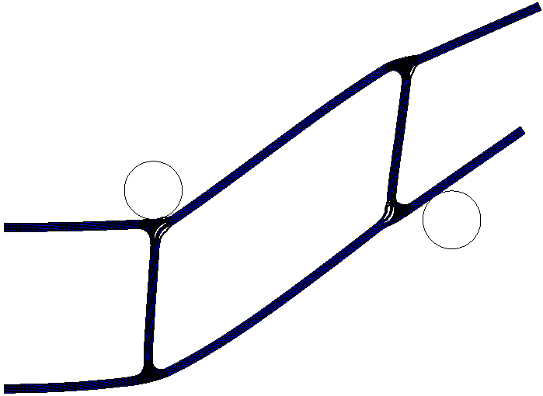

**Figure 8.** Delamination and Hashin’s Matrix Tensile Failure in Four-Point Bending Test Simulation

The load-displacement curve obtained by FEA is compared with experimental results in Fig. 9. It is seen that load increases linearly up to 4-5 mm displacement. Then, there is a major drop in load level as a result of first delamination initiation around rib-facesheet intersection and there is a close match between test and simulation. After that point, as displacement increases, load increases as well up to next damage. When Hashin's damage initiates for an element or delamination failure grows, load decreases again. This trend continues until that the total displacement reaches to 30 mm. It can be said that although it is not possible to predict accurately the successive load drops after the first failure in the finite element model for progressive damage analysis, the general trend in load-displacement curve after first delamination initiation is also predicted reasonably well.

4point

**Figure 9.** Load-Displacement Curves Obtained in Four-Point Bending Tests and FEA Simulation

5. Conclusion

In this study, progressive failure analysis of corrugated core type composite sandwich structure is performed both experimentally and numerically. Compression tests and four-point bending tests are performed. Finite Element Model is developed in ABAQUS/Explicit to simulate these tests and predict failure response of structures under different loading conditions. In-ply damage modes are investigated by Hashin's Failure Criterion, which is the default damage initiation criterion in ABAQUS. On the other hand, initiation and evolution of delamination failure are simulated using Cohesive Zone Model (CZM). CZM is defined in ABAQUS by introducing Interaction Properties, mainly interfacial fracture strength, fracture energy and penalty stiffness values for each failure mode. Both compression and four-point bending tests are simulated separately. Numerical results are validated with experiments by comparing failure mechanisms and load-displacement curves of both compression and four-point bending simulations.

References

[1] K. Cinar, F. Oz, N. Ersoy. Failure behavior of corrugated core panel under out-of-plane loading, 2015

[2] Hexcel. HexPly ® 8552 - Product Data Sheet - EU Version pp. 1–6, 2016

[3] ABAQUS (2015) ABAQUS 6.15 Analysis User's Manual. Online Documentation Help: Dassault Systèmes.

[4] A. Turon, C. Davila, P. Camanho, and J. Costa. An engineering solution for mesh size effects in the simulation of delamination using cohesive zone models, 1665-1682, 07 2007.

[5] M. Falk, A. Needleman, and J. Rice. A critical evaluation of cohesive zone models of dynamic fracture, 09 2001.

[6] V. S. Sokolinsky, K. C. Indermuehle, and J. A. Hurtado. Numerical simulation of the crushing process of a corrugated composite plate. Composites Part A: Applied Science and Manufacturing, 1119-1126, 2011.