Characterisation of through-the-thickness tufted preforms during manufacturiNg

I. Gnaba, P. Wang, X. Legrand and D. Soulat

University of Lille, ENSAIT, GEMTEX, F-59056, France
Email :{ imen.gnaba; peng.wang; xavier.legrand; damien.soulat}@ensait.fr

Keywords: Textiles composites, Through-the-thickness reinforcement, Tufting, Mechanical characterisation, Manufacturing

Abstract
Textile composites are widely used to manufacture thicker and more complex parts. In aerospace, transport and energy industry, the 3-Dimensional fabrics have been developed to replace the multilayered reinforcements in some applications to increase the performance through-the-thickness. The manufacturing of 3-Dimensional tufted preforms as well as the influence of the tufting parameters are deeply described in the present work. This study highlights the mechanical performance of dry through-the-thickness tufted preforms where the tensile and the bending behaviours are particularly characterised and compared to the mechanical behaviours of the untufted preform.

1. Introduction

Textile composites are widely used in several sectors such as aerospace, defense and aeronautics where the need to manufacture a thicker, lighter and more complex parts. The advantage of such growth is also related to their excellent mechanical performance.

However, the weak properties in the thickness of the laminate have led to the large use of 3-Dimensional fabrics. Through-the-thickness reinforcements have been widely reviewed by Gnaba et al. [1]. This kind of reinforcement provides mechanical connections between layers which enhance the performance of the laminate [2-6].

Stitching technology is developed to bind dry reinforcements together or to strengthen composites through-the-thickness by inserting structural yarns [7-9]. Tufting process represents the simplest one-sided stitching technology and it is specifically designed for the dry preform/liquid composite moulding process route. The process involves the insertion of additional threads, via a single needle, through the layers of a laid-up dry preform [10, 11].

The mechanical performances of tufted –reinforced composites have been deeply examined in several researches [7, 10-14]. However, few studies [11, 15] outline the impact of tufting on the mechanical properties of dry preforms which is a key point for understanding the preforming behaviour of tufted fabrics during manufacturing.

The present study deals with the investigation of the mechanical performances of dry through-the-thickness tufted preforms. Thus, the tensile and bending behaviours are studied in order to highlight the effect of tufting in the mechanical performance of dry preforms.

2. Materials and methods

2.1. Tufting technique

The tufting technique has become one of the most relevant technologies of through-the-thickness reinforcements. Figure 1 illustrates the tufting process where tufts are inserted, via a single needle, with the simple friction of the tufting thread at the surface laminate without generating any tension or fiber crimping.

The threads can be fully inserted or applied to a partial depth through the preform thickness. When the needle penetrates the whole preform thickness, a loop of yarn is formed on the underside of the structure. The loops are not tied or interlocked and the tufting yarns remain in position because of the natural friction between the fabric and the thread.

This technology requires access from a single side of the preform, which makes it ideally suitable for local, tailor-made reinforcement of complex and three-dimensional shapes.

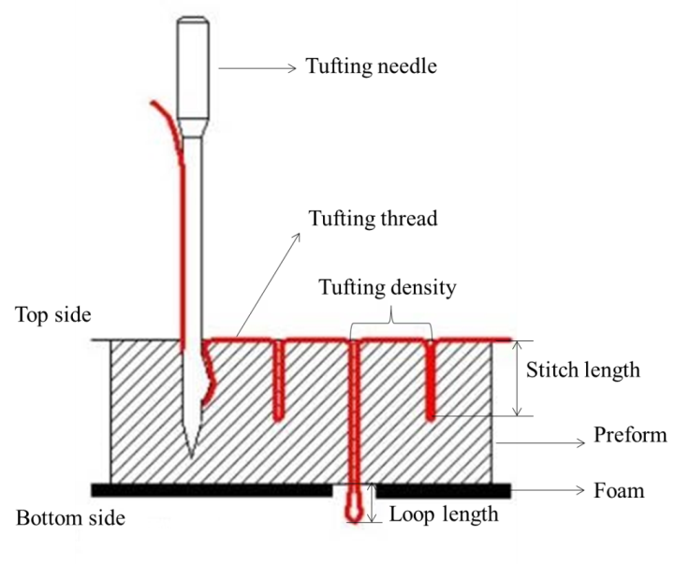

Figure 1. Scheme of the tufting technology.

In order to manufacture tufted preforms, a tufting machine was developed in our laboratory as shown in figure 2. This bench is supplied by a tufting device which is made by a tufting needle with 2 mm of diameter. A presser foot connected to a pneumatic jack which applies a specific pressure on the fabric. Added to that, feeding equipment is integrated to deliver the tufting yarn during the tufting process.

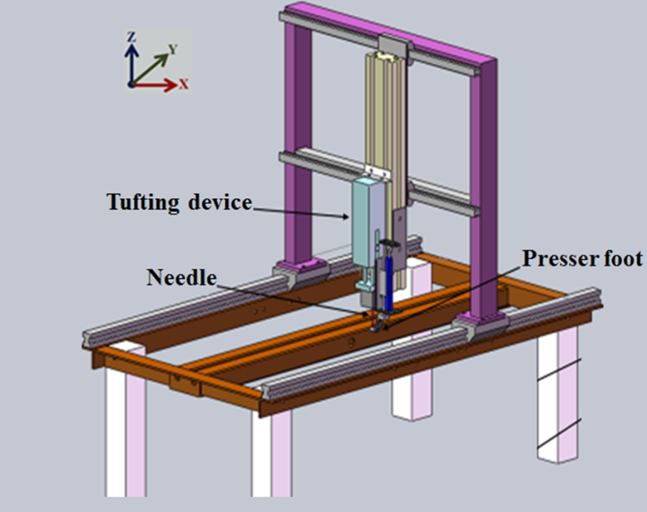

Figure 2. Tufting machine designed in the Gemtex-ENSAIT laboratory.

2.2. Tufted preforms

The main properties of tested specimens in this work are illustrated in table 1. It should be noted that a carbon yarn with a fineness of 2*1K 15S 67Tex was used as a tufting thread.

Table 1. Main properties of tested preforms.

Specimen references | Areal density  (g/m²) | Tufting spacing  (mm) | Tufting  orientation (°) | Number of layers | Scheme
Untufted | 622 | - | - | 4 | -
Tufted 0° | 722 | 10 | 0 | 4 | 
Tufted 90° | 722 | 10 | 90 | 4 | 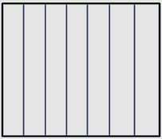
Tufted 0/90° | 778 | 10 | 0/90 | 4 | 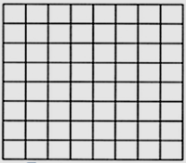

3. Mechanical characterisation

3.1. Experimental tests

In order to improve the understanding of the forming process of the tufted reinforcements, the present study deals with the investigation of the mechanical performances of dry through-the-thickness tufted preforms. The tensile and bending behaviours are particularly characterised and compared with the mechanical behaviours of the untufted preform.

The tensile test was performed using the Instron bench with a speed of 100 mm/min and the test is carried out in the transverse direction (90°). The size of the preforms is about 200 x 50 mm².
Figure 3 (a) shows an example of the back side of tufted 90° preform during the tensile test.

Regarding, the bending behaviour which is performed using the cantilever device, as mention in figure 3 (b), where the sample size is about 80 x 10 mm².
The flexural stiffness is calculated using a specific formula (Ep.1) where M matches with the areal density of the material and C is the experimental flexural length [16].

G [N.m] = M [g/m²] * C³ [m³]. | (1)

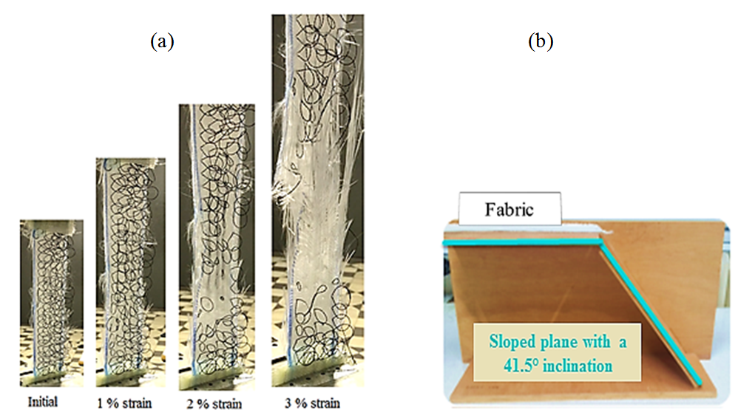

Figure 3. Illustrations of (a): Tensile test, (b): Bending test.

3.2. Analysis of the results

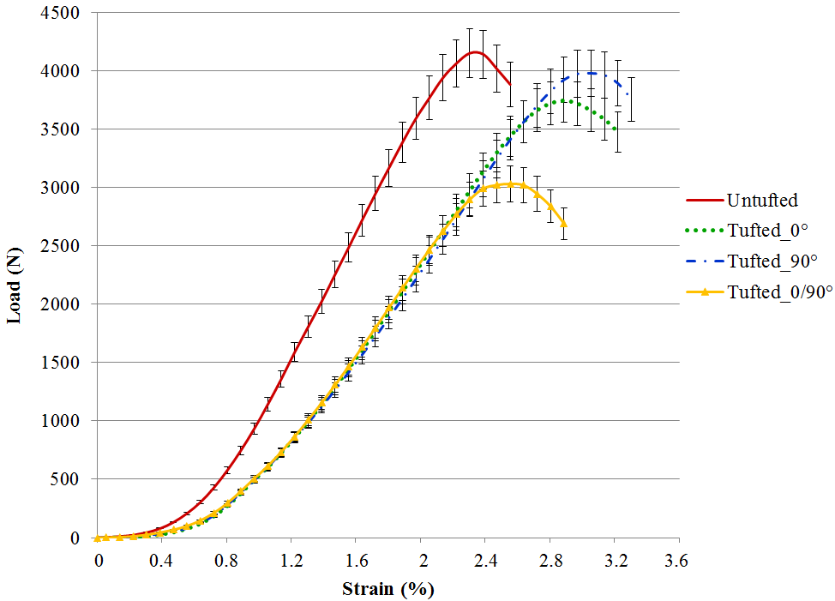

Figure 4. Tensile Load/Strain curves.

Figure 4 illustrates the typical Load/Strain curves of untufted and tufted preforms. The graphs shown are the mean value of five tested specimens for each structure.

It was observed that the tensile load increases in accordance with the strain where the increase of the strain raises the tensile force.
All Load/Strain plots for all samples, independently of the tufting thread orientation, are distinguished by a non-linear aspect at large strain. In addition, the preforms tufted at 0° and 90° present a similar strain at break (≈ 2.9 %) while a homogeneous break for the untufted and tufted 0/90° preforms where the failure strain is around 2.3-2.4 %.

On the basis of these results, it can be noted that the fabric tufted in the same direction as the tensile test, can be marked the better tensile properties in comparison to the other tufted preforms. The maximum load of the tufted 90° is higher than the maximum tensile force of the tufted 0° and 0/90°.

In general, the tensile curve can be divided into three main sections:

- Crimping region: characterised by a similar slope for all the tested specimens where the load increases in function of the strain. In this zone, the load strengthens the material by removing fiber breakage and crimping.
- Elastic response: matches with the increase of the slope. In this section, the fibers are extremely stretched in the loading direction.
- Failure zone: the load decreases in a non-linear trend as the strain increases. In this region, the glass fabric is fully damaged and the loops are swallowed from the preform without generating any fracture of the tufting thread.

The flexural behaviours of the same preforms (as the tensile test) are illustrated in figure 5. This graph shows that through-the-thickness reinforcements influence the bending properties where all tufted specimens present a greater flexural stiffness than the untufted preform. This can be explained by that tufting will tend to reduce delamination and to improve the flexural strength.

It was also observed that the bending stiffness is mainly controlled by the areal density of the fabric where the preform characterised by a higher areal density (tufted 0/90°), is distinguished by the greatest material stiffness.

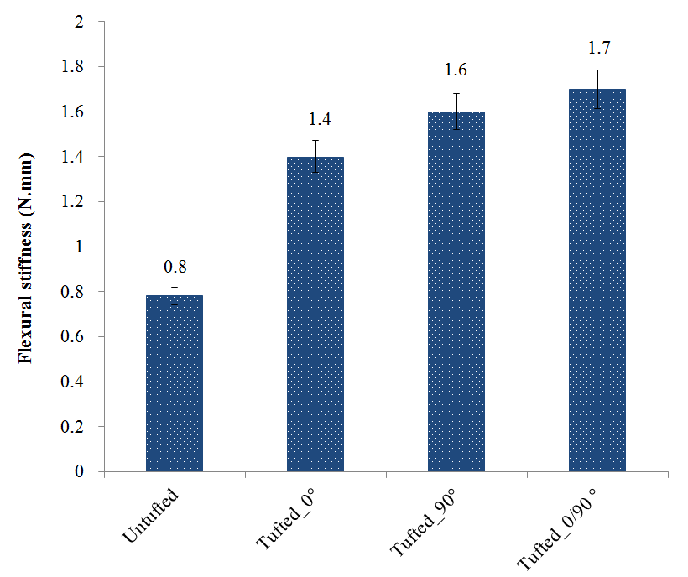

Figure 5. Flexural stiffness of tufted and untufted preforms.

3. Conclusions

This study outlined the influence of the tufting technology on the mechanical behaviour of dry preforms. It was observed that the tuft thread orientation affects significantly the mechanical properties of tufted structures.

The addition of threads through-the-thickness of the laminate may lead to a larger strain at the break where tufting delays the tensile fracture.

However, the flexural behaviour is extremely influenced by the tufting technique where all tufted specimens present a higher flexural stiffness than the untufted sample. Also, the bending properties depend on the areal density of the material where the flexural stiffness increases in function of the areal density.

As a future work, the influence of the tufting parameters, such as the tufting density, the loop length and the pattern, of dry preforms will be deeply studied.

An experimental investigation of the in-plane shear of tufted structures will be examined in order to highlight the preforming behaviour of tufted structures

Acknowledgments

This project is funded by the French National Research Agency (ANR) for the project “COMP3DRE”.

References

- I. Gnaba, X. Legrand, P. Wang and D. Soulat. Through-the-thickness reinforcement for composite structures: A review. Journal of Industrial Textiles, https://doi.org/10.1177/1528083718772299, 2018.
- A. P. Mouritz and B. N. Cox. A mechanistic interpretation of the comparative in-plane mechanical properties of 3D woven, stitched and pinned composites. Composites: Part A, Vol. 41, pp. 709–728, 2010.
- A. P. Mouritz and B. N. Cox. A mechanistic approach to the properties of stitched laminates. Composites: Part A, Vol. 31A, pp. 1–27, 2000.
- A. P. Mouritz, et al. Review of applications for advanced three-dimensional fibre textile composites. Composites : Part A, Vol. 30A, pp. 1445–1461, 1999.
- A. P. Mouritz, et al. A review of the effect of stitching on the in-plane mechanical properties of fibre-reinforced polymer composites. Composites: Part A, Vol. 28A, pp. 979–991, 1997.
- X. Chen, et al. An overview on fabrication of three-dimensional woven textile preforms for composites. Textile Research Journal, Vol. 81, pp. 932-944, 2011.
- A Henao, et al. Mechanical performance of through-thickness tufted sandwich structures. Composite Strutures, Vol. 92, pp. 2052-2059, 2010.
- C. Sickinder et al. Structural Stitching as a Method to design High-Performance. Composites in Future. TechTextil Conference, 2001.
- P. Pérès, et al. Composite behavior of assemblies with AEROTISS® 03S technology. 16th international conference on composite materials, 2007.
- L.S. Liu, P. Wang, X. Legrand, D. Soulat. Investigation of mechanical properties of tufted composites: Influence of tuft length through the thickness. Composite structures, 172:221-228, 2017.
- L.S. Liu, T. Zhang, P. Wang, X. Legrand and D. Soulat. Influence of the tufting yarns on formability of tufted 3-Dimensional composite reinforcement. Composites: Part A, 78: 403-411, 2015.
- G. Dell’Anno, DDR. Cartié, IK. Partridge and A. Rezai. Exploring mechanical property balance in tufted carbon fabric/epoxy composites. Composites: Part A. 38:2366–2373, 2007.
- MC. De Verdiere, AK. Pickett, AA. Skordos and V. Witzel. Evaluation of the mechanical and damage behaviour of tufted non crimped fabric composites using full field measurements. Compos. Sci. Technol. 69:131–138, 2009.
- JWG. Treiber. Performance of tufted carbon fibre/epoxy composites. PhD Thesis, Cranfield University, 2011.
- RA. Saboktakin. Integrity assessment of preforms and thick textile reinforced composites for aerospace applications.PhD Thesis, École de technologie supérieure Université du Québec, 2013.
- E. De Bilbao, D. Soulat, G. Hivet and A. Gasser. Experimental Study of Bending Behaviour of Reinforcements, Experimental Mechanics, 50(3):333-35, 2010.

