IMPROVING INTERLAMINAR STRENGTH OF COMPOSITE LAMINATES BY COATING THE FIBERS WITH CELLULOSE NANOCRYSTALS-BONDED CARBON NANOTUBES

A.V. Kumar¹, A. Budhani², M. Tran³ and A. Asadi⁴

¹Texas A&M University, Department of Mechanical Engineering, College Station, TX, USA
Email: annuatha@tamu.edu
²Texas A&M University, Department of Mechanical Engineering, College Station, TX, USA
Email: anjalibudhani17@tamu.edu
³Texas A&M University, Department of Material Science and Engineering, College Station, TX, USA
Email: minhjerry@tamu.edu
⁴Texas A&M University, Departments of Engineering Technology and Industrial Distribution & Mechanical Engineering & Material Science and Engineering Department, College Station, TX, USA
Email: amir.asadi@tamu.edu

Keywords: Hybrid composites, Interlaminar strength, Cellulose nanocrystals, Carbon nanotube, nanomaterials

Abstract
The objective of this study is to make hybrid carbon fiber reinforced polymer composites with enhanced interlaminar strength using cellulose nanocrystals (CNC) and carbon nanotubes (CNT). We integrated the nanoparticles by coating the carbon fibers through immersion in CNC or/and CNT aqueous suspensions prior to resin infusion in a vacuum-assisted resin transfer molding (VARTM) process. Three types of hybrid CFRP samples are prepared in this work: CNC-coated, CNT-coated and CNC-CNT coated and their interlaminar strength are compared with that of composites with no nanoparticles. The results show an improvement in the interlaminar shear strength of composites coated with 0.2 wt% CNC concentration.

1. Introduction

Carbon-Fiber composites (CFRP) are widely used in industries. These composites can be manufactured by numerous processes amongst which the mostly used ones are out-of-autoclave processes and vacuum assisted resin transfer molding (VARTM) [1–5]. The key limitation of these composites is low interlaminar shear strength (ILSS). Various methods such as stitching [6], z-pinning [7] and 3D weaving [8] have been introduced to provide good interlaminar strength. Carbon Nanotubes (CNT) with their excellent intrinsic properties are a good candidate to stitch the adjacent layers of composites and hence increase the interlaminar adhesion. It has been reported that with significant improvement in mechanical properties, CNT also help in increasing thermal and electrical conductivity of composites [9]. Numerous methods have been introduced to incorporate CNT into polymer matrix, i.e. (i) interleaving [10, 11], (ii) directly introducing CNT into matrix by sonication, shear mixing, extrusion, (iii) integrating a layer of CNT on carbon fibers using chemical vapor deposition (CVD) [12, 13] (iv) conventional approach of spraying or immersing into the suspension [14-17]. Most of these methods, however, are not scalable and particularly cannot prevent agglomeration of CNT when introduced in CFRP composites. In addition, drawbacks such as increased viscosity and decreased wettability in mixing CNT with polymers, reduction of fiber strength and mechanical coherence in CVD due to CF surface damage, and lack of control on depositing locations in spray coating negatively affect the improvement in properties, inter-laminar toughness and multifunctionality of hybrid composites [18].

In this study we introduce a novel scalable technique to incorporate CNT in CFRP composite using CNC. We show that CNC will improve the dispersion and stabilization of hydrophobic CNT in water and thus prevents agglomeration. Then, we coat the carbon fibers with CNC-CNT by passing through an aqueous suspension to create nanostitches between adjacent plies in the hybrid laminates. The results indicate that the composites containing CNC and CNT have higher ILSS compared to that of neat composites.

2. Experimental Details

2.1. Materials

The carbon fiber used in this work is plain woven with 3K tow size and the resin is bicomponent epoxy resin consisting diglycidyl ether of Bisphenol-A epoxy 635 thin epoxy and 556 slow polyamide hardener supplied by US Composites (Wes Palm Beach, FL). The multiwalled CNT (NC7000) was supplied by Nanocyl, Belgium (average diameter of 9 nm and length of 1.5 µm) and the CNC (NCV-100) was purchased from Celluforce (diameter of 2.3-4.5 nm and length of 44-108 nm).

2.2. Sample Preparation

The samples were prepared using eight plies and 65 wt. % epoxy. The CNC, CNT and CNC-CNT concentrations were 0.2 wt.% in an aqueous suspension. The carbon fibers for hybrid composites were coated using a bath filled with aqueous suspension of CNC and/or CNT. The coated fibers were dried for 6 hours before being used in the VARTM process. In the VARTM process, as schematically shown in Fig. 1, the reinforcement (carbon fibers – coated and non-coated) were placed on a mylar (polyester) film. Then, one layer of peel ply was added over the carbon fibers to prevent sticking of the final fabric to the mold and a part of it was on the mold near resin inlet and outlet connectors to direct and increase the resin flow. Infusion mesh was put on the peel ply over the carbon-fiber area to enhance the resin flow. The entire package was enclosed in a vacuum bag and sealed with two-sided butyl tape. Two external hoses were connected to the inlet of the resin source and vent to the vacuum pump. Prior to resin infusion, the inlet was closed and the vacuum pump was turned on to draw the air trapped inside the mold. After establishing the vacuum, degassed resin was infused from the inlet. The excess resin was removed from the vent, led to the catch pot (shown in Figure 2). Then, the inlet was closed, and the vent was left open until the resin was cured. When the resin was cured completely (about 24 h later), the CFRP laminate was removed from the mold. Five samples were cut from each plate using waterjet.

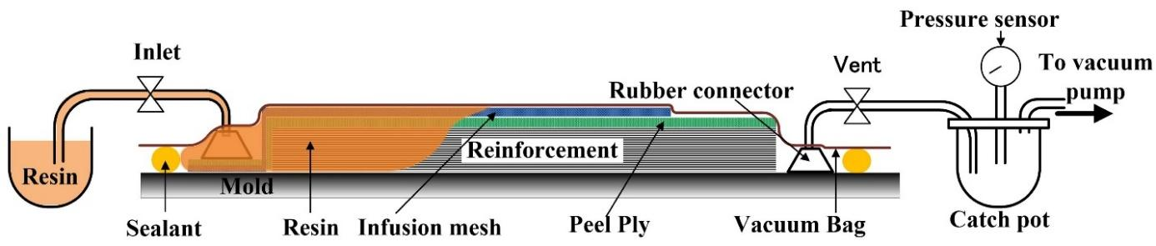

Figure 1. VARTM Setup

To graft carboxyl groups on the CNT walls, we oxidized raw CNT in a 3:1 mixture of H₂SO₄:HNO₃ under sonication at different temperatures and time-periods, namely mild and harsh treatment. For both treatments, initially, 250 mg of raw CNT were added to a concentrated mixture of sulfuric (45 mL) and nitric acid (15 mL) at a 3:1 vol ratio and ultrasonicated in a sonication bath for 2 h at 23 ˚C [19]. In the mild treatment (M-CNT), 190 mL deionized water (DI-H₂O) was added and the suspension was sonicated for another 1 h at 23 ˚C. Two levels of harsh treatments were performed on the CNT acid suspensions; (1) the suspension was stirred in an oil bath for 5 h at 60 ˚C (H-CNT), and (2) 190 mL DI-H₂O was added and the suspension was stirred in an oil bath for 5 h at 60 ˚C (HW-CNT). After oxidation, the CNT were isolated with a polyvinylidene fluoride (PVDF) filter membrane under vacuum and washed four times with DI-H₂O during the filtration process to remove any trace of acid residue.

2.3. Characterization

To evaluate the quality of dispersion, we used Zeta potential (Malvern Zetasizer Nano) that characterizes the surface charge of the molecule in solution at 25˚C. The solution of M-CNT and H-CNT and CNT-CNC suspension was diluted to 0.01 wt.% for all solutions. Each Z-potential value is an average of six measurements. Short beam shear tests were carried out to measure the interfacial shear strength for different batches using ASTM D2344 standard. Each value is an average of five measurements. We also used Fourier transform infrared (FTIR) spectroscopy (Shimadzu IRAffinity-1) to evaluate the bonds between CNT and CNC.

3. Results and Discussion

Fig. 2 visually indicates that the presence of CNC can stabilize the CNT dispersion in water even after one month in contrast to CNT sedimentation in few hours in the absence of CNC. It is noted that in the absence of CNC only H-CNT are stable in water; however, harsh treatment is more energy intensive and possibly damage the walls of CNT due to exposure to acidic environment at higher temperature (60 vs. 23) and duration (5 h vs. 1 h) compared to M-CNT.

(a)
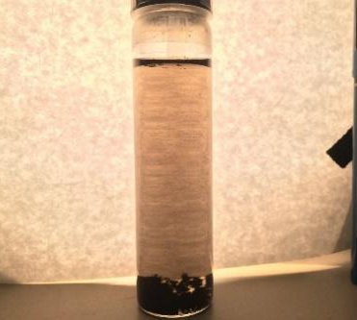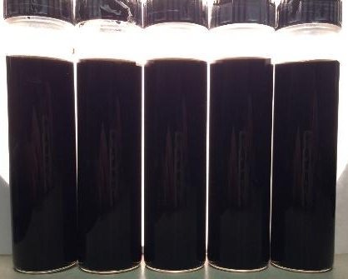
(b)
4:1
3:1
2:1
1:1
1:2

Figure 2. (a) Multi-walled CNT in water after 3 h, (b) CNC-CNT in water
after one month (CNT: CNC mass ratio is shown on the vials).

Zeta potential values of CNT in water with and without CNC suggest that the presence of CNC causes intermolecular rearrangement that leads to better dispersion and stability, as shown in Table 1.

The FTIR spectrum of CNC-CNT dispersion is shown in Fig. 3 for M-CNT and M-CNT: CNC (1:1). The FTIR scan of pristine CNT (as received) were subtracted from background of both plots to smoothen the baseline. Introducing CNC in the aqueous suspension of CNT created =C−H bending, C−O and C=O stretching, C−C skeletal vibrations, −C−H (O−C−H) bending, C=O=C and O=C=O stretching and C−H stretching due to formations of new hydrogen bonding. The strong O−C−H bending (1400-1500 cm-1), C−H stretching (2850-3000 cm-1) and C−O (1000-1300 cm-1) and C=O (1700 cm-1) stretching ester bonds imply a potential interaction between −OH groups on CNC and –COOH groups on partially treated M-CNT. These results are in concert with the results obtained by Liu et al. [20]

Table 1. Zeta potential values for different CNT: CNC mass ratios (1mg/mL) at room temperature.

Specimen Type | Z- Potential (mV))
CNC | -47.77 ± 1.3
M-CNT | -32.50 ± 1.2
H-CNT | -37.27 ± 0.9
M-CNT: CNC (4:1) | -49.07 ± 0.2
M-CNT: CNC (3:1) | -51.75 ± 0.5
M-CNT: CNC (2:1) | -52.87 ± 0.2
M-CNT: CNC (1:1) | -54.90 ± 0.7
M-CNT: CNC (1:2) | -55.05 ± 0.5

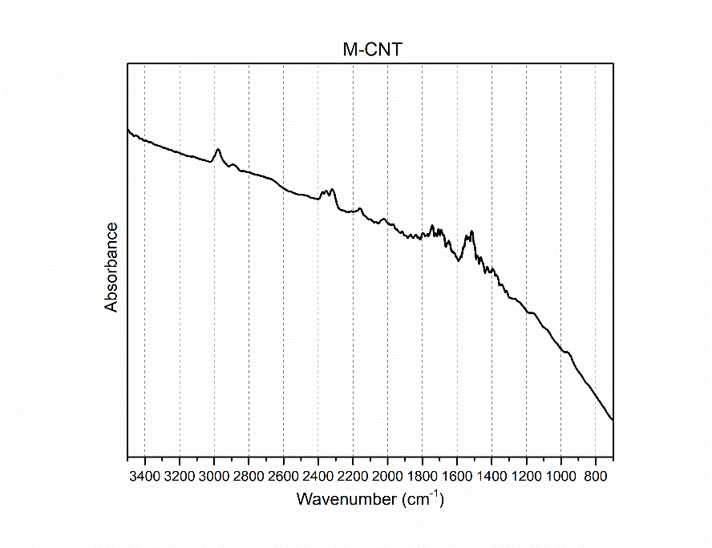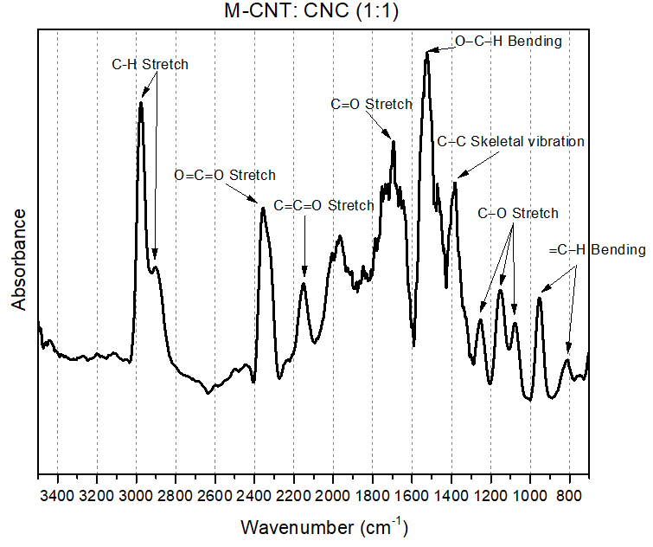
(b)
(a)
Figure 3. (a) FTIR spectra of M-CNT and M-CNT: CNC (1:1)

The ILSS values for different composites are presented in Fig. 4. The composites coated with 0.2 wt.% CNC shows ~14% higher ILSS compared to that of neat composites indicating the effectiveness of CNC in creating nanostitches. The ILSS for composites coated with 0.2 wt.% CNT and 0.2 wt.% CNC-CNT do not show any improvement considering the statistical variations. As we have only tested one concentration, i.e. 0.2 wt.%, it is plausible that a lower concentration is an optimum value for CNT and combination of CNC-CNT. We are currently characterizing the composites with various CNC and CNT concentrations. It is noted that the reported concentrations for CNC and CNT are the weight fraction in water that used in the immersion and coating process.

4. Conclusions

The results show that CNC can stabilize the dispersion of CNT in water. The suggested technique can be used as a scaling up solution for integrating CNT in composites. We showed that hybrid composites containing carbon fibers coated with CNC and CNT have higher ILSS compared to the neat composites. In addition, hybrid composites containing only CNC show better ILSS improvement. More tests at different concentrations are required to determine the optimum CNC-CNT concentration.

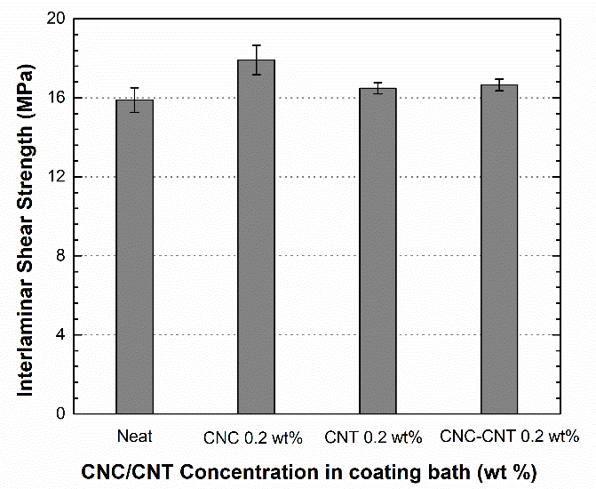

Figure 4. ILSS values for different hybrid composites

References
[1] Bakis, C.E., et al., Fiber-Reinforced Polymer Composites for Construction—State-of-the-Art Review. Journal of Composites for Construction, 2002. 6(2): p. 73-87.
[2] Pendhari, S.S., T. Kant, and Y.M. Desai, Application of polymer composites in civil construction: A general review. Composite Structures, 2008. 84(2): p. 114-124.
[3] Mouritz, A.P., et al., Review of Advanced Composite Structures for Naval Ships and Submarines. Vol. 53. 2001. 21-42.
[4] Phil, E., and Costas Soutis, eds. Polymer composites in the aerospace industry. No. 50. Elsevier, 2014..
[5] Lewis, D. and B.L. Wardle, Interlaminar Shear Strength Investigation of Aligned Carbon Nanotube-Reinforced Prepreg Composite Interfaces, in 56th AIAA/ASCE/AHS/ASC Structures, Structural Dynamics, and Materials Conference. 2015, American Institute of Aeronautics and Astronautics
[6] Tong, L, Sun, X, Tan, P. Effect of long multi-walled carbon nanotubes on delamination toughness of laminated composites. J Compos Mater 2008; 42: 5–23
[7] Mouritz, A.P., Review of z-pinned composite laminates. Vol. 38. 2007. 2383-2397
[8] Mouritz, A.P., et al., Review of applications for advanced three-dimensional fibre textile composites. Composites Part A: Applied Science and Manufacturing, 1999. 30(12): p. 1445-1461.
[9] Wang, B.-C., X. Zhou, and K.-M. Ma, Fabrication and properties of CNTs/carbon fabric hybrid multiscale composites processed via resin transfer molding technique. Composites Part B: Engineering, 2013. 46: p. 123-129
[10] White, K.L. and H.-J. Sue, Delamination toughness of fiber-reinforced composites containing a carbon nanotube/polyamide-12 epoxy thin film interlayer. Polymer, 2012. 53(1): p. 37-42.
[11] Zhou, H., et al., Delamination toughening of carbon fiber/epoxy laminates by hierarchical carbon nanotube-short carbon fiber interleaves. Composites Science and Technology, 2017. 140: p. 46-53.
[12] Marcos, F., Tzounis, L., Sacco, L., Stamm, M. Candal, R., Rubiolo G.H., and Goyanes, S. "Carbon nanotubes grown on carbon fiber yarns by a low temperature CVD method: A significant enhancement of the interfacial adhesion between carbon fiber/epoxy matrix hierarchical composites." Composites Communications 3 (2017): 33-37.
[13] Richard, L., Lachman, N., Florin, P., Wagner, D., and Wardle, B.L. "Hierarchical carbon nanotube carbon fiber unidirectional composites with preserved tensile and interfacial properties." Composites Science and Technology 117 (2015): 139-145.
[14] Chandrasekaran, V.C.S., Advani S.G., and Santare, M.H., Role of processing on interlaminar shear strength enhancement of epoxy/glass fiber/multi-walled carbon nanotube hybrid composites. Carbon, 2010. 48(13): p. 3692-3699.
[15] Jingjing, Q., Zhang, C., Wang, B. and Lianget, R. Carbon nanotube integrated multifunctional multiscale composites. Nanotechnology, 2007. 18(27): p. 275708.
[16] Asadi, A., Miller, M., Moon, R.J. and Kalaitzidou, K. "Improving the interfacial and mechanical properties of short glass fiber/epoxy composites by coating the glass fibers with cellulose nanocrystals." Express Polymer Letters 10, no. 7 (2016): 587.
[17] Asadi, A., Miller, M., Sanzida, S., Moon, R.J. and Kalaitzidou ,K.. "Introducing cellulose nanocrystals in sheet molding compounds (SMC)." Composites Part A: Applied Science and Manufacturing 88 (2016): 206-215.
[18] Lubineau G, Rahaman A. A review of strategies for improving the degradation properties of laminated continuous-fiber/epoxy composites with carbon-based nanoreinforcements. Carbon. 2012;50(7):2377-2395.
[19] S.A. Hawkins, H. Yao, H. Wang, H.J. Sue. Tensile properties and electrical conductivity of epoxy composite thin films containing zinc oxide quantum dots and multi-walled carbon nanotubes, Carbon, 115:18-27, 2017.
[20] Liu, Y., et al., Aqueous Dispersion of Carbon Fibers and Expanded Graphite Stabilized from the Addition of Cellulose Nanocrystals to Produce Highly Conductive Cellulose Composites. ACS Sustainable Chemistry & Engineering, 2018. 6(3): p. 3291-3298.

