Strength and fracture toughness of oxide-fibre/molybdenum-matrix composites
S.T. Mileiko
Institute of Solid State Physics of Russian Academy of Science, Chernogolovka Moscow distr., Russian Federation, mileiko@issp.ac.ru

Composites with molybdenum matrix and three types of oxide fibres in the Al₂O₃-Y₂O₃ system are obtained. Those fibres are yttrium aluminim perovsckite YAlO₃ (YAP), yttrium aluminium monoclinic Y₄Al₂O₉ (YAM), and YAG-YAM eutectic. Mechanical testings of the composites have shown that (i) the composites are sufficiently strong at high temperature, up to 1400ºC; (ii) critical strength intensity factor measured for all the composites is reaching values 25 – 30 MPa∙m^{½} ; (iii) The average values of notch sensitivity is about 0.7. Obviously, it is possible to enhance fracture properties of the composites by using for the matrix appropriate molybdenum alloys.

Introduction
The present high temperature alloys used in severe conditions of loading in detrimental environments are based on nickel and this sets a limit for the use temperature of about 1100^{о}С. Aerospace and energy technologies of near future require urgently an enhance in the use temperature of materials up to, at least, 1300^{о}С. Niobium and molybdenum alloys to satisfy this requirement have been developing on the base of known fundamental knowledge on alloys strengthening and this makes limitations caused by a rather low fracture toughness of high strength alloys [,,]. The result is a limit to a strengthening degree and, finally, to the use temperature. This is a usual correlation between strength and fracture toughness of metal alloys [,].
Metal matrix composites reinforced with strong and brittle fibres are characterised by simultaneous increase in their strength and fracture toughness with an increase in fibre volume fraction provided they are designed in an appropriate way [4,]. Real composites demonstrate synergetic effects [], one of which is an effect of reinforcing fibres of special chemical compositions on the oxidation resistance of molybdenum matrix. In fact, the fibres containing, for example, yttrium decrease the oxidation rate of the molybdenum matrix by orders of the magnitudes [,] as a result of the formation of yttrium molybdates on the surface of a composite specimen. Hence, a study of high temperature strength and fracture toughness of oxide-fibre/molybdenum-matrix composites becomes that of a practical importance. In the present paper, we present some results of this study obtained in the last two years in deatls.

Fabrication of composite specimens
Composite specimens were obtained by the internal crystallisation method (ICM) [4,]. The ICM for producing oxide-fibre/molybdenum-matrix composites consists of three main steps. First, a molybdenum carcass with continuous channels is prepared by the diffusion bonding of an assembly of molybdenum wire and foil. The process is performed in such a way as to prevent the gaps between neighbouring fibres being filled with the foil material. Consequently, the channel cross-section is formed by two planar and two concave lines; this is the shape of the resulting fibres. Then, the carcass is infiltrated with an oxide melt driven by capillary force. The 3rd step is crystallising the melt to form fibres in the channels of the molybdenum carcass by pulling the block up into the cold zone of the furnace. An example of the microstructure of the composites obtained by the ICM is presented in Figure 1.

Method of testing composites
Original composite specimens were produced with a shape shown schematically in Figure 2a. Their size was ~5 Χ 15 Χ 65 mm³. The specimens were used at first for measuring values of critical stress intensity factor K*. Two parts of a specimen obtained as a result of fracture test were cut along their length as shown in Figure 2b to make 6 sub-specimens to be used in testing to measure the bending strength at room and high temperatures.

Figure 1. SEM micrograph of a cross-section of the composite. The “black” phase is yttrium aluminium perovskite YAlO₃ (YAP), the “grey” one is Y₄Al₂O₉.

(a) | (b)
Figure 2. (a) A specimen for measuring the value of the critical stress intensity factor and strength of the notched specimen. (b) Schematic of cutting the specimen shown at the left side to make six sub-specimens for measuring composite strength (unnotched specimens).
The value of critical stress intensity factor K* were measured by testing single-edge notched bend (SENB) specimens shown schematically in Figure 2a similar to those developed for metal alloys according to ASTM-399. The values of K* were calculated by using the approximation recommended by ASTM-399:
$$K^{*}=\frac{3QLc^{1/2}}{2h^{2}w}Y\left(\frac{c}{h}\right)$$
where
$$Y=\left[1.96-2.75\frac{c}{h}+13.66{\left(\frac{c}{h}\right)}^{2}-23.98{\left(\frac{c}{h}\right)}^{3}+25.22{\left(\frac{c}{h}\right)}^{4}\right].$$
Here L is distance between the supports, c is notch length, h and w are height and width of the specimen, respectively. These sizes in the present experiments are L ≈ 60 mm, h ≈ 15 mm, w ≈ 5 mm, c ≈ (0.45 – 0.55)h. The value of Q corresponds to a maximum load.
This test gives also the strength value of a notched specimen, $σ_{N}^{*}$. Normally, sub-specimens 2 and 5 were tested at room temperature to obtain the value of strength of un-notched specimen. Since the microstructure and strength of the fibres can change along the length of the original specimen, in what follows the average of the strength values of sub-specimens 2 and 5 will be used as the strength $σ_{0}^{*}$ of un-notched specimen. Hence, ratio ${σ_{N}^{*}}/{σ_{0}^{*}}$ is the notch sensitivity of a composite. Note that the value of K* for really tough composites can hardly be used in calculations of ultimate loading of a composite structural element containing a defect following procedures of linear fracture mechanics (LFM) since fracture processes in such composites do not localised in a small volume at the front of the crack tip as it happens in metallic elements. Fracture zone in composites can be too large to accept hypothesises of LFM [4,6]. So it would be appropriate to call the value of K* determined by the method described above as apparent critical stress intensity factor. On the other hand, the value of notch sensitivity can be used for comparison of various composite materials only.

Results and discussion
We choose for these tests composites reinforced with some complex oxides in the Al₂O₃-Y₂O₃ system. At least two reasons make this choice sensible. First, the presence of yttrium can provide an enhanced oxidation resistance of the composites [8,9]. Secondly, the system contains a number of the oxides and only sapphire and garnet fibres as well as their eutectic have been studied in the fibrous form. Special features of the composite fabrication process and microstructure of the composites will be publishes elsewhere, here we present results of mechanical testing.
Four types of the fibres to reinforce the molybdenum matrix were used:
- Yttrium aluminim garnet Y₃Al₅O₁₂ (YAG)
- Yttrium aluminim perovsckite YAlO₃ (YAP)
- Yttrium aluminium monoclinic Y₄Al₂O₉ (YAM)
- YAG-YAM eutectic.
The YAG fibres are rather well-known, all other oxides as fibres were obtained and studied for the reinforcements for the first time, at least for the author’s knowledge.
First of all, it should be noted that the composite specimens were obtained by the internal crystallisation method [4], in which the matrix was undergone to heating above the melting point of an oxide; hence, molybdenum occurred to be fully recrystallised in the process. The temperature dependence of the matrix strength is presented in Figure 3. Recrystallisation causes embrittleness of molybdenum, the value of critical strength intensity factor of the matrix is very low, less than 10 MPa·m^{½}. A dependence of mechanical properties of composites on fibre crystallisation rate is to be expected, so in the present experiments crystallisation rate was 2 – 10 50 – 250 mm/min. Fibre volume fraction in the composites was 0.35 – 0.40.
  - Strength properties
All experimental points obtained in testing YAP-based-fibre/Mo-matrix composites at temperatures up to 1400ºC are plotted in Figure 4a. Comparing these data with the temperature dependence of the matrix strength of (Figure 3) one can see that the contribution of the fibre into the composite strength at room temperature is not essential. A reason for that is a combination of a strong scale dependence of the ICM-fibre strength [10] and low matrix strength that yields a large critical fibre length and rather low effective fibre strength in the composites [4]. To reveal a possible dependence of the fibre strength on its crystallisation rate the data presented in Figure 4a are replotted in Figure 4b. No noticable dependence of the composite strength on crystallisation rate of the reinforcing fibre can be seen. The same is true with regard to the YAG-fibre/Mo-matrix composites, Figure 5.

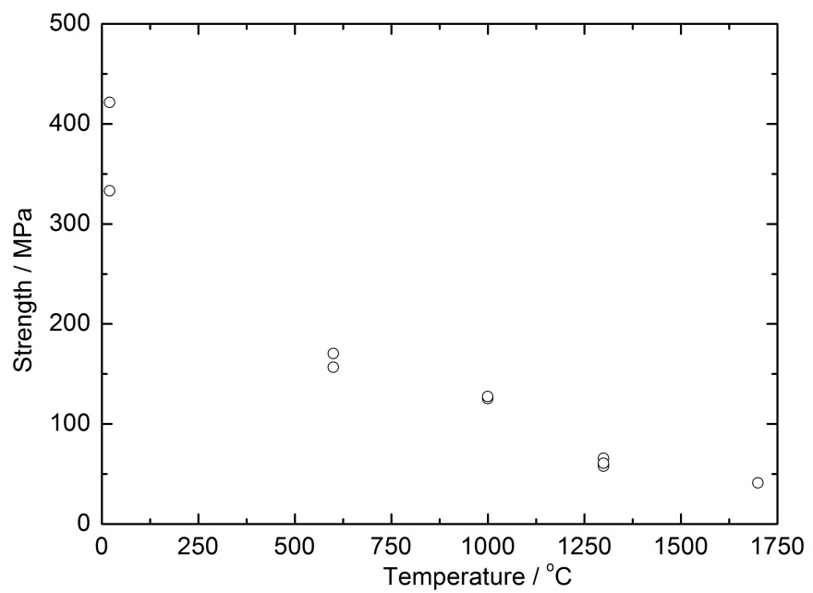
Figure 3. Temperature dependence of the molybdenum matrix strength.
Room temperature strength of YAM-fobre/Mo-matrix composites is low than that of the composites just mentioned (Figure 6). However, adding YAG-component to YAM to crystallise the eutectic fibre (actually, the fibre has a nealy eutectic composition as the eutectic point on the published phase diagrams is determined just approximately) increases the composite strength essentially. Taking into account all the data in Figure 6 gives the composite strength equal to 600±63 MPa, a value a bit higher than those obtained in testing composite of the three other types listed above.
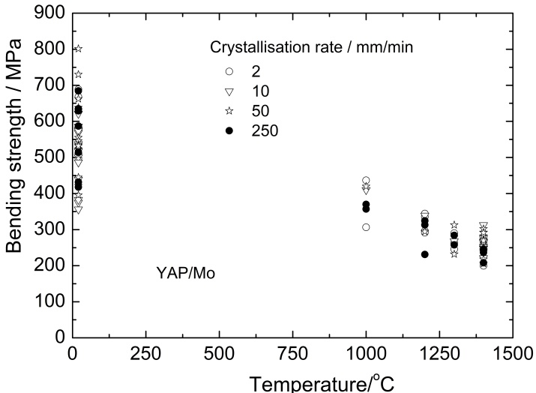 | 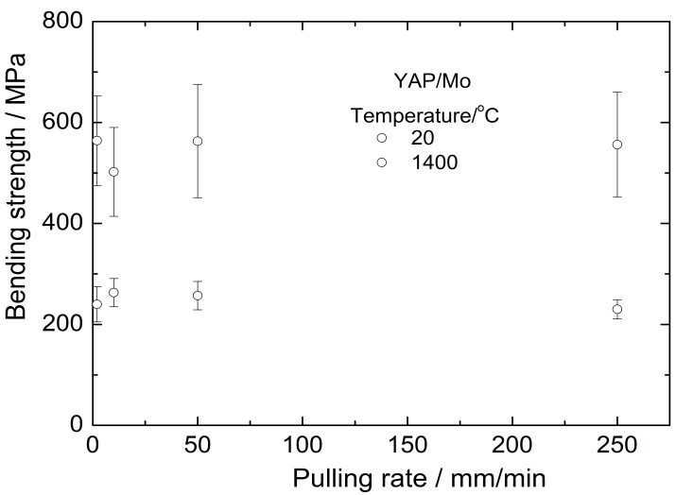
(a) | (b)
Figure 4. (a) Temperature dependence of strength of YAP-based-fibre/Mo-matrix composites. (b) Composite strength versus crystallisation rate of the reinforcing fibres.
The values of the apparent critical stress intensity factor correlate with notch sensitivity of the composites, Figure 8. The notch sensitivity of three types of the composites determined on the bases of all data presented in Figure 8 is described in Table 1. It can be seen that (i) the data are characterised by large scatter caused by various fabrication parameter of the composites and, perhaps some other factors; (ii) the average values of notch sensitivity is about 0.7. Still, it is possible to enhance fracture properties of the composites by using for the matrix appropriate molybdenum alloys.
  - Fracture toughness and notch sensitivity
Much more interesting data were obtained in measuring fracture characteristics of the composites. The dependence of apparent critical stress intensity factor K* on the fibre crystallisation rate is presented in Figure 7. It can be seen that introducing brittle fibres into metal matrix of low fracture toughness leads an essential increase in the value of K*. The largest increase is observed in the case of composites with YAP and YAM-YAG fibres. The latter can be determined by a composite microstructure of the fibre. It is also important to note that the dependence of K* on the eutectic fibre crystallisation rate has a maximum corresponding to the rate of about 10 mm/min.
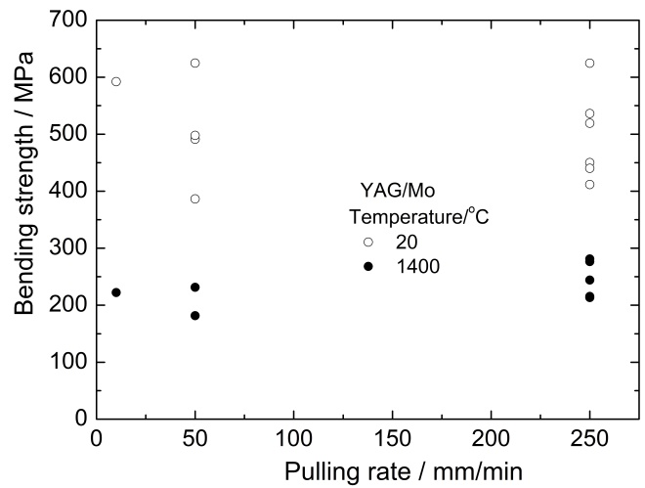 | 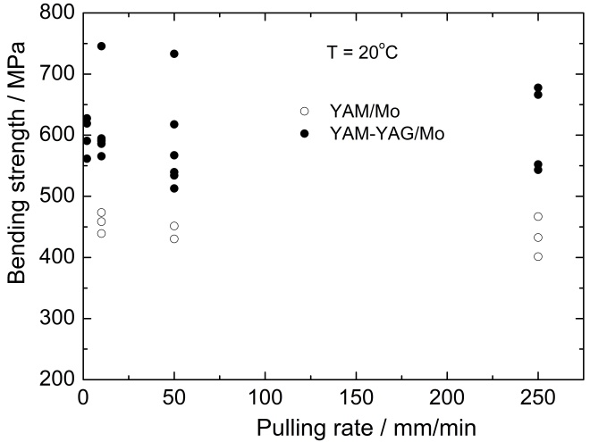
Figure 5. Room and high temperature strength of YAG-fibre/Mo-matrix composites versus crystallisation rate of the reinforcing fibres. | Figure 6. Room and high temperature strength of YAM-fibre/Mo-matrix and YAM-YAG-eutectic fibre/Mo-matrix composites versus crystallisation rate of the reinforcing fibres.
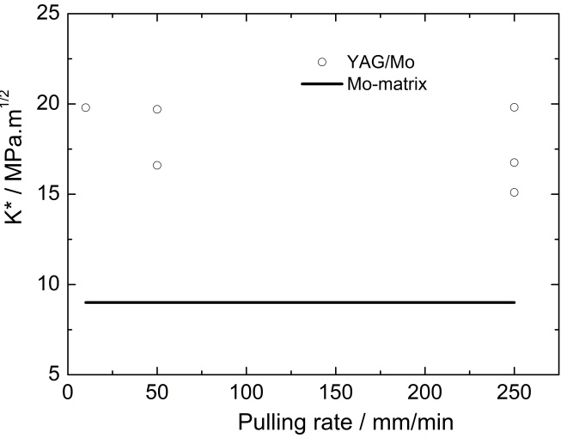 | 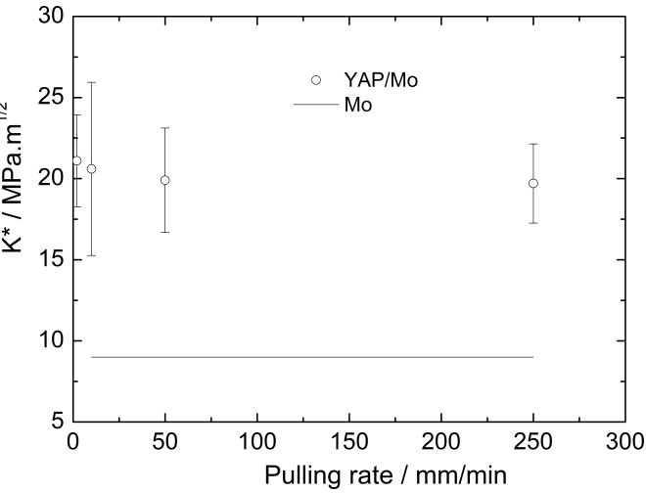
(a) | (b)
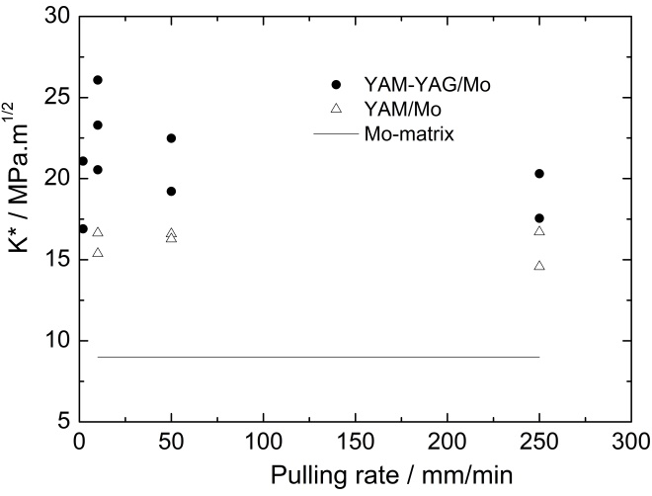
(c)
Figure 7. Apparent critical stress intensity factor of the composites versus crystallisation rate of the reinforcing fibres.

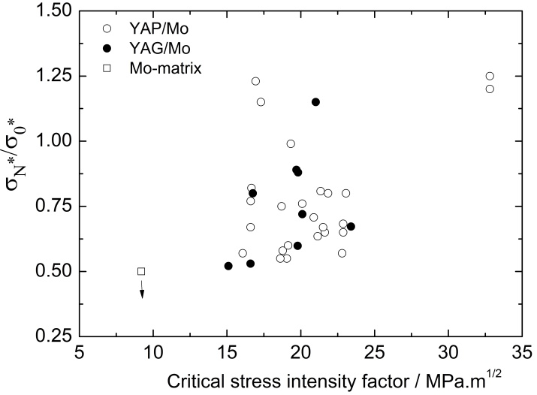 | 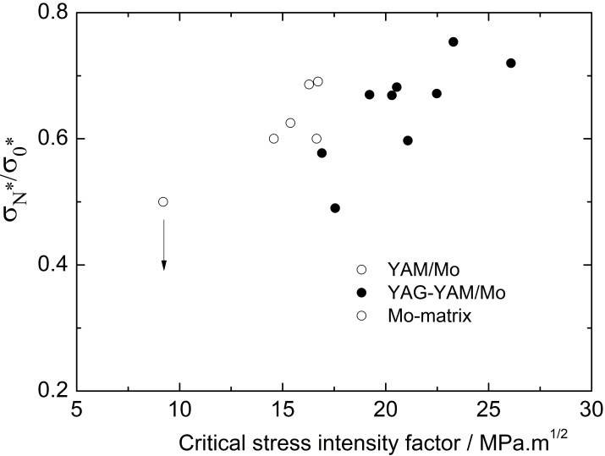
(a) | (b)
Figure 8. Correlation between apparent critical stress intensity factor and notch sensitivity of the composites.
Table 1. Characteristics of the notch sensitivity of the composites
Reinforcing fibre | Notch sensitivity
 | Mean value | Standard deviation
YAP | 0.777 | 0.218
YAG | 0.751 | 0.203
YAM-YAG | 0.647 | 0.080

Conclusions
- For the first time, composites with molybdenum matrix and three types of oxide fibres in the Al₂O₃-Y₂O₃ system are obtained. Those fibres are yttrium aluminim perovsckite YAlO₃ (YAP), yttrium aluminium monoclinic Y₄Al₂O₉ (YAM), and YAG-YAM eutectic.
- The composites are sufficiently strong at high temperature, up to 1400ºC.
- Critical strength intensity factor measured for all the composites is reaching values 25 – 30 MPa∙m^{½},which is much higher than those for high temperature molybdenum alloys now under development.
- The average value of notch sensitivity is about 0.7.
- Obviously, it is possible to enhance fracture properties of the composites by using for the matrix appropriate molybdenum alloys. The author’s team is now working in this direction.
Aknowledgements
The author gratefully acknowledges the funding by Russian Science Foundation, Project # 16-19-10624. Special thanks to the author’s colleagues participating actively in the fabrication and testing the composites, N. A. Prokopenko, A.A. Kolchin, A.Ya. Mizkevich, V.A. Chumichev, and S.A. Abashkin.

R. Tanaka at al., Research and development of niobium-based superalloys for hot components of gas turbines, In Proceedings of the International Gas Turbine Congress 2003, Tokyo
J.A. Lemberg et al., Intermetallics, 20 (2012) 141-154.
M. Krüger et al., Intermetallics 48 (2014) 10-18.
S.T. Mileiko, Metal and Ceramic Based Composites, Elsevier, Amsterdam, 1997.
R.O. Ritchie, Nature Materials,10 (2011) 811-822.
S.T. Mileiko, Composites Part B 116 (2017) 1-6.
S.T. Mileiko, Composites and Nanostructures, 2015, 7, 191-206 (in Russian)
S.T. Mileiko and N.I. Novokhatskaya, Composites and Nanostructures, 2012, # 4, 5-14 (in Russian).
S.T. Mileiko and N.I. Novokhatskaya, J. Mater. Eng. Perform. 24 (2015) 2836-2840.
S.T. Mileiko ST, Composites and Nanostructures, 2009, #1,6-37 (in Russian).

