CHARACTERIZATION OF AN UV-LASER TREATMENT PROCESS FOR ADHESIVE BONDING OF CFRP

B. Rauh¹, S. Kreling², M. Geistbeck¹, K. Dilger²

¹Central Research & Technology, Airbus, Munich, Germany
Email: benedikt.rauh@airbus.com, Web Page: http://www.airbus.com
²Institute of Joining and Welding, Technische Universität Braunschweig, Braunschweig, Germany
Web Page: http://www.ifs2.tu-braunschweig.de

Keywords: laser; surface treatment; ultra violet; adhesive bonding; cfrp; cleaning; composites; release agents

Abstract
In aerospace industry, composite materials allow advanced lightweight designs. Adhesive bonding as joining technology would offer new perspectives in this development. Due to surface contaminations that remain on composite surfaces after demoulding, pre-treatment of these surfaces is necessary to allow robust bonding. In this study, the influence of an UV-laser cleaning process onto CFRP surfaces was investigated. A previously developed model for a cleaning process that removes the release agent contamination by ablating a thin epoxy layer underneath was supported by measuring and characterizing the generated particles. One purpose of this development was to ensure resin material remains on the surface to cover the carbon fibres. X-ray photoelectron spectroscopy (XPS) investigations of laser treated resin material and carbon fibre samples, demonstrated the advantage of this approach. The positive impact on adhesive bonding was proven by single lap shear tests.

1. Introduction

Aerospace lightweight developments are driven by the reduction of kerosene consumption and with that the reduction of CO₂ or equivalent exhaustion gases. Furthermore, lowering the structural weight allows the extension of possible flight ranges. These developments are based on using the right materials for the right application. Mix-material concepts are widely used in modern aerospace products whereas adequate joining technologies are still under investigation. In this context adhesive bonding promises reduced weight compared to metal fasteners as well as reduced crack initiation in the substrate structure especially if one joining partner is made of CFRP [1,2]. Due to the use of release agents in the CFRP manufacturing process, adhesive bonding needs surface preparation before the adhesive can be applied [3–6]. In recent years several approaches were made to use laser irradiation to prepare the CFRP surface for the bonding procedure. Thermoset resins revealed a low laser ablation threshold [7], which led to a determined examination of ablating the resin in order to expose and directly bond on the carbon fibres [8,9]. This approach allows it to introduce the load directly into the stiff fibre layers but also showed the tendency to generate delamination failure [3]. Recent investigations focused on the removal of the production contaminations without exposing the fibres [4,10]. CFRP surface with a smooth cleaning treatment showed higher shear strengths than CFRP surfaces with exposed fibres [4,11]. A cleaning model was presented that is based on different absorption behaviours of the contamination and the matrix resin (Figure 1). In this model the laser irradiation is transmitting the contamination layer and sublimates the resin material underneath which leads to a vapour bubble. Several laser pulses increase the temperature as well as the pressure in this bubble and lead to an explosive removal of the covering contamination layer (SEM micrographs are shown on Figure 2). In this research paper experimental results on the laser ablation dust will be presented that support this cleaning model. Furthermore, the approaches of exposing the fibres and of cleaning the surface without exposing the fibres will be discussed in the context of XPS measurements of laser treated epoxy base material and carbon fibres.
Step 1 | Step 2 | Step 3 | Step 4
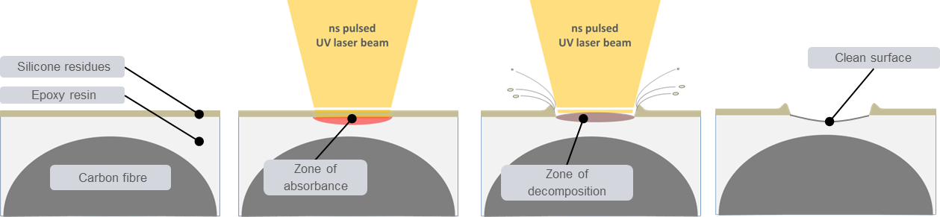
Figure 1. Model of the ns-pulsed UV laser cleaning process with wavelengths less than 320 nm [4]
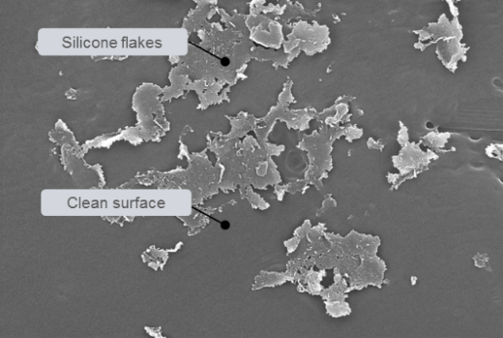  1 µm | 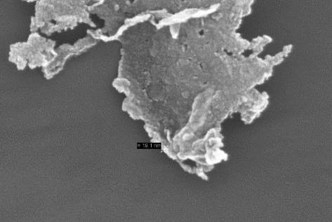  200 nm
Figure 2. Si-based contamination is ablated via silicone flakes [4]

2. Experimental

2.1. Materials

For the laser ablation dust investigation YSH70A carbon fibres from Mitsui in an LY556/HY906/DY062 epoxy resin material were used. The semi-permanent release agent Frekote 44-NC from Henkel that is based on a reaction product of PDMS and TMAS was used to allow demoulding from the metallic moulds.

For the comparison between removal model and fibre exposure M60JB carbon fibres from Toray and L20/EPH960 epoxy resin were used. For single lap shear tests eight uni-directional layers were oriented in quasi-isotropic set-up with 0° top-layers and 1.6 mm overall thickness. For these samples the adhesives EA9321 Aero from Henkel Loctite was used and 1 wt.% of glass bowls with 75-150 µm diameter added to adjust the bondline thickness.

2.2. Surface analytics

Scanning electron microscopy (SEM)
A JEOL JSM-6320 and Zeiss Auriga field-emission scanning electron microscope (SEM) with an acceleration voltage of 15 kV was used to evaluate surface morphologies.

X-ray photoelectron spectroscopy (XPS)
The Quantum 2000 Scanning ESCA Microprobe from Physical Electronics Inc. has a beam diameter of 200 µm and allows the detection of all elements with an atomic number of 3 and above.

Energy-dispersive x-ray spectroscopy (EDX)
Based on SEM micrographs chemical compositions of specific areas were determined using EDX scans. The analysis was performed with Oxford Instruments Aztec 2.2 SP2 and an X-Max 50 detector.

2.3. Particle measurement

A polycarbonate track-etch filter with 200 nm holes in combination with an extraction nose was positioned approx. 20 mm besides the CFRP sample during laser treatment. Figure 3 shows the measurement setup which allows the collection of the dust, generated in the laser process. The surface of the filter is investigated via SEM after laser treatment.

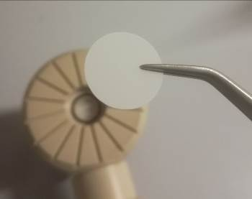 | 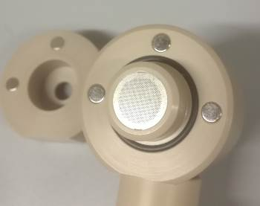 | 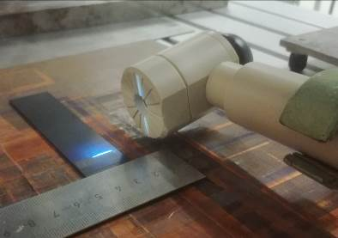
a) | b) | c)
Figure 3. Measurement equipment for ablated particles: a) track-etch filter; b) extraction nose with magnetic fixture to clamp track-etch filter; c) positioning during laser treatment

Additionally, the particle measurement device Abakus® mobil air from Markus Klotz GmbH was used to detect the particle distribution in the laser dust. This device works with the 90° scattered light method and determines particle sizes from 0.3 µm to 10 µm. Figure 4 shows that four different setups were investigated in order to examine the influence of extraction onto the redeposition during the laser process.

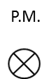 | 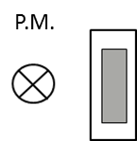 | 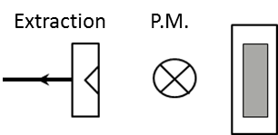 | 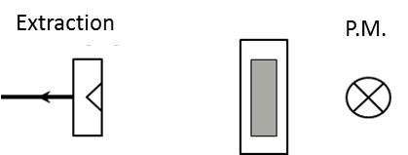
a) | b) | c) | d)
Figure 4. Setup for the particle measurement (P.M.): a) measuring in atmosphere in the test environment; b) measuring the particles in 20 mm distance to the sample without extraction;
c) measuring the particles in the extraction current (20 mm distance to the sample and 30 mm to the extraction);
d) measuring the particles in 20 mm distance to the sample with extraction (50 mm distance)

2.4. Laser surface treatment

Investigations by the authors regarding the light absorbance of epoxy material and of Si-based release agent showed that laser irradiation with wavelengths below 320 nm is most suitable to treat CFRP surfaces [4]. It allows ablation of resin material very shallow to the surface [4]. In this study a ns-pulsed UV laser system from Coherent Inc. is used with 266 nm wavelength. Table 1 lists the laser parameters that were used in this investigation.

Table 1. Laser parameter definition
Parameter  [-] | Frequency  [kHz] | Pulse duration  [ns] | Scanning speed [mm/s] | Average power  [%]
LP, 100 % | 30 | 20 | 450 | 100
LP, 75 % | 30 | 20 | 450 | 75
LP, 50 % | 30 | 20 | 450 | 50
LP, 25 % | 30 | 20 | 450 | 25
LP, 19 % | 30 | 20 | 450 | 19
LP, 12.5 % | 30 | 20 | 450 | 12.5
LP, 6.25 % | 30 | 20 | 450 | 6.25

2.5. Single lap shear (SLS)

Single lap shear tests were conducted acc. to DIN EN 1465 with sample dimensions of 100 mm x 25 mm. To evaluate the failure criteria, the following criteria explanations (acc. to DIN ISO 10365, additional CSF-resin, CSF-fibre added) were used:
AF = Adhesion failure
CF = Cohesive failure in the adhesive
CSF-fibre = Fibre tear out
CSF-resin = Inter-resin failure or interface resin-fibre failure

3. Results and discussion

3.1. Particle removal process

Figure 5 shows SEM images of the track-etch filter surface before and after extraction of the laser dust. In the initial state a smooth surface with homogeneous 200 nm holes can be observed. After filtering the dust different particles cover the surface. In general, there are two types of particles noticeable: very small globular shaped particles (< 50 nm) and bigger particles (> 200 nm) with sharp edges which look like breaking edges. The SEM area of the filter after extraction was additionally examined with EDX. The element distribution reveals a significant accumulation of silicon at the bigger particles. This result indicates that the bigger particles are residues of the silicone based release agent of the CFRP surface.

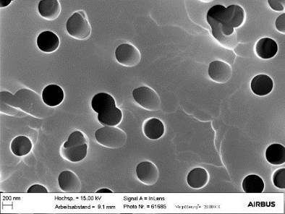 | 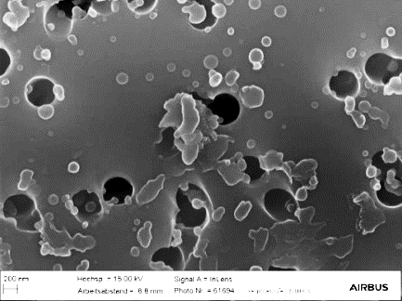 | 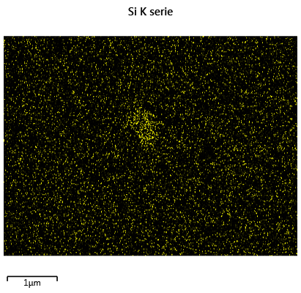  Si
a) | b) | c)
Figure 5. SEM-micrograph of the polycarbonate Track-Etch-Filters: a) Initial state; b) After extraction of the laser dust; c) EDX element distribution of b)
Figure 6 presents an EDX line scan of the globular shaped particles. The element distribution shows neither a rise of silicon nor an increase of oxygen compared to the polycarbonate filter material. The high amount of carbon signals a polymeric origin of the particle. It is most probably a residue of the CFRP epoxy resin material. The globular shape is a sign for recombination from vapour state which could have led to an energetically advantageous geometric form.

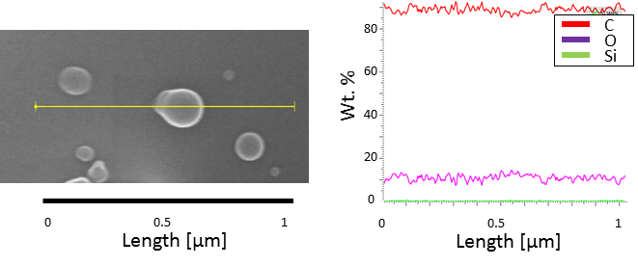
Figure 6. EDX line scan of a globular particle on the track etch filter surface

The results indicate that the epoxy resin material is sublimated during the laser process and recombines to small globular shaped particles during cooling. On the other side the release agent particles show no sign for sublimation but have breaking edges. Both observations support the cleaning model stated in [4], which demonstrates that the laser light is transmitting the silicone based release agent layer and removes this layer by sublimating the epoxy material underneath. The breaking edges are a sign for the stated explosive removal by a pressure bubble.

Looking at the amount of particles generated by laser treating a 135 mm² CFRP surface, (a) almost no particles were counted for the state of no laser treatment (=atmosphere). In case of laser treatment and without any extraction (b) more than 3 mio. particles in the size between 0.3 to 10 µm are generated (see Figure 7). According to the track-edge filter measurement, these consist of the ablated release agent material. In case an extraction system (c) is added to the laser treatment process, the number of particles in the air flow is similar to the experiment without an extraction system. This means that all generated particles are exhausted. In order to validate this further and in case the extraction is placed on the opposite side of the sample than the particle measurement device (d), the number of counted particles is equal to the atmosphere. To conclude, during laser treatment a high number of particles between 0.3 µm and 10 µm diameter are generated. They are a sign for ablated contamination. In case they redeposit back onto the surface the cleaning effect would be egalized. However it is possible to inhibit these particles to redeposit onto the treated CFRP surface by adding an extraction as this sucks away all measured laser dust particles.

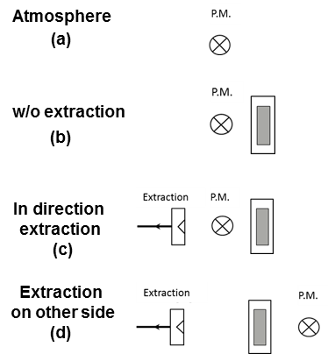 | 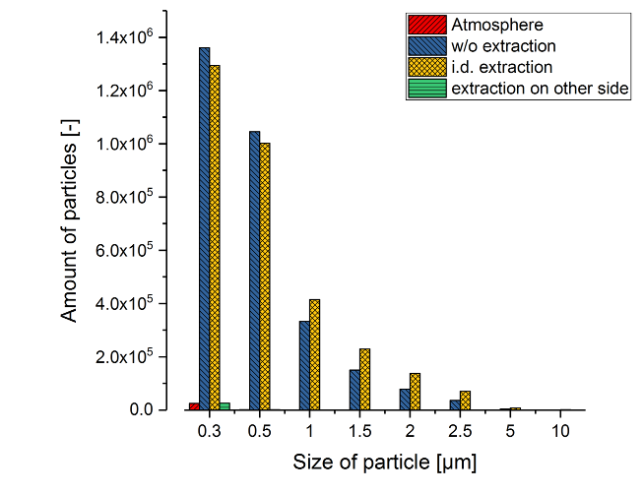
Figure 7. Counted dust particles during laser process (135 mm² laser field)

3.2. Investigations on the effect of laser irradiation onto carbon fibre and resin base material

In order to evaluate whether the proposed laser cleaning model with hardly any resin ablation or more extensive laser treatment with fibre exposure is preferable, the effect of laser irradiation onto the main CFRP contents was investigated: carbon fibres and epoxy resin. Table 2 lists the XPS fine-scan results of a L20/EPH960 epoxy resin before and after laser treatment. While the amount of carbon and oxygen almost did not change, the amount of nitrogen increases from 0.9 at. % N to 3.4 at. % N during treatment. This can be explained by the removal of surface contaminations and the exposure of the amine components in the resin. Looking onto the C1s spectra a significant increase of the hydroxy groups from 12.5 % to 21 % is noticeable. As these functional group works as bonding partner in the adhesive bonding reaction this symbols a surface activation.

Table 2. XPS fine-scan results of the L20/EPH960 resin surface
 | C1s | O1s | N1s | Others | C-C / C-H | C-O | C=O | O-C=O | O1s
 |  |  |  |  | 284,8 | 1,5 | 2,9 | 4,2 | 532,9
Initial | 83,5 | 13,7 | 0,9 | 1,9 | 84 | 12,5 | 2,5 | 1 | 100
After laser | 82,6 | 13,4 | 3,4 | 0,6 | 77,5 | 21 | 1,5 | 0 | 100

Table 3 lists the XPS fine-scan results of the M60J carbon fibre surface before and after laser treatment. The treatment reduces the amount of oxygen on the fibre surface from 22.3 at. % in initial state to 13.4 at. %. This comes along with the significant reduction of hydroxy groups in the C1s spectra. As a result, more carbon single bonds are established during treatment which increases the amount of carbon on the surface. As already stated the reduction of hydroxy groups is disadvantageous for adhesive bonding and is a sign for deactivation.

Table 3. XPS fine-scan results of the M60J carbon fibre surface
 | C1s | O1s | Others | C-C / C-H | C-O | O-C=O | O1s
 |  |  |  | 284.8 | 1.5 | 4.2 | 532.9
Initial | 77,2 | 22,3 | 0,5 | 63 | 35 | 1 | 100
After laser | 86,5 | 13,4 | 0,1 | 74 | 23 | 1 | 100

SEM micrographs of the carbon fibre surface do not show any sign for a laser effect onto the topology. In Figure 8 there is no significant difference observable between an initial surface and a surface after laser irradiation, although after laser irradiation the rills are slightly more defined. There are also no signs for a damage noticeable. However, the impact of the laser treatment onto the fibre seizing cannot be evaluated, as the seizing is too thin to be detected using SEM.

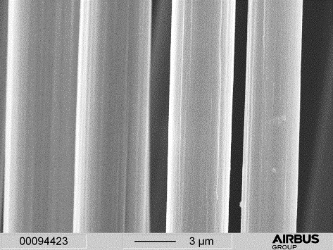  3 µm | 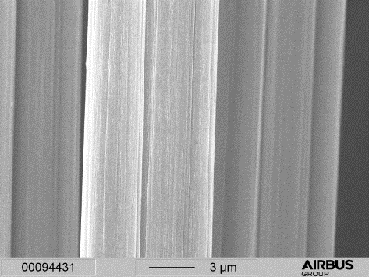  3 µm
a) | b)
Figure 8. SEM micrographs of the carbon fibre surface a) initial state b) after laser

3.3 Surface investigations on laser treated CFRP

In the initial state of the CFRP surface approx. 0.3 at. % of Si are measured via XPS as residues of the release agent. Grinding the surface led to 0.0 at. % Si but also to significant abrasion of the epoxy resin down to the carbon fibres. Damages of the fibres from partial abrasion to fibre cut-off can be observed. Laser treatment (LP) with 100 % average power led to exposed fibres (Figure 9) and a contaminant-free surface. Like the investigation on the pure carbon fibre there are no topology damages noticeable. With LP, 75% power only the tips of fibres were exposed but the silicon was completely removed. Reducing the laser power reduced the ablation of the resin and with that the exposure of the fibres. LP, 6.25 % power led to no observable modification of the CFRP surface topology and to a contamination level of approx. 0.2 at. % Si.

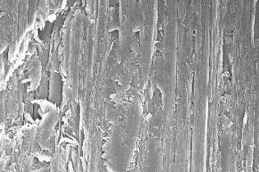  10 µm | 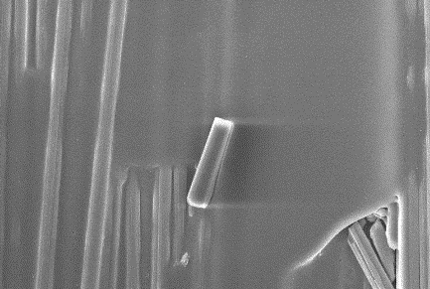  10 µm | 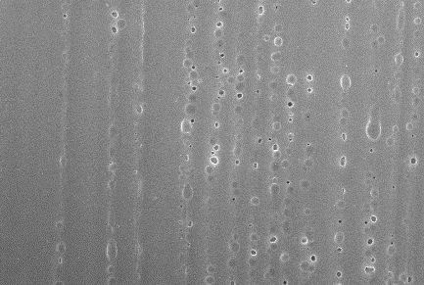  10 µm
- at. % Si | - at. % Si | - at. % Si
Grinded | LP, 100 % Power | LP, 75 % Power
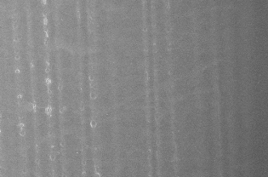  10 µm | 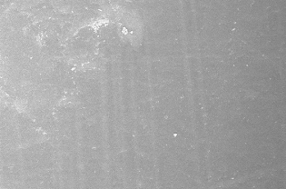  10 µm | 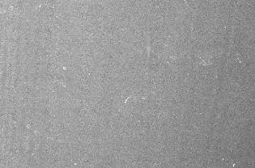  10 µm
0.6 at. % Si | 0.5 at. % Si | 0.2 at. % Si
LP, 50 % Power | LP, 25 % Power | LP, 6.25 % Power
Figure 9. SEM- and XPS-results of laser treated CFRP

3.3 Single lap shear results of single material combination

To review the efficiency of the different treatment procedures by using bonding strength as an indicator, single lap shear tests were performed. The specimen with a manually grinded surface revealed a joint strength of approx. 17.5 MPa (Figure 10). The samples mainly failed by carbon fibre tearing (CSF-fibre), which indicates that the substrate material was cleaned but also damaged. The delamination of the fibres inhibits higher single lap shear strength. Laser treatment with LP, 100 % power which significantly exposed carbon fibres led to similar shear strength values. However the failure mode changed to mainly failure between adhesive and carbon fibres (CSF-resin). Reducing the exposure of carbon fibres which is done by lowering the laser power led to increasing shear strengths. A big difference can be observed between 50 % power and 25 % power. This is the threshold where the first fibre tips were observable. The highest shear strength was achieved with 6.25 % power with approx. 35 MPa and a bondline failure predominantly between resin and fibres (CSF-resin). Although laser treatment with exposed fibres and with the cleaning approach failed approx. 60 % on top of the fibres, laser treatment with the lower energy led to an increase of the lap shear strength by a factor of almost two. The explanation can be found in the deactivation of the carbon fibres and therefore a lower amount of chemical bonds between the adhesive and the fibre surface compared to the chemical bonds between resin material and the fibre surface.

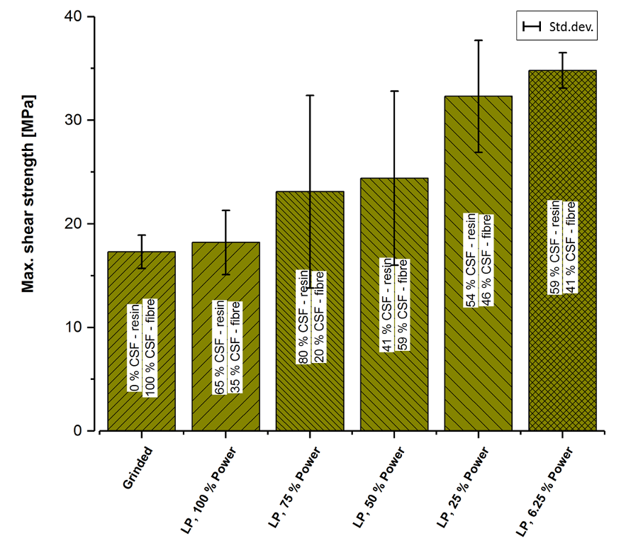
Figure 10. CFRP - single lap shear results after different treatments (100 % Power = fibre exposure, 6.25 % Power = cleaning model)

4. Conclusion

For laser treatment of CFRP prior to adhesive bonding an existing cleaning model [4] was supported by experiment results. Therefore, the generated laser dust was investigated. On the one side the particles found on a track-etch filter showed traces of sublimation and recombination for resin material as well as a non-thermal history for the release agent particles. On the other side the particle distribution revealed a high number of release agent particles that are generated during laser treatment. However, an extraction system during laser treatment proved as very effective and could remove all generated and countable dust particles. These results evaluate the cleaning model and demonstrate that this approach is promising to be used in production environment. Furthermore, the cleaning process was compared against laser treatment that exposes carbon fibres. The effect of fibre exposure during laser treatment was examined by irradiating the CFRP base materials: the epoxy resin and the carbon fibres. While the laser treatment increased the hydroxy groups on the resin it decreased the hydroxy groups on the fibre surface. This effect influenced the single lap shear strength of the treated CFRP surface. The samples with exposed fibres showed the same shear strength value as grinded surface with approx. 17.5 MPa. Treating the surface with only a low amount of energy, with no fibres exposed, led to a shear strength value of approx. 35 MPa. For this CFRP material it is preferable to smoothly clean the surface instead of exposing the carbon fibres. These results demonstrate that the laser cleaning approach has a high potential to serve as surface preparation technology for CFRP pre-treatment prior adhesive bonding.

Acknowledgments

The German Ministry for Education and Research (BMBF) supported part of the presented work in the project “HyBriLight” (13N12715). The authors are responsible for the contents of this publication. The authors thank the following colleagues from the central research department of Airbus: Max Kolb for supporting the surface analytics, Heiko Fietzek for supporting the laser activity, Andreas Helwig for his inputs regarding particle measurements, Mehmet Toru for the lap shear testing. Special thanks go to Airbus Defence and Space, in specific Manuela Süss, for the overall support.

References

[1] Kreling S, Fischer F, Delmdahl R, Gäbler F, Dilger K. Analytical characterization of CFRP laser treated by excimer laser radiation. Physics Procedia 2013;41:282–90. doi:10.1016/j.phpro.2013.03.080.
[2] Nattapat M, Marimuthu S, Kamara AM, Esfahani MRN, Marimuthu S, Kamara AM, et al. Laser Surface Modification of Carbon Fiber Reinforced Composites Laser Surface Modification of Carbon Fiber Reinforced Composites. Materials and Manufacturing Processes 2015;30:1450–6. doi:10.1080/10426914.2015.1019097.
[3] Kreling PS. Laserstrahlung mit unterschiedlicher Wellenlänge zur Klebvorbehandlung von CFK. Aachen: Shaker Verlag; 2015.
[4] Rauh B, Kreling S, Kolb M, Geistbeck M, Boujenfa S, Suess M, et al. UV-laser cleaning and surface characterization of an aerospace carbon fi bre reinforced polymer. International Journal of Adhesion and Adhesives 2018;82:50–9. doi:10.1016/j.ijadhadh.2017.12.016.
[5] Davis GD. Contamination of Surfaces: Origin, Detection and Effect on Adhesion. Surface and Interface Analysis 1993;20:368–72.
[6] Wingfield JRJ. Treatment of composite surfaces for adhesive bonding. International Journal of Adhesion & Adhesives 1993;13:151–6. doi:10.1016/0143-7496(93)90036-9.
[7] Fischer F, Kreling S, Jäschke P, Frauenhofer M, Kracht D, Dilger K. Laser Surface Pre-Treatment of CFRP for Adhesive Bonding in Consideration of the Absorption Behaviour. The Journal of Adhesion 2012;88:350–63. doi:10.1080/00218464.2012.660042.
[8] Hesse D. Abtragen und Schneiden von Kohlefaserverbundwerkstoffen mit Excimer-Laserstrahlung 1995:142.
[9] Fischer F, Kreling S, Dilger K. Surface Structuring of CFRP by using Modern Excimer Laser Sources. Physics Procedia 2012;39:154–60. doi:10.1016/j.phpro.2012.10.025.
[10] Stefan K, Blass D, Dilger K. Duroplastische CFK mit dem Laser vorbehandeln. Adhäsion - Kleben Und Dichten n.d.:42–6.
[11] Rauh B, Kreling S, Fietzek H, Suess M, Geistbeck M, Dilger K, et al. LASER SURFACE TREATMENT OF CFRP AND TI6AL4V FOR ADHESIVE BONDING OF HYBRID JOINTS. Hybrid Materials and Structures, Bremen: 2018.

