Development of a Resistance Welding Process for thermoset fiber composite components with co-cured thermoplastic boundary layer

L. Zweifel*¹, J. Brunner¹, S. Nakouzi-Queloz¹, C. Brauner¹ and C. Dransfeld¹

¹Institute of Polymer Engineering, FHNW University of Applied Sciences and Art Northwestern Switzerland, Klosterzelgstrasse 2, 5210 Windisch, Switzerland
*Email: lucian.zweifel@fhnw.ch, Web Page: http://www.fhnw.ch/ikt/

Keywords: Resistance Welding, Thermoset Composite, Process Development, Hybrid Materials, Joining

Abstract
Within this study, the resistance welding of thermoset composite with thermoplastic boundary layers was investigated. The specimens were prepared by co-curing a thermoplastic layer, which created an interphase with the epoxy matrix by reaction induced phase separation. The resistance welding of such specimens was investigated in a custom built welding rig with systematic variation of relevant processing parameters using a design of experiments: such as thermal insulation, compaction pressure, current input, time and moisture content. With optimized parameters, a lap shear strength based on ASTM D1002 of 36 MPa was achieved. The methods have a comparable performance of very good structural adhesive albeit with a much shorter cycle time and high potential for automation.

Introduction

Carbon fibre reinforced polymers (CFRPs) based on thermosetting epoxy matrix systems exhibit superior strength and stiffness at low weight and therefore find an increasing success for large aircraft structures. Commonly such components are cured in an autoclave at high pressure and temperature in order to achieve high quality and reproducibility.

The efficient joining of carbon-fibre reinforced thermoset materials for industrial applications is a key to enable lightweight design concepts with the premise of applying the right material at the right place. Joining with adhesives results in high costs and long process times. This relates to time-consuming pre-treatment of the surfaces in order to ensure a sufficient level of adhesion. This is why riveted or bolted joints are still commonly used. However, the holes act as notches, resulting in significant stress concentrations, which must be taken into account in the design. There is a need for an efficient joining technique that leads to strong, cost-effective and reliable joints. Thermoplastic welding, with the ability of melting and reprocessing offers advantages compared to thermosets, which cannot be re-melted once they are cured [1].

An attractive approach of using the thermoplastic welding process for thermosets is to co-cure a thermoplastic boundary layer during the cure process of a thermoset resin. This leads to a weldable surface which can be processed with thermoplastic welding processes such as resistance welding, ultrasonic welding or induction welding. When co-curing the thermoplastic with an epoxy system, the thermoset precursors diffuse into the thermoplastic followed by a reaction induced phase separation. The diffusion rate depends on the local concentration and its affinity for the components of the epoxy resin and the thermoplastic polymer as well as their respective molecules [2]. The result is a pronounced heterogeneous morphology with a thermoplastic-rich phase and a thermoset-rich phase, with strong mechanical interlocking at the micrometer scale [3]. It was shown that polyetherimide (PEI) is very suitable candidate for this interphase formation in certain epoxy precursors and corresponding temperatures.

The aim of this study was to investigate the resistance welding process of aerospace grade epoxy prepreg structures with co-cured PEI surface layers, by systematic variation of processing parameters, such as power, time, pressure and external heat transfer conditions.

Materials and Methods

Materials and manufacturing of composite laminates

An aerospace certified prepreg with carbon fabric reinforcement (1/4 satin weave) and 40% vol. resin content was used to manufacture the laminates with a final T_{g} >200°C. Four plies were laid up symmetrically balanced. A thermoplastic polyetherimide (PEI Ultem 1000, Sabic) film was applied on the surface. The thickness of the final laminate was around 1.5mm. The laminates were co-cured in a heated press.

Welding equipment and welding process

A resistance welding setup shown in Figure 1 was developed within this study, which allowed systematic variation of power input, pressure and time, also stamps (respectively clamps) with different thermal conductivity where realized to influence the heat transfer conditions. Force, temperature, current, voltage and time where acquired online via LabVIEW.

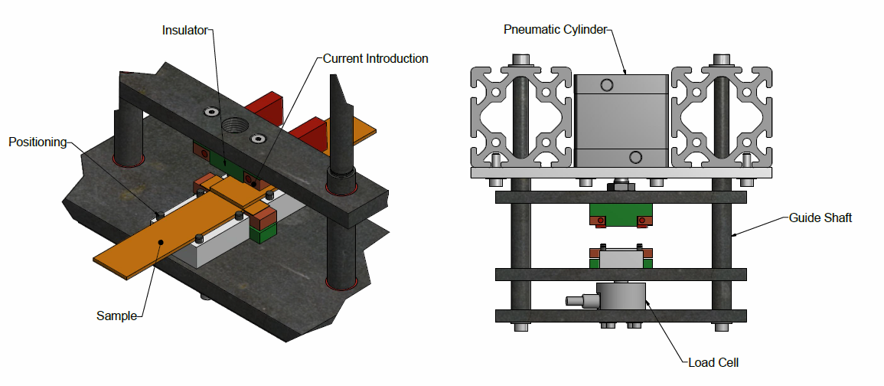
Figure 1 Detailed view of the developed welding setup

Resistance welding is influenced by three main process parameters. The specific power P (Eq. 1) is the most relevant process parameter to influence which temperature is present in the joint. If the power is too low, no melting will take place, and if it is too high, there is a risk of polymer degradation.

$$P= \frac{U∙I}{l_{Mesh} ∙b}$$ | (1)

The specific power is calculated using the measured voltage U [V] and current I [A]. The area refers to the size of the heating element, where l_{Mesh} [m] is the length and b [m] is the width. The other process parameters are the welding time t [s], which is determined by the time of the electrical power application, and the surface pressure p [MPa].

$$p=\frac{F}{l_{Stem}∙ b}$$ | (2)

The force was measured by the load cell, which is inserted directly in the welding setup. The area of pressure was determined by the stamp size. The length l_{Stem} [mm] and width b [mm] were kept constant. To generate a process window, a set of parameter combinations was examined using a design of experiment to find out how to ensure an ideal process. In literature, two special features stand out: On the one hand, low power and a long welding time lead to excessive heat loss through the composite. On the other hand, a very high temperature gradient is generated by high power and short welding time and local overheating occurs. Both features are characterized by poor shear strength [1].

For the welding process co-cured CFRP plate were placed in the welding setup. A steel mesh with an areal weight of 0.19 g/m² was placed between the plates and connected to the electrical power supply. Power time and pressure were applied accordingly.

Testing and analysis

The welded joints were mechanically tested following the ASTM D1002 standard in a Zwick 100kN universal tensile test machine with a testing speed of 1.3 mm/min to determine the apparent lap shear strength (LSS). Ten coupons with the same process parameters were used for the robustness analysis and for the design of experiment. The lap shear strength was calculated as the maximum load divided by the overlap area. Furthermore, fractured specimens were investigated by optical microscopy of the fracture area as well as by micrograph of sections.

Results and discussion

Preliminary experimental study of influencing parameters

In order to gain a better understanding of the experimental process, the observations on influencing parameters have been summarized in Table 1 and indicate possible causes for the variability of joint strength.

Table 1. Influencing Parameters
Parameter | Comment
Thermal Insulation | The clamps in the welding setup serve on the one hand to apply the required pressure and on the other hand as thermal insulation. They were therefore made out of a temperature resistant polymer, which has a low heat transfer coefficient and can be used up to 300°C.
Pressure Distribution | A uniform pressure distribution in the weld connection was necessary for a good consolidation [4, 5]. The pressure was applied by pneumatic piston and cylindrical guides which were sensitive to alignment errors.
Current Introduction | Two copper elements were used, which clamped the mesh in between. For a constant and smooth flow of current the steel mesh must be clamped homogeneously.
Moisture Content | Polyetherimide and epoxies absorb moisture, which must be taken into account during processing. Before welding, samples were dried at 150°C for four hours. Shi [6] relates the influence of moisture to different failure modes.

It was important that the process showed a certain stability, such that experiments with nominal equal process parameters (pressure, power, time) could be repeated with a low standard deviation, which is relevant to industrial applications. The knowledge of the empirically determined optimum processing parameters during the development of the welding setup was applied by using a robustness analysis. Ten samples are welded with identical conditions. Table 2 summarizes the optimum processing parameters and the effect on lap shear strength and its variability.

Table 2. Input of optimum process conditions for robustness analysis
Parameter | Value | Comment
Specific power | 65 kW/m² | -
Welding time | 120 s | -
Consolidation time | 180 s | The pressure remains for a certain amount of time after welding.
Pressure | 1.2 MPa | -
Waiting period | 10 min | If several welds are made one after the other, it was shown that due to the constant heating and poor cooling of the PEEK clamps, the connection strength is different.
Lap shear strength | 36.3 ± 1.38 MPa | -

A mean of 36.3 MPa was achieved with a standard deviation of 1.38 MPa, which corresponds to 3.8%, which was an indication of good reproducibility.

Fracture behaviour

For a better understanding of the failure modes Figure 2 shows a schematic of the different zone throughout a the welding connection. Opposed to standard adhesives joints with adherents and adhesive, these joints showed distinct layered domains, starting with the CFRP at the adherent side, followed by the interphase gradient with the PEI, an area with pure PEI and the metal mesh in the centre (which is also infiltrated with PEI). The failure mode is considered to be cohesive if a break occurs within the bulk of the material, or in the heating element (cracking of the heating element). This type of failure usually resulted in maximum lap shear strength, which implied the best weld quality. If edge defect occurred at the interface between the composite and the heating element and lower lap shear strengths were obtained, indicating incomplete bonding.

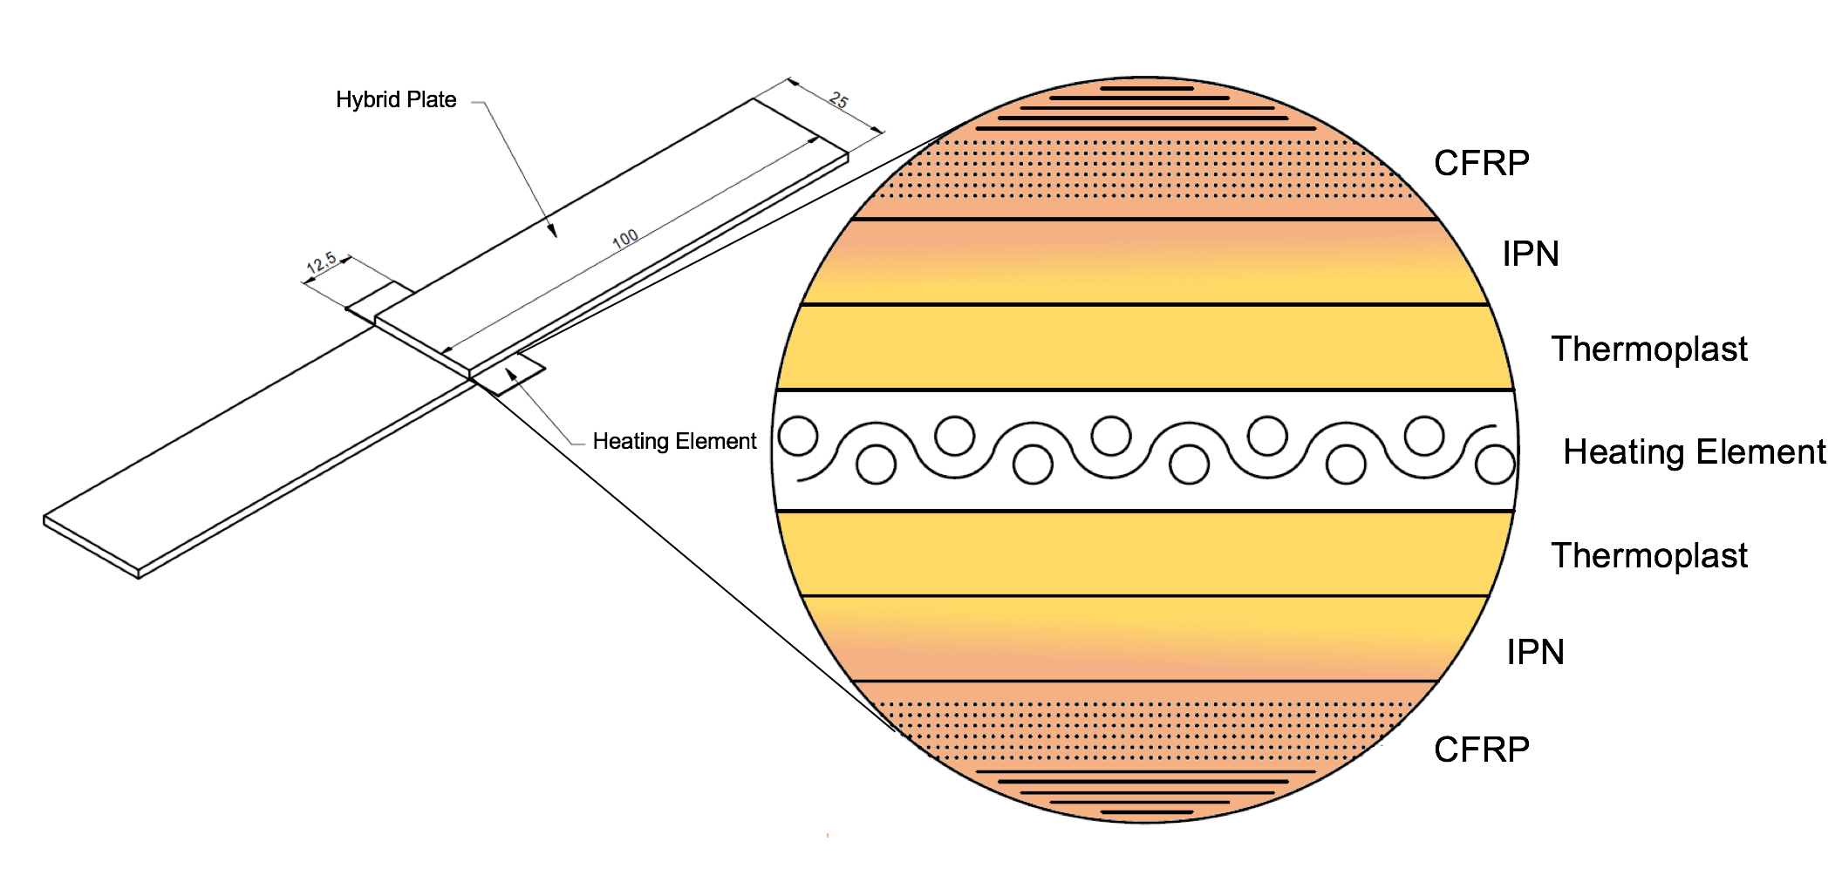

Figure 2. Simplified view of the applied resistance welding process

The analysis of the fracture surfaces was consistent in the optimum process window. The fracture typology was dominant composite failure within the CFRP or cohesive failure in the metal mesh, but also showed small sections of apparent adhesive failure (Fig. 3). This was a strong indication that the interphase between the PEI and the epoxy was stronger than the constituents and showed the potential of a fully developed network between thermoplastic and epoxy.

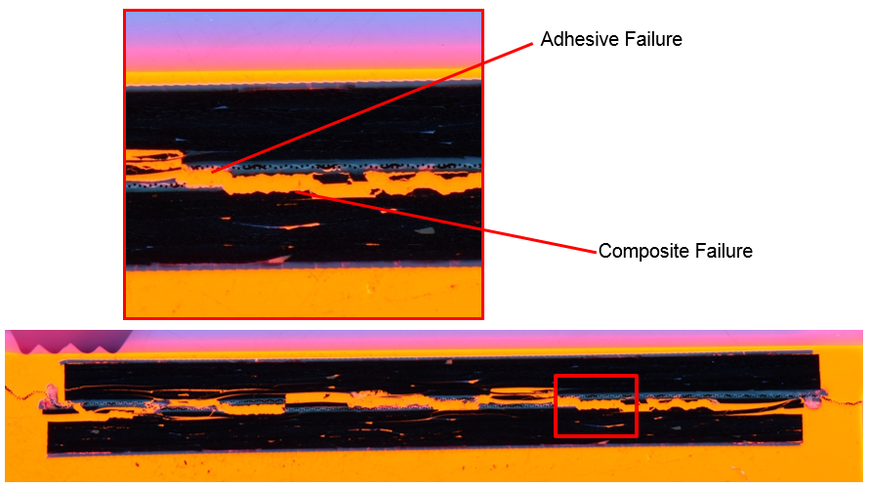

Figure 3. Cross section micrograph of fracture specimen showing a dominant composite failure

Process window by design of experiments

Based on the previous determined optimum processing conditions, the design of experiment served to correlate the main processing parameters to the strength of the welded joint. The initial process parameters (power, pressure, time) were modified in order to assess the influence on the lap shear strength of the joint.

Table 3. Range of process parameters for the design of experiment
Parameter | Minimum | Maximum
Specific power | 65 kW/m² | 120 kW/m²
Welding time | 60 s | 180 s
Pressure | 0.8 MPa | 1.6 MPa

Analysis of the welding quality

The welded samples were categorized in three weld qualities (Fig. 4) for a better understanding.

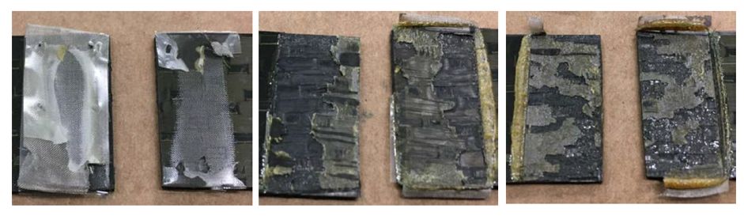
Figure 4. From left to right: Underprocessed weld, weld in process window, overprocessed weld

The specific power was an essential parameter that influences which temperature is present in the welded joint. A minimum, as well as a maximum boundary could be determined to create a process window. The minimum would be the minimal energy supply, whereby from a certain time a connection is created. The maximum was determined by the onset of degradation behaviour of the epoxy resin. In a first step, the effect of minimum to maximum power was taken in to account. At 60kW/m² and 80s welding time only a local melting was visible. At 100kW/m² and 80s welding time a complete weld was achieved. This led to the realization that time and power have a common influence on the resulting temperature in the compounds. It also meant that power and time are coupled factors. It is possible to couple a low power with a longer welding time and create similar results with high power and low welding time. This would suggest that the energy input defined as the product of time and specific power might be as relevant.

$$E=P ∙ t \left[\frac{kJ}{m^{2}}\right] .$$ | (3)

The onset of degradation however could be related to specific power: from 100kW/m², slight discoloration is visible at the edge of the power supply. If the power is further increased to 120kW/m² this proportion extends to the entire welding area. Shi [6] also describes degradation as a feature of PEI discoloration and additional mesh tearing. With increasing power, it was found that there were large fluctuations and local overheating in the mesh during the process. Therefore, the level 120kW/m² was determined as an upper bound of the specific power.

The importance of the homogeneity of the pressure could already be recognized by the sensitivity analysis. In this case it is interesting to see what influence the level of pressure has on the shear strength. It was shown that pressure at low power (<70kW/m²) was essential for a good joint strength. The strength of the connection could also be related to the fracture path. At high power (> 90kW/m²), the high energy input leads to increased temperature and lower viscosity. This made the PEI flow better. Due to the high pressure, the PEI was forced out of the connection. When the PEI flows out, the actual connection became stiffer and therefore the shear strength distribution along the lap was less homogeneous and had higher maxima at its extremities; this resulted in a lower apparent lap shear strength. Therefore high pressures should only be used with low specific power.

Regression analysis and response surface

The results were used to generate a suitable model and thus a processing window using the design of experiment (DoE) software Modde. This method allowed the computation of confidence intervals of measured data and thus enabled the identification of outliers. The lap shear strength was represented as an implicit function according to y=f(x1, x2, x3), where y is the lap shear strength and x1 to x3 the process parameters, for example camping time and specific power in the example of figure 5.

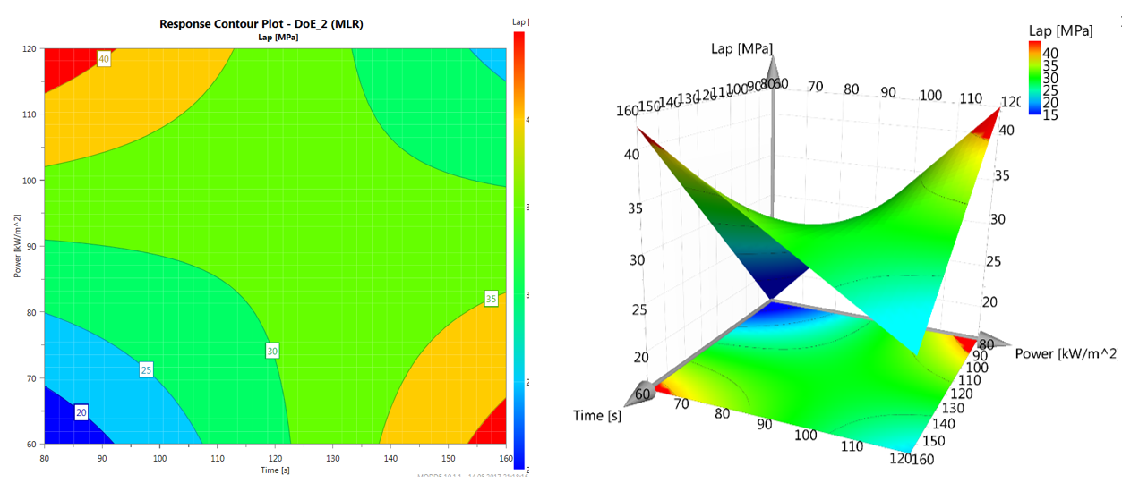
Figure 5. The implicit function (response surface) of the lap shear strength as a function of time and power

The use of a multiple regression was used to compare the experimental data with the created model. By maximizing the coefficient of determination (R²) a model was created which reflected the experimental data in a suitable way. This method was used for several parameter combinations. For example, a process window can be derived directly out of Figure 5. The response surface also indicated that high power and short times as well as low power and long times may both yield high joint strength. The parameter setting with power of 65kW/m², welding time of 120s and pressure of 1.2MPa showed the best fitting to the model. Furthermore, with this setting the degradation behaviour could be reduced to a minimum.

Conclusion

In this study the resistance welding process of aerospace grade epoxy prepreg structures with co-cured PEI surface layers, was developed by systematic variation of processing parameters, such as power, time, pressure and external heat transfer conditions. An optimum process was developed with a relatively high average lap shear strength of 36MPa. The robustness analysis revealed that with an optimum processing parameter set of 65kW/m², 120s and 1.2MPa a standard deviation of only 1.4MPa was achieved. The fracture surfaces of optimum joints suggest that the interphase between the PEI and the epoxy is stronger than its constituents.

This work shows that good joints results from a specific power range of 60kW/m² to 100kW/m². However, these values depend on the welding time, which is at least 120s for low power and 60s for high power. In addition, furthermore increasing specific power requires decreasing clamping pressure. At low power, the level of pressure has a major impact on the quality of the connection. At high specific power, the PEI has a too low viscosity and begins to flow out of the welded connection due to high pressures. Which leads to lower lap shear strength and brittle fracture behaviour.

Future work will focus on better understanding the effect of thermal degradation of the epoxy matrix in the welding process and will explore the industrial application in complex geometries.

Acknowledgments
The authors gratefully acknowledge the funding by the Swiss Innovation Agency - Innoswiss (Grant No.
25320.1 PFIW-IW).

References
[1] D. Stavrov and H. . Bersee, “Resistance welding of thermoplastic composites-an overview,” Compos. Part A Appl. Sci. Manuf., vol. 36, 2005.

[2] I. F. Villegas and R. van Moorleghem, “Ultrasonic welding of carbon/epoxy and carbon/PEEK composites through a PEI thermoplastic coupling layer,” Compos. Part A Appl. Sci. Manuf., vol. 109, no. February, pp. 75–83, 2018.

[3] B. Lestriez, J. P. Chapel, and J. F. Gérard, “Gradient interphase between reactive epoxy and glassy thermoplastic from dissolution process, reaction kinetics, and phase separation thermodynamics,” Macromolecules, vol. 34, no. 5, pp. 1204–1213, 2001.

[4] C. Ageorges and L. Ye, “Resistance welding of thermosetting composite / thermoplastic composite joints,” Adv. Mater., vol. 32, no. 2001, 2006.

[5] M. Hou, “Thermoplastic Adhesive for Thermosetting Composites,” Mater. Sci. Forum, vol. 706–709, pp. 2968–2973, 2012.

[6] H. Shi, I. F. Villegas, and H. E. N. Bersee, “Strength and failure modes in resistance welded thermoplastic composite joints: Effect of fibre-matrix adhesion and fibre orientation,” Compos. Part A Appl. Sci. Manuf., vol. 55, pp. 1–10, 2013.

