**Acousto-ultrasonic damage evaluation of carbon fibre composites using pencil lead break sources**

Pierre DUCHENE1, Salim CHAKI2 and Patricia KRAWCZAK3

1 IMT Lille Douai,Institut Mines-Telecom, Polymers and Composites Technology & Mechanical Engineering Department, 941 rue Charles Bourseul, 59508 Douai, France

Email: [pierre.duchene@imt-lille-douai.fr](mailto:pierre.duchene@imt-lille-douai.fr), Web Page: [https://www.imt.fr/](https://www.imt.fr/mines-douai-2/)

2 IMT Lille Douai,Institut Mines-Telecom, Polymers and Composites Technology & Mechanical Engineering Department, 941 rue Charles Bourseul, 59508 Douai, France

Email: [salim.chaki@imt-lille-douai.fr](mailto:salim.chaki@imt-lille-douai.fr), Web Page: [https://www.imt.fr/](https://www.imt.fr/mines-douai-2/)

3 IMT Lille Douai,Institut Mines-Telecom, Polymers and Composites Technology & Mechanical Engineering Department, 941 rue Charles Bourseul, 59508 Douai, France

Email: [patricia.krawczak@imt-lille-douai.fr](mailto:patricia.krawczak@imt-lille-douai.fr), Web Page: [https://www.imt.fr/](https://www.imt.fr/mines-douai-2/)

**Keywords:** Polymer-composites, Mechanical damage, Non-destructive testing, Acousto-ultrasonic, Guided waves

**Abstract**

Acoustic emission (AE) is a passive non-destructive testing (NDT) technique, which can detect evolving damage in materials or structures submitted to mechanical loading. Therefore, free stress structures cannot be monitored by AE. Moreover, there are numerous applications where mechanical loading stimulation is not desirable as it may induce damage in the material as in the case of composite pressure containers that must be submitted to hydraulic pressure test to use AE. This paper proposes a novel active method based on acousto-ultrasonic (AU) analysis for damage evaluation without mechanical loading. It uses pencil lead break sources as stimulus and data fusion processing to improve damage assessment. After a detailed description of the AU procedure, a case of study is presented on a carbon fibre/epoxy matrix composite material submitted to unidirectional stepwise fatigue loading. Damage assessment is obtained for each fatigue loading step as damage location mapping.

1. Introduction

Polymer composites are increasingly used to manufacture mechanically critical structures in aerospace, energy or marine applications. Thus, safety requirements often impose damage monitoring of such structures while cost-effectiveness issues require reducing the amount of inspections. Non-destructive testing (NDT) methods are frequently considered for this purpose because of their ability to detect and characterise damage of polymer composite parts [1].

Many NDT techniques provide imaging data making it possible to locate damage in the tested material. This is the case with passive [2] or active infrared thermography [3]. The obtained results are limited to surface or subsurface evaluation [4]. Infrared thermography allows the detection of defects in the active configuration [5] and the visualisation of damage propagation in the passive setup [6]. Deformation field results may also be obtained by means of digital image correlation so as to evaluate the damage state of the material [7]. Imaging data can be obtained by scanning the area of interest. This method is applied with ultrasonic waves in C-scan mode using immersion probes [8] or Lamb waves [9] for damage assessment. However, in most of cases, it cannot be performed in-situ (on a testing machine). Depending on the type of material and the expected monitoring, characterisations based on terahertz [10], eddy current [11], shearography (speckle pattern interferometry) [12] or even electrical resistivity [13] are also available. Most of above mentioned techniques are limited when characterisation is required through the thickness of the material. Other methods may overcome these limitations, such as computed micro-tomography (µCT) which allows the visualisation of cracks propagation in the material [14]. However, µCT is considered as a semi-destructive technique.

Only few NDT techniques can be applied on any kind of materials; acoustic emission (AE) is one of them [15]. This technique is used for evolutive damage detection while a mechanical load is applied to the material. An AE event originates with the activation of a damage mechanism: matrix cracks, fibre/matrix debonding, delamination and fibre breakage. The release of energy is detected by appropriate sensors (usually piezoelectric).

Acousto-ultrasonic (AU) technique can be used to detect non-evolving damage. The propagation of artificial acoustic waves in the material allows Lamb wave generation due to the mode conversion and enable the evaluation of global damage and delamination characterisation [16]. In the literature, this technique may refer to acousto-ultrasonics [17], Lamb waves [18] or even guided waves [19].

Receiving data from multiple sensors makes it possible to introduce a data fusion strategy between each probe to improve the damage assessment of the material. Fusion of experimental results is a thriving topic as it increases diagnostic accuracy for damage evaluation. Several methods exist and have been applied in the literature. The present work will only use one merger operator.

The purpose of this paper is to propose a novel AU-based non-destructive method for damage characterisation of polymer composites and the associated data fusion method. The obtained imaging results allow damage localisation in the material thanks to AU parameter maps at mm² scale. In the particular case of a stepwise fatigue test, the generation of AU maps provides damage evaluation.

2. Description of the acousto-ultrasonic technique

This novel method is based on artificial sources to generate guided waves, through the material, received by a piezoelectric sensor. It consists in varying the artificial source position on a network of locations. The knowledge of the position of the artificial source enables to generate 2D maps for each wave parameter. AU parameter variations on the whole mesh allows damage characterisation and localisation in the tested specimen. A step by step description of this technique is provided hereafter.

**2.1 Construction of the mesh on the area of interest**

The first step consists in drawing a mesh on the area of interest. It can be an entire structure or a part only. The mesh size and the number of receiving sensors depend on the expected precision. If a large area is studied (for example 1m²), the use of a small mesh pitch (of 1cm) will increase the data available and results precision but also the time required to implement the technique. In addition, depending on the material attenuation, multiple receiving sensors will be required to ensure that each node of the mesh is effectively detected by at least one sensor. Receiving sensors can be placed on nodes of the mesh (reducing the number of test points) or outside of it.

The Figure 1 illustrates the mesh on a composite material. Here, 92 nodes are available on a 120x20mm area. In the length direction, 23 nodes are drawn with a pitch of 5.2mm, while only 4 are drawn in the width direction using a 4.5mm pitch. This mesh is not accurate enough to obtain a complete damage characterisation. Hence, the precision of the obtained maps will be numerically increased with the use of data interpolation.

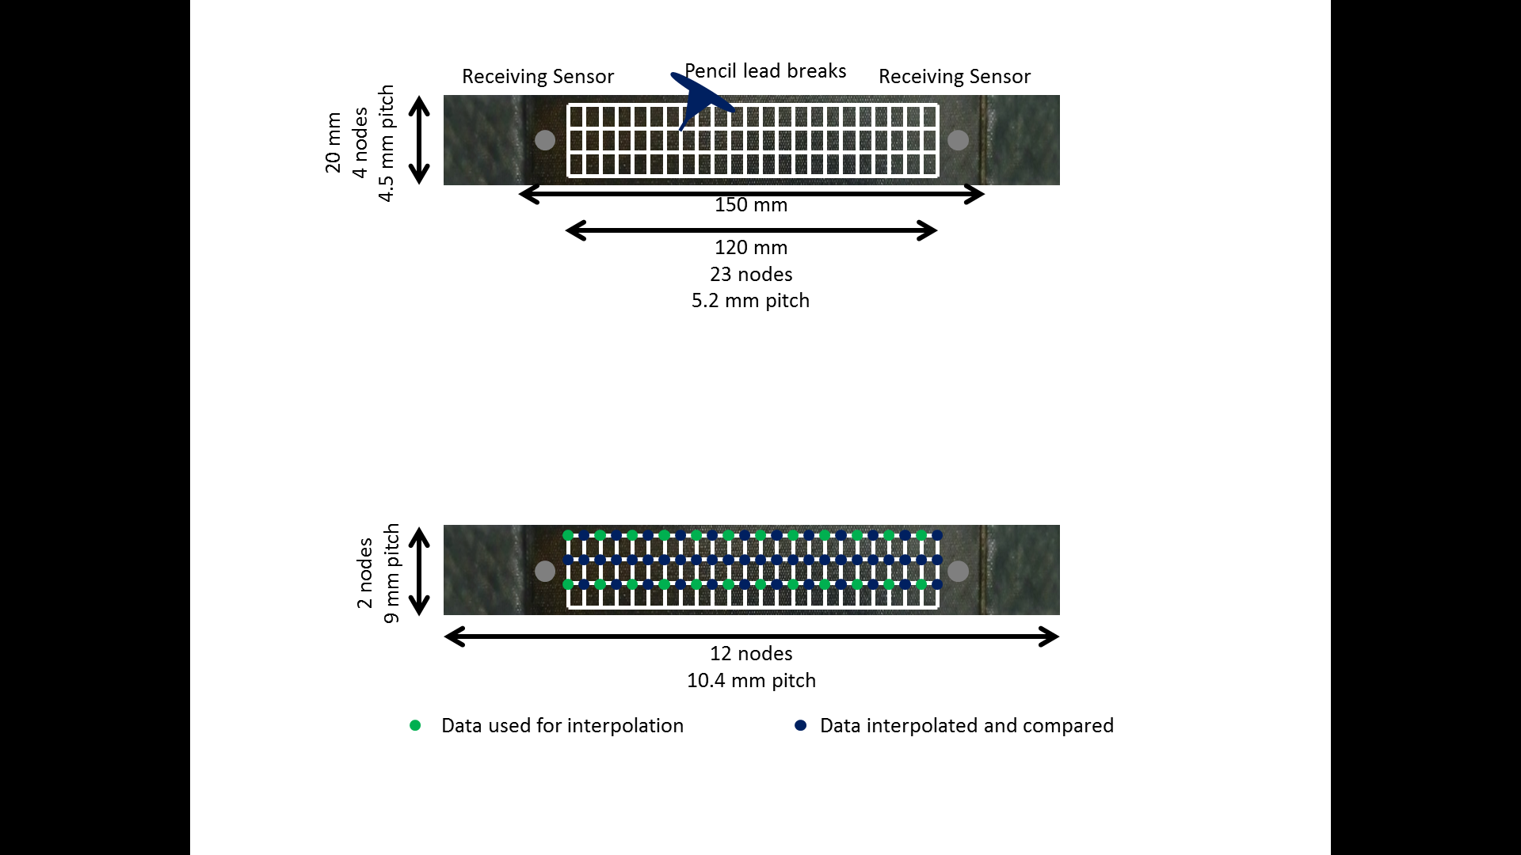

Figure 1 Mesh drawn on the composite specimen

**2.2 Generation of artificial sources**

The generation of artificial sources require all receiving sensors to be placed on the area of interest. The artificial wave is generated using pencil lead breaks (according to ASTM E76 standard) at each node. To ensure repeatability of the generated sources, pencil breaks are performed at least three times. It provides average AU parameters at each node of the mesh and ensures the validity of the recorded data.

To check the robustness of the method, AU parameters are evaluated on 10 nodes among the 92 drawn on the sample with 5 pencil lead breaks. The reliability of this method is then evaluated in terms of mean value and standard deviation (see Table 1). The amplitude parameter is steady with a standard deviation limited to 3dB. The number of counts also steady with less than 2 counts of standard deviation. The peak frequency exhibits a standard deviation in this same order of magnitude. Following the standard, only a few disparities appear during pencil lead breaks at the verification nodes. Thus, this method can be considered as robust.

Table 1 Evaluation of repeatability of pencil lead breaks

|  |  |  |
| --- | --- | --- |
| AU parameter | Mean value over  5 pencil lead breaks | Standard deviation |
| Amplitude (dB) | 86.50 | 3.02 |
| Number of counts | 8.68 | 1.29 |
| Peak frequency (kHz) | 181.67 | 4.41 |

**2.3 Acousto-ultrasonic maps generation through data interpolation**

A numerical mesh of the area of interest is computed, including the position of the AU wave sources and the corresponding parameters. For some applications, the mesh pitches are not accurate enough to evaluate damage on the area of interest. Otherwise, obtaining a finer digital mesh size can be interesting for damage characterisation. This issue can be solved using a numerical interpolation of the previous parameters on a refined mesh. Then, it is possible to generate mm² scale maps with the use of a numerical interpolation. Only linear interpolation is developed due to its high performance.

To validate this data interpolation method, pencil lead breaks are done on the surface of the composite specimen. Only a third of data is used for map generation while the rest is interpolated and compared to experimental values. The mesh used for interpolation has doubled in pitch compared to the initial grid. Mesh parameters are presented in Table 2.

Table 2 Parameters of the mesh for data interpolation

|  |  |  |
| --- | --- | --- |
| Configuration | Initial mesh | Mesh for interpolation validation |
| Number of nodes in the length direction | 23 | 12 |
| Pitch in the legnth direction (mm) | 5.2 | 10.4 |
| Number of nodes in the width direction | 4 | 2 |
| Pitch in the width direction (mm) | 4.5 | 9 |

The mean difference between interpolated data and experimental results is presented in Table 3. All parameters introduce an error being less than 2% which proves the quality of the interpolation. From the specimen viewpoint, the same area is studied with a third of the available data. Thus, additional AU recordings can only increase AU damage maps precision. The generation of accurate mm² scale maps can be performed with the use of the 92 nodes of the mesh.

Table 3 Evaluation of the interpolation quality

|  |  |
| --- | --- |
| AU parameter | Difference between interpolated parameter and real values in % |
| Amplitude (dB) | 0.6 |
| Number of counts | 1.7 |
| Peak frequency (kHz) | 2.0 |

**2.4 Data fusion of acousto-ultrasonic parameters**

Each sensor provides a damage map of the material and a reliable estimation of damage in its vicinity. In this case, combining several maps can reduce the error of damage estimation by multiplying the number of data sets. In the present study, parameters maps from these sensors are merged using a maximum amplitude fusion rule.

In the case of the composite specimen, two sensors are placed on the surface of the tested specimen. Each sensor provides a damage map based on the results of the mesh. The data fusion method based on amplitude maximum rule consists in preserving only the highest amplitude from the two sensors at mm² scale. This merge operator highlights each AU wave for damage assessment (see Figure 2), evaluated from 0 (undamaged state) to 1 (failure state).

|  |  |  |
| --- | --- | --- |
| Sensor 1 | Sensor 2 | Fusion |

Figure 2 Effect of maximum amplitude rule at 80% of ultimate tensile stress

The merged map allows identification of damage from the two sensors to a more accurate mechanical assessment. Most of damage is located in the bottom of the specimen (from 80 to 120 mm lengths) as indicated by sensor 1. Nevertheless, the upper area (from 0 to 60 mm lengths) is also damaged, as identified by sensor 2. One sensor alone would not have been enough to evaluate the degradation of the material, meanwhile, a fused damage map allows the identification of a near-to-failure damage state.

With the composite material, Only two sensors are used on the composite material due to the space required to position the mesh and sensors. It is possible to use multiple sensors in applications where more space is availible. The presented maximum amplitude rule would be even more efficient if the number of data sets available is significant.

This new method requires the use of a mesh on the area of interest to generate artificial acoustic sources. The design of the grid and the number of nodes is a critical step as it defines the precision of the result. However, if the mesh pitches are too coarse to perform damage evaluation, some post-treatments can be performed in order to increase the precision such as numerical interpolation. A more accurate damage assessment is allowed with the use of multiple sensors during the experimental setup. Merging the corresponding data sets provides a precise map for damage localisation.

3. Damage assessment

**3.1 Experimentals**

All tests were performed on carbon/epoxy specimens manufactured from a unidirectional pre-preg (HexPly M79, Hexcel) with a quasi-isotropic [-45/90/45/0]S layup. The size of specimen is a standard fatigue test sample (length of 250mm, useful length of 150mm, width of 20mm, thickness of 2.1mm, thick end tabs of 5mm). Material’s properties are summarised in Table 4. The fatigue limit of the material is estimated at 60% of the ultimate tensile stress (UTS) from Wohler tests, which corresponds to 376 MPa. The AU-based method is applied on these composite samples in the above-described configuration, namely, 92 nodes with two sensors (Euro Physical Acoustics, µ80 sensors, 10mm of diameter and 175-200 kHz as available frequencies).

Table 4 Physical and mechanical properties of the composite material

|  |  |  |
| --- | --- | --- |
| Parameter | Average | Standard deviation |
| Young’s modulus (GPa) | 50.7 | 3.7 |
| Ultimate tensile stress (MPa) | 564.8 | 48.2 |
| Ultimate tensile strain (%) | 3.5 | 0.3 |
| ρ density (g/cm3) | 1.56 | 0.3 |
| Fibre volume content (%) | 62.41 | 1.2 |

The monoaxial fatigue test was carried out at room temperature using a hydraulic fatigue test machine (Instron 8800). The multi-step fatigue test consists in applying successive blocks of 3000 cycles with an R ratio equal to 0.1 (R=σmin/σmax). The maximum tensile stress is increased by 10% UTS after each block from undamaged state to complete failure (10% UTS, 20% UTS, 30% UTS …).

AU signals acquisition was performed using two pre-amplifier at 40 dB (Figure 3) and an acquisition equipment (DisP, Euro Physical Acoustics). The sensitivity of sensors was verified by additional pencil lead breaks to ensure proper mounting and coupling. During the application of the method, AU maps were computed and merged to improve the material damage assessment.

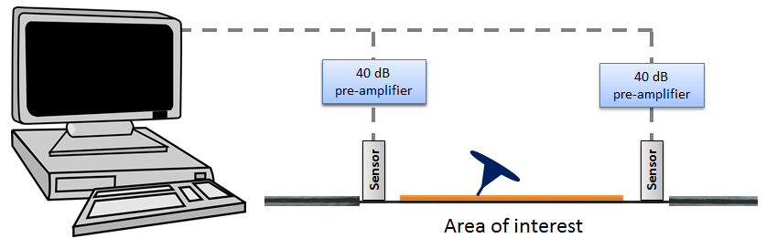

Figure 3 Acousto-ultrasonic recording set-up

**3.2 Mechanical damage assessment through amplitude parameter**

The AU method and the data fusion strategy was applied after three fatigue blocks for the generation of damage evolution maps. Similarly to Chaki et al. [20], a damage indicator is defined using the variation of amplitude (Eq.1). This indicator allows the visualisation of damage propagation in the material. The use of fused imaging results allows localisation of most damaged areas and damage assessment. The corresponding maps are presented in Figure 4.

|  |  |
| --- | --- |
|  | (Eq.1) |

Different stages are identified from these maps for damage evaluation. In the case of a low applied mechanical load (see Figure 4(a)), degradation due to mechanical damage starts to appear. In the classical fatigue life scenario, it can be identified as the initiation phase. The distribution of damage in the material is still homogeneous.

|  |  |  |
| --- | --- | --- |
| (a) | (b) | (c) |

Figure 4 Evolution of amplitude damage parameter maps after fatigue blocks at 10% UTS (a), 40% UTS (b), 80% UTS (c)

Propagation of damage occurs at 40% UTS (see Figure 4(b)). This change in material behaviour can be considered as an indication of a damage threshold between these fatigue blocks. The spreading of damage to the entire specimen can be linked to the second part of the fatigue life scenario, namely, the propagation phase. Some areas show a high level of damage even if the mechanical load is still far from that inducing the ultimate failure. This could be a consequence of local heterogeneities within the material that promotes damage propagation in the material.

Finally, a near-to-failure damage state is presented (see Figure 4(c)). The damage distribution is heterogeneous with a significant damaged area at the bottom of the specimen. This part of the specimen correspond to the initiation of the ruin of the material, which highlights the interest of this AU-based method.

Conclusion

A new method for damage assessment, based on the 2D representation of acousto-ultrasonic waves has been proposed. Interestingly, this method does not require to submit the tested material to a mechanical load. The robustness of the method was verified to ensure its reliability (pencil lead breaks and data interpolation). Then, a case of study on a carbon/epoxy composite material was presented. It highlights the interest of maximum amplitude fusion rule for mechanical damage assessment and localisation. Obtained maps display revelant information from two data sets on a new damage map of the material allowing the identification of the three main stages of a composite material fatigue life (initiation, propagation and failure). The localisation of most damaged areas and their monitoring with merged acousto-ultrasonic maps provide an accurate damage assessment of the material.

Acknowledgments

Thanks are due to Direction Générale de l’Armement (DGA), France, for co-funding Pierre DUCHENE’s PhD grant and to Dr Bénédicte LEVASSEUR, DGA advisor. The authors also acknowledge the European Union (European Regional Development Fund FEDER), the French state and the Hauts-de-France Region council for co-funding the ELSAT 2020 by CISIT project (POPCOM action).

References

[1] P. Duchene, S. Chaki, A. Ayadi, and P. Krawczak, A review of non-destructive techniques used for mechanical damage assessment in polymer composites, *Journal of Materials Science,* 1-24.

[2] C. Meola and G. M. Carlomagno, Infrared thermography to evaluate impact damage in glass/epoxy with manufacturing defects, *International Journal of Impact Engineering,* 67: 1-11, 2014.

[3] L. Toubal, M. Karama, and B. Lorrain, Damage evolution and infrared thermography in woven composite laminates under fatigue loading, *International Journal of Fatigue,* 28: 1867-1872, 2006.

[4] C. Meola, G. M. Carlomagno, A. Squillace, and A. Vitiello, Non-destructive evaluation of aerospace materials with lock-in thermography, *Engineering Failure Analysis,* 13: 380-388, 2006.

[5] S. G. Zacharia, A. Siddiqui, and J. Lahiri, In situ thermal diffusivity determination of anisotropic composite structures: Transverse diffusivity measurement, *NDT & E International,* 48: 1-9, 2012.

[6] W. Harizi, S. Chaki, G. Bourse, and M. Ourak, Mechanical damage assessment of glass fiber-reinforced polymer composites using passive infrared thermography, *Composites Part B: Engineering,* 59: 74-79, 2014.

[7] N. Tableau, Z. Aboura, K. Khellil, L. Marcin, and F. Bouillon, Accurate measurement of in-plane and out-of-plane shear moduli on 3D woven SiC-SiBC material, *Composite Structures,* 172: 319-329, 2017.

[8] W. Harizi, S. Chaki, G. Bourse, and M. Ourak, Mechanical damage characterization of glass fiber-reinforced polymer laminates by ultrasonic maps, *Composites Part B: Engineering,* 70: 131-137, 2015.

[9] C. Ramadas, A. Hood, I. Khan, K. Balasubramaniam, and M. Joshi, Transmission and reflection of the fundamental Lamb modes in a metallic plate with a semi-infinite horizontal crack, *Ultrasonics,* 53: 773-781, 2013.

[10] C.-H. Ryu, S.-H. Park, D.-H. Kim, K.-Y. Jhang, and H.-S. Kim, Nondestructive evaluation of hidden multi-delamination in a glass-fiber-reinforced plastic composite using terahertz spectroscopy, *Composite Structures,* 156: 338-347, 2015.

[11] X. Gros, K. Ogi, and K. Takahashi, Eddy current, ultrasonic C-scan and scanning acoustic microscopy testing of delaminated quasi-isotropic CFRP materials: a case study, *Journal of Reinforced Plastics and Composites,* 17: 389-405, 1998.

[12] G. De Angelis, M. Meo, D. P. Almond, S. G. Pickering, and S. L. Angioni, A new technique to detect defect size and depth in composite structures using digital shearography and unconstrained optimization, *NDT & E International,* 45: 91-96, 2012.

[13] A. Todoroki and Y. Tanaka, Delamination identification of cross-ply graphite/epoxy composite beams using electric resistance change method, *Composites Science and Technology,* 62: 629-639, 2002.

[14] S. C. Garcea, I. Sinclair, and S. M. Spearing, In situ synchrotron tomographic evaluation of the effect of toughening strategies on fatigue micromechanisms in carbon fibre reinforced polymers, *Composites Science and Technology,* 109: 32-39, 2015.

[15] P. O. Moore, R. Miller, and R. Hill, Nondestructive Testing Handbook, Volume 6, Acoustic Emission Testing, American Society for Nondestructive Testing, *Inc., USA,* 2005.

[16] C. Ramadas, J. Padiyar, K. Balasubramaniam, M. Joshi, and C. Krishnamurthy, Lamb wave based ultrasonic imaging of interface delamination in a composite T-joint, *NDT & E International,* 44: 523-530, 2011.

[17] A. Vary, *The acousto-ultrasonic approach*, in *Acousto-Ultrasonics*, & Springer, 1988.

[18] P. Kudela, M. Radzienski, W. Ostachowicz, and Z. Yang, Structural Health Monitoring system based on a concept of Lamb wave focusing by the piezoelectric array, *Mechanical Systems and Signal Processing,* 108: 21-32, 2018.

[19] M. Mohabuth, A. Kotousov, C.-T. Ng, and L. F. Rose, Implication of changing loading conditions on structural health monitoring utilising guided waves, *Smart Materials and Structures,* 27: 025003, 2018.

[20] S. Chaki, W. Harizi, G. Bourse, and M. Ourak, Multi-technique approach for non destructive diagnostic of structural composite materials using bulk ultrasonic waves, guided waves, acoustic emission and infrared thermography, *Composites Part A: Applied Science and Manufacturing,* 78: 358-361, 2015.