Study of notch effect and fibre orientation on fatigue strength of short glass fibre reinforced polyamide
Gabriel Stadler^{1*}, Andreas Primetzhofer¹, Gerald Pinter^{2,3} and Florian Grün¹

¹Chair of Mechanical Engineering, Department Product Engineering, Montanuniversität Leoben, Franz-Josef-Strasse 18, 8700 Leoben, Austria
²Chair of Material Science and Testing of Polymers, Department Polymers, Montanuniversität Leoben, Otto-Gloeckel-Strasse 2, 8700 Leoben, Austria
³Polymer Competence Center Leoben GmbH, Roseggerstraße 12, 8700 Leoben, Austria
*gabriel.stadler@unileoben.ac.at

Keywords: Short fibre reinforced polyamide, notch effect, fibre orientation, life time assessment

Abstract
Short fibre reinforced polymer structural components, which are often applied in the automotive sector have, due to innovative lightweight designs in general, complex geometries with many notches. Therefore, the effect of notches interacting with the local fibre orientation on the life time prediction needs to be investigated. By notching injection moulded flat specimen extracted from plates, an directed and known fibre orientation around the notch exists. Fatigue tests have been performed on notched specimen with different notch radii and fibre orientations in order to examine the influence of notch sharpness and the local fibre orientation on high cycle fatigue. The results show an up to 30% higher notch support number in longitudinal specimen, compared to transversal oriented specimen. Moreover it can be shown, that notches decrease the endurable fatigue strength, different, depending on fibre orientation. However the endurable fatigue strength show an increase at specimen with very sharp notches compared to the remeaing, investigated notches.

1. Introduction

Increasing demand on lightweight solutions, in order to save energy consumption and to reduce greenhouse gas emissions, especially in the automotive industry, requires beside construction measures an application fair usage of materials. For this, short fibre reinforced polymers (sfrp) present a material which already substitute metals in certain components. Therefore it’s necessary to know the fatigue behavior and the influence parameters on the lifetime of sfrp components.
The concept of local S/N-curves, which is originally developed for metals, may also be used for sfrp, shown in [1–3]. Lifetime prediction, using the concept of the local S/N-curve, is based on a material specific S/N-curve, shifted by local influences, like stress superelevations due to notches [4,5], temperature [6,7], fibre orientation [8] and mean stress [9]. For the lifetime assessment of sfrp, beside the local fibre orientation, the interaction with other influence factors, like temperature, needs to be considered. [10]
Notch support effect describes the support of high loaded areas in the notch root, by less loaded areas, which can be quantified in a notch support number, n. This notch support number is according to Seibel et al. [11] defined as the relation between the maximal local strength σ_{a,max} and a reference strength value of the plain material σ_{a,unnotched}, , shown in Equation 1.
(1)

Eichlseder et. al present in [12] a model (Equation 2), where the notch support number is determined by the local stress gradient χ’ and the endurable tensile fatigue strength σ_{tf}. The reference endurable fatigue strength σ_{bf} and a reference stress gradient χ’=2/b are determined by bending fatigue tests.

(2)

In order to determine the notch support number, a reference notch support number of a specimen with a relative gradient of χ’=1 (by setting b=2mm, presented in [13]) can be used.

(3)
The notch effect number K_{f} is the relation between the endurable fatigue strength at certain number in fatigue cycles (in this case N=10⁶) of an unnotched specimen σ_{a,n,unnotched} and a notched σ_{a,n,notched}, shown in Equation 4.

(4)

According to [14,15] short fibre reinforced polymers show a pronounced notch support effect. Reasons for this behavior are the plastification capacity, viscous effects in the matrix and the statistical size effect, which consideres the propybility of imperfections in an investigated volume [16]. Moreover the notch sensitivity of sfrp is also reduced by micro stress peaks, caused by stiffness differences between matrix and fibres.

2. Experimental

2.1 Materials and Specimen

The investigated material is a filled, PA6T/6I with a filler content of 50%wt of short E-glass fibre. Bone formed specimen have been extracted from injection moulded plates with dimentions of 100x100x2 mm, shown in Figure 1

Figure 1. Specimen extraction plan from injection moulded plates in mm, according to [17]

The shape of the specimen is shown in Figure 2. Extraction directions are longitudinal and perpendicular to the main fibre orientation at certain positions, depicted in Figure 1. Boreholes have been drilled in the center of the specimen, to realize notches at areas with an well known fibre orientation. The present fibre orientation near the notches is determined with computer tomographic measurements. The borehole diameters of the specimen are d=0.5, 1, 1.5 and 2 mm, leading to notch radii of r=0.25, 0.5, 0.75 and 1mm.

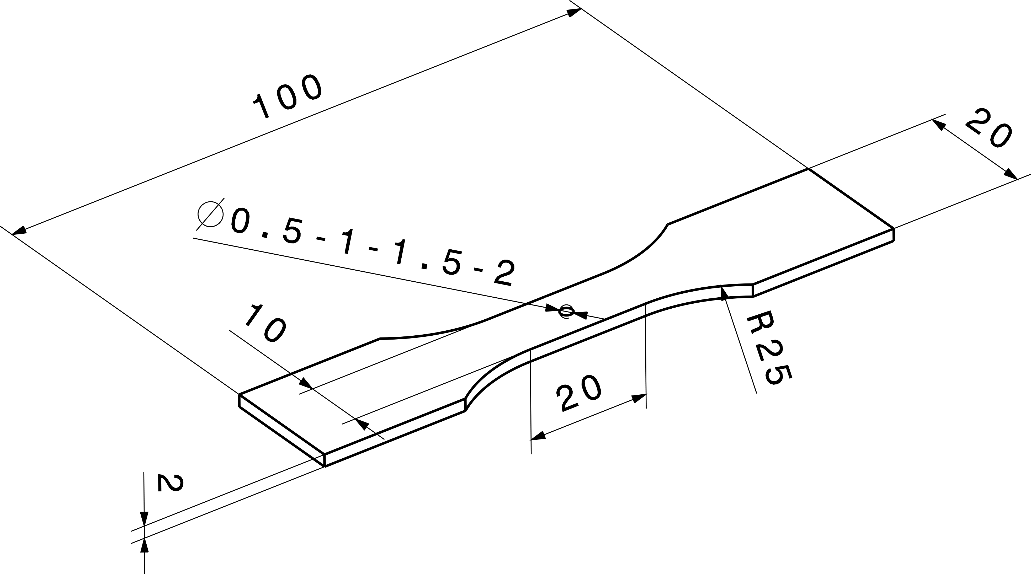

Figure 2. Notched specimen with different radii in mm

The mean values of the fibre orientation tensor for polyamide with 50%wt of E-glass fibre at specific areas along the plate, are shown in Figure 1. The extraction positions on the plate ( Figure 1) and the course of the fibre orientation along the plate are shown in [18]. Position 1 (plate centre) represents the fibre orientation in the centre of the transversal and position 3 (right specimen centre) the longitudinal extracted specimen. The Z-direction represents the melt flow direction. Figure 3 shows the mean values of the fibre orientation tensor at centre of the longitudinal and transversal orientated specimen, respectively.

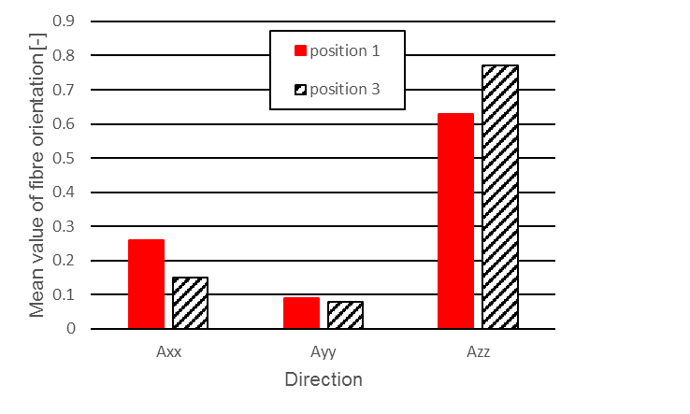

Figure 3. Mean values of the fibre orientation tensor at the centre positions of the longitudinal (position 3) and trasveral (position 1) orientated specimen

2.2 Fatigue Tests

Fatigue tests were performed on a electro mechanical testing machine BOSE ElectroForce AT3550. For the tests, specimen have been loaded with a stress ratio of R=0.1 at a frequency of f=10 Hz. In order to ensure a temperature increase below 5° C, a monitoring with a contact thermometer has been applied. The force regulation was performed to the nominal stress in the remaining cross-section. The fatigue tests were limited by specimen fracture or reaching a maximum of fatigue cycles N=10⁶.

3. Structure Simulations

Simulations with an anisotropic material model have been performed in order to recive the position and the value of the highest loaded point of the specimen. Further the stress gradient outward this point has been determined. The simulations were performed with both longitudinal and transversal oriented specimen. In order to get comparable results a meshing standard for notches, according to [19,20] has been used. The results show a nearly linear increase of the stress gradient with a decreasing notch radii from unnotched to a notch radius up to r=0.5 mm. Only the step between r=0.5 and 0.25 mm shows a disproportionate increase of the stress gradient, depicted in Figure 4.

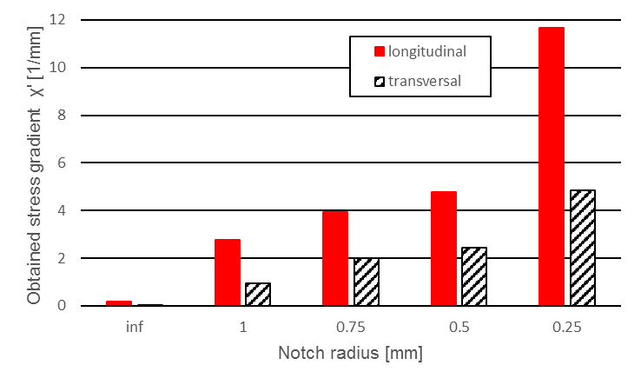

Figure 4. Optained stress gradient at different notch radii based on anisotropic simulations

4. Results

It can be shown, that the endurable fatigue strength of notched specimen at N=10⁶ is beneath those of unnotched, plotted in Figure 6. Further the S/N-curves of specimen with notch radii between r=0.5 and 1 mm show small differnces in position and slope, especially at transversal oriented specimen. Only the S/N-curve of the specimen with a notch radius of r=0.25 mm tends to those of the unnotched specimen, shown in Figure 5.

a)
b)

Figure 5. S/N-curves of transversal (a) and longitudinal specimen (b) with different notch radii.

It can be shown, that the notch effect number K_{f} is nearly constant despite different notch radii, but decreases with a notch radius of r=0.25 mm, derived from Figure 6.

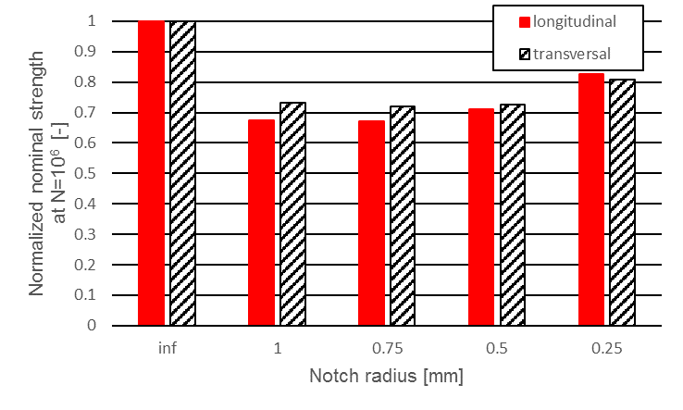

Figure 6. Nominal stress at different notch radii.

According to the model, in Equation. 3, the notch support number in the stress gradient model only depends on the local stress gradient χ’ to the power of K_{D}. It can be shown, that this model fits well with the experimental data, depicted Figure 5. Figure 4 shows the relative stress gradient χ’ is way higher for longitudinal fibre orientation, compared to transversal fibre orientation at the same notch radii. Therefore the notch support is also higher for longitudinal fibre orientation (Figure 7). In Figure 7, the test points of the specimen with a notch radius of r=0.25 mm are exemplary highlighted.

Figure 7. Notch support number depending on the stress gradient for different notch radii

5. Conclusions and Outlook

Fatigue tests on notched specimen have been performed. The results show an effect of the fibre orientation on the notch support effect. Moreover simulations have been carried out, to recive the local stress maxima and the stress gradients.
The results show a nearly constant notch effect number K_{f} from notch radius r=1mm up to a notch radius of r=0.5mm. Notches with a radius of r=0.25mm show an increasing notch effect number.
One reason for the different notch support between longitudinal and transversal oriented, notched specimen may be found in the different crack propagation. While longitudinal oriented fibres have inter alia an crack stopping (fibre bridging) effect, transversal orientated fibres just deflect cracks. Therefore the local endurable fatigue stress (maximal stress amplitude) is higher in longitudinal orientated specimen than transversal at certain notch radii. Another reason is the greater stress gradient in longitudinal fibre orientation at a certain notch sharpness, which leads to a smaller, high loaded areas. So, according to the statistical size effect, longitudinal fibre orientation is less sensitive to notches. Due to inner defects (for example at weak spots) the notch sensitivity of external notches decreases with notch radii near fibre length. The plastification capacity of transversal oriented specimen is, because the stresses are mostly absorbed by the matrix, higher compared to those of longitudinal. Nevertheless the higher maximal load of the longitudinal oriented specimen, leads to a higher stress rearrangement caused by plastification.
Further investigations and analysis of the fractured surfaces in order to get the reasons for this behaviour and to deviate a model, have to be done.

Acknowledgments

The research work of this paper was performed at the Chair of Mechanical Engineering at the Montanuniversität of Leoben in collaboration with the Polymer Competence Center Leoben GmbH (PCCL, Austria) within the framework of the COMET-program of the Austrian Ministry of Traffic, Innovation and Technology with contribution by Borealis Polyolefine GmbH, Engineering Center Steyr GmbH & CoKG (MAGNA Powertrain ECS), EVONIK Industries AG, Schaeffler Technologies AG & Co KG, Volkswagen AG as well as EMS-Chemie AG (EMS-Grivory) as associated partner. The PCCL is founded by the Austrian Government and the State Governments of Styria, Lower and Upper Austria.

References

[1]. C. Guster; G. Pinter; A. Mösenbacher and W. Eichlseder: Evaluation of a Simulation Process for Fatigue Life Calculation of Short Fibre Reinforced Plastic Components; Procedia Engineering 10 (2011) 0, pp. 2104–2109.
[2]. B. Unger; H. Fleischer; C. Guster and G. Pinter: Lebensdauerberechnung für Kunststoffkomponenten; in DVM-Tag 2008 Leichtbaustrategien (DVM Ed.), DVM, Berlin, 2008, pp. 39–51.
[3]. C. Gaier; H. Fleischer; C. Guster and G. Pinter: Einfluss von Faserorientierung Temperatur und Feuchtigkeit auf das Ermüdungsverhalten von kurzfaserverstärkten Thermoplasten; MP Material Testing 52 (2010) 7-8, p. 9.
[4]. A. Bernasconi; F. Cosmi and E. Zappa: Combined effect of notches and fibre orientation on fatigue behaviour of short fibre reinforced polyamide; Strain 46 (2010) 5, pp. 435–445.
[5]. R. Nienhaus and S. Kurzbeck: Influence of Notches on the Fatigue Behaviour of Short Fibre Reinforced Polyamide Considering Enviromental Temperature; in ECCM (Hg.) 2014–16th European Conference of Composite.
[6]. M. de Monte; E. Moosbrugger and M. Quaresimin: Influence of temperature and thickness on the off-axis behaviour of short glass fibre reinforced polyamide 6.6 – Quasi-static loading; Composites Part A: Applied Science and Manufacturing 41 (2010) 7, pp. 859–871.
[7]. A. Mösenbacher; J. Brunbauer; P. F. Pichler; C. Guster et al.: Modeling and validation of fatigue life calculation method for short fibre reinforced injection moulded parts; in 16th European Conference of Composite Materials (ECCM Ed.), 2014.
[8]. A. Bernasconi; E. Conrado; A. Cavallaro and P. J. Hine: A Local Stress Analysis of The Effect of Fibre Orientation on The Fatigue Behaviour of a Short Fibre Reinforced Polyamide; in 20th International Conference on Composite Materials (ICCM Ed.), 2015.
[9]. A. Primetzhofer; A. Mösenbacher and G. Pinter: Influence of mean stress and weld lines on the fatigue behaviour of short fibre reinforced polyamide; in 20th International Conference on Composite Materials (ICCM Ed.), 2015.
[10]. A. Mösenbacher and C. Guster: Fatigue behaviour of a short glass fibre reinforced polyamide; in 3nd Fatigue Symposium Leoben (Chair of Mechanical Engineering Ed.), Chair of Mechanical Engineering, Leoben, 2012, pp. 152–160.
[11]. E. Siebel and M. Stieler: Ungleichförmige Spannungsverteilung bei schwingender Beanspruchung; VDI-Zeitschrift 97 (1955), pp. 121–126.
[12]. W. Eichlseder: Fatigue analysis by local stress concept based on finite element results; Computers & Structures 80 (2002) 27–30, pp. 2109–2113.
[13]. M. Hück; L. Thrainer and W. Schütz: Berechnung von Wöhler-Linien für Bauteile aus Stahl, Stahlguss und Grauguss, synthetische Wöhler-Linien; VDE-Bericht ABF 11 (1981).
[14]. C. M. Sonsino and E. Moosbrugger: Fatigue design of highly loaded short-glass-fibre reinforced polyamide parts in engine compartments; International Journal of Fatigue 30 (2008) 7, pp. 1279–1288.
[15]. A. Mösenbacher; P. F. Pichler; J. Brunbauer; C. Guster et al.: Lebensdauerberechnung an Strukturbauteilen aus kurzfaserverstärkten Thermoplasten; in Die Betriebsfestigkeit als eine Schlüsselfunktion der Zukunft (DVM-Arbeitskreis Betriebsfestigkeit Ed.), 2013, pp. 301–316.
[16]. E. Haibach: Betriebsfestigkeit, Springer, Berlin, 2006.
[17]. J. Brunbauer; A. Mösenbacher; C. Guster and G. Pinter: Fundamental influences on quasistatic and cyclic material behavior of short glass fiber reinforced polyamide illustrated on microscopic scale; Journal of Applied Polymer Science 131 (2014) 19, n/a-n/a.
[18] A. Primetzhofer; A. Mösenbacher and G. Pinter: Fatigue Design Methodology for Short Fibre Reinforced Polymers Considering Fibre Orientation and Weld Lines; in Polymer procesing society Asia/Australia Conference 2016 (PPS Ed.), 2016, pp. 203–204.
[19] A. Primetzhofer; G. Stadler; G. Pinter and F. Grün: Lebensdauerberechnung - Konzepte für prozessabhängige Materialien am Beispiel faserverstärkter Kunststoffe; in (R)Evolution des Antriebs - Auswirkung auf die Betriebsfestigkeit der Bauteile in der Wirkungskette (DVM Ed.), Berlin, 2017, pp. 241–256.
[20]. W. Fricke: Guideline for the Fatigue Assessment by Notch Stress Analysis for Welded Structures; IIW-Doc. (2009) XIII-2240r1-08/XV-1289r1-08.

