THERMO-MECHANICAL BEHAVIOUR OF THERMOPLASTIC COMPOSITE LAMINATES WITH THERMAL ENERGY STORAGE/RELEASE CAPABILITY

A. Dorigato, G. Fredi, T. Meneghini and A. Pegoretti

University of Trento, Department of Industrial Engineering, Via Sommarive 9 38123 Trento, Italy
Email: andrea.dorigato@unitn.it
Web Page: https://webapps.unitn.it/du/it/Persona/PER0009668/Curriculum

Keywords: composites, polyamide 12, thermal energy storage, phase change materials

Abstract
Multifunctional thermoplastic composites with thermal energy storage/release properties were produced by using a glass fabric, a polyamide 12 (PA12) matrix and two different phase change materials (PCMs), i.e. a microencapsulated paraffin wax and a carbon nanotubes shape stabilized paraffin. The melt flow index of the matrices (i.e the PA12/PCM blends) decreased with the PCM amount, while differential scanning calorimetry (DSC) tests highlighted that for the matrices with microcapsules, the melting enthalpy was about the 70% of the theoretical value, because of the fracture of some microcapsules during the compounding process. On the other hand, paraffin leakage and/or degradation in matrices with shape stabilized wax determined a considerable drop of the melting enthalpy. For all the compositions of the matrices, glass fabric reinforced laminates showed similar fiber and void volume contents, except for that with the highest amount of shape stabilized wax. Mechanical behaviour of the resulting composites was only marginally impaired by PCM introduction, while a more important decrease of the stiffness, of the failure properties and of the interlaminar shear strength was registered in the shape-stabilized wax systems.

1. Introduction

Thermal energy storage (TES) systems, being able to store and release thermal energy in certain temperature intervals, are widely applied in thermal management applications in order to reduce the discrepancy between energy availability and demand [1]. In phase change materials (PCMs), thermal energy is stored/released through reversible solid/solid or solid/liquid phase transitions, and are generally classified as organic, inorganic or eutectic. Because of their elevated energy density, small volume change during phase transition, narrow working temperature range, tunable operating temperature, low density and cheapness, organic PCMs, and particularly paraffin waxes, are probably the most widely utilized [2]. Generally speaking, the drawbacks of organic PCMs are related to their limited thermal conductivity and their need to be confined to avoid leakage at the molten state [3]. In order to solve this problem, it is possible to encapsulate PCMs in organic or inorganic micro and nanoshells, protecting thus PCM from the external environment. Otherwise, it is possible to confine the PCM though a polymer matrix, a porous material or an inorganic nanofiller (i.e. shape stabilization).
In most cases, multifunctional materials are prepared adding a dedicated module containing PCMs. However, in this way a substantial increase of the mass and of the volume of the components often results. Therefore, it could be interesting in many cases to develop a multifunctional structure able to contribute to the thermal management. At this aim, in literature many papers on encapsulated or shape stabilized PCMs incorporated in polymer matrices can be found, while only few works dealing with the characterization of multifunctional composite structures with TES functions can be found [4]. Recently, multifuctional epoxy/carbon fiber laminates with different contents of a CNTs stabilized paraffin were prepated and thermo-mechanically characterized [5]. Because of their good fracture toughness and impact resistance, unlimited shelf life at room temperature, limited cost and relatively short fabrication time [6], fiber reinforced thermoplastics (FRTs), both in combination with long and short fibers, are attracting both the industrial and the academic interest. Quite surprisingly, no papers focused on the development of structural thermoplastic composites with TES capability can be found in the open literature.
Therefore, the objective of the present paper is that to prepare and thermo-mechanically characterize FRTs systems with a PA12 and E-glass fabrics, in which TES capability in the temperature interval 40-50 °C was obtained by adding two different PCMs at various concentrations, i.e. (1) a commercial microencapsulated PCM with a paraffinic core and a melamine formaldehyde shell, and (2) a paraffin shape stabilized with CNTs. The most promising compositions of the matrices were then utilized to prepare composite laminates reinforced with glass fiber fabrics.

2. Experimental

Microtek MPCM43D paraffin microcapsules, constituted by a paraffin wax having a melting temperature of 43 °C encapsulated in a melamine formaldehyde shell (10-15 wt% of the total PCM mass), were supplied by Microtek Laboratories Inc. (Dayton, OH, USA). These microcapsules had a mean size of 17-20 µm, and a melting enthalpy of 190-200 J/g. Following an experimental approach recently reported by our group [5], shape stabilized PCM (ParCNT) was produced mixing paraffin wax with CNTs at a relative concentration of 85:15. In this case a RT44HC paraffin, provided by Rubitherm Technologies GmbH (Berlin, Germany), was utilized (melting temperature = 44 °C, melting enthalpy = 240 J/g), while multi walled carbon nanotubes NC7000® were acquired by Nanocyl SA (Sambreville, Belgium), and were characterized by a diameter 9.5 nm, a length 1.5 µm and a BET surface area of 250 300 m²/g. Polymeric chips of a Rilsan® PA12 thermoplastic matrix, supplied by Arkema Group (Lyon, France) (density 1.01 g/cm³, melting temperature 174 °C) were utilized as matrix. Bidirectional E-glass fiber fabrics (GF), having a mean fiber diameter of 12 µm, were provided by Angeloni Srl (Venice, Italy). All the materials were used as received.
PA12/PCM blends were produced through melt compounding at 200 °C in a Thermo Haake Rheomix 600 mixer at various PCM concentrations (from 15 wt% to 60 wt%), keeping a rotor speed of 60 rpm and a mixing time of 5 minutes. The resulting materials were hot pressed in a Carver press at 200 °C for 5 minutes at a pressure of 1.75 MPa. Square sheets 120 wide and 2 mm thick of neat PA12 and PA12/PCM blends at different relative concentrations were prepared. Neat PA12 sample was called PA12-N, while the blends with capsules were designed as PA12-Cx and the blends with ParCNT were denoted as PA12-Px (x = 15, 30, 45, 60). The blends with the most promising compositions were utilized to prepare laminates with E-glass fiber fabrics at five different matrix compositions, i.e. PA12 N, PA12-C30, PA12-C60, PA12-P30 and PA12- P60. PA12/PCM sheets with a thickness of 0.3 mm were prepared through melt compounding and hot pressing and alternated to the glass fiber fabric to prepare composites with 5 laminae. With this stacking sequence, laminates 120 mm wide and 2 mm thick were prepared through hot pressing at 200 °C for 5 minutes at a pressure of 3.4 MPa. The resulting composites were designated as GF N, GF-C30, GF-C60, GF-P30 and GF-P60.
Melt flow index (MFI) tests were carried out with a Dynisco LMI D4000 machine at 230 °C and with a weight of 2.16 kg. Density measurements were performed at 23°C through a Micrometrics AccuPyc 1330TC pycnometer, as the average of 99 consecutive measures. Scanning electron microscopy (SEM) micrographs of the cryofractured matrix samples were taken through a Jeol IT300 microscope at an accelerating voltage of 10 kV, after Pt-Pd sputtering. Differential scanning calorimetry (DSC) was carried out in a temperature interval between 0 and 230 °C at a heating/cooling rate of 10 °C/min, under a nitrogen flow of 150 ml/min. Thermogravimetric analysis (TGA) was performed between 30 °C and 700 °C, at a heating rate of 10 °C/min, by using a Mettler TG 50 machine under a nitrogen flow of 200 ml/min. Vicat tests were conducted following the ASTM D 1525 standard at a heating rate of 120 °C/h and under an applied load of 10 N, in a silicone oil bath, testing samples with dimensions 10x10x5 mm³. Quasi-static tensile tests on the matrices were carried out with a universal testing machine Instron 4502 according to the ASTM D638-10 standard, using dumbbell 1BA specimens (standard UNI EN ISO 527-2). Five specimens were tested for each composition at 0.25 mm/min for the determination of the elastic modulus, by using a resistance extensometer with a gauge length of 12.5 mm, while five other specimens were tested until failure, at a crosshead speed of 10 mm/min.
Optical microscope images of the laminates were acquired with a Leica DM6000M microscope. The density at 23 °C of the laminates was determined with a He pycnometer Micrometrics AccuPyc 1330TC, as the average of 99 measures. DSC and TGA tests were performed with the same parameters utilized for the matrices. Quasi-static tensile tests were carried out on the laminates, according to the ASTM D3039 standard, by using an Instron 4502 universal testing machine equipped with a 10 kN load cell, testing rectangular specimens 100 x 10 mm² (and the thickness of the laminate), cut from each laminate. Interlaminar shear strength of the laminates were performed according to ASTM D 2344 standard by using an Instron 5969 testing machine, by using samples 15 x 5 x 2 mm³, fixing a span length of 8 mm and a crosshead speed of 1 mm/min.

3. Results and Discussion

For as the processability of the matrices with microcapsules is concerned, it is interesting to note that MFI decreases with the capsule content, with a minimum of 5.2 g/10 min for the PA12-C60 sample. The same trend can be detected in the matrices with CNT-stabilized paraffin, but the decrease is more dramatic. In fact, the MFI is halved with a ParCNT concentration of only 15 wt%, and is close to 0.7 g/10 min for a ParCNT amount of 30 wt%. It is probable that the CNT introduction led to a noticeable increase of the viscosity of the polymer at the molten state. Comparing the two PCM systems, it is clear that the effect of the capsules is less intense than that of the ParCNT, indicating a better processability of this PCM in the preparation of the laminates.
In SEM images of the PA12-C15 and PA12-C60 samples, capsules with diameters from 5 to 20 µm can be detected, together with a rather good adhesion between PA12 and the organic shell of the capsules. It is important to notice that some capsules are broken, probably because of the elevated shear stresses applied during the production process or the cryofracture operations. Moreover, the microcapsules seem to be uniformly dispersed within the matrix, with a morphological continuity of the polymer matrix. In the sample with 15wt% of ParCNT small domains of the PCM phase can be dectected, but the interfacial adhesion is poorer than that observed with the capsules. However, the PCM domains are not visible in the PA12-P60 sample. In the micrographs of other specimens with the same composition a non uniform distribution of the ParCNT and the presence of large domains, with a mean dimension of 500 µm, was observed.
In Table 1 the most important results of DSC tests on the prepared matrices are summarized. For the matrices with capsules, the PCM melting enthalpy increases with the capsules concentration, and the relative melting enthalpy is about the 70% of the theoretical one. This is probably because some capsules were damaged during the thermal processing of the matrices, with a partial paraffin leakage out of the blend. However, the greatest fraction of the thermal energy storage/release capability is retained. On the contrary, in the matrices with ParCNT, the PCM melting enthalpy values are rather limited and are in the range 14-21 J/g, well below the expected ones. This probably means that paraffin was degraded or leaked out of the matrix during the processing. Moreover, a PA12 crystallization temperature increase of 5 °C can be detected in ParCNT blends.
The paraffin leakage/degradation detected in the matrices is visible also in the TGA results. TGA curves shift to lower temperature increasing the capsules content, with a consequent decrease of the temperatures associated to a mass loss of the 1% (T_{1%}) and of the 5% (T_{5%}). This behaviour can be explained considering that PCM capusles are a lower degradation temperature with respect to neat PA12, and also ParCNT powder has a limited degradation peak temperature (T_{d}), i.e. 210 °C. It can be therefore concluded that PCM encapsulation within PA12 delays the degradation of the PCM and improves the overall thermal resistance, while CNTs do not show any significant thermal barrier effect.

Table 1. Results of the DSC tests on the prepared matrices.
Sample | [°C] | [J/g] | [%] | [°C] | [J/g] | [°C] | [J/g] | [°C] | [J/g]
PA12-N | -- | -- | -- | 181.2 | 47.9 | -- | -- | 155.7 | 52.0
PA12-C15 | 43.9 | 20.5 | 68.3 | 179.8 | 40.9 | 32.4 | 18.1 | 153.2 | 40.8
PA12-C30 | 45.9 | 46.8 | 77.9 | 179.3 | 35.6 | 23.0 | 46.8 | 152.0 | 36.0
PA12-C45 | 46.2 | 61.2 | 67.9 | 172.2 | 31.0 | 24.7 | 61.2 | 155.7 | 31.1
PA12-C60 | 49.1 | 76.2 | 63.8 | 180.2 | 25.9 | 21.8 | 71.7 | 152.6 | 23.8
PA12-P15 | 43.3 | 16.1 | 57.3 | 172.2 | 46.6 | 33.2 | 11.3 | 160.5 | 46.3
PA12-P30 | 43.1 | 21.1 | 37.6 | 177.7 | 42.6 | 32.6 | 15.6 | 165.4 | 42.8
PA12-P45 | 43.5 | 14.0 | 16.7 | 178.4 | 42.8 | 29.2 | 8.6 | 158.7 | 41.3
PA12-P60 | 44.0 | 16.4 | 14.6 | 178.0 | 46.4 | 30.4 | 12.2 | 160.7 | 46.1

melting temperature of the PCM [°C]
= PCM melting enthalpy [J/g]
= relative PCM melting enthalpy [%]
melting temperature of PA12 [°C]
melting enthalpy of PA12 [J/g]
= crystallization temperature of the PCM [°C]
= PCM crystallization enthalpy [J/g]
= crystallization temperature of PA12 [°C]
crystallization enthalpy of PA12 [J/g]

The most important results of the mechanical properties of the matrices are summarized Table 2. All the blends present lower mechanical properties with respect to neat PA12, probably because of the poor mechanical properties of the PCMs themselves, with a negative trend with the PCM concentration. The only exception is the increase of the elastic modulus in the matrices with ParCNT, probably due to the increase of CNTs amount in the matrices. These results are in accordance with the conclusions reported in Vicat tests, where the Vicat softening temperature (VST) of the blends are similar to that of the PA12-N, meaning that the melting of both PCMs is not responsible of a substantial softening of the matrix. In the ParCNT based blends, the VST slightly increases with the PCM content, probably because of the presence of CNTs in the matrices.

Table 2. Results of quasi-static tensile tests and Vicat tests on the prepared matrices.
Sample | [MPa] | [MPa] | [MPa] | [MPa] | [%] | VST  [°C]
PA12-N | 1794 ± 91 | 52.5 ± 1.4 | 13.4 ± 1.6 | 40.3 ± 1.9 | 20.0 ± 1.3 | 175.3
PA12-C15 | 1340 ± 73 | 34.7 ± 1.2 | 5.7 ± 0.2 | 34.7 ± 1.2 | 5.7 ± 0.2 | 172.5
PA12-C30 | 1007 ± 49 | 24.6 ± 1.5 | 5.3 ± 0.7 | 24.6 ± 1.5 | 5.7 ± 0.2 | 173.2
PA12-C45 | 1027 ± 29 | 24.8 ± 4.5 | 4.2 ± 1.0 | 24.6 ± 1.5 | 4.2 ± 1.0 | 172.5
PA12-C60 | 973 ± 39 | 20.0 ± 2.2 | 5.6 ± 0.8 | 20.0 ± 2.2 | 5.6 ± 0.8 | 173.2
PA12-P15 | 1316 ± 67 | 29.8 ± 4.6 | 5.1 ± 1.4 | 27.5 ± 3.4 | 5.5 ± 1.6 | 173.2
PA12-P30 | 1345 ± 17 | 32.3 ± 2.4 | 6.4 ± 1.3 | 31.8 ± 2.7 | 6.7 ± 1.3 | 174.6
PA12-P45 | 1378 ± 38 | 27.6 ± 2.5 | 4.2 ± 0.7 | 22.7 ± 6.6 | 4.2 ± 0.6 | 175.7
PA12-P60 | 1529 ± 55 | 24.1 ± 6.5 | 3.3 ± 1.3 | 23.2 ± 7.3 | 3.3 ± 1.2 | 179.4

As s summary, the microstructural and thermo-mechanical characterization of the matrices revealed that the capsules may be more suitable than Par CNT in combination with the PA12, in view of the production of long fiber multifunctional composites. Neverthless, in this work composites with both matrix systems at two different PCM fractions (30 wt% and 60 wt% respect to the matrix), were prepared and characterized.
In Fig. 1(a-f) optical microscope images of the polished surface of the produced laminates are reported. From the images at lower magnification (Figure 2a, b, c, e, f) it can be detected that in all the laminates the fibers are homogeneously wetted and maintained the original orientation. A good fiber wetting can be better appreciated in the high magnification image of GF-C60 (Figure 2d), where it is possible to appreciate the capsules in the interlaminar region. As an exception, in GF-P60 laminate (Figure 2f) the fibers are not clearly wetted and an evident distortion of the fabric is highlighted. Moreover, the high viscosity of the matrix in this laminate determines a non homogeneous distribution of the matrix across the thickness of the laminate and an incomplete wetting of the fabric can be easily observed.

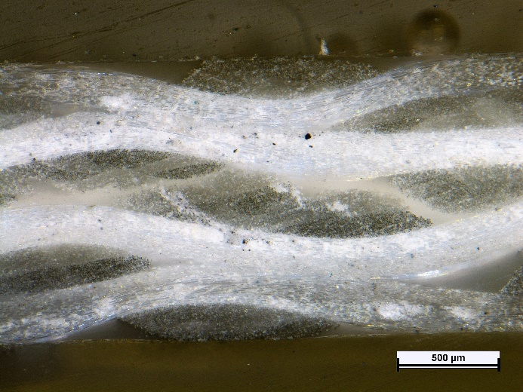 | 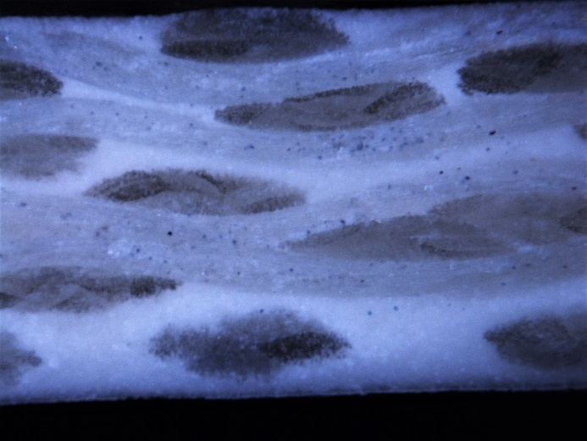
(a) | (b)
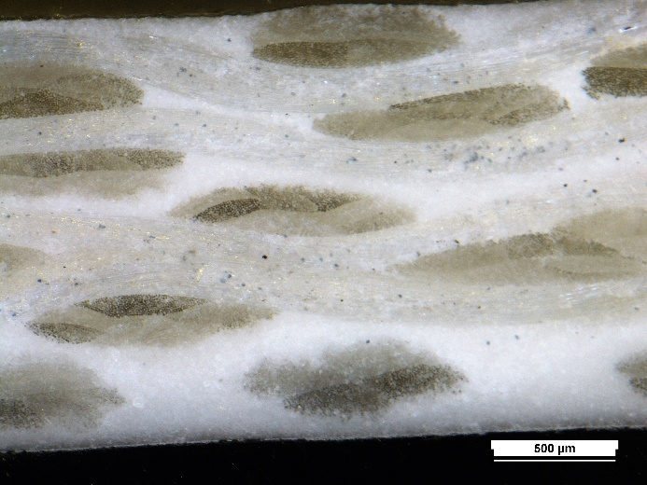 | 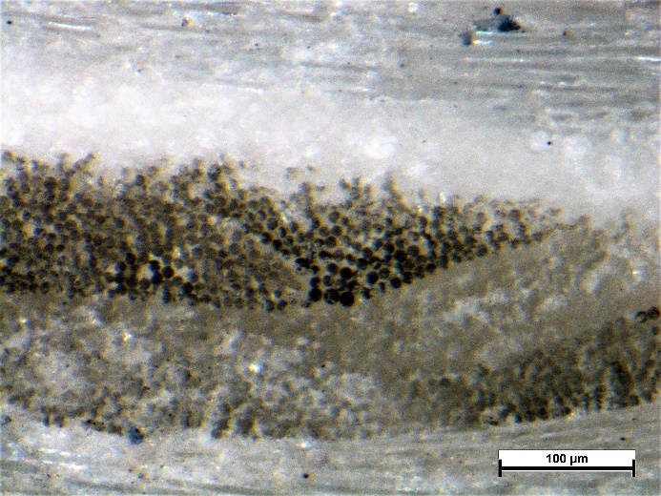
(c) | (d)
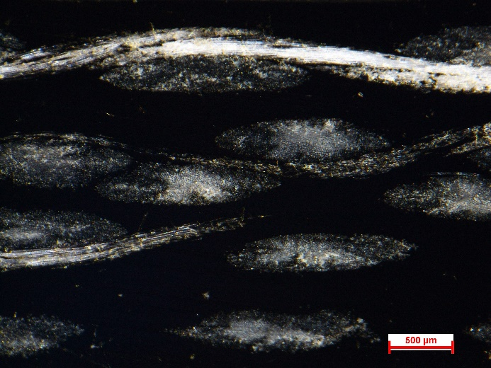 | 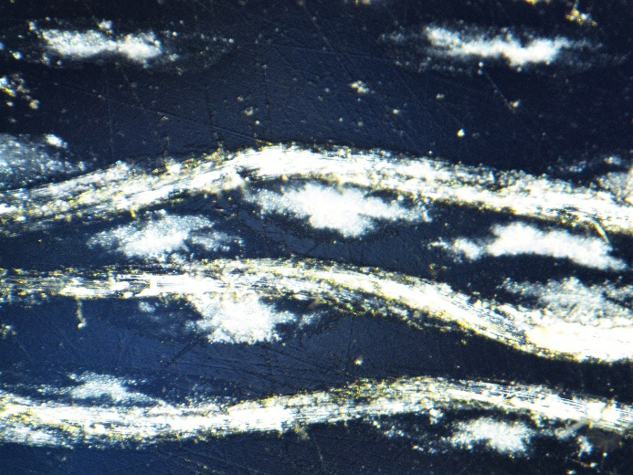
(e) | (f)

Figure 1. Optical microscope images of the polished surface of the prepared laminates (a) GF-N, 48x; (b) GF-C30, 48x; (c) GF-C60, 48x; (d) GF-C60, 256x; (e) GF-P30, 48x; (f) GF-P60, 48x.

The real weight and volume fraction of the consitutents and of the voids in the laminates was determined through termogravimetric analysis and helium picnometry. The fiber volume fraction is around 50-55% for the GF-N, GF-C30, GF-C60 and GF-P30 laminates, and also the volume fraction of voids is similar in these samples (around 2 vol%). Therefore, the mechanical properties of these laminates can be directly compared. On the contrary, the GF-P60 laminate presents a much higher void content (9.8 vol%), in accordance with the optical microscope micrographs, and also the fiber volume content is noticeably lower (i.e. 32.7 vol%). The properties of this laminate could not be directly compared with those of the other laminates.
In Table 3 the results of DSC tests on the prepared composites are compared. Similarly to what happens with the matrices, GF-P60 is the laminates with the highest melting enthalpy (i.e. 17.1 J/g). Considering relative melting enthalpy values, it is evident that the lamination process causes a further breaking of the capsules and degradation of the paraffin, further decreasing the thermal energy storage/release capability in the composites. In the future it will be necessary to prevent microcapsules damage to improve the thermal energy storage/release properties of the laminates. Once again, the samples with ParCNT have a stronger decrease of the relative melting enthalpy with respect to the matrices, probably because ParCNT degrades more than the microencapsulated PCM, in good agreement with the TGA results. Therefore, it can be concluded that the microcapsules can be more effectively incorporated in glass fiber/PA12 laminates.

Table 3. Results of the DSC tests on the prepared laminates
Sample | [°C] | [J/g] | [%] | [°C] | [J/g] | [°C] | [J/g] | [°C] | [J/g]
GF-N | -- | -- | -- | 179.9 | 11.5 | -- | -- | 154.2 | 11.4
GF-C30 | 43.9 | 6.5 | 44.2 | 178.8 | 8.7 | 25.2 | 3.1 | 152.4 | 8.3
GF-C60 | 46.3 | 17.1 | 52.7 | 178.9 | 8.5 | 23.2 | 13.8 | 152.4 | 8.0
GF-P30 | 43.0 | 5.3 | 31.9 | 178.5 | 16.2 | 39.7 | 2.0 | 160.3 | 16.1
GF-P60 | 43.5 | 8.4 | 15.8 | 178.7 | 21.0 | 31.3 | 5.6 | 160.1 | 21.0

melting temperature of the PCM [°C]
= PCM melting enthalpy [J/g]
= relative PCM melting enthalpy [%]
melting temperature of PA12 [°C]
melting enthalpy of PA12 [J/g]
= crystallization temperature of the PCM [°C]
= PCM crystallization enthalpy [J/g]
= crystallization temperature of PA12 [°C]
crystallization enthalpy of PA12 [J/g]

The mechanical behaviour of the prepared composites was then investigated through tensile and short beam shear tests, and in Table 4 the most important results are reported. The stress at break is decreased upon PCM addition, especially in the laminates with ParCNT, for which also a decrease of the elastic modulus with respect to the GF-N sample can be detected. Interestingly, the elastic modulus of the laminates with capsules do not considerably differ for that of GF-N, meaning that for these samples the stiffness is influenced mainly by the elastic properties of the fibers, and the matrix is able to effectively transfer the load to the fibers. Considering that also the strain at break is not negatively affected by the PCM introduction, it can be stated that with microcapsules addition the mechanical properties are substantially retained, while ParCNT addition determines a sensible drop of both the stiffness and of the failure properties. The same conclusions are also valid for the interlaminar shear strength values (ILSS). The experienced ILSS decrease of the laminates with ParCNT can be attributed to the poor interfacial adhesion, because of the high viscosity and the limited mechanical properties of the matrices with ParCNT.

Table 4. Results of the quasi-static tensile tests and short beam shear tests on the prepared laminates.
Sample | [GPa] | [MPa] | [%] | ILSS  [MPa]
GF-N | 13.1 ± 0.3 | 160 ± 29 | 2.7 ± 0.3 | 11.2 ± 1.7
GF-C30 | 12.7 ± 0.9 | 124 ± 18 | 3.0 ± 0.4 | 9.8 ± 1.7
GF-C60 | 13.3 ± 0.7 | 114 ± 10 | 3.0 ± 0.7 | 9.4 ± 2.1
GF-P30 | 9.9 ± 0.4 | 92 ± 9 | 3.5 ± 0.1 | 6.7 ± 0.3
GF-P60 | 6.5 ± 0.1 | 56 ± 15 | 3.5 ± 1.1 | 5.5 ± 1.8

4. Conclusions

Glass fiber reinforced thermoplastic composite laminates with thermal energy storage/release capability were developed through a PA12 matrix and two different paraffin based PCMs (microcapsules and ParCNT), and a themo-mechanical characterization of the resulting materials was then performed. The fluidity of the PA12 decreased with the PCM content, especially for the matrices with ParCNT, suggesting that the systems with microcapsules could be more easilty processed. DSC tests on the PA12/microcapsules blends revealed an enhancement of the melting enthalpy with the PCM concentration, with a relative enthalpy value of about 70%. This means that a partial breakage of the capsules and leakage/degradation of the PCM occurred. A more consistent drop of the melting/crystallization enthalpy was detected for the matrices with ParCNT, because of a more intense paraffin degradation and leakage during the thermo-mechanical processing. Quasi-static tensile tests revealed that PCM addition within PA12 led to a general drop of the mechanical properties, because of the lower mechanical properties of the PCM and the non optimal adhesion with PA12 matrix. On the other hand, Vicat Softening Temperature was practically not affected by the presence of the PCMs.
The thermo-mechanical characterization of the laminates demonstrated that all the composites had approximatively the same fiber and void volume concentration, expect those with the highest amount of ParCNT, where the elevated viscosity of the matrix lead to a lower fiber fraction and higher void content. The relative melting enthalpy values were lower than those of the corresponding matrices, meaning that the lamination process caused a further damage of the capsules and degradation of paraffin. Interestingly, the mechanical performancs of the laminates were only slightly affected by microcapsules addition, while in the composites with ParCNT a more evident decrease of the elastic modulus, of the stress at break and of the interlaminar shear strength could be detected.

References

[1] K. Pielichowska, K. Pielichowski K. Phase change materials for thermal energy storage. Progress in materials science, 65:67-123, 2014.
[2] S. Himran, A. Suwono, G.A. Mansoori. Characterization of alkanes and paraffin waxes for application as phase change energy storage medium. Energy Sources, 16:117-128, 1994.
[3] R.K. Sharma, P. Ganesan, V.V. Tyagi, H.S.C. Metselaar, S.C. Sandaran. Developments in organic solid-liquid phase change materials and their applications in thermal energy storage. Energy Conversion and Management, 95:193-228, 2015.
[4] S. Yoo, E. Kandare, R. Shanks, M.A. Al-Maadeed, A. Afaghi Khatibi. Thermophysical properties of multifunctional glass fibre reinforced polymer composites incorporating phase change materials. Thermochimica Acta, 642:25-31, 2016.
[5] G.Fredi, A. Dorigato, L. Fambri, A. Pegoretti. Wax confinement with carbon nanotubes for phase changing epoxy blends. Polymers, 9:405-420, 2017.
[6] P.K. Mallick P. K. Fiber reinforced composites. Materials, manufacturing, and design.Taylor & Francis Group, 2008.

