A potential failure mode of honeycomb enhanced silica-based thermal protection material

Zhou Fang¹, Kezhu Mao¹ , Lijuan Luo¹, Xin Liang¹, Hongjie Sun¹, Yi Zhang¹ and Hongjun Guo¹

¹ Aerospace Research Institute of Materials & Processing Technology, Beijing,P R China
Email: ffzzxbk@163.com

Keywords: honeycomb enhanced ablator, ablation behavior, failure mode, forming process

Abstract

Honeycomb enhanced silica-based thermal protection materials are widely employed in the thermal protection system for various spacecrafts. The qualities of the material are evaluated by mechanical tests, nondestructive tests and arc-jet tests. After one ablation test, the surface of the material was fragmented, different from a smooth morphology. The surface recession rate was much higher than normal, increasing from 0.1535 mm/s to 0.2196 mm/s. This indicated that the material failed during ablation, even had passed a series of rigorous tests. The morphology of ablative material was analyzed by microscope and SEM. The aggregations of inner micro pores were observed, which could not be detected by X-Ray nondestructive test. During ablative test, the charring structure become much weaker near the pore aggregation locations, which were corroded and peeled easily under the effect of both inner pyrolysis gas and external hypersonic thermal airstream. To minimize the aggregation of the inner micro pores, an accurate processing parameter limitation is determined by researching the growth rate of viscosity of raw material. This indicates that a mature heritage honeycomb enhanced silica-based thermal protection material may fail for a new reason. The manufacturing process has to be under elaborate control.

1. Introduction

Honeycomb enhanced silica-based thermal protection material is composed of honeycomb with ablator composites inside. This kind of material has been employed in many spacecrafts, such as AVCOAT 5026-39 HC/G in Apollo[1], Lockheed Martin’s SLA-561V [2], H96 or H88 in Shenzhou[3] and etc. The material protects spacecrafts from the ultra high temperature during reentry, by ablation mechanism. This protection process generally consists of thermal deformation of material, diffusion of inner pyrolysis gas, thermal blockade effect, radiation cooling on surface and etc.
Ablator materials are usually evaluated by stagnation ablation tests. During the tests, recession rate, mass losing rate, surface and background temperature are recorded. Then the material is in deep analysis with these data. After one stagnation ablation test, one honeycomb enhanced silica-based ablator (marked as material A) lost the surface charring layer seriously and the surface became out of flatness. This results must be forbidden, for the rugged morphology can cause the imbalance aerodynamic configuration and the unpredictable thermal protect effect, which may result in mission failed. Considering material A has been evaluated many times by stagnation ablation tests with the same parameters, the reason why this material failed must be found. This paper analysises the failure mode and discusses the mechanism. A new processing parameter is proposed to control the quality of honeycomb enhanced silica-based thermal protection material.

2. Materials and Methods

2.1. Manufacturing Procedure

Silicone rubber was mixed with glass sphere and some other fillers under stirring until the green material was homogeneous. Then the green material was pressed into honeycomb under a specific pressure in autoclave. The material was then solidified and processed into a cylinder with a bulb in front, as stagnation sample.

2.2. Experiment Methods

The tests were conducted by arc wind tunnel facility named FD04 in China Academy of Aerospace Aerodynamics. The parameters were air flow, heat flux of 6MW/m², stagnation pressure of 40kPa, and heating time of 33s. The background temperatures of samples during tests, the weight of samples before and after tests, and the thickness of samples before and after tests have been recorded.
The mass losing rate was calculated with Eq(1). The surface recession rate was calculated with Eq(2). The effective ablation heat was calculated with Eq(3).
$m_{t}=\frac{m_{1}−m_{2}}{t}$ (1)
$V_{t}=\frac{L_{1}−L_{2}}{t}$ (2)
$H_{T}=\frac{q_{\text{scw}}×t}{(m_{1}−m_{2})/S}$ (3)
m_{t}: mass losing rate, g/s
m₁: weight of sample before test, g
m₂: weight of sample after test, g
t: test time, s
Vt: surface recession rate, mm/s
L1: thickness of sample before test, mm
L2: thickness of sample after test, mm
H_{T}: effective ablation heat, kJ/kg
q_{scw}: stagnation cooling wall heat flux, kW/m²
S: surface area, m²

3. Material Responses and Discuss

3.1. Ablation Properties

The normal samples and failure samples are marked as material A-N and material A-F, respectively. The results are summarized in Table 1. The data were an average of 3 samples. There were no differences between material A-N and material A-F in all ablation properties, except surface recession rate. Statistically significant difference of surface recession rate Vt was observed between material A-N and material A-F (p＜0.05, n≥3). There were no significant differences for the density, effective ablation heat, highest background temperature and mass losing rate between material A-N and material A-F.

Table 1. Ablative Performance of material A-N and material A-F
Sample | density  （g/cm³） | （kJ/kg） | Vt（mm/s） | m_{t}  （g/s） | Highest background temperature（℃）
A-N | 0.715 | 19946 | 0.1535 | 0.8289 | 58
A-F | 0.700 | 20028 | 0.2196 | 0.8439 | 62

3.2. Ablation Morphologies

In general, the ablator can be divided into charring layer, pyrolysis zone and virgin material from surface to back. The zone being degradation is defined as pyrolysis zone, and the remaining completely pyrolysis zone is defined as charring layer. The surface morphologies of material A are shown in Fig.1. The surface charring layer of material A-N was intact and smooth, while the surface charring layer of material A-F was fragmentary. The charring layer of material A-F was missing and the inner layer exposed, as the darker area in Fig.1(b). The exposed inner layer was sunken than the surrounding charring layer.

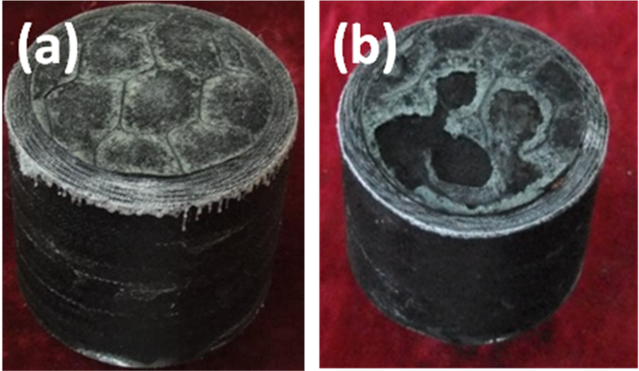
Figure 1. the surface of (a)material A-N and (b)material A-F after ablation test.
Several moments of material A-F ablation are shown in Fig.2. The ablator surface retreated steadily at first, as shown in Fig.2(a). The organic compounds began to degradation during ablation. In general, the charring layer is porous, so that the pyrolysis gas can overflow through the charring layer. The surface charring layer remain intact and ablation recession slightly, if the material ablates normally. The charring layer of material A-F was jacked up by pyrolysis gas and blew away by the shearing force of heat flux, as shown in Fig.2(b) and Fig.2(c). Once a piece of charring layer was missing, there was a pit appeared on the surface. The rugged surface increased the local heat flux and aggravated the ablation, resulting in increasing ablation recession. So the surface recession rate of material A-F was much higher than normal (material A-N), as shown in Table 1.
This non uniform ablation recession must be forbidden. The local missing charring layer will destroy the designed aerodynamic configuration, increasing the difficulty of spacecraft control. Furthermore, the uncertain ablation recession will reduce the thickness of heat shield, which is disastrous for the safety of thermal protection system.

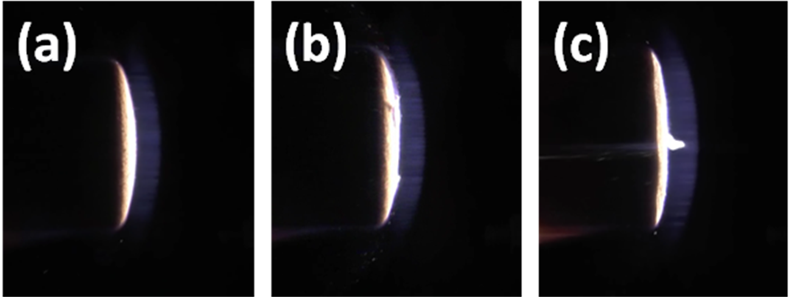
Figure 2. video stills of material A-F at (a)1s, (b)5s and (c)20s during ablation.

As mentioned above, an ablator can be divided into charring layer, pyrolysis zone and virgin material from ablation surface to back. The sections of both material A-N and material A-F are shown in Fig.3. Although both pyrolysis zones were porous, the pyrolysis zone of material A-F was much weaker, as shown in Fig3(b). The crack in pyrolysis zone of material A-N was a damage of cutting the sample. The whole charring layer of material A-F was much thinner than normal, due to the missing charring layer, as shown in Fig3(b).

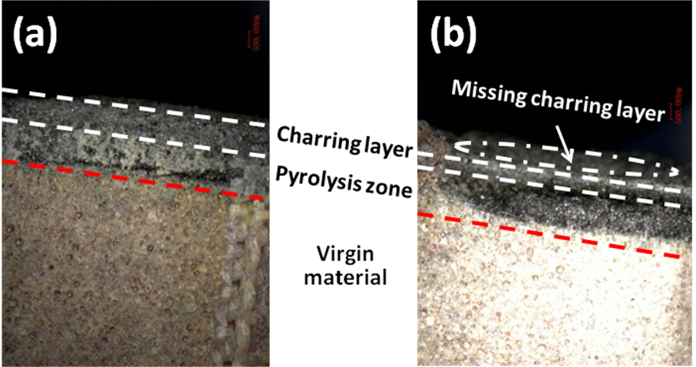
Figure 3. Section of (a)material A-N and (b)material A-F after ablation test.

The enlarged view of surface is shown in Fig.4. The inner charring layer was under the missing charring layer in Fig.3(b). The inner charring layer was less charred than the intact charring layer, with a color of black, rather than a color of green of the intact charring layer. The boundary was apparent, because of the altitude and color differences between the intact charring layer and the inner charring layer.

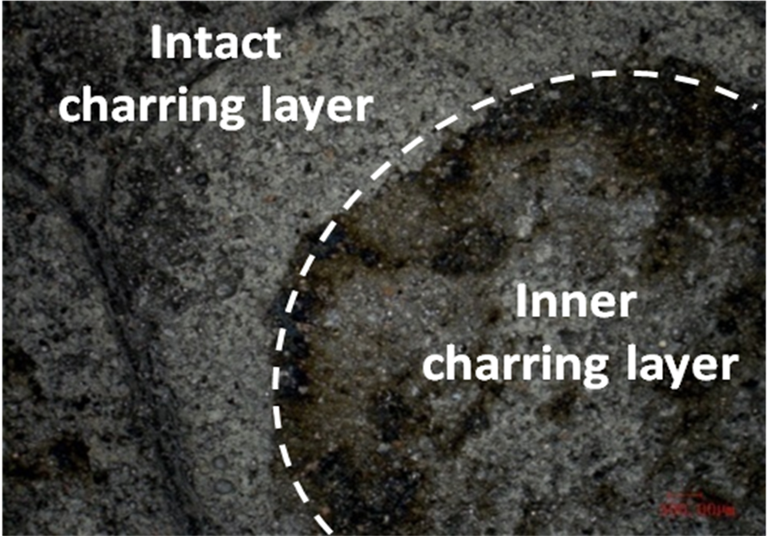
Figure 4. Enlarged view of incomplete char layer

The SEM morphologies of both material A-N and material A-F after ablation are shown in Fig.5. The surface of material A-N was smooth and intact, as shown in Fig.5(a,b). Some pits could be observed, due to the broken glass spheres. The pores on surface were under uniform distribution, and the diameter was about 20 um. While the surface of material A-F was rugged and fractured, as shown in Fig.5(c,d). Some fillers was aggregate, and the surroundings were loosened. The diameter of pores on the surface of material A-F was about 150 um, larger than that on material A-N.

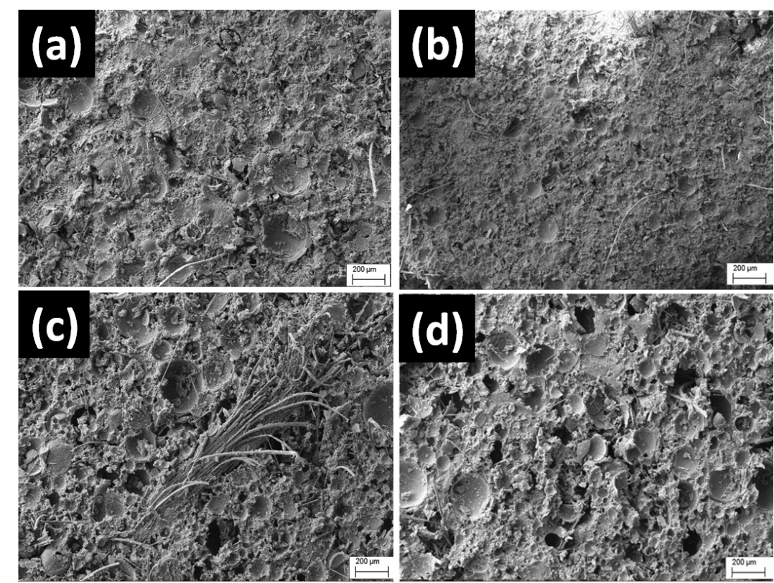
Figure 5. SEM images of (a,b)material A-N and (c,d)material A-F

3.4.Failure Mode Analysis and Quality Control

The honeycomb enhanced silica-based thermal protection material, which is shorten as material A in this paper, has a porous structure. The porous structure is composed of noninterconnected and interconnected pores. The noninterconnected pores are the inner part of glass spheres, which is mainly around 100um in diameter. The interconnected pores are the gaps between component matrix, glass sphere and some other fillers. In general, the pyrolysis gas, which is generated during ablation, flows out through the interconnected pores. The gas pressure may be as high as 6 MPa[4]. If the virgin material is uncompated, resulting in loosened micro structure, and cannot bear the pyrolysis gas pressure, the weak charring layer will be jacked up, as shown in Fig.5. The jacked charring layer will be blown away by ablation flux, as shown in Fig.2.

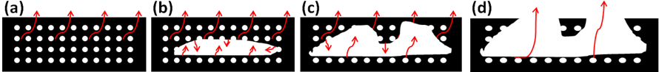
Figure 6. process of missing charring layer forming

The uncompacted virgin material in honeycomb resulted in the missing charring layer, leading to the failure. But this uncompacted micro structure was not detected by nondestructive testing (NDT). The virgin material was pressed into honeycomb in autoclave, and the micro structure was dense by pressure. The micro structure of material A-F was loosened, because of non-densification by pressure.
The only difference between material A-N and material A-F is the processing time. The processing time of material A-N was less than that of material A-F. The viscosity of raw material increased with the processing time, as shown in Fig.6. The viscosity increased faster after a certain time, as an exponential function. The processing time of material A-N was before the inflection point, while the processing time of material A-F was after the inflection point. It is difficult to press the raw material into honeycomb completely and densely, due to the high viscosity of raw material. The potential flaw was not detected by X-Ray nondestructive testing.

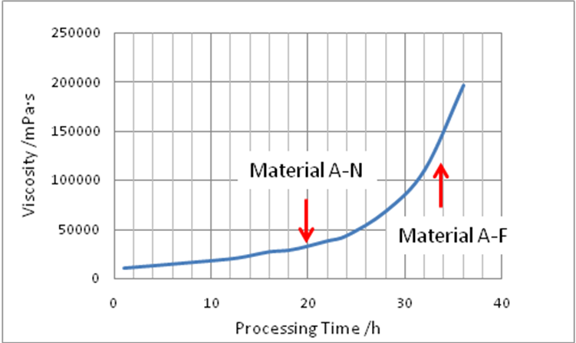
Figure 7. viscosity of raw material
The viscosity depends on the cure degree of room temperature vulcanized silicone rubber(RTV), which is the main constituent of the material. During processing, the degree of cure increased, which was in correspondence with the increasing viscosity. It is difficult to press the raw material into honeycomb completely and densely, as the viscosity increasing during processing. This resulted in the increasing number and size of interconnected pores, which weaked the charring layer and increased the amount of pyrolysis gas, leading to the failure.
Further researches were conducted to prove the speculation. Material A-1, A-2, A-3 were prepared, with the processing time of 20h, 28h and 36h, respectively. After ablation, the surface morphologies are shown in Fig.7. The surface of material A-1 was intact and smooth, while the surface charring layer of material A-2 and A-3 were fragmentary. The area of missing charring layer increased, as the processing time increasing.

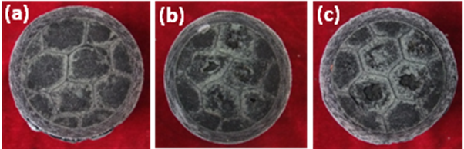
Figure 8. the surface of material after ablation with processing time of (a)20h, (b)28h and (c)36h.

4. Conclusions

A potential failure mode of honeycomb enhanced silica-based thermal protection material was observed. The viscosity of RTV increased with the processing time increasing, resulting in many undetectable pores, which resulted in the charring layer jacked up by pyrolysis gas and blew away by shearing force of heat flux. The surface recession increased abnormally, due to the increasing missing charring layer and the increased local heat flux during ablation. By shorten the processing time and keep the viscosity in a low degree, this failure mode will be forbidden.

References

[1] Bartlett EP, Anderson LW, Curry DM. An evaluation of ablation mechanisms for the Apollo heat shield material. J Spacecraft Rock , 8:463–9, 1971.
[2] Donskoy AA. Silicon organic heat-shielding materials for aircraft external surfaces. New approaches to polymer materials. Nova Publishers, 1995.
[3] Chunming Wang, Xin Liang, Baogang Sun and etc. Application of low desity ablative material on Shenzhou spacecraft. Aerospace materials & technology, 2:5-8,2011.
[4] Shengbo Shi, Linjie Li, Jun Liang, and Shuo Tang. Surface and volumetric ablation behaviors of SiFRP composites at high heating rates for thermal protection applications. International Journal of Heat and Mass Transfer, 102:1190–1198, 2016.

