MODE I FRACTURE SPECIMENS EXHIBITING OSCILLATORY CRACK MIGRATION

David Mollenhauer¹, Simon Baril-Gosselin², Endel Iarve³, Chun Li², Dan Rapking⁴, Eric Zhou⁴, and Michael Braginsky⁴

¹U.S. Air Force Research Laboratory, USA, david.mollenhauer@us.af.mil
²National Research Council, Canada
³University of Texas at Arlington, USA
⁴University of Dayton Research Institute, USA

Keywords: polymer matrix composite, delamination, migration, X-FEM, model, fracture

Abstract
Damage propagation in [90/0₁₀/90]_{s} double cantilever beam specimens, previously studied experimentally, was shown to exhibit an oscillating fracture pattern throughout the central two 90° plies. Interface delamination between 0° and 90° plies periodically migrated through the 90° plies in an oscillating manner. The experimental study showed significant toughening of the [90/0₁₀/90]_{s} specimens when compared with a standard 0° DCB of the same material. The [90/0₁₀/90]_{s} specimens were modeled in the present work. Damage was modeled using a Regularized eXtended-Finite Element Method to represent transverse matrix cracking and a standard interface cohesive zone method to represent interface delamination. A series of plane-strain and 3D models were produced to examine the effects of varying interfacial/ply strength and fracture toughness. 2D models qualitatively reproduced the oscillating migrating crack pattern, generally with a larger period of oscillation and lower fracture toughness. The 3D models illustrated that the oscillating migration is not responsible for the majority of toughening. Rather, it is concluded that the primary mechanism for increased toughness is a 3D, fiber bridging phenomenon as described in the experimental effort.

1. Introduction
Characterization of Mode I interlaminar fracture toughness, G_{I}, of unidirectional composites is generally well understood through the standardized ASTM test D5528. Recently, however, an oscillating, trapezoidal fracture pattern was documented in [1] for a [90/0₁₀/90]_{s} double cantilever beam (DCB) configuration manufactured from carbon fiber/epoxy unidirectional prepreg material. This phenomenon is shown in the dimensioned photograph in Figure 1 where a crack is seen growing through the central 90° layers in a trapezoidal pattern. The crack migrates from one 90°/0° interface through the 90° layers, follows the interface for a distance, then migrates to the other 90°/0° interface.
Crack migration from a delaminated interface, through adjacent plies to the neighboring ply interface has been well documented and studied [2-6]. The motivation for delamination migration is postulated to be related to the local shear stress state at the delamination tip. If the resolved normal stresses at the tip have a tendency to turn the delamination toward the 0° ply, then migration will not occur. However, if the resolved normal stress favors opening a transverse matrix crack and the energy is also conducive, then the delamination will tend to migrate. In the present work, it is assumed that this phenomenon is repeated after every migration event, thus oscillating the migration periodically.
An oscillating migration pattern was also observed in [7] in specimens consisting of 0° and ±45° plies with a double 45° ply at the central interface. It was observed that the complicated oscillating-bridging phenomenon was more prevalent in the thinner, less stiff specimens and greatly reduced in the specimens with larger bending stiffness in each DCB arm. Additionally, [7] observed variations in measured G_{Ic} values with the all 0° specimens having the lowest G_{Ic} and the thinner multi-directional laminates displaying the highest G_{Ic} values and the highest amount of fiber bridging.

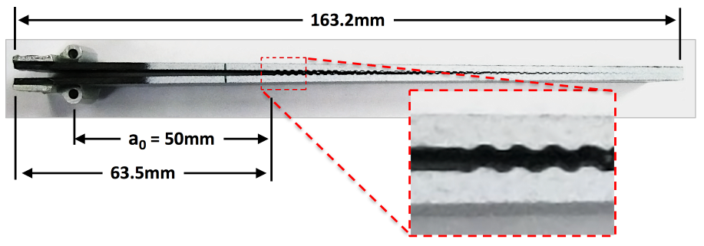
Figure 1. Photograph of [90/0₁₀/90]_{s} specimen damage. Teflon starter crack extends 63.5mm from left edge.
It was observed in [1] that the [90/0₁₀/90]_{s} DCB specimens displayed a significant increase in toughness when compared with the [0₂₂] specimens. Average load-displacement curves for each case are shown in Figure 2 where the toughening region is shown by the gradual rounding of the curve before steady load drop. This toughening was attributed to the significant fiber bridging observed in the failed [90/0₁₀/90]_{s} specimens. The bridging proved to be highly variable, resulting in significant variability in measured G_{Ic} for these specimens. In the present effort, numerical modeling was employed in an attempt to 1) duplicate the oscillatory migration phenomenon and 2) ascertain the effect of the oscillatory migrations on apparent G_{Ic}.

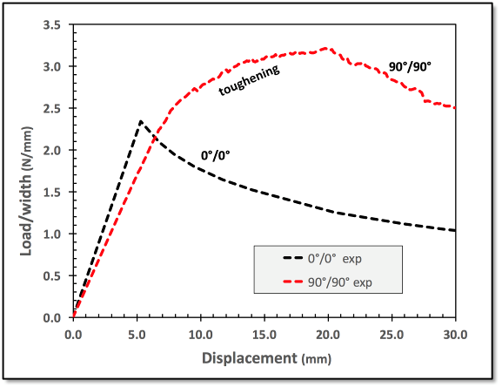
Figure 2. Average load displacement curves from both the [0₂₂] and [90/0₁₀/90]_{s} DCB specimens.

2. Numerical Modeling
Test specimens in [1] were manufactured in an autoclave from Cytec CYCOM 5276-1/G40-800 prepreg material. A 10μm thick layer of Teflon was inserted at the laminate mid-plane to act as a starter crack. Numerical models were constructed to closely match the experimental specimens with material properties obtained from the manufacturer’s literature [8].

2.1. Modeling Method
Developments in the simulation of damage evolution in laminated composites have allowed the representations of matrix damage in a discrete manner [9]. That is, matrix cracks are modeled explicitly in a mesh-independent form and are allowed to interact with each other and delaminations between plies. This Discrete Damage Modeling (DDM) approach has been applied to a variety of laminated and textile composite configurations, including to a test specimen for characterizing delamination migration in laminated composites [10]. The DDM method employed in the present work is based on a Regularized eXtended Finite Element Method (RXFEM) that allows for the modeling of displacement discontinuities associated with individual cracks in a general 3D setting, without regard to mesh orientation, by inserting additional degrees of freedom in the process of the simulation [9]. This methodology is a variant of the X-FEM where the Heaviside step function is replaced by a continuous approximation. The propagation of the mesh independent crack is then performed by using a cohesive zone method of the type described in [11]. This technique has been extensively used in laminated composites where crack orientation is predefined by fiber orientation. In this effort, the crack initiation was predicted using the 3D failure criterion LaRC04, which allows the definition of the crack direction in the plane transverse to the fiber orientation [12].

2.2. Modeling Details
Consulting [1], a meshed model was produced, as shown in Figure 3 that represents the average dimensions of the tested DCB specimens (see Figure 1). The mesh shown in Figure 3 has a thickness in the Y-direction matching the [90/0₁₀/90]_{s} specimen average thickness of 3.27mm. This mesh was used to model both the [90/0₁₀/90]_{s} specimens and the [0₂₂] specimens with the appropriate change of 90° ply properties to 0° ply properties. A single layer of elements in the Z-direction, 0.5mm thick, was employed with the front and back faces fixed in the Z-direction. Equal and opposite displacements in Y were applied at the points indicated in Figure 3, while fixing these points in X. Baseline Y displacements were incrementally increased by 0.2mm per load step. For brevity, 0° model results are omitted from this paper.
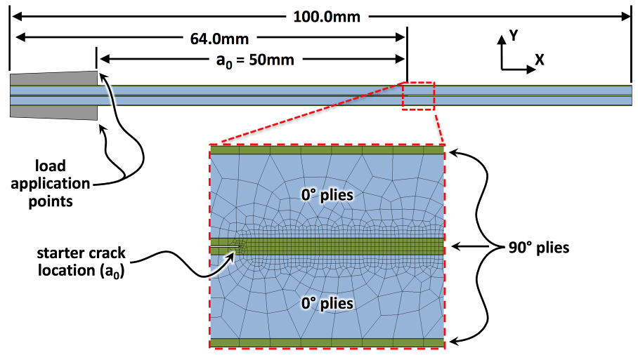
Figure 3. Mesh details used through the modeling effort.

Three damage configurations were considered in this plain-strain model and are schematically shown in Figure 4. Figure 4a describes the [0₂₂] DCB specimen which contained a single RXFEM cohesive zone running along the specimen mid-plane. No other interfaces or cracks were allowed to occur, thus simulating a 0° specimen where the starter crack essentially extends along the original plane. Two damage configurations were evaluated for [90/0₁₀/90]_{s} DCB specimens. Figure 4b is the [90/0₁₀/90]_{s} equivalent to configuration 4a. Although this model could not manifest the oscillating crack damage pattern, it was envisioned to show a baseline behavior of an ideally growing extension of the starter crack. Finally, the damage configuration shown in Figure 4c contains interface cohesive zones above and below the 90° plies while allowing for initiation and growth of RXFEM cracks within these plies.
A number of different plain-strain simulation cases were executed, varying strength, fracture, and/or load-step properties in an effort to understand which property contributed to delamination migration frequency and increases or decreases to the simulated load-displacement behavior. A list of cases studied is shown in Table 1 with each case described and the properties varied highlighted in blue font.
Finally, two 3-dimensional [90/0₁₀/90]_{s} specimens were modeled. Plies were meshed as shown in Figure 3 with 20 elements extruded in the Z-direction across the 20mm width of the specimen with elements biased toward the free edges. These 3D models were simplified by truncating the geometry at the hinge load application point and by modeling only 12.7mm length of the damage zone. Both models employed a load-control feature intended to manage unstable delamination growth. Case 7 had minimal load control applied while Case 8 had a high level of load control.
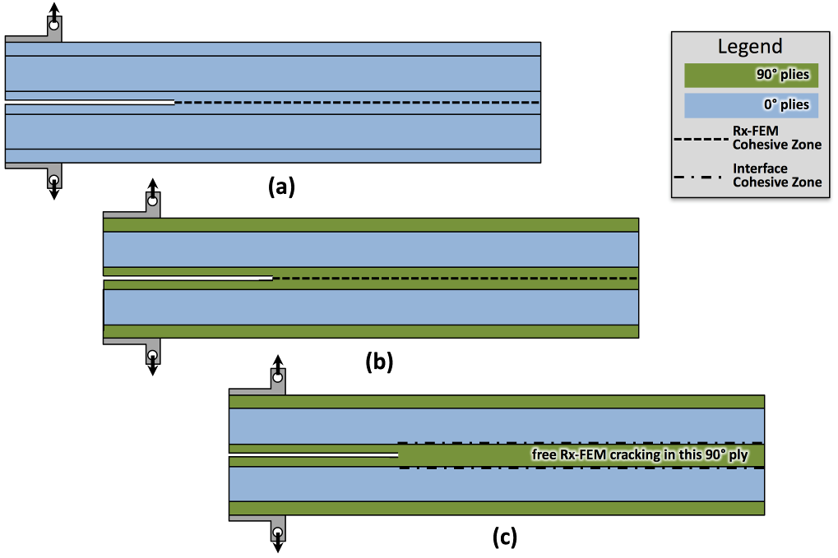
Figure 4. Schematics (not to scale) of the 3 model types employed in the present effort. (a) & (b) consists of the plies shown with a central RXFEM cohesive zone along the specimen mid-plane and no interface cohesive zone between the upper and lower central ply interfaces. (c) consists of cohesive zone interfaces above and below the central 90° plies while allowing RXFEM cracking in these plies.

Table 1. Case Descriptions for Plain-Strain and 3D [90/0₁₀/90]_{s} DCB Simulations
Case # | Description | RXFEM Crack |  |  |  | Interface
Case # | Description | Y_{T}  MPa | S  MPa | G_{Ic}  N/m | G_{IIc}  N/m | G_{Ic}  N/m | G_{IIc}  N/m
0 | Single RXFEM crack on centerline | 90 | 139 | 250 | 1600 | N/A | N/A
1 | Interface cohesive zones & free RXFEM cracking in 90° plies | 90 | 139 | 250 | 1600 | 250 | 1600
2 | Same as #1 with increased interface G_{Ic} | 90 | 139 | 250 | 1600 | 300 | 1600
3 | Same as #1 with increased interface G_{IIc} | 90 | 139 | 250 | 1600 | 250 | 1920
4 | Same as #1 with increased RXFEM G_{Ic} | 90 | 139 | 300 | 1600 | 250 | 1600
5 | Same as #1 with ¼ sized load steps | 90 | 139 | 250 | 1600 | 250 | 1600
6 | Same as #2 with decreased strengths | 72 | 111 | 250 | 1600 | 300 | 1600
7 | 3D DCB, same as #6 w/load control 1 | 72 | 111 | 250 | 1600 | 300 | 1600
8 | 3D DCB, same as #6 w/load control 2 | 72 | 111 | 250 | 1600 | 300 | 1600

3. Modeling Results

3.1. Plain-Strain Case Study Results
Two simulations, Cases 0 and 1, of the [90/0₁₀/90]_{s} specimen were conducted using the damage modeling configurations shown in Figure 4b and Figure 4c, respectively. Case 0 shows a smoothly behaving load drop that is significantly lower than that observed in experiment, with no indication of toughening. When both interfaces are allowed to delaminate and transverse cracks are enabled, the load drop shows a rough, saw-tooth behavior as shown by Case 1. Again, the curve is well below the observed experimental behavior of the 90°/90° interface. However, Case 1 did manifest the oscillatory crack behavior. The oscillation period observed in experiment averaged 1.65mm for a complete cycle, while Case 1 showed a larger average period of 4.5mm between complete migration cycles.

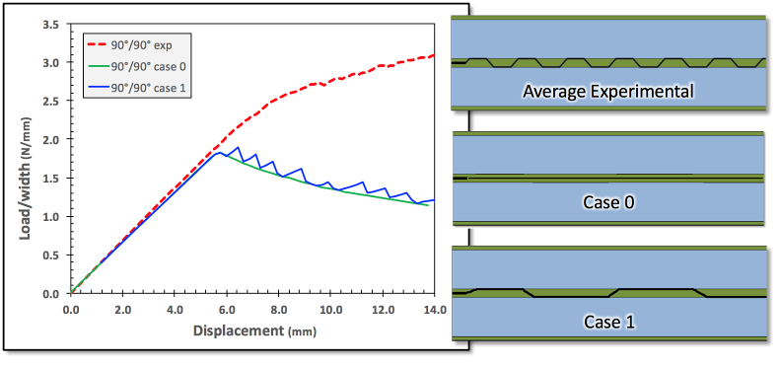
Figure 5. Load-displacement curves from experiment and initial modeling for both types of laminates.
As described in [3], delamination migration occurs through a transverse matrix crack when the local shear stress favors turning the delamination away from the 0° ply. To illustrate this, shear strain distributions were extracted from 4 separate load steps from Case 5 and are shown in Figure 6. Steps 28 and 36 are converged steps immediately before the formation of a transverse matrix crack that would enable migration. Steps 29 and 37 are load steps where an RXFEM crack has been inserted and partially opened. Once fully open, the delamination will generally migrate. It is clear from these images that the local shear strain sign is appropriate for driving the formation of a transverse matrix crack in the direction away from the adjacent 0° ply.
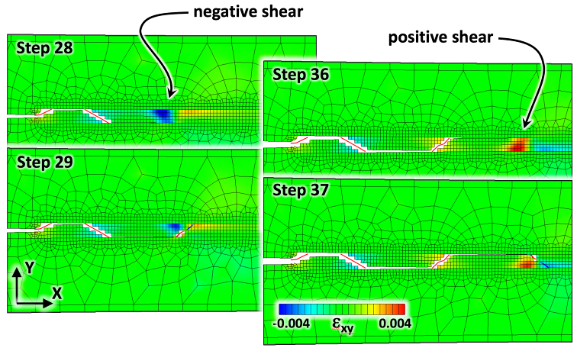
Figure 6. Shear strain distributions from just before formation of and just after formation of a transverse matrix crack allowing delamination migration. These data were extracted from Case 5.

A comparison between the experimentally obtained load-displacement curve and simulation results from Cases 1 and 2 is shown in Figure 7. Also included in this figure is a to-scale sketch of the damage patterns observed in each case, with the experimental damage pattern represented as an average of the observed behavior. As mentioned before, the migration period for Case 1 is significantly larger than the experimental average. Increasing the Mode I fracture toughness by 20% for the 0°/90° interfaces reduced the period slightly, increased the load-displacement curve, and caused a few RXFEM cracks to be inserted but not open (shown as yellow lines in Figure 7).
A mechanism by which the local interfacial fracture toughness could plausibly be larger is illustrated in Figure 8. Micrographs presented in [6] show delaminations “attempting” to migrate, but failing. Image analysis of these arrested, kinked delaminations shows an increase of ~20% in path length, leading to the choice of a 20% G_{Ic} increase in the current case study. Closely examining the shear strain fields prior to delamination migration (Figure 6) indicates a broad area of shear strain that would favor migration. This is likely the cause of incomplete migrations where the energy is insufficient to allow the delaminations to fully migrate out of the ply interface, but making small excursions possible.

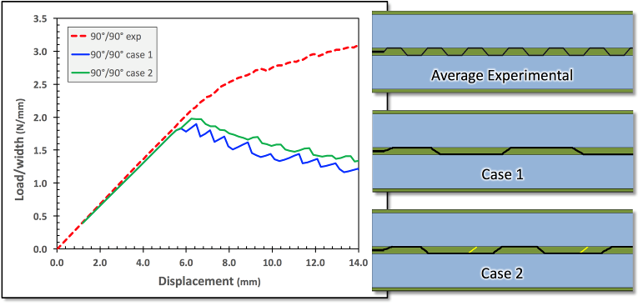
Figure 7. Load-displacement curves and damage patterns obtained from experiment (average) and Cases 1 & 2. Note, that inserted RXFEM cracks that did not open are shown in yellow.
Due to proceedings page limitations, detailed descriptions of case study results will be omitted. However, two broad observations can be made. The oscillatory delamination migration was qualitatively reproduced and the load-displacement curve does not show the toughening seen in [1]. The delamination migration represented in these plane-strain models, while contributing to a slight increase in toughness, is not responsible for the toughening observed experimentally.

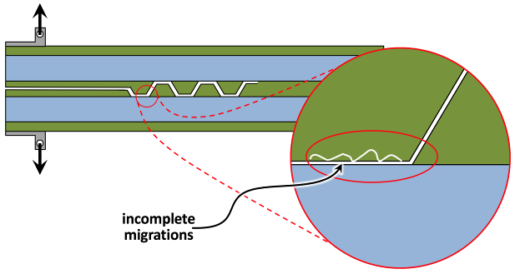
Figure 8. Schematic of a possible mechanism for increased fracture toughness at the 0°/90° interface.

3.2. 3D Model Results
Load-displacement results from Cases 7 and 8 are shown in Figure 9. Also in this figure are cut-away views of delamination and matrix crack damage. Both 3D model load-displacement curves exhibit tougher behavior than the plain-strain model. As with the 2D models, Case 8 shows no continued toughening. However, Case 7 shows indication of toughening. The primary difference is a result of fiber bridging. Case 7 predicted migration spacing whereby transverse matrix crack insertion occurred simultaneously at the free edges and in the specimen center, but at different axial locations. This caused an unequal propensity to delaminate at either the top or bottom interface across the width of the specimen. The bridged ligaments eventually peel away from one side or the other, but during this process, absorb a significant amount of energy. Case 8 had a high level of load-control applied in order to suppress rapid delamination growth. As a result, cracking tended to initiate at the minimum element spacing required by the RXFEM technique. While this allowed for rapid migratory oscillations, it suppressed fiber bridging.

4. Discussion
The [90/0₁₀/90]_{s} case study indicates that, as suspected in [1], the majority of toughening observed in the experimental effort results from fiber bridging. Due to the stochastic nature of composites it is easily envisioned that there would be significant differences in formation of transverse matrix cracking across the width of a specimen, as evident by coarse results from Case 7. Experimentally this is shown when examining images of the side of a failed specimen as shown in Figure 10a. In this figure, a series of magnifications indicate the complexity of the delamination path. There are the expected large migrations causing an oscillatory, trapezoidal migration pattern. Additionally, however, there are a significant number of the trapezoidal sections delaminated on both their top and bottom interface surfaces with many showing further sub-division through transverse matrix cracking. Indeed, in Figure 10b, ligaments appear to be pulled in an alternating manner from side to side while incorporating additional locally fractured ligaments. This is supported by [6] who observed evidence of fiber bridge cracks propagating across the width of the specimen.
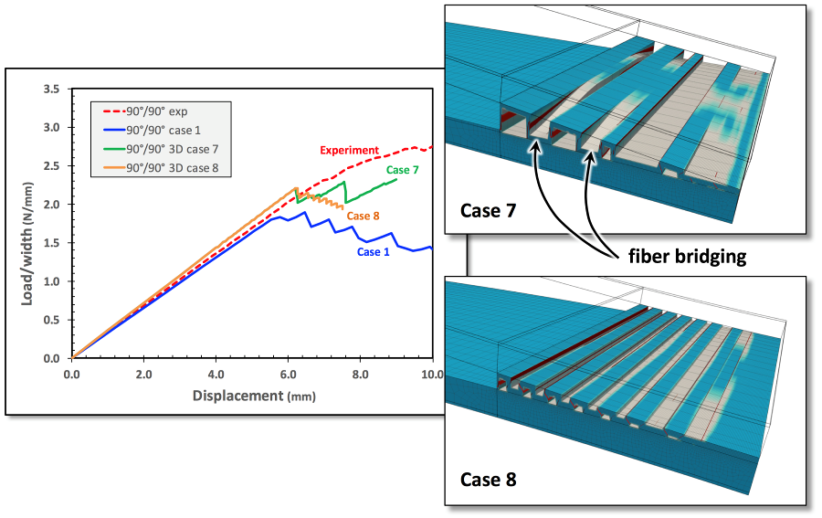
Figure 9. Comparison of experimental, plain-strain, and 3D load-displacement curves. Cut-away views of Cases 7 & 8 are shown, illustrating fiber bridging. Blue color indicates no damage, tan color indicates delamination, and red color indicates transverse matrix cracking.
In this simple DCB example, the global G_{Ic} behavior for delamination whose propagating force is in the direction transverse to the fibers showed initially the same value as for those whose propagation is aligned with the fibers [1]. G_{Ic} for this case was then shown to rise until a steady state value was achieved, coincident with a steady state of ligament production versus released ligaments in the bridging process. Greenhalgh [3] and Pernice [6] describe clearly that a delaminating interface will tend to be driven toward one of the bounding interfaces due to the local shear stress at the delamination tip, which was verified in the current modeling effort. The indication was that structural models must include mechanisms to capture delamination migration to properly account for the increased toughness observed through migration. Sun [7] showed that the apparent G_{Ic} in a DCB at 45°/45° interfaces was larger than at 0°/0° interfaces, but was also dependent on specimen thickness.
Predictive models of delamination evolution would need the fidelity to not only include the mechanism for delamination migration through transverse matrix cracking but also to determine the local shear stress state at the delamination crack tip. As shown in [1,7] and the present numerical study, certain loading configurations result in oscillatory behavior of the delamination, requiring the models to capture the density of bridging events and subscale bridging damage to properly represent increasing G_{Ic} with increasing delamination length. Also, as mentioned above (Figure 8) and in [3,6] there is some indication that the local interfacial fracture toughness of a θ°/φ° interface may be different from a 0°/0° interface even if the shear stress level is not sufficient to induce a migration or if the bounding ply restricts migration. Truly predictive models would need to incorporate this as well.
As it has been indicated, the observed G_{Ic} at initiation in a θ°/φ° interface is very similar to that of a 0°/0° interface. One might think that using the 0°/0° initiation G_{Ic} and incorporation of predictive migration capability would provide conservative simulation results. In most cases this is likely true. However, in the case of certain fiber failure events near notches, the local fiber-direction stress can be reduced by combinations of transverse matrix cracking and delamination [13]. In these situations, the presence of the delamination reduces the fiber stress concentration, thus increasing the apparent strength of the notched laminate. If a baseline 0°/0° G_{Ic} is used, then the predicted delamination might be larger than in reality. This would lead to a non-conservative prediction of fiber failure. In all probability, this is unlikely as the situation described in [13] is a result of a very small delaminated region where the 0°/0° G_{Ic} approximation is still valid.
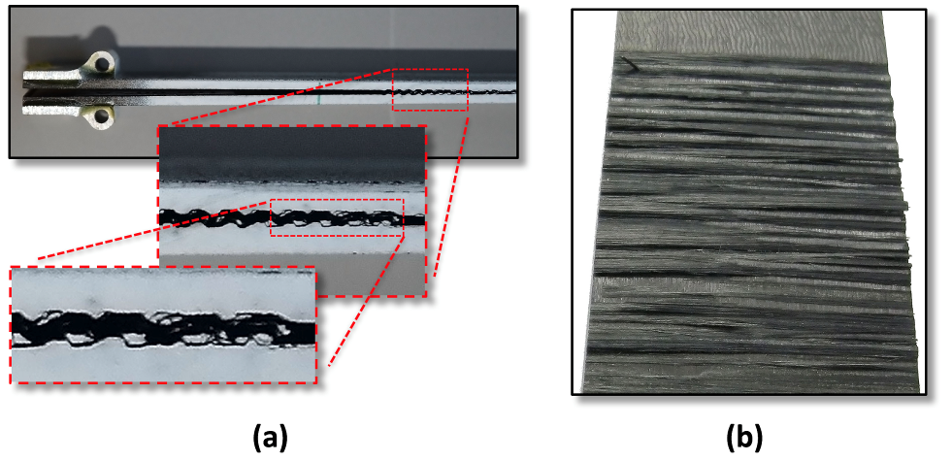
Figure 10. Failed [90/0₁₀/90]_{s} specimen showing complex delamination growth & ligament formation.

5. Conclusions
A numerical effort to elucidate oscillatory delamination behavior in [90/0₁₀/90]_{s} DCB specimens was described. Plane-strain models were able to qualitatively capture the trapezoidal delamination oscillations but were unable to reproduce the frequency of delamination migrations observed in experiment. The experimentally observed toughening due to bridging was not represented either. The case study conducted showed that, of the factors varied, increasing the interfacial G_{Ic} and reducing the load step size had the most favorable effects on oscillation frequency. 3D models of sufficient refinement were able to coarsely capture local bridging effects, producing apparent G_{Ic} toughening.

6. References
[1] Baril-Gosselin, S. and Li, C., “Characterizing and Predicting the Effects of Weave Geometry on Mode I Fracture Toughness of Composites,” American Society for Composites 31st Annual Technical Conference and Proceedings, 19-21 Sep 2016.
[2] He, M. and Hutchinson, J., “Kinking of a Crack Out of an Interface,” J. Appl. Mech., 56(2):270–8, 1989.
[3] Greenhalgh, E.S., Rogers, C., and Robinson, P., “Fractographic Observations on Delamination Growth and the Subsequent Migration Through the Laminate,” Comp. Sci. Technol., 69:2345–51, 2009.
[4] Ratcliffe, J.G., Czabaj, M.W., and O’Brien, T.K., “A Test for Characterizing Delamination Migration in Carbon/Epoxy Tape Laminates,” NASA/TM – 2013–218028, 2013.
[5] Ratcliffe and De Carvalho, “Investigating Delamination Migration in Composite Tape Laminates,” NASA/TM – 2014–218289, 2014.
[6] Pernice, De Carvalho, Ratcliffe, and Hallett, “Experimental Study on Delamination Migration in Composite Laminates,” Composites Part A, 73:20-34, 2015.
[7] Sun, Yau, Aldersiesten, and Benedictus, “Mode I Quasi-Static Delamination Growth in Multidirectional Composite Laminates with Different Thickness,” American Society for Composites 31st Annual Technical Conference and Proceedings, 19-21 Sep 2016.
[8] CYCOM 5276-1 Epoxy Resin System Technical Data Sheet, https://cytec.com/sites/default/ files/datasheets/CYCOM_5276-1_031912.pdf
[9] Iarve and Mollenhauer, Numerical Modeling of Failure in Advanced Composite Materials, 1st Edition, Chapter 9: Mesh-Independent Matrix Cracking and Delamination Modeling in Advanced Composite Materials, Camanho & Hallett, Woodhead Publishing, 2015.
[10] Mollenhauer, Zhou, Hoos, Iarve, Braginsky, Breitzman, and Rapking, “Multi-Scale Simulation of Delamination Migration,” American Society for Composites 31st Annual Technical Conference and Proceedings, 19-21 Sep 2016.
[11] Turon, Camanho, Costa, and Davila, “A Damage Model for the Simulation of Delamination in Advanced Composites under Variable-Mode Loading,” Mechanics of Materials, 38:1072-89, 2006.
[12] Pinho, Dávila, Camanho, Iannucci, and Robinson, “Failure Models and Criteria for FRP under In-Plane or Three-Dimensional Stress States Including Shear Non-Linearity,” NASA/TM-2005-213530, 2005.
[13] Iarve, Mollenhauer, Whitney, and Kim, “Strength Prediction in Composites with Stress Concentrations: Classical Weibull and Critical Failure Volume Methods with Micromechanical Considerations,” J. Mater. Sci. 41(20):6610–6622, 2006.

