**Preparation of Self-reinforced Poly(lactic acid) Composites  
Using Melt-blown Microfibrous Mats**

**Daniel Vadas1, Dávid Kmetykó 1, Katalin Bocz1, György Marosi1**

*1Department of Organic Chemistry and Technology, Budapest University of Technology and Economics, Budafoki út 8, H-1111 Budapest, Hungary*

As sustainability became a major topic of the scientific communication, biocomposites gained much importance among other structural materials. Over the last few decades, a wide variety of biopolymers have been developed, among which poly(lactic acid) (PLA) has been considered as the most promising bio-based and biodegradable polymer. However, the poor impact strength and thermal stability of PLA have to be improved to make it suitable for durable applications. Self-reinforcement (SR) is a good way to increase the impact strength and heat deflection temperature (HDT) of a thermoplastic polymer, moreover, the SR composites are fully recyclable. Lately, researchers found novel directions to achieve SR-PLA structures. *Somord et al.* [1] succesfully produced SR-PLA nanocomposites for the first time by means of hot-compaction of electrospun PLA fibres. This technique allowed a productivity of 0.32 g/h, which makes it hardly scalable.

In this work, SR-PLA composites were produced using melt-blown PLA nonwoven mats as starting material. Three types of PLA differing at D-lactide content were processed by the solvent-free melt-blowing technology. As high as 120 g/h productivity and 2-16 µm filament diameter were achieved. The crystallinity of the PLA microfibres was enhanced by thermal annealing; 2-3 fold increase in the degree of crystallinity was obtained (*Figure 1*), as measured by differential scanning calorymerty (DSC).

*Figure 1. The effect of annealing time on the crystallinity of PLA fibres*

The obtained PLA mats were then processed via hot compaction technique and formed into SR-PLA composites (*Figure 2*).

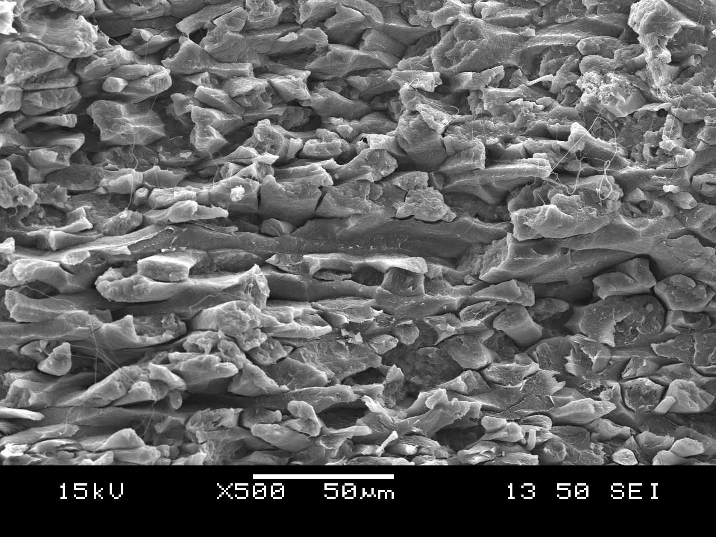

*Figure 2. Fracture surface of SR-PLA composite (D-lactid content: 0,5%)*

The composite preparation conditions were comprehensively studied focusing on the morphological, thermal and mechanical properties of the obtained unique, microstructural SR-PLA composites. The prepared SR-PLA composites, composed of highly crystalline reinforcing fibres, can be characterised with enhanced thermo-mechanical properties. Furthermore, due to the high fibre-matrix interfacial area, substantial improvement in ductility and toughness was achieved when compared to isotropic PLA film.

[1] K. Somord, O. Suwantong, N. Tawichai, T. Peijs, N. Soykeabkaew: *Self-reinforced poly(lactic acid) nanocomposites of high toughness.* Polymer, (2016) 103: 347–352