Hybrid CFRP-elastomer-metal laminates: Influence of lay-up parameters on its damping behaviour

W. V. Liebig¹, V. Sessner², A. Jackstadt¹, K. A. Weidenmann² and L. Kärger¹

¹Karlsruhe Institute of Technology, Institute of Vehicle System Technology,
Rintheimer Querallee 2, D-76131 Karlsruhe, Germany
²Karlsruhe Institute of Technology, Institute for Applied Materials,
Engelbert-Arnold-Str. 4, D-76131 Karlsruhe, Germany
Email: wilfried.liebig@kit.edu, vincent.sessner@kit.edu, kay.weidenmann@kit.edu, luise.kaerger@kit.edu

Keywords: Constrained layer damping, vibration, visco-elasticity, time-temperature superposition

Abstract
In this work, the damping behaviour of hybrid carbon fibre-reinforced plastics/elastomer/metal-laminates is investigated with regard to the influence of multilayer composite parameters, such as lay-up and visco-elastic material behaviour of the constituents. Elementary experimental studies (dynamic mechanical analysis) are performed to characterise the visco-elastic material behaviour of the elastomer and the carbon fibre-reinforced plastics. Furthermore, numerical studies are conducted by implementation of the visco-elastic material behaviour into commercial finite-element software. Therefore, detailed multi-layer finite-element models are created, offering a high flexibility concerning the finite-element type and number of elements especially in thickness direction of the laminate. In particular, existing material models are used and the influence of each constituent on the system’s damping behaviour is investigated. Owing to the detailed 3D modelling, no restrictions to the limits of equivalent single-layer or layer-wise shell elements arise.

1. Introduction

The combination of fibre-reinforced plastics (FRP) and metals impresses with excellent mechanical and fatigue properties by low density [1]. Most of the so called fibre-metal laminates (FML) can be found in aerospace applications, however, it can be recorded, that the use of hybrid materials also increases in the fields of typical mechanical engineering purposes, e.g. in the ship building and automotive industry. The highest lightweight potential is promised by using a combination of carbon fibre-reinforced plastics (CFRP) and aluminium. In this case, however, special attention has to be paid to the corrosion potential and the significant mismatch of the thermal expansion between these two materials. To avoid these challenges a possibility is to introduce of an elastomeric layer and, hence, to develop the FML to a hybrid CFRP-elastomer-metal laminate (HyCEML).

The development of HyCEML allows the reduction of the thermal expansion mismatch between FRP and metal and, in addition, the prevention of galvanic corrosion. More important, it enables the possibility with regard to a smart design of laminated structures by flexible stiffness and adaptable damping behaviour. Owing to the visco-elastic material behaviour of the elastomer and the CFRP the vibration and damping behaviour can be adjusted to the design requirements [11]. Therefore, a detailed knowledge about the mechanical material behaviour of HyCEML and its constituents is essential and is the objective of this work.

2. Materials and methods

2.1. CFRP-elastomer-metal laminates

The investigated CFRP-elastomer-metal laminates (HyCEML) consist of common CFRP prepreg material HexPly M77/38%/UD150/CHS (provided by Hexcel Corporation), elastomer (El) Kraibon SAA9579-52 (provided by Gummiwerk Kraiburg GmbH & Co. KG) and aluminium (Al) alloy 2024-T3 AlCLAD sheets (provided by Kastens Knauer GmbH). For this study, the lay-up of HyCEML is varied depending on the setup of the investigation. However, the nominal thickness of specimens is set to be t = 2.5 mm, where the elastomeric layer is always between the CFRP- and aluminium-layer to avoid galvanic corrosion.

2.2. Mechanical material behaviour and material models of the constituents

As input for the numerical examinations quasi-static material properties are identified by performing experimentally tensile tests based on EN ISO 527-4 [2] and ISO 37 [3] by using testing machines from Zwick GmbH & Co. KG. To measure the strain and to determine the Poisson’s ratio digital image correlation (DIC) is used. In the case of CFRP mechanical properties, the transverse shear modulus G₃₂ is calculated by applying the rule of mixture assuming that Poisson’s ratio ν₃₂ is 0.4 [10]. Furthermore, the mechanical properties of aluminium are taken from a data sheet. All mechanical quasi-static properties from the HyCEML constituents are summarised in Table 1 for CFRP and in Table 2 for elastomer and aluminium, respectively.

Table 1. Elastic properties of CFRP M77/CHS (t_{CFRP} = 0.15 mm).

Elastic modulus  / GPa | Poisson’s ratio  / – | Shear modulus  / GPa | Density  / kg/m³
E₁ = 113.7 | ν ₂₁ = 0.3371 | G₂₁ = 3.76 | ρ = 1496
E₂ = 7.75 | ν ₃₁ = 0.3381 | G₃₁ = 3.76
E₃ = 7.75 | ν ₃₂ = 0.4000 | G₃₂ = 2.75

Table 2. Elastic properties of elastomer (t_{El} = 0.5 mm) and aluminium (t_{Al} = 0.3 mm).

Type | Elastic modulus  E / GPa | Shear modulus  ν / – | Density  ρ / kg/m³
SAA9579-52 | 0.074 | 0.48 | 1180
AL2024-T3 | 73.10 | 0.31 | 2780

Furthermore, to qualify the visco-elastic material behaviour of CFRP and elastomer, dynamic mechanical analysis (DMA) tests based on ISO 6721-4 [4] are carried out gathering a data base in a frequency range of f = 0.1 Hz to 10 Hz at a continuous temperature between T = -80 °C and 50 °C in a step size of 3 °C. The dataset is used to describe the storage and loss modulus over a wide range of frequency by applying Williams-Lendel-Ferry approach, also known as the time-temperature superposition principle. The visco-elasticity of the elastomer can be modelled by build-in software methods, whereas an extended user-defined material model is required to describe the orthotropic visco-elasticity of fibre-reinforced plastics.

2.3 Numerical model, boundary conditions and FE mesh

For measuring the influence of visco-elasticity of the polymeric constituents, a virtual test setup based on ISO 6721-3 [5] is chosen. In this case, a cantilever beam (length × width = 180 mm × 15 mm) clamped on one side is modelled in Abaqus and is excited by a harmonic force on the opposite side. A detailed schematic picture of the test setup is shown in Fig. 1.

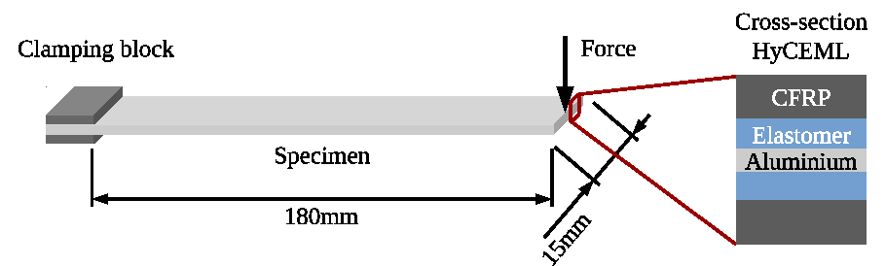

Figure 1. Schematic test setup of the HyCEML cantilever beam based on ISO 6721-3 [5].

In a first step the mesh fineness is evaluated for all numerical studies and optimised to reduce the calculation time. For that purpose, a detailed parameterised multi-layer finite element model is generated, where a minimum of three elements through the layer thickness is chosen. As know from previous analysis [6], 20-nodes volume elements (C3D20H) capture the material behaviour of HyCEML with a high accuracy in terms of depicting the transverse deformation and hence, are chosen for this investigation. In general, a modal analysis is not carried out, owing to the fact, that in this case all time or frequency depending material behaviour is neglected by FE software [7]. Hence, the result shown in the following section is based on steady-state analysis.

3. Results and discussion

In comparison to experimental studies, the impact of visco-elasticity of polymeric constituents of HyCEML on vibration properties, can be clearly identified by numerical investigations. In the following, the visco-elasticity of elastomer and CFRP is either taking into account or neglected to highlight its effect on vibration properties of HyCEML. For all graphs, the amplitude of the material response is normalised to the initial deflection of the cantilever beam [8].
In the first step, four numerical calculations are carried out to present in detail the influence of the visco-elasticity of the elastomer and CFRP, respectively. In Fig. 2 the amplitude of the cantilever beam is faced to the excited frequency. It can be illustrated, that as soon as visco-elasticity is considered the material response of HyCEML leads to higher values of the natural frequencies. This can be traced back to the increase of storage modulus with increasing frequency. In addition, also a reduction of the amplitude, i.e. increasing of damping values of HyCEML, can be observed. For both effects, the elastomer has the greatest influence.

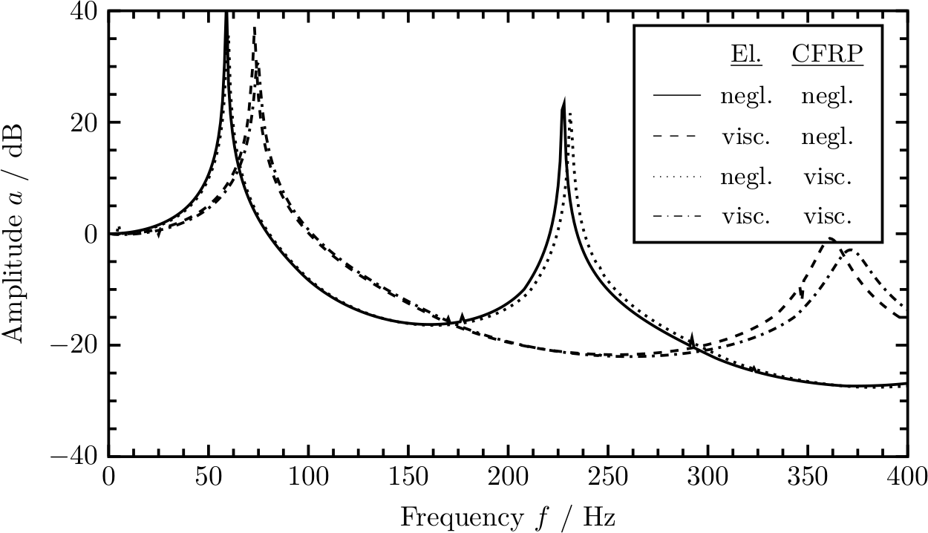

Figure 2. Numerical investigation of the influence of visco-elasticity of HyCEML constituents (elastomer and CFRP) on the damping behaviour of the hybrid laminate.

In the second step, the lay-up is varied from the typical laminate structure [CFRP/El/Al]_{s} to [Al/El/CFRP]_{s}. Fig. 3 shows the material response (amplitude versus frequency) of both lay-ups for a constant harmonic force excitation. If aluminium is placed on the outer side of the laminate the natural frequency is reduced to lower frequency values. Also, a reduction of the damping can be observed, which can be traced back to the fact, that the visco-elasticity of the elastomer and the CFRP plays just a minor importance when these layers are placed in the middle of the laminate. Hence, the energy dissipation due to the visco-elasticity of the polymeric constituents in shear is reduced.

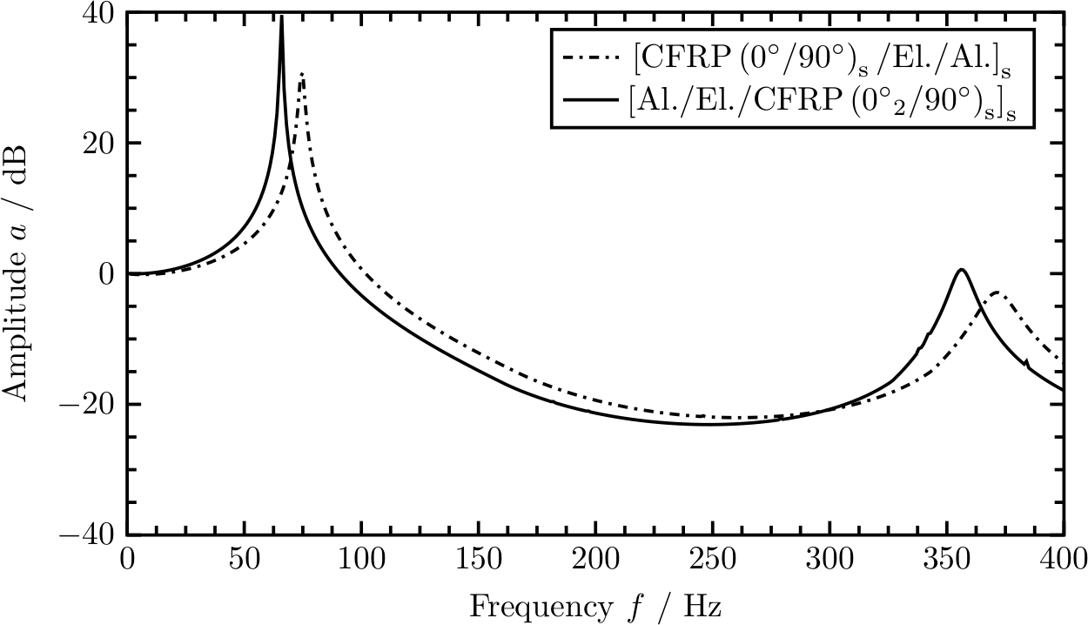

Figure 3. Influence of the laminate structure on the damping behaviour of yCEML, considering visco-elasticity of the HyCEML constituents (elastomer and CFRP).

To sum up the influence of the visco-elasticity of the polymeric constituents of HyCEML on its damping behaviour, Table 3 includes the loss factors based on half power value bandwidth (3dB) method [9] for undamped [CFRP/El/Al]_{s} and damped [CFRP/El/Al]_{s} and [Al/El/CFRP]_{s} laminates, respectively. It can be shown, that each mode shows an individual dissipation behaviour and the second natural frequency is more damped than the first natural frequency. It also can be confirmed, that CFRP on the outer side of a laminate has a greater influence on damping of HyCEML than aluminium as shown in Fig. 3.

Table 3. Loss factors based on half power value bandwidth (3dB) method for undamped and damped hybrid CFRP-elastomer-metal laminates.

Laminate | Loss factor @  1. natural frequency | Loss factor @  2. natural frequency
[CFRP/El/Al]_{s} undamped | 0.0065 | 0.0035
[CFRP/El/Al]_{s} damped | 0.0147 | 0.0219
[Al/El/CFRP]_{s} damped | 0.0068 | 0.0136

4. Conclusion

In this work, the influence of the visco-elasticity of the polymeric constituents on the damping behaviour of a hybrid CFRP-elastomer-metla laminate (HyCEML) is investigated and characterised. Usually, the direct influence of visco-elastic material behaviour on the structural damping can be hardly characterised by experimental studies. Hence, numerical investigations are conducted allowing to neglect or to take into account the visco-elasticity and thus to highlight the effect of every constituent. Therefore, a build-in material model is used to describe the visco-elasticity for the elastomer and a orthotropic visco-elastic material model is developed for CFRP. It can be figured out, that the greatest influence on damping is coming from the elastomer, whereas a further attributed proportion is based on visco-elastic effects of the CFRP.

Acknowledgments

The authors would like to acknowledge the funding of this work by the German Research Foundation (DFG) via SPP1897 “Calm, Smooth, Smart”, project KA 4224/3-1 “HyCEML – Hybrid CFRP/elastomer/metal laminates containing elastomeric interfaces for deliberate dissipation”. In addition, the authors thank Gummiwerk Kraiburg GmbH & Co. KG for providing the elastomer.

References

[1] R. Alderliesten, Fatigue and fracture of fibre metal laminates, Vol. 236 of Solid mechanics and its applications, Springer, Cham, 2017
[2] European Committee for Standardization, Plastics - Determination of tensile properties - Part 4, EN ISO 527-4 (July 1997)
[3] International Organization for Standardization, Rubber, vulcanized or thermoplastic – Determination of tensile stress-strain properties, ISO 37 (November 2017)
[4] International Organization for Standardization, Plastics - Determination of dynamic mechanical properties - Part 4: Tensile vibration - Non-resonance method, ISO 6721-4 (May 2008)
[5] International Organization for Standardization, Plastics – Determination of dynamic mechanical properties - Part 3: Flexural vibration, Resonance-curve, ISO 6721-3 (December 1996)
[6] W. V. Liebig, V. Sessner, K. A. Weidenmann, L. Kärger, Numerical and experimental investigations of the damping behaviour of hybrid CFRP-elastomer-metal laminates, accepted manuscript in Composite Structures
[7] Dassault Systemes, Abaqus 2017 Documentation (2017)
[8] D. J. Ewins, Modal Testing: Theory and Practice (Engineering Dynamics), Research Studies Press, England, 1984
[9] VDI Verein Deutscher Ingenieure eV (2005) Damping of materials and members (Experimental techniques for the determination of damping characteristics) - Part 5. VDI 3830-5
[10] R. Jones, Mechanics of Composite Materials, 2nd Edition, Taylor and Francis, Inc. Philadelphia, 1999.
[11] E. Sarlin, Y. Liu, M. Vippola, M. Zogg, P. Ermanni, J. Vuorinen, T. Lepistö, Vibration damping properties of steel/rubber/composite hybrid structures, Composite Structures 94 (11) (2012) 3327–3335.

